**Project: Prime Number**

Application : Console Application

Language: C#

1: Below screen will ask you to enter count of numbers which you want to see Primes.

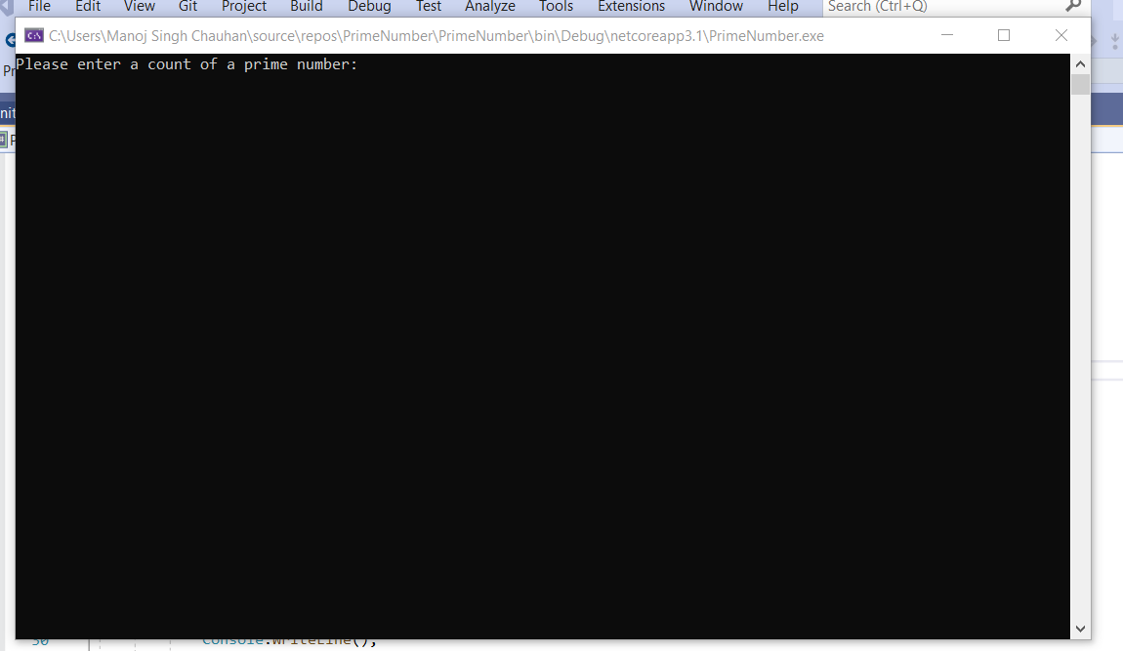

2: Entered the number 5. Application returns N+1 * N+1 multiplication grid.

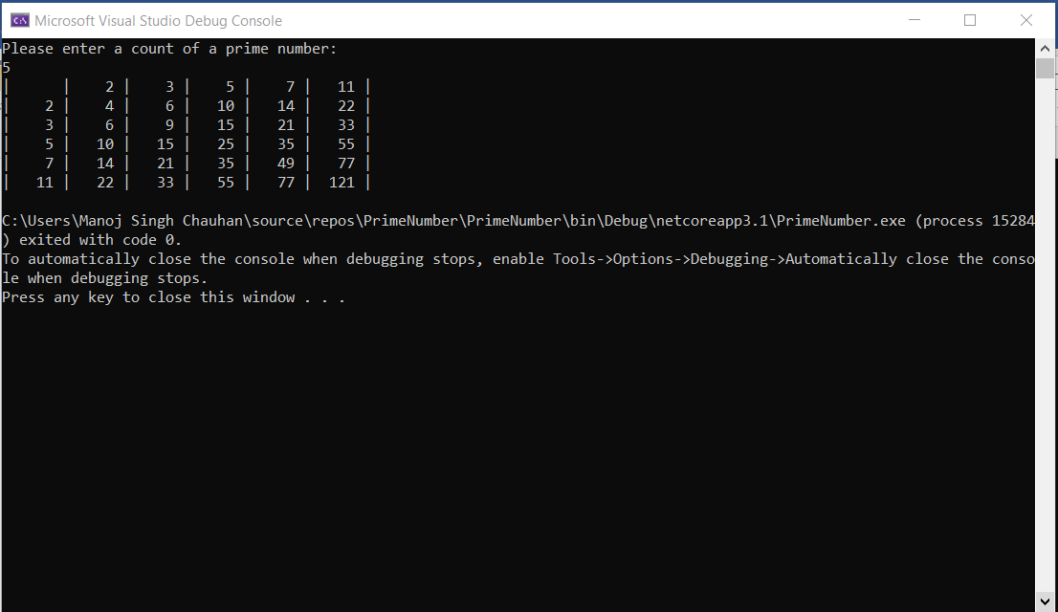

2: Entered the number 15. Application returns N+1 * N+1 multiplication grid.

