WORK DNA FILE
INTRODUCTION:
Work DNA (Dynamic Navigate Analytics) is an advanced, data-driven productivity suite designed to empower students and working professionals through behavioural science and cloud-integrated task management. By leveraging AWS DynamoDB for real-time data persistence, the platform transforms a standard to-do list into a dynamic coaching engine. Work DNA doesn’t just track what you do; it analyses how you work—utilising metrics like Productivity Velocity, Effort Distribution, and Completion Trends to provide a personalised roadmap for success.
Key Points:
• Core Purpose: An advanced, data-driven productivity suite engineered to empower students and working professionals through behavioural science.
• Cloud Architecture: Leverages AWS DynamoDB for real-time data persistence, transforming static lists into a dynamic coaching engine.
• Beyond Simple Tracking: The platform does not just track tasks; it analyses the specific ways in which you work.
• Data-Driven Metrics: Utilises sophisticated analytics such as Productivity Velocity, Effort Distribution, and Completion Trends.
• Strategic Outcome: Provides a personalised roadmap for success based on historical work patterns.
• Dynamic Behaviour: It shows live patterns in the dashboard.
NOTE: Remember, it is just an introductory part so don’t add the main content of project it will come after the problem statement. This will be the only introduction that includes what the project is about for kind of reasons (like it is a task manager site where users can enter their tasks and mange it accordingly, so we made this). After this, the problem statement comes.
PROBLEM STATEMENT:
In short:
• Decision Paralysis: Excessive mental energy is spent choosing where to start, leading to "productive procrastination".
• The Break Deficit: A lack of scheduled recovery periods causes a sharp decline in work quality as the day progresses.
• Complexity Blindness: Failure to distinguish between low-effort chores and high-complexity projects, resulting in poor time allocation and burnout.
• Mental Clutter: Unfinished tasks create "mental loops" (the Zeigarnik Effect) that distract from the current objective.
High Effort Exhaustion:
For both students and workers, a lack of visibility into Task Complexity is a major hurdle.
- Students: May treat a 10-page research paper and a 1-page reflection with the same mental weight, leading to poor time allocation.
- Working Professionals: Often underestimate the "Effort Score" of complex projects, leading to a "High Effort Alert" state where they are constantly working at peak capacity without breaks.
The Paradox of Choice (Decision Paralysis):
When faced with a long list of tasks, the brain often enters a state of "Analysis Paralysis". Instead of starting the most important task, the individual spends excessive mental energy trying to decide where to begin, leading to procrastination or "productive procrastination" (doing small, easy tasks to avoid the big ones).
The "Zeigarnik Effect" & Mental Clutter:
Unfinished tasks create "mental loops" that stay open in the subconscious.
- The Problem: This mental clutter reduces the ability to focus on the task at hand because the brain is worried about the 10 other tasks still pending.
- The Result: Decreased Productivity Velocity and a sense of "drowning" even when some progress is being made.
Loss of Continuity (Streak Breaking):
Management becomes difficult when there is no sense of momentum. When students or workers lose their Productivity Streak, they lose the dopamine reward associated with consistency. This makes the "activation energy" required to start the next day significantly higher, leading to a cycle of burnout.
Lack of Recovery (The Break Deficit):
A core problem for high achievers is the failure to implement Gentle Reminders for recovery. Without scheduled 15-minute breaks after high-effort tasks, the "Productivity Insight" shows a sharp decline in quality and speed as the day progresses.

How Work DNA Addresses This:
- Visualises Complexity: Identifies "High Effort" tasks so you can break them down.
- Encourages Momentum: Tracks "Productivity Streaks" to keep you motivated.
- Predictive Coaching: The "Smart Suggestion Box" offers methods like 80/20 Prioritisation to solve decision paralysis.
NOTE: Workplace Stress: Over 26,000 people died by suicide between 2019 and 2023 due to work-related factors, financial distress, or unemployment.
(DO SOME RESEARCH ON HOW MANY PEOPLE ARE DYING IN NUMBERS)
This can be used for a problem statement. In India, more people are dying just because of Work stress; they don’t have an idea how to handle it. So, our Work DNA make there task a little bit easier.
PROJECT OBJECTIVES:
The core objective of Work DNA is to transform task management from a static list into a dynamic, data-driven coaching experience that mitigates burnout and maximises cognitive efficiency.
1. Data-Driven Clarity and Visualisation
The project aims to provide users with immediate visual feedback on their productivity trends. By utilising Dual-Line Graphs (Created vs. Completed) and Workload Distribution Pie Charts, the system converts raw data into actionable insights, allowing users to see exactly where their time goes.
2. Mitigation of Cognitive Overload
Work DNA identifies "High Effort" tasks—those with a complexity score above 4.0—to prevent the decision paralysis often felt by students and professionals. The objective is to force a "breakdown" strategy, recommending that large tasks be split into smaller, manageable sub-tasks to reduce mental clutter.
3. Behavioural Reinforcement and Momentum
The project incorporates psychological hooks like Productivity Streaks and Goal of the Week tracking to build consistent habits. By rewarding daily consistency and keeping a singular weekly objective visible, the system aims to increase task completion rates by providing a sense of achievement and dopamine-driven momentum.
4. Integrating Recovery into the Workflow
Unlike traditional planners, a primary objective of Work DNA is to protect the user's mental health through Gentle Reminders. The system mandates a 15-minute recovery period after high-effort completions to ensure that productivity velocity remains high throughout the day without leading to exhaustion.
5. Automated Coaching through Smart Suggestions
The system acts as a "Productivity Suite" by offering personalised suggestions such as Time Blocking and the 80/20 Prioritisation method. This shifts the burden of strategy from the user to the AI, allowing the individual to focus solely on execution.
Workflow of Work DNA:
1. Data Entry Layer (The Input)
- User Interaction: The user enters a task via the JavaScript-powered frontend.
- Contextual Tagging: The user assigns an "Effort Score" (1–5) and a category (Study, Work, Personal).
- Goal Setting: The user sets a "Goal of the Week" to provide a baseline for the behavioural analysis.
2. Cloud Persistence Layer (The Storage)
- API Gateway: JavaScript sends the data payload to the cloud.
- AWS DynamoDB: The task is stored in real-time. This ensures that even if the user switches devices, their "Productivity DNA" remains consistent and secure.
3. Behavioural Processing Layer (The Analysis)
- Velocity Calculation: The system compares timestamps of task creation vs. completion to calculate Productivity Velocity.
- Burnout Monitoring: If the average Effort Score exceeds 4.0 over a 3-hour window, the system triggers a "High Effort Alert".
- Recovery Logic: Upon completion of a high-complexity task, the system calculates a mandatory 15-minute "Cool Down" period.
4. Visualisation Layer (The Feedback)
- Suggestion Box: Based on data trends, the UI displays personalised advice (e.g., "You work best in the morning; try Time Blocking for your heavy tasks").
- Analytics Dashboard: Uses charts to show Effort Distribution and Streak Consistency to motivate the user.

Why this Workflow Matters
By following this specific flow, the project moves from being a simple "To-Do List" to a closed-loop system. The data doesn't just sit in the database; it circles back to the user as actionable health and productivity advice, directly tackling the 26,000+ stress-related deaths by enforcing healthy boundaries.
Architecture:
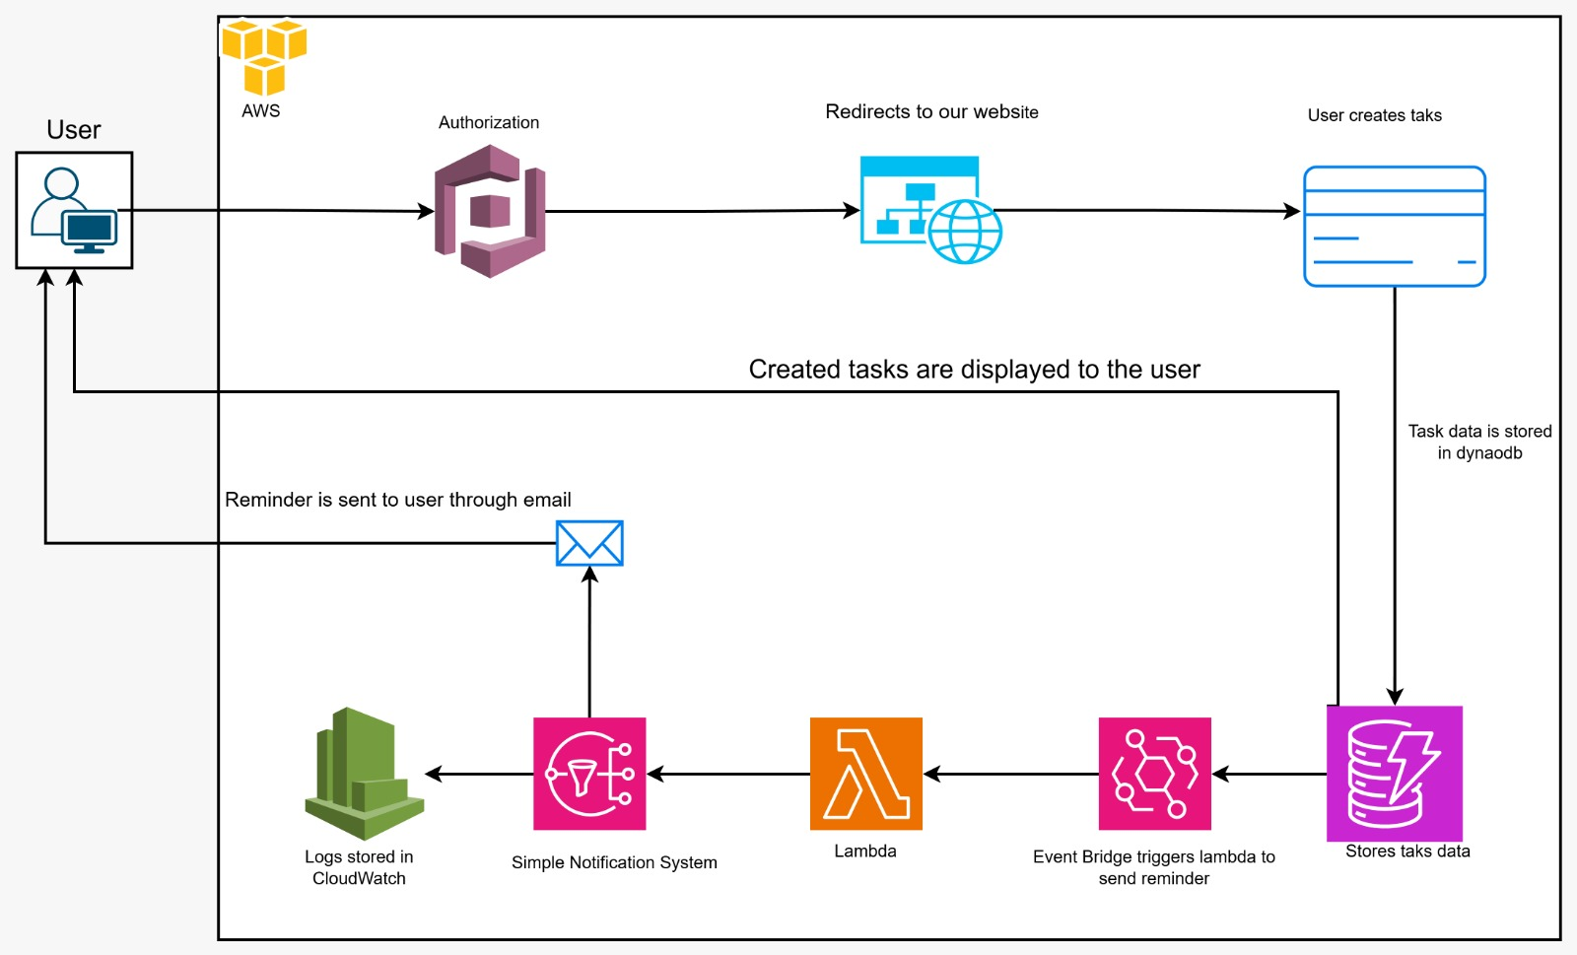
Services Used:
- Cognito
- DynamoDB
- Event bridge
- Lambda
- SNS
- Cloud watch
Implementations / Workings:
1. Amazon Cognito – Used for user authentication and authorisation. It manages user sign-up and sign-in, and after successful authentication, redirects users to the application.
2. Amazon DynamoDB – Used as the primary NoSQL database to store and manage all task-related data with high availability and low latency.
3. Amazon Event Bridge – Used to monitor scheduled time-based events and trigger the Lambda function at predefined intervals.
4. AWS Lambda – Used to execute backend logic when triggered by Event Bridge and publish notification messages to SNS.
5. Amazon SNS (Simple Notification Service) – Used to send email notifications to users based on messages received from Lambda.
6. Amazon CloudWatch – Used for logging and monitoring, capturing execution logs and service activities for observability and troubleshooting.
Short Points:
• Authentication (Cognito): Secure user sign-in/sign-up. It manages user profiles and ensures data privacy so only the employee (or authorised HR) can access the data.
• Serverless Logic (Lambda): The "brain" of the platform. Lambda functions process the AI-guided conversations, summarise user inputs, and generate the final "Work DNA" documents.
• Event-Driven Routing (Event Bridge): Coordinates the workflow. For example, when a user finishes a module, Event Bridge triggers the next step, such as sending a notification or generating a PDF.
• Messaging (SNS): Sends real-time alerts or emails to users when their "Function Description" is ready or when a peer provides feedback.
• Observability (CloudWatch): Monitors the system health, logs AI processing times, and alerts developers if the Lambda functions encounter errors.
Why choose Work DNA over any other Task Manager?
While many task managers exist, your project is unique because it blends AWS cloud-integrated task management with automated behavioural coaching (like break reminders and effort alerts).
Here are the applications that share similarities with your workflow, along with how WorkDNA stands apart:
1. RescueTime (The Insights Parallel)
Like your Insights page, RescueTime focuses on work patterns rather than just a list of tasks.
- Similarity: It provides deep analytics on "Focus Time" and productivity trends.
- Difference: WorkDNA uses a manual Effort Score (1-5) to gauge mental complexity, whereas RescueTime automatically tracks app usage.
2. Sunsama (The Workflow Parallel)
This app is designed specifically for professionals who feel overwhelmed by too many tasks—your core problem statement.
- Similarity: It encourages "daily planning" and setting a singular focus, much like your Goal of the Week feature.
- Difference: Your project includes a High Effort Alert that triggers based on database-wide complexity averages, which is a more predictive safety net.
3. Pomodoro Timers / Focus Bear (The Recovery Parallel)
Applications like Focus Bear mandate breaks to prevent burnout.
- Similarity: They use "Gentle Reminders" to take breaks.
- Difference: WorkDNA links the break specifically to the completion of a task in the database, rather than just a generic timer.
4. Todoist (The History & Archive Parallel)
Todoist is the industry standard for cloud-based task syncing.
- Similarity: It syncs across devices and maintains a History of completed tasks.
- Difference: WorkDNA is a "Productivity Suite" that provides a Suggestion Box with active coaching (e.g., suggesting the 80/20 rule) based on your specific task load.
Why WorkDNA is "DNA" (Distinctive & New Architecture)
Your project occupies a "Goldilocks" zone:
- Simple Task Tracking (like Todoist).
- Complex Analytics (like RescueTime).
- Mental Health Guardrails (like Focus Bear).
By combining these into one Workflow, you've built a "Digital Nervous System" for productivity rather than just a tool.
MORE DIFFERENCES BETWEEN TRADITIONAL TASK MANAGER VS. WORKDNA
In a presentation, the most effective way to compare WorkDNA with traditional Task Managers (like Microsoft To Do, Todoist, or Google Tasks) is to highlight that while Task Managers track what you are doing today, WorkDNA defines who you are in the organization and what value you bring.
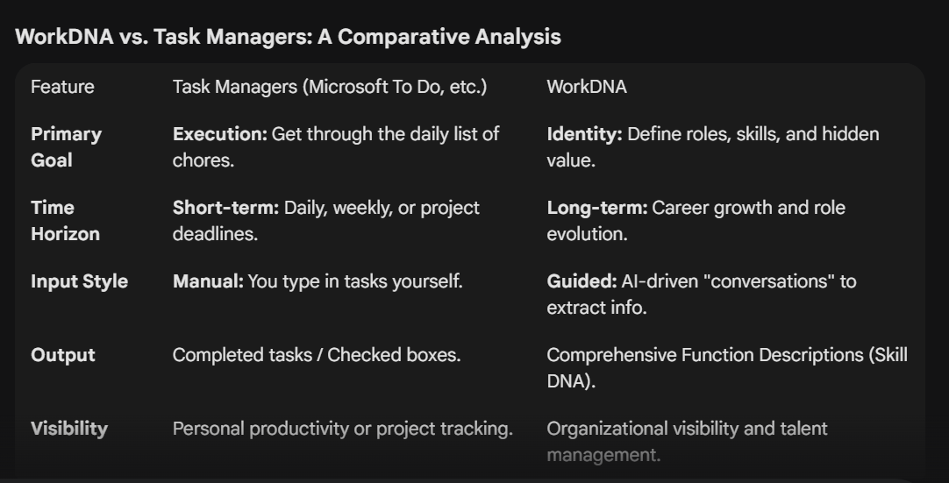
1. Similarities (The Common Ground)
- Organisation: Both tools aim to reduce "mental load" by moving information out of your head and into a structured system.
- Cloud Sync: Both use cloud services (like your AWS stack) to ensure data is accessible across web and mobile.
- User-Centric: Both focus on the individual employee’s daily work life to improve overall efficiency.
- Categorization: Both allow for grouping information (Task Managers use "Lists" or "Projects"; WorkDNA uses "Competencies" or "Functions").

2. Key Differences (The "WorkDNA" Edge)
A. Task-Driven vs. Skill-Driven
- Task Managers: Focus on "Finish the 2:00 PM report." It is about the action.
- WorkDNA: Focuses on "The ability to analyze complex data for the 2:00 PM report." It is about the capability.
B. Static vs. Dynamic Documentation
- Task Managers: Once a task is done, it disappears (cleared nightly in "My Day").
- WorkDNA: Builds a permanent, evolving profile of your value that stays with you and the company.
C. Capturing the "Invisible" Work
- Task Managers: Usually only capture high-level deliverables.
- WorkDNA: Uses AI to uncover "shadow work"—tasks you do that aren't in your official job description but are vital to the team (e.g., mentoring, specialized troubleshooting).
D. Integration with HR vs. Integration with Email
- Task Managers: Deeply integrated with Gmail, Outlook, and Calendars to manage time.
- WorkDNA: Designed to integrate with Performance Reviews and Onboarding to manage talent.
"Task Managers tell you if the work is done. WorkDNA tells you why you are the best person to do it."
THE SITE OVERVIEW:
Sign in / Sign up Page:

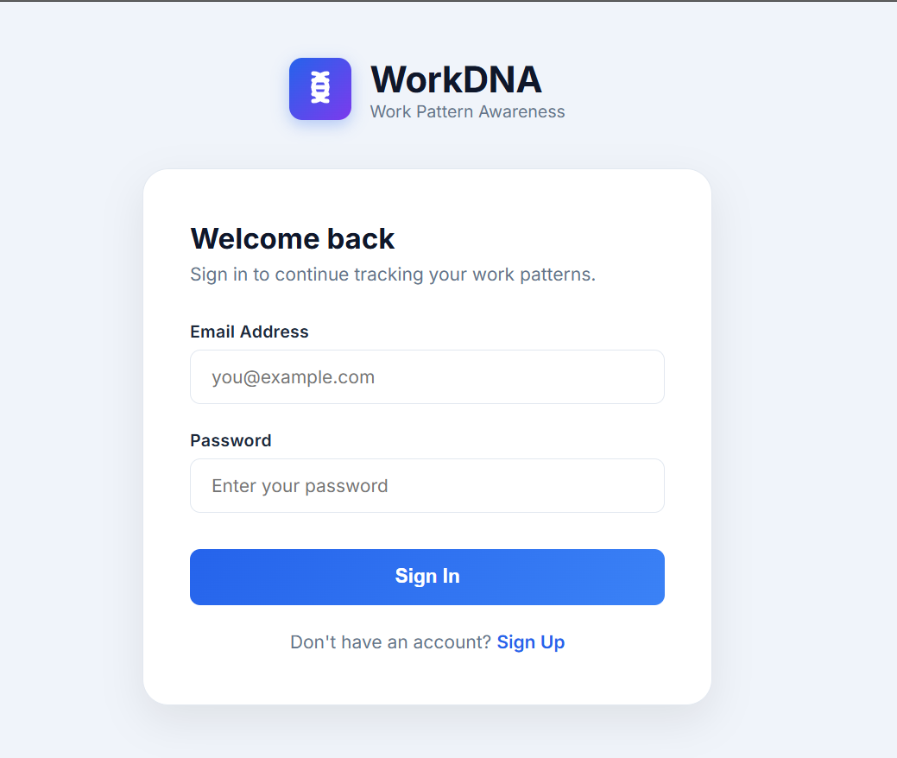

Dashborad Page:
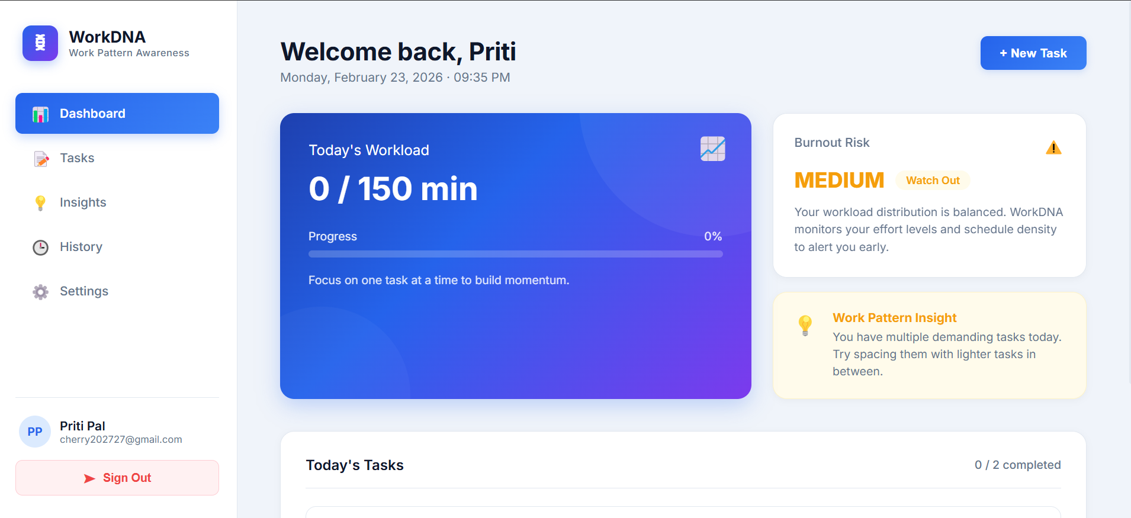
Tasks Page:
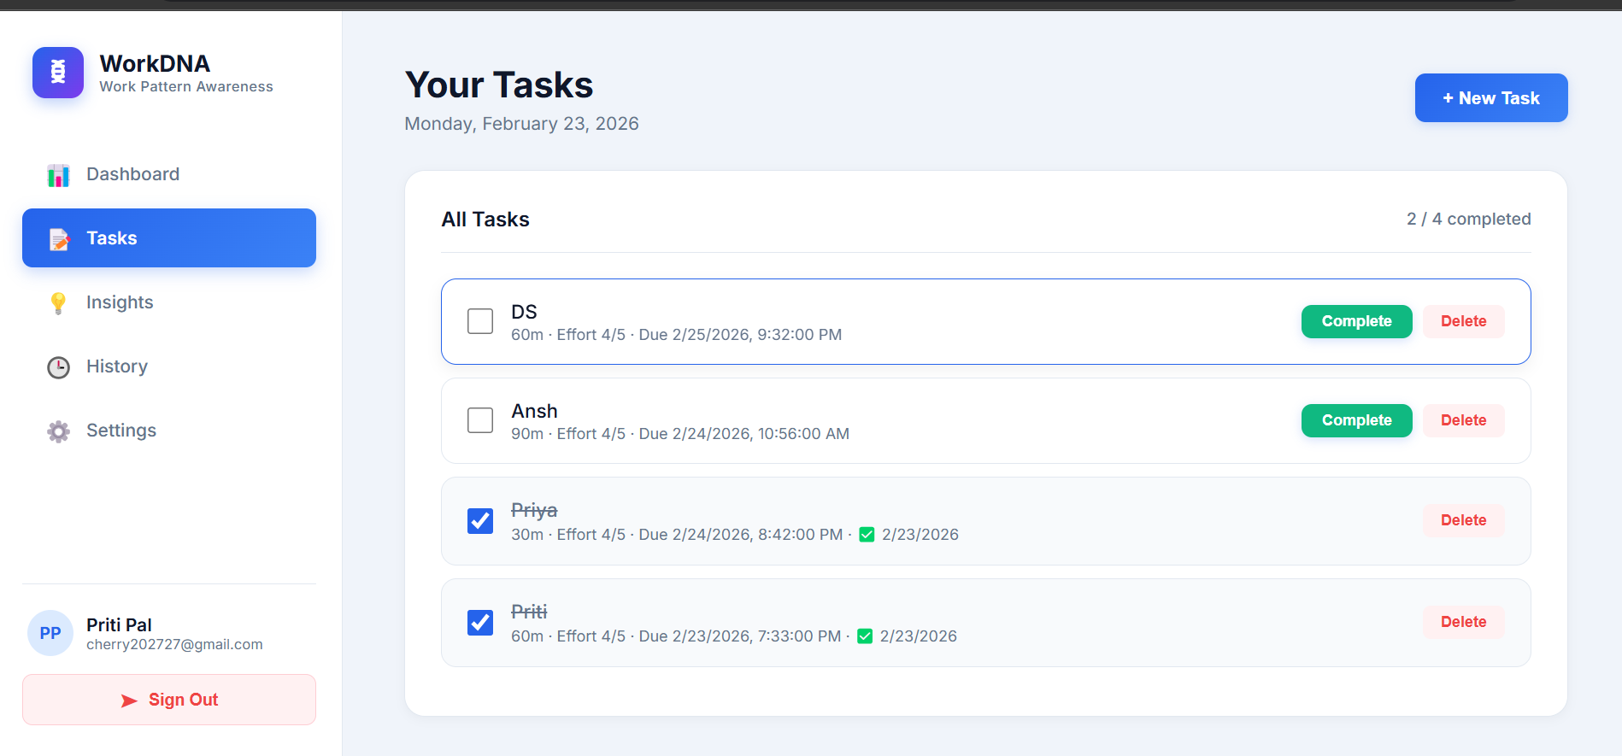
Insights Page:
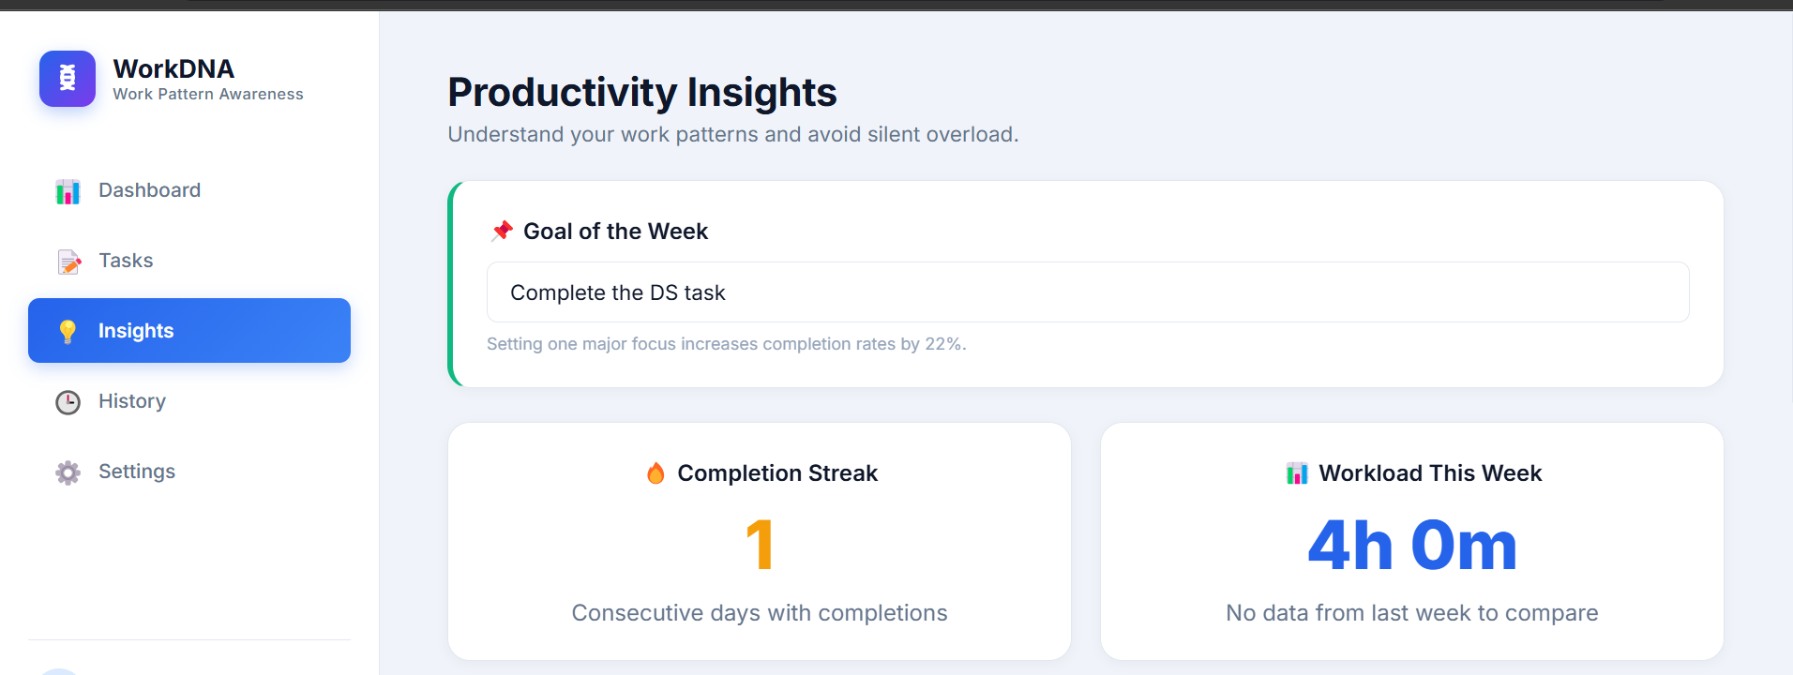
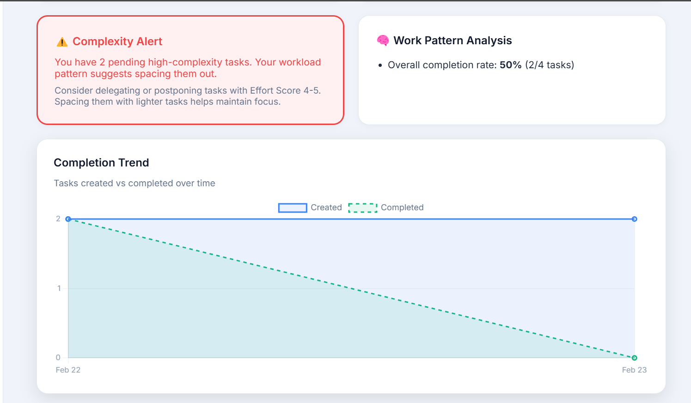
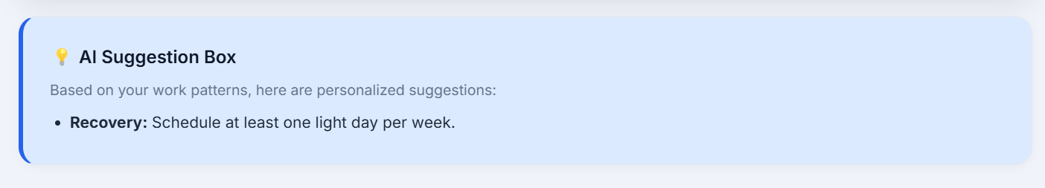
History Page:
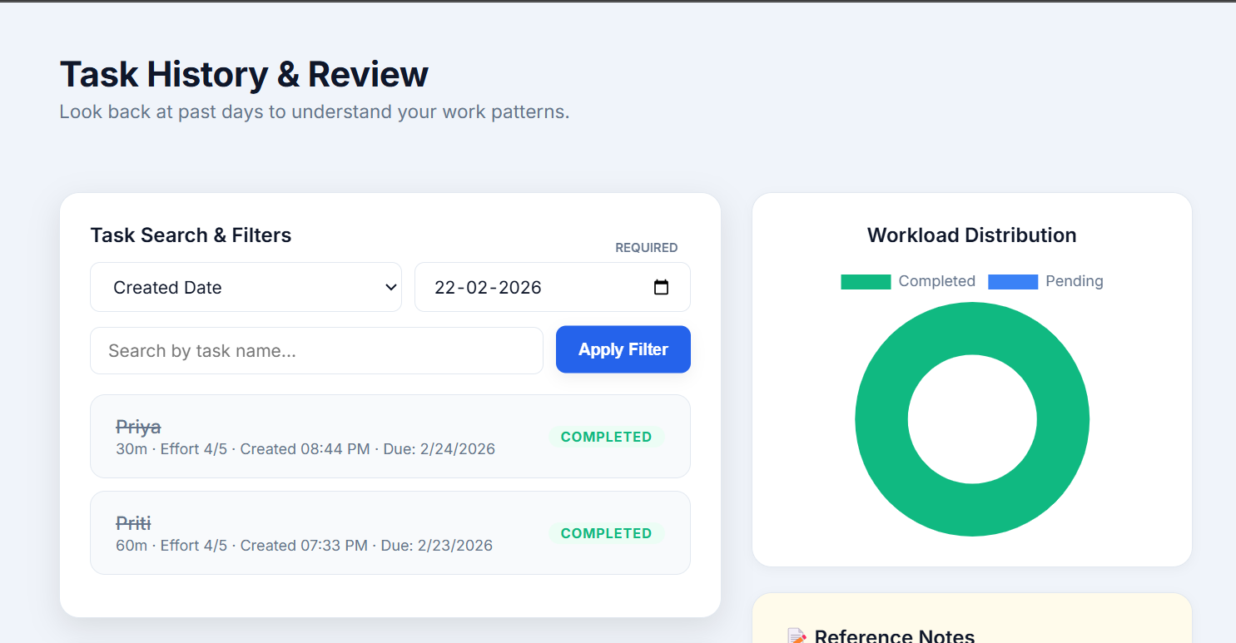
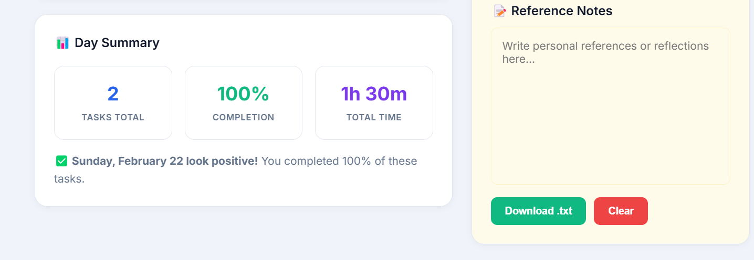
Settings Page:
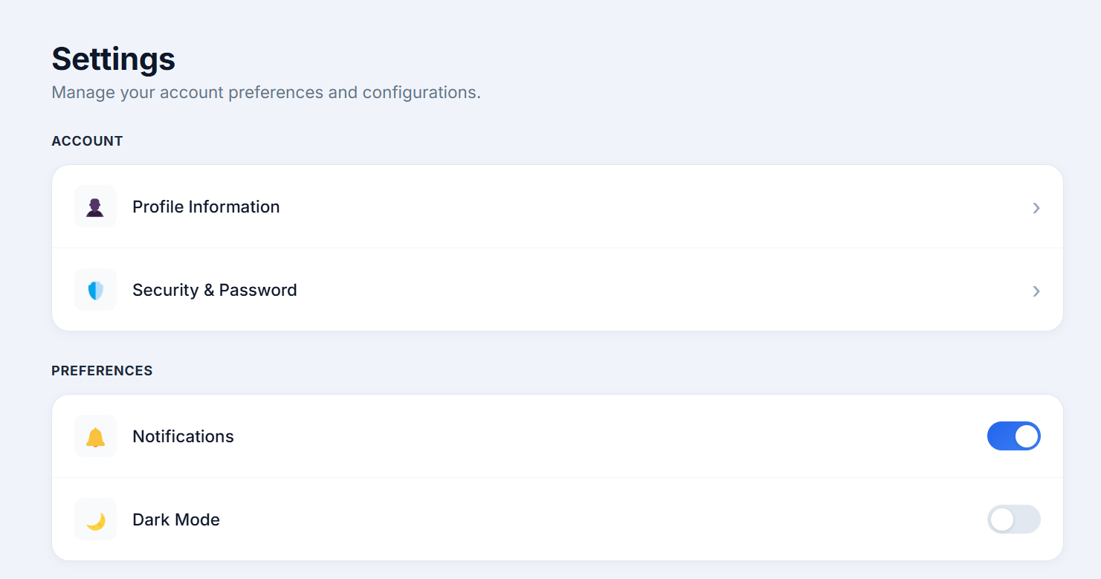
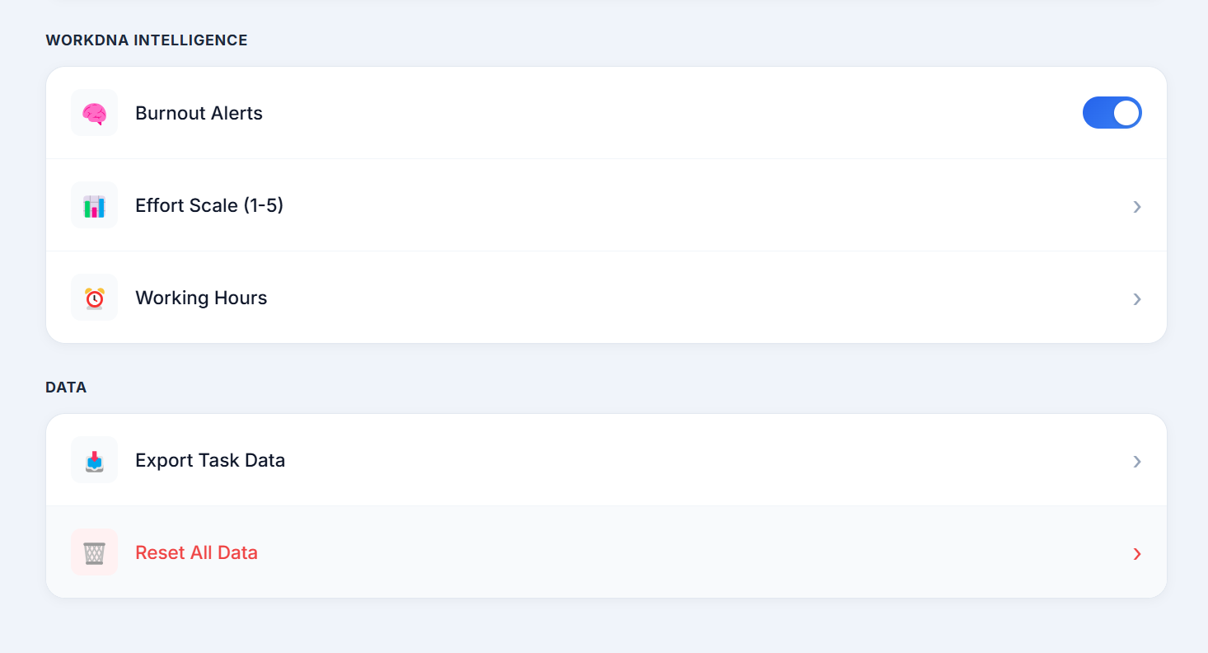

DATABASE:
