Q.1

a) Navigate and List

cdac@DESKTOP-T10L2Q2:~$ pwd

/home/cdac

cdac@DESKTOP-T10L2Q2:~$ mkdir - Linux Assignment

b) File Management:

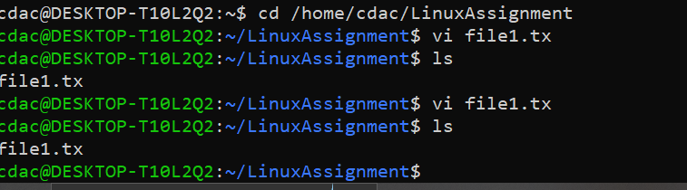

c) Directory Management:

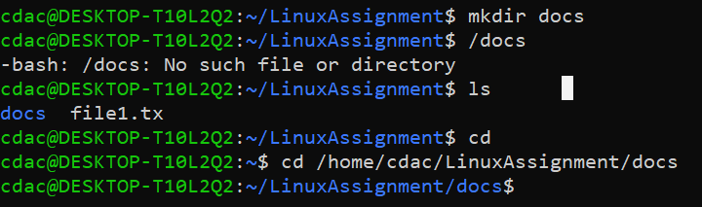

d) Copy and Move Files:

a. Copy the "file1.txt" file into the "docs" directory and rename it to "file2.txt"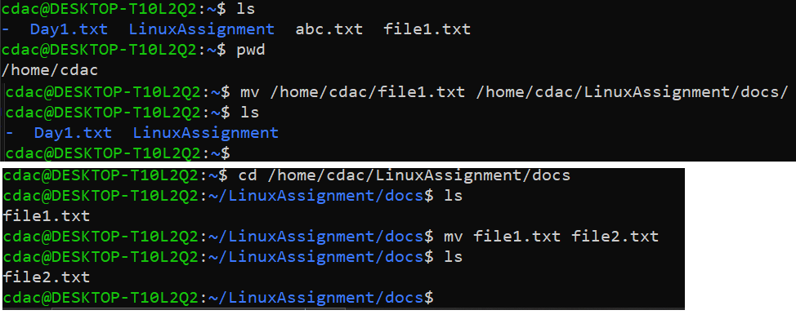

e) Permissions and Ownership:

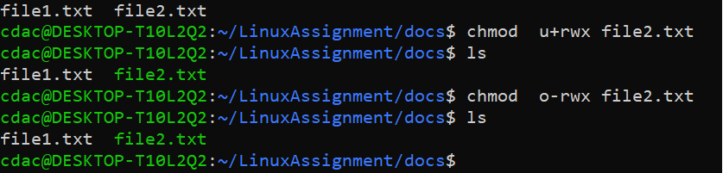

f) Final Checklist:

g) File Searching

h) System Information: (Date and time)

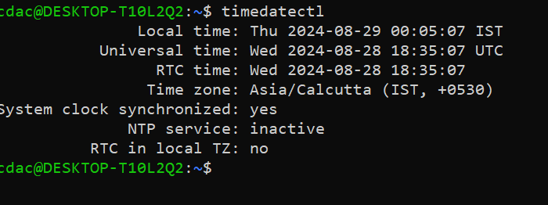

1. Networking:
2. 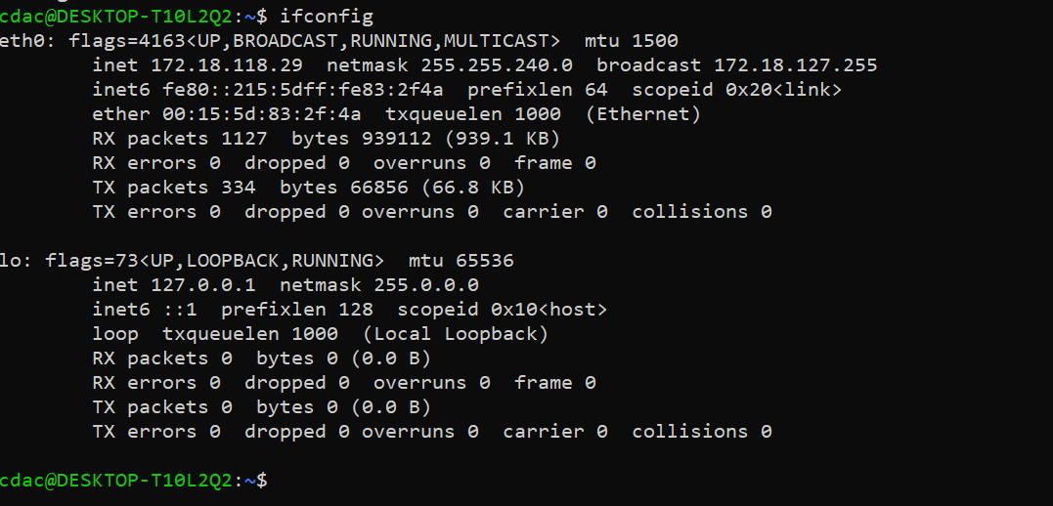
3. 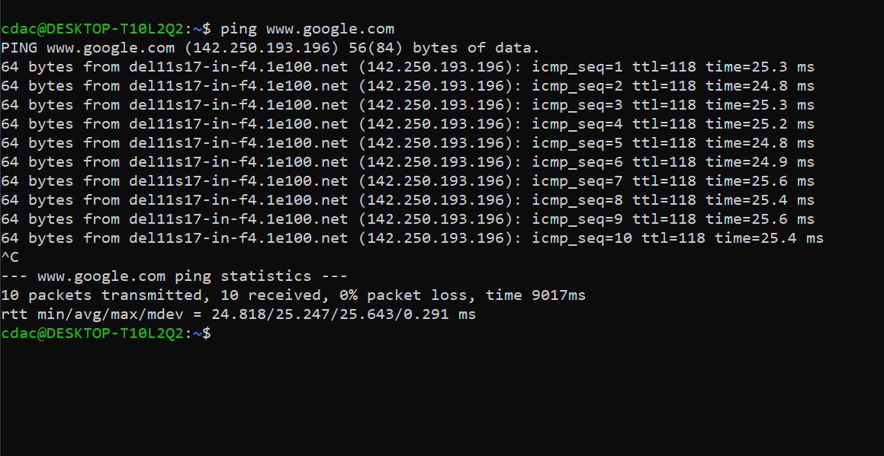

j) File Compression:

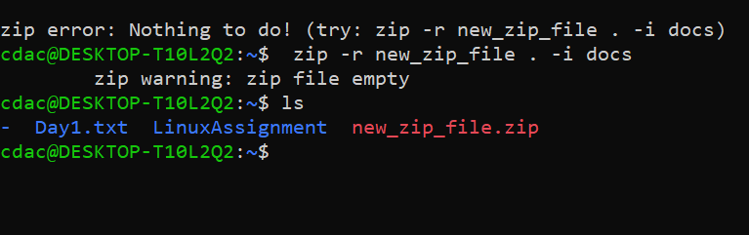

f) File Compression

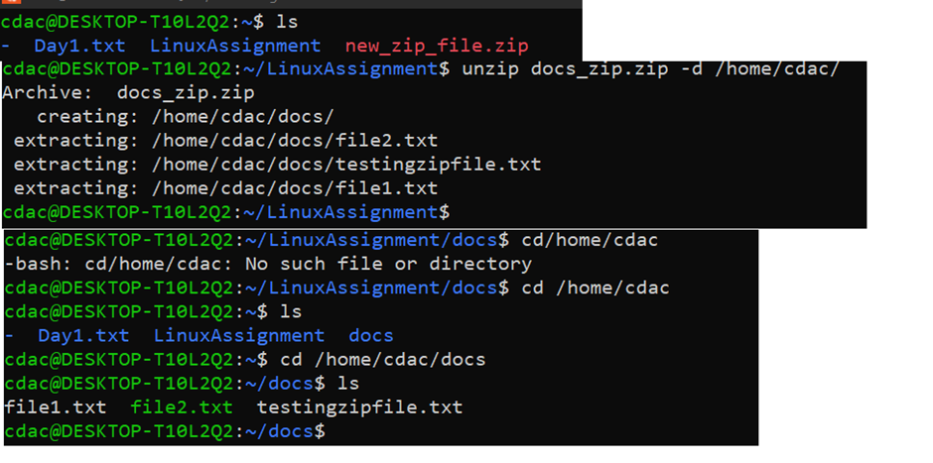

k) Open the "file1.txt" file in a text editor and add some text to it.

