1. Design and implement a class named InstanceCounter to track and count the number of instances created from this class.

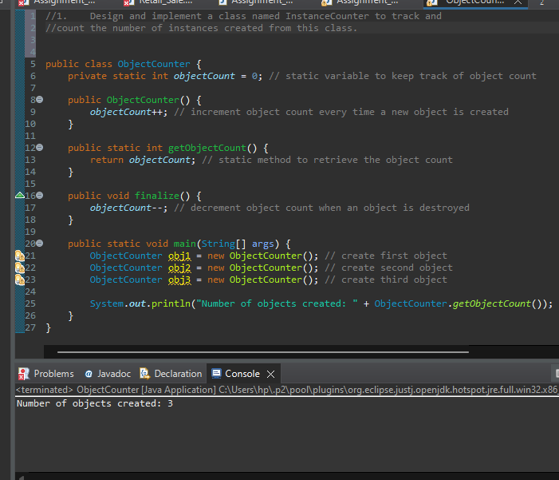

1. Design and implement a class named Logger to manage logging messages for an application. The class should be implemented as a singleton to ensure that only one instance of the Logger exists throughout the application.

The class should include the following methods:

* **getInstance()**: Returns the unique instance of the Logger class.
* **log(String message)**: Adds a log message to the logger.
* **getLog()**: Returns the current log messages as a String.
* **clearLog()**: Clears all log messages.

