9112391862

[pritikhodankar018@gmail.com](mailto:pritikhodankar018@gmail.com)

Gadge nagar, Amravati

[https://www.linkedin.com/in/priti-khodankar7577-7194 l.com](https://www.linkedin.com/in/priti-khodankar7577-7194%20l.com)

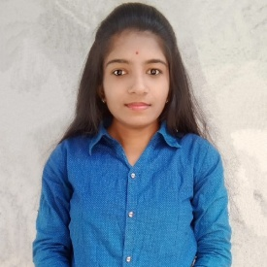To work in a challenging environment where I can put my efforts and knowledge to reach the respective company's goals and objectives.

2022

2020

2017

2015



Master of computer application Pursuing



Bachelor of computer application 70.35%



HSC 57.85%



SSC 68.60%

Core JAVA MySQL

Hibernate Spring JDBC

Collection



# Vehicle Showroom Management System Technology - ASP.Net

Database - Sql

In vehicle showroom management system has to show the vehicle information and their price. They can be show the vehicle images .

Online Exam

# Technology - Spring Boot

Database - MySQL

In Online Exam project there has to be taking a small exam and show the marks.

# **EXTRA-CURRICULUM ACTIVITIES**

Participated in College level Poster Presentation Workshop on Self Development

MS-CIT

Tally ERP

English Typing - 30 WPM

English Hindi Marathi

Date of birth - 18/04/2000 Marital status - Unmarried Nationality - Indian

Skills - Hard working, Good manners Strength - Self-motivated



Priti Khodankar