**Created branch Dev on git hub 🡪 Dev 🡪 feature**

**Git clone** [**https://github.com/pritikoli1994k/Task3.git**](https://github.com/pritikoli1994k/Task3.git)

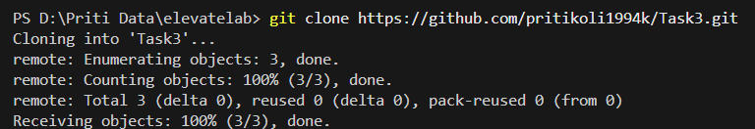

**1.Initialize repo and push to GitHub.**

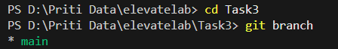

**2. Create dev, feature, and main branches.**

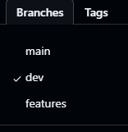

**Switch on dev:**

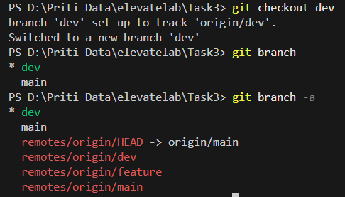

**3. Use pull requests to merge.**

**Getting pull Request and merging it dev 🡪 main**

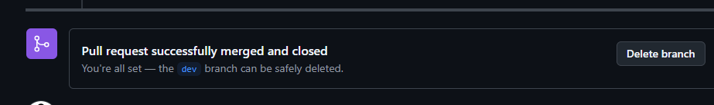

**4.Add a proper README.md.**

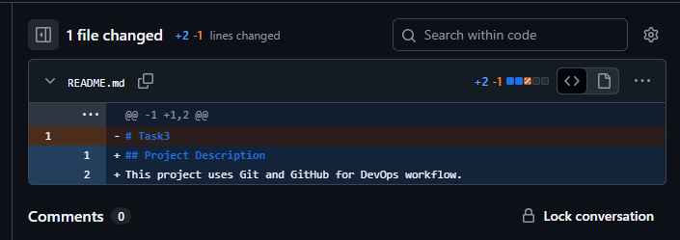

**5.Use .gitignore and tags.**

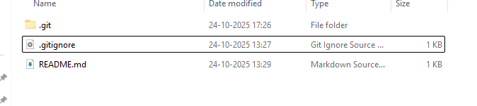

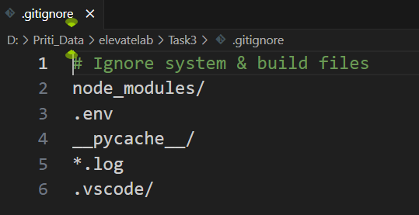

**4.1 Tag Added**

