1. **First, make a repo on GitHub:**
2. **Clone it on the local system:**
3. **Open folder in VS Code:**

**extract_data.py**

import pandas as pd

print("Extract Data")

# Sample data

data = {

'Id': [101, 102, 103],

'Name': ['Ram', 'Raj', 'Raja'],

'Age': [29, 34, 42]

}

# Create DataFrame

df = pd.DataFrame (data)

# Display the DataFrame

print(df)

**jenkinfile**

pipeline {

    agent any

    stages {

        stage('Checkout Code') {

            steps {

                checkout scm

            }

        }

        stage('Extract Data') {

            steps {

                // Replace script_path.py with your actual Python script

                bat '"C:\\Users\\tanuj\\AppData\\Local\\Programs\\Python\\Python313\\python.exe" "D:\Priti_Data\AVD\DataOps\githubdemo2\myjenkin1\extract_data.py"'

            }

        }

    }

}

**Path gets here :**

tanuj@Tanuj MINGW64 /d/Priti_Data/AVD/DataOps/githubdemo2/myjenkin1 (main)

$ where python

C:\Users\tanuj\AppData\Local\Programs\Python\Python313\python.exe

C:\Users\tanuj\AppData\Local\Programs\Python\Python312\python.exe

C:\Users\tanuj\AppData\Local\Microsoft\WindowsApps\python.exe

Add to git :

tanuj@Tanuj MINGW64 /d/Priti_Data/AVD/DataOps/githubdemo2/myjenkin1 (main)

$ git add .

tanuj@Tanuj MINGW64 /d/Priti_Data/AVD/DataOps/githubdemo2/myjenkin1 (main)

$ git commit -m "updatedjenkin successful jenkinsfile"

[main 92eddab] updatedjenkin successful jenkinsfile

1 file changed, 9 insertions(+), 5 deletions(-)

tanuj@Tanuj MINGW64 /d/Priti_Data/AVD/DataOps/githubdemo2/myjenkin1 (main)

$ git push

Enumerating objects: 5, done.

Counting objects: 100% (5/5), done.

Delta compression using up to 8 threads

1. **Create new item in jenkin :**
2. **Check status 🡪 then click on configure 🡪 paste git project URL**

**🡪http://localhost:8080/job/extract_pipeline_1/configure**

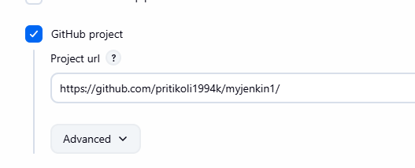

**Now build the pipeline 🡪Click on build now 🡪**

**Output:** 