A
Project Report on
WEBSITE BLOCKER
Submitted by

Mr. OMM DIPTA ROUT
Roll No : 11031016

for the partial fulfillment of the requirements for the degree of
Bachelor of Computer Applications (BCA)



LAKSHYA INSTITUTE OF TECHNOLOGY
Acharya Vihar, Bhubaneswar – 751019
August, 2022

CERTIFICATE
I hereby declare that the work which is being presented in the project report entitled “Website Blocker”, in partial fulfillment of the requirements for the award of Degree of Bachelor of Computer Applications (BCA) submitted to the Department of Bachelor of Computer Applications, LIT, BBSR is an authentic record of my own work. The content presented in this project report has not been submitted for the award of any other degree of this or any other University.
Omm Dipta Rout
(Regd. No : )

It is certified that the above statement made by the student is correct to the best of my knowledge and belief.

Prof. Sujit Kumar Pradhan
Assistant Professor, Department of BCA
Countersigned by:

Faculty In-Charge, BCA Head, Department of BCA

External Examiner

ACKNOWLEDGEMENT

I would like to thank Mr. Sujit Kumar Pradhan, Assistant Professor, Department of Bachelor of Computer Applications (BCA) for the opportunity to work with him, for his invaluable guidance, encouragement, suggestions and untiring support. He has been an advisor in true sense both academically and morally though out this project work.
I am highly grateful to Mr. Chandrakant Rout for providing all the necessary infrastructure to complete my MCA Project Work.
I extend my sincere thanks to Mrs. Smruti Rout for their continuous inspiration and intellectual support during this project work.
Special thanks to my family members especially to my parents and friends whose uninterrupted love, inspiration and blessings helped me to complete my Industrial Project Work.
I thank and owe my deepest regards to all who have helped me directly or indirectly.

Omm Dipta Rout
(Roll No: 11031016)

ABSTRACT

Website Blocker is a tool that denies access to websites permanently or by schedule. To use the internet safely we can block all websites from unwanted categories.
While creating Python Website Blocker Application, we are going to use only one module – Tkinter Module to make easy GUI using Python. We will be making two functions Block() and Unblock(). As the names suggest these functions will perform blocking and unblocking of websites respectively. These websites are added to the host file of the system.We are going to create a website blocker using python which will give us a window where we can type the url of the website and then we can block those website. We will also have an unblock feature added to it so that we can unblock any website in future if we want. We use Tkinter Modules for creating GUI.

LIST OF FIGURES

Figure 1: | To Run the command
Figure 2: | Output Screen

Figure 3: After Blocking

Figure 4: After Unblocking

TABLE OF CONTENTS

CERTIFICATE |  |  | I
ACKNOWLEDGEMENTS |  |  | II
ABSTRACT |  |  | III
LIST OF FIGURE |  |  | IV
WESITE BLOCKER PYTHON PROJECT |  |  | VI
PROJECT FILE STRCUTURE |  |  | VII
CODE  HOW TO RUN |  |  | VIII-X  XI

OUTPUT SCREEN XII-XIII
FUTURE SCOPE |  |  | XIV
SUMMARY & CONCLUSION |  |  | XV
REFERENCE |  |  | XVI

CHAPTER 1
Website Blocker Python Project

The objective of Website Blocker python project is to block the given websites from any device. This project will help the user to stay away from their distraction by blocking websites from their device so that they can not open them.
In this Python Website Blocker Project, the user can enter multiple websites to block, and then clicking on the block button will check the condition that if the website already blocked then print ‘already blocked’ else blocked all that websites and print ‘blocked’.

Python Website Blocker Project Prerequisites:
This project requires basic understanding of Python like defining functions, creating loops etc. To use Tkinter Module we need to install it using the following command:
pip install tk

CHAPTER 2

Project File Structure

Let us have a look at the steps we will be performing to create the Python Website Blocker project

Importing the required library
Creating GUI window
Hostpath and IP address.
Creating Block function to block websites
Creating Unblock function to unblock websites
Creating labels and buttons
Main command

Code:
Python_project/website_blocker.py

#import module
from tkinter import*

host_path='D:\Projects\Data'
ip_address='127.0.0.1'

def block():
website_list=enter_Website.get(1.0,END)
Website = list(website_list.split(','))
with open (host_path,'r+')as host_file:
file_content=host_file.read()
for web in Website:
if web in file_content:
display=Label(window,text='Already Blocked',font='arial')
display.place(x=200,y=200)
# display.after(10,display.Label(window,text='omm',font='arial'))
# display.place(x=200,y=200)

else:
host_file.write(ip_address+' '+web)
Label(window,text='Blocked',font='arial').place(x=200,y=200)

def unblock():
website_list=enter_Website.get(1.0,END)
#print(website_un)
Website = list(website_list.split(','))
temp_f=''
with open (host_path,'r+')as host_file:
file_content=host_file.read()
#print(file_content)
for web in Website:
if web in file_content:
Label(window,text=web+'UnBlocked\n',font='arial').place(x=350,y=200)
with open(host_path,'r+') as website_un:
for line in website_un:
print('Line1 :-'+line)
if web in line:
temp_un=ip_address+' '+web
line=line.replace(temp_un,'')
print('line2 :- '+line)
temp_f=temp_f+line

with open(host_path,'w') as new_file:
new_file.write(temp_f);
print(temp_f)
else:
display=Label(window,text='Already UnBlocked',font='arial')
display.place(x=350,y=200)

# for web in Website:
# if web in file_content:
# with open (host_path,'r+')as f:
# for line in file_content:
# if line.strip(',')!=website_list:
# f.write(line)

def close():
window.destroy()

#to make a window
window=Tk()

#set size of window
window.geometry('650x400')
window.maxsize(750,600)
window.minsize(550,300)

#set title of window
window.title('WEBSITE BLOCKER')

#set Header
Label(window,text='WEBSITE BLOCKER',font=('bold',15),fg='purple').pack()
Label(window,text='Developed By @ODR_MUNA',font=('bold',12),fg='purple').pack(side=BOTTOM)

Label(window,text='Enter website :').place(x=100,y=50)
enter_Website = Text(window,font=(10),width=30,height=1)
enter_Website.place(x=200,y=48)

Button(window,text='Block',font=('bold',10),bg='red',fg='white',command=block).place(x=150,y=100)
Button(window,text='Un Block',font=('bold',10),bg='green',fg='white',command=unblock).place(x=270,y=100)
Button(window,text='Exit',font=('bold',10),bg='pink',fg='white',command=close).place(x=400,y=100)
window.mainloop()

How to Run:
Open Window CMD in admin mode & set path
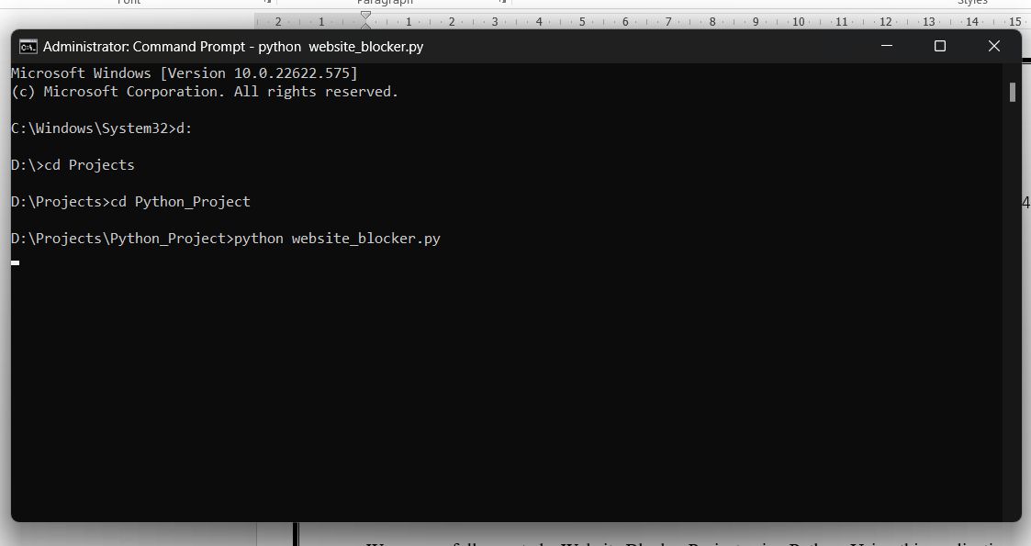
Fig:- Comands for run
Output Screen:
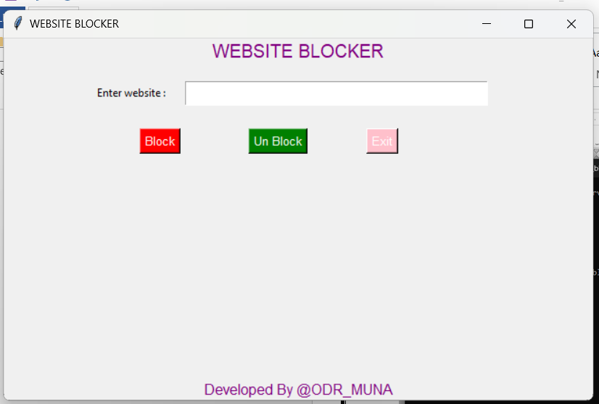
After Block a Website:
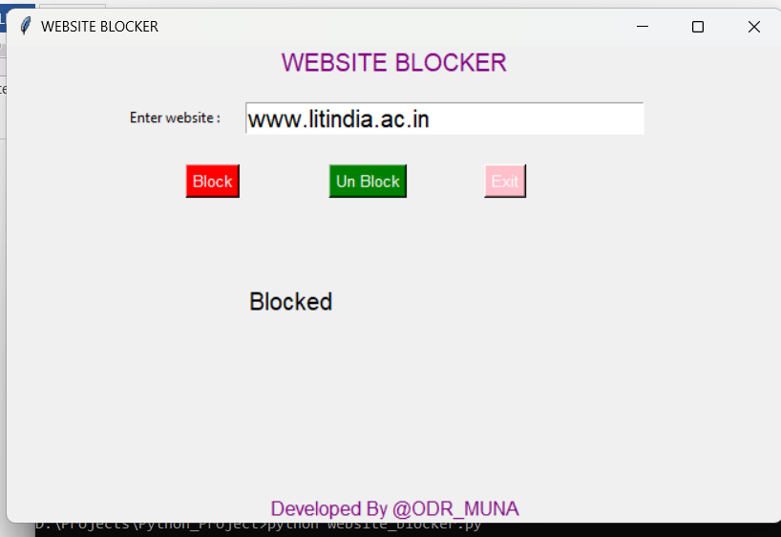
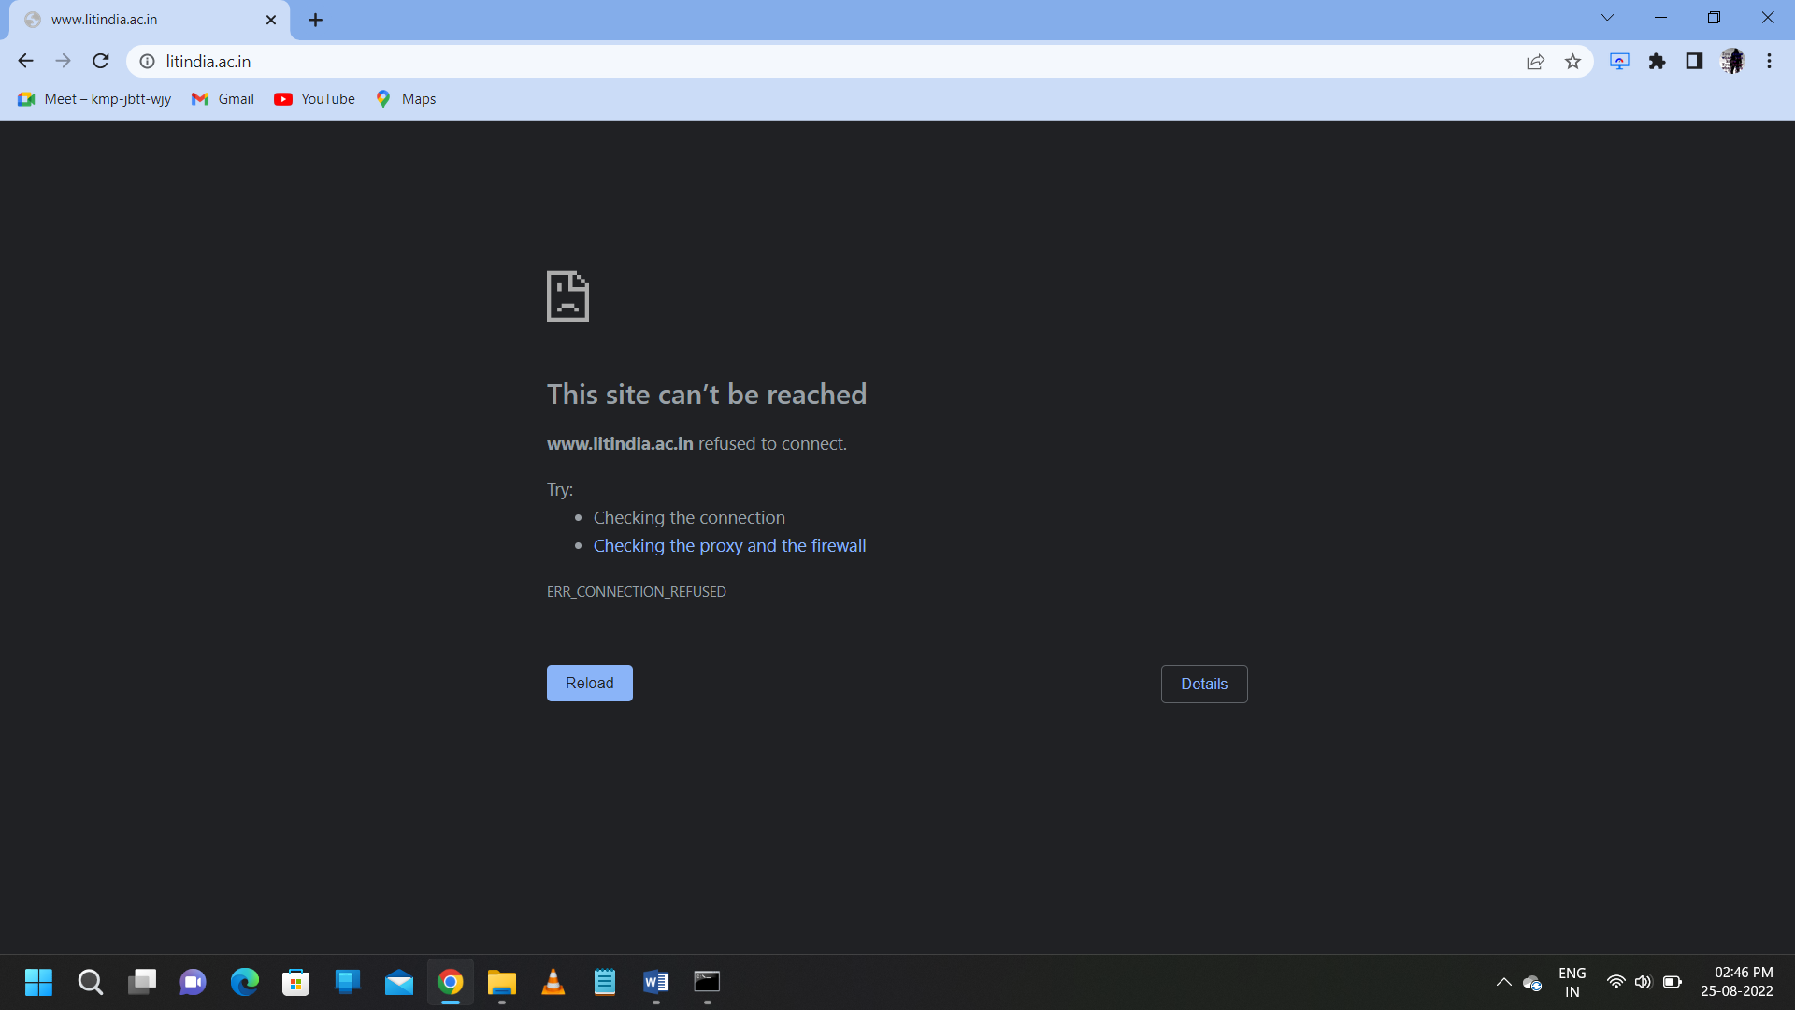
Fig:- after block a website
After unblock a Website:
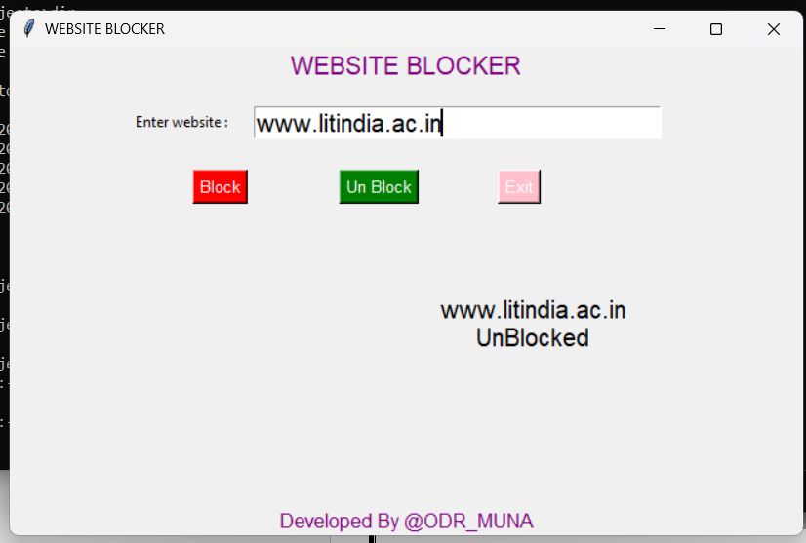


Fig:- after unblock a website

Future Scope
In future website blocker can be used to block all kind of irrelevant sites such as the sites which students access during the school time which is not related to the topic or their courses.
After updating our application more, it can be used by the government to block all the confidential sites from all the users so that any confidential data does not get public.
Many more all the scam websites which are scamming normal people through online can be blocked all over the country.

Summary

We successfully created a Website Blocker Project using Python. Using this application we can block and unblock any websites that we want. We made our GUI using the Tkinter Module and its inb

Conclusion

The project ended this week. Like many things it did not work as I planned though I would spend some enjoyable time discovering what I wanted to do for a living identify a few companies to speak about my plans secure an existing high paying job in a non-traditional manner save the world a little while I was at it and write about my progress which would be formed for me and inspiring for you. I was willing to be flexible on saving the world and inspiring you.

Reference:
- https://www.python.org/
- https://wiki.python.org/
- https://www.geeksforgeeks.org/
- https://www.w3schools.com/python/

