HIGH-LEVEL DESIGN (HLD)
PolicyFlow AI
Enterprise Expense Compliance & Exception Agent

HLD Version 1.0
Based on FRD v1.0 | Portfolio POC | 15-20 Working Days
Deployment Target: AWS containerized architecture behind Cloudflare
Status: Baseline Architecture for Detailed Design and OpenSpec implementation
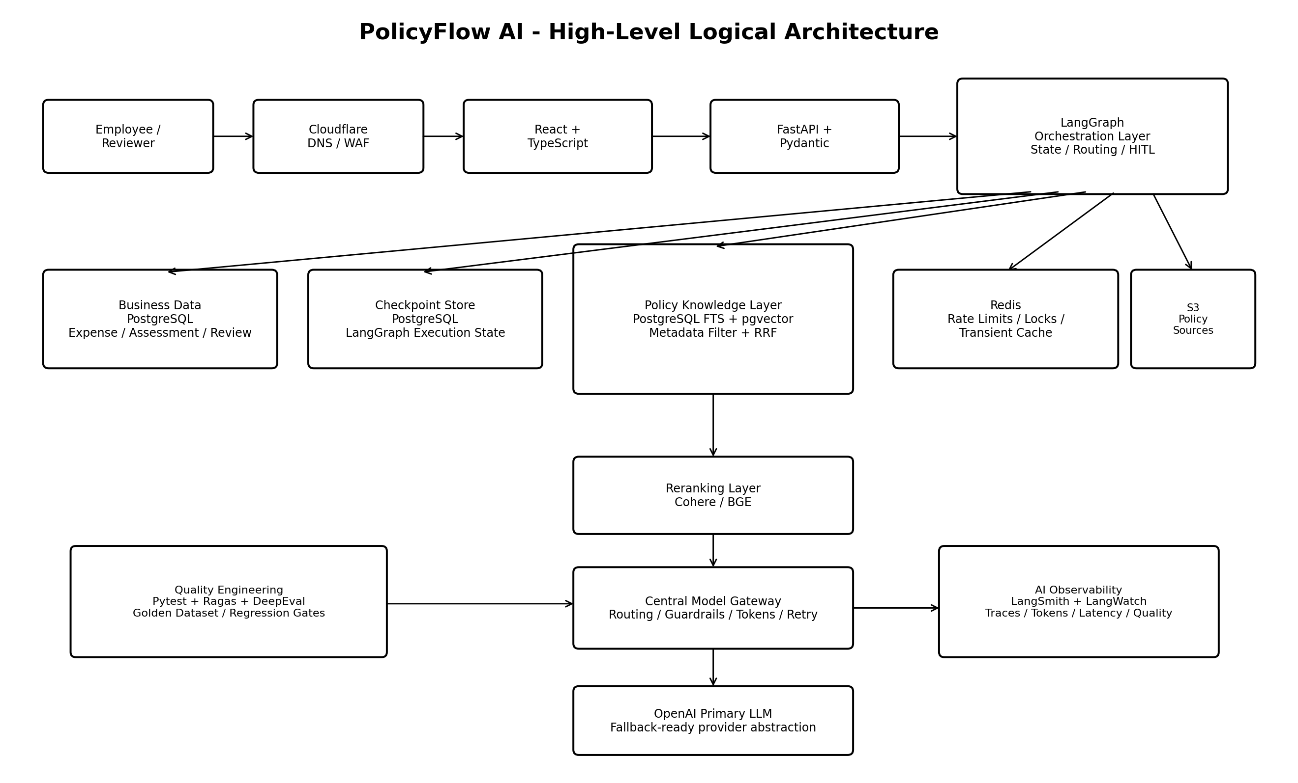

1. Document Control
Field | Value
Document | High-Level Design (HLD)
Project | PolicyFlow AI - Enterprise Expense Compliance & Exception Agent
Version | 1.0
Upstream Source | PolicyFlow AI FRD v1.0
Purpose | Define the system architecture, component boundaries, data flows, deployment topology, and major design decisions.
Next Artifact | Detailed Low-Level Design (LLD) and OpenSpec change specifications
Data Scope | Synthetic/publicly created policy and expense data only

2. Purpose and Design Scope
This HLD translates the FRD into an implementable system architecture. It defines the major runtime components, trust boundaries, persistence model, AI/RAG flow, orchestration model, integration interfaces, deployment topology, observability model, and key architecture decisions. It intentionally avoids class-level, function-level, SQL DDL, and exhaustive API payload detail; those belong in the LLD.

3. Architecture Drivers
- Finishable by one engineer in 15-20 working days.
- Easy to explain end-to-end on a whiteboard in an interview.
- Grounded policy decisions with strict citations and safe abstention.
- Explicit separation of probabilistic AI reasoning from deterministic business controls.
- Durable LangGraph state with human interrupt/resume.
- Business truth independent from orchestration checkpoint internals.
- Low operational complexity: PostgreSQL + pgvector instead of a separate vector platform; ECS/Fargate instead of Kubernetes.
- Provider governance through a central Model Gateway.
- End-to-end quality visibility through tracing, RAG evaluation, and regression testing.

4. System Context
Actor / External System | Interaction
Employee | Asks policy questions, submits expenses, provides clarifications and exception justification.
Human Reviewer | Reviews exception cases and approves, rejects, or requests more information.
Cloudflare | Provides public DNS/TLS edge, WAF/rate controls, and optional Zero Trust.
OpenAI | Primary LLM provider accessed only through the Model Gateway.
Cohere/BGE | Second-stage reranking service/model.
LangSmith / LangWatch | AI trace, latency, token, and quality observability.
GitHub Actions | CI/CD pipeline to build, test, publish, and deploy containers to AWS.

5. High-Level Logical Architecture
Figure 1. Logical architecture. The LangGraph orchestration layer coordinates retrieval, model reasoning, deterministic validation, persistence, and HITL rather than allowing the LLM to directly own workflow or business truth.

6. Major Components
Component | Technology | High-Level Responsibility
Web UI | React + TypeScript | Employee and reviewer experience; forms, grounded responses, citations, exception review.
Edge | Cloudflare | DNS/TLS, WAF, basic rate protection, optional Zero Trust.
API Service | FastAPI + Pydantic | REST boundary, request/response validation, correlation IDs, application service entry points.
Agent Orchestrator | LangGraph | State machine, conditional transitions, clarification loop, retrieval/reasoning stages, HITL interrupt/resume.
Business Persistence | PostgreSQL | Authoritative expense, assessment, exception, review, and audit state.
Checkpoint Persistence | PostgreSQL | LangGraph thread/checkpoint state separated logically from business records.
Policy Knowledge Store | PostgreSQL + pgvector | Policy metadata, chunks, lexical tsvector search, vector embeddings, source references.
Transient Coordination | Redis | Rate limits, ingestion locks, short-lived caches, transient coordination.
Reranking | Cohere or BGE | Second-stage relevance ordering after hybrid retrieval.
Model Gateway | Python service/module boundary | Provider abstraction, routing, retry, token controls, structured output validation, tracing.
LLM | OpenAI primary | Policy interpretation, classification, summarization, structured reasoning from supplied evidence.
Observability | LangSmith + LangWatch | Graph/model traces, latency, tokens, retrieval context, AI quality metrics.
Quality | Pytest + Ragas + DeepEval | Deterministic tests, golden-dataset RAG/agent evaluation, regression gates.
Deployment | Docker, GitHub Actions, AWS ECS/Fargate | Containerized runtime, registry/deploy pipeline, health checks and rollouts.

7. Bounded Runtime Flows

7.1 Flow A - Policy Q&A
- Employee submits a policy question.
- FastAPI validates and invokes LangGraph using a thread/request context.
- LangGraph classifies the request, creates metadata filters, and invokes hybrid retrieval.
- FTS and pgvector candidates are fused using RRF and reranked.
- Top evidence is sent through the Model Gateway to OpenAI with a strict evidence-only prompt.
- Pydantic and citation validation run before the answer is returned.
- If evidence is insufficient, the response explicitly abstains.

7.2 Flow B - Expense Assessment and Exception Review
- Employee submits structured expense details.
- LangGraph checks mandatory fields; missing context produces a clarification and checkpointed wait.
- Relevant policy evidence is retrieved and reranked.
- The LLM extracts the applicable policy rule into a structured schema.
- Deterministic application code evaluates amount, receipt, and configured thresholds.
- COMPLIANT/NON_COMPLIANT/INSUFFICIENT_INFORMATION may complete immediately.
- NEEDS_REVIEW collects justification and interrupts the graph at a human-review boundary.
- Reviewer action resumes the same thread; final decision and audit events are persisted.

8. LangGraph Orchestration Architecture
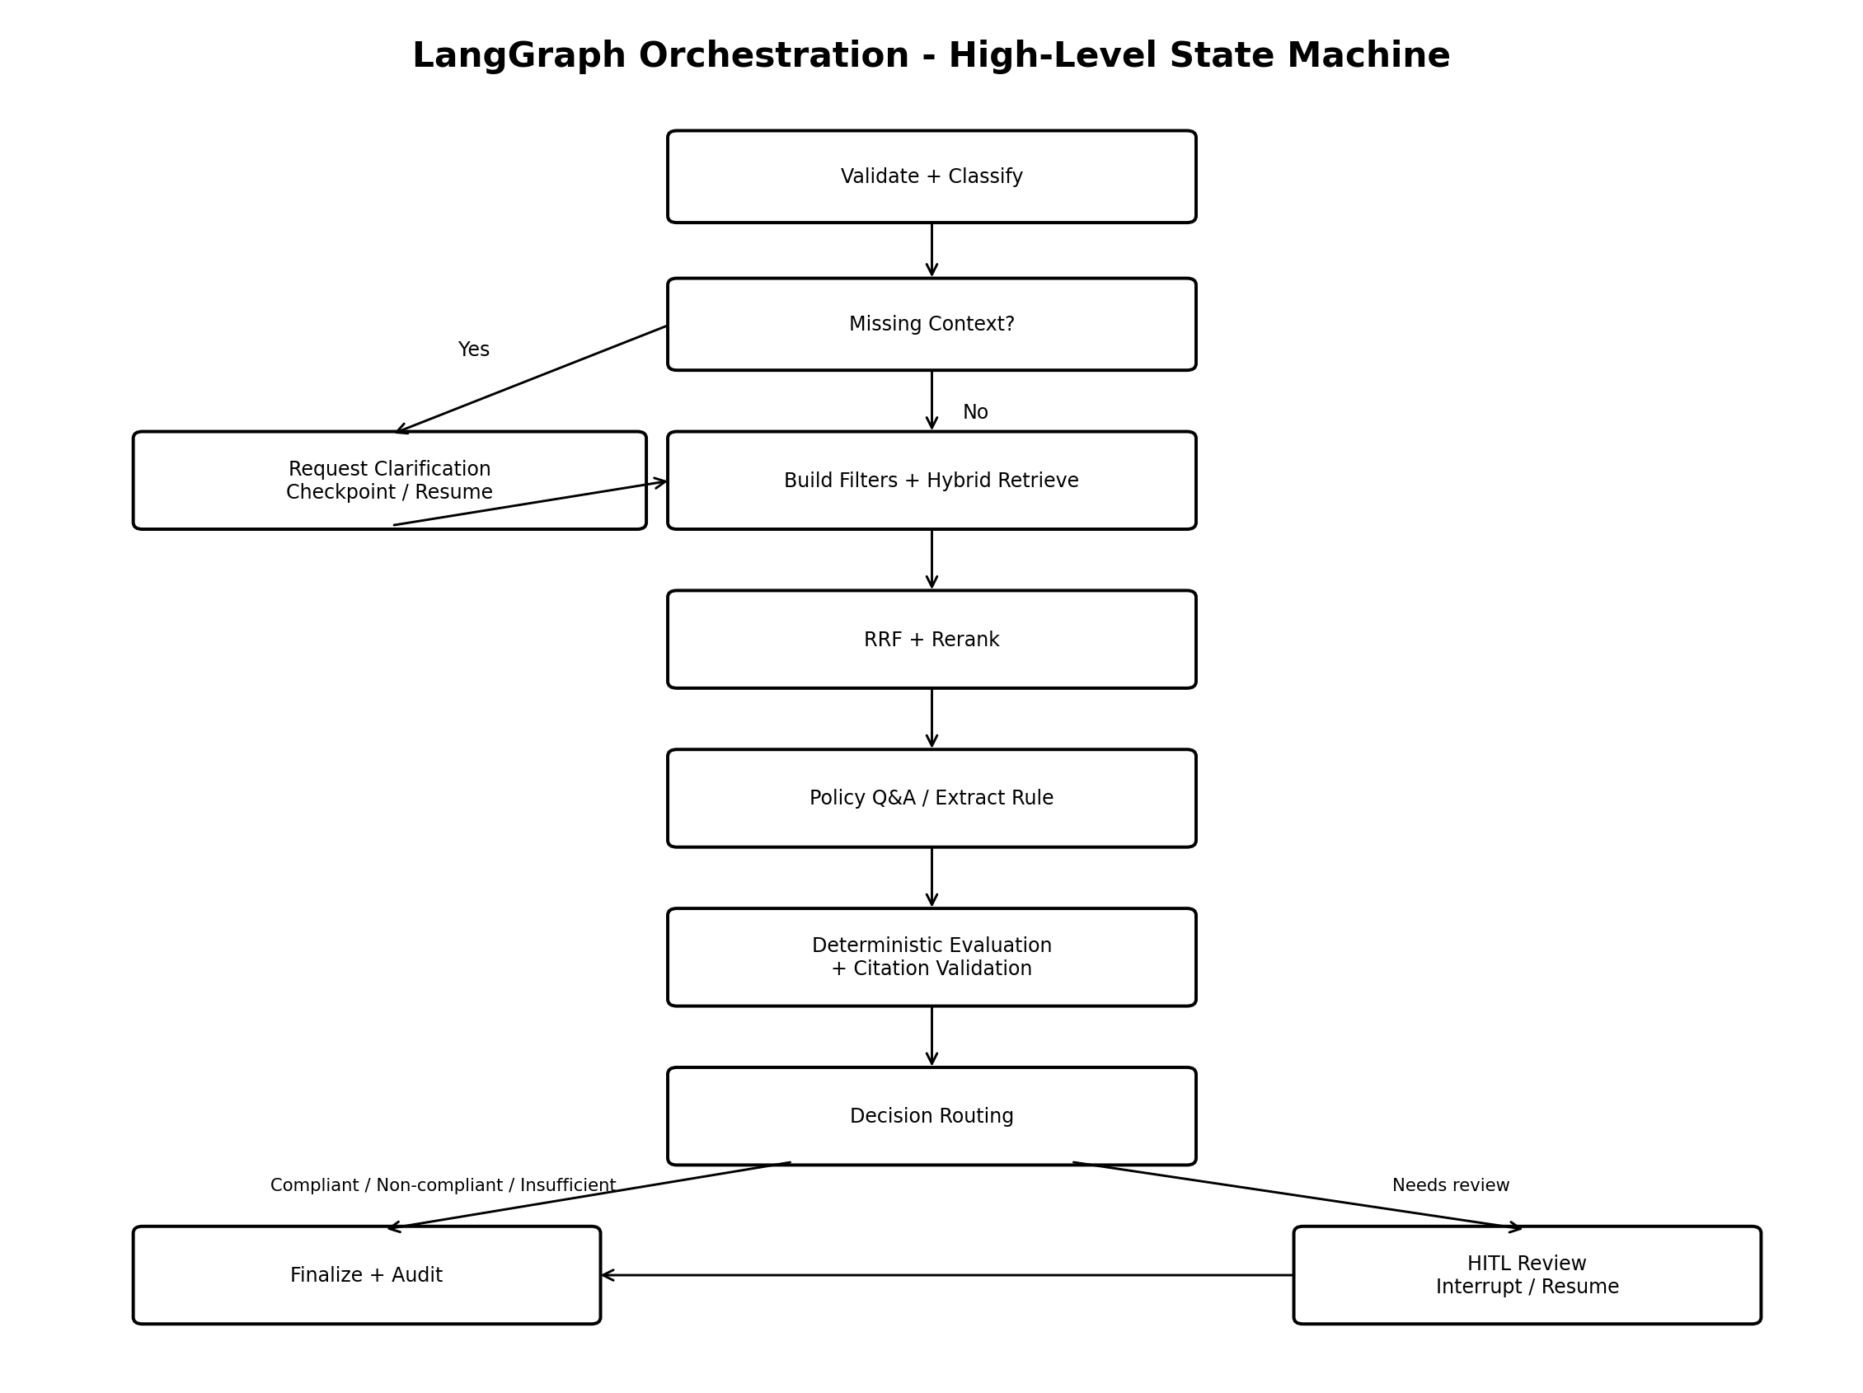
Figure 2. High-level state machine. LangGraph owns execution state and routing; PostgreSQL business tables remain authoritative for final business records.

8.1 Orchestration Principles
- State is compact and ID-oriented; large documents and full retrieved payloads are not persisted unnecessarily in checkpoints.
- Conditional edges are deterministic wherever possible.
- LLM calls are bounded to interpretation/classification/explanation tasks and return structured Pydantic-compatible output.
- Human review is a first-class graph interrupt, not an external ad-hoc workflow.
- Checkpoint state can be expired independently of business records.

8.2 High-Level Node Groups
Node Group | Purpose
Request Control | Validate request, classify scenario, detect missing data.
Retrieval | Build metadata filters, run lexical/vector search, fuse and rerank.
Reasoning | Answer policy Q&A or extract applicable policy rule.
Deterministic Controls | Evaluate thresholds, validate citations, apply routing/confidence policy.
HITL | Interrupt, persist, resume after reviewer action.
Finalization | Persist business outcome, emit audit event, create API response.

9. Data Architecture

9.1 Logical Store Separation
RDS PostgreSQL (single POC instance)
app schema -> expenses, assessments, exceptions, reviews
rag schema -> policy documents, policy chunks, embeddings, lexical vectors
audit schema -> agent/workflow audit events
checkpoint DB/schema -> LangGraph checkpointer tables
ElastiCache Redis -> transient cache / locks / rate limiting
S3 -> source policy documents / optional evaluation artifacts
Using one RDS instance minimizes POC operational cost while preserving logical separation. The architecture can later split workloads into independent databases without changing domain ownership boundaries.

9.2 Business Data Ownership
Data | Owner / System of Record | Notes
Expense | Business PostgreSQL | Durable domain entity.
Assessment | Business PostgreSQL | Structured decision and evidence references.
Exception Request | Business PostgreSQL | Business workflow state independent of checkpoint internals.
Reviewer Decision | Business PostgreSQL | Authoritative human decision.
Policy Documents/Chunks | RAG PostgreSQL | Versioned synthetic knowledge corpus.
Graph Thread/Checkpoint | LangGraph checkpoint store | Execution state only; not authoritative business reporting data.
Short-lived Cache/Lock | Redis | Non-authoritative and rebuildable.
Traces | LangSmith/LangWatch | Operational AI telemetry; payload minimization applies.

10. Policy Ingestion Architecture
Synthetic Policy File (S3/local)
-> parser
-> document metadata normalization
-> section-aware chunker
-> embedding generation
-> rag.policy_document + rag.policy_chunk
-> tsvector lexical index + pgvector index
-> ingestion audit / content hash
- Chunking is hierarchical: document -> section -> subsection -> paragraph group.
- Target chunk size is roughly 400-700 tokens with limited overlap only when needed.
- Policy version, status, effective dates, category/domain, section, and source reference accompany each chunk.
- Content hash/idempotency prevents accidental duplicate ingestion.
- Redis lock can prevent concurrent ingestion of the same document.

11. Retrieval and Reranking Architecture
Normalized Query
-> deterministic metadata filters
-> PostgreSQL FTS top-N
-> pgvector semantic top-N
-> Reciprocal Rank Fusion
-> 10-20 candidates
-> Cohere/BGE reranker
-> top 3-5 evidence chunks
-> reasoning model
The hybrid design is intentional: policy queries often contain exact terms, limits, section identifiers, and category names while also requiring semantic matching of paraphrased questions. The second-stage reranker improves ordering before the costly reasoning step.

12. Model Gateway Architecture
No graph node directly invokes a provider SDK. All model traffic passes through a single gateway abstraction.
LangGraph Node
-> ModelGateway.generate(use_case, messages, response_model, metadata)
-> prompt/version policy
-> provider/model route
-> token budget
-> retry/backoff
-> OpenAI adapter
-> Pydantic validation
-> tracing / cost metadata
-> validated result
Gateway Capability | High-Level Design
Provider abstraction | OpenAI primary; fallback-ready adapter contract.
Model routing | Use-case based selection so lightweight tasks need not use the most expensive model.
Token control | Maximum prompt/completion budget; optional per-thread accounting.
Reliability | Bounded retries/backoff for transient errors; safe failure on repeated validation/provider failure.
Structured output | Pydantic response schemas before downstream business logic.
Governance | Central prompt versions, guardrails, telemetry and provider settings.
Observability | Trace model, latency, token usage, validation/retry events.

13. Deterministic Controls and Guardrails
Concern | Deterministic / Guardrail Strategy
Numeric policy limits | Application code compares submitted values to structured policy thresholds.
Receipt/document requirement | Application code applies required/missing logic after policy rule extraction.
Citation validity | Citation must resolve to a chunk retrieved in the current evidence set and active policy version.
Policy eligibility | Metadata filtering excludes inactive/expired/unrelated policy before reasoning.
Low evidence | Return INSUFFICIENT_INFORMATION / safe abstention rather than inventing a rule.
Exception approval | Always human-controlled in the POC.
Prompt injection | Bounded prompt, approved corpus only, input checks, and evidence-only system instructions.
Structured output failure | Bounded repair/retry, then safe failure/abstention.

14. API and Integration Architecture
Interface | High-Level Contract
POST /api/v1/policy/query | Policy question -> grounded answer + citations.
POST /api/v1/expenses | Create expense and initiate assessment graph.
POST /api/v1/threads/{thread_id}/continue | Resume after clarification/user input.
POST /api/v1/expenses/{expense_id}/exceptions | Submit exception justification.
GET /api/v1/reviews/pending | Reviewer work queue.
POST /api/v1/reviews/{exception_id}/decision | Persist human decision and resume graph.
GET /api/v1/expenses/{expense_id} | Retrieve consolidated business status/result.
POST /api/v1/admin/policies/ingest | POC ingestion endpoint or CLI equivalent.
GET /health | Container/ALB liveness/health endpoint.

API payloads use explicit Pydantic versioned models. The LLD will define concrete request/response schemas, error codes, idempotency semantics, and OpenAPI examples.

15. Security Architecture
- Cloudflare protects the public edge with TLS/WAF/rate controls; AWS ALB fronts ECS services.
- Application secrets and provider/database credentials are stored in AWS Secrets Manager and injected at runtime.
- Portfolio deployment uses only synthetic/public data; confidential employer/customer data is explicitly excluded.
- RDS/Redis are placed within the VPC and not directly exposed to the public internet.
- Application and database identities follow least privilege where practical for the POC.
- External AI observability should minimize raw sensitive content and prefer IDs/metadata.
- Exception approval remains a human action and is auditable.

16. Observability and Evaluation Architecture
Layer | Signals
API/Infrastructure | request ID, status, latency, container health, logs, AWS metrics.
LangGraph | thread ID, node execution, transition, interrupt/resume, node latency, errors.
Retrieval | filters, lexical/vector candidate IDs, scores, fused/reranked IDs.
Model | provider/model, prompt version, input/output tokens, latency, retries, structured validation.
Business | expense decision, variance, exception state, reviewer outcome.
Quality | precision/recall, faithfulness, context relevance, citation correctness, regression status.

LangSmith is used primarily for graph/model traces; LangWatch complements it with higher-level AI quality/operational monitoring. Ragas/DeepEval run offline or in CI against a golden dataset rather than synchronously adding latency to every production request.

17. AWS Deployment Architecture
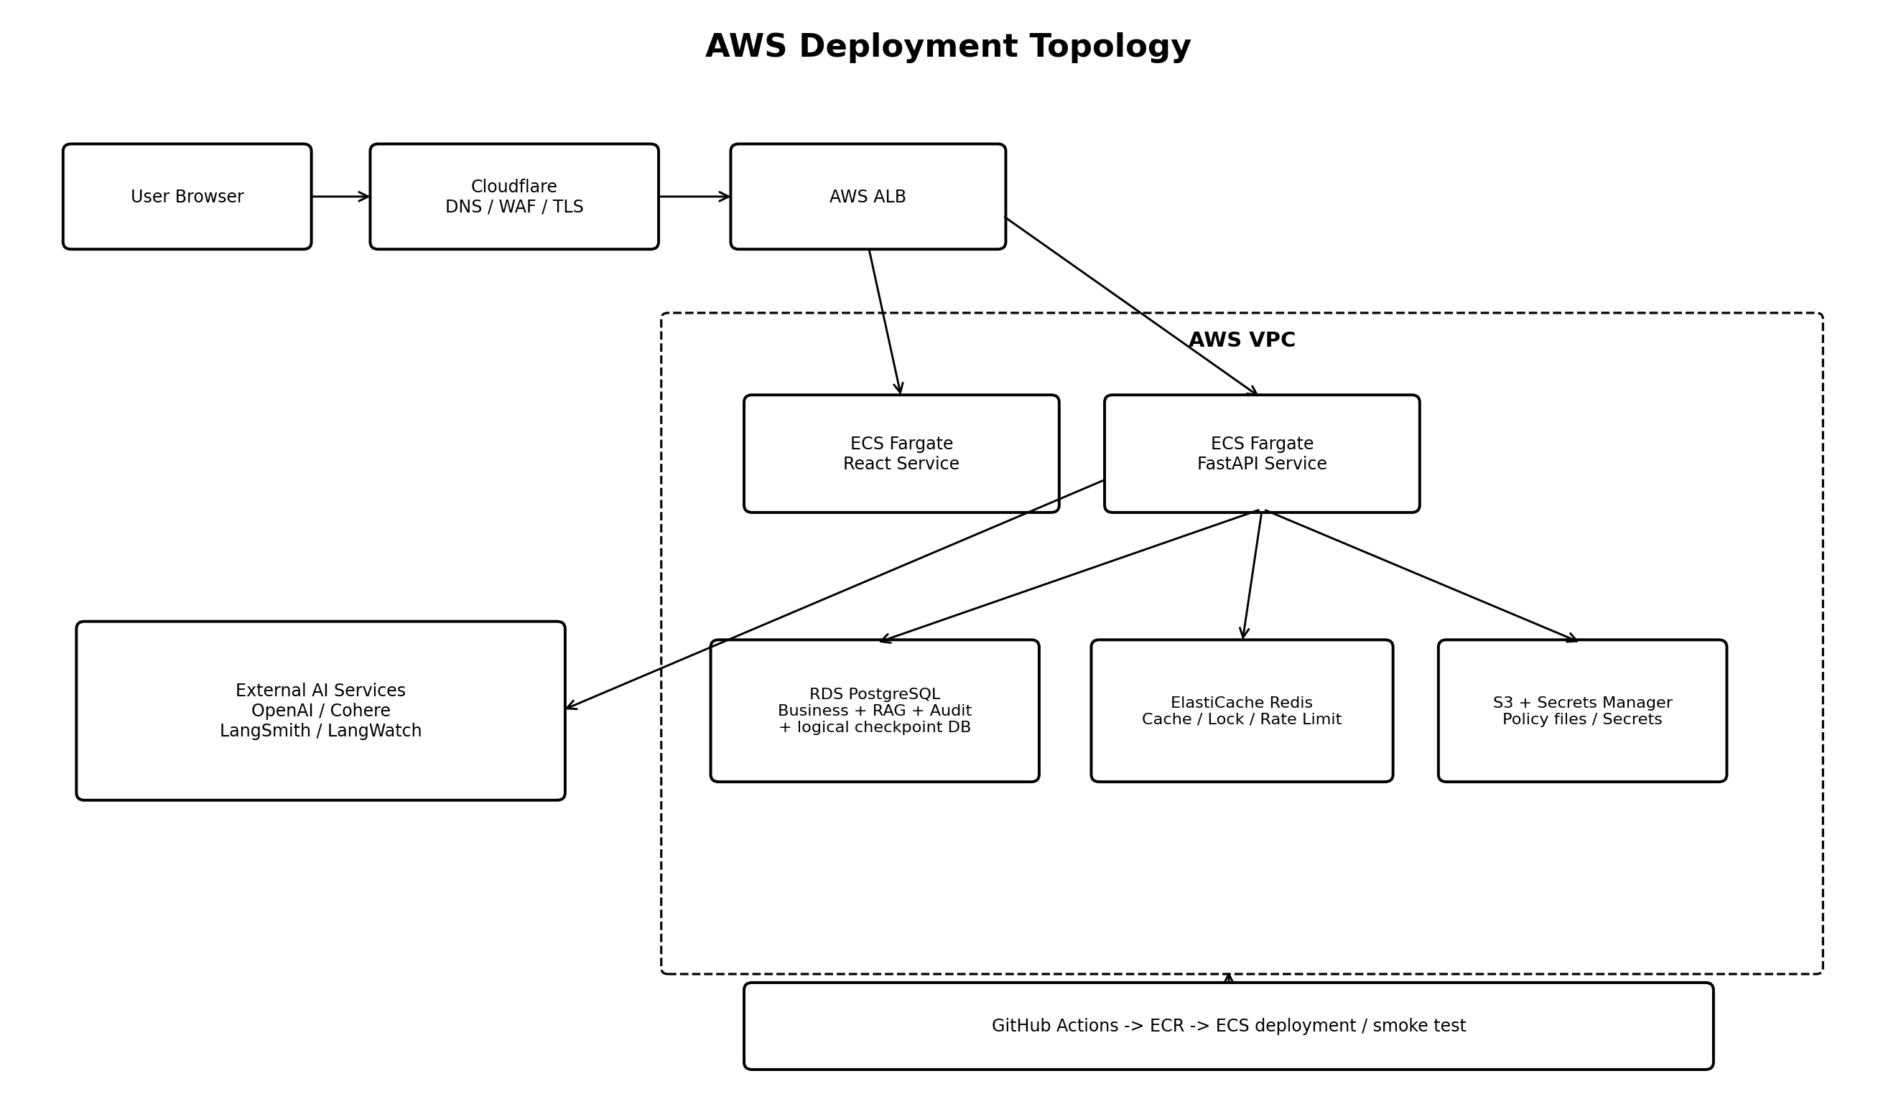
Figure 3. POC deployment topology. ECS/Fargate is preferred over EKS to reduce operational complexity and preserve the 15-20 day delivery target.
Service | Architecture Role
Cloudflare | DNS/TLS edge, WAF, optional Zero Trust.
AWS ALB | Routes HTTP traffic to ECS services and performs health checks.
ECS/Fargate - React | Serves the frontend container.
ECS/Fargate - FastAPI | Runs API, LangGraph, retrieval/gateway application components.
RDS PostgreSQL | Business state, RAG/pgvector, audit, and logically separated checkpoint persistence.
ElastiCache Redis | Rate limit/cache/lock/transient coordination.
S3 | Synthetic policy source files and optional test/evaluation artifacts.
Secrets Manager | Secrets and provider/database credentials.
ECR | Container image registry.
CloudWatch | Infrastructure/container logs/alarms in addition to AI-specific observability.

18. Deployment and CI/CD Flow
Developer Push / Pull Request
-> lint + type checks
-> Pytest
-> migration validation
-> RAG golden-set smoke evaluation
-> Docker build
-> push to Amazon ECR
-> update ECS service
-> ALB health check / smoke test
-> deployment result

19. Scalability and Performance Approach
- FastAPI/ECS service is stateless with respect to durable workflow state, so horizontal scaling is possible.
- LangGraph checkpoints reside in PostgreSQL, allowing different container instances to resume a thread.
- pgvector HNSW plus metadata filtering supports the small POC corpus and provides a path to moderate scale.
- Redis absorbs transient coordination, locks, and cache/rate-limit workloads.
- Retrieval candidate sizes and top-K are intentionally bounded to control reranking/LLM latency and cost.
- Model Gateway supports routing cheaper/faster models for lightweight tasks.
- If vector volume or query scale grows materially, a future architecture can benchmark a dedicated vector platform without changing the domain API.

20. Availability and Failure Handling
Failure Scenario | High-Level Behavior
OpenAI transient failure | Gateway retry/backoff; optional fallback route; otherwise safe error/abstention.
Reranker unavailable | Configurable fallback to fused retrieval order for POC, with trace warning.
Insufficient retrieval evidence | Return INSUFFICIENT_INFORMATION; no invented policy.
Container restart during HITL wait | Resume from PostgreSQL checkpoint using thread_id.
Redis unavailable | Fail non-critical cache features where possible; authoritative state remains in PostgreSQL.
Duplicate reviewer submission | LLD should implement idempotent review/finalization based on exception/review state.
Invalid model structured output | Bounded retry/repair then safe failure.

21. Key Architecture Decisions (ADRs)
ADR | Decision | Rationale / Trade-off
ADR-001 | LangGraph over a simple linear chain | Workflow requires conditional routing, clarification loops, persistence, and HITL interrupt/resume.
ADR-002 | PostgreSQL + pgvector over standalone vector DB | Reduces POC infrastructure while supporting transactional state, metadata filters, FTS, and vector search in one platform.
ADR-003 | Separate business state from checkpoint state | Prevents orchestration internals from becoming the system of record and allows independent retention/evolution.
ADR-004 | Hybrid lexical + vector retrieval | Exact policy terminology and semantic paraphrases both matter.
ADR-005 | Second-stage reranking | Improves evidence quality before expensive reasoning while keeping candidate context small.
ADR-006 | Central Model Gateway | Avoids direct provider coupling and centralizes tokens, retries, guardrails, validation and telemetry.
ADR-007 | Deterministic controls for thresholds | Predictable business rules should not be delegated solely to probabilistic generation.
ADR-008 | Human exception approval | Risk-bearing policy exceptions remain human-controlled and auditable.
ADR-009 | ECS/Fargate over EKS | Lower deployment/operations overhead fits the POC timeline and still demonstrates containerized cloud architecture.
ADR-010 | Offline Ragas/DeepEval | Quality evaluation should not add full evaluator-model latency/cost to every interactive request.

22. Architecture-to-Requirement Traceability
FRD Capability | HLD Component(s)
Policy Q&A | React, FastAPI, LangGraph, RAG, Reranker, Model Gateway, Citation Validator.
Expense Assessment | FastAPI, LangGraph, Business PostgreSQL, RAG, structured policy rule, deterministic evaluator.
Clarification/Resume | LangGraph + PostgreSQL checkpointer.
Exception HITL | LangGraph interrupt/resume, Reviewer UI, Business PostgreSQL, Audit.
Hybrid Retrieval | PostgreSQL FTS, pgvector, metadata filter, RRF, reranker.
Strict Citations | RAG metadata + citation validator + structured response.
Model Governance | Central Model Gateway + Pydantic + trace hooks.
Observability | LangSmith, LangWatch, CloudWatch, audit events.
Evaluation | Ragas, DeepEval, Pytest, golden dataset.
AWS Deployment | Cloudflare, ALB, ECS/Fargate, RDS, ElastiCache, S3, Secrets Manager, ECR.

23. Implementation Phasing
Phase | Days | Architecture Outcome
1. Platform Foundation | 1-3 | React/FastAPI skeleton, schemas, Alembic, PostgreSQL/Redis, Docker Compose, OpenSpec baseline.
2. Knowledge/RAG | 4-7 | Policy ingestion, FTS+pgvector, metadata filtering, RRF, reranking, citations.
3. LangGraph | 8-11 | State graph, Q&A, assessment, clarification/checkpointing, deterministic controls.
4. HITL + Gateway | 12-14 | Exception interrupt/resume, reviewer flow, Model Gateway, guardrails.
5. Quality | 15-16 | Tracing, observability, golden dataset, Ragas/DeepEval/Pytest.
6. AWS/CI-CD | 17-18 | ECR/ECS/RDS/Redis/S3/Secrets/Cloudflare/GitHub Actions.
7. Contingency | 19-20 | Deployment fixes, quality tuning, diagrams, README/demo polish.

24. HLD Acceptance Criteria
- Every FRD use case maps to a named runtime flow and set of components.
- Business data, RAG data, checkpoint data, cache/transient state, and telemetry have explicit ownership boundaries.
- LLM provider calls are isolated behind the Model Gateway.
- Hybrid retrieval and reranking have explicit stages and bounded candidate flow.
- Human review is represented as a checkpointed LangGraph interrupt/resume flow.
- AWS deployment topology can be drawn and explained without additional hidden infrastructure.
- Architecture contains no dependency on confidential enterprise data or internal systems.
- The design remains implementable by one engineer within the agreed 15-20 day POC timeline.

25. LLD Topics to Define Next
- Concrete Python package/module structure and class responsibilities.
- Exact Pydantic request/response/state schemas and validation rules.
- LangGraph node function contracts, edge predicates, interrupt payloads, and checkpoint configuration.
- PostgreSQL DDL, constraints, indexes, Alembic migrations, and retention rules.
- Embedding model/dimension and exact pgvector index parameters.
- FTS query construction, RRF formula/constants, candidate sizes, reranker configuration and thresholds.
- Model Gateway interface, provider adapter contract, retry policy, prompt templates and token budgets.
- Citation object schema and validation algorithm.
- API payloads, status/error codes, authentication demo strategy, and idempotency handling.
- Observability attribute schema, logging structure, Ragas/DeepEval test dataset format, and CI gates.
- Dockerfiles, docker-compose services, AWS networking/security groups, ECS task definitions, and deployment variables.

26. Interview Whiteboard Summary
The architecture can be explained in one sentence:
React -> FastAPI -> LangGraph -> Hybrid Policy RAG -> Reranker -> Model Gateway -> OpenAI -> Deterministic Rules/Citations -> Response or HITL -> Persist/Audit
The three principal trade-offs to explain are:
- pgvector keeps the POC operationally simple while still enabling hybrid lexical/vector retrieval; a dedicated vector DB is a future scaling choice, not a default requirement.
- LangGraph checkpoint state is execution state, while PostgreSQL business records remain the durable system of record.
- LLMs interpret unstructured policy evidence; deterministic code owns numeric rules, citation validation, workflow thresholds, and human approval boundaries.

