LOW-LEVEL DESIGN DOCUMENT
PolicyFlow AI
Enterprise Expense Compliance & Exception Agent
LLD Version 1.0
Derived from FRD v1.0 and HLD v1.0
Implementation Baseline | Python 3.12 + React/TypeScript + LangGraph
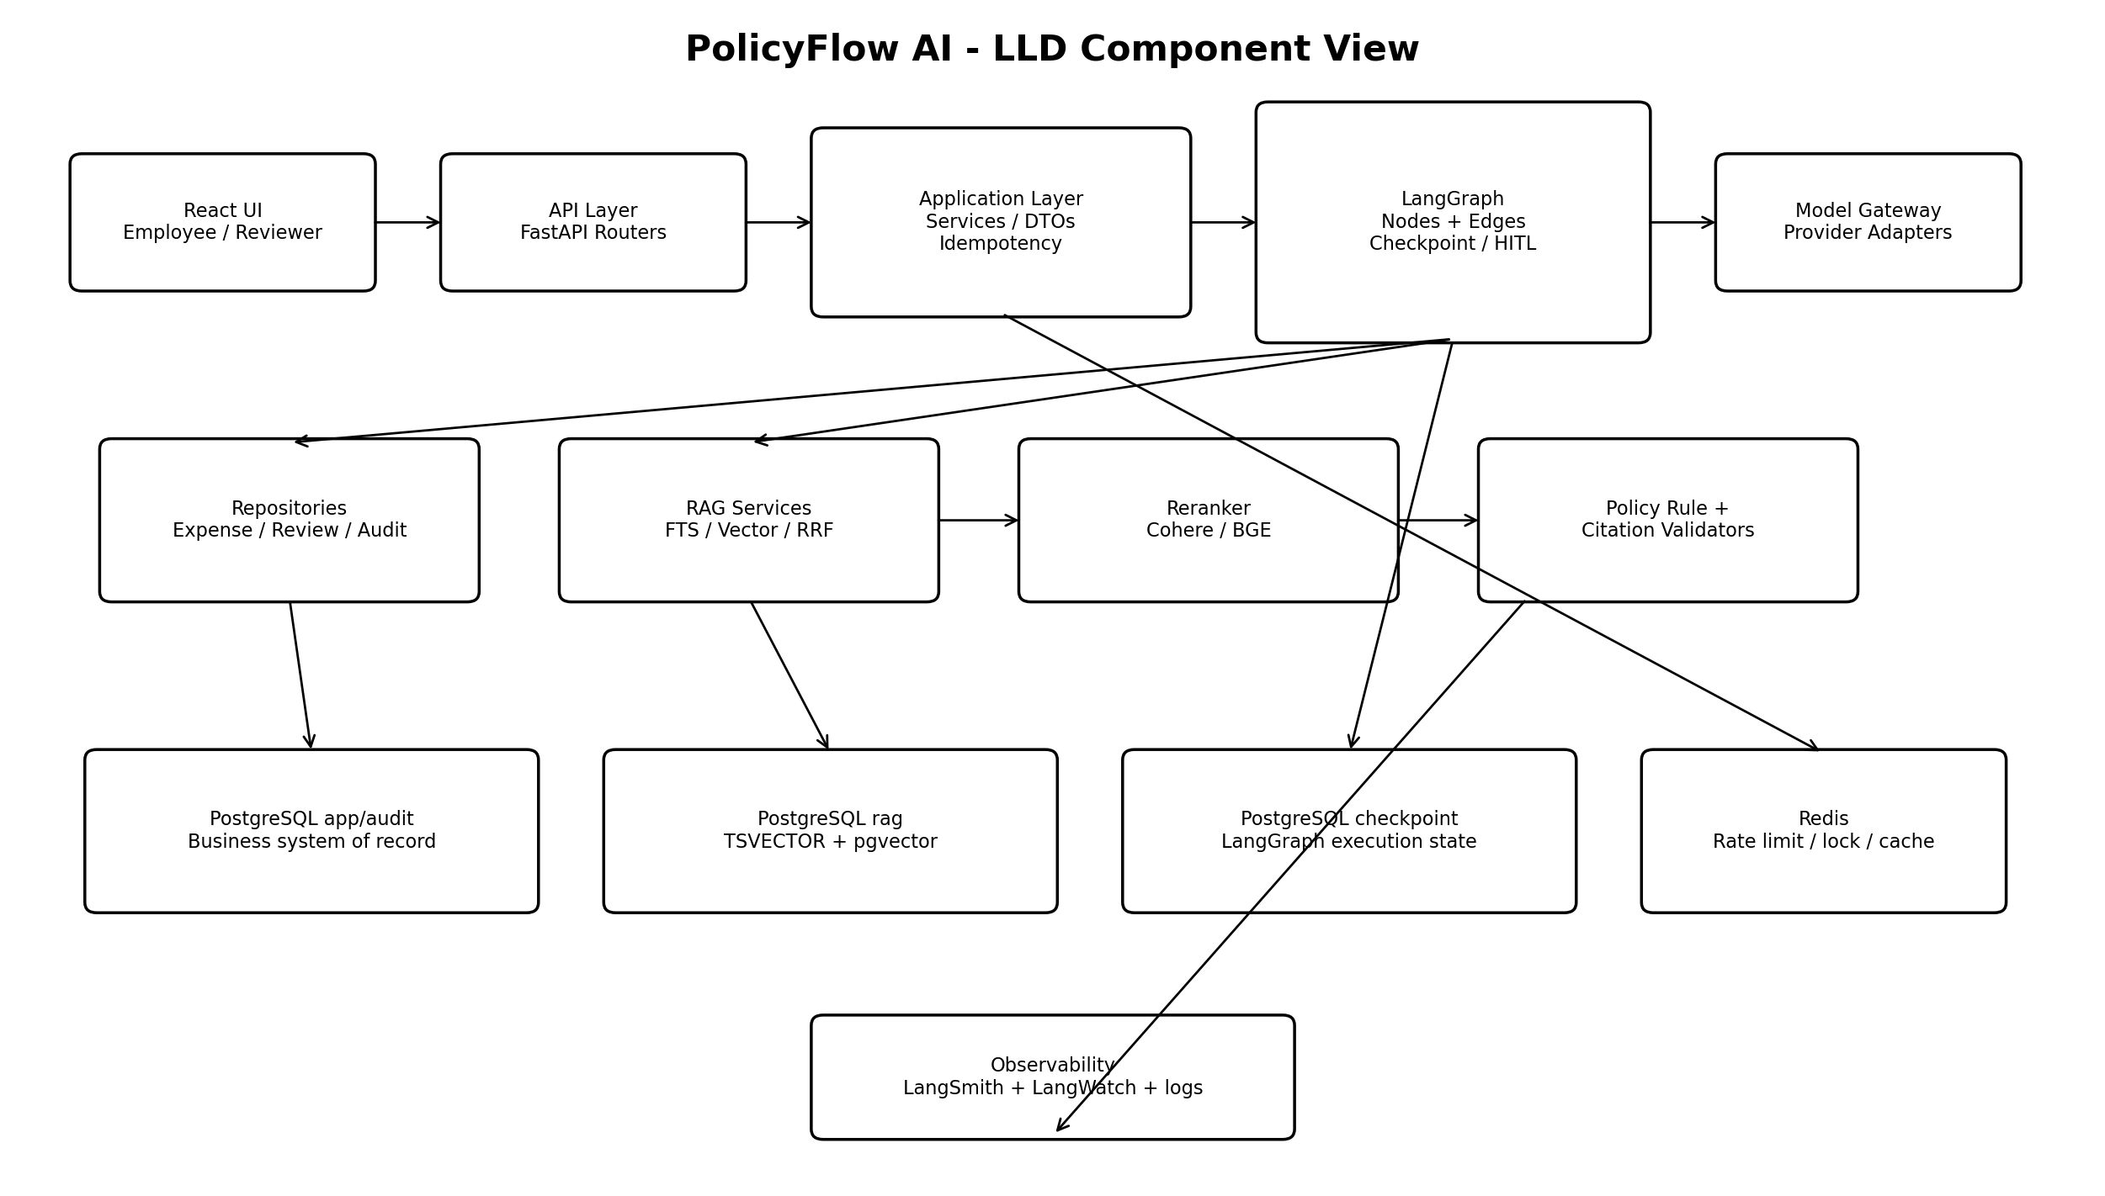

1. Document Control
Field | Value
Document | Low-Level Design (LLD)
Project | PolicyFlow AI - Enterprise Expense Compliance & Exception Agent
Version | 1.0
Inputs | FRD v1.0; HLD v1.0
Purpose | Define implementable modules, contracts, schemas, graph nodes, algorithms, persistence, APIs, tests and deployment configuration.
Scope | 15-20 day portfolio POC; synthetic/public data only

2. Design Intent
This LLD converts the HLD component boundaries into concrete implementation contracts. It intentionally keeps one deployable backend service while separating API, application, orchestration, RAG, model, persistence, guardrail and observability concerns in code. The business database remains authoritative; LangGraph checkpoints are execution state only.

3. Technology Baseline
Layer | Selected Technology
Frontend | React + TypeScript
API | Python 3.12, FastAPI, Pydantic v2
Workflow | LangGraph StateGraph + PostgreSQL checkpointer
Business/RAG DB | PostgreSQL + Alembic + pgvector + FTS
Coordination | Redis
Reranking | Cohere Rerank primary; BGE adapter optional
LLM | OpenAI through central Model Gateway
Observability | LangSmith + LangWatch + structured logs
Evaluation | Pytest + Ragas + DeepEval
Local | Docker Compose
Cloud | Cloudflare -> ALB -> ECS/Fargate -> RDS/ElastiCache/S3/Secrets Manager

4. Source Repository Structure
policyflow-ai/
frontend/
src/{api,components,features,types,pages}/
backend/
app/
main.py
api/v1/{policy.py,expenses.py,reviews.py,admin.py,health.py}
core/{config.py,logging.py,security.py,errors.py}
schemas/{policy.py,expense.py,review.py,common.py}
graph/{state.py,builder.py,edges.py,nodes/,prompts/}
rag/{ingestion.py,chunking.py,retriever.py,rrf.py,reranker.py,citations.py,embeddings.py}
gateway/{base.py,service.py,openai_adapter.py,fallback.py,token_budget.py}
rules/{expense_rules.py,confidence.py}
db/{session.py,models/,repositories/}
services/{policy_service.py,expense_service.py,review_service.py}
observability/{tracing.py,metrics.py,audit.py}
alembic/
tests/{unit,integration,evaluation,fixtures}/
policies/synthetic/
eval/golden/
openspec/
infra/{docker,aws,cloudflare}/
.github/workflows/

5. Detailed Component Design

5.1 Backend Layer Responsibilities
Layer | Concrete Responsibility
API routers | HTTP validation, status mapping, correlation IDs; no policy logic.
Services | Use-case transaction boundary and repository/graph coordination.
Graph | Stateful orchestration, conditional routing, interrupt/resume.
RAG | Ingestion, metadata filters, FTS/vector retrieval, RRF, reranking, citation construction.
Rules | Deterministic numeric/document checks and confidence routing.
Gateway | Provider-neutral model invocation, token budgets, retries, structured output.
Repositories | Persistence only; no LLM calls or workflow routing.
Observability | Trace attributes, audit events, metrics and sanitized logging.

6. Pydantic Domain Contracts

6.1 Expense Request/Response
class ExpenseCreate(BaseModel):
expense_type: Literal["HOTEL","MEAL","TAXI"]
amount: Decimal = Field(gt=0, max_digits=12, decimal_places=2)
currency: str = "INR"
location: str
travel_type: Literal["DOMESTIC","INTERNATIONAL"]
purpose: str
receipt_available: bool
class ExpenseAssessmentResponse(BaseModel):
expense_id: UUID
thread_id: str
decision: Literal["COMPLIANT","NON_COMPLIANT","NEEDS_REVIEW","INSUFFICIENT_INFORMATION"]
policy_limit: Decimal | None
confidence: float = Field(ge=0, le=1)
explanation: str
citations: list[Citation]
next_action: str | None

6.2 Policy Rule and Citation
class PolicyRule(BaseModel):
rule_type: Literal["AMOUNT_LIMIT","RECEIPT_REQUIRED","PROHIBITION","REVIEW_REQUIRED"]
category: str
amount_limit: Decimal | None = None
currency: str | None = None
condition: str | None = None
source_chunk_ids: list[UUID]
class Citation(BaseModel):
chunk_id: UUID
policy_code: str
policy_version: str
section_id: str
section_title: str
excerpt: str

6.3 Review Contract
class ReviewDecisionRequest(BaseModel):
decision: Literal["APPROVE","REJECT","REQUEST_MORE_INFORMATION"]
comments: str = Field(min_length=3, max_length=2000)
class ReviewResumePayload(BaseModel):
exception_id: UUID
reviewer_id: str
decision: str
comments: str

7. LangGraph Detailed Design

7.1 State
class ExpenseState(TypedDict, total=False):
thread_id: str
request_id: str
scenario: Literal["policy_qa","expense_assessment","exception_review"]
user_query: str
expense_id: str
expense: dict
missing_fields: list[str]
metadata_filters: dict[str, Any]
lexical_hits: list[dict]
vector_hits: list[dict]
fused_hits: list[dict]
reranked_hits: list[dict]
policy_rule: dict
citations: list[dict]
decision: str
confidence: float
explanation: str
exception_id: str
exception_justification: str
reviewer_decision: str | None
reviewer_comments: str | None
model_usage: dict
errors: list[str]

7.2 Node Contracts
Node | Inputs | Outputs / Side Effects
validate_request | request/state | normalized state or validation error
classify_intent | user_query/scenario hint | scenario enum
detect_missing_fields | expense | missing_fields
request_clarification | missing_fields | interrupt payload or clarification response
build_metadata_filters | scenario/expense | active/category/region/effective filters
hybrid_retrieve | query/filters | lexical_hits, vector_hits
fuse_results | two ranked lists | fused_hits with RRF score
rerank_results | fused_hits | reranked_hits top-K
extract_policy_rule | top evidence | validated PolicyRule via gateway
evaluate_expense | expense + PolicyRule | deterministic decision/variance
validate_citations | citations + retrieved set | valid citations or safe failure
evaluate_confidence | retrieval/citation signals | confidence + routing flag
collect_exception | expense/decision | exception record + justification
human_review | exception context | interrupt payload; checkpoint persisted
finalize_decision | review result/assessment | business persistence + final response
audit_event | state/event | append-only audit event

7.3 Edge Predicates and Interrupt
missing_fields? -> request_clarification : build_metadata_filters
scenario == policy_qa -> grounded_answer -> validate_citations
scenario == expense_assessment -> extract_policy_rule -> evaluate_expense
decision == NEEDS_REVIEW -> collect_exception -> human_review
confidence < MIN_CONFIDENCE or no valid citations -> INSUFFICIENT_INFORMATION
human_review:
interrupt({exception_id, expense_summary, policy_rule, citations, justification})
resume:
graph.invoke(Command(resume=ReviewResumePayload(...)), config={"configurable":{"thread_id": thread_id}})

7.4 Checkpoint Configuration
Use a PostgreSQL LangGraph checkpointer with thread_id as the stable workflow key. A request_id identifies an individual API call; thread_id survives clarification and HITL turns. Checkpoint tables must be logically separated from app business tables. Final review state must be committed idempotently to business tables before returning success.

8. Expense Decision Algorithm
1. Require at least one valid active policy citation.
2. Convert PolicyRule amount to Decimal; never float for money.
3. If a policy explicitly prohibits the category/condition -> NON_COMPLIANT.
4. If a mandatory receipt/document condition fails -> policy-defined NON_COMPLIANT or NEEDS_REVIEW.
5. If amount_limit exists and amount <= limit -> COMPLIANT.
6. If amount_limit exists and amount > limit and exception is allowed -> NEEDS_REVIEW.
7. If evidence is conflicting, incomplete or below confidence threshold -> INSUFFICIENT_INFORMATION.
8. LLM recommendation cannot override steps 1-7.

9. Policy RAG Detailed Design

9.1 Ingestion Pipeline
load source -> validate metadata -> content hash/idempotency check
-> parse sections -> section-aware chunks (target 400-700 tokens)
-> generate embeddings -> compute TSVECTOR
-> transactionally insert document/chunks -> mark ACTIVE only after success

9.2 Retrieval Parameters
Parameter | Initial POC Value
Lexical candidates | 20
Vector candidates | 20
RRF constant k | 60
Fused candidates to reranker | 10-20
Final evidence top-K | 3-5
Metadata filters | status=ACTIVE; category/domain; region/travel type when relevant; effective date
Embedding dimension | Configuration-driven; DB VECTOR dimension must match chosen embedding model
Reranker | Cohere adapter primary; BGE adapter behind same interface

9.3 RRF Formula
RRF(document) = SUM( 1 / (k + rank_i(document)) )
Default k = 60.
Deduplicate by chunk_id before reranking.
Preserve lexical_rank, vector_rank, rrf_score and rerank_score for observability.

9.4 Citation Validation Algorithm
valid_ids = {hit.chunk_id for hit in reranked_hits}
for citation in model_output.citations:
require citation.chunk_id in valid_ids
require chunk.document.status == ACTIVE
require effective_date <= assessment_date < expiry_date (when expiry exists)
require policy/version/section metadata exactly match stored chunk
build excerpt server-side from stored chunk, not from model text
if zero valid citations for a material conclusion: abstain / INSUFFICIENT_INFORMATION

10. Database Physical Design

10.1 Business Tables
Table | Important Columns / Constraints
app.expense | UUID PK; amount NUMERIC(12,2) CHECK >0; currency CHAR(3); status enum/check; created_at/updated_at
app.assessment | UUID PK; expense_id FK; decision; policy_rule JSONB; confidence NUMERIC; prompt_version/model; unique active/finalization key
app.exception_request | UUID PK; expense_id/assessment_id FK; justification; variance NUMERIC; status; timestamps
app.review | UUID PK; exception_id FK; reviewer_id; decision; comments; reviewed_at; unique final review as required
audit.agent_event | bigserial/UUID PK; thread_id/request_id; node/event; model/tokens/latency; chunk/citation IDs JSONB; created_at

10.2 RAG Tables and Indexes
CREATE EXTENSION IF NOT EXISTS vector;
CREATE INDEX policy_chunk_fts_gin ON rag.policy_chunk USING GIN(search_vector);
-- vector dimension is fixed after embedding model selection
CREATE INDEX policy_chunk_embedding_hnsw ON rag.policy_chunk USING hnsw (embedding vector_cosine_ops);
CREATE INDEX policy_doc_active_idx ON rag.policy_document(status, domain, effective_date);
CREATE INDEX policy_chunk_metadata_gin ON rag.policy_chunk USING GIN(metadata);

10.3 Alembic Migration Order
001_extensions_schemas
002_business_tables
003_policy_document_chunk
004_fts_indexes
005_vector_index
006_audit_tables
007_constraints_seed_reference_data

11. Repository Contracts
Repository | Core Methods
ExpenseRepository | create(), get(), update_status(), save_assessment()
PolicyRepository | upsert_document(), insert_chunks(), get_chunk(), search_fts(), search_vector()
ExceptionRepository | create_exception(), get_pending(), save_review(), finalize()
AuditRepository | append_event(), list_for_thread()

12. Model Gateway Detailed Design

12.1 Interfaces
class ModelGateway(Protocol):
async def invoke_structured(self, task: ModelTask, messages: list, output_schema: type[BaseModel], context: ModelContext) -> BaseModel: ...
class ProviderAdapter(Protocol):
async def generate(self, request: ProviderRequest) -> ProviderResponse: ...

12.2 Routing and Retry
Concern | Design
Primary | OpenAI adapter
Task routing | intent/summary can use lower-cost model; policy rule extraction uses configured reasoning model
Retries | Only transient timeout/429/5xx; exponential backoff with small bounded retry count
Validation retry | At most one repair/retry for invalid structured output
Fallback | Optional second configured model/provider adapter; never bypass guardrails
Token budget | Per task max input context, max output tokens, and per-thread budget counters
Timeout | Explicit provider timeout; propagate safe service error/abstention

12.3 Prompt Contracts
Prompts are versioned files/constants by task. Policy reasoning prompt requires evidence-only reasoning, no invented thresholds, explicit chunk IDs, and structured PolicyRule output. Exception-summary prompt may summarize justification but must not output an authoritative approval.

13. Redis Design
Key Pattern | Purpose / TTL
ratelimit:{principal}:{route} | API request count; short rolling TTL
lock:policy-ingest:{hash} | Prevent duplicate concurrent ingestion; TTL with ownership token
cache:retrieval:{query_hash} | Optional short-lived retrieval cache; invalidate by policy corpus version
thread:budget:{thread_id} | Optional transient token/cost counter; checkpoint/business state remains PostgreSQL

14. REST API Detailed Contracts
Endpoint | Success | Key Errors
POST /api/v1/policy/query | 200 PolicyAnswerResponse | 400 validation; 422 unsupported; 503 model/retrieval unavailable
POST /api/v1/expenses | 201 expense + assessment/next action | 400/422; 409 idempotency conflict; 503
POST /api/v1/threads/{id}/continue | 200 resumed result/next clarification | 404 thread; 409 invalid graph state
POST /api/v1/expenses/{id}/exceptions | 201 exception / HITL pending | 404; 409 not eligible for exception
GET /api/v1/reviews/pending | 200 list | 403 role
POST /api/v1/reviews/{id}/decision | 200 final/pending result | 404; 409 already finalized; 422 invalid decision
GET /api/v1/expenses/{id} | 200 aggregate view | 404
POST /api/v1/admin/policies/ingest | 202/201 ingestion result | 400; 409 duplicate; 403 role
GET /health | 200 | 503 dependency readiness when using readiness endpoint

14.1 Idempotency
POST expense, exception and review-decision endpoints accept an Idempotency-Key. Persist key + request hash + resulting resource ID for the POC or enforce equivalent unique operation keys. A repeated key with a different payload returns 409. Reviewer finalization uses a database transaction and unique constraint/row lock to prevent double approval.

15. Error Model
{
"error": {
"code": "POLICY_EVIDENCE_INSUFFICIENT",
"message": "Unable to determine the applicable policy from verified evidence.",
"request_id": "...",
"retryable": false
}
}
Code | HTTP | Handling
VALIDATION_ERROR | 422 | Return field errors
RESOURCE_NOT_FOUND | 404 | No retry
WORKFLOW_STATE_CONFLICT | 409 | Refresh current state
POLICY_EVIDENCE_INSUFFICIENT | 200/422 by endpoint contract | Safe abstention; not provider failure
MODEL_TEMPORARILY_UNAVAILABLE | 503 | Retryable
RATE_LIMITED | 429 | Retry-After
INTERNAL_ERROR | 500 | Opaque client message; detailed sanitized log

16. Transaction and Concurrency Design
- Expense creation and initial business record commit occur before long-running model calls; assessment is appended after graph result.
- Final review decision is transactional: lock exception row, verify PENDING, insert review, update exception/expense status, append audit event, then commit.
- LangGraph checkpoint persistence is not used as a substitute for business transaction integrity.
- Policy ingestion uses content_hash uniqueness plus Redis lock to avoid duplicate concurrent ingestion.

17. Observability Schema
Area | Attributes
Correlation | request_id, thread_id, expense_id, exception_id
Graph | node_name, edge, interrupt/resume, duration_ms
Retrieval | filters, lexical_count, vector_count, chunk IDs, ranks, rrf_score, rerank_score
Model | task, provider, model, prompt_version, input_tokens, output_tokens, latency_ms, retry_count
Quality | citation_valid_count, confidence, decision, abstention_reason
Security/Privacy | Do not log secrets; minimize raw justification/query content in external telemetry

18. Evaluation and Test Design

18.1 Test Pyramid
Level | Examples
Unit | RRF, deterministic rules, citation validator, Pydantic validators, confidence logic
Repository integration | PostgreSQL CRUD, FTS/vector queries, Alembic migrations
Graph integration | happy path, clarification resume, NEEDS_REVIEW interrupt/resume
Gateway contract | structured output, timeout, retry, invalid schema
RAG evaluation | golden query -> expected policy/section; Precision@5, Recall@10, citation correctness
End-to-end | React/API -> graph -> DB for two demo scenarios

18.2 Golden Dataset Shape
{
"id": "hotel-domestic-over-limit-01",
"query": "Can I claim INR 9500 hotel for domestic client travel?",
"expected_policy_code": "POL-002",
"expected_section": "4.3",
"expected_decision": "NEEDS_REVIEW",
"required_facts": {"limit": 7000},
"tags": ["hotel","domestic","over_limit"]
}

18.3 CI Quality Gates
Block deployment on failing deterministic tests/migrations. Run a small deterministic RAG smoke set on pull requests and the fuller Ragas/DeepEval suite on main/release or manually to control cost. Store benchmark results as build artifacts and compare against agreed thresholds from the FRD.

19. Frontend Detailed Design
Feature | Components / Behavior
Policy Q&A | PolicyQueryPage, AnswerCard, CitationDrawer
Expense submit | ExpenseForm, AssessmentResult, ClarificationPanel
Exception | ExceptionJustificationForm, status timeline
Reviewer | PendingReviewList, ReviewDetail, DecisionForm
API state | Typed client models matching OpenAPI; loading/error/retry states
HITL continuation | Poll/refetch or explicit refresh for POC; reviewer action invokes resume endpoint

20. Security Implementation
- Demo role header/session may represent EMPLOYEE/REVIEWER/ADMIN; isolate behind an AuthContext so enterprise OIDC can replace it later.
- Validate and normalize all API input; limit request sizes and supported categories.
- Never expose provider/database secrets to frontend; inject backend secrets from AWS Secrets Manager.
- Use parameterized ORM/SQL queries; whitelist sortable/filterable fields.
- Cloudflare/ALB TLS edge; security groups restrict RDS/Redis to ECS tasks.
- Treat retrieved policy text as untrusted context: prompts explicitly ignore instructions embedded in documents; deterministic output validation remains authoritative.

21. Docker Compose Design
services:
frontend: React dev/prod container
backend: FastAPI Python 3.12
postgres: PostgreSQL + pgvector
redis: Redis
backend depends on postgres/redis health checks.
Alembic upgrade head runs as an explicit migration step, not concurrently in every backend replica.

22. AWS Deployment Detail
Element | LLD Configuration
Cloudflare | DNS proxy/WAF/rate rules -> ALB hostname
ALB | HTTPS listener; /api/* -> backend target group; frontend routes -> frontend target group or chosen static delivery
ECS backend | Fargate task, private subnets, health endpoint, env/secrets injection, autoscaling optional
ECS frontend | Containerized React delivery per project constraint; alternative static hosting is deliberately not used in baseline
RDS | PostgreSQL with pgvector; private; automated backups; app/rag/audit/checkpoint logical separation
ElastiCache | Private Redis; security group only from ECS
S3 | Synthetic policy source objects/evaluation artifacts
Secrets Manager | DB, OpenAI, Cohere, LangSmith/LangWatch secrets
CloudWatch | Container/infrastructure logs and alarms

23. Configuration Variables
APP_ENV, LOG_LEVEL, API_PREFIX
DATABASE_URL, CHECKPOINT_DATABASE_URL, REDIS_URL
EMBEDDING_PROVIDER, EMBEDDING_MODEL, EMBEDDING_DIMENSION
RERANK_PROVIDER, RERANK_MODEL, RRF_K, RETRIEVAL_TOP_N, RERANK_TOP_K
OPENAI_API_KEY, OPENAI_PRIMARY_MODEL, OPENAI_FALLBACK_MODEL
MODEL_TIMEOUT_SECONDS, MAX_OUTPUT_TOKENS, THREAD_TOKEN_BUDGET
LANGSMITH_API_KEY, LANGWATCH_API_KEY
MIN_CONFIDENCE, CITATION_REQUIRED=true

24. Detailed Runtime Sequence
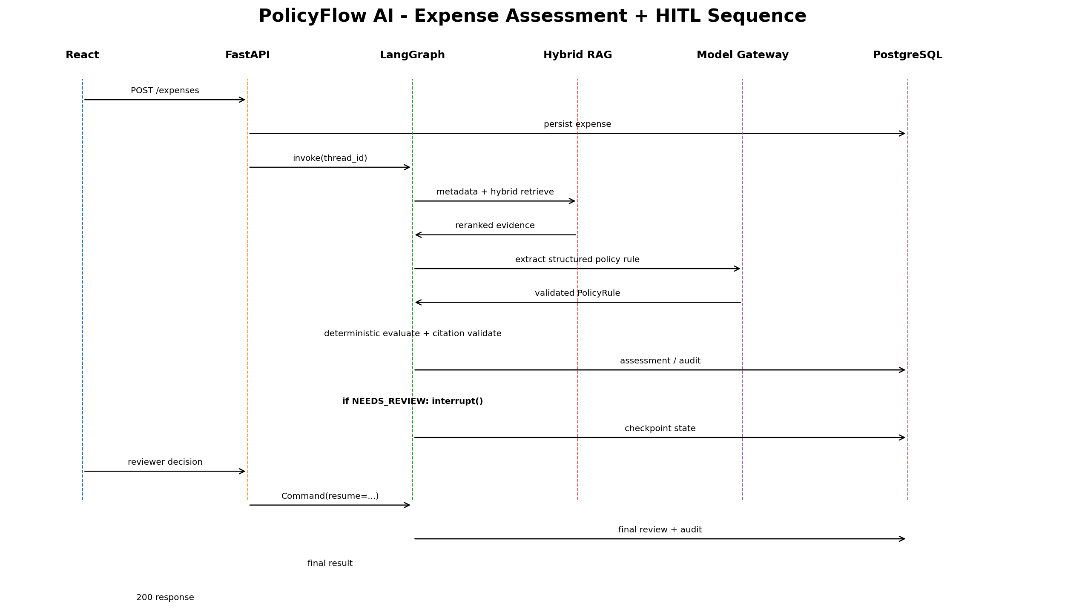

25. Failure Handling
Failure | Behavior
No policy hits | Return INSUFFICIENT_INFORMATION; no fabricated limit
Reranker unavailable | Configured safe fallback to fused ranking or fail closed based on environment; emit telemetry
LLM timeout/429 | Gateway bounded retry; fallback model if configured; otherwise 503/safe continuation
Invalid structured output | One bounded repair/retry; then safe failure
Citation mismatch | Reject generated conclusion and abstain/re-evaluate
Redis unavailable | Core business/checkpoint flow continues where possible; rate/cache features degrade safely
PostgreSQL unavailable | Fail request; never pretend persistence succeeded
Reviewer duplicate action | 409 due to final-state check/unique constraint
Container restart during HITL | Resume by thread_id from PostgreSQL checkpoint

26. Traceability to HLD
HLD Area | LLD Sections
Major components | 4-5
LangGraph architecture | 7-8
Data architecture | 10-11,16
Policy ingestion/retrieval | 9
Model Gateway | 12
Guardrails | 8-9,15,20
API integration | 14-15
Observability/evaluation | 17-18
AWS/CI-CD | 21-23,27

27. Implementation Order
Days | Implementation Slice
1-3 | Repo, config, Docker, schemas, Alembic, base APIs
4-7 | Policy ingestion, embeddings, FTS/vector, RRF, reranker, citations
8-11 | LangGraph nodes/edges/checkpointer, policy Q&A, expense rules, clarification
12-14 | Model Gateway, exception HITL, reviewer API/UI, guardrails
15-16 | Tracing, LangWatch, Pytest, Ragas/DeepEval golden set
17-18 | GitHub Actions, ECR/ECS/RDS/Redis/Cloudflare
19-20 | Hardening, benchmark, README/demo/diagrams

28. Definition of Done
- All three FRD use cases pass end-to-end with synthetic data.
- Policy answers and decisions expose verified citations.
- Money/threshold decisions are deterministic and unit tested.
- Clarification and HITL workflows resume from PostgreSQL checkpoints using the same thread_id.
- Business truth is queryable without reading LangGraph checkpoint tables.
- Model calls go only through the Model Gateway.
- Golden retrieval/decision tests meet FRD acceptance thresholds.
- Local Docker Compose and AWS deployment both pass smoke tests.
- No confidential data or secrets are present in source, policy corpus, traces, or demo artifacts.

29. Implementation Notes / Decisions to Freeze Before Coding
Decision | Recommended Freeze
Embedding model/dimension | Choose on Day 4 and create matching VECTOR(d) migration; do not change casually afterward.
Reranker | Cohere primary for fastest POC; keep BGE adapter interface optional.
Confidence threshold | Start configuration-driven; calibrate on golden set rather than inventing a permanent value.
Auth | Simple demo role abstraction; no enterprise SSO scope.
Frontend deployment | Keep containerized on ECS to satisfy fixed project requirement.
Policy corpus | 5-8 synthetic documents; versioned and hash-controlled.
Scope | No OCR, payment, fraud, ERP, multi-agent, Kafka or Kubernetes additions.

30. Interview-Level Implementation Summary
At implementation level, PolicyFlow AI is one FastAPI service with a LangGraph state machine. The graph calls a hybrid PostgreSQL RAG layer, then a reranker and a governed Model Gateway. The model extracts a structured policy rule; deterministic Python code applies monetary and documentation controls and validates citations. PostgreSQL business tables store the authoritative expense/review result, while a separate PostgreSQL checkpointer stores resumable graph execution. Redis is transient only. Over-limit cases interrupt the graph for human review and resume by thread_id. This makes each technology directly traceable to a concrete reliability, governance, retrieval, or workflow requirement.

