Documentation on Enron Email Project
(Thanks to Cassandra Shi)

- Dataset Description

The Enron email dataset contains data from about 150 users, mostly senior management of Enron. The corpus contains a total of about 0.5 millions messages. This dataset does not contain attachments and some messages has been deleted “as part of a redaction effort due to requests from affected employees”. To download the original Enron email dataset and for more information on this dataset, please visit: http://www.cs.cmu.edu/~enron/ .

Since Hadoop platform is more efficient in processing one large file than a large number of small files, I merged the original files into larger files. The merged data can be download here: https://www.dropbox.com/s/nzv3xg2va960fgb/Enron%20Merged.zip
In the “By name” folder, all emails under one user account are merged into one larger file. The “enron-all.” file is a combines every single email in the Enron email.

- Homework Problem: We want to create a “social network” diagram that shows the number of emails sent from each email user to another email user in the dataset. IOW, we want to fill in a matrix like this:

From/To | Email1 | Email2 |  |  |  |  | EmailN
Email1 | x | ? |  |  |  |  | ?
Email2 | ? | x |  |  |  |  | ?
 | ? |  | x
 | ? |  |  | x
 |  |  |  |  | x
 |  |  |  |  |  | x | ?
EmailN | ? |  |  |  |  |  | x

- Test applications on local machine
Your program(s) can be tested on the local machine with a small portion of data before running on the cluster. With Hadoop Eclipse plugin, it is fairly easy to do so.
First make sure under your Eclipse’s Hadoop Map/Reduce setting, the Hadoop installation directory is pointed to the right location:
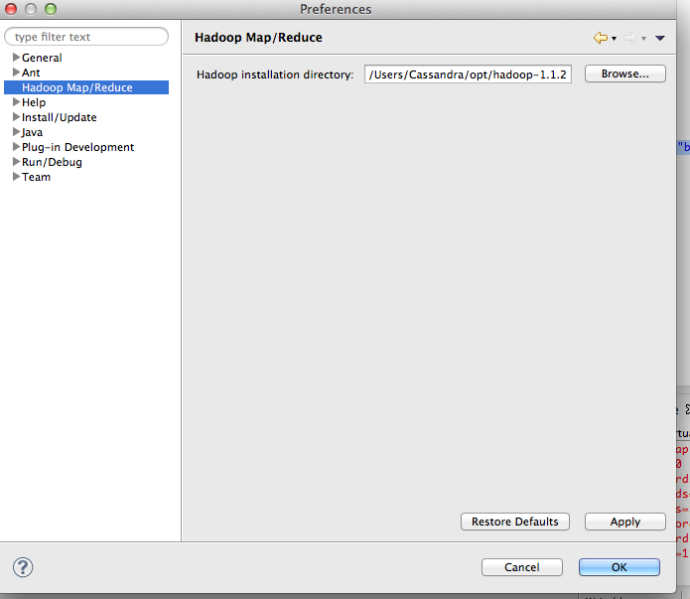

Then chose the file you want to run, right click the file and chose the run on hadoop option:
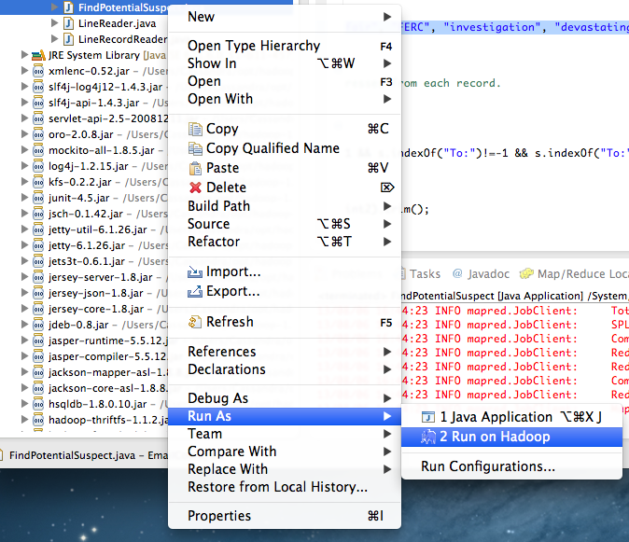

4.Running the Applications on the Hadoop Clusters
To run the applications on the Hadoop clusters, we need to create a jar file for each application. There are two ways do so. If you already have Hadoop Eclipse plugin installed , and the version you are using on your machine is the same as the one running on Heinz cluster, the easiest way is to:

Export Jar File From Eclipse

Go to Eclipse > File > Export > Java > Jar File and choose check the following options:

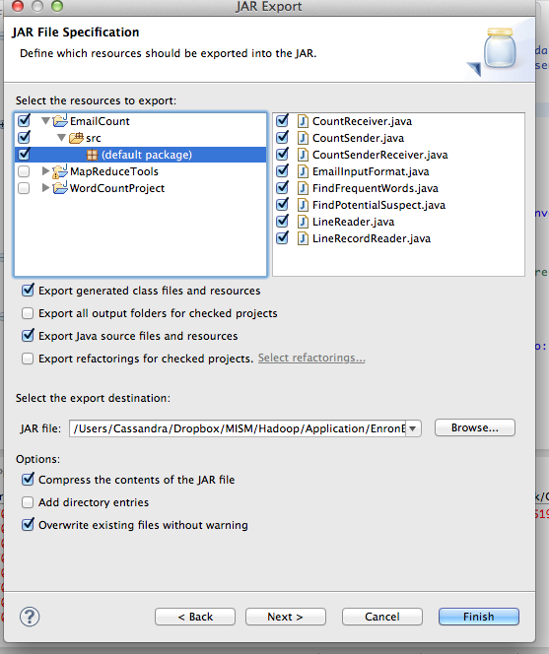

Then transfer the jar file to Heinz Cluster using sftp or equivilant (e.g., WinSCP for Windows).

If you are on a machine without Hadoop or Eclipse Hadoop Plugin installed, you need to login to your Heinz Cluster Account and do it in the command line:

Compile and Creating Jar File from Command Line:
First all the source files that are used need to be transferred to Heinz Cluster from sftp.

Open your command line tool and connect to Heinz Cluster using SFTP:

$sftp [Your User Name]@HEINZ-JUMBO.HEINZ.CMU.LOCAL
$put [file directory from your local machine]
$bye (quit sftp)

Using “put” command to upload files from your local machine to Heinz Jumbo, if you wish to download files from Heinz Jumbo, use the “get” command.

Connect to Heinz Jumbo:
$ssh -l [Your User Name] HEINZ-JUMBO.HEINZ.CMU.LOCAL

Note that your default working directory in Heinz Jumbo will be /home/[your user name]. Your default working directory in HDFS will be /user/your user name].

Make a directory named enronEmail_classes, and compile the java source files. Pay attention that the order of compilation could be important; some classes may need to be compiled first if other files are dependent on them.

Create a jar file
jar -cvf enronEmail.jar -C enronEmail_classes/ .

Run the application

Make sure that the output directory doesn’t exist before running the application. To delete an existing directory in HDFS:

hadoop dfs -rmr [directory]

hadoop jar /home/cassandra/enronEmail.jar CountReceiver(main class name) /user/cassandra/input /user/cassandra/output

...

More commands to interact with HDFS, please refer to http://hadoop.apache.org/docs/r0.18.3/hdfs_shell.html

To view the result and move it from HDFS to the server directory:

$mkdir CountReceiverOutput
$hadoop dfs -getmerge /user/cassandra/output ~/CountReceiverOutput/

$cat ~/CountReceiverOutput/output

