**How to install Java?**

Double click on jdk-8u241-windows-x64

Then It will show pop up message “Do you want to allow this app to make changes to your device with Yes and No button”

Click on Yes to proceed.

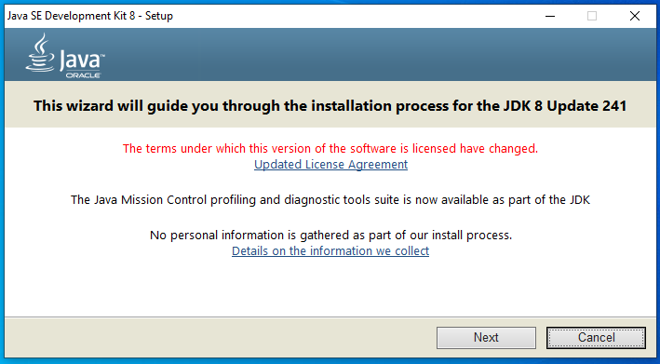

Click on Next button.

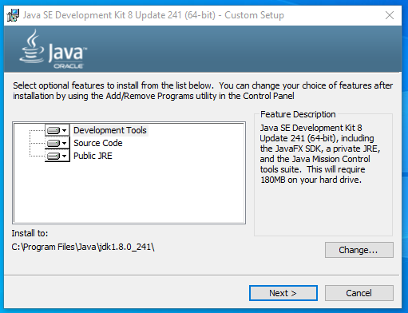

Click on Next button

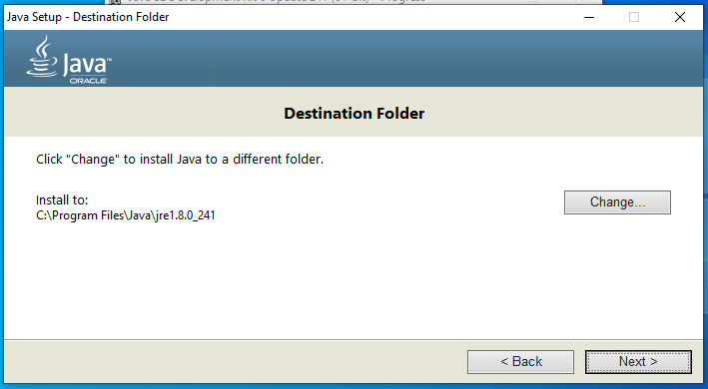

Click on next button

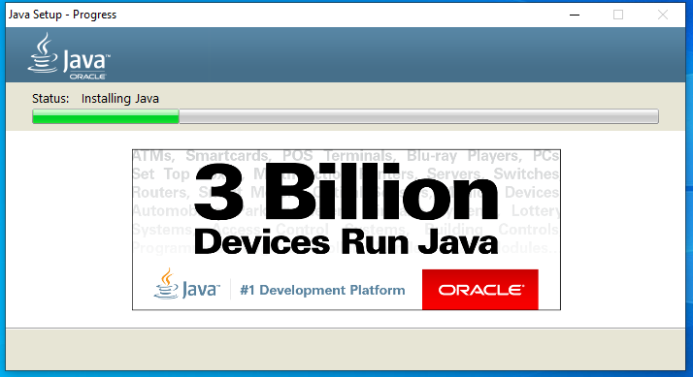

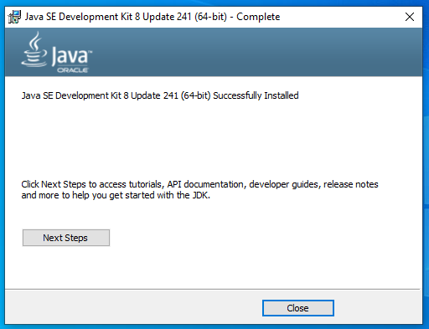

Click on close button

**How to set class path in java.**

Windows 10 Operating system, click on My Computer then Right click->select properties.

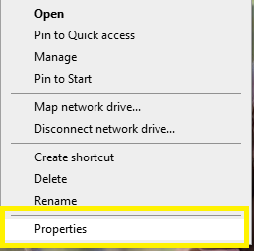

On left hand side menu-> Select Advanced System Setting option.

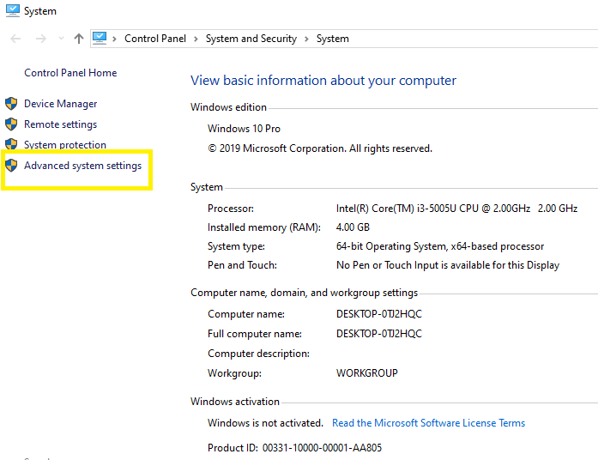

Click on Environment variable button at displayed on bottom off screen.

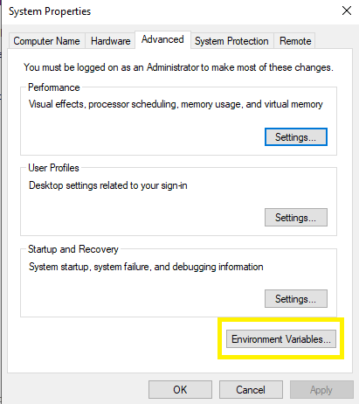

Go to System variable section, Click on New button and set JAVA_HOME and JRE_HOME

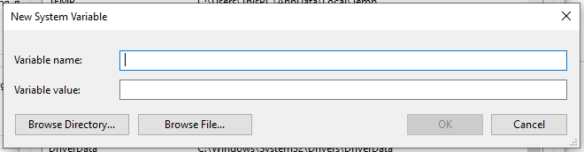

Type

Variable name as JAVA_HOME

Variable value as C:\Program Files\Java\jdk1.8.0_241

Click on ok button then again Go to System variable->Click on New button

Same apply for JRE also

Variable name as JRE_HOME

Variable value as C:\Program Files\Java\jre1.8.0_241

After that it looks like

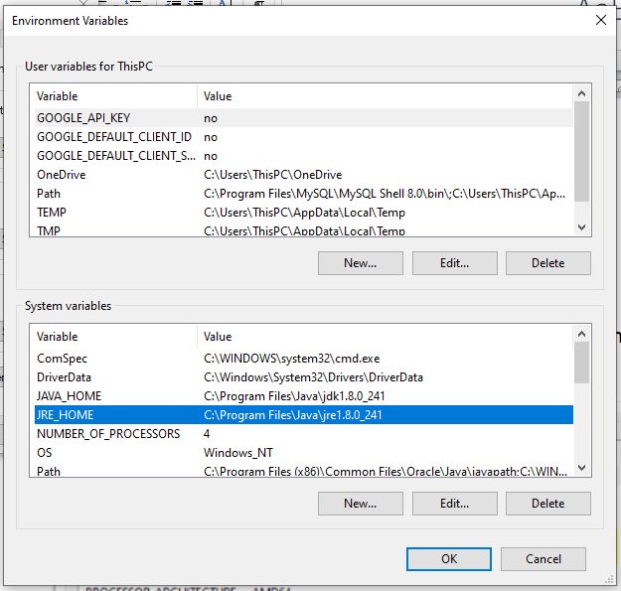

Click on Ok button.

Then go to command prompt and type

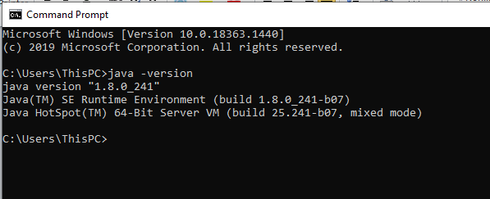

**Note-Share above screenshot on whatsapp personally not in group**