

Life Expectancy

Description

Context

Although there have been lot of studies undertaken in the past on factors affecting life expectancy considering demographic variables, income composition and mortality rates. It was found that affect of immunization and human development index was not taken into account in the past. Also, some of the past research was done considering multiple linear regression based on data set of one year for all the countries. Hence, this gives motivation to resolve both the factors stated previously by formulating a regression model based on mixed effects model and multiple linear regression while considering data from a period of 2000 to 2015 for all the countries. Important immunization like Hepatitis B, Polio and Diphtheria will also be considered. In a nutshell, this study will focus on immunization factors, mortality factors, economic factors, social factors and other health related factors as well. Since the observations this dataset are based on different countries, it will be easier for a country to determine the predicting factor which is contributing to lower value of life expectancy. This will help in suggesting a country which area should be given importance in order to efficiently improve the life expectancy of its population.

Content

The project relies on accuracy of data. The Global Health Observatory (GHO) data repository under World Health Organization (WHO) keeps track of the health status as well as many other related factors for all countries The data-sets are made available to public for the purpose of health data analysis. The data-set related to life expectancy, health factors for 193 countries has been collected from the same WHO data repository website and its corresponding economic data was collected from United Nation website. Among all categories of health-related factors only those critical factors were chosen which are more representative. It has been observed that in the past 15 years , there has been a huge development in health sector resulting in improvement of human mortality rates especially in the developing nations in comparison to the past 30 years. Therefore, in this project we have considered data from year 2000-2015 for 193 countries for further analysis. The individual data files have been merged together into a single data-set. On initial visual inspection of the data showed some missing values. As the data-sets were from WHO, we found no evident errors. Missing data was handled in R software by using Missmap command. The result indicated that most of the missing data was for population, Hepatitis B and GDP. The missing data were from less known countries like Vanuatu, Tonga, Togo, Cabo Verde etc. Finding all data for these countries was difficult and hence, it was decided that we exclude these countries from the final model data-set. The final merged file(final dataset) consists of 22 Columns and 2938 rows which meant 20 predicting variables. All predicting variables was then divided into several broad categories:​Immunization related factors, Mortality factors, Economical factors and Social factors.

Acknowledgements

The data was collected from WHO and United Nations website with the help of Deeksha Russell and Duan Wang.

Inspiration

The data-set aims to answer the following key questions:

- Does various predicting factors which has been chosen initially really affect the Life expectancy? What are the predicting variables actually affecting the life expectancy?
- Should a country having a lower life expectancy value(<65) increase its healthcare expenditure in order to improve its average lifespan?
- How does Infant and Adult mortality rates affect life expectancy?
- Does Life Expectancy has positive or negative correlation with eating habits, lifestyle, exercise, smoking, drinking alcohol etc.
- What is the impact of schooling on the lifespan of humans?
- Does Life Expectancy have positive or negative relationship with drinking alcohol?
- Do densely populated countries tend to have lower life expectancy?
- What is the impact of Immunization coverage on life Expectancy?

Data:
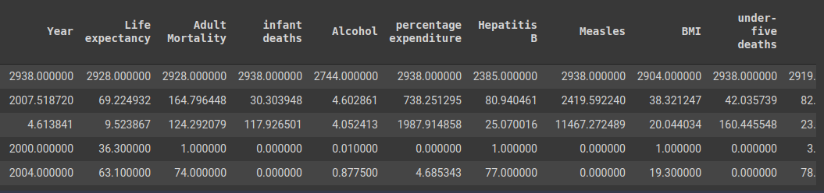
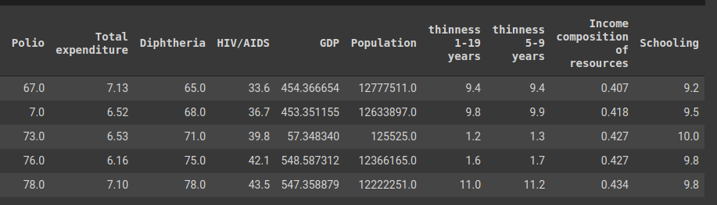

Data Types of all the columns:
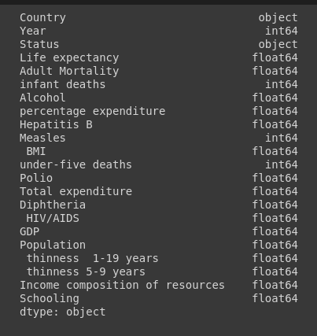

The Total Size of the date set is 2938 records with 22 columns.
25% of it is taken as a sample and sample has been taken through random sampling which is 734 records.

Let’s Start Visualising the data and gain some insights on the overall structure of the data.

Number of Developed countries and Developing countries:

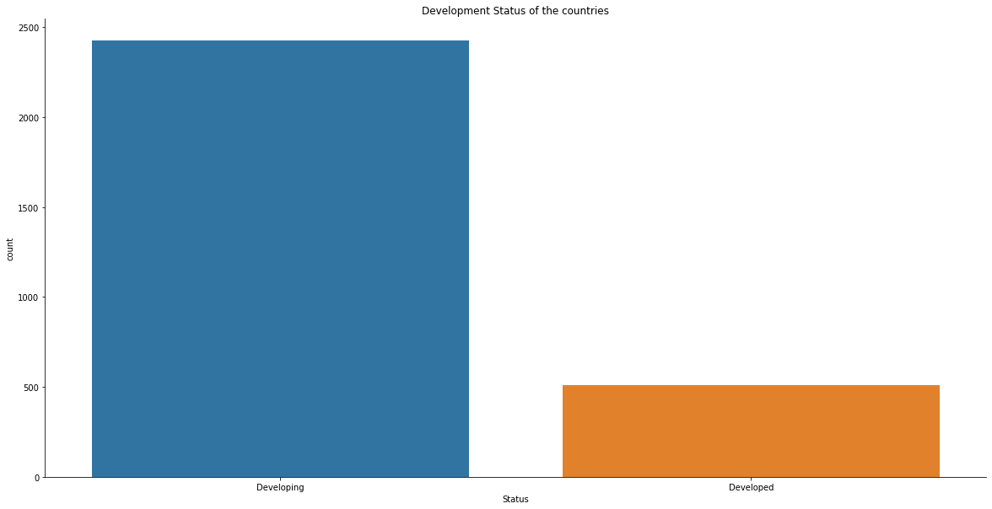
It Looks like that most of the survey was done in developing countries or this is due to the fact that there are many developing countries than developed countries

The distribution of Average Life:

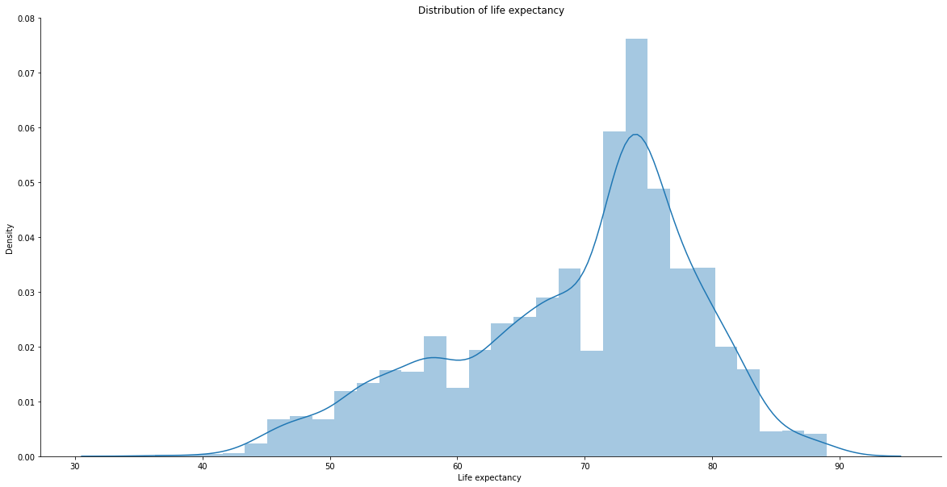
The peak of the life expectency can be seen between 70 -80 this tells us that majority of the people die a natural death and as a senior citizen.

Pairplot of Different Mortality Rate:

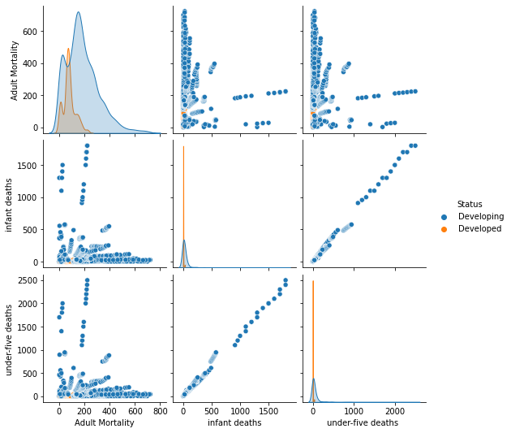
From the above pair plot it is visible that the mortality rate is lower in developed countries and also infant deaths and under-five deaths have a very strong correlation almost perfect because it basically means the same.

The distribution for all three are left skewed.

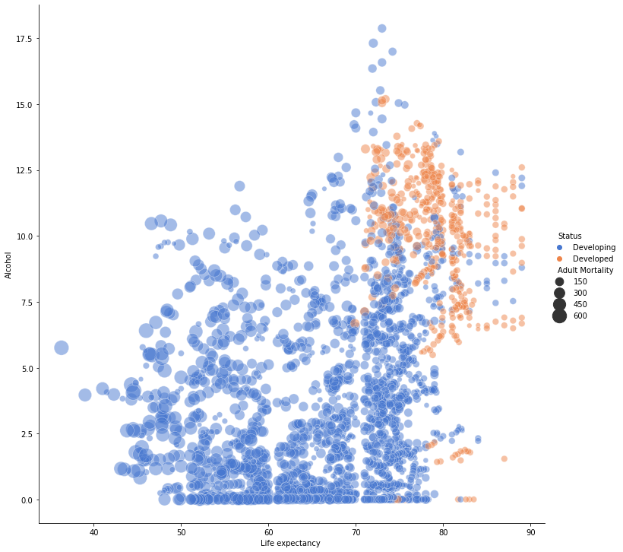
Correlation plot between Life expectency and Alcohol:

Even though there is no correlation between Life expectancy and Alcohol
The above plot tells us 3 importants points:
- The developed countries are at the right hand side of the graph which tells us that developed countries have higher life expectency.
- Most of the points are gathered towards the bottom which means the lower the alcohol consumption the lower the mortality rate of live expectancy.
- Even though developed countries have high alcohol consumption rate still their life expectancy is high this is maybe because of the quality of the alcohol.

Now Let us try to answer all the questions we aim to answer.

Question 1: Does various predicting factors which has been chosen initially really affect the Life expectancy? What are the predicting variables actually affecting the life expectancy?

The metric for deciding which factors put major impact is correlation, well see which factors are most correlated to life expectancy in that way can determine which factors will have the most impact on life expectancy.

We will start by looking at different mortality rates.
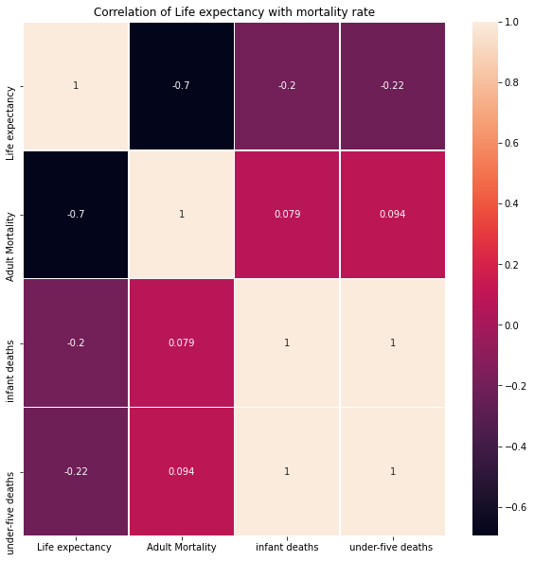
The heatmap above plots the correlation of mortality rates with life expectacy.

Next we will look at the diseases.

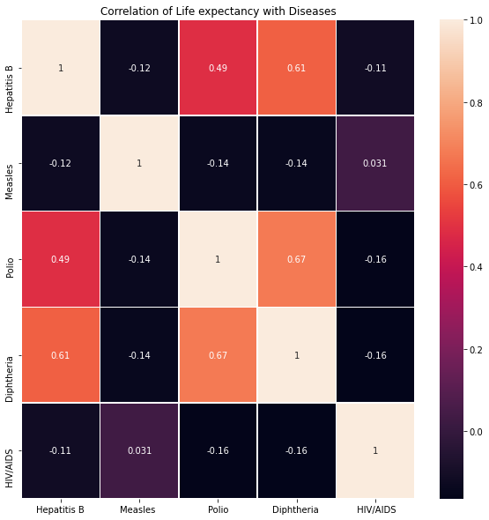

Correlation of Life expectancy with Physical features

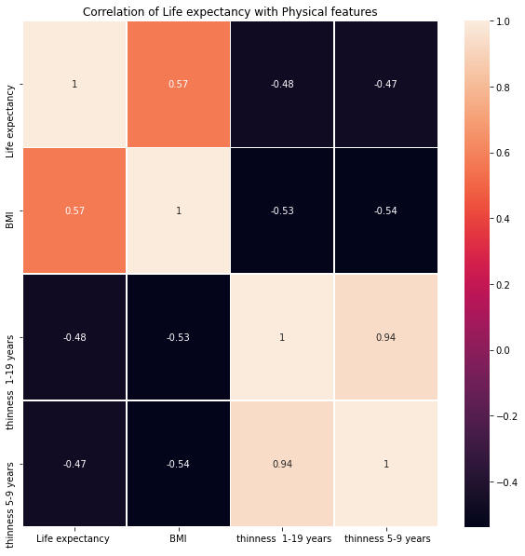

Correlation of Life expectancy with Other features like country expenditure and economy.

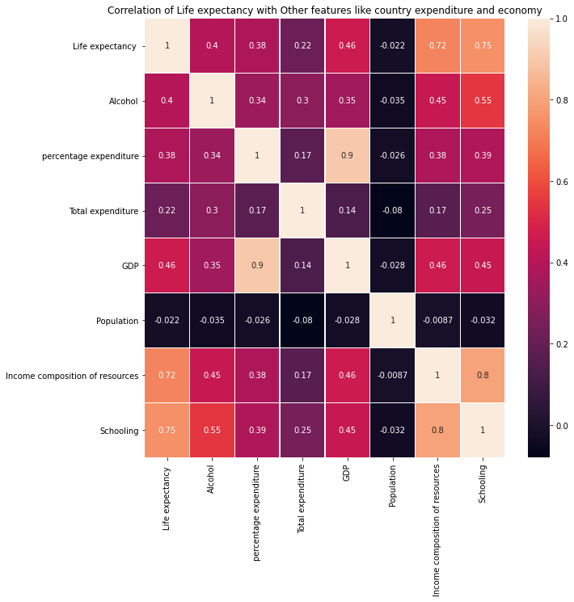
So in my opinion there are some features that are affeting life expectancy
The features that are affecting Life expectency are:
- Adult Mortality
- Diphtheria
- Schooling
- Income composition
- Alcohol
- GDP
- BMI
Question 2: Should a country having a lower life expectancy value(<65) increase its healthcare expenditure in order to improve its average lifespan?

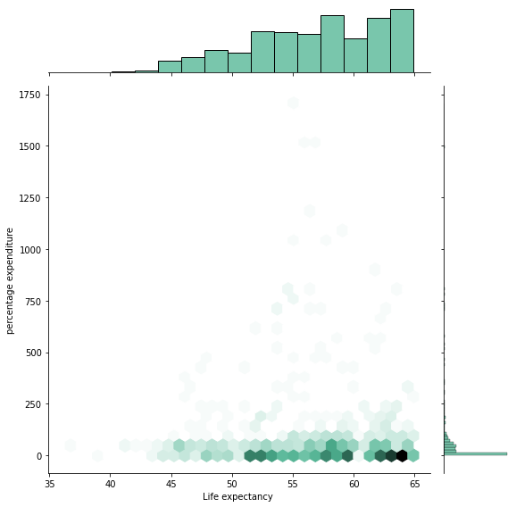
from the above hexbin plot we can assume that Life expectancy is more with less percentage expenditure
from both the cases we can confirm one thing that higher expenditure is not required for increasing life expectancy.So the answer is no countries with life expectancy less than 65 are not required to increase their total expenditure.

Question 3: How does Infant and Adult mortality rates affect life expectancy?

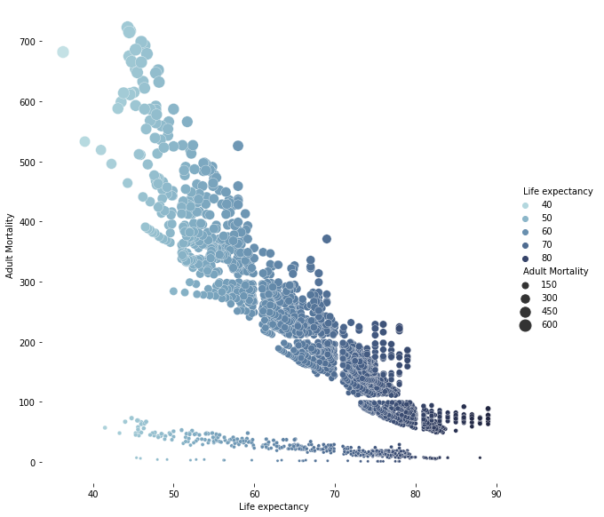
We can see that there is a negative correlation between Adult mortality rate and life expectancy, which is completely reasonable because countries with higher Adult death rate have lower life expectancy.

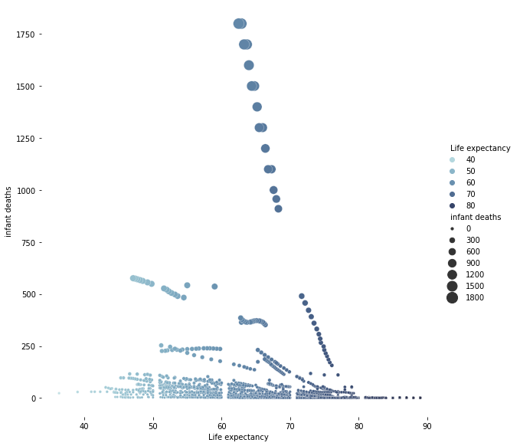

The above plot tells us that there is a very low negative correlation this is because infants are usually below 15-10 years of age so that means they did'nt lived long enough for the country to make an effect that's infants deaths doesn't determine the life expectancy of a particulary country although there are some countries which is not suitable for a child like war prone countries and that's why we are seeing a very low correlation instead of no correlation.
So the answer is that Adult mortality rate affects life expectancy but infant deaths do not.

Question 4: Does Life Expectancy has positive or negative correlation with eating habits, lifestyle, exercise, smoking, drinking alcohol etc.

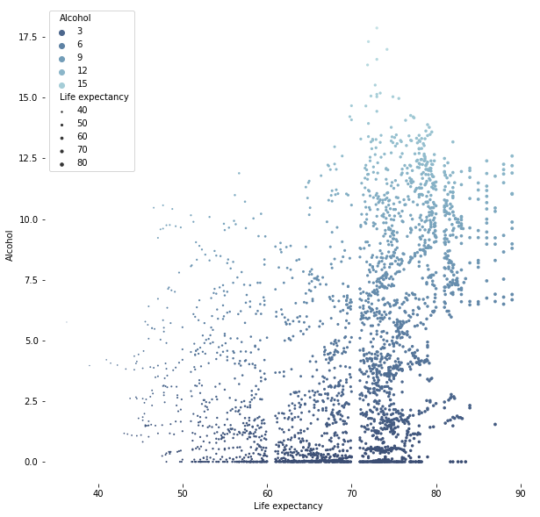
The Above plot makes it clear that there is no correlation between alcohol and Life expectancy.

Question 5: What is the impact of schooling on the lifespan of humans?

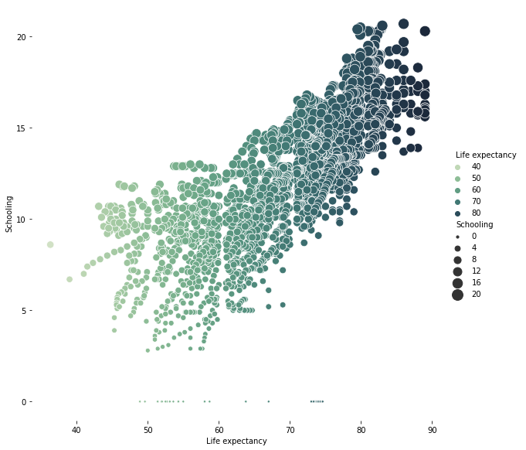

Schooling has a positive correlation with Life expectancy, Which mean the higher the years of schooling the higher the life expectancy.

Question 6 : Does Life Expectancy have positive or negative relationship with drinking alcohol?

The correlation score of alcohol with life expectency is 0.4048767611266013.

As we have seen before even though Alcohol has low correlation with life expectancy we can say that it has a positive correlation.

Question 7 : Do densely populated countries tend to have lower life expectancy?

Distribution of life expectency per year.

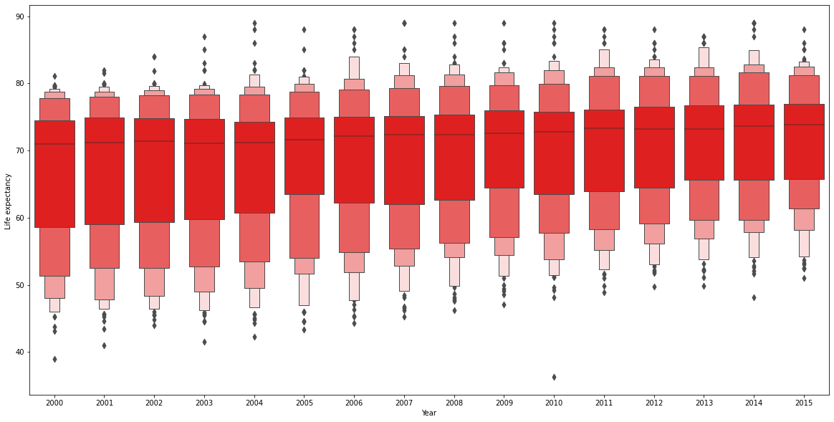

Distribution of Population Per year.

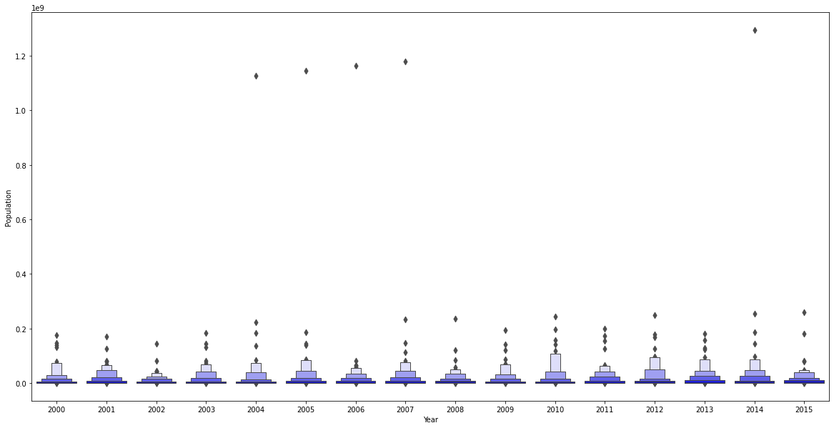

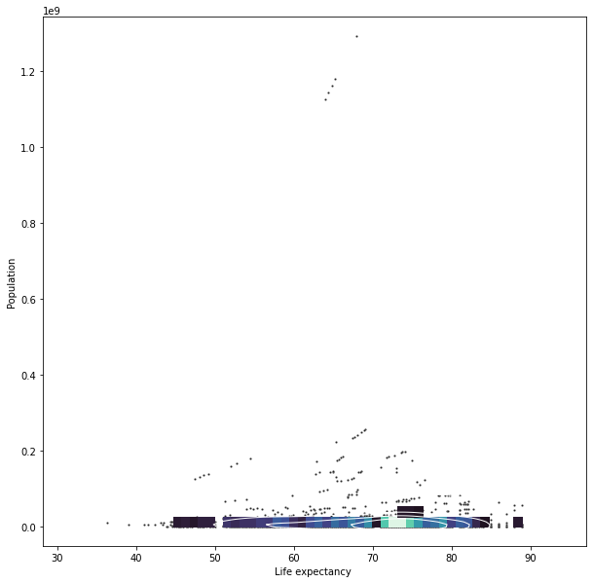

Form the above plots we can clearly see that the density of the plots are highli concentrated towards the bottom right which clearly means that More life expectancy is expected in countries with high population.

Question 8: What is the impact of Immunization coverage on life Expectancy?

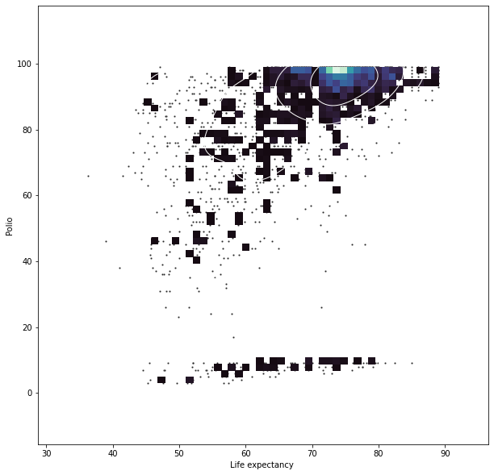
The density of life expectation is higher where there is high polio that means Immunization coverage has a good impact on Life expectancy.

The correlation value is : 0.46555580597719726

It is also showing a positive correlation.

So that answers all our question.

