CHANDIGARH UNIVERSITY
Department of Computer Science and Engineering (AI and ML)
Business Intelligence Lab
Lab File: Experiments 7 and 10
Submitted by | Pritom
UID | 24bai71020
Programme | B.E. Computer Science and Engineering (AI and ML)
Submitted to | [Instructor name]
Academic session | [Semester / Section / Group]
Date of submission | 4 November 2026

Index
Exp. No. | Title of experiment | Date | Faculty signature
7 | Integration of Advanced Analytics with BI Reports using Microsoft Power BI
10 | BI Deployment, Monitoring and Backup & Restore using Microsoft Power BI

Yellow highlighted items (dates, instructor name, screenshots) are to be completed by hand or pasted from Power BI before printing.

Experiment 7
Integration of Advanced Analytics with BI Reports using Microsoft Power BI
Unit 2 | Session 7

Aim
To integrate advanced analytics with Business Intelligence reports using Microsoft Power BI and generate business insights, strategic recommendations and executive presentations that support organizational decision-making.

Tools / Software Required
- Microsoft Power BI Desktop
- Global Superstore dataset (Global_Superstore_2018_3.xlsx: Orders, Returns, People sheets)
- Power Query Editor
- Microsoft PowerPoint

Theory
Advanced analytics in Business Intelligence turns reports into actionable insight by finding trends, strengths, weaknesses and opportunities. Power BI supports KPI analysis, trend analysis, comparative analysis, ranking, segmentation and interactive reporting. The aim is to convert findings into recommendations that managers can act on.

Business Scenario
Global Superstore management observed that sales are increasing but profitability is not growing as expected. As BI consultants, the task is to review performance and recommend corrective actions.

Procedure
- Opened the reports and dashboards created in Experiments 5 and 6 in Power BI Desktop on the Orders data (51,290 rows).
- Created measures: Total Sales, Total Profit, Profit Margin %, Average Discount %, Sales YoY %, Profit YoY %.
- Analyzed sales and margin by Market and Region (Part A, step 2).
- Analyzed profit by Category and Sub-Category (step 3) and by Customer Segment (step 4).
- Analyzed yearly and monthly trends (step 5) and added a discount-band analysis to find the root cause.
- Documented observations; identified strengths, weaknesses and opportunities (Part B).
- Prepared the Business Insight Report, a 7-slide executive presentation and a recommendation summary sheet (Parts C and D).
[Paste Power BI screenshot: Executive dashboard from Experiments 5 and 6 with KPI cards and slicers]

Observations and Output

Headline KPIs
KPI | Value | Remark
Total Sales | $12.64M | 2014 to 2017
Total Profit | $1.47M | After losses
Profit Margin | 11.61% | About 12 cents per dollar of sales
Average Discount | 14.29% | All order lines
Loss-making lines | 24.5% | Loss of $920.6K

Sales and profit by market
Market | Sales | Profit | Margin | Avg discount
Asia Pacific | $4.04M | $403.2K | 9.97% | 18%
Europe | $3.29M | $449.6K | 13.68% | 9%
USCA | $2.36M | $304.2K | 12.87% | 15%
LATAM | $2.16M | $221.6K | 10.24% | 14%
Africa | $0.78M | $88.9K | 11.34% | 16%
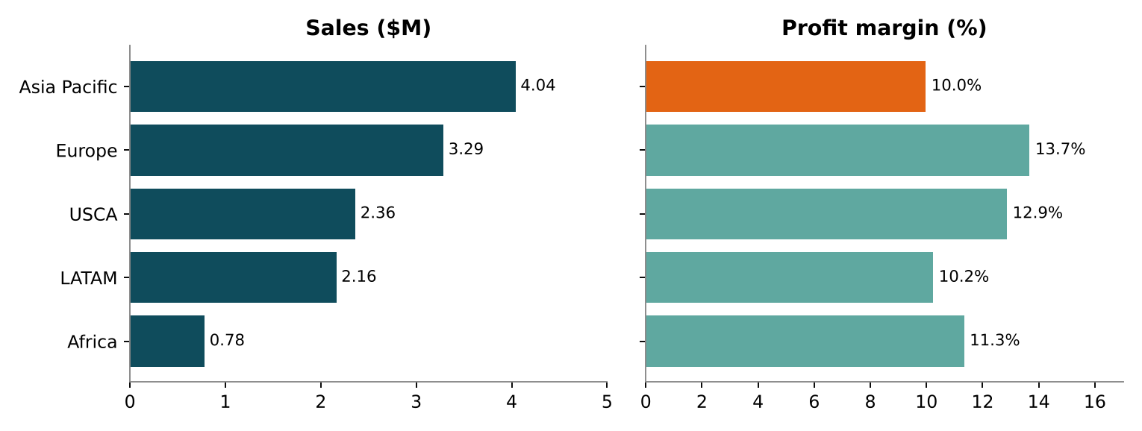
Figure 7.1: Sales and profit margin by market
Three regions lose money: Western Asia (-$53.9K), Western Africa (-$50.4K) and Central Asia (-$7.3K), with average discounts of 35 to 43%. Turkey (-$98.4K), Nigeria (-$80.8K) and the Netherlands (-$41.1K) are the largest country-level losses.

Profitability by category
Category | Sales | Profit | Margin | Avg discount
Technology | $4.74M | $663.8K | 13.99% | 14%
Office Supplies | $3.79M | $518.6K | 13.69% | 14%
Furniture | $4.11M | $285.1K | 6.94% | 17%
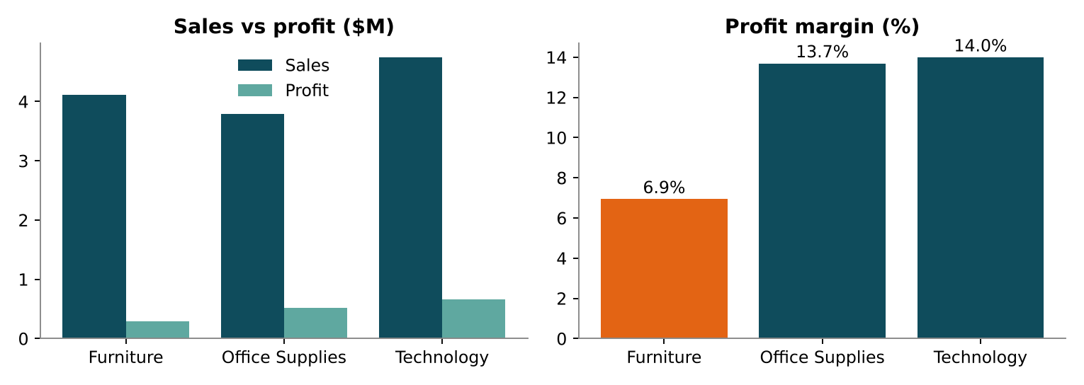
Figure 7.2: Sales, profit and margin by category
Tables is the only loss-making sub-category (-$64.1K, margin -8.46%, average discount 29%). Furniture is 32.5% of sales but 19.4% of profit. Segment margins are almost equal (Consumer 11.5%, Corporate 11.5%, Home Office 12.0%), so segment is not the cause.

Yearly and monthly trend
Year | Sales | Profit | Margin | Sales growth
2014 | $2.26M | $248.9K | 11.02% | n/a
2015 | $2.68M | $307.4K | 11.48% | +18.5%
2016 | $3.41M | $406.9K | 11.95% | +27.2%
2017 | $4.30M | $504.2K | 11.73% | +26.3%
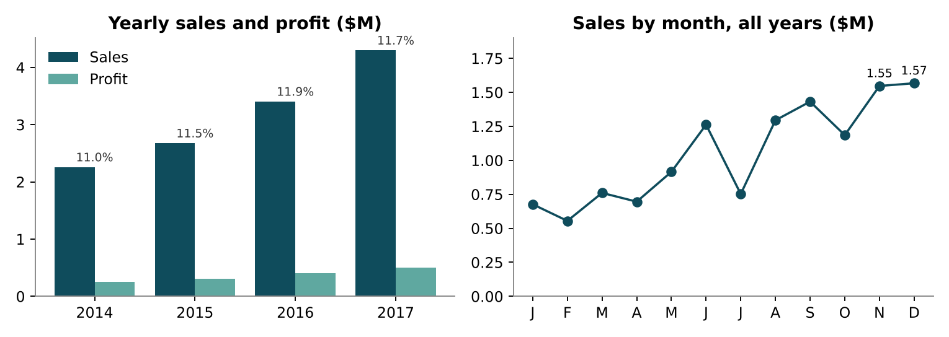
Figure 7.3: Yearly sales, profit and margin; monthly sales (peak November and December)

Root cause: discount analysis
Discount band | Sales | Profit | Margin | Order lines
0% | $6.99M | $1,770.7K | 25.3% | 15,574
0-10% | $1.96M | $338.2K | 17.2% | 3,095
10-20% | $1.76M | $173.3K | 9.9% | 4,376
20-30% | $0.38M | -$21.2K | -5.5% | 843
30-50% | $1.18M | -$380.9K | -32.4% | 3,693
50%+ | $0.37M | -$412.6K | -111.0% | 2,439
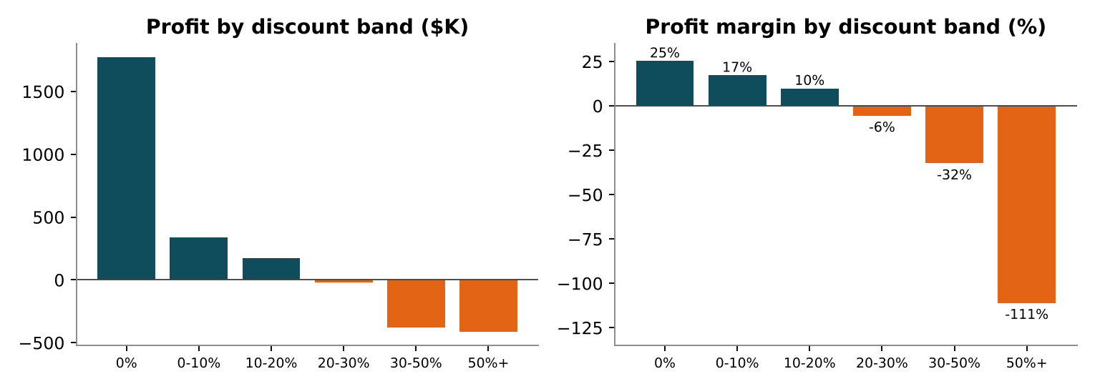
Figure 7.4: Profit and margin by discount band

Strengths, weaknesses and opportunities
Type | Finding
Strengths | Sales grew every year (+90%) and profit more than doubled (+103%); Technology and Office Supplies earn 13 to 14% margins; undiscounted orders earn 25.3% margin; Europe earns 13.68% at only 9% discount
Weaknesses | Order lines discounted above 20% lose $814.7K; Furniture margin only 6.94% (Tables negative); three loss-making regions lose $111.6K; margin flat at 11 to 12%, and in 2017 profit growth (23.9%) trailed sales growth (26.3%)
Opportunities | Cap discounts (break-even on lines above 20% would lift profit to about $2.28M, an upper bound); reprice Furniture; apply Europe-style discipline in Asia Pacific; plan for the November to December peak

Recommendations (justified by the data)
- Cap standard discounts at 20% and require approval above it (lines above 20% lose $814.7K).
- Reprice or restructure Tables and Furniture (Tables -$64.1K; Furniture margin 6.94%).
- Turn around Western Asia, Western Africa and Central Asia (combined loss $111.6K).
- Shift Asia Pacific from volume to margin (32% of sales, 9.97% margin; each +1 point is worth about $40K).
- Prioritise Copiers, Accessories, Paper and Labels (margins 17 to 24%) and plan stock for September to December.
- Add Discount %, Margin % and Loss Lines % KPIs to the dashboard for monitoring.
Deliverables prepared: Business Insight Report (Word), Executive Presentation (7 slides), Recommendation Summary Sheet and the supporting Power BI dashboard (.pbix).

Result
Advanced analytics techniques were successfully integrated with Business Intelligence reports and dashboards. The analysis showed that growth is healthy but margin has stalled, mainly because of discounts above 20%, the Furniture category and a few loss-making regions. Business strengths, weaknesses, opportunities and recommendations were identified and communicated through a professional report and executive presentation.

Learning Outcomes
- Applied advanced analytical techniques to business reports and dashboards (CO3-BT3).
- Analyzed organizational performance using BI tools and KPIs (CO3-BT4).
- Generated business insights and developed data-driven strategic recommendations (CO5-BT6).
- Communicated findings through a professional report and presentation (CO5-BT6).

Experiment 10
BI Deployment, Monitoring and Backup & Restore using Microsoft Power BI
Unit 3 | Session 10

Aim
To understand and design Business Intelligence deployment, monitoring, backup and recovery strategies using Microsoft Power BI, ensuring availability, reliability and continuity of BI solutions.

Tools / Software Required
- Microsoft Power BI Desktop and Power BI Service
- Global Superstore dataset (Global_Superstore_2018_3.xlsx)
- Microsoft Excel; Microsoft PowerPoint (optional)

Theory
BI deployment makes reports, dashboards and analytical solutions available to end users. Monitoring tracks performance, usage, refresh status and operational health. Backup and restore protect BI assets from accidental deletion, corruption or failure. Together they improve reliability, security and business continuity.

Business Scenario
Global Superstore has built reports, dashboards, analytics, security policies and automated reporting. Management wants to deploy the solution organization-wide, monitor it and establish backup and recovery procedures. The task is to act as BI Solution Architect and design the complete strategy.

Procedure
- Identified the BI assets from Experiments 5, 6, 7 and 9 and listed what must be deployed (Part A, steps 1 and 2).
- Defined users, objectives and the phased BI Deployment Plan (steps 3 to 5).
- Designed the Dev, Test and Prod workspace structure, roles, responsibilities and governance guidelines (Part B, steps 6 to 9).
- Defined monitoring requirements and built the Monitoring Matrix (Part C, steps 10 and 11).
- Identified components to back up, set the backup schedule and designed restore procedures (Part D, steps 12 to 14).
- Analyzed the disaster scenario of a deleted executive dashboard and documented recovery and continuity actions (Part E, steps 15 to 17).

Observations and Output

Deliverable 1: BI Deployment Plan
Asset | From | Target | Users
Global Superstore semantic model (51,290 rows) | Exp 5, 6 | GS-BI-Prod, certified | All consumers
Executive Dashboard | Exp 6 | Prod, Executives audience | CEO, management
Sales Performance Report | Exp 5 | Prod, Sales and Regional audiences | Sales, Regional Managers
Finance and Profit Report | Exp 7 | Prod, Finance audience | Finance Managers
Regional Report | Exp 5, 9 | Prod, Regional audience (RLS) | 23 Regional Managers
Security configuration (RLS, SecurityMap) | Exp 9 | Dataset security in Prod | Security Administrator

Phase | Activity | Detail | Exit criteria
1 | Prepare | Create workspaces and Entra ID groups; versioned source storage | Ready
2 | Build (Dev) | Publish PBIX; validate measures on masked data | Developer checklist
3 | UAT (Test) | Test RLS per role; Finance and Sales validate KPIs | UAT sign-off
4 | Release (Prod) | Approved promotion; refresh at 06:00 daily; certify model | Smoke test passes
5 | Publish app | Four audiences: Executives, Finance, Sales, Regional | Access confirmed
6 | Hypercare | Two weeks of daily monitoring and training | No severity 1 or 2 for 5 days
Objectives: one certified model, 100% intended-user access at go-live, refresh success rate of 99% or higher, RLS test plan passing 100%, no direct edits in Prod.

Deliverable 2: Workspace and Role Structure Diagram
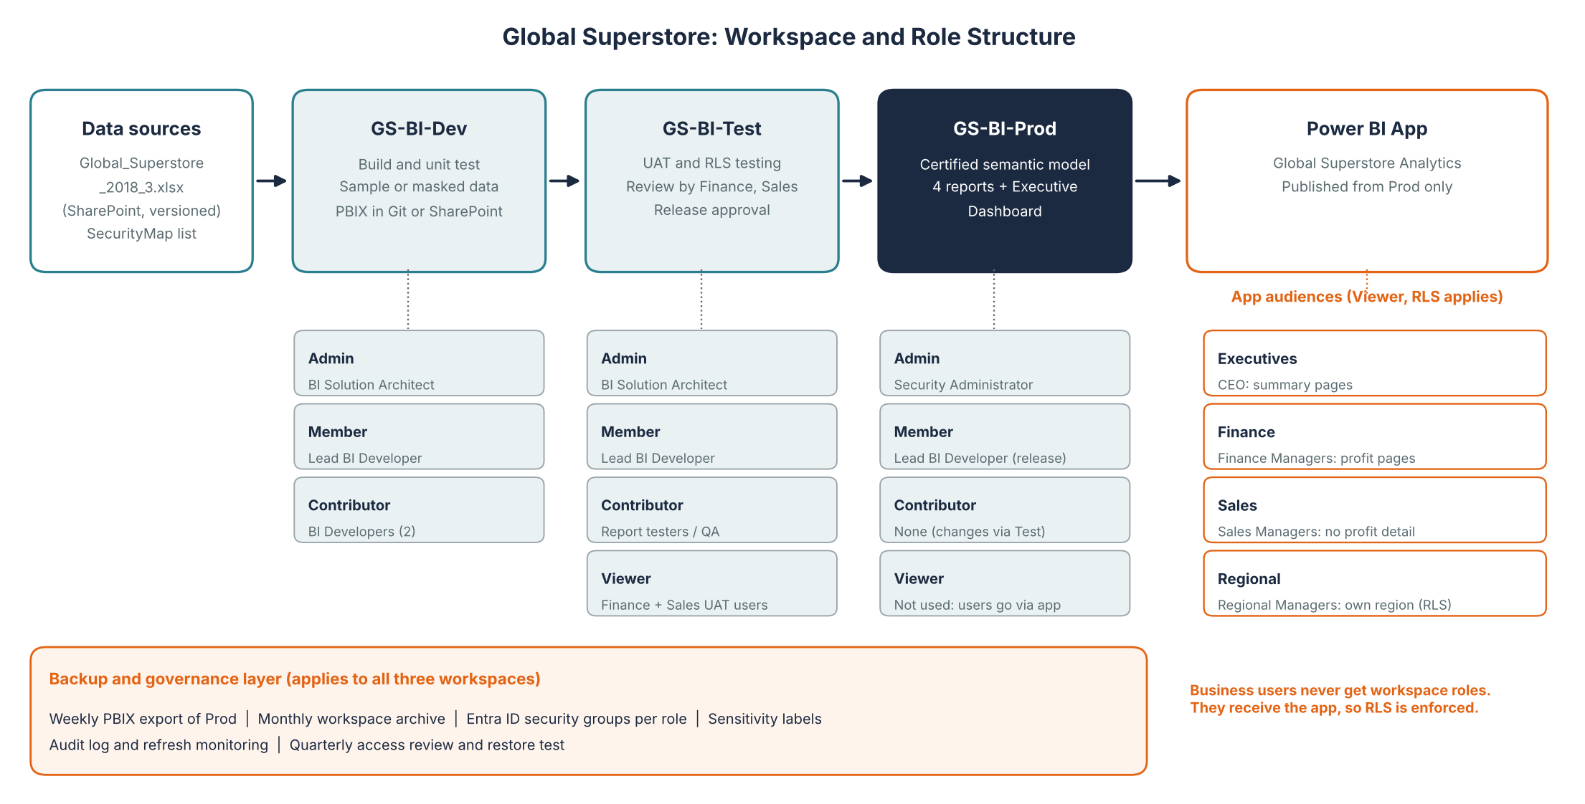
Figure 10.1: Workspace structure, roles and app audiences
Role | Held by | Responsibility
Administrator | Solution Architect (Dev, Test); Security Administrator (Prod) | Settings, membership, governance, restore
Member | Lead BI Developer | Own lifecycle, approve and promote releases, publish app
Contributor | BI Developers; QA testers | Create and edit reports and datasets; cannot publish app
Viewer | UAT users (Test); business users get the app in Prod | View content with RLS applied
Governance: naming standards; build only in Dev and change Prod only by promotion; one certified semantic model; roles through Entra ID groups; RLS reviewed each release; change tickets and approvals; named dataset owners; quarterly access review and retirement of unused reports.

Deliverable 3: Monitoring Matrix
Metric | Source in Power BI | Frequency | Target / alert | Responsible
Dataset refresh status | Refresh history, failure email | Daily | 100% success by 07:00 | Lead Developer
Refresh duration | Refresh history | Weekly | Alert above 2x average | BI Developer
Data reconciliation | KPI vs source ($12,642,502 sales) | Weekly | Zero variance | BI Developer / Finance
Dashboard usage | Usage metrics report | Weekly | 80% active users monthly | Solution Architect
Report performance | Performance Analyzer | Each release | Page load under 5 s | BI Developer
User activity | Audit log (views, exports, shares, deletions) | Daily alerts | Alert on mass export or deletion | Security Admin
Access and RLS integrity | Role lists, SecurityMap | Monthly | All managers mapped | Security Admin
Capacity / gateway health | Capacity Metrics app | Daily | CPU below 80% | Solution Architect
Backup success | Backup log | Daily, weekly | 100% present and readable | BI Developer

Deliverable 4: Backup and Recovery Plan
Frequency | Backup | Retention | Owner | Method
Daily | Source Excel and SecurityMap snapshot, refresh log | 14 days | BI Developer | Automated copy
Weekly | All Prod reports and model as PBIX | 8 weeks | BI Developer | REST API export
Per release | Version tag, dashboard tile screenshots | Last 10 | Lead Developer | Change log
Monthly | Workspace archive: items, roles, app settings, documentation | 12 months | Security Admin | Scripted export
Quarterly | Restore test in a test workspace | Report | Solution Architect | Practice restore

Recovery objectives (proposed): RPO 24 hours; RTO 2 hours for the Executive Dashboard and 8 hours for other reports.
Failure | Restore procedure | RTO
Report or dashboard deleted | Check Test copy, else latest PBIX; refresh and verify; publish to Prod; bind to certified model; re-add to app; re-pin dashboard tiles; republish app | 2 to 8 h
Semantic model corrupted | Republish last good PBIX; restore source; reset credentials and refresh; reconcile | 4 h
Source file lost | Restore daily copy; refresh; confirm 51,290 rows | 2 h
Workspace deleted | Admin restore within retention period, else rebuild from monthly archive and re-assign roles and audiences | 8 to 24 h
Note: Power BI has no simple undelete for an individual report, so PBIX backups and the Test workspace copy are the main safety net. Dashboard tiles are not stored in the PBIX and are re-pinned from documentation.

Deliverable 5: Disaster Recovery Report (summary)
Scenario: the Executive Dashboard is deleted by mistake one day before a management meeting. Impact: executives cannot present KPIs (sales $12.64M, profit $1.47M, margin 11.61%) or open their links; the dataset and reports are unaffected. Recovery: rebuild the dashboard from the documented tiles, restoring any missing report from the Test workspace or the latest PBIX, re-add it to the Executives audience and republish the app, then validate the KPIs against source and test RLS.
Time (illustrative) | Action | Owner
10:00 | Detect via audit alert; open incident; confirm scope | Security Admin
10:30 | Notify CEO office; start rebuild; prepare fallback | Solution Architect
11:30 | Restore any missing report from Test or PBIX backup | Lead Developer
12:00 | Re-add to app audience; republish; restore subscription | Lead Developer
12:30 | Validate KPIs against source and test RLS | BI Developer, Finance
13:00 | Sign-off and notify executives | Solution Architect
15:00 | Offline pack: PDF of dashboard and Experiment 7 executive deck | BI Developer
Continuity actions: use the PDF and presentation as fallback; one point of contact for communication; validate before release; re-check access; log the incident. Prevention: restrict Member rights, document dashboards, alert on deletions, rehearse restores quarterly.
The full document is in BI_Deployment_Monitoring_Backup_Exp10.docx.

Result
A complete BI deployment, monitoring, backup and recovery strategy was successfully designed. Deployment plans, monitoring procedures, workspace structures and backup mechanisms were developed to ensure reliable and secure BI operations.

Learning Outcomes
- Analyzed deployment requirements for BI solutions (CO4-BT4).
- Designed workspace structures and governance models (CO5-BT6).
- Evaluated monitoring requirements for deployed BI solutions (CO4-BT4).
- Developed backup and recovery strategies and a complete deployment and maintenance plan (CO5-BT6).
References: Sharda, Delen & Turban, Business Intelligence and Analytics; Rick Sherman, Business Intelligence Guidebook; Cindi Howson, Successful Business Intelligence; Microsoft Power BI Documentation (Security, Administration and Deployment).

