Study Abroad Discovery Platform
Complete Product, UI/UX, Technical Architecture, Backend Schema, ER Diagram and Implementation Specification
Working product name: AbroadHUB
Document version: 1.0 | Date: 24 August 2026
Purpose
This document consolidates the full project specification into one implementation reference. It covers product goals, user flows, frontend design, backend architecture, PostgreSQL schema, security, authentication, API contracts, ER relationships, responsive behavior, light/dark mode, and the implementation sequence.

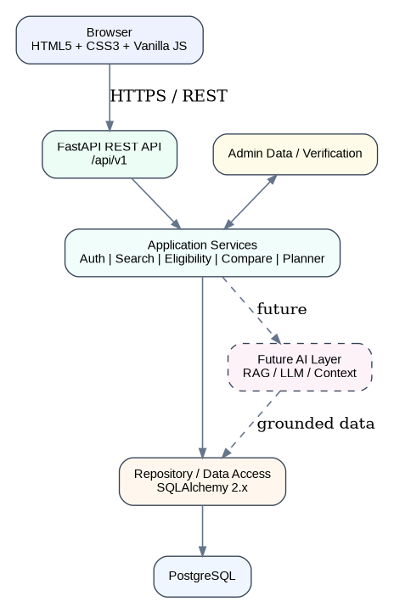
Figure 1. High-level system architecture

1. Executive Summary
The platform is a study-abroad discovery and decision-making workspace. It helps students move from an initial intention to study abroad toward a concrete shortlist and application plan. The product is not intended to be a generic directory or a chatbot-first application.
The primary experience is: Discover -> Explore -> Understand -> Check Fit -> Compare -> Shortlist -> Plan -> Apply.

Core product value
- Structured country, university and course information.
- Clear presentation of eligibility requirements, tuition, deadlines and documents.
- Source-backed academic information with verification metadata.
- Personalized profile and deterministic eligibility evaluation.
- Comparison and shortlist workflows.
- Lightweight application planner.
- Future context-aware AI assistant grounded in the platform data.

Technology
Layer | Technology
Frontend | HTML5, CSS3, Vanilla JavaScript, ES Modules
Backend | Python, FastAPI, Pydantic v2
ORM | SQLAlchemy 2.x
Database | PostgreSQL
Migrations | Alembic
Testing | Pytest, HTTPX
Linting | Ruff
Future AI | RAG/LLM service behind FastAPI

2. Product Principles
- Clarity over information density.
- Source before opinion.
- Progressive disclosure instead of giant forms.
- Personalization without unnecessary complexity.
- No admission or visa guarantees.
- The core product works without AI.
- The database is the source of truth; AI is a later interface over structured data.
- Glass is a material used selectively, not the entire design system.

3. Target Users and Primary User Journey

Primary user
An international student researching countries, universities and courses, often without a strong understanding of admission systems, costs or eligibility rules.

Primary journey
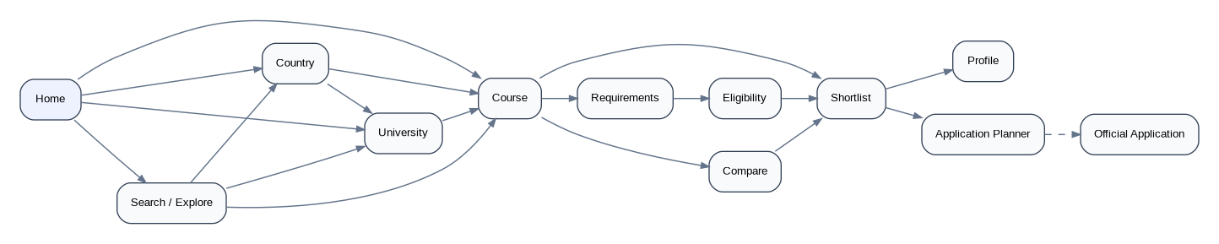
Figure 2. Primary application flow

Canonical decision path
Landing
-> Search / Country
-> University
-> Course
-> Requirements
-> Eligibility
-> Compare
-> Shortlist
-> Profile / Planner
-> Official application

4. Frontend Product Surface

Required pages
Area | Pages
Home | Landing page
Countries | Country listing, country details
Universities | University listing, university details
Courses | Course listing, course details
Decision support | Compare, Shortlist, Eligibility
User | Profile, Application Planner
Auth | Login, Signup, Forgot Password, Verification
System | 404, loading, empty, error, outdated states
Admin | Data management and verification interfaces, when implemented

Navigation
Desktop: Logo | Explore | Compare | Shortlist | Search | Theme | Profile
Mobile: Logo | Search | Theme/Menu

Landing page
The landing page is minimal and search-led. It contains a short hero, global search, popular destinations, fields of study, a concise explanation of the workflow, and a trust/source message. Avoid oversized marketing sections.

Course detail page
The course page is the most important page. It must immediately communicate course name, university, location, degree, duration, language, tuition, deadline, requirements, eligibility, source and next actions.
Course header
- Course name
- University
- Location
- Degree / Duration / Language
- Check Eligibility / Save / Compare
Course content
- Overview
- Eligibility
- Requirements
- Tuition and Costs
- Deadlines
- Documents
- Sources

5. UI/UX Design System

Visual direction
- Premium, minimal, calm, editorial and trustworthy.
- Strong typography and whitespace.
- Neutral palette with one restrained accent.
- Soft borders and restrained shadows.
- Selective glass surfaces inspired by premium consumer interfaces.
- No neon gradients, AI robots, giant glowing controls or template-heavy card grids.

Typography
Recommended system stack: -apple-system, BlinkMacSystemFont, SF Pro Display, SF Pro Text, Segoe UI, Roboto, Arial, sans-serif. Exact font licensing must be verified before bundling proprietary font files.
Token | Suggested size | Use
Display | 56px | Hero / large editorial heading
H1 | 48px | Primary page title
H2 | 36px | Major section
H3 | 24px | Subsection
Body large | 18px | Intro / supporting copy
Body | 16px | Standard content
Small | 14px | Supporting metadata
Metadata | 13px | Compact labels

Spacing
Use a 4px-based scale: 4, 8, 12, 16, 20, 24, 32, 40, 48, 64, 80, 96, 120.

Glass rules
- Use glass for navbar-on-scroll, search overlays, compare tray, sticky course actions, modals, filter sheets and AI panel.
- Do not make every card or section glass.
- Light mode glass: translucent white, subtle dark border, moderate blur.
- Dark mode glass: translucent dark surface, subtle light border, moderate blur.
- Provide fallback styling when backdrop-filter is unavailable.

Light and dark mode
Implement a shared HTML structure using CSS custom properties. Use data-theme="light" and data-theme="dark" on the document root. Default to saved user preference; if absent, use system preference. Persist explicit user choice. Do not invert colors mechanically.
Dark mode readability rule
Dark mode must be designed independently. Never use black text on dark surfaces, overly dim gray body text, or white browser-default form controls. Course requirements, deadlines and long-form content must remain comfortable to read for extended sessions.

6. Responsive Design Requirements
Every element must be responsive: navbar, search, cards, lists, filters, course sidebar, sticky actions, comparison, forms, modals, bottom sheets, AI panel, tables, images, icons and footer.

Responsive breakpoints
Range | Primary behavior
Mobile: ~320-767px | One column, bottom-sheet filters, compact navigation, stacked actions
Tablet: ~768-1023px | Reduced columns, compact filters, flexible sidebars
Desktop: ~1024-1279px | Two-column layouts where useful
Wide: 1280px+ | Full content width up to about 1200-1320px

Do not use horizontal overflow as a substitute for responsive design except where a comparison table explicitly benefits from horizontal scrolling. Long course and university names must wrap naturally.

Touch targets
Interactive targets should provide an approximately 44px touch area. This applies to buttons, icon controls, filters, theme toggle, save, compare and menus.

7. Application Flow Details

Discovery
- User opens Home.
- User searches or chooses a country.
- User opens a country, university or course.
- User reads details and requirements.
- User optionally creates a profile and checks eligibility.
- User compares and saves preferred options.
- User moves saved options into the application planner.

Authentication interruption flow
Course page
-> Save
-> User not authenticated
-> Login / Signup
-> Successful authentication
-> Return to original course
-> Complete Save

Eligibility flow
Course -> Check Eligibility
-> Existing profile?
Yes -> Evaluate
No -> Progressive profile setup -> Evaluate
-> Strong Match / Possible Match / Weak Match / Unknown

8. Backend Architecture

Figure 3. Backend and frontend architecture

Layering
Router
-> Pydantic schema validation
-> Service layer
-> Repository / SQLAlchemy
-> PostgreSQL
- Routers handle HTTP concerns and dependency injection.
- Services contain business rules.
- Repositories isolate database access.
- Pydantic schemas define request/response contracts.
- PostgreSQL remains the authoritative data store.
- The architecture is a modular monolith, not microservices.

9. Backend Project Structure
backend/
app/
main.py
config.py
database.py
dependencies.py
security.py
api/v1/
models/
schemas/
services/
repositories/
utils/
alembic/
tests/
alembic.ini
requirements.txt
.env.example

Core dependencies
FastAPI, Uvicorn, Pydantic v2, pydantic-settings, SQLAlchemy 2.x, Alembic, psycopg, Pytest, HTTPX and Ruff. Avoid unnecessary dependencies.

10. Database and ER Diagram
The database is relational and normalized. UUIDs are recommended for primary keys. Public entities also have human-readable slugs. Authoritative academic records use active status and source verification rather than destructive deletion.
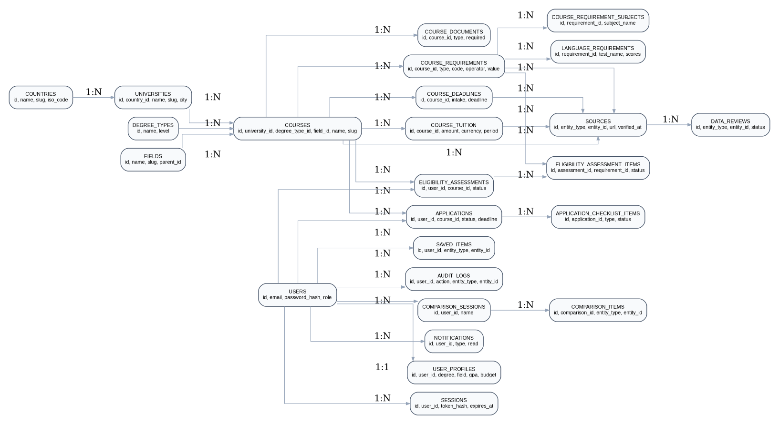
Figure 4. Core entity relationship diagram

Core relationship summary
- Country 1:N University.
- University 1:N Course.
- Degree Type 1:N Course.
- Field 1:N Course, with optional parent hierarchy.
- Course 1:N Requirements, Deadlines, Tuition records and Documents.
- Course requirements can have subject rows and language/test detail rows.
- Course, requirement, deadline and tuition facts can reference source records.
- User 1:1 Profile and 1:N Sessions, Saved Items, Eligibility Assessments, Applications, Notifications and Comparisons.
- Eligibility Assessment 1:N Assessment Items.
- Application 1:N Checklist Items.

11. PostgreSQL Schema - Reference and Academic Data

countries
Column | Type | Notes
id | UUID PK | Primary identifier
name | VARCHAR(120) | Country name
slug | VARCHAR(140) UNIQUE | Public URL key
iso_code | VARCHAR(3) UNIQUE | ISO code
flag_code | VARCHAR(10) | Optional display code
currency_code | VARCHAR(3) | Default currency
description | TEXT | Country overview
study_overview | TEXT | Study guidance
cost_overview | TEXT | Cost guidance
student_info | TEXT | Student information
visa_overview | TEXT | General visa context
is_active | BOOLEAN | Soft publication state
created_at / updated_at | TIMESTAMPTZ | Audit timestamps

country_languages
Column | Type | Notes
id | UUID PK
country_id | UUID FK | countries.id
language_code | VARCHAR
language_name | VARCHAR
is_primary | BOOLEAN
Unique | country_id + language_code | Avoid duplicates

country_costs
Column | Type | Notes
id | UUID PK
country_id | UUID FK | countries.id
cost_type | VARCHAR | tuition/living/accommodation/etc.
minimum_amount | NUMERIC | Estimate
maximum_amount | NUMERIC | Estimate
currency_code | VARCHAR
period | VARCHAR | monthly/yearly/etc.
source_id | UUID FK | Provenance
effective_from / until | DATE | Validity

universities
Column | Type | Notes
id | UUID PK
country_id | UUID FK | countries.id
name | VARCHAR | Institution name
slug | VARCHAR UNIQUE | Public URL
short_name | VARCHAR | Search alias
logo_url | TEXT
website_url | TEXT | Official site
city | VARCHAR
state_region | VARCHAR
postal_code | VARCHAR
description | TEXT
institution_type | VARCHAR | public/private/etc.
founded_year | INTEGER
latitude / longitude | NUMERIC | Optional
is_active | BOOLEAN
created_at / updated_at | TIMESTAMPTZ

degree_types and fields
Entity | Important columns
degree_types | id, name, slug, level, description
fields | id, name, slug, parent_id, description

Fields are hierarchical so Computer Science can have subfields such as AI, Data Science, Software Engineering and Cybersecurity.

12. PostgreSQL Schema - Courses and Requirements

courses
Column | Type | Notes
id | UUID PK
university_id | UUID FK | universities.id
name | VARCHAR | Course name
slug | VARCHAR UNIQUE | Public URL
degree_type_id | UUID FK
field_id | UUID FK
description | TEXT
duration_value | NUMERIC
duration_unit | VARCHAR | years/months
study_mode | VARCHAR | full-time/part-time/mixed
attendance_type | VARCHAR | on-campus/online/hybrid
language_notes | TEXT
credits | NUMERIC
application_url | TEXT | Official application
official_course_url | TEXT | Official course source
is_active | BOOLEAN
created_at / updated_at | TIMESTAMPTZ

course_requirements
Column | Type | Notes
id | UUID PK
course_id | UUID FK
requirement_type | VARCHAR | academic/language/test/subject/etc.
requirement_code | VARCHAR | minimum_cgpa, ielts, gre, degree, etc.
requirement_name | VARCHAR | Human label
operator | VARCHAR | eq/gt/gte/lt/lte/contains/one_of/required/not_required
value_numeric | NUMERIC | Numeric comparison
value_text | TEXT | Text/list comparison
unit | VARCHAR | 10, score, years, etc.
is_required | BOOLEAN
is_strict | BOOLEAN
notes | TEXT
source_id | UUID FK

course_requirement_subjects
Column | Type | Notes
id | UUID PK
requirement_id | UUID FK
subject_name | VARCHAR | Prerequisite subject
minimum_credits | NUMERIC | Optional
minimum_grade | VARCHAR | Optional
is_required | BOOLEAN
notes | TEXT

language_requirements
Column | Type | Notes
id | UUID PK
course_requirement_id | UUID FK
test_name | VARCHAR | IELTS/TOEFL/PTE
overall_min_score | NUMERIC
reading_min_score | NUMERIC
writing_min_score | NUMERIC
listening_min_score | NUMERIC
speaking_min_score | NUMERIC
validity_months | INTEGER | Optional
source_id | UUID FK

course_deadlines
Column | Type | Notes
id | UUID PK
course_id | UUID FK
intake_name | VARCHAR
intake_year | INTEGER
deadline_type | VARCHAR | application/scholarship/etc.
deadline_date | DATE
timezone | VARCHAR
is_final | BOOLEAN
is_open | BOOLEAN
source_id | UUID FK

course_tuition
Column | Type | Notes
id | UUID PK
course_id | UUID FK
amount | NUMERIC
currency_code | VARCHAR
period | VARCHAR | semester/year/etc.
tuition_type | VARCHAR
student_category | VARCHAR | domestic/EU/international/all
notes | TEXT
source_id | UUID FK
effective_from / until | DATE
is_current | BOOLEAN

course_documents
Column | Type | Notes
id | UUID PK
course_id | UUID FK
document_type | VARCHAR | passport/transcript/CV/etc.
document_name | VARCHAR
description | TEXT
is_required | BOOLEAN
submission_format | VARCHAR
source_id | UUID FK

13. PostgreSQL Schema - Provenance, Data Quality and Trust

sources
Column | Type | Notes
id | UUID PK
source_type | VARCHAR | official university/government/testing body/trusted external
source_name | VARCHAR
source_url | TEXT
entity_type | VARCHAR | course/requirement/deadline/etc.
entity_id | UUID | Referenced record id
published_at | TIMESTAMPTZ | Optional
last_verified_at | TIMESTAMPTZ | Verification timestamp
verification_status | VARCHAR | verified/needs_review/outdated/unavailable
verified_by | UUID | Admin/editor user
verification_notes | TEXT

data_reviews
Column | Type | Notes
id | UUID PK
entity_type / entity_id | VARCHAR/UUID | What is being reviewed
review_type | VARCHAR
reason | TEXT
assigned_to | UUID | Reviewer
status | VARCHAR | pending/in_review/verified/rejected
reviewed_at | TIMESTAMPTZ
notes | TEXT

audit_logs
Column | Type | Notes
id | UUID PK
user_id | UUID FK | Actor
action | VARCHAR | create/update/delete/verify/publish/etc.
entity_type | VARCHAR
entity_id | UUID
old_values | JSONB | Prior state
new_values | JSONB | New state
ip_address | INET/VARCHAR
user_agent | TEXT
created_at | TIMESTAMPTZ

Trust model
Every important factual value should be traceable to a source, with a verification status and timestamp. The UI must distinguish verified facts, estimates, unavailable information and AI interpretation.

14. PostgreSQL Schema - User, Authentication and Sessions

users
Column | Type | Notes
id | UUID PK | User identifier
email | VARCHAR UNIQUE | Normalized lowercase email
password_hash | TEXT | Argon2id/bcrypt hash only
auth_provider | VARCHAR | local/google/etc.
provider_user_id | VARCHAR nullable | OAuth identity
role | VARCHAR | user/editor/admin
is_verified | BOOLEAN | Email verification state
is_active | BOOLEAN | Account state
created_at / updated_at | TIMESTAMPTZ
last_login_at | TIMESTAMPTZ

sessions
Column | Type | Notes
id | UUID PK
user_id | UUID FK | users.id
session_token_hash | TEXT | Never store raw token
expires_at | TIMESTAMPTZ
created_at | TIMESTAMPTZ
last_seen_at | TIMESTAMPTZ
revoked_at | TIMESTAMPTZ nullable
ip_address | INET/VARCHAR
user_agent | TEXT

user_profiles
Column | Type | Notes
id | UUID PK
user_id | UUID UNIQUE FK | One profile per user
first_name | VARCHAR
last_name | VARCHAR
country_of_residence | VARCHAR
current_degree | VARCHAR
field | VARCHAR
current_university | VARCHAR
graduation_year | INTEGER
gpa | NUMERIC
gpa_scale | NUMERIC
work_experience_years | NUMERIC
research_experience_years | NUMERIC
target_degree | VARCHAR
preferred_intake | VARCHAR
budget_amount | NUMERIC
budget_currency | VARCHAR
created_at / updated_at | TIMESTAMPTZ

Authentication flow
Signup
-> validate request
-> normalize email
-> hash password
-> insert user
-> insert profile
-> create session
-> set HTTP-only cookie
Login
-> normalize email
-> find user
-> verify password hash
-> create session
-> set HTTP-only cookie
-> update last_login_at
Logout
-> identify session
-> revoke session
-> clear cookie

15. PostgreSQL Schema - Personal Decision Support

saved_items
Column | Type | Notes
id | UUID PK
user_id | UUID FK
entity_type | VARCHAR | country/university/course/scholarship
entity_id | UUID | Referenced entity
created_at | TIMESTAMPTZ
Unique | user_id + entity_type + entity_id | Prevent duplicates

comparison_sessions and comparison_items
Table | Important columns
comparison_sessions | id, user_id, name, created_at, updated_at
comparison_items | id, comparison_id, entity_type, entity_id, position, created_at

eligibility_assessments
Column | Type | Notes
id | UUID PK
user_id | UUID FK
course_id | UUID FK
overall_status | VARCHAR | strong_match/possible_match/weak_match/unknown
matched_count | INTEGER
unmatched_count | INTEGER
unknown_count | INTEGER
profile_snapshot | JSONB | Inputs used to reproduce result
assessment_version | VARCHAR | Rule version
created_at | TIMESTAMPTZ

eligibility_assessment_items
Column | Type | Notes
id | UUID PK
assessment_id | UUID FK
requirement_id | UUID FK
status | VARCHAR | matched/unmatched/unknown/not_applicable
user_value | TEXT/JSONB
required_value | TEXT/JSONB
explanation | TEXT | Human-readable reason
created_at | TIMESTAMPTZ

applications
Column | Type | Notes
id | UUID PK
user_id | UUID FK
course_id | UUID FK
intake_id | UUID nullable
status | VARCHAR | researching/shortlisted/preparing/ready/applied/etc.
application_deadline | DATE
notes | TEXT
submitted_at | TIMESTAMPTZ
decision_date | TIMESTAMPTZ
created_at / updated_at | TIMESTAMPTZ

application_checklist_items
Column | Type | Notes
id | UUID PK
application_id | UUID FK
document_type | VARCHAR
label | VARCHAR
description | TEXT
is_required | BOOLEAN
status | VARCHAR | pending/in_progress/completed/not_required
completed_at | TIMESTAMPTZ
notes | TEXT

notifications
Column | Type | Notes
id | UUID PK
user_id | UUID FK
notification_type | VARCHAR | deadline/data_update/application/system
title | VARCHAR
message | TEXT
reference_type | VARCHAR
reference_id | UUID
is_read | BOOLEAN
read_at | TIMESTAMPTZ
created_at | TIMESTAMPTZ

16. API Design

API base
/api/v1

Authentication
Method | Endpoint | Purpose
POST | /api/v1/auth/register | Create user + profile + session
POST | /api/v1/auth/login | Authenticate and create session
POST | /api/v1/auth/logout | Revoke session
GET | /api/v1/auth/me | Return current authenticated user
POST | /api/v1/auth/forgot-password | Future password reset start
POST | /api/v1/auth/reset-password | Future reset completion
POST | /api/v1/auth/verify-email | Future email verification

Profile
Method | Endpoint | Purpose
GET | /api/v1/profile | Read current profile
PUT | /api/v1/profile | Update current profile

Future academic APIs
Domain | Example endpoints
Countries | GET /api/v1/countries, GET /api/v1/countries/{slug}
Universities | GET /api/v1/universities, GET /api/v1/universities/{slug}
Courses | GET /api/v1/courses, GET /api/v1/courses/{slug}
Search | GET /api/v1/search?q=...
Requirements | GET /api/v1/courses/{id}/requirements
Deadlines | GET /api/v1/courses/{id}/deadlines
Sources | GET /api/v1/courses/{id}/sources

API response convention
{
"data": {...},
"meta": {...}
}
{
"error": {
"code": "ERROR_CODE",
"message": "Human readable message"
}
}

17. Security Architecture
- Passwords are hashed using Argon2id or another modern memory-hard algorithm. Plain-text passwords never reach storage or logs.
- Authentication uses a secure HTTP-only session cookie. Raw session tokens are never stored in the database.
- Production cookies use Secure and an appropriate SameSite policy.
- CORS is explicit; wildcard origins are not used with credentials.
- Authorization is checked on the server. The frontend cannot decide user identity or privileges.
- Sensitive fields and authentication secrets are excluded from logs.
- Login and password reset endpoints receive rate limiting.
- Input validation and database constraints protect against malformed data and duplicate accounts.
- State-changing cookie-authenticated requests should use appropriate CSRF protection when required by the deployment model.

Critical rule
Never trust the browser for identity
A frontend request must not be allowed to select another user by sending a user_id. FastAPI derives the authenticated identity from the session cookie and applies server-side authorization.

18. Performance and Reliability
- Avoid infinite loops, recursive renders, request storms and duplicate initialization.
- Use page-specific initialization rather than running all page modules on every page.
- Debounce search input and abort obsolete requests where useful.
- Do not use heavy backdrop blur over large areas.
- Prefer CSS sticky behavior over continuous scroll JavaScript when possible.
- Use pagination and server-side filtering instead of downloading thousands of records.
- Use loading, empty and error states for every data-driven screen.
- Do not hide errors; diagnose the root cause.
- Keep the main thread responsive. Browser freeze is a release-blocking defect.

Performance debugging order
1. Infinite loops
2. Duplicate initialization
3. Repeated API calls
4. Excessive DOM rendering
5. Expensive synchronous JS
6. Large images
7. Expensive CSS effects
8. Decorative animation

19. Authentication and Frontend Integration

Cookie-based browser flow
Frontend signup
-> POST /auth/register
-> FastAPI
-> PostgreSQL
-> Set-Cookie: study_abroad_session
Frontend refresh
-> GET /auth/me with credentials: include
-> FastAPI validates session
-> User restored

Frontend auth state
- Keep current user and authentication state in a small ES module.
- Do not store raw session tokens in localStorage or sessionStorage.
- Use credentials: include in API requests that rely on cookies.
- Restore user state from /auth/me after refresh.
- Clear local auth state after successful logout or session expiration.
- Prevent double-submit of login, signup and profile forms.

20. Error, Empty and Loading States
State | Behavior
Loading | Skeleton or lightweight loading indicator
Empty | Explain why there are no records and offer next action
Error | Explain failure and provide retry when appropriate
Unavailable | State that information is currently unavailable
Outdated | Warn that information may have changed and point to official source
Success | Provide concise confirmation after server-side success

21. Admin and Data Verification

Admin capabilities
- Create/edit countries, universities and courses.
- Edit requirements, tuition and deadlines.
- Attach official sources.
- Mark content verified, needs review, outdated or unavailable.
- Review data quality issues.
- Publish/unpublish records.
- Inspect audit logs.

Publishing flow
Draft -> Review -> Verified -> Published
Published -> Needs Review -> Re-verified -> Published
Published -> Outdated when source validity expires

22. Implementation Plan

Phase 0 - Repository foundation
- Monorepo structure and documentation.
- Backend environment and requirements.
- Frontend HTML/CSS/JS shell.
- GitHub Actions CI.
- README and .gitignore.

Phase 1 - Backend foundation
- FastAPI application.
- Configuration.
- PostgreSQL connection.
- SQLAlchemy base and session dependency.
- Alembic initialization.
- Health endpoint.
- Request ID, CORS and error handling.

Phase 2 - Database
- Create reference tables.
- Create country/university/course schema.
- Create requirements/deadlines/tuition/documents.
- Create sources and data review tables.
- Create user/auth/profile tables.
- Create saved/compare/eligibility/application tables.
- Seed a small verified dataset.

Phase 3 onward
- Public APIs and search.
- Frontend design system and connected discovery experience.
- Authentication integration.
- Eligibility engine.
- Compare and shortlist.
- Application planner and notifications.
- Admin verification.
- Production hardening.
- AI layer last.

23. AI Integration Plan - Future
AI is a later layer, not the source of truth. The platform should first create reliable structured data and deterministic decision logic.
Course page
-> contextual AI request
-> FastAPI
-> retrieve course + requirement + source + user profile
-> AI service
-> answer + sources
-> frontend assistant panel
- AI should distinguish official requirements, estimates and interpretation.
- AI should not override deterministic eligibility rules.
- AI answers should expose relevant sources.
- AI usage should be rate-limited and tracked.
- The core product must remain useful if the AI service is unavailable.

24. Recommended Frontend Structure
frontend/
index.html
pages/
css/
tokens.css
reset.css
typography.css
layout.css
components.css
forms.css
responsive.css
js/
main.js
api/
components/
pages/
state/
utils/
assets/

Reusable components
- Navbar
- Search
- Country item
- University item
- Course item
- Requirement row
- Source info
- Eligibility summary
- Compare tray
- Modal
- Bottom sheet
- Toast
- Skeleton
- Breadcrumb

25. Development and QA Checklist

Functional
- All major links work.
- Detail pages receive stable identifiers.
- Search and filters work.
- Save and compare interactions work.
- Profile persistence works.
- Signup and login persist user data in PostgreSQL.
- Refresh restores authenticated state.
- Logout revokes the session.

Responsive
- Mobile, tablet and desktop layouts are intentional.
- No accidental horizontal overflow.
- Filter sidebars convert to bottom sheets on mobile.
- Comparison remains readable on small screens.
- Sticky actions do not cover content.

Theme
- Light mode readable and coherent.
- Dark mode readable and coherent.
- Theme preference persists.
- No flash of incorrect theme.
- Inputs, tables, icons, glass, modals and status colors adapt.

Reliability
- No uncaught JavaScript errors.
- No infinite request loops.
- No duplicate initialization.
- No page freeze.
- API failures produce bounded, retryable errors.
- Database migrations are reproducible.

26. Definition of Done
The foundation is considered complete when the frontend, FastAPI backend and PostgreSQL database work as one system, authentication is real and persistent, and the core user journey can be executed without broken navigation or browser freezes.
Browser
<-> Vanilla JS frontend
<-> FastAPI REST API
<-> SQLAlchemy
<-> PostgreSQL
Authentication
signup -> users + profile + session
login -> verify hash + session
me -> restore user
logout -> revoke session

27. Final Architecture Principles
- Build the decision engine before the intelligence layer.
- Use PostgreSQL as the authoritative source of user and academic data.
- Use source and verification metadata for trust.
- Keep the frontend framework-free and modular.
- Keep authentication secure and cookie-based.
- Keep business rules on the backend.
- Use deterministic eligibility for hard requirement checks.
- Use AI later as a grounded explanation and discovery layer.
- Prefer a modular monolith over premature microservices.
- Fix functional reliability before visual polish.
One-sentence product architecture
Reliable study-abroad data + clear UX + deterministic decision support + secure user persistence, with AI added later as a contextual interface over the trusted data layer.

