**Twitter API**

Generating Keys and Tokens

horizontal line

# 

# Steps:

1. For generating keys and tokens , it is must and required to have your account on Twitter.
2. Navigate to link [apps.twitter.com](https://apps.twitter.com)
3. A new web-page will appear. Here click on “Create New App”.

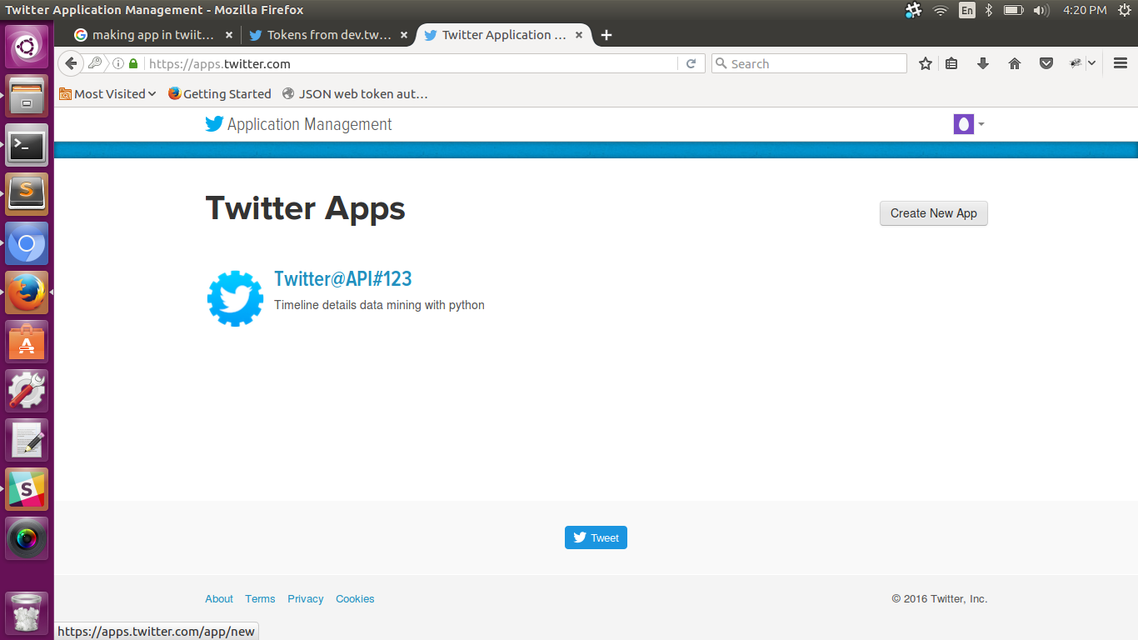

4. A new web-page will appear. Create your Application there by filling all necessary fields.

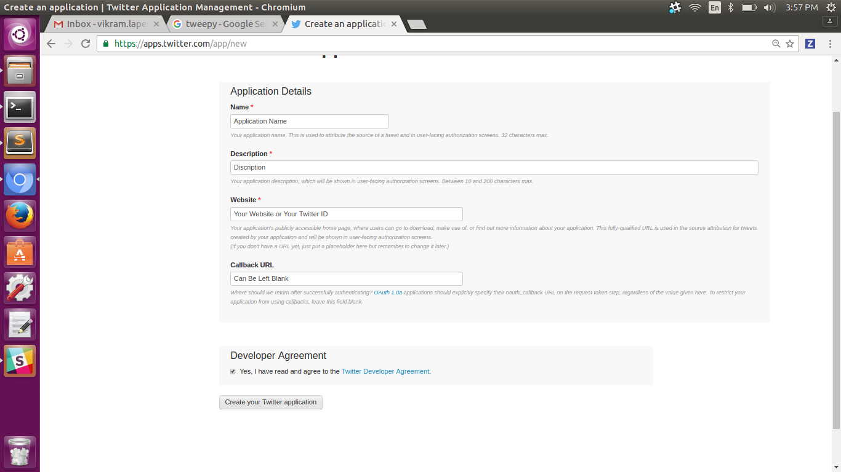

5. After creating Application, your tokens and keys would be generated on new web-page. Make sure the permissions are “Read and Write”

