**Facebook API**

Generating Tokens Through Graph Api

horizontal line

# Introduction

Here let us see how to get no. of likes and other page data of a facebook page using Graph API. No official python sdk for Graph API is available. We can use Graph API REST method to interact with API.

Since facebook graph api update, graph api requests need to be authenticated. Get Access token from <https://developers.facebook.com/tools/explorer>. This token is not a permanent access token, it will expire. For permanent access we need to create an facebook application and do oauth to get access token.

STEPS:

1. Go to this link:<https://developers.facebook.com/tools/explorer>
2. Click on “Get Token” drop down ,and select appropriate choice from the dropdown by clicking on it.

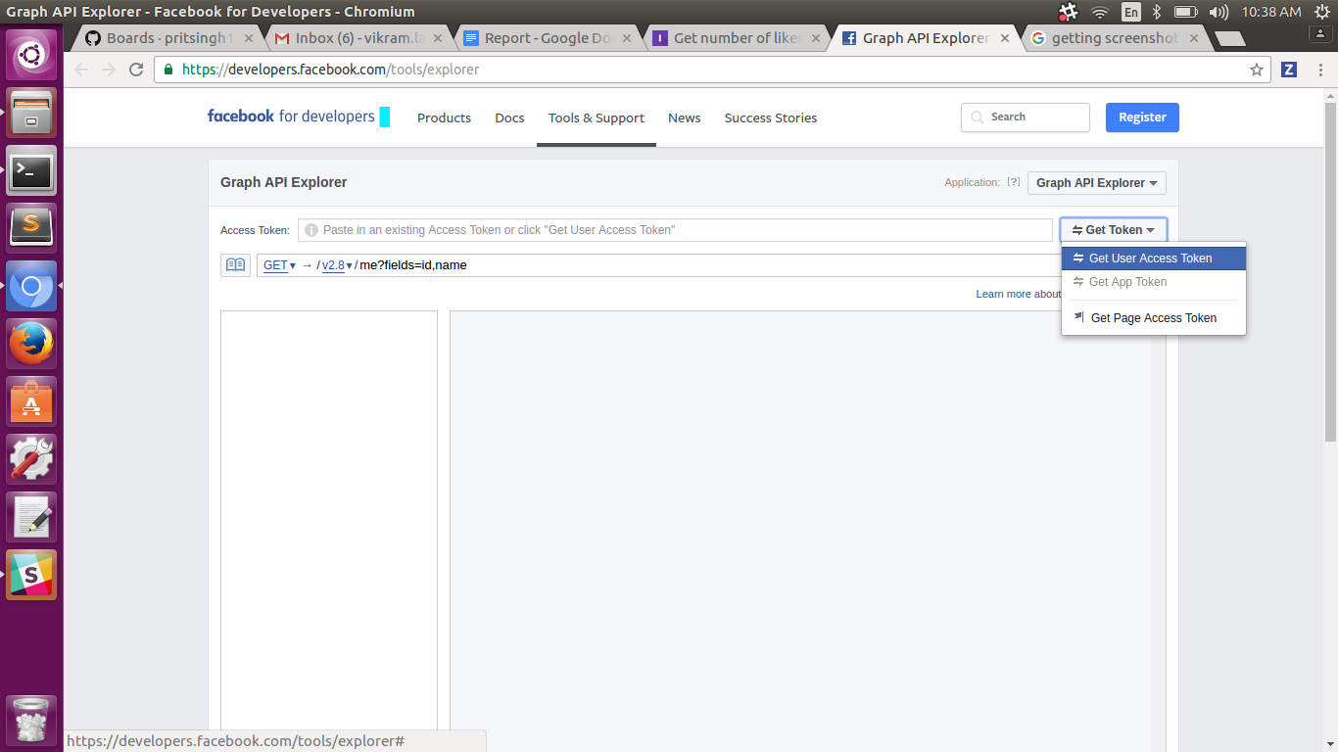

3. After clicking on choice , a box will appear.

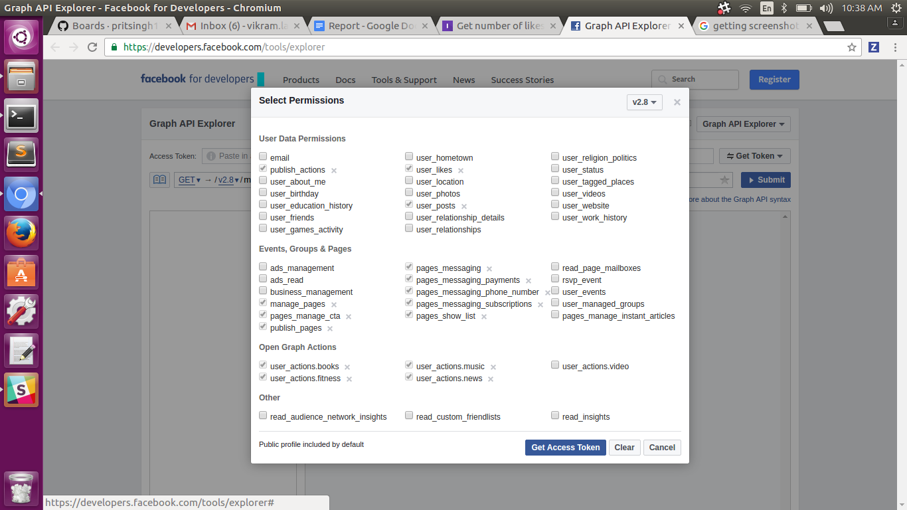

4. Select various permissions according to your choice , and then click on

“Get Access Token”.

5. Token would be generated.