# Business Problem

High cancellation rates have been observed recently at City Hotel and Resort Hotel. As a result, each hotel is currently coping with a variety of problems, such as decreased revenues and less than optimum hotel room usage. In order to boost their effectiveness in producing income, hotels must therefore cut cancellation rates, and we must provide extensive business counsel to solve this issue.

The major subjects of this research are an investigation of hotel booking cancellations as well as other reasons that don't affect their business or yearly income creation.



# Assumptions

1. No exceptional events will significantly affect the data used between 2015 and 2017.

2. The data is still up to date and can be effectively used to examine potential hotel developments.

3. The hotel's use of any suggested strategy has not resulted in any unexpected drawbacks.

4. None of the alternatives that were recommended are now being used by the hotels.

5. Booking cancellations are the main element affecting the effectiveness of money generation.

6. Cancellations leave unoccupied rooms for the duration of the reservation.

7. Customers cancel bookings at hotels the same year they make them.

# Research Question

1. What factors influence hotel reservation cancellations?

2. How can we improve the cancellation of hotel reservations?

3. How will hotels be supported in choosing their prices and marketing strategies?

# Hypothesis

1. When prices are higher, there are more cancellations.

2. Customers typically cancel when there is a larger waiting list.

3. Most customers who make arrangements do so through traditional travel agencies.

# Analysis and Findings

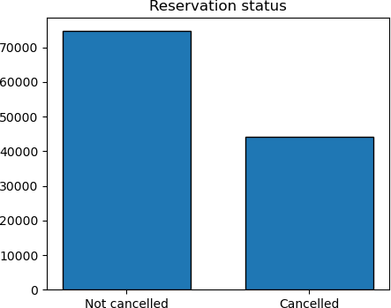

The percentage of reservations that are cancelled against those that are not is displayed in the accompanying bar graph. It is clear that a sizable number of bookings remain that have not been cancelled. 37% of customers still cancel their reservations, which has a big impact on the revenue for the hotels.

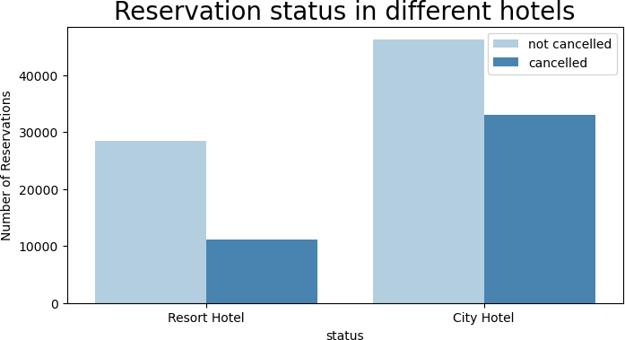

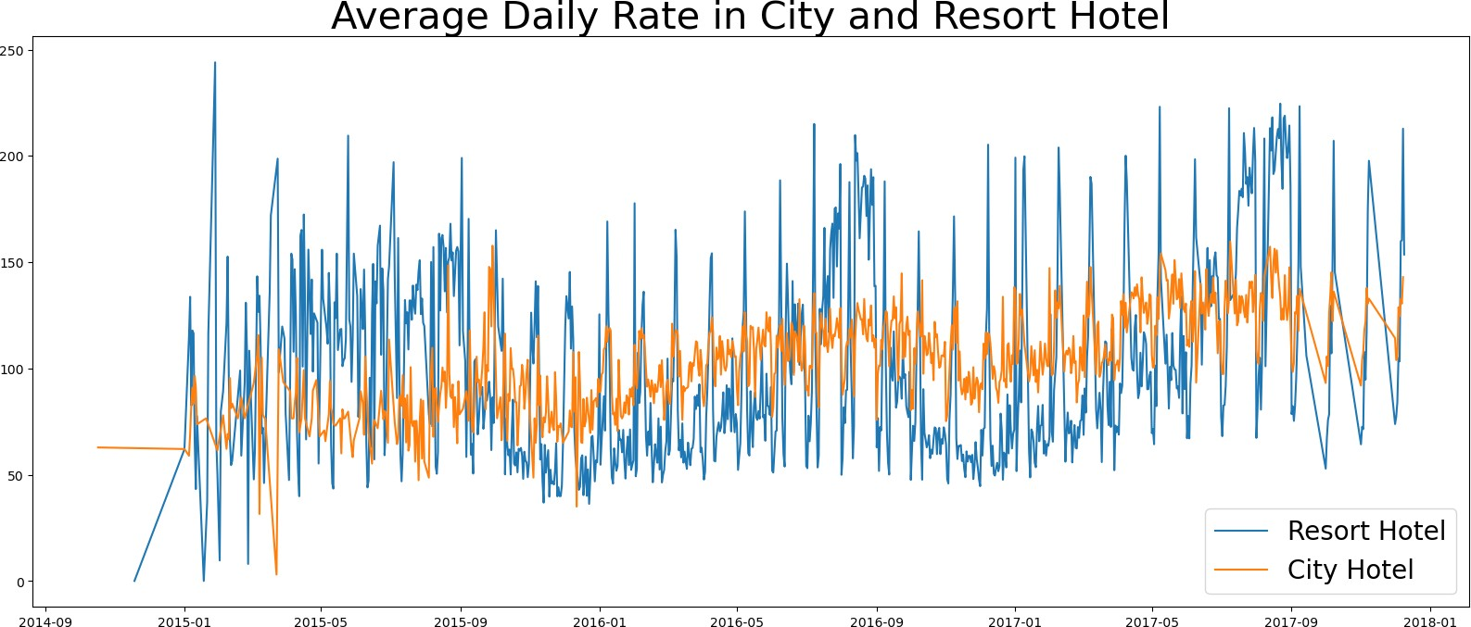City hotels have more reservations than resort hotels do. The cost of hotels at resorts could be higher than in cities.

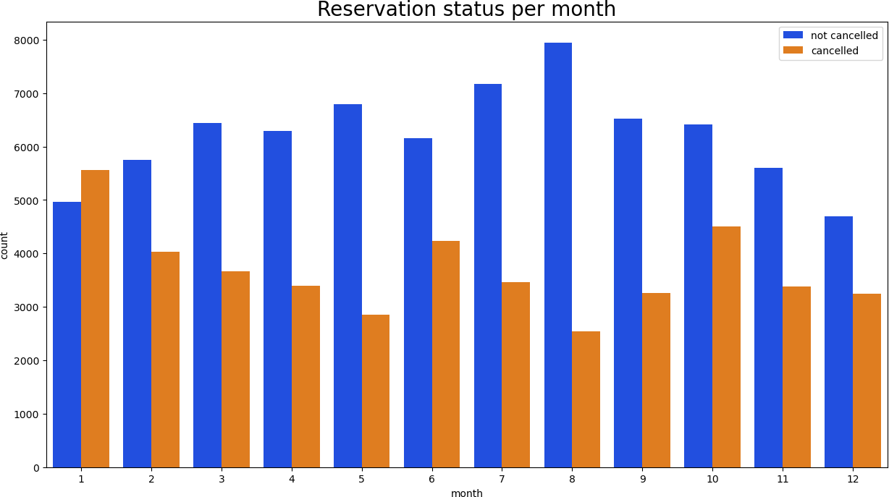The line graph up top demonstrates that, on certain days, a city hotel's average daily tariff is less than a resort hotel's, and on other days, it is even less. It goes without saying that resort hotel rates may increase on weekends and during holidays.

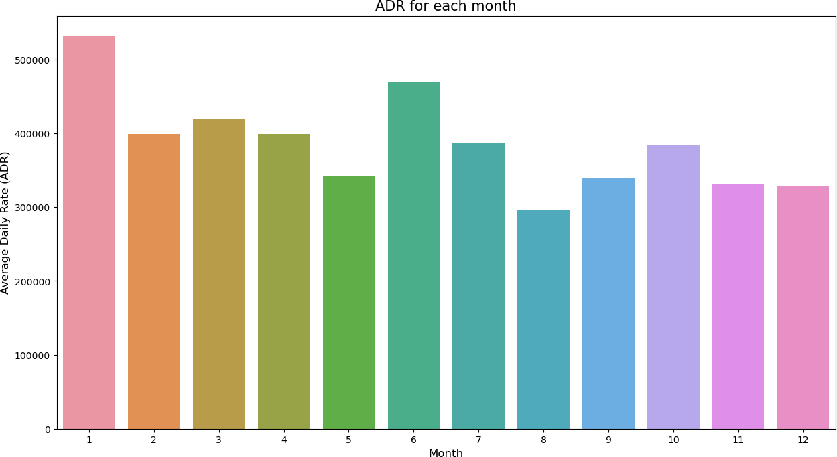 In order to assess the months with the highest and lowest reservation levels according to reservation status, we produced the grouped bar graph. As can be seen, August is the month with the most confirmed reservations as well as the most cancelled reservations. The most cancelled reservations, however, occur in January.

This bar graph shows that cancellations occur more frequently when prices are highest and less frequently when prices are lowest. Hence, the only cause of the cancellation is the price of the lodging.

Let's look at the countries with the most cancelled reservations now. The top country with the most cancellations is Portugal.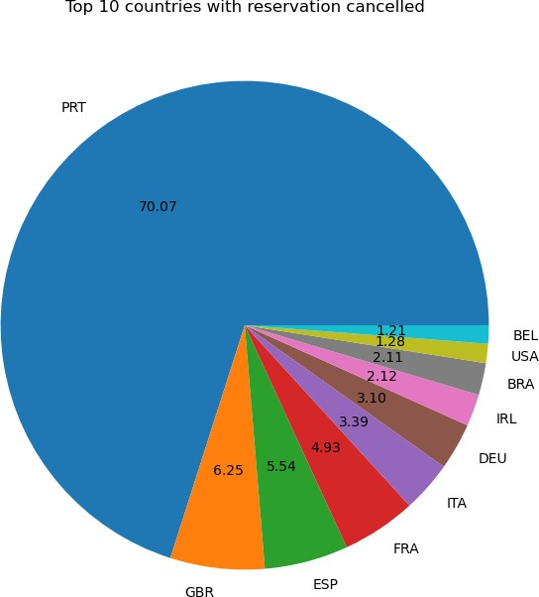

Let's look at the region from which visitors to hotels are coming and making reservations. Is it coming from offline or online travel agents, direct or groups? 27% of the customers are groups, while 46% come via online travel agencies. Just 4% of customers make direct reservations at hotels by going there in person.

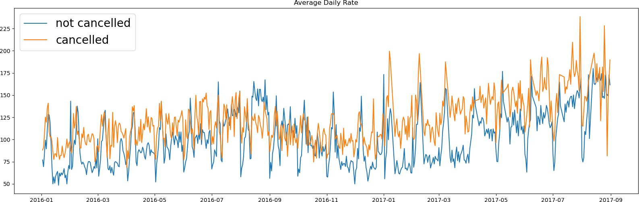

The graph shows that bookings are cancelled more frequently than they are not, depending on the average daily pricing. That amply supports the prior analysis that higher prices result in more cancellations.

# Suggestions

1. As prices increase, cancellation rates do as well. Hotels should improve their pricing tactics and attempt to cut the costs for particular hotels based on locations in order to prevent cancellations of reservations. The customers may also receive certain discounts from them.

2. Since compared to city hotels, the ratio of cancellations to non-cancellations at resort hotels is higher. Hence, on weekends and during holidays, hotels should offer a fair discount on room rates.

3. While cancellations are at their greatest in January, hotels might launch campaigns or marketing with a reasonable budget to boost income.

4. To lower the cancellation rate, they can also improve the standard of their hotels and services, particularly in Portugal.