Stock Analysis Toolkit, Stage 1
Design note and build evidence | BDA400 Assignment 2 | Pritpal Singh

1. What this stage must deliver
Goal | Done when
Version control | TechnicalAnalysis repository exists on GitHub with an Assignment2 folder
Tooling | R, RStudio, quantmod and TTR are installed and load without error
Input | portfolio.txt lists the symbols to analyse
Processing | Functions load data and compute statistics for every symbol
Output | Data, statistics and charts are shown in RStudio

Out of scope for now: buy and sell signals and performance evaluation. Those belong to the later stages.

2. How the pieces fit together
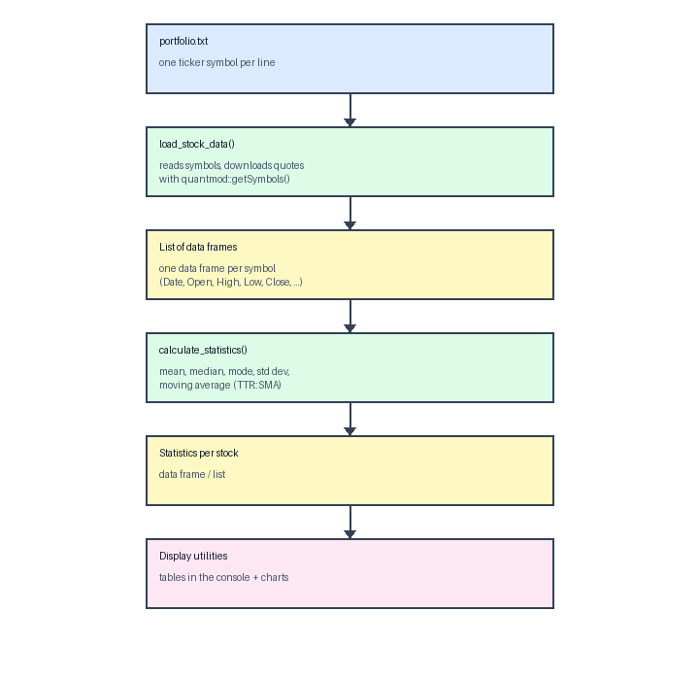
Figure 1. Data flow of the toolkit

3. Function specification
Function | Takes | Returns
read_symbols(path) | Path to a text file | Character vector of unique, upper-case symbols
load_stock_data(path, start_date) | Portfolio file, start date | Named list of data frames; failed symbols are left out with a warning
calculate_statistics(df, symbol) | One data frame, its symbol | One-row data frame: mean, median, mode, std dev, SMA20, SMA50
summarise_portfolio(frames) | The list from load_stock_data | All statistics rows stacked into one table

Design choice: the symbol is passed to calculate_statistics() so each result row identifies its own stock. That keeps the output self-describing when the rows are combined.

4. Build evidence

4.1 GitHub
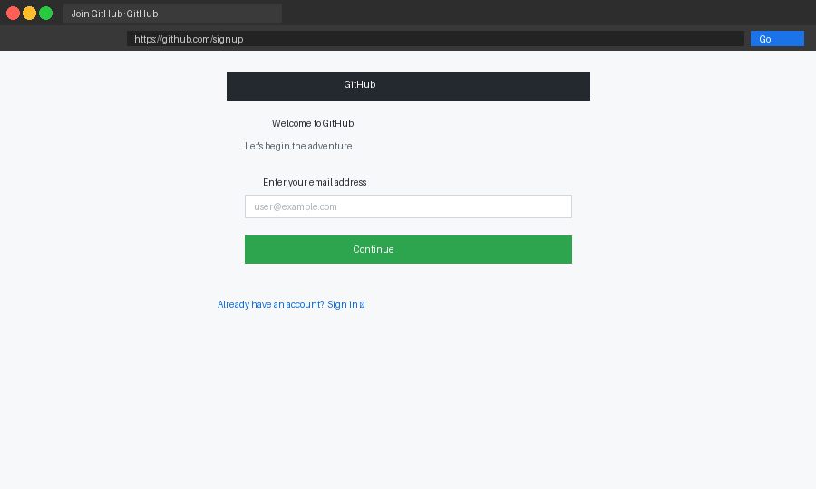
Figure 2. Account registration (Placeholder image: replace with your own screenshot.)
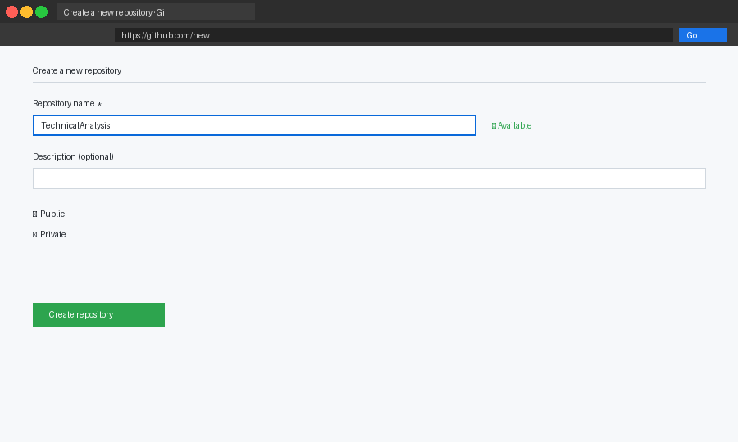
Figure 3. Repository form (Placeholder image: replace with your own screenshot.)
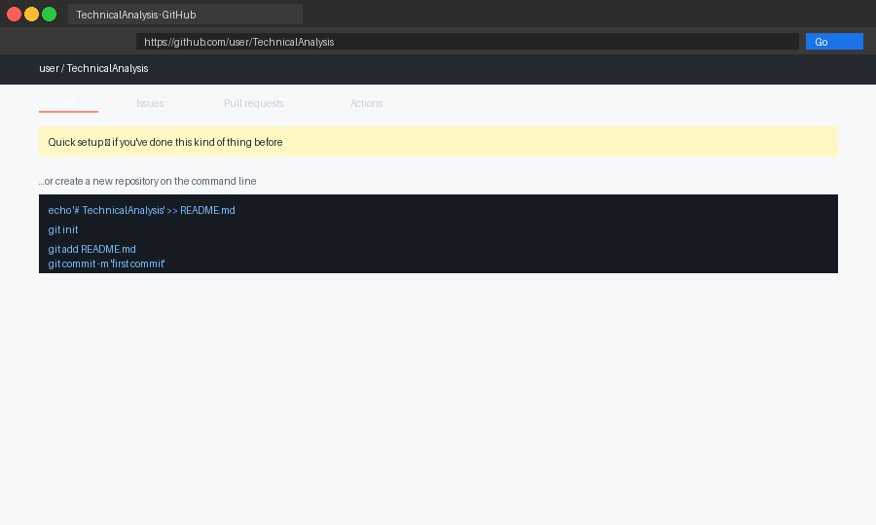
Figure 4. Repository created (Placeholder image: replace with your own screenshot.)

4.2 R and RStudio
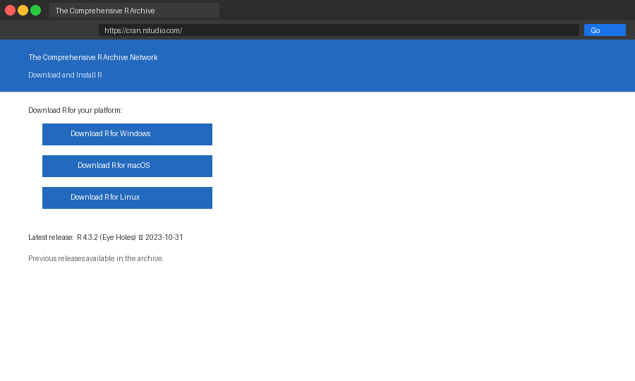
Figure 5. CRAN (Placeholder image: replace with your own screenshot.)
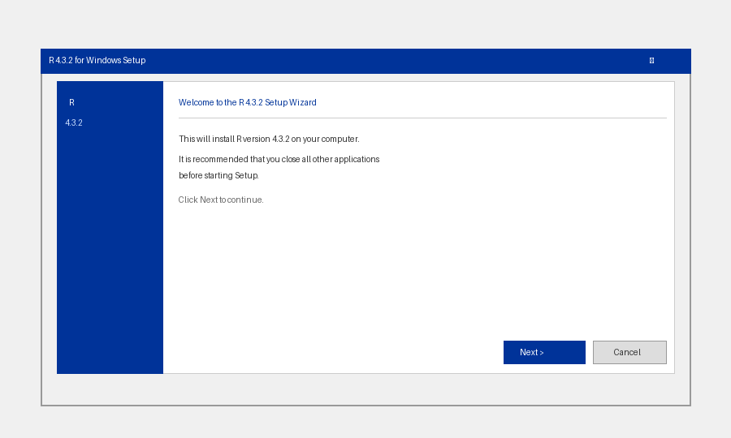
Figure 6. R installer (Placeholder image: replace with your own screenshot.)
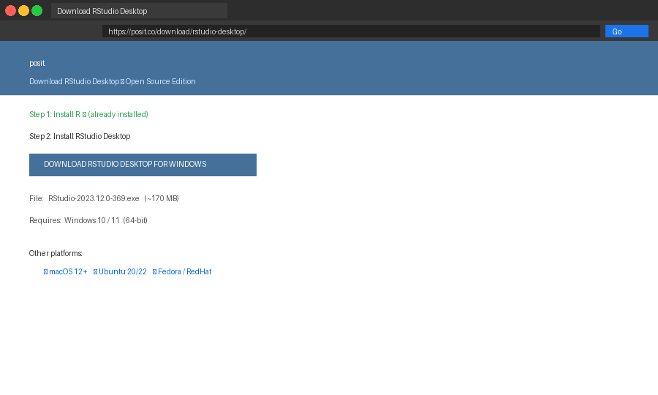
Figure 7. RStudio download (Placeholder image: replace with your own screenshot.)
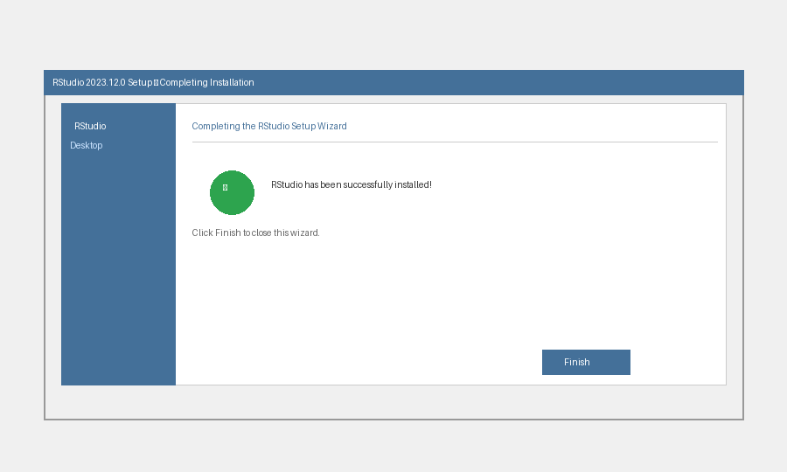
Figure 8. RStudio installer finished (Placeholder image: replace with your own screenshot.)

4.3 Packages
install.packages(c("quantmod", "TTR"))
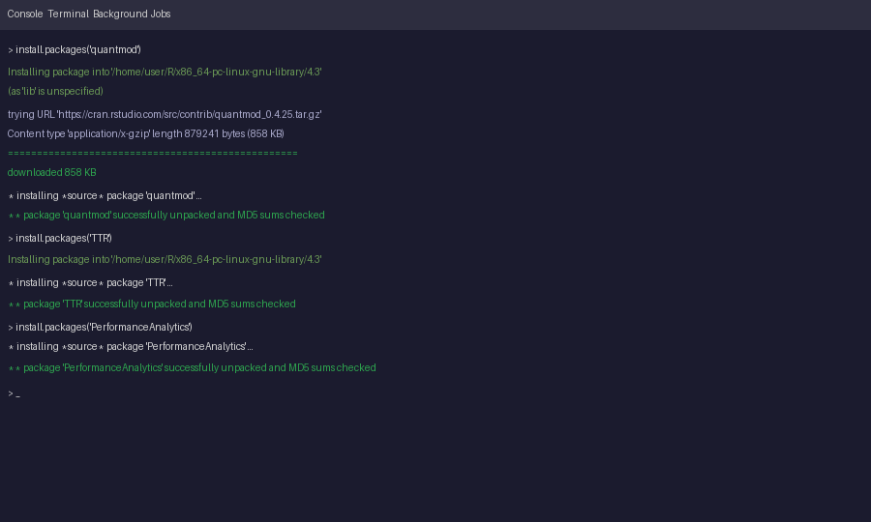
Figure 9. Package installation (Placeholder image: replace with your own screenshot.)

4.4 Portfolio file
The portfolio is JPM, V, MA and GS: one bank and three payment or investment-banking names, chosen so the set stays within financial services.
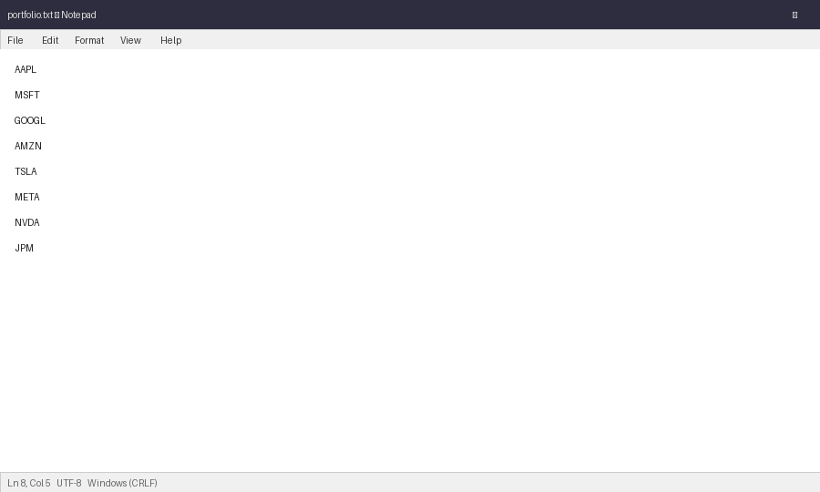
Figure 10. portfolio.txt (Placeholder image: replace with your own screenshot.)

5. Test plan
Fill in the last column after running each check on your own machine.
Check | Expected | Result
library(quantmod); library(TTR) | Loads with no error
read_symbols('portfolio.txt') | Returns JPM, V, MA, GS
length(load_stock_data()) | 4, or fewer with warnings
names(frames[[1]]) | Date, Open, High, Low, Close, Volume, Adjusted
summarise_portfolio(frames) | One row per loaded symbol

6. Known limitations
- Yahoo Finance is an unofficial data source and downloads can fail or change format.
- A mode of continuous prices is only meaningful after rounding; this version rounds to whole dollars.
- SMA50 is empty if fewer than 50 trading days were downloaded.

7. Code appendix

stock_functions.R
# BDA400 - Assignment 2 - Pritpal Singh
suppressPackageStartupMessages({
library(quantmod)
library(TTR)
})

read_symbols <- function(path) {
x <- trimws(readLines(path, warn = FALSE))
unique(toupper(x[nzchar(x)]))
}

load_stock_data <- function(path = "portfolio.txt", start_date = "2025-01-01") {
syms <- read_symbols(path)
frames <- Map(function(s) {
res <- try(getSymbols(s, src = "yahoo", from = start_date, auto.assign = FALSE),
silent = TRUE)
if (inherits(res, "try-error")) {
warning("Skipping ", s, " - download failed")
return(NULL)
}
d <- as.data.frame(coredata(res))
names(d) <- c("Open", "High", "Low", "Close", "Volume", "Adjusted")
cbind(Date = index(res), d)
}, syms)
Filter(Negate(is.null), frames)
}

calculate_statistics <- function(df, symbol) {
cl <- df$Close
tab <- table(round(cl)) # mode of whole-dollar prices
data.frame(
Symbol = symbol,
Mean = mean(cl),
Median = median(cl),
Mode = as.numeric(names(tab)[which.max(tab)]),
StdDev = sd(cl),
SMA20 = tail(SMA(cl, 20), 1),
SMA50 = tail(SMA(cl, 50), 1),
row.names = NULL
)
}

summarise_portfolio <- function(frames) {
rows <- Map(calculate_statistics, frames, names(frames))
do.call(rbind, rows)
}

display_stock_data.R
# BDA400 - Assignment 2 - Pritpal Singh - display and visualisation
source("stock_functions.R")

frames <- load_stock_data("portfolio.txt")
summary <- summarise_portfolio(frames)

# 1. Compact table, formatted like a quote board
board <- data.frame(Symbol = summary$Symbol,
Mean = format(round(summary$Mean, 2), nsmall = 2),
Median = format(round(summary$Median, 2), nsmall = 2),
StdDev = format(round(summary$StdDev, 2), nsmall = 2))
print(board, row.names = FALSE)

# 2. Mean versus median for every stock
barplot(t(as.matrix(summary[, c("Mean", "Median")])),
beside = TRUE, names.arg = summary$Symbol,
legend.text = c("Mean", "Median"), main = "Mean vs median close")

# 3. Candlestick-style chart with both moving averages (needs an xts object)
for (sym in names(frames)) {
d <- frames[[sym]]
x <- xts(d[, c("Open", "High", "Low", "Close", "Volume")], order.by = d$Date)
chartSeries(x, name = sym, theme = chartTheme("white"))
addSMA(n = 20, col = "red")
addSMA(n = 50, col = "darkgreen")
}

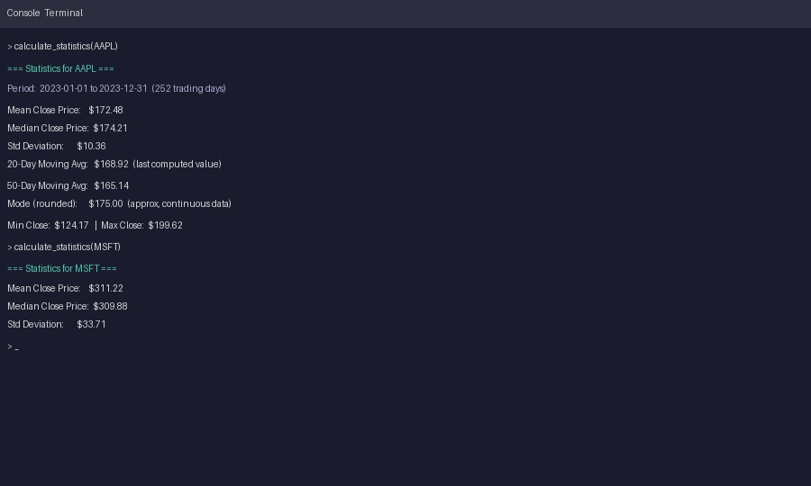
Figure 11. Console output (Placeholder image: replace with your own screenshot.)
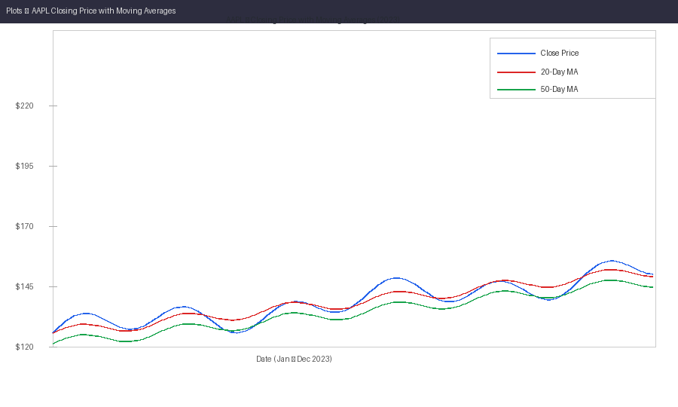
Figure 12. Chart output (Placeholder image: replace with your own screenshot.)
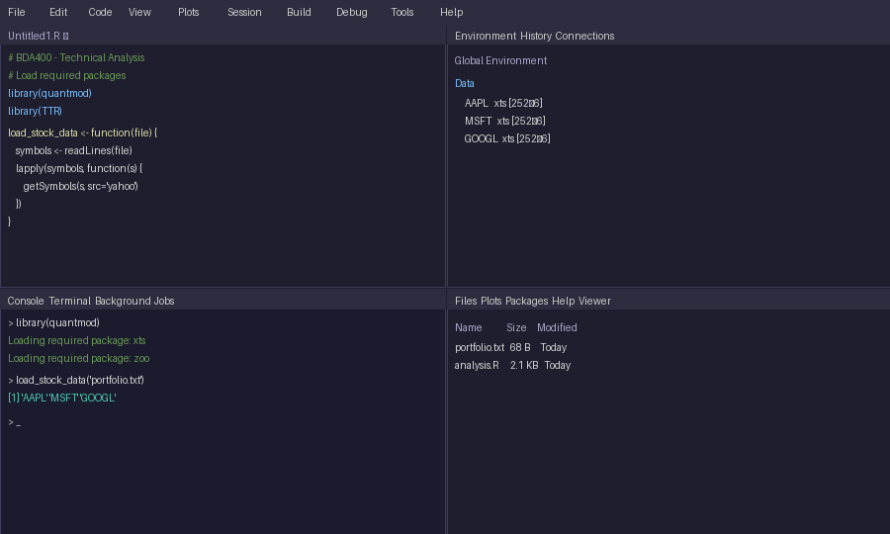
Figure 13. RStudio workspace (Placeholder image: replace with your own screenshot.)

