Smart Tanker — Technical Architecture
Best-practice architecture for a real-time, multi-tenant water tanker SaaS

1. Design Principles
- Multi-tenant from day one — every table carries a tenant_id; government bodies and private operators share infrastructure but never see each other's data.
- Separate real-time traffic from request/response traffic — the WebSocket gateway is its own service so a spike in GPS updates never slows down bookings or payments.
- Stateless API layer — REST servers hold no session state, so you can add more instances behind a load balancer without any special handling.
- Event-driven for anything non-instant — notifications, report generation, and reconciliation run through a job queue instead of blocking the request that triggered them.
- Narrow real-time fan-out — clients subscribe only to the specific tanker or fleet channel relevant to them, not a global broadcast, keeping bandwidth and battery use low.

2. System Architecture
The diagram below shows how the three client apps talk to a shared backend, how real-time data flows separately from regular API traffic, and where external services plug in.
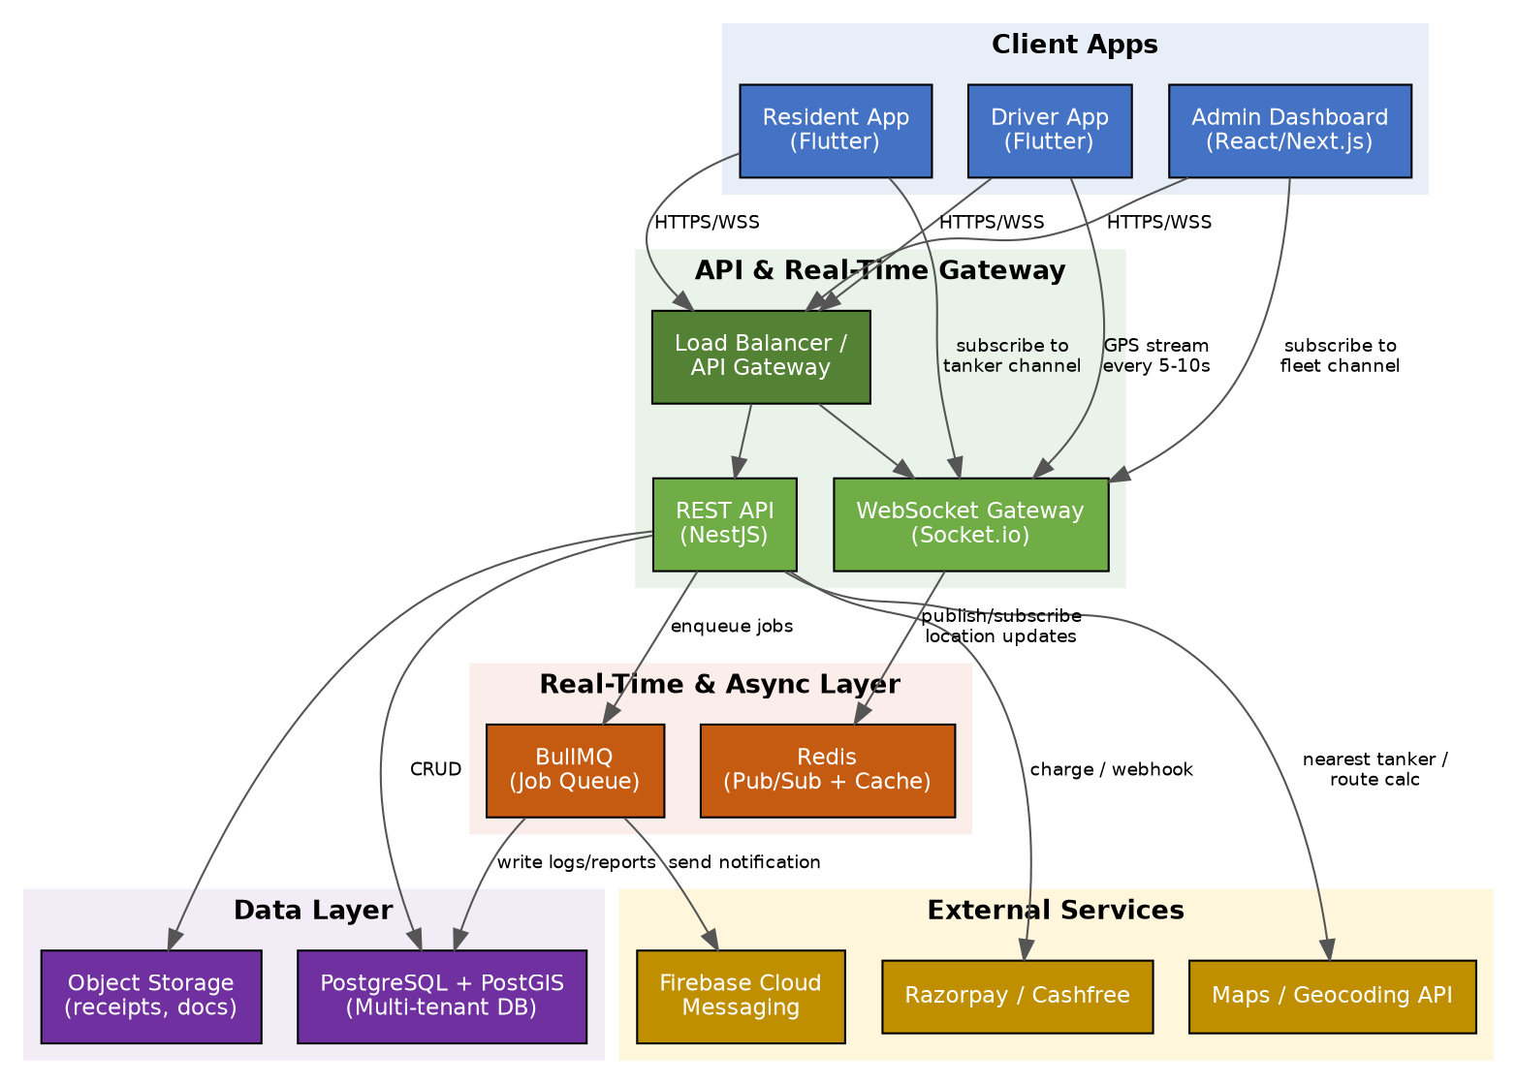

2.1 Layers
Layer | Technology | Responsibility
Client apps | Flutter (Resident, Driver) + React/Next.js (Admin) | UI, local caching, GPS capture, map rendering
API gateway / LB | Nginx or cloud load balancer | TLS termination, routing, rate limiting
REST API | NestJS (Node.js) | Bookings, auth, rate cards, tenant config, payments
WebSocket gateway | Socket.io | Live GPS streaming, live status updates
Pub/Sub + cache | Redis | Fan-out of location updates, session/token cache
Job queue | BullMQ (Redis-backed) | Notifications, report generation, reconciliation
Database | PostgreSQL + PostGIS | Tenants, users, requests, tankers, routes, geospatial queries
Object storage | S3-compatible bucket | Delivery photos, digital receipts, exported reports
External services | Razorpay/Cashfree, Firebase Cloud Messaging, Maps API | Payments, push notifications, geocoding/routing

3. Real-Time Data Flow (Single Booking)
This is the step-by-step path a single tanker request takes, from the resident tapping "Request" to the delivery being logged.
- Resident requests a tanker → rules engine checks tenant config, quota, and category to compute amount due.
- If amount due is zero, the request auto-confirms; otherwise Razorpay/Cashfree checkout runs first.
- Confirmed request enters the dispatch queue; a dispatcher or the auto-assignment logic (PostGIS nearest-neighbor query) picks a tanker.
- Driver app is notified via Firebase push, and begins streaming GPS location over its WebSocket connection every 5-10 seconds.
- Redis pub/sub fans that location out only to the resident and admin dashboard currently watching that tanker's channel.
- Delivery is confirmed via OTP entered by the resident; this closes the request and captures a GPS-stamped completion record.
- The completed request, payment status, and route history are written to PostgreSQL for reporting and audit.

4. Multi-Tenancy Model
Government bodies and private operators are both modeled as "tenants" on the same schema, distinguished by tenant type and configuration rather than separate infrastructure:
- Shared schema, tenant_id column on every table — simplest to operate and cheapest to scale for a single-region product.
- Row-level security policies in PostgreSQL enforce that a tenant's queries can never return another tenant's rows, even if application code has a bug.
- Each tenant has its own rate card, quota rules, and branding config, loaded at runtime — this is what lets the same app codebase serve a free government rollout and a fully paid private operator.
- If a single large government contract later needs strict data isolation (e.g. a state government requiring its own database), that tenant can be migrated to a dedicated schema or database without changing the application code.

5. Scalability & Reliability
Concern | Approach
Rising WebSocket connections | Horizontally scale the Socket.io layer with a Redis adapter so multiple gateway instances share pub/sub state.
Database growth | Partition location_logs by month; keep only recent data hot, archive older logs to object storage.
Driver battery/bandwidth | Adaptive ping interval — faster while moving, slower when idle or parked.
Dropped connections | Driver app queues location updates locally and syncs on reconnect; resident app shows "last known location" with a timestamp rather than a stale live marker.
Payment reliability | Idempotent webhook handling keyed on gateway transaction ID, since providers can retry webhook delivery.
Regional outage | Stateless API and WebSocket layers allow multi-region deployment behind a global load balancer if the product expands beyond one country.

6. Security
- JWT-based auth with short-lived access tokens and refresh tokens; phone OTP login via Firebase Auth for residents and drivers.
- Role-based access control (resident, driver, tenant-admin, super-admin) enforced at the API layer.
- Row-level security in PostgreSQL as a second line of defense for tenant data isolation.
- Razorpay/Cashfree webhook signatures verified before any payment status is trusted.

6.1 Encryption Strategy
Encryption is applied differently depending on whether the server itself needs to read the data to do its job:
Data / Channel | Approach | Why
In-app chat (resident ↔ driver) | True end-to-end encryption (E2EE) | Only the two participants need to read it — no operational reason for the server to see plaintext.
Uploaded documents / delivery photos / KYC | End-to-end encrypted at rest, keyed to the uploading and viewing parties | Sensitive personal documents; server only needs to store and relay them, not read them.
Live GPS location | Encrypted in transit (WSS/TLS) + encrypted at rest, not E2EE | The dispatch engine and admin dashboard must read location to match tankers, compute ETAs, and provide oversight — true E2EE would make the platform blind to its own fleet.
Payment details | Never touches Smart Tanker's servers directly — handled via Razorpay/Cashfree tokenization | PCI-DSS scope is offloaded to the payment provider.
PII (phone, address, ID numbers) | Field-level encryption (AES-256) at the application layer before writing to PostgreSQL | Limits exposure even if the database itself is ever breached.
All network traffic | TLS 1.2+ for REST, WSS for WebSocket | Prevents interception in transit across every channel.

This gives residents and drivers genuine end-to-end privacy for anything that is purely a conversation between them (chat, shared documents), while keeping location data protected in transit and at rest — without disabling the real-time matching and admin oversight the product depends on.

7. Summary
The architecture keeps three concerns cleanly separated: fast request/response traffic (REST + Postgres), high-frequency real-time traffic (WebSocket + Redis), and anything that can happen a little later (job queue). Multi-tenancy is handled through configuration and row-level security rather than duplicated infrastructure, which is what makes it realistic to sell the same product to both a municipal government and an independent tanker operator without maintaining two systems.

