SQL CASE Study 1
1.Display the number of states present in the Location Table.
Query: Select Count (Distinct State) as TotalStates from Location
Select distinct State from Location;
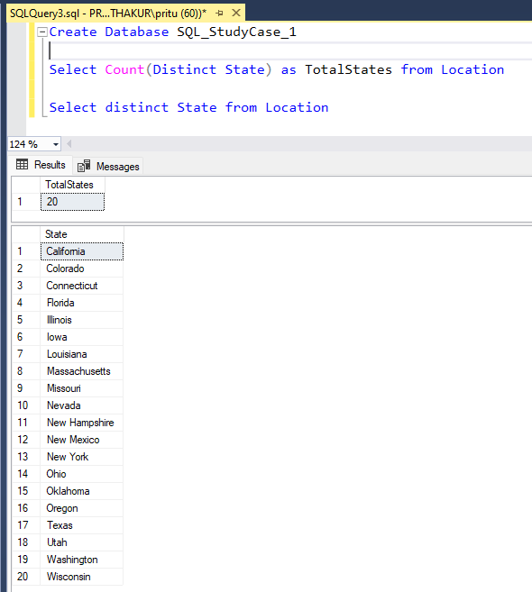
2. How many products are of regular type?
Query: Select Count (*) As Regular_Products
FROM Product
WHERE Product.Type = 'Regular';
Select Product_Type, Type from Product where Type = 'Regular'
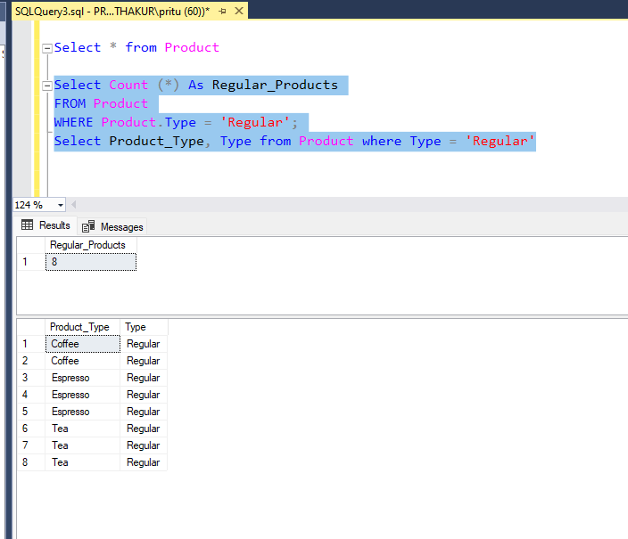

3. How much spending has been done on marketing of product ID 1?
Query: Select Sum (Marketing) as TotalMarketingExpense,ProductId from Fact where ProductId = 1
Group By ProductId
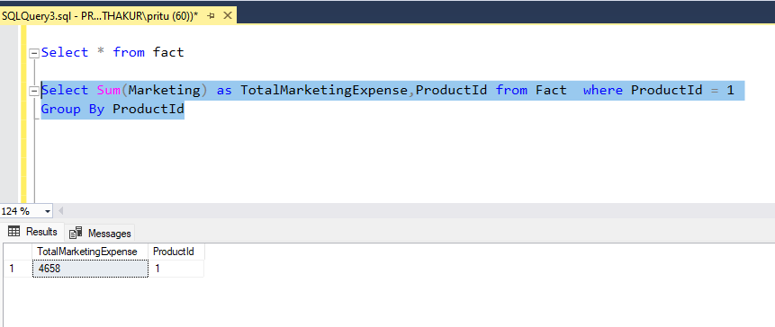

4. What is the minimum sales of a product?
Query: Select Min (Sales) as MinimumSales,ProductId from fact group by ProductId order by ProductId asc

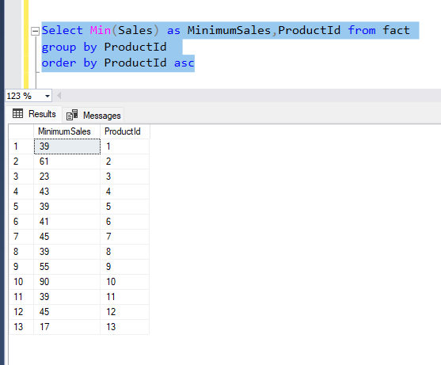

5. Display the max Cost of Goods Sold (COGS).
Query: 1). Select Max (COGS) from Fact
2). Select * from Fact where COGS = (Select Max(COGS) from Fact)
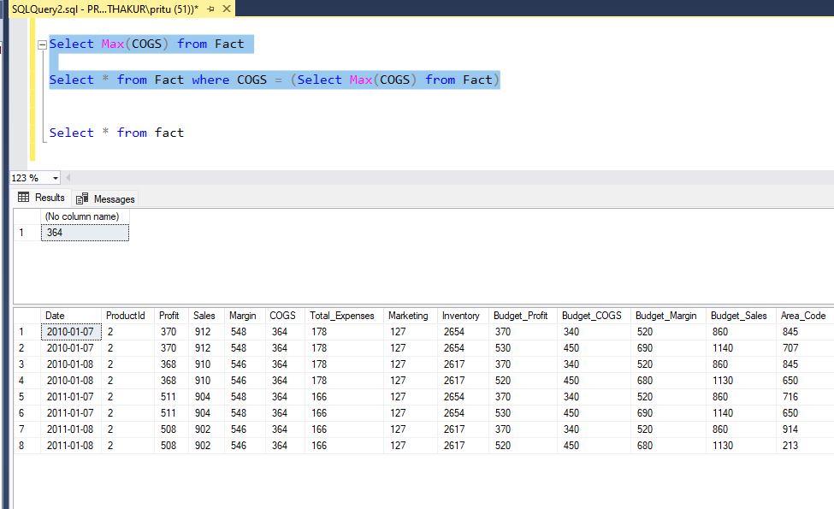

6. Display the details of the product where product type is coffee.
Query: Select * from Product where Product_Type='Coffee'
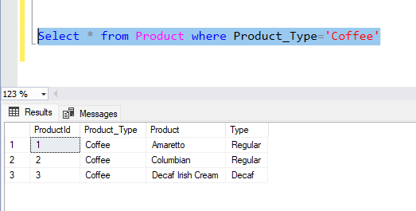
7. Display the details where total expenses are greater than 40.
Query: Select * from Fact where Total_Expenses > 40

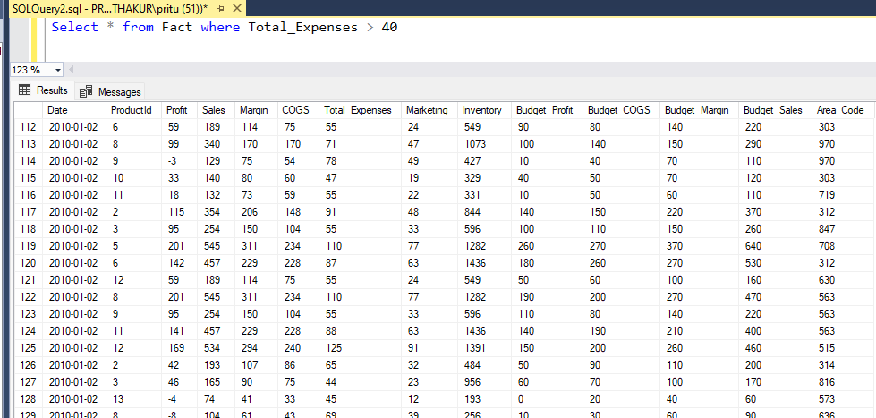

8. What is the average sales in area code 719?
Query: 1) Select Avg (Sales) as AverageSale,Area_Code from fact group By Area_Code having Area_Code = 719
Or
2) Select Avg (Sales) as AverageSale from fact where Area_Code = 719

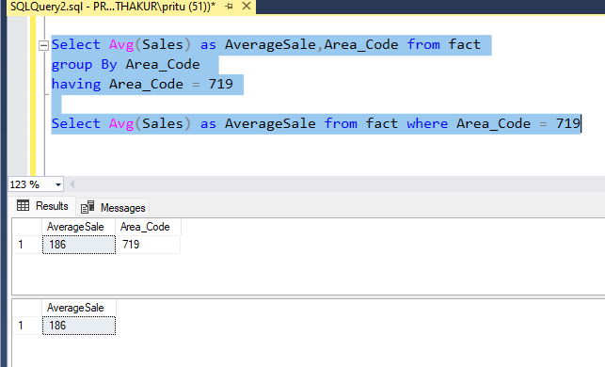

9. Find out the total profit generated by Colorado state.
Query: Select Sum(F.Profit) as TotalProfit from Fact F
inner join Location L
on F.Area_Code = L.Area_Code
where L.State= 'Colorado'

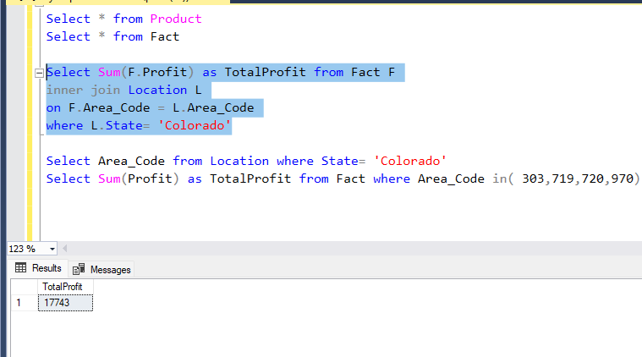

10. Display the average inventory for each product ID.
Query: Select ProductId,Avg(Inventory) as AverageInventory from Fact
group by ProductId order by ProductId asc

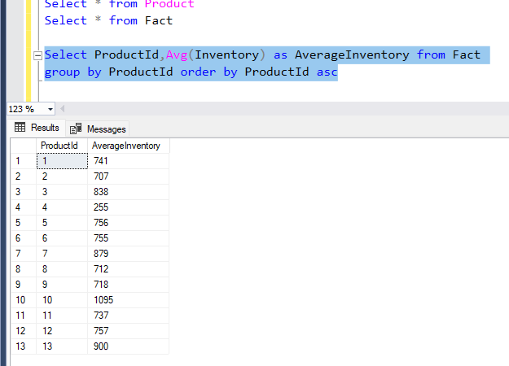

11. Display state in a sequential order in a Location Table.
Query: Select Row_Number() Over(Order By State asc) as RowNumber, State From Location
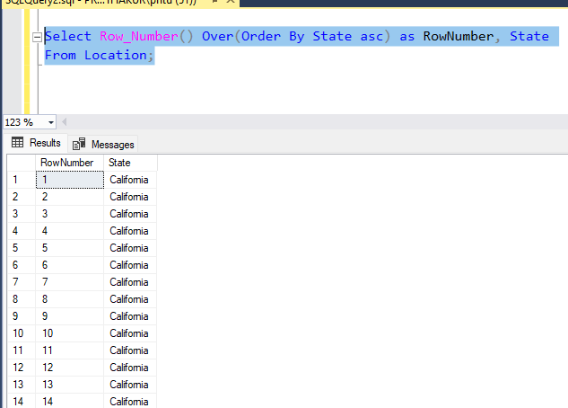

12. Display the average budget of the Product where the average budget margin should be greater than 100.
Query:
Select ProductID, Avg(Budget_Margin) as AverageBudget From Fact Group By ProductID
Having Avg (Budget_Margin) > 100

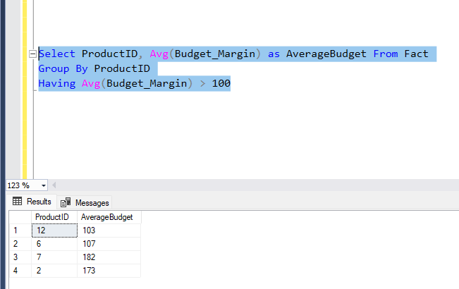

13. What is the total sales done on date 2010-01-01?
Query:
Select Sum (Sales) as TotalSales from Fact where Date = '2010-01-01'
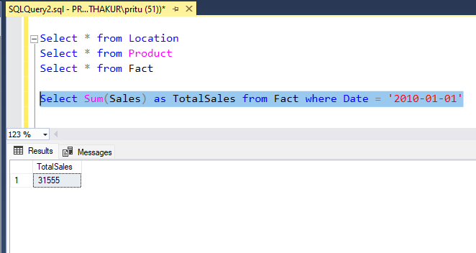
14. Display the average total expense of each product ID on an individual date.
Query:
Select Avg(Total_Expenses) as AverageExpense,ProductId,Date from Fact
Group by ProductId,date
Order By ProductId, Date asc;
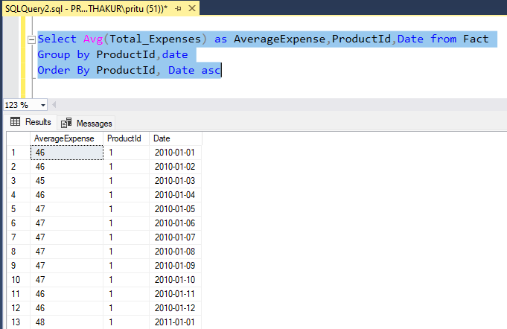

15. Display the table with the following attributes such as date, productID, product_type, product, sales, profit, state, area_code.
Query: Select F.Date, F.ProductID, P.Product_type,
P.Product, F.sales, F.Profit, L.State, L.area_code
FROM FACT F
left join Product P
on P.ProductId=F.ProductId
join Location L
on L.Area_Code=F.Area_Code
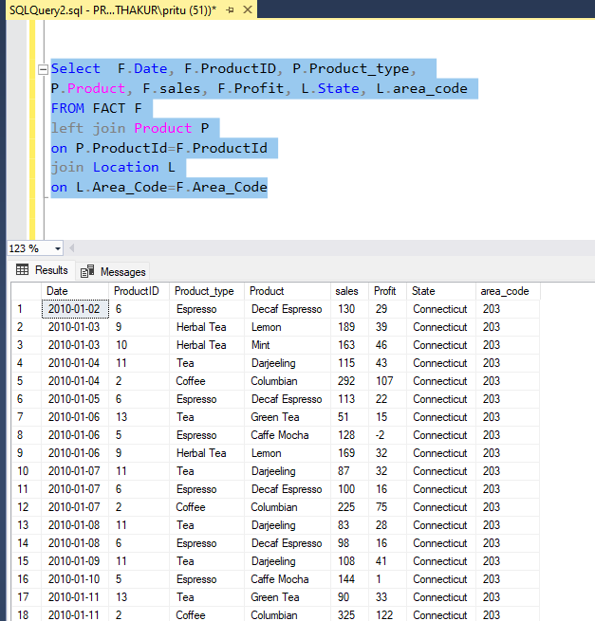

16. Display the rank without any gap to show the sales wise rank.
Query: Select ProductId, Sales, Dense_Rank() Over (Order by Sales desc) As Rank From Fact;
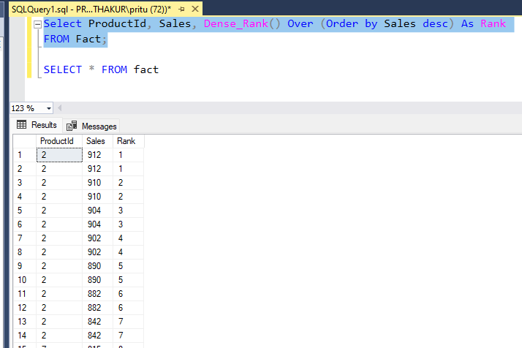

17. Find the state wise profit and sales.
Query:
Select L.State, Sum(F.Profit) as Total_Profit, Sum(F.Sales) as Total_Sales From Fact F JOIN Location L
On F.Area_Code = L.Area_Code
Group By L.State
Order By Total_Profit desc;

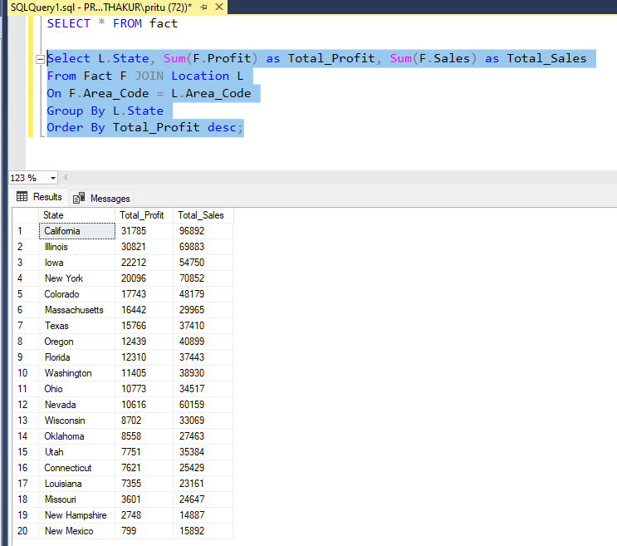

18. Find the state wise profit and sales along with the product name.
Query:
Select L.State,P.Product, Sum(F.Profit) as Total_Profit, Sum(F.Sales) as Total_Sales
From Fact F JOIN Location L
On F.Area_Code = L.Area_Code
Join Product P
on F.ProductId = P.ProductId
Group By L.State,P.Product
Order By L.State,Total_Profit desc;

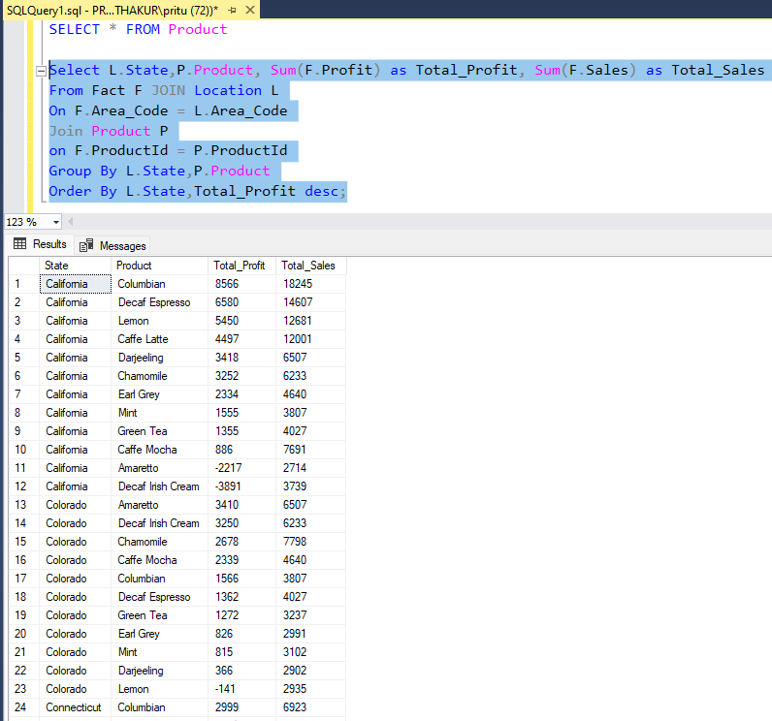

19. If there is an increase in sales of 5%, calculate the increased sales.
Query:
----------Increased Sales with Product Name and state wise------------------
Select L.State,P.Product,Sum(F.Sales) as Original_Sales,Sum(F.Sales) * 1.05 as Increased_Sales
From Fact F Join Location L On F.Area_Code = L.Area_Code
Join Product P On F.ProductID = P.ProductID
Group By L.State, P.Product
Order By L.State, Original_Sales desc;
------------------Increased Sale from fact Table------------------------------------
Select ProductId,Sales as Original_Sales,Sales * 1.05 as Increased_Sales
From Fact;
----------------Increased sale for Total sales-----------------------------------
Select ProductId,Sum (Sales) as Total_Original_Sales, Sum (Sales) * 1.05 AS Total_Increased_Sales
From Fact
Group By ProductId
Order By ProductId;

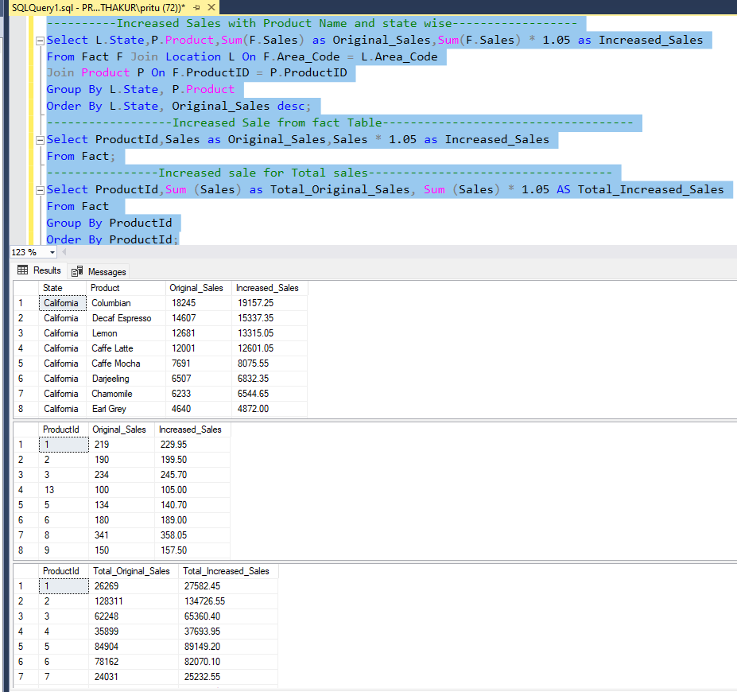

20. Find the maximum profit along with the product ID and product type.
Query:
SELECT F.ProductID,P.Product_Type,MAX(F.Profit) as Maximum_Profit
FROM Fact F
JOIN Product P
ON F.ProductID = P.ProductID
GROUP BY F.ProductID, P.Product_Type
ORDER BY ProductId,Maximum_Profit DESC;
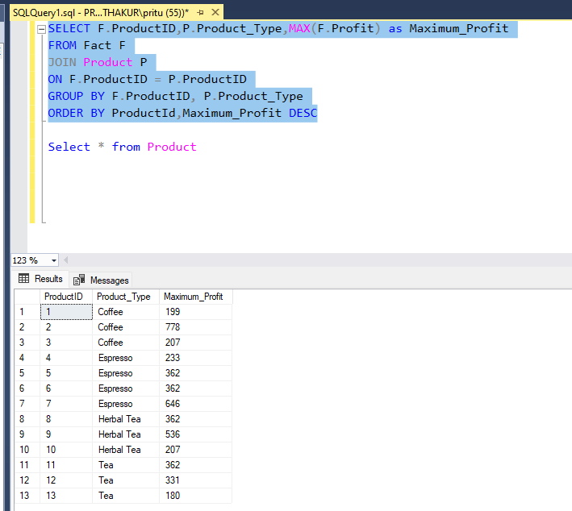

21.Create a stored procedure to fetch the result according to the product type from Product Table.
Query: Create Procedure DetailsByProduct
@InputProduct Nvarchar(100)
As
Begin
Select *
From Product
Where Product_Type = @InputProduct;
End;
Exec DetailsByProduct @InputProduct='Coffee'
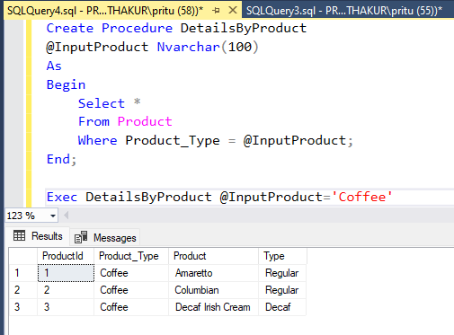
22. Write a query by creating a condition in which if the total expenses is less than 60 then it is a profit or else loss.
Query:
Select Date,ProductId,Total_Expenses,
Case when Total_Expenses < 60 Then 'Profit'
Else 'Loss'
End as ProfitOrLoss
from Fact;
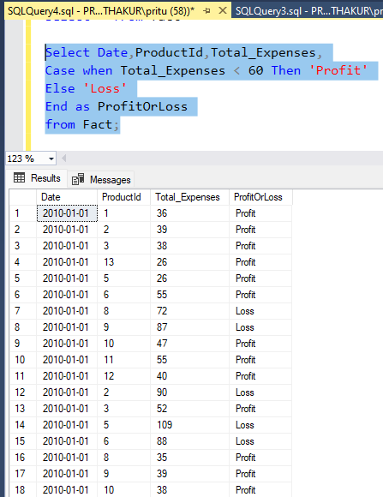

23. Give the total weekly sales value with the date and product ID details. Use roll-up to pull the data in hierarchical order.
Query: SELECT
CONCAT(
FORMAT(Date, 'yyyy-MM'), ' - Week ',
DATEPART(WEEK, Date) - DATEPART(WEEK, DATEADD(MONTH, DATEDIFF(MONTH, 0, Date), 0)) + 1
) AS WeekOfMonthYear,
-- YEAR(Date) AS YearNum,
-- MONTH(Date) AS MonthNum,
ProductID,
SUM(Sales) AS TotalSales
FROM Fact
GROUP BY ROLLUP (
CONCAT(
FORMAT(Date, 'yyyy-MM'), ' - Week ',
DATEPART(WEEK, Date) - DATEPART(WEEK, DATEADD(MONTH, DATEDIFF(MONTH, 0, Date), 0)) + 1
),
ProductID)
ORDER BY TotalSales;

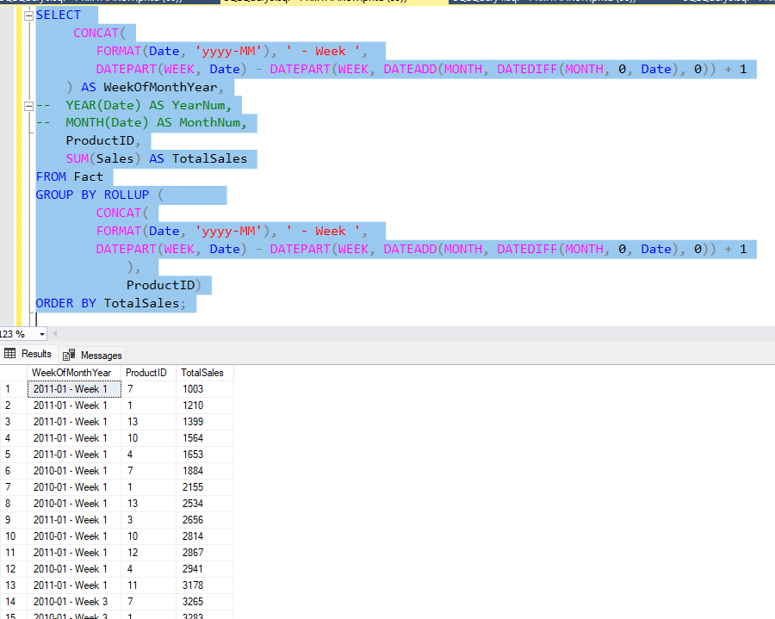

24. Apply union and intersection operator on the tables which consist of attribute area code.
Query:
SELECT Area_Code FROM Fact
UNION
SELECT Area_Code FROM Location
Order By Area_Code asc;

SELECT Area_Code FROM Fact
INTERSECT
SELECT Area_Code FROM Location
ORDER BY AREA_CODE ASC;
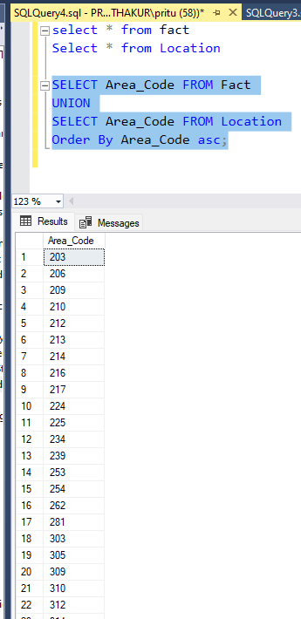
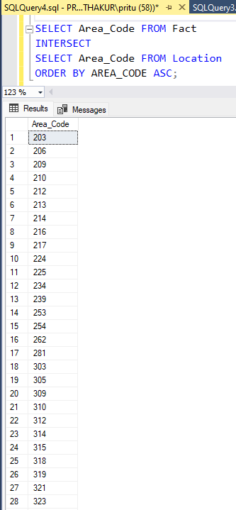

25. Create a user-defined function for the product table to fetch a particular product type based upon the user’s preference.
Query: CREATE FUNCTION DetailsByProductType
(@InputProduct VARCHAR(100))
RETURNS TABLE
AS
RETURN
(
SELECT ProductId, Product, Product_Type
FROM Product
WHERE Product_Type = @InputProduct
);
Select * from DetailsByProductType('Tea')

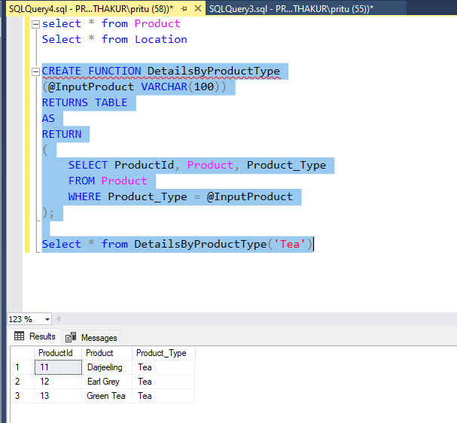

26. Change the product type from coffee to tea where product ID is 1 and undo it.
Query:
Begin Tran
Update Product
Set Product_Type ='Tea' where ProductId = 1
Rollback
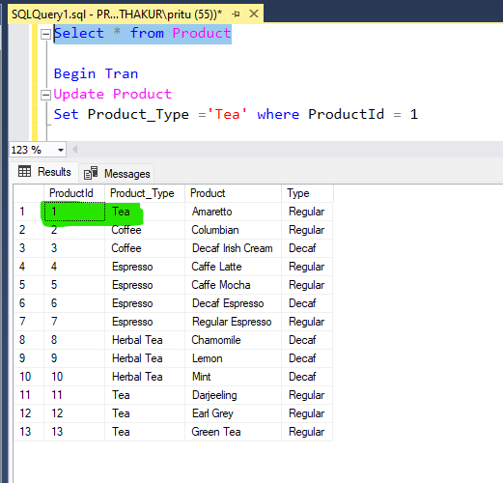

Rollbacked
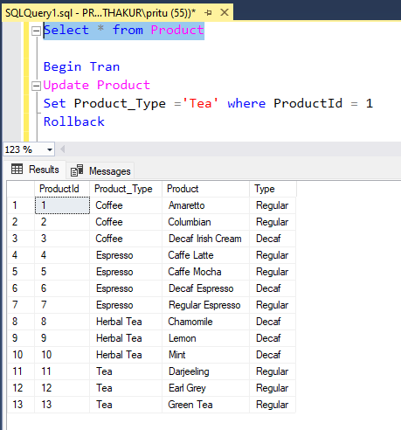
27. Display the date, product ID and sales where total expenses are between 100 to 200.
Query:
Select Date,ProductID,Sales,Total_Expenses from Fact where Total_Expenses between 100 and 200.
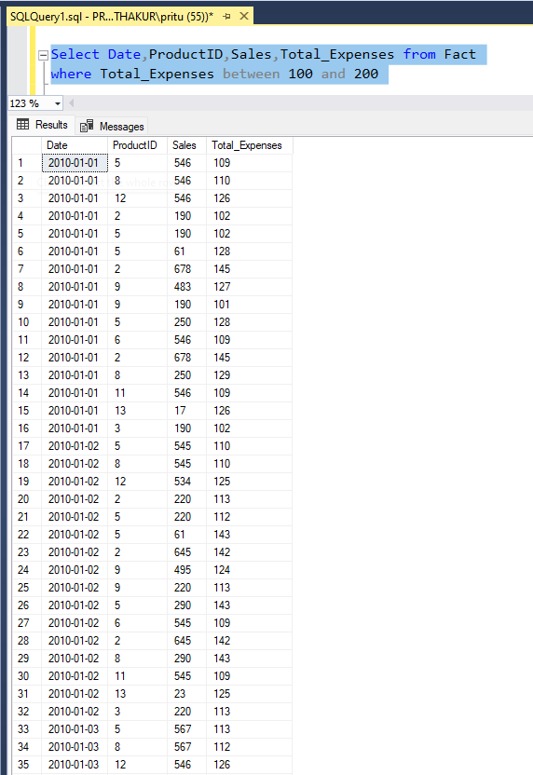
28. Delete the records in the Product Table for regular type.
Query: Delete from Product where Type='Regular'
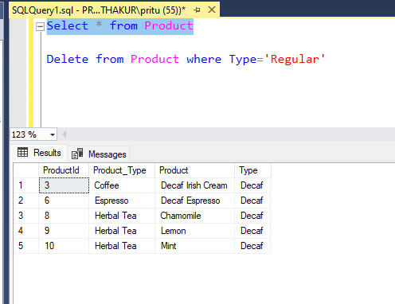

29. Display the ASCII value of the fifth character from the column Product.
Query: SELECT Product,
ASCII(SUBSTRING(Product, 5, 1)) AS FifthCharacterASCII
FROM Product;

