SQL_CaseStudy_2
Simple Queries
- List all the employee details.
Query:
Select * from EMPLOYEE
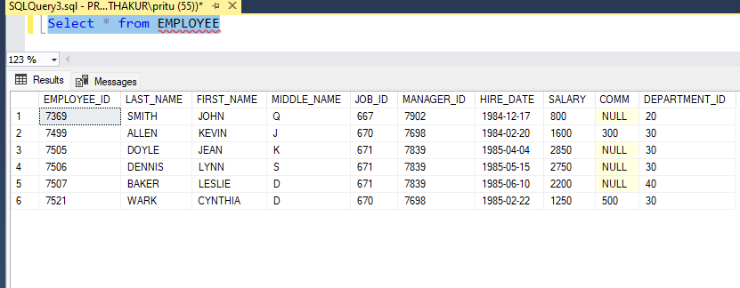

- List all the department details.
Query:
Select * from Department
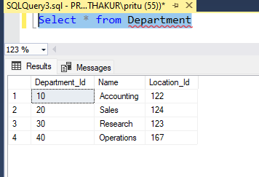

- List all job details.
Query:
Select * from Job

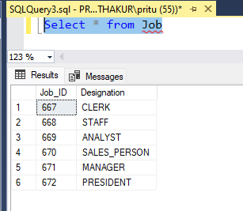

- List all the locations.
Query:
Select * from Location

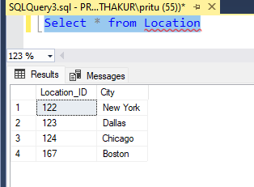
- List out the First Name, Last Name, Salary, Commission for all Employees.
Query:
Select First_Name, Last_Name, Salary, Comm From Employee;

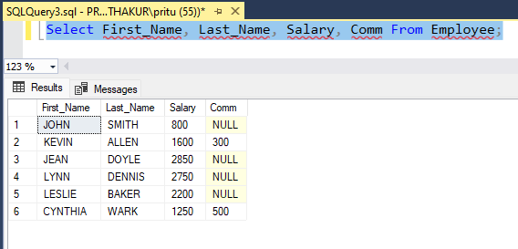

- List out the Employee ID, Last Name, Department ID for all employees and alias Employee ID as "ID of the Employee", Last Name as "Name of the Employee", Department ID as "Dep_id".

Query:
Select Employee_ID as "ID of the Employee",
LAST_NAME as "Name of the Employee",
DEPARTMENT_ID as "Dep_id" from Employee

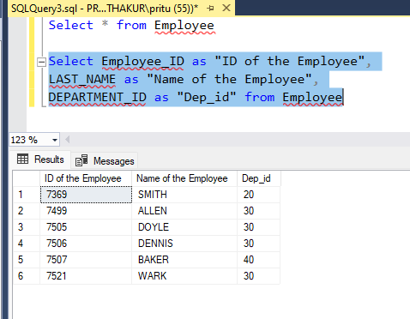

7. List out the annual salary of the employees with their names only.
Query:
Select FIRST_NAME,LAST_NAME,SALARY from Employee
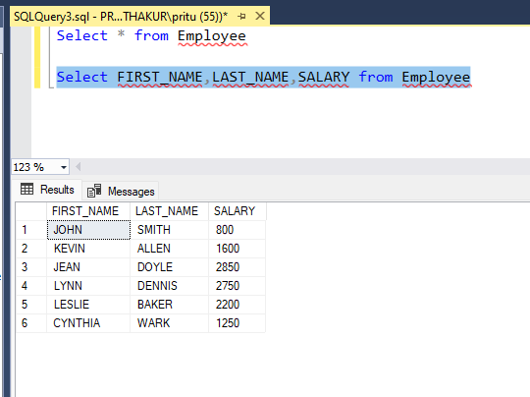

Where Condition
- List the details about "Smith".
Query: Select * from Employee where Last_name = 'Smith'
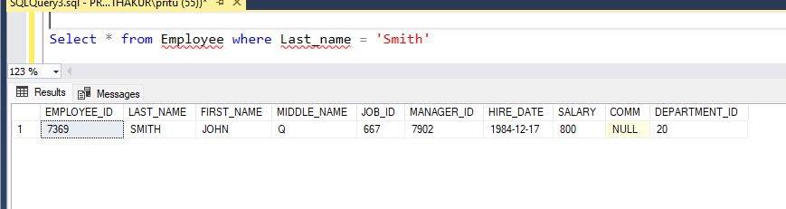

2. List out the employees who are working in department 20.
Query: Select * from Employee where DEPARTMENT_ID = 20
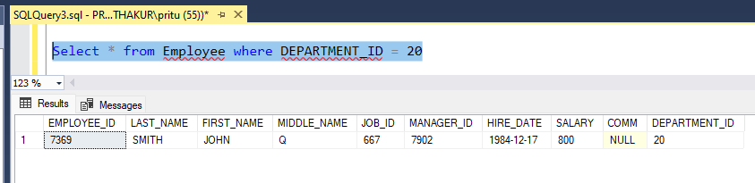

3. List out the employees who are earning salary between 2000 and 3000.
Query: Select * from Employee where salary between 2000 and 3000
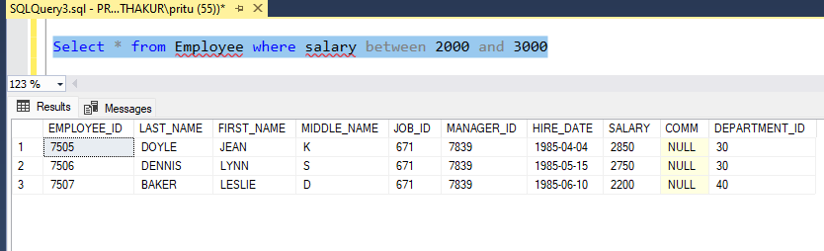

4. List out the employees who are working in department 10 or 20.
Query: Select * from Employee where department_id =10 or department_id =20
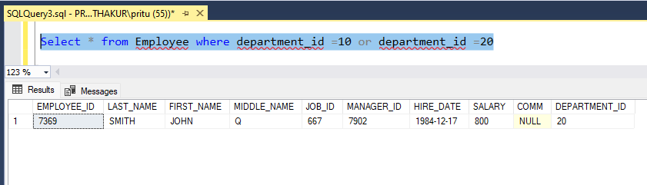

5. Find out the employees who are not working in department 10 or 30.
Query: Select * from Employee where department_id not in(10,30)
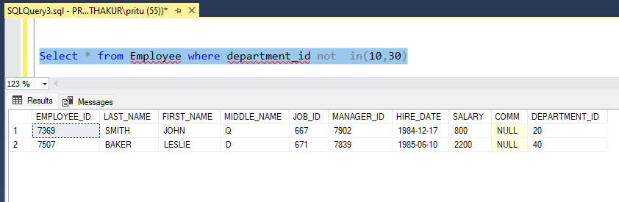

6. List out the employees whose name starts with 'L'.
Query: Select * from Employee where First_name like 'L%'
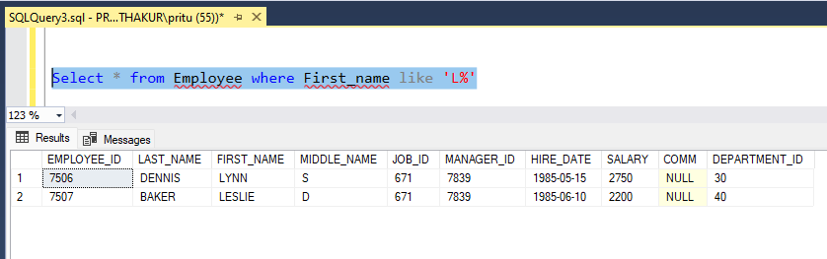

7. List out the employees whose name starts with 'L' and ends with 'E'.
Query: Select * from Employee where First_name like 'L%%E'
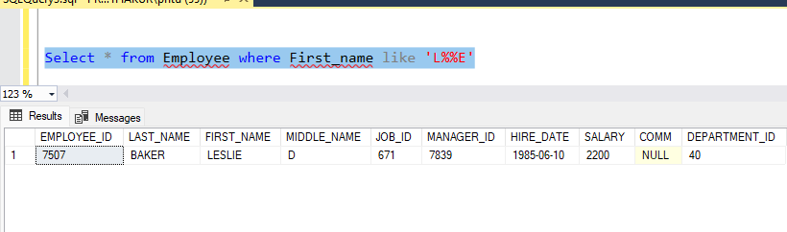

- List out the employees whose name length is 4 and start with 'J'.
Query: Select * from Employee where First_name like 'J___'
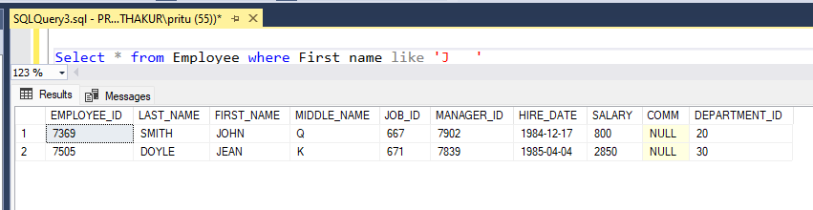

- List out the employees who are working in department 30 and draw the salaries more than 2500.
Query: Select * from Employee where Department_Id = 30 and Salary > 2500
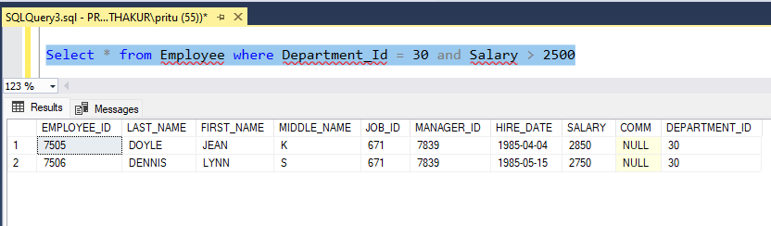

10. List out the employees who are not receiving commission.
Query: Select * from Employee where comm is null

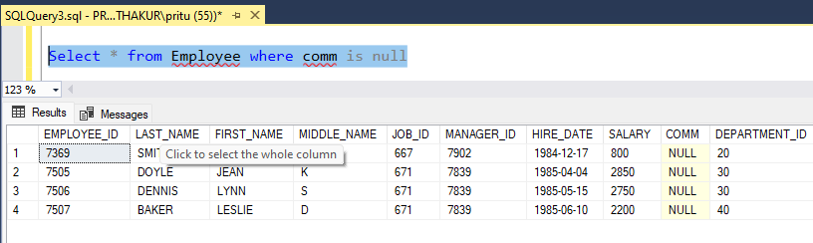

ORDER BY Clause:
- List out the Employee ID and Last Name in ascending order based on the Employee ID.
Query: SELECT EMPLOYEE_ID,LAST_NAME FROM EMPLOYEE ORDER BY EMPLOYEE_ID ASC
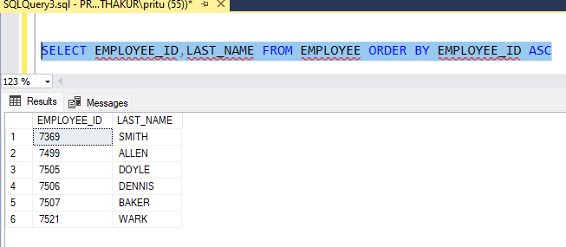

2. List out the Employee ID and Name in descending order based on salary.
Query: SELECT SALARY,EMPLOYEE_ID,FIRST_NAME,LAST_NAME FROM EMPLOYEE ORDER BY SALARY DESC
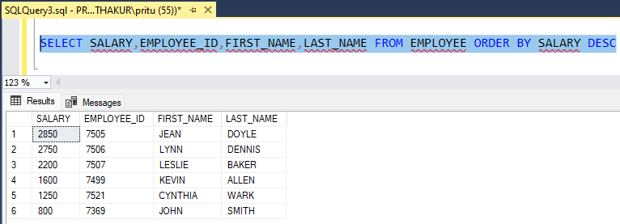

3. List out the employee details according to their Last Name in ascending-order.
Query: SELECT * FROM EMPLOYEE ORDER BY LAST_NAME ASC
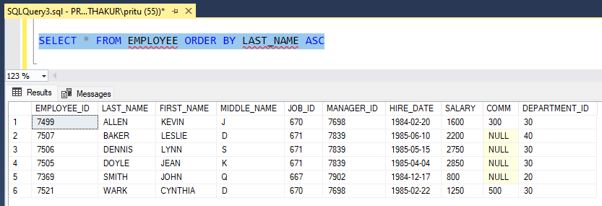
4. List out the employee details according to their Last Name in ascending order and then Department ID in descending order.
Query: SELECT * FROM employee
ORDER BY last_name ASC, department_id DESC;
SELECT * FROM employee
ORDER BY department_id DESC, last_name ASC;

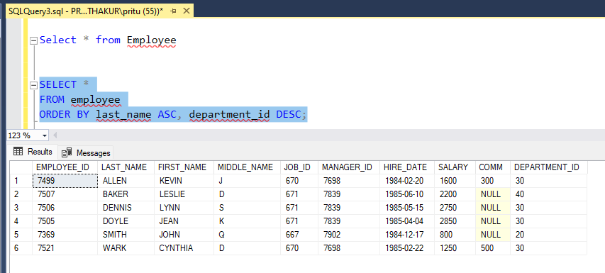
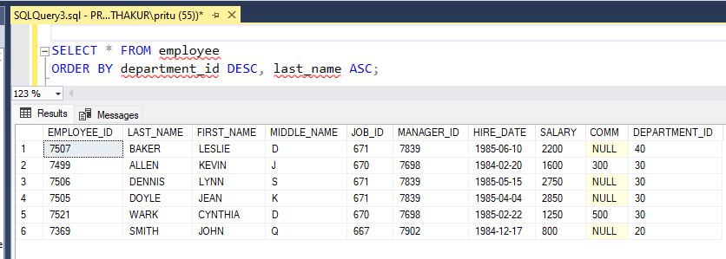

GROUP BY and HAVING Clause:
- List out the department wise maximum salary, minimum salary, and average salary of the employees.
Query: Select max(SALARY) as Maximum_Salary,Min (Salary)as Minimum_Salary,avg(Salary) as Average_Salary,DEPARTMENT_ID from EMPLOYEE
group by DEPARTMENT_ID
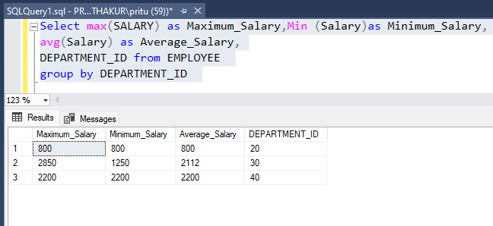

2. List out the job wise maximum salary, minimum salary and average salary of the employees.
Query: Select JOB_ID,
max(SALARY) as Maximum_Salary,
Min (Salary)as Minimum_Salary,
avg(Salary) as Average_Salary
from EMPLOYEE
group by JOB_ID
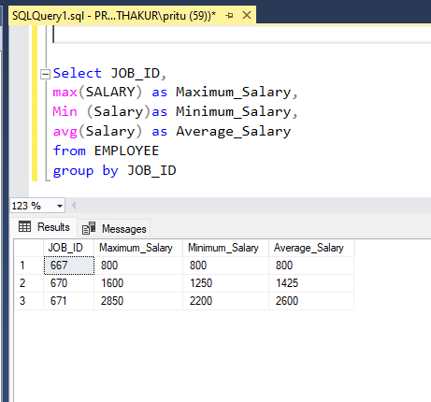

3. List out the number of employees who joined each month in ascending order.

Query:
SELECT
FORMAT(hire_date, 'yyyy-mm-dd') AS DateOfJoining,
COUNT(*) AS EmployeeCount
FROM Employee
GROUP BY FORMAT (hire_date, 'yyyy-mm-dd')
ORDER BY DateOfJoining ASC;

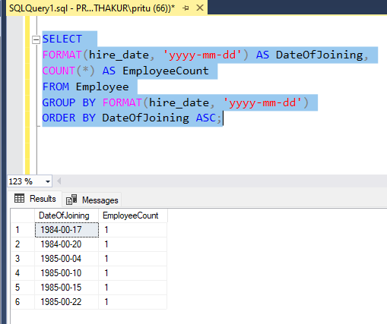

4. List out the number of employees for each month and year in ascending order based on the year and month.
Query: SELECT
YEAR(HIRE_DATE) AS Year,
MONTH(HIRE_DATE) AS Month,
COUNT(*) AS EmployeeCount
FROM EMPLOYEE
GROUP BY YEAR(HIRE_DATE), MONTH(HIRE_DATE)
ORDER BY Year ASC, Month ASC;
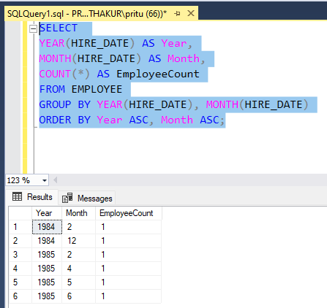

- List out the Department ID having at least four employees.
Query:
SELECT DEPARTMENT_ID,COUNT(*) AS EMPLOYEE_COUNT FROM EMPLOYEE
GROUP BY DEPARTMENT_ID HAVING COUNT(*) >= 4
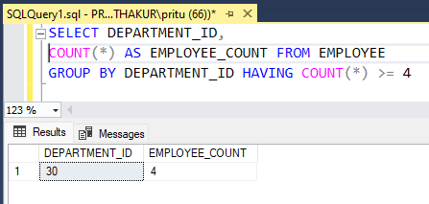

6. How many employees joined in February month.
Query:
SELECT HIRE_DATE,EMPLOYEE_ID FROM EMPLOYEE GROUP BY HIRE_DATE,EMPLOYEE_ID HAVING MONTH(HIRE_DATE)=2
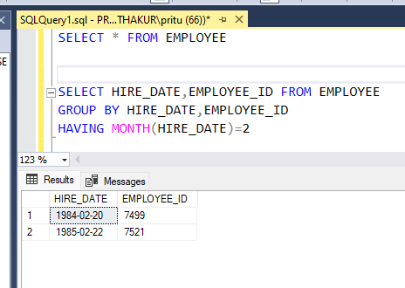

- How many employees joined in May or June month.
Query:
SELECT HIRE_DATE,EMPLOYEE_ID FROM EMPLOYEE
GROUP BY HIRE_DATE,EMPLOYEE_ID
HAVING MONTH(HIRE_DATE)in(5,6)
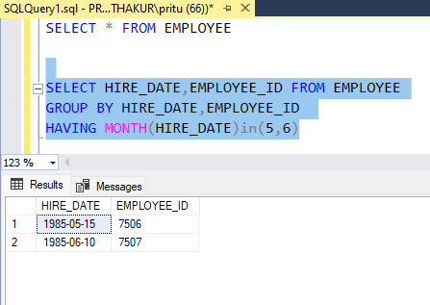

8. How many employees joined in 1985?
Query:
SELECT HIRE_DATE,EMPLOYEE_ID FROM EMPLOYEE
GROUP BY HIRE_DATE,EMPLOYEE_ID
HAVING YEAR(HIRE_DATE) = 1985

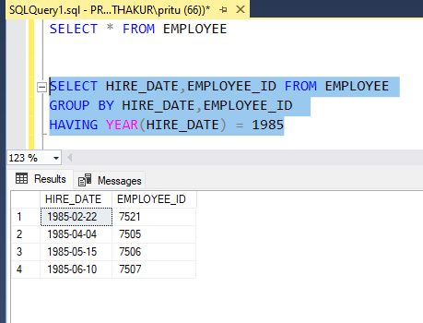

9. How many employees joined each month in 1985?
Query:
SELECT
MONTH(HIRE_DATE) AS HIRING_MONTH,
EMPLOYEE_ID
FROM EMPLOYEE
GROUP BY HIRE_DATE,EMPLOYEE_ID
HAVING YEAR(HIRE_DATE) = 1985
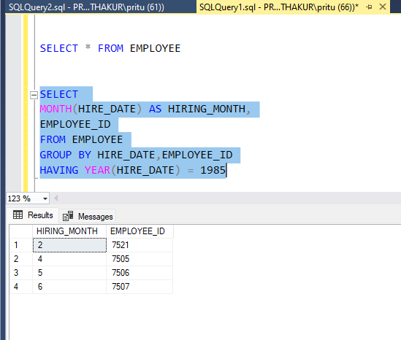

10. How many employees were joined in April 1985?
Query:
SELECT COUNT(*) AS EmployeeHiredInApril85
FROM EMPLOYEE
GROUP BY YEAR(hire_date), MONTH(hire_date)
HAVING YEAR(hire_date) = 1985
AND MONTH(hire_date) = 4;

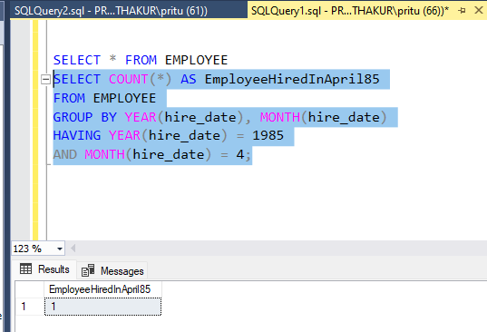

11. Which is the Department ID having greater than or equal to 3 employees joining in April 1985?
Query:
SELECT DEPARTMENT_ID,
COUNT(*) AS EmployeeCount
FROM EMPLOYEE
WHERE YEAR(hire_date) = 1985
AND MONTH(hire_date) = 4
GROUP BY department_id
HAVING COUNT(*) >= 3
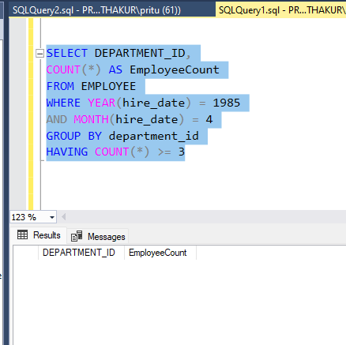

Joins:
- List out employees with their department names.
Query:
Select e.EMPLOYEE_ID,e.LAST_NAME,e.FIRST_NAME,e.JOB_ID,
e.MANAGER_ID,e.SALARY,e.DEPARTMENT_ID ,d.Name from EMPLOYEE as e
JOIN DEPARTMENT as d
ON e.DEPARTMENT_ID=d.Department_Id
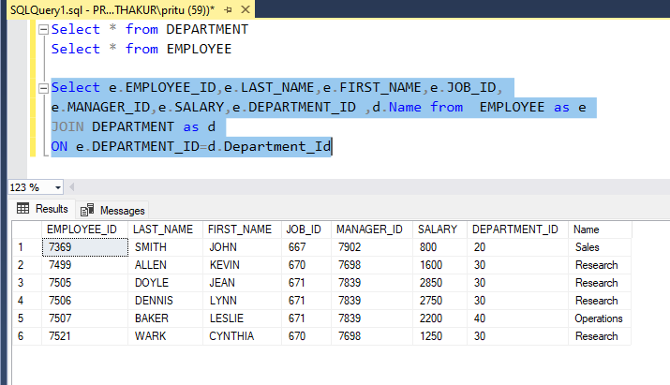

- Display employees with their designations.
Query:
Select e.EMPLOYEE_ID,e.LAST_NAME,e.FIRST_NAME,
e.JOB_ID,j.Designation from EMPLOYEE as e
JOIN JOB as j
ON e.JOB_ID=j.Job_ID
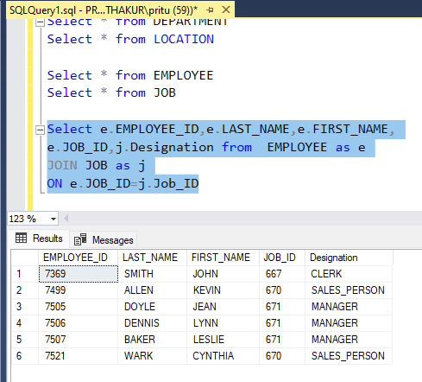
- Display the employees with their department names and city.
Query:
Select E.EMPLOYEE_ID,E.LAST_NAME,E.FIRST_NAME,
E.DEPARTMENT_ID,L.Location_ID,L.City,D.Name from EMPLOYEE as E
JOIN DEPARTMENT as D
ON E.DEPARTMENT_ID = D.Department_Id
Join LOCATION as L
on D.Location_Id =L.Location_ID
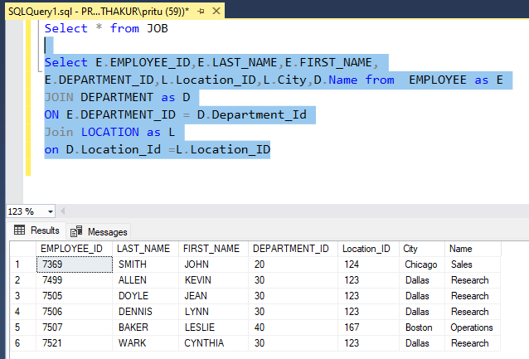

- How many employees are working in different departments? Display with department names.
Query:
Select Count(EMPLOYEE_ID) as E_Count,d.Name from EMPLOYEE as e
join DEPARTMENT as d
on E.DEPARTMENT_ID = d.Department_Id
group by d.Name
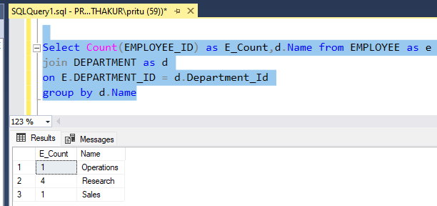
- How many employees are working in the sales department?
Query;
Select Count(e.EMPLOYEE_ID) as E_Count from EMPLOYEE as e
join DEPARTMENT as d
on E.DEPARTMENT_ID = d.Department_Id
where d.Name ='Sales'

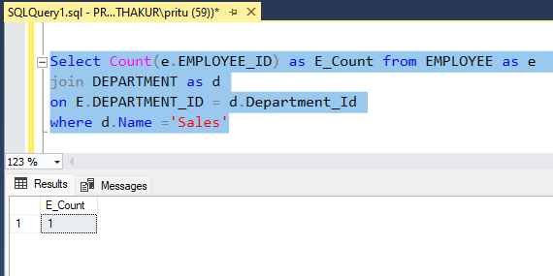
- Which is the department having greater than or equal to 3 employees and display the department names in ascending order.
Query:
Select Count(E.EMPLOYEE_ID) as Employee_Count,D.Name from Employee as E
join DEPARTMENT as D
on E.DEPARTMENT_ID = D.Department_Id
group by D.Name
having Count(E.EMPLOYEE_ID) >= 3
Order by D.Name asc
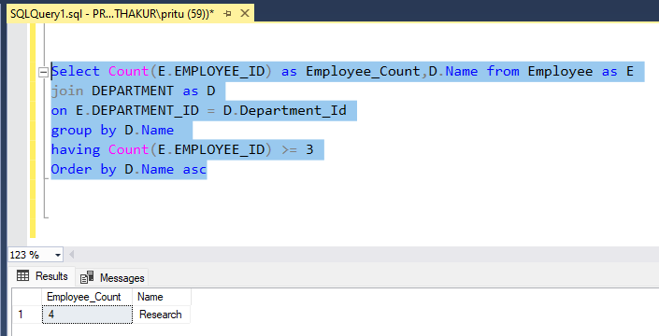
- How many employees are working in 'Dallas'?
Query:
Select Count(E.EMPLOYEE_ID) as Employee_Count, L.City from Employee as E
join DEPARTMENT as D
on E.DEPARTMENT_ID = D.Department_Id
join Location as L
on D.Location_Id = L.Location_ID
group by L.City
having L.city ='Dallas'

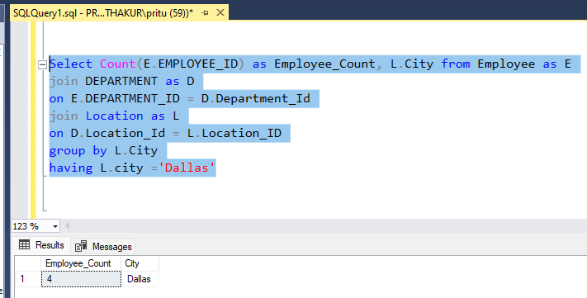

- Display all employees in sales or operation departments.
Query:
Select E.EMPLOYEE_ID, E.FIRST_NAME,E.LAST_NAME,
E.JOB_ID,E.MANAGER_ID,E.SALARY, D.Name from Employee as E
join DEPARTMENT as D
on E.DEPARTMENT_ID = D.Department_Id
where D.Name in ('Sales','Operations')
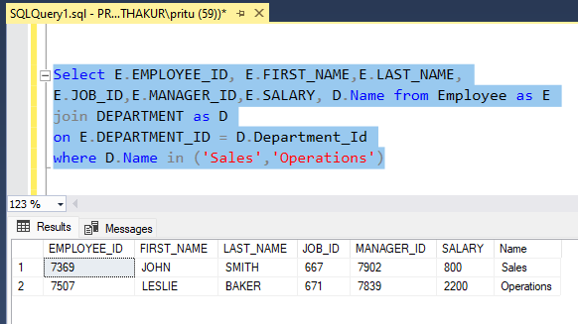

CONDITIONAL STATEMENT
- Display the employee details with salary grades. Use conditional statement to create a grade column.
Query:
Select EMPLOYEE_ID,FIRST_NAME,LAST_NAME,SALARY,
CASE
When Salary>= 2500 Then 'A'
When Salary>= 2000 Then 'B'
When Salary>= 1200 Then 'C'
When Salary>= 800 Then 'D'
Else 'E'
End as Salary_Grade
from EMPLOYEE;
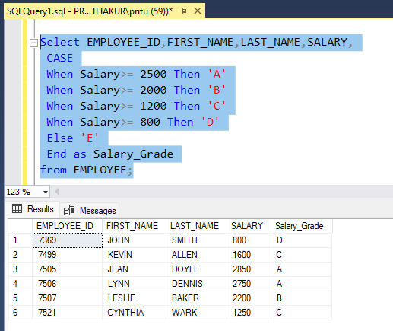

- List out the number of employees grade wise. Use conditional statement to create a grade column.
Query: Select
CASE
When Salary>= 2500 Then 'A'
When Salary>= 2000 Then 'B'
When Salary>= 1200 Then 'C'
When Salary>= 800 Then 'D'
Else 'E'
End as Salary_Grade,
COUNT(EMPLOYEE_ID) AS EMPLOYEE_COUNT
from EMPLOYEE
Group By
CASE
When Salary>= 2500 Then 'A'
When Salary>= 2000 Then 'B'
When Salary>= 1200 Then 'C'
When Salary>= 800 Then 'D'
Else 'E'
End
Order By Salary_Grade
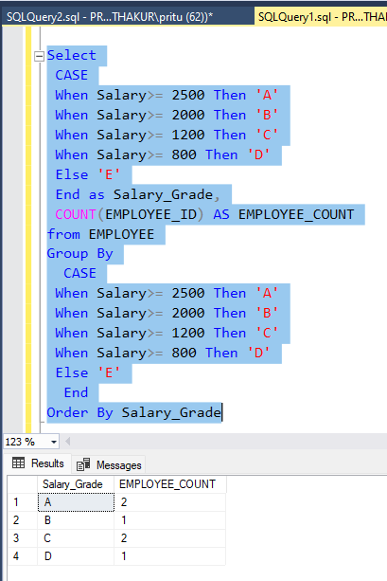

- Display the employee salary grades and the number of employees between 2000 to 5000 range of salary.
Query:
Select
CASE
When Salary>= 2500 Then 'A'
When Salary>= 2000 Then 'B'
When Salary>= 1200 Then 'C'
When Salary>= 800 Then 'D'
Else 'E'
End as Salary_Grade,
COUNT(EMPLOYEE_ID) AS EMPLOYEE_COUNT
from EMPLOYEE WHERE SALARY BETWEEN 2000 AND 5000
Group By
CASE
When Salary>= 2500 Then 'A'
When Salary>= 2000 Then 'B'
When Salary>= 1200 Then 'C'
When Salary>= 800 Then 'D'
Else 'E'
End
Order By Salary_Grade

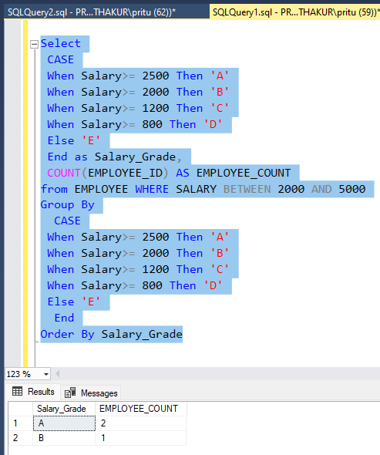

Subqueries:
- Display the employees list who got the maximum salary.
Query: SELECT *
FROM EMPLOYEE
WHERE salary = (
SELECT MAX(salary)
FROM EMPLOYEE
)
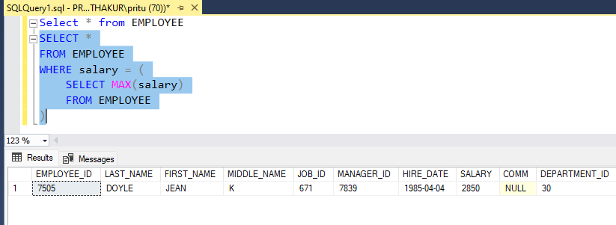
- Display the employees who are working in the sales department.
Query: SELECT *
FROM EMPLOYEE
WHERE DEPARTMENT_ID = (
SELECT DEPARTMENT_ID
FROM DEPARTMENT
WHERE Name = 'sales'
)
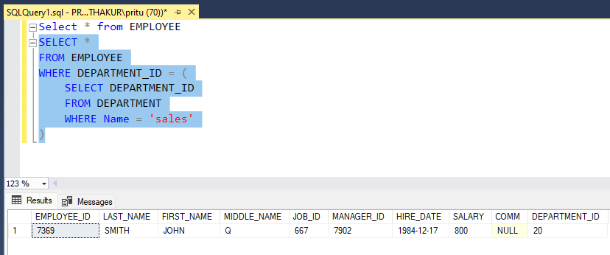
- Display the employees who are working as 'Clerk'.
Query: SELECT *
FROM EMPLOYEE
WHERE JOB_ID = (
SELECT JOB_ID
FROM JOB
WHERE Designation = 'Clerk')
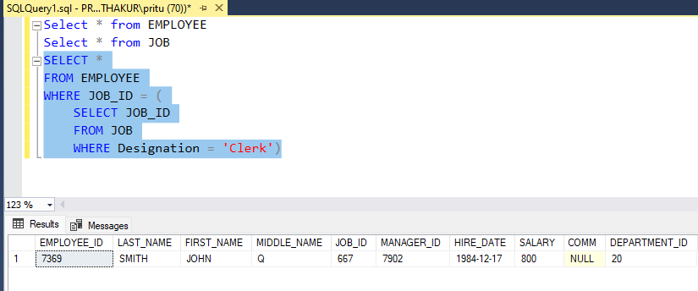

- Display the list of employees who are living in 'Boston'.
Query:
Select * from EMPLOYEE where DEPARTMENT_ID In
(Select Department_Id from DEPARTMENT where
Location_Id =(Select Location_Id from LOCATION where City='Boston'))
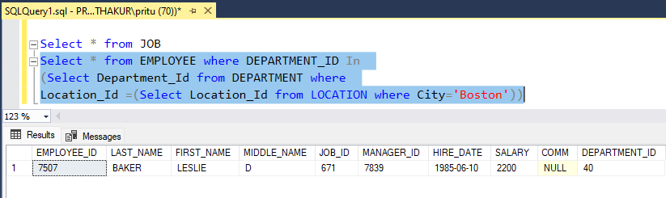

- Find out the number of employees working in the sales department.
Query: Select count(*) as Employees_in_Sales_Dept from EMPLOYEE
where DEPARTMENT_ID IN
(select Department_Id from DEPARTMENT
where Name = 'Sales')
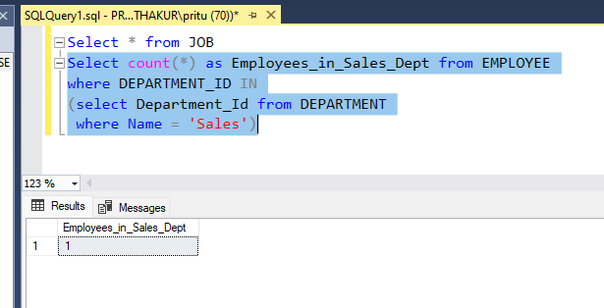
- Update the salaries of employees who are working as clerks on the basis of 10%.
Query: UPDATE EMPLOYEE
SET Salary = Salary *1.10
Where Job_Id IN
(Select J.Job_ID from JOB J where Designation='Clerk')
Select * from JOB
Select * From EMPLOYEE

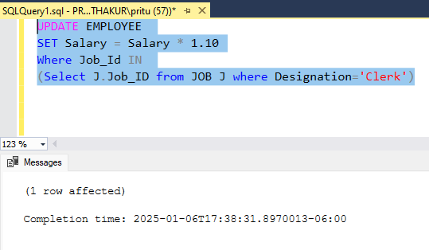

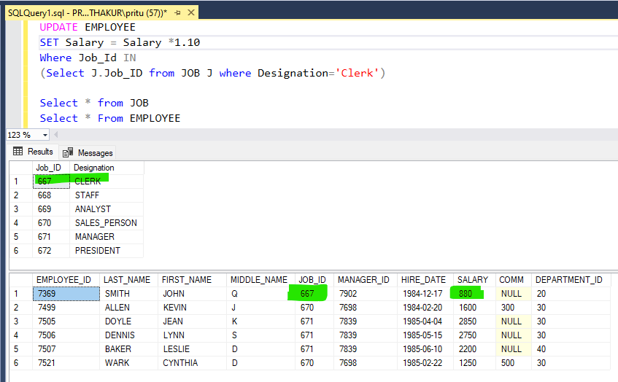
- Display the second highest salary drawing employee details.
Query: Select * from EMPLOYEE
where salary = (select max(salary)from EMPLOYEE
where salary < (select max(salary)from EMPLOYEE))
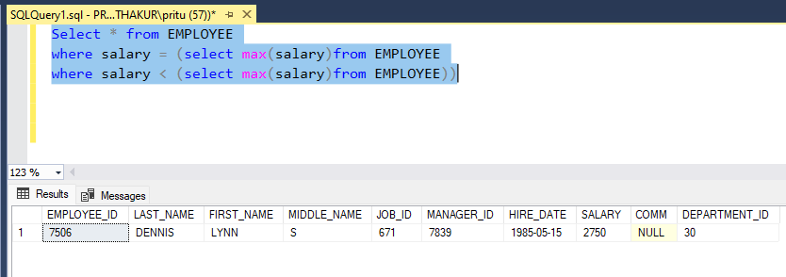
- List out the employees who earn more than every employee in department 30.
Query:
Select * from EMPLOYEE
where salary > (select max(salary)from EMPLOYEE
where DEPARTMENT_ID=30)

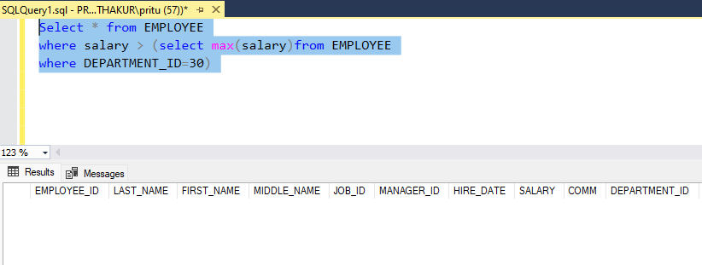

- Find out which department has no employees.
Query:
Select * from DEPARTMENT where Department_Id
not in (Select Distinct Department_Id from EMPLOYEE)
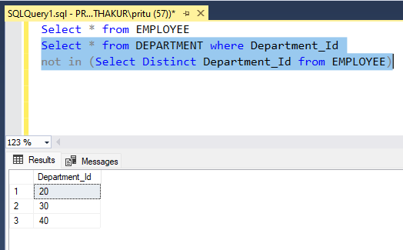
- Find out the employees who earn greater than the average salary for their department.
Query:
Select * from EMPLOYEE E where E.SALARY >
(Select avg(e.SALARY) from EMPLOYEE e
where e.DEPARTMENT_ID = E.DEPARTMENT_ID)

