Module 3 – Assignment
Tasks To Be Performed:
Importing Data from Excel:
- Open Power BI Desktop.

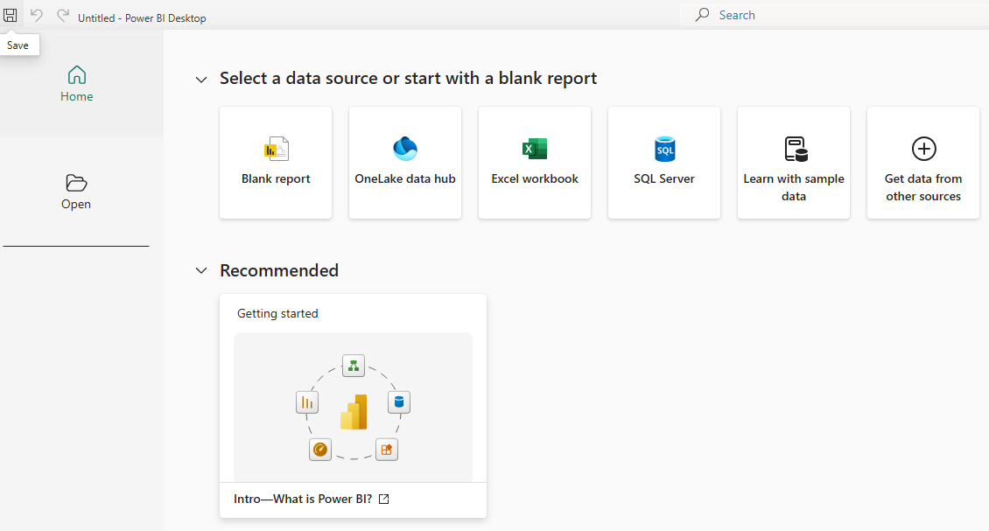
- Import the sales-Europe Excel file.

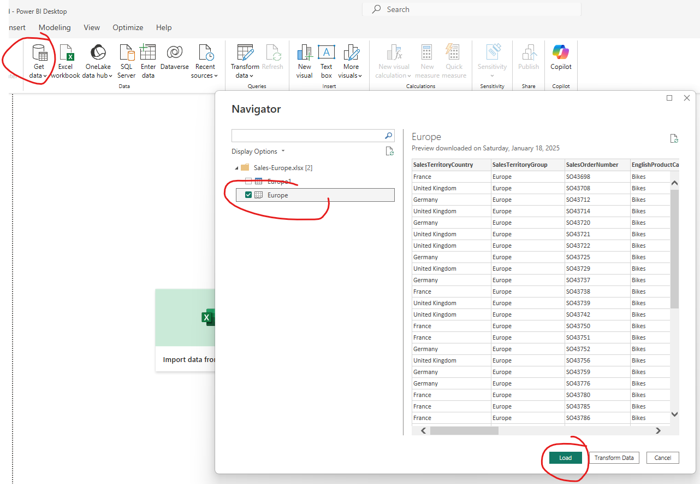
- In the Navigator window, select Europe, and click on Load.

- Import the sales-North America Excel file.

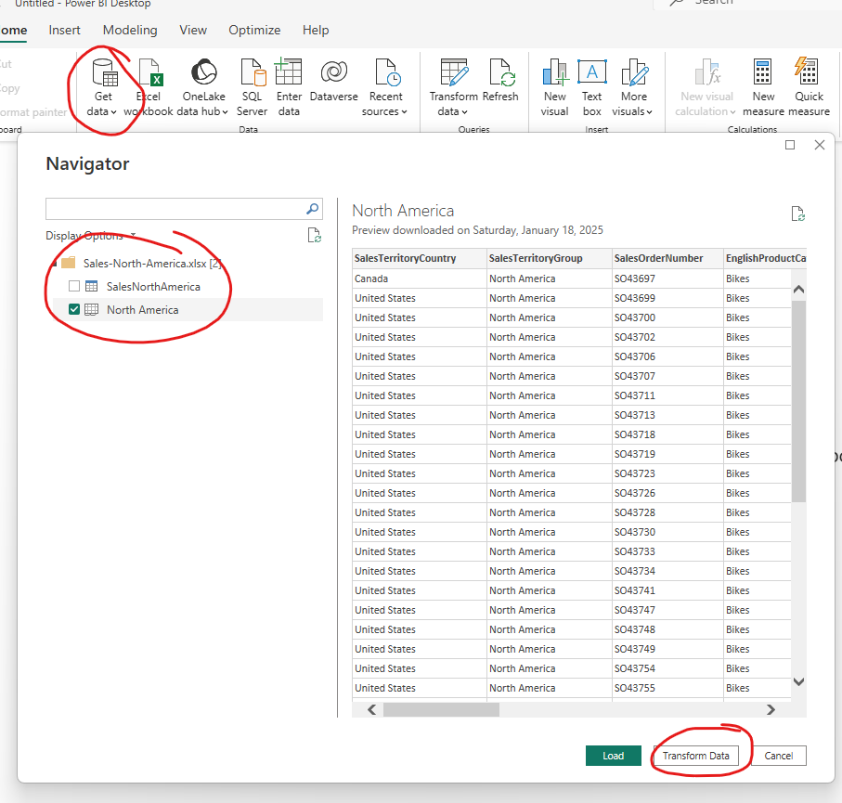

- In the Navigator window, select North America, and click on Transform Data to open in Power Query Editor.
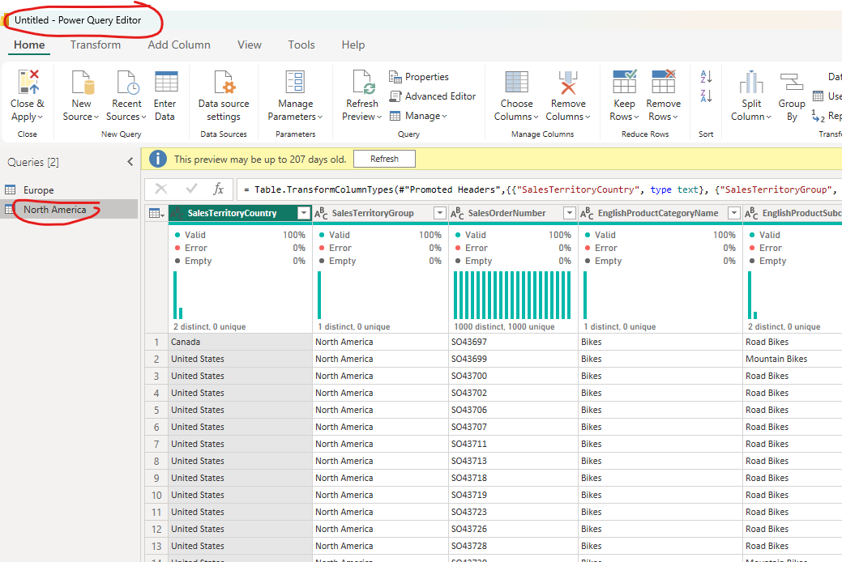

Shaping and Combining Data:
- In the Queries pane, click on Europe to display the data in the preview mode.

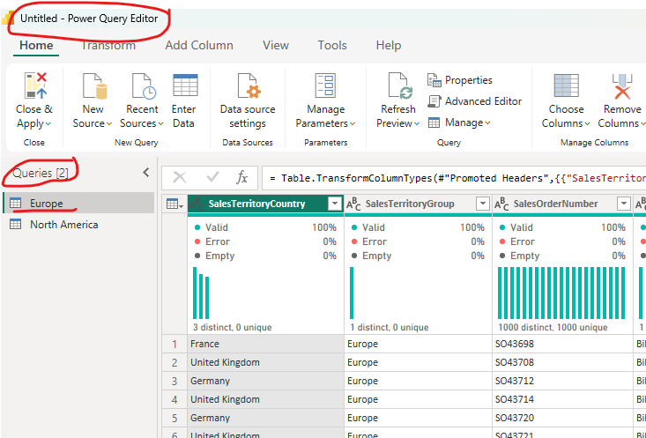
- Remove ProductKey and SalesOrderNumber columns.

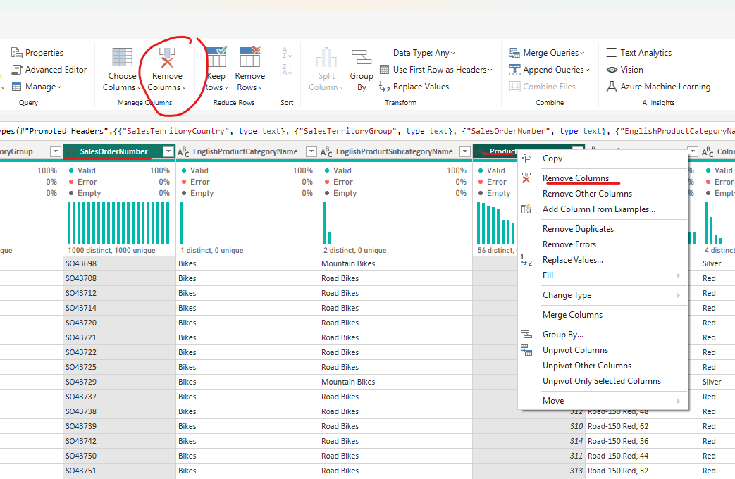

- Rename the SalesTerritoryCountry column to Country.

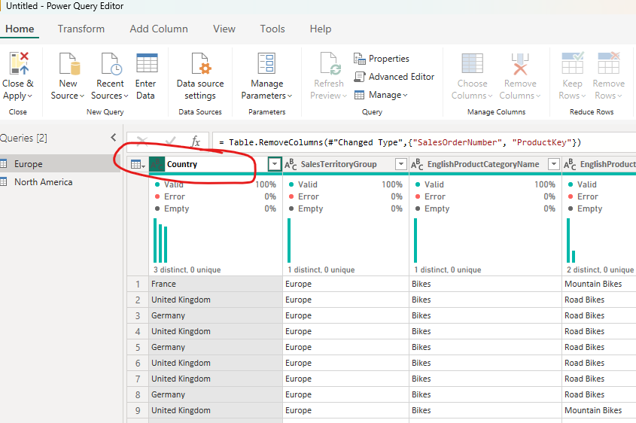
- Rename the SalesTerritoryGroup column to Sales Territory.

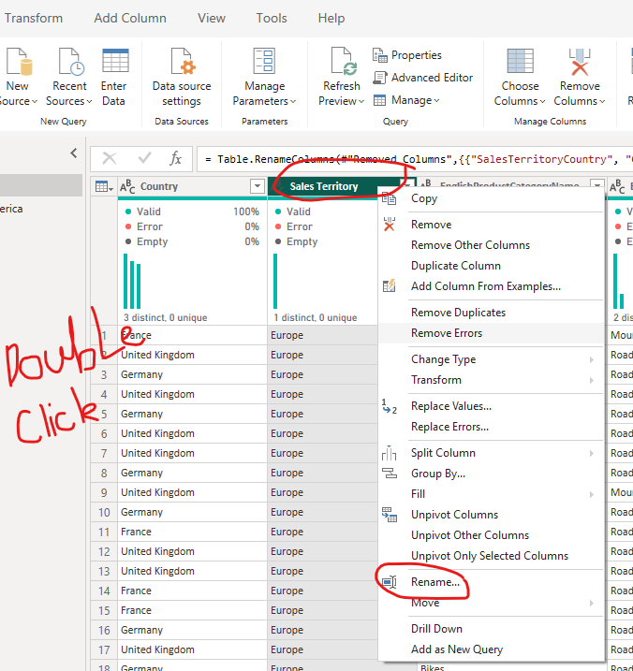

- Rename the EnglishProductCategoryName to Main Category.

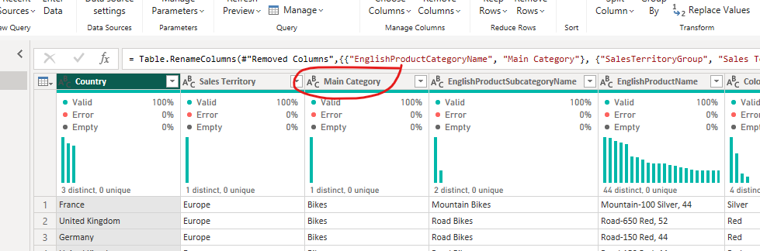

- Rename the EnglishProductSubcategoryName column to Sub Category.

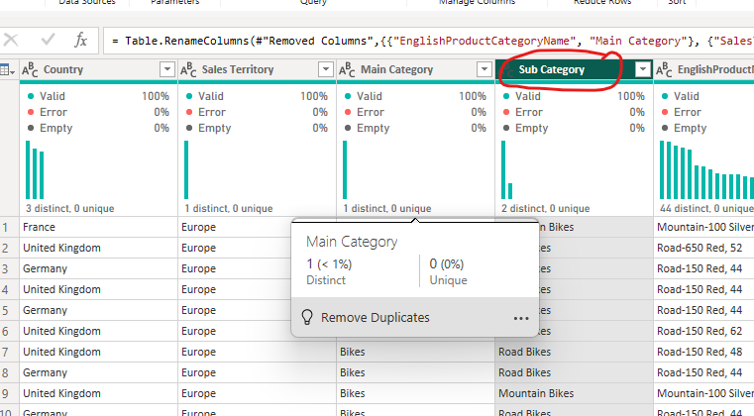

- Rename EnglishProductName to Product.
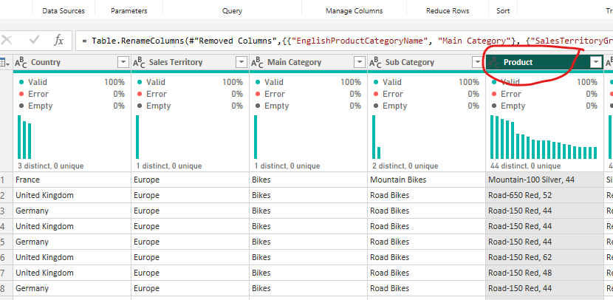

- Move the color column to the left.
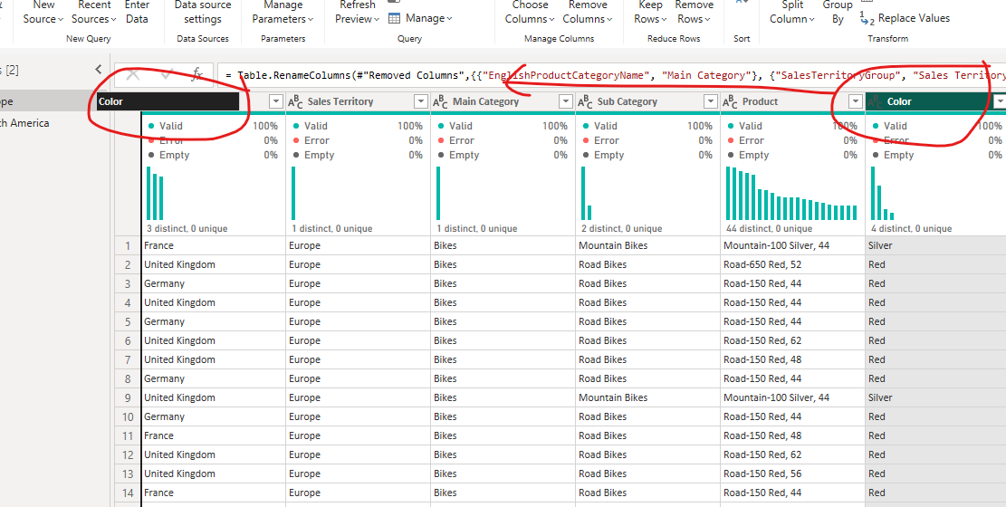

- In the Queries pane, click on North America.
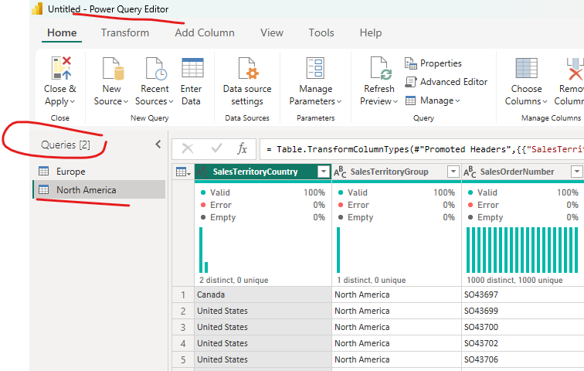

- Repeat Steps from 2 to 8.
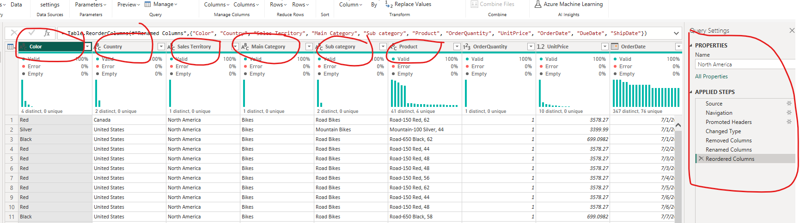

- Append Europe and North America tables.
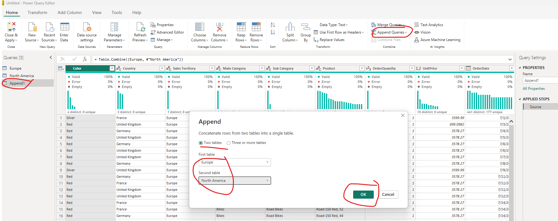
- Import the country code.xlsx.

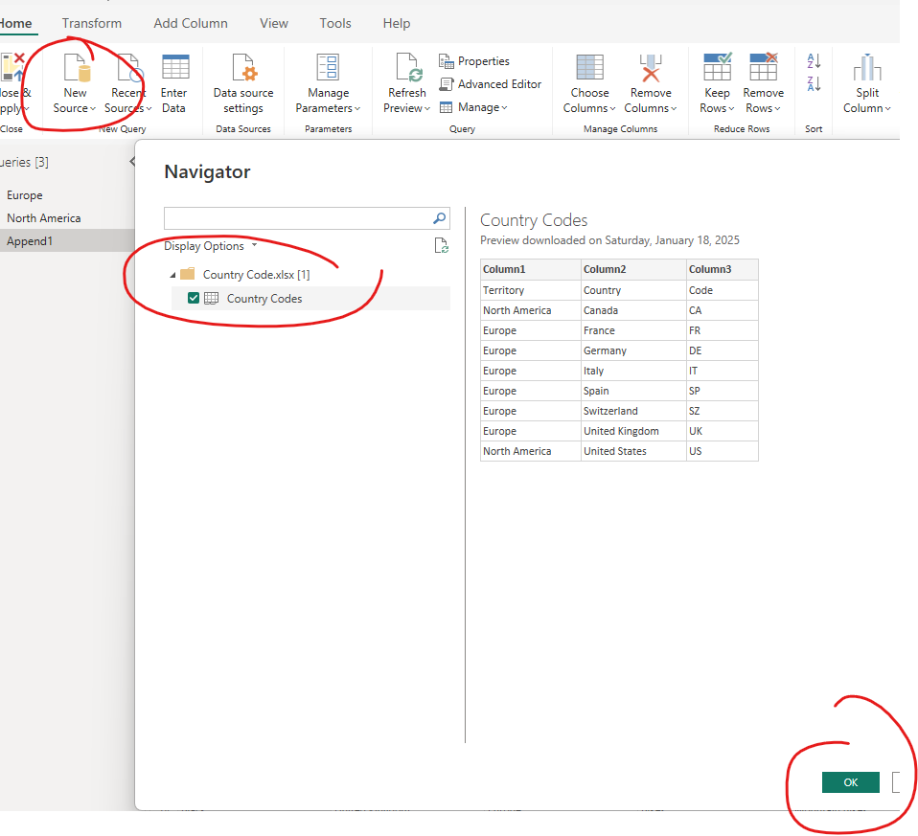
- Merge the country code query with Europe.
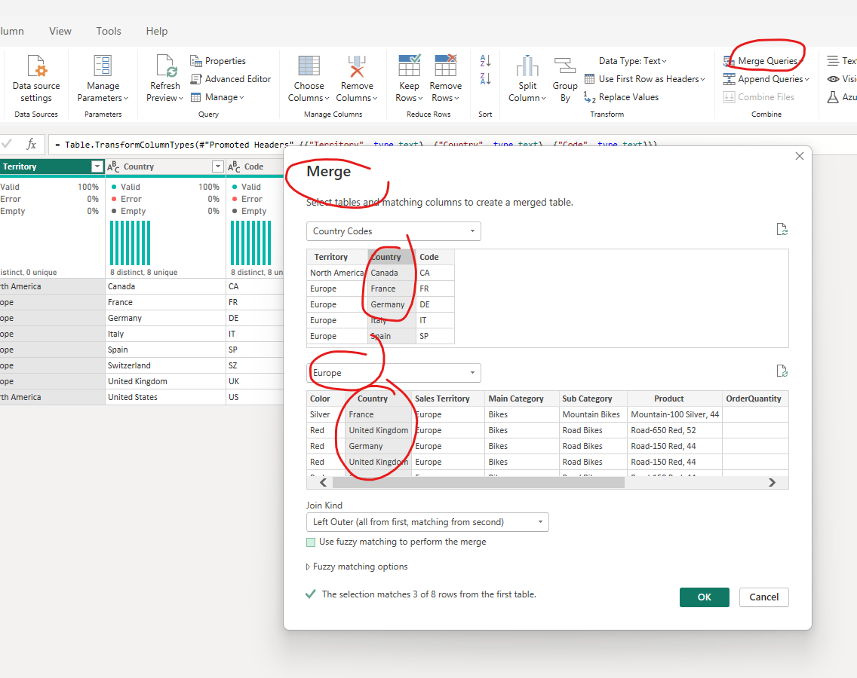

- Get the country code from the merged column, and move it to the beginning of the table.

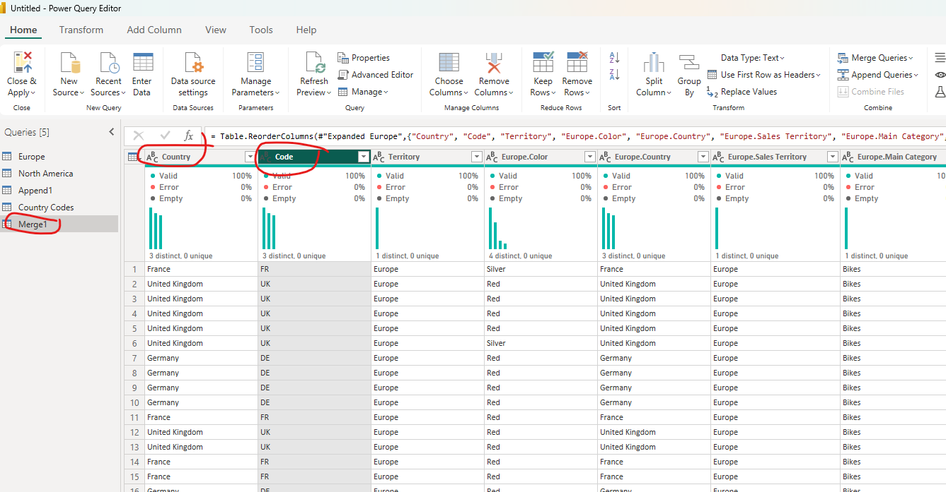
- Rename the Code column to Country Code.

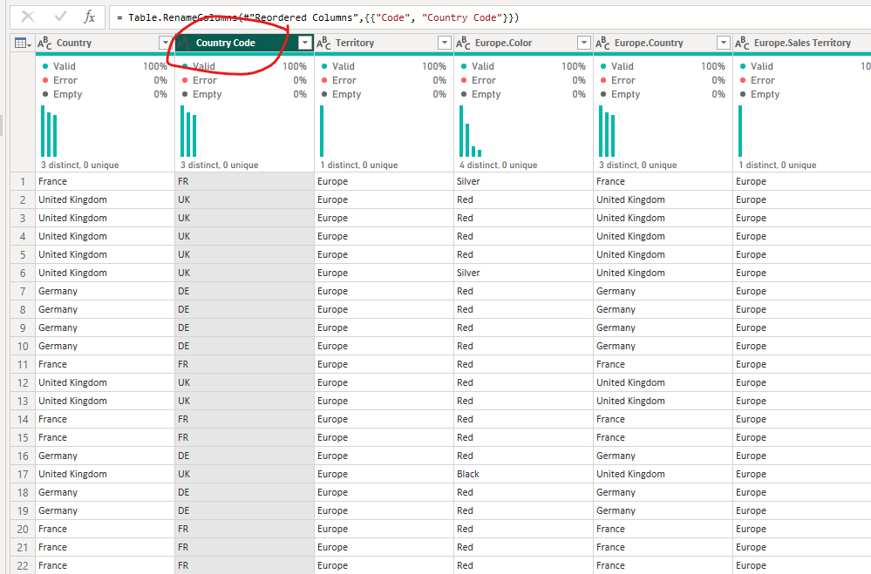
- Save the file as Shaping and Combining Data.
