Tasks To Be Performed
- Publish the report created in the Assignment 5 to the Power BI Service.
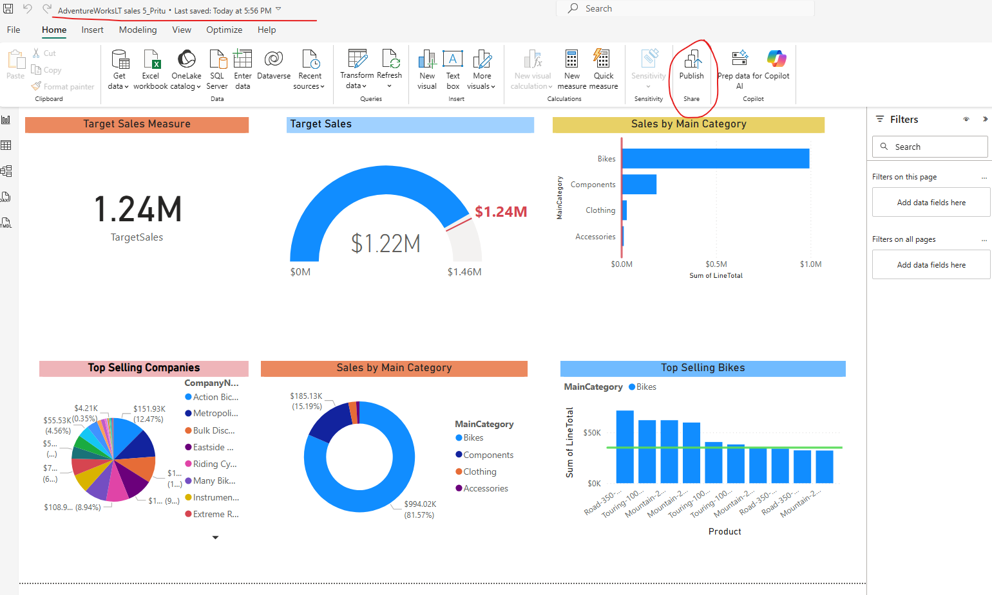

- Create a new dashboard called Sales.

- Pin Target Sales, Top Selling Customers, Orders by Main Category, Top Selling Bikes, Sales by Main Category visuals to the Sales Dashboard.

- Open Sales Dashboard, add a subtitle as Sales Target for 2020 under Target Sales Visual.
Solution: For 2,3 and 4 task link to Dashboard – Sales_PT - Power BI

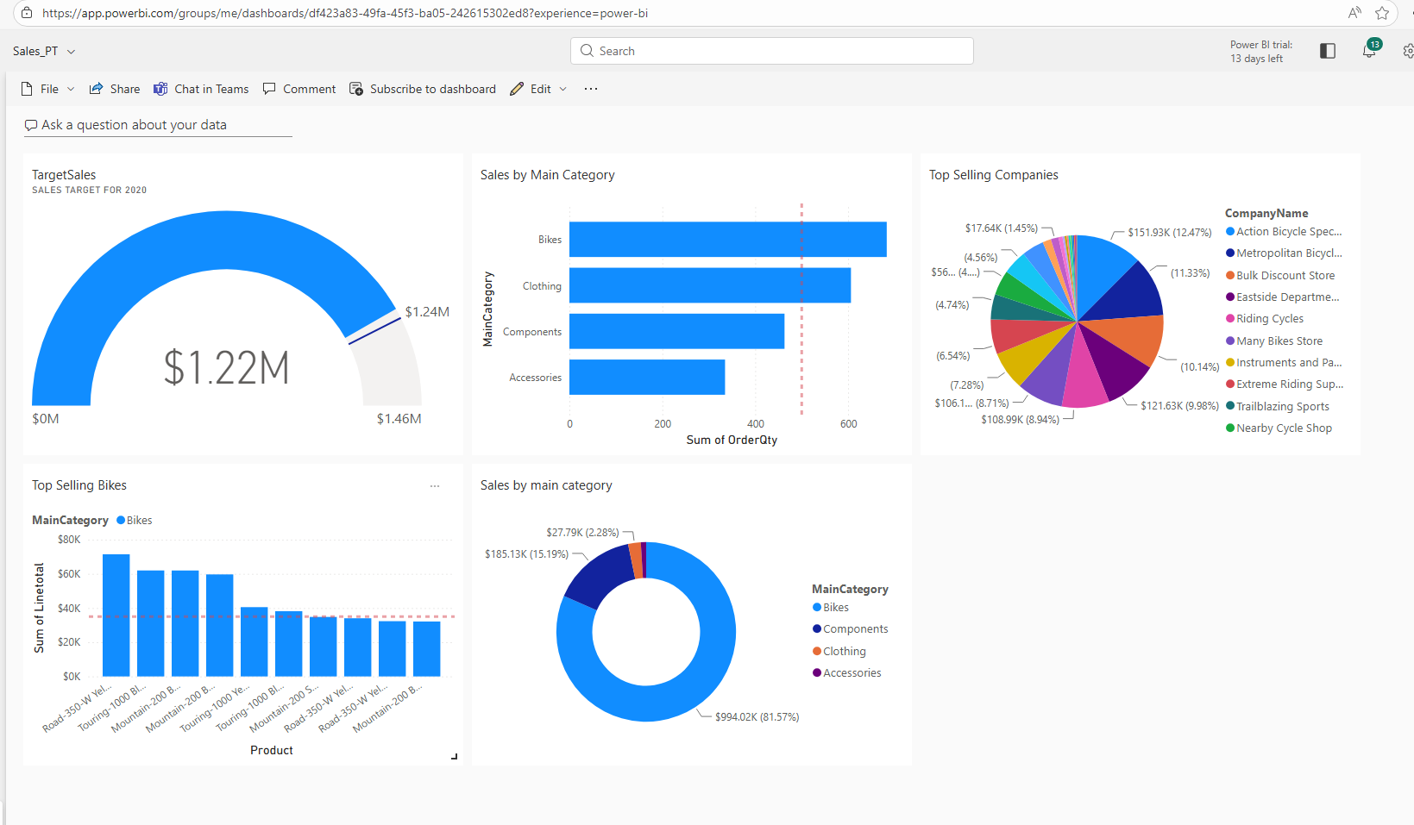

- Open the top selling bikes in Focus Mode and change the Line Total is greater than 32000 to 40000 and Exit Focus Mode.
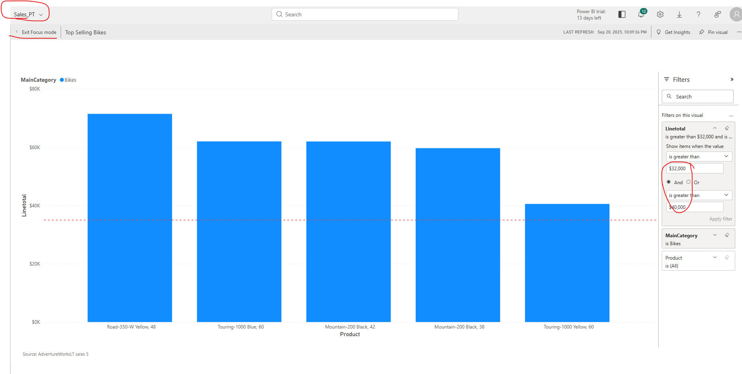

- Use Q&A feature to find out the top country regions by Target Sales and use Pie Chart to visualize it.
- Pin that visual to the Sales Dashboard.
Solution – could not perform task 7 and 8 due to below error.

