CASE STUDY - Using Files as a Data Source

The tasks to be completed:
- Reduce the size of the Excel file by formatting it.
Solution: On home tab on excel ribbon Editing ClearClear Format.

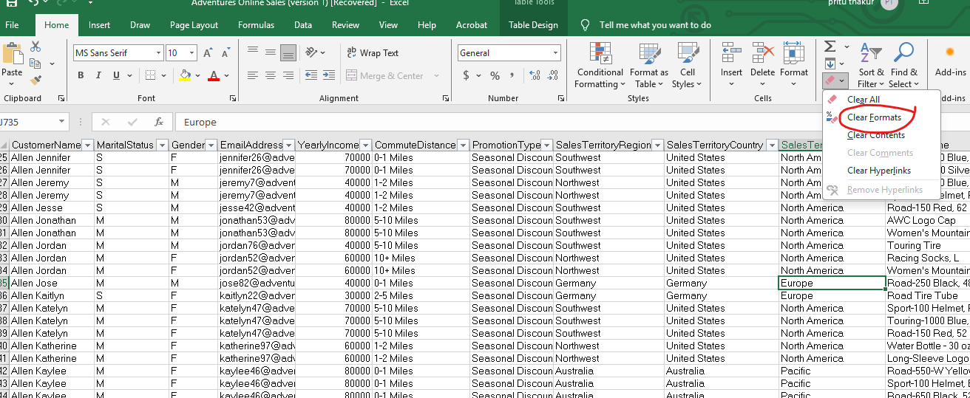

- Change the cell style to normal.
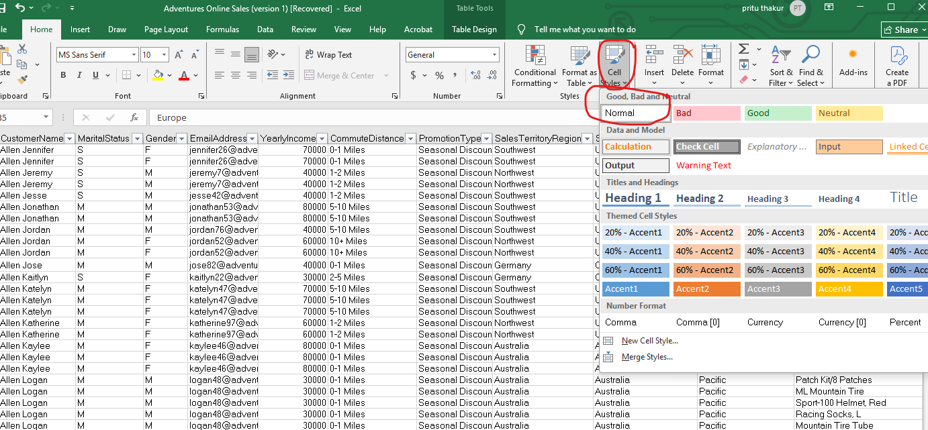
3.Convert the cells into table.
Since its already in table format option is greyed out in Insert ribbon.
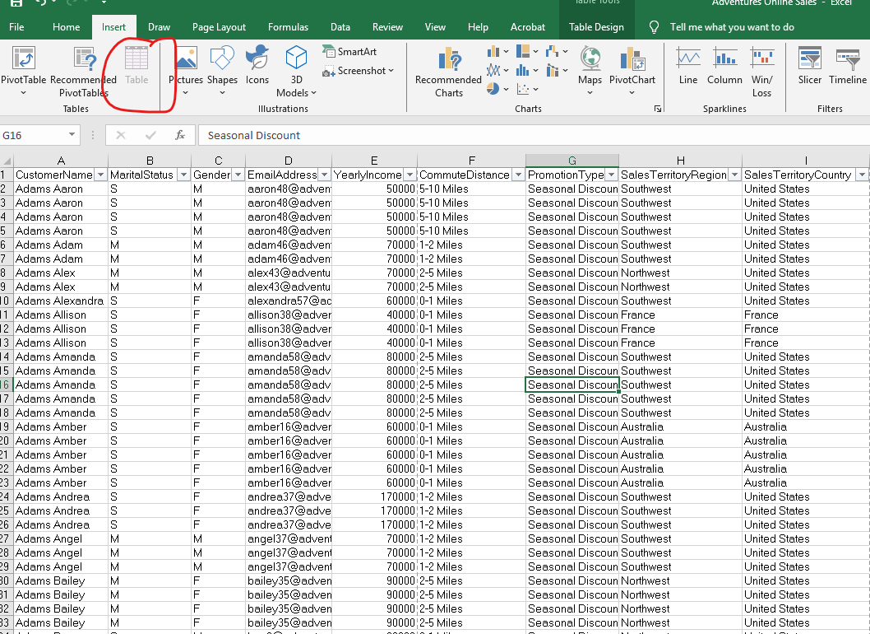
Import Adventure Sales excel file into Power BI Desktop.
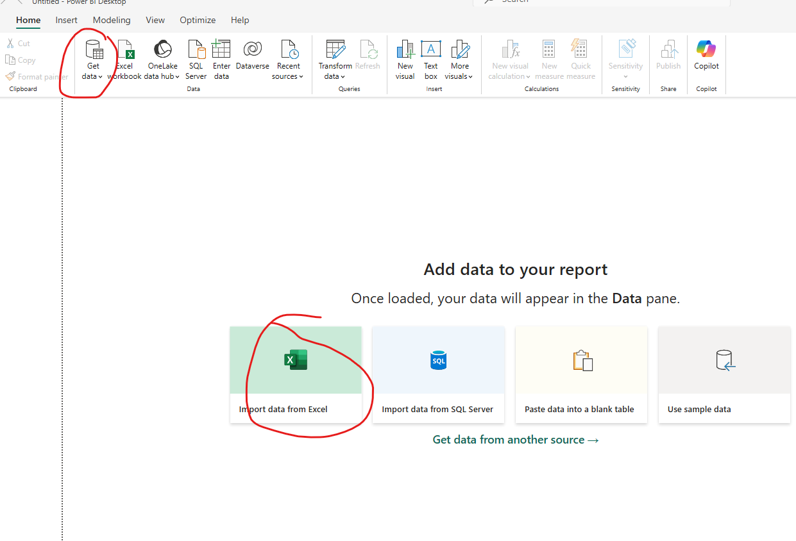
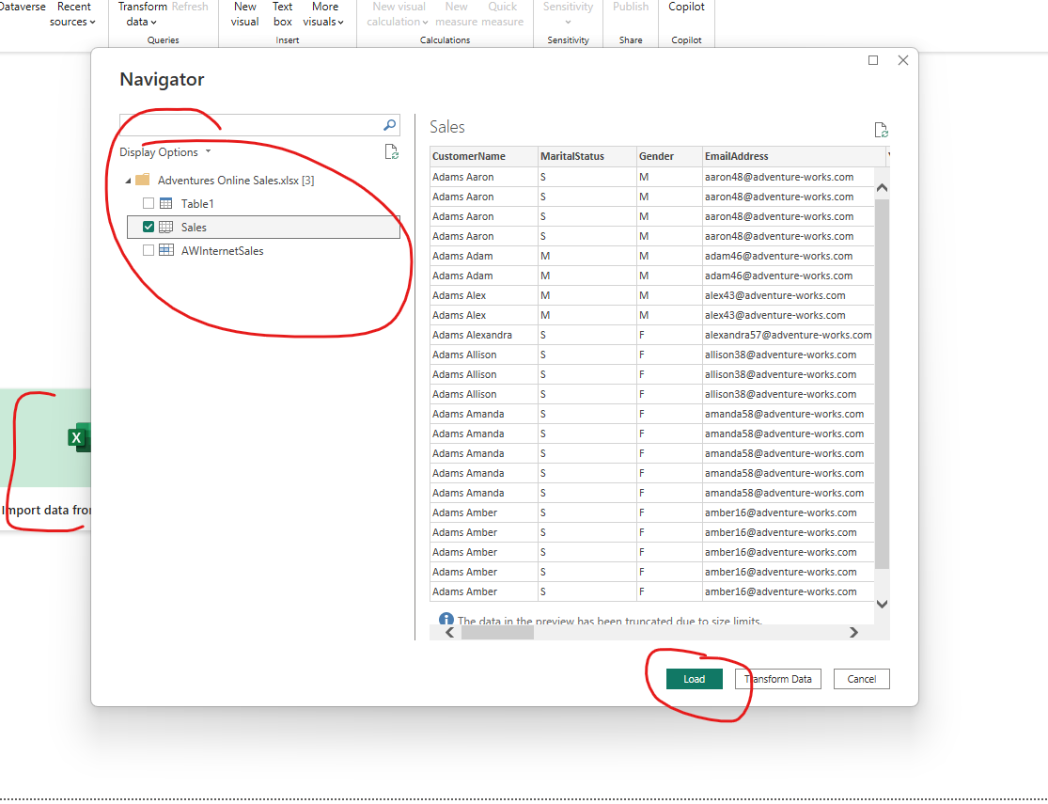

Data Loaded.

5.Convert the Order Date, Due Date and ShipDate to a Date type in Power BI Desktop.
Solution: Ctrl+Select 3 Columns right click Change type Date
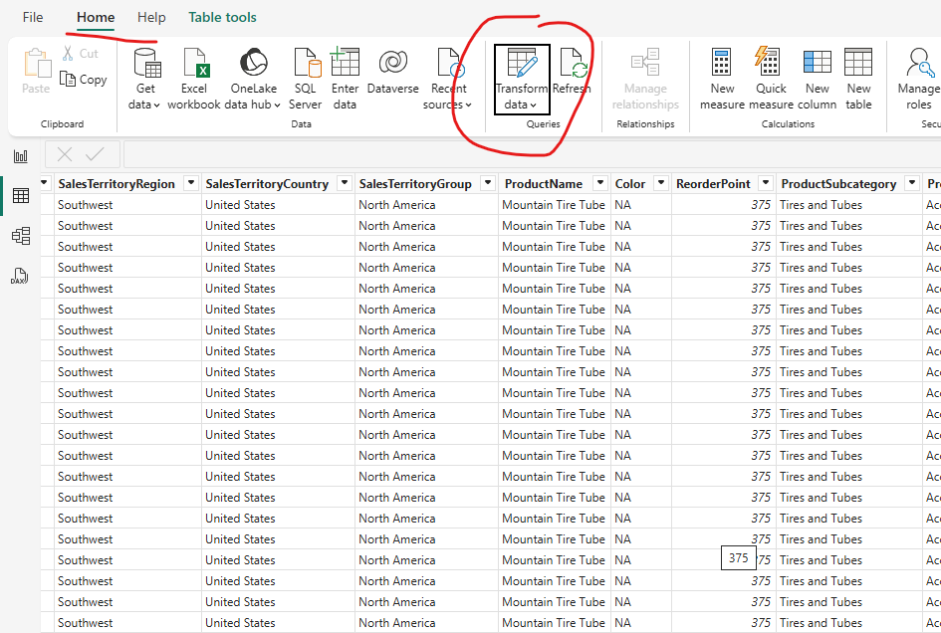
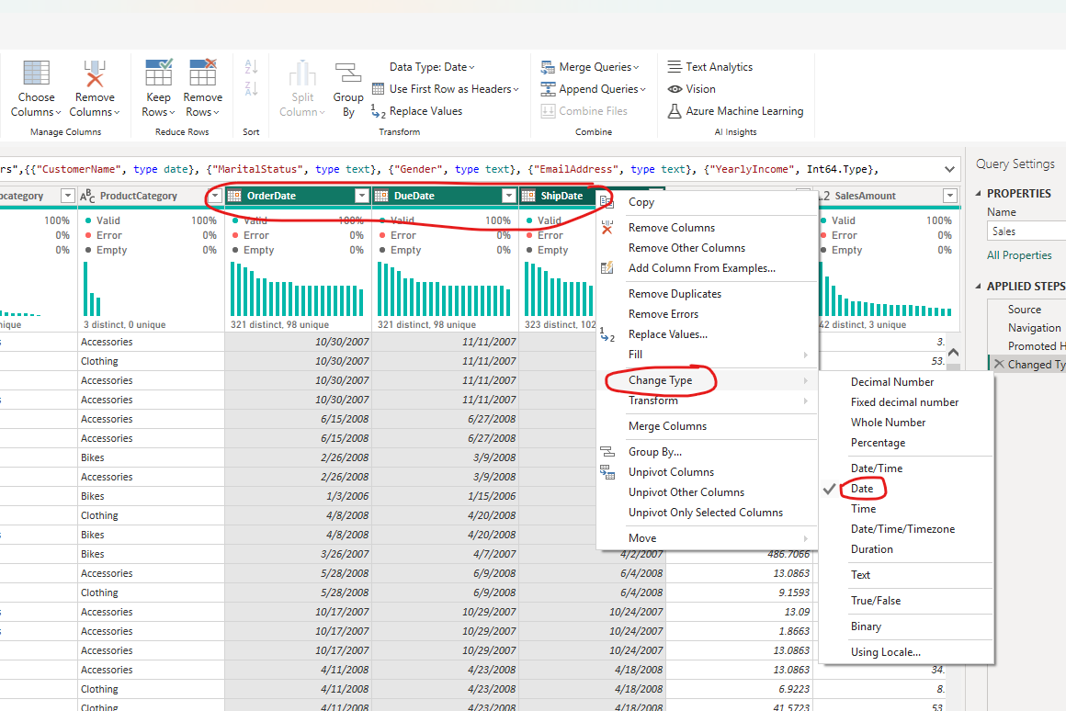

6. Convert the Standard Cost, Sales Amount, Tax Amt to the US Dollar Currency type.
Solution: Following same steps as above fir currency as well

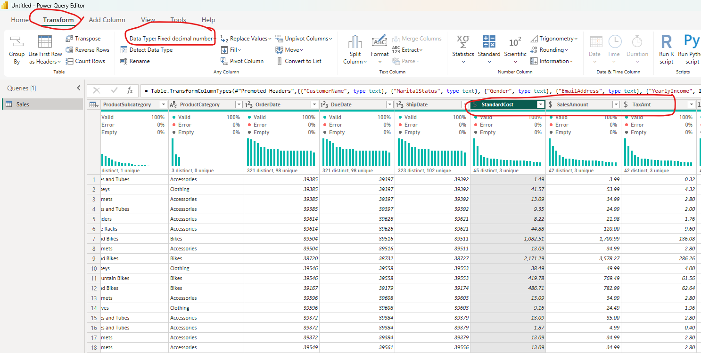
7. Load Sales table into Power BI Desktop
Solution: Already performed in Task 4 import Adventure Sales excel file into Power BI Desktop

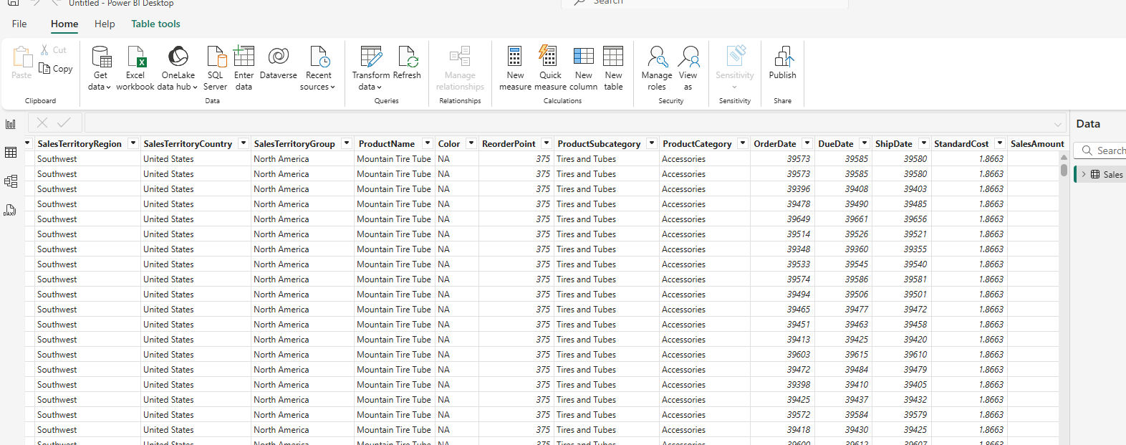
8. Create a Column chart of Sales Amount vs Sales Territory Group.
Solution
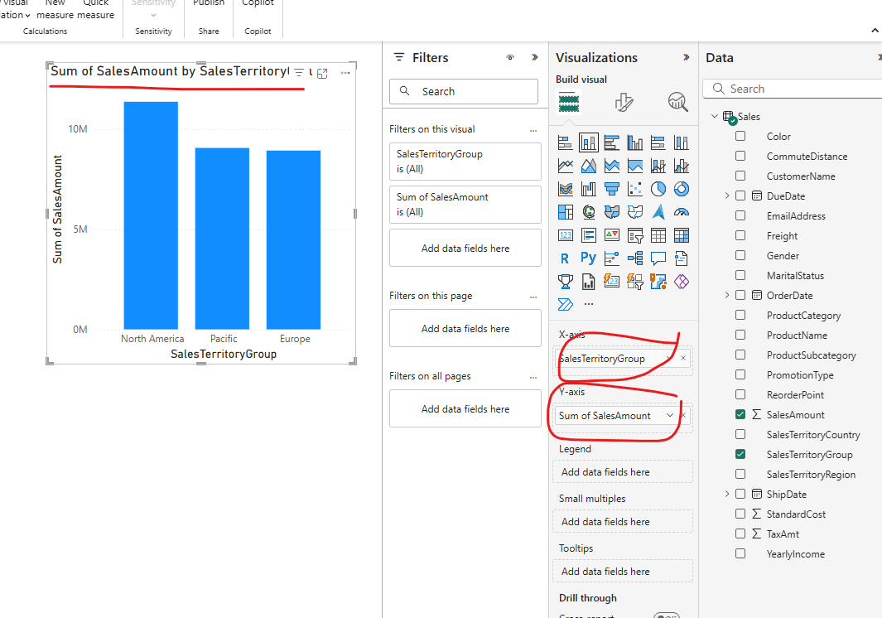

9. Create a Map Visual with Sales Territory Country and Sales Amount.
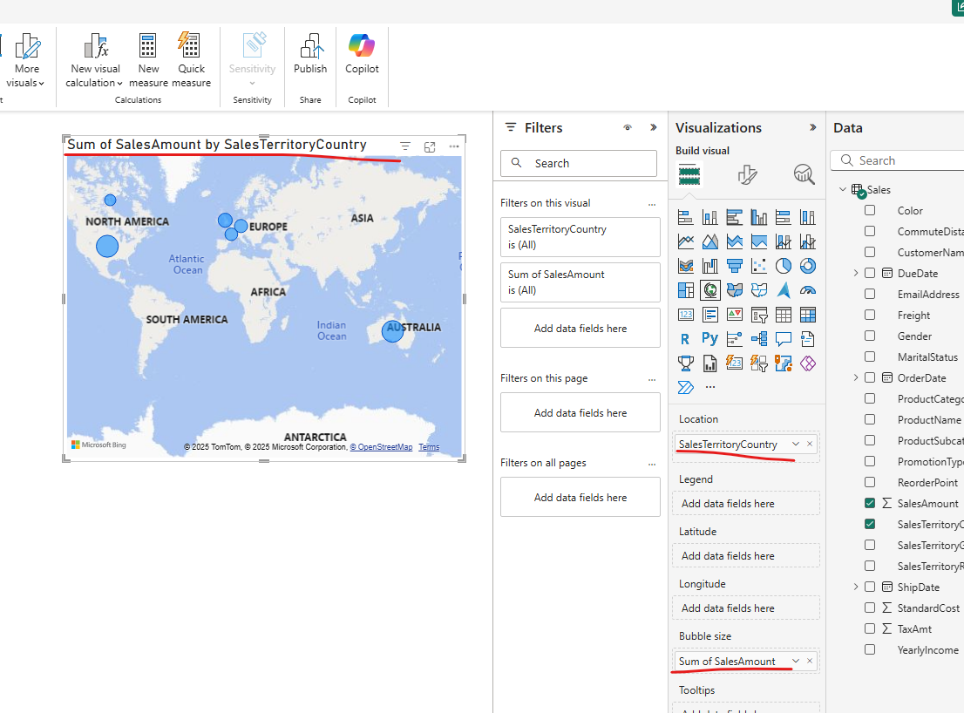
10. Display the Top 10 products based on the sales Amount.

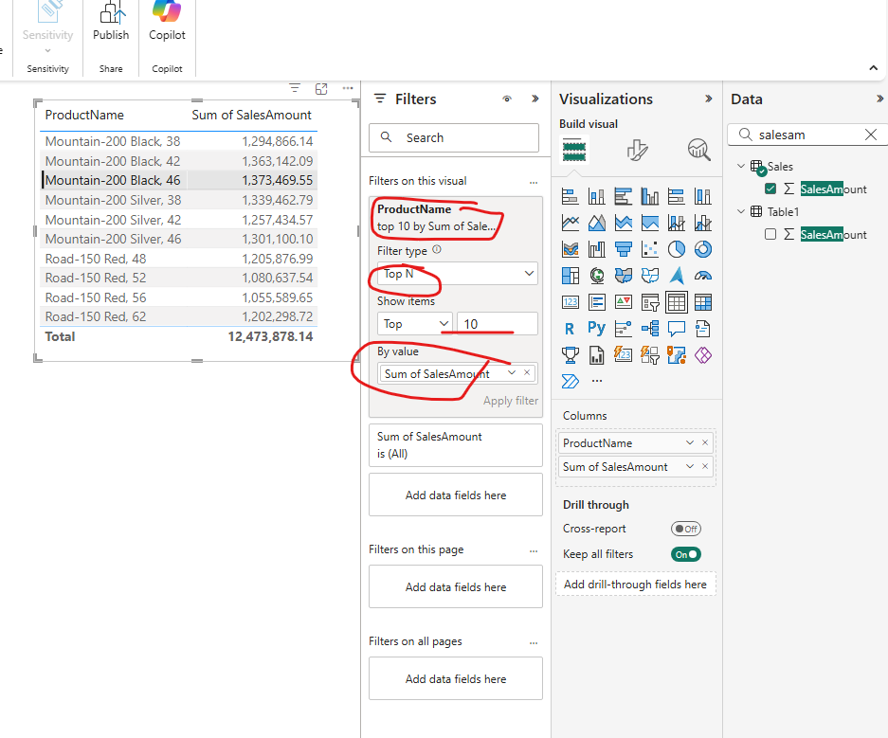

11. Show the product distribution based on category using a pie chart.
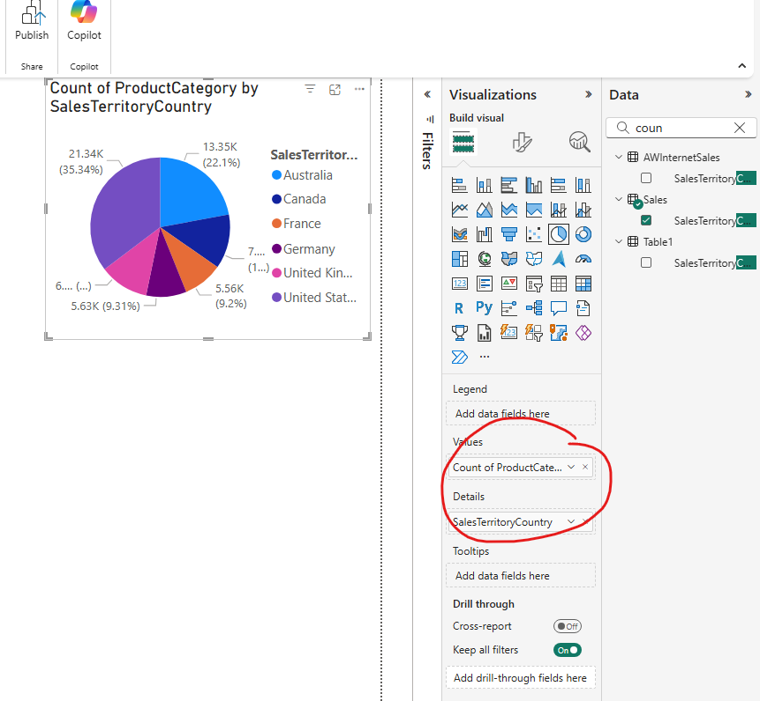

12. Save the Report as Adventure Works Excel.
