CASE STUDY - CREATING A REPORT IN POWER BI

The tasks to be completed:
- Import AdventureWorksDW Database into Power BI Desktop.
Solution: Open Power Bi Desktop application on system and go to blank report.
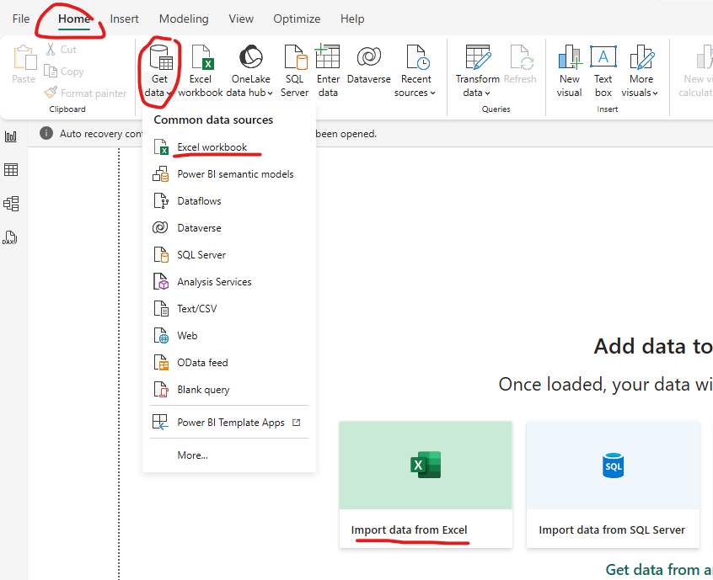

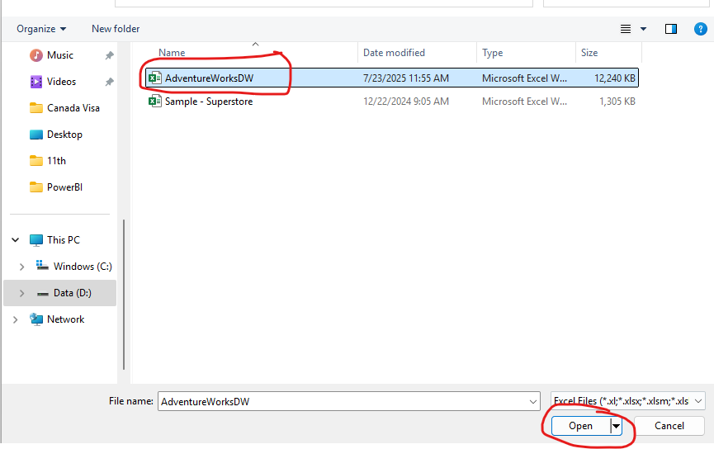

2) Import FactInternetSales table and other related tables from AdventureWorks Database

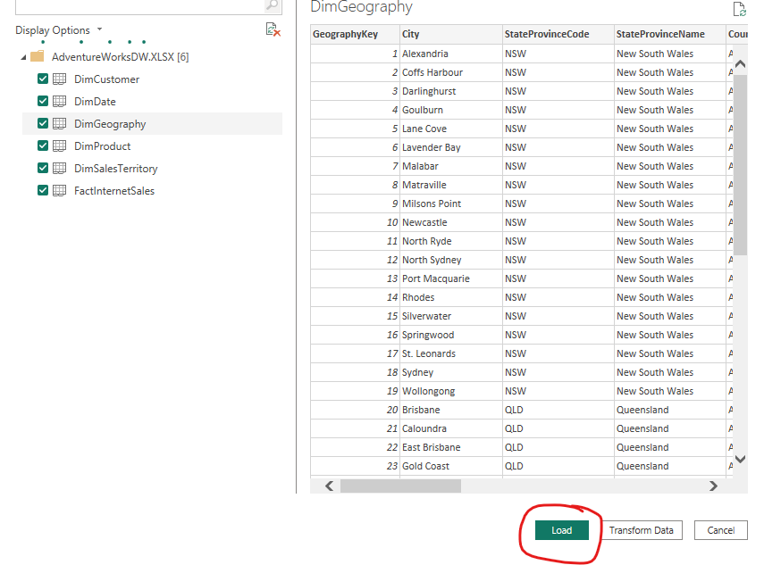
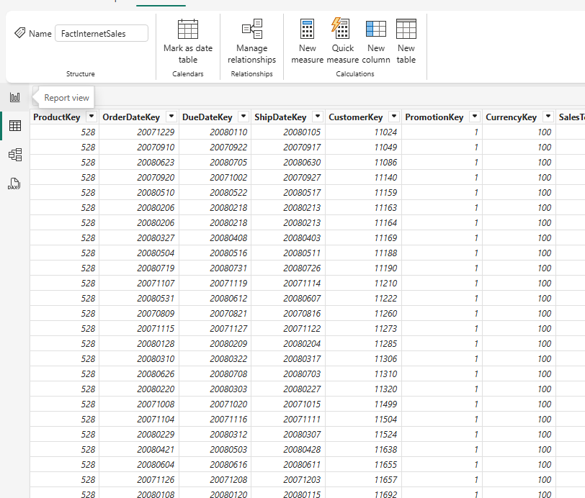

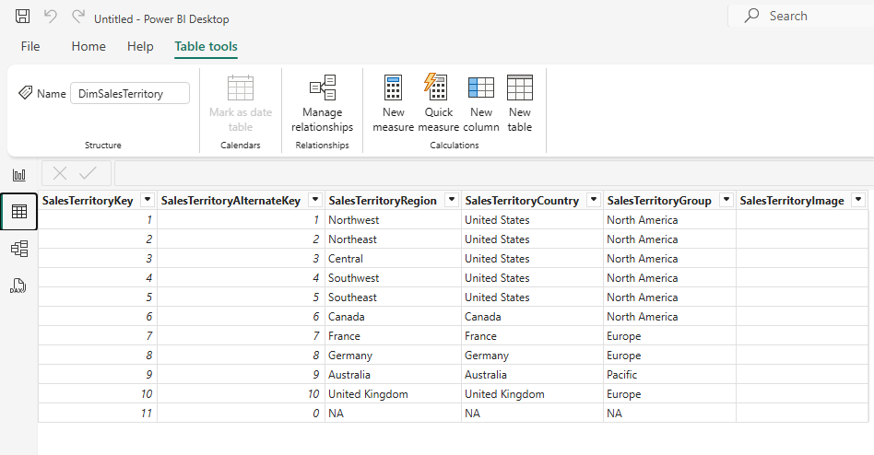

- Create a Column chart of Sales Amount vs. English name of the week.
Solution: Establishing relationship between the table factInternetSales and Dim date to make a column chart for the sales amount and English name of the week column from the two different tables.

Date key and Order date key are common columns in the two tables which establish the relationship.

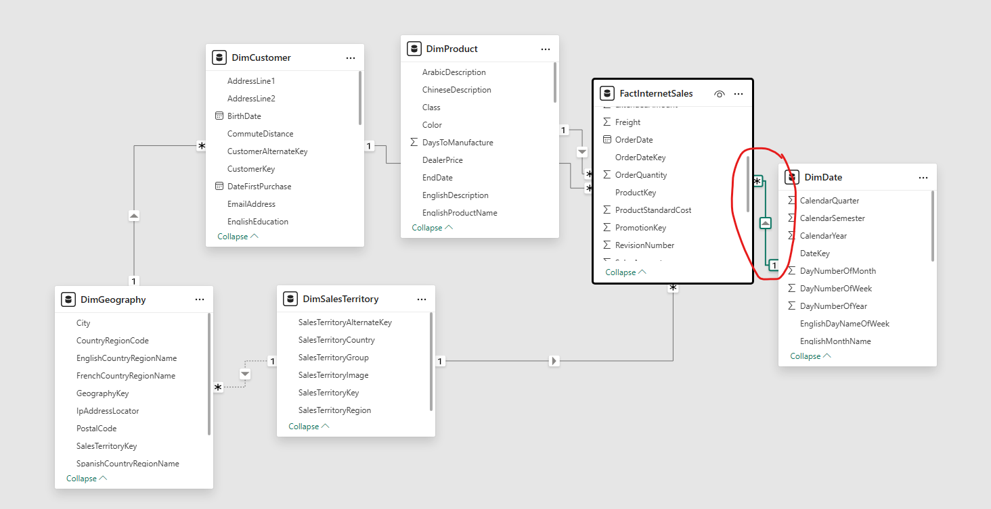

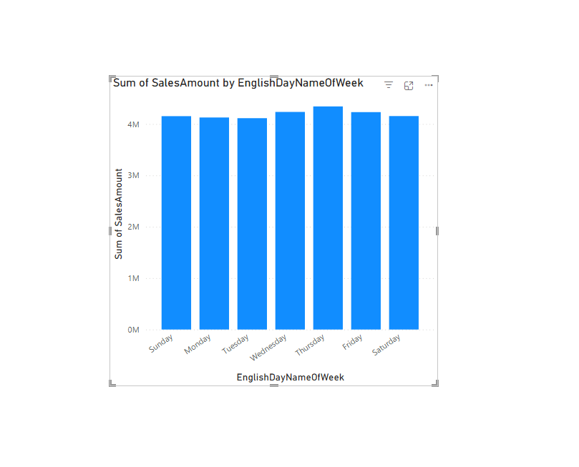
To align the bar chart as per the week start from Sunday to Monday rather than alphabet wise need to sort the column according to day number of week.
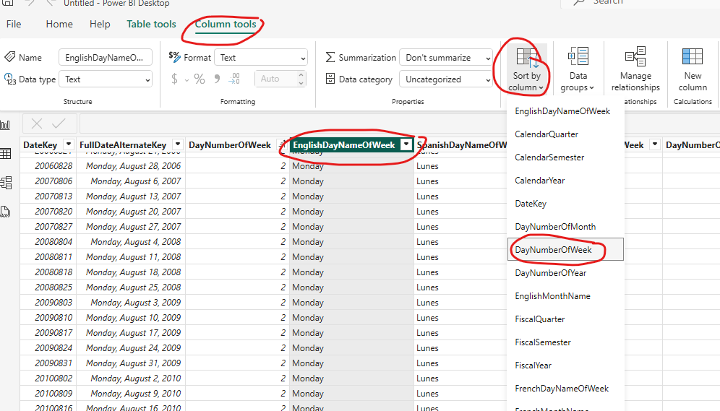

- Rename the title as Sales by day of the Week and center align it.
Solution:
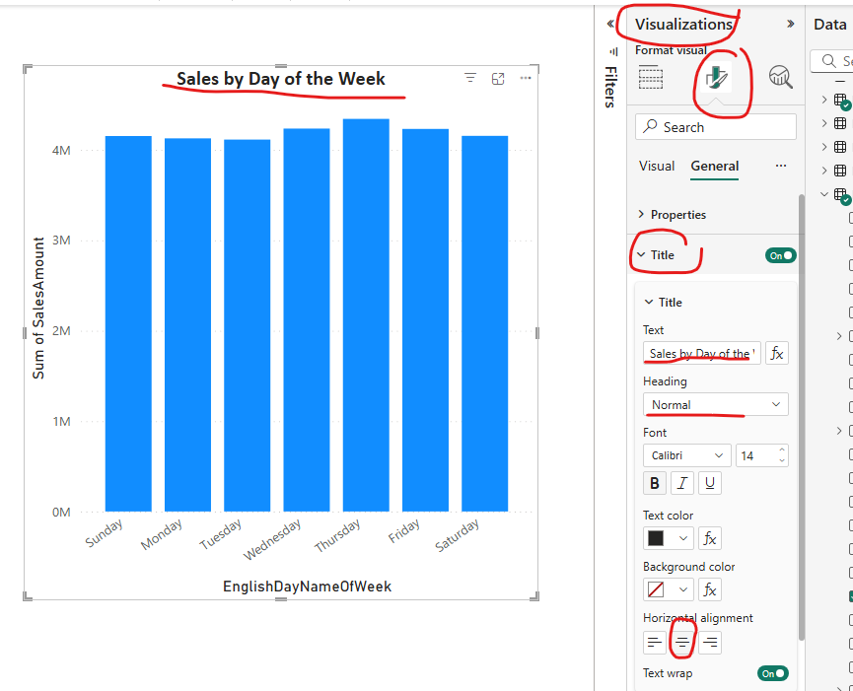

- Create a Pie chart with legend as Calendar Quarter and values as Sales Amount.
Solution:
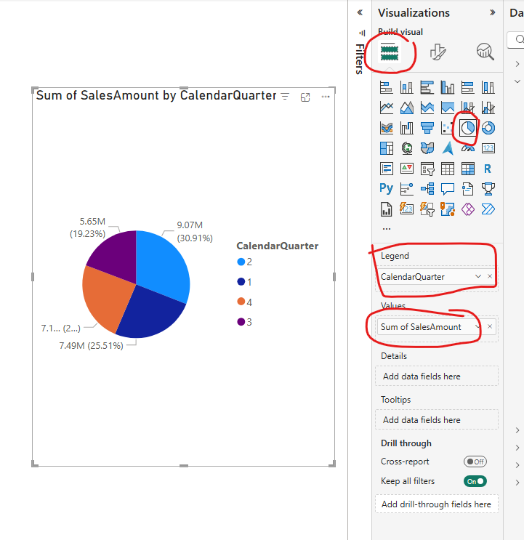

- Rename the title as Sales by Calendar Quarter and center align

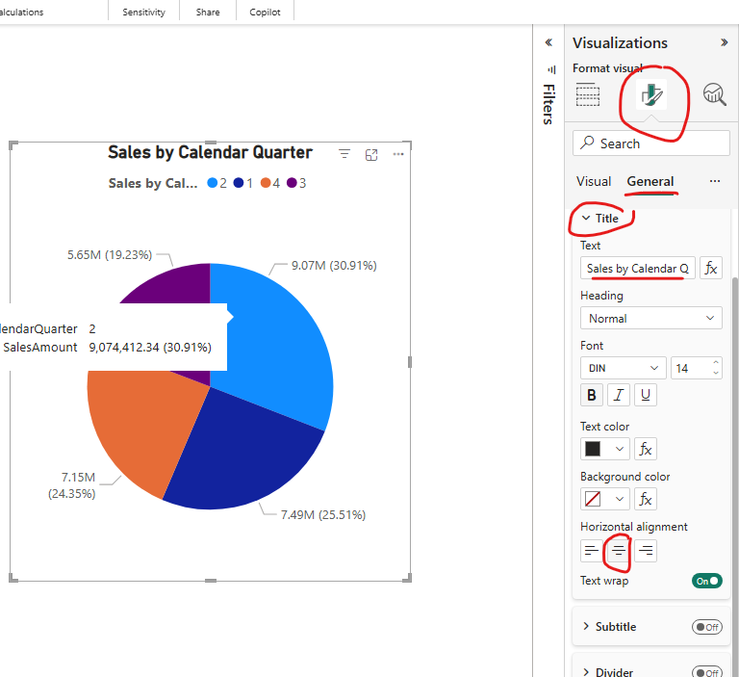

- In the pie chart, give 1st Quarter Red color, 2nd Quarter blue color, 3rd Quarter yellow and 4th Quarter green.

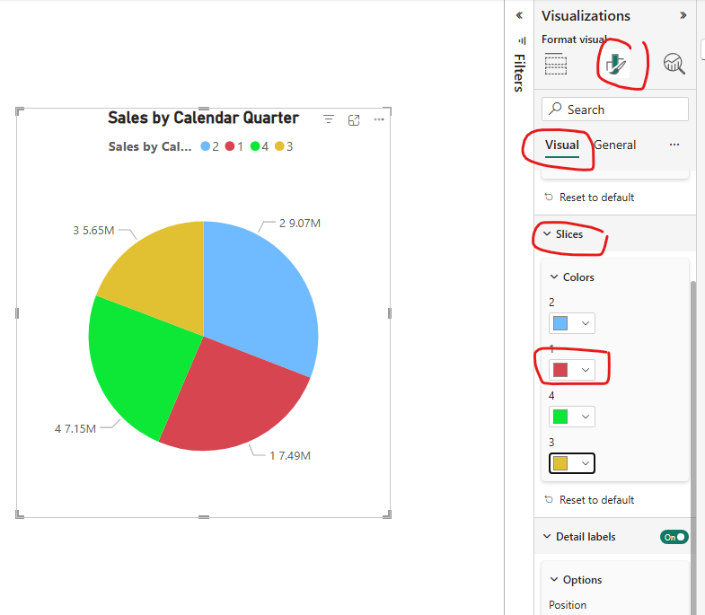

- Create a Map visual with Sales Territory Country and Sales Amount.
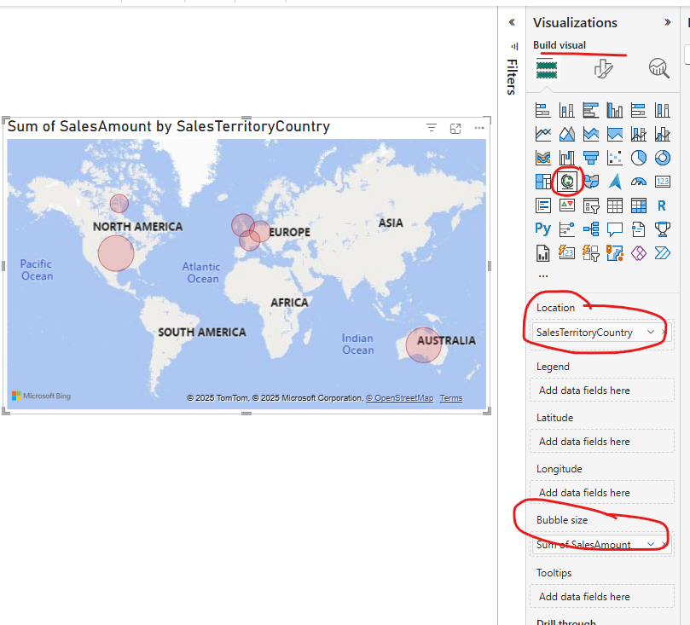

- Rename it as sales by country and center align.

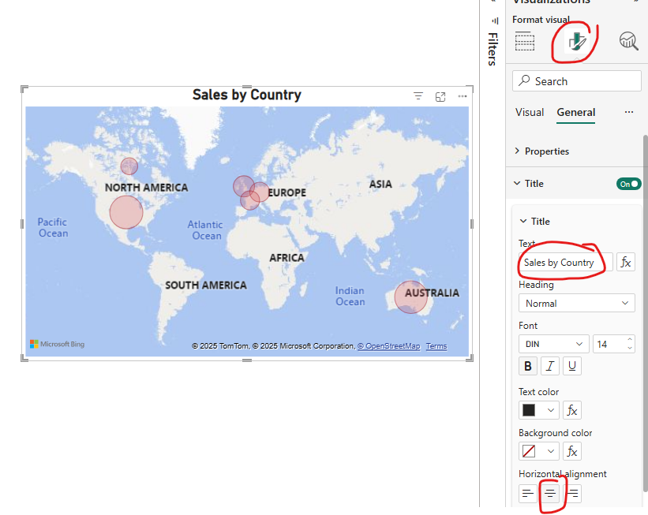

- Create a Funnel of Commute Distance and Sales Amount.

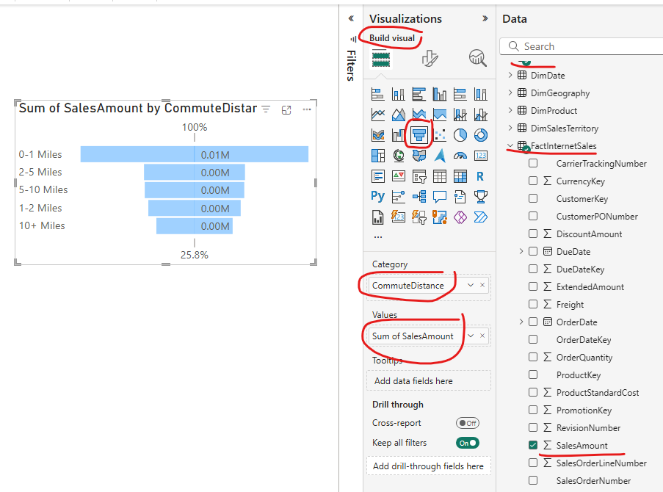

- Rename it as Sales by commute Distance and center align it.
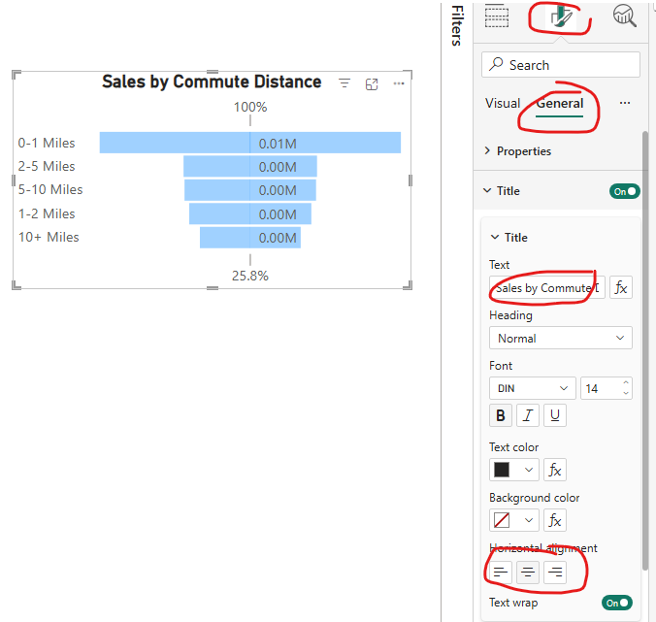

12) Save it as Adventure Works Sales.

