

Ultimate
College Essay
System

A step-by-step, strategy-driven guide that helps students craft authentic, insight-rich college essays that reveal who they are, how they think, and why they belong.

Table of Contents

Part 1
Introduction to College Essays ................................................ Section 1
What Makes a Great Personal Statement? ............................ Section 2
Brainstorming System (Topic Discovery) .............................. Section 3
Structure Templates ................................................................. Section 4
Drafting Guide + Example Paragraphs ................................... Section 5
Sample Essays (Evaluated) ...................................................... Section 6
Part 2
PIQ Overview + Strategy ........................................................... Section 7
PIQ Writing Template ................................................................ Section 8
PIQ Brainstorming Worksheets ............................................... Section 9
Part 3
Supplements Overview .......................................................... Section 10
"Why This School" Essay System .......................................... Section 11
"Why This Major" Essay System ............................................ Section 12
Diversity / Community / Identity Essays ............................. Section 13
Leadership, Activity, and Impact Essays ............................. Section 14
Part 4
Revision Guide .......................................................................... Section 15
Proofreading Checklist ........................................................... Section 16
Supplemental Templates & Worksheets

Ultimate College Essay System: Part 1
Step by Step: The Personal Statement

Section 1: Introduction to College Essays
Objective: To demystify the essay process and shift the mindset from "impressing" to "connecting."
The "Soul" of Your Application
Admissions officers (AOs) read thousands of applications. Grades and test scores tell them can you do the work; essays tell them who will do the work.
- The Transcript = Your Academic Potential.
- The Essay = Your Character, Voice, and Perspective.
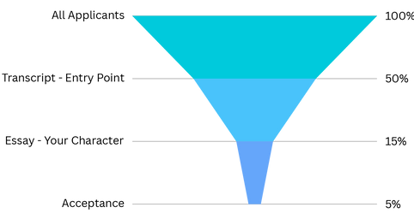
The Golden Rule of Essays
Insight > Events.
The biggest mistake students make is thinking the essay is about what happened to them. It isn’t. It is about what they learned from what happened.
- Bad Essay: A play-by-play of winning the state championship.
- Good Essay: How the silence in the locker room after a loss taught you about empathy.
The Three Main Essay Categories
You aren't just writing "an essay." You are managing a portfolio.
- The Personal Statement (Common App): The main movie. This goes to almost every school. It’s your core identity.
- UC PIQs (University of California): The interview. Short, direct, value-focused responses.
- Supplemental Essays: The dating profile. Specific questions like "Why us?" or "Why this major?" tailored to each college.

Section 2: What Makes a Great Personal Statement?
Objective: To establish the criteria for success before writing a single word.
The Three Traits AOs Look For
You don't need a tragedy or a Nobel Prize to get into a Top 20 school. You need these three things:
- Reflection: Can you analyze your own life?
- Growth: Have you changed over the last four years?
- Authenticity: Does this sound like a 17-year-old, or a 40-year-old trying to sound smart?
The Big Three Mistakes
Avoid these common traps that bore admissions readers.
- The Resume Rehash: Listing things already found in your Activities List. (e.g., "I am the president of Debate Club...")
- The "Hero" Complex: Trying to prove you are perfect. Vulnerability is much more interesting than perfection.
- The Trauma Dump: Sharing a difficult event without showing the recovery, growth, or insight derived from it.
The "Is It Working?" Checklist
Before you commit to a draft, run your idea through this filter.
Criteria | Yes/No
Does it reveal a core value? | ☐
Is it vulnerable? (Do you admit a struggle?) | ☐
Does it show how you think? | ☐
Could anyone else have written this? (If yes, start over) | ☐
Is the focus 70% insight, 30% plot? | ☐

Section 3: Brainstorming System (Topic Discovery)
Objective: To discover a topic that highlights your values rather than just recounting an event.
Worksheet 1: The Values & Identity Map
Admissions officers aren't looking for events; they are looking for characteristics.
Instructions: Circle your top 5 core values from the list below. Then, write a specific memory associated with each.
- Curiosity, Resilience, Community, Leadership, Empathy, Creativity, Efficiency, Justice, Humor, Tradition, Independence.
Top Value | Specific Memory / Story
1. __________ | _________________________________________________
2. __________ | _________________________________________________
3. __________ | _________________________________________________
4. __________ | _________________________________________________
5. __________ | _________________________________________________

Worksheet 2: "Moments of Change" Prompts
Great essays often hinge on a pivot point—a moment where the "Old You" became the "New You."
Answer these briefly:
- The Realization: When was a time you realized you were wrong about something fundamental?
  - Notes: _________________________________________________
- The Challenge: When did you try something hard and fail? What did you do the next day?
  - Notes: _________________________________________________
- The Quiet Moment: What is a small ritual (baking, a specific drive home, a hobby) that centers you?
  - Notes: _________________________________________________
The Topic Evaluation Scorecard (T20-Tested)
Use this to grade your brainstorming ideas.
- Is it unique to you? (1 = Generic, 5 = Highly Personal)
- Does it show growth? (1 = Static, 5 = Transformative)
- Is it "risky"? (1 = Safe/Boring, 5 = Vulnerable/Interesting)
- Can you write 650 words on it? (1 = No, 5 = Easily)
Decision Rule: If an idea scores below a 12 total, toss it. If it’s 15+, keep it.
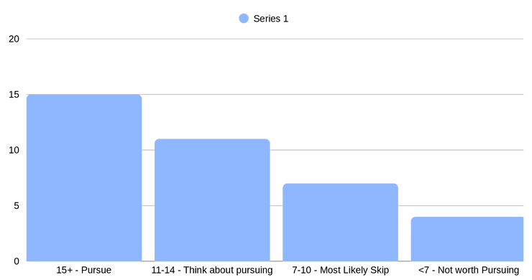

Section 4: Structure Templates
Objective: To provide a skeleton for your essay so you don't stare at a blank page.
Structure A: The Narrative Arc (Problem → Change)  Best for: Essays about overcoming a challenge or a specific event.  - The Hook (10%): Drop us right into the middle of the action. (Show, don't tell).  - The Inciting Incident (10%): What problem did you face? What went wrong?  - The Struggle (20%): What did you try? Did it fail? How did you feel?  - The Pivot/Growth (30%): What internal realization changed your approach?  - The Outcome & Future (30%): How do you act differently now? How will you bring this to campus? | 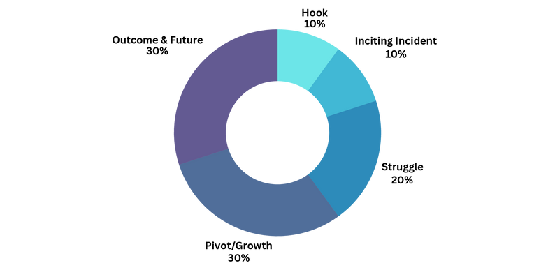
Structure B: The Montage (Thematic Objects)
Best for: Essays about a hobby, a personality trait, or a collection of small stories.
- The Thread (Introduction): Introduce a metaphor (e.g., "My laptop stickers," "My messy desk").
- Vignette 1 (Body): Sticker A represents my love for coding. (Insight: I love logic).
- Vignette 2 (Body): Sticker B is from a failed debate tournament. (Insight: I learned resilience).
- Vignette 3 (Body): Sticker C is a joke from my brother. (Insight: Family grounds me).
- The Synthesis (Conclusion): How these pieces combine to make you.
Fill-in-the-Blank Outline Template
Chosen Structure: _____________________
- Paragraph 1 (Intro): The image or scene I will start with is:
- Paragraph 2 (Context): What does the reader need to know about my background?
- Paragraph 3 ( The "Aha!" Moment): The specific insight I want to reveal is:
- Paragraph 4 (Future Application): Because of this, I will be a student who...

Section 5: Drafting Guide + Example Paragraphs
Objective: To get words on paper. Write ugly now, fix it later.
How to Write a Hook
Don't start with "I was born in..." or "I have always loved..." Start with action.
- Boring: "I learned a lot from working at the coffee shop."
- Better (In Media Res): "The steam wand screamed, the line of customers snaked out the door, and I had just spilled a latte on my shoes."
Building Transitions
Transitions are the glue that holds your essay together. They shouldn't just move time forward; they should connect ideas.
- Time Transition: "Two weeks later..." (Basic)
- Idea Transition: "While the burns on my hands healed, my pride was still stinging." (Better - connects physical to emotional).
First Draft Rules (The "Zero Draft")
- Do not look at the word count. Write 1,000 words if you need to. We cut later.
- Do not edit grammar. Just get the flow down.
- Write like you talk. If you wouldn't say "henceforth" to your friend, don't write it here.

Section 6: Sample Essays (Evaluated)
Objective: To see what a successful Personal Statement looks like in practice.
(Note: These are shortened examples for clarity).
Sample 1: The "Everyday Object" (Montage Structure)
Topic: Baking bread as a metaphor for patience and scientific inquiry.
The Essay:
The timer on my phone isn't a suggestion; it’s a law. If I pull the sourdough starter out at 7:00 AM, the temperature must be exactly 72 degrees. For years, I tried to rush this. I thought if I turned the oven up higher, the bread would bake faster. It didn't. It burned.
Counselor Commentary:
- The Hook: Immediate action. We know exactly where we are (kitchen) and what the stake is (precision).
- The Insight: The student admits failure ("It burned"). This shows vulnerability.
The Essay:
Baking taught me that variables cannot be forced. In my chemistry lab, I used to get frustrated when titrations didn't turn pink instantly. Now, I watch the beaker like I watch the dough rise. I learned that waiting isn't passive; it's an active state of observation.
Counselor Commentary:
- The Bridge: The student connects the hobby (baking) to the academic interest (chemistry). This is crucial for T20 schools—showing how your brain works across different disciplines.

Sample 2: The "Perspective Shift" (Narrative Arc)
Topic: Changing a mindset about a family responsibility.
The Essay:
Saturday mornings were not for cartoons; they were for translation. As the only English speaker in my house, I was the bridge between my parents and the world. Utility bills, doctor appointments, parent-teacher conferences—I was the voice for everyone but myself. I resented it. I wanted to be a kid.
Counselor Commentary:
- Authenticity: The student admits a negative emotion ("I resented it"). This is powerful. It makes the eventual growth feel earned.
The Essay:
But when I translated my father's symptoms to the ER doctor, I realized my words weren't a burden; they were a tool. I wasn't just repeating sentences; I was advocating. That shift—from passive translator to active advocate—drove me to intern at the public defender's office. I don't just want to speak for others; I want to fight for them.
Counselor Commentary:
- The Growth: The "Aha!" moment moves from resentment to empowerment.
- The Future: It connects directly to a career path (law/advocacy) without sounding like a resume.

Ultimate College Essay System: Part 2
The University of California (UC) Personal Insight Questions

Section 7: PIQ Overview + Strategy
Objective: To switch gears from "storytelling" (Common App) to "reporting" (UCs).
The "Anti-Essay" Mindset
If the Common App is poetry, the UC PIQs are journalism.
Admissions officers at the University of California do not want flowery language, metaphors, or suspenseful hooks. They want facts. They read quickly—often in less than 5 minutes per application.
- Common App: "The rain lashed against the window as I contemplated my existence."
- UC PIQ: "I organized a fundraiser that gathered $5,000 for storm relief."
The "Impact Formula"
To stand out to the UCs, you must prove you add value.
Every single response should answer one question: What did you actually do?
- Situation (10%): What was the problem or opportunity?
- Action (60%): What specific steps did you take? (This is the most important part).
- Impact (20%): What was the result? Use numbers if possible.
- Reflection (10%): Why does this matter?
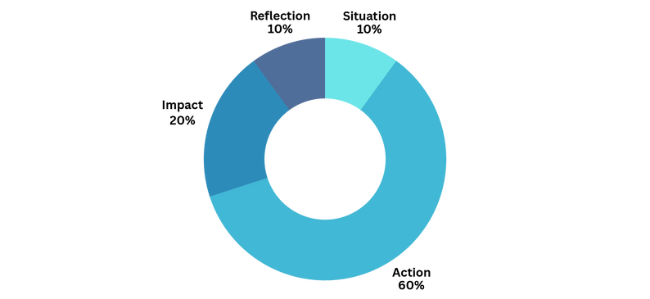
Common Misconceptions (Avoid These!)
Don't waste your limited word count (350 words max) on fluff.
- Myth: "I need to be creative."
  - Truth: You need to be clear.
- Myth: "I should use quotes."
  - Truth: Never use quotes. Use your own words.
- Myth: "I can repeat topics from my Activity List."
  - Truth: PIQs are for expanding on activities, giving context that a bullet point cannot.

Section 8: PIQ Writing Template
Objective: To structure your answers so they are impossible to misunderstand.
The 4-Part "SAIR" Outline
Use this structure for almost every PIQ. It keeps you focused on the action.
- Situation: Briefly set the context. "As the captain of the debate team, membership had dropped by 50%."
- Action: The bulk of the essay. "I initiated a mentorship program... I redesigned our recruitment flyers... I personally called 20 families."
- Impact: The concrete result. "Membership recovered to 30 students, and we won the regional final."
- Reflection: The skill gained. "I learned that leadership is about retention, not just recruitment."
Do’s and Don’ts Checklist
Do This | Don't Do This
DO use "I" statements repeatedly. | DON'T talk about "we" or the team too much.
DO quantify results (numbers, $, %). | DON'T be vague ("I helped a lot of people").
DO get straight to the point. | DON'T write a creative "hook" intro.
DO focus on recent events (10th-12th grade). | DON'T talk about middle school.

Annotated Sample PIQ (Shortened)
Prompt: What would you say is your greatest talent or skill?
The Response:
My greatest skill is connecting disparate communities through coding. (Direct Answer). During my junior year, I noticed our school’s volunteer club struggled to track hours. (Situation).
I taught myself Python over three weekends. I met with the club president to outline needs. I built a script that automated hour-logging and sent email reminders. I debugged the code for two weeks to ensure privacy compliance. (Action - note the specific verbs).
The system saved the club officers 10 hours of administrative work per week and increased volunteer retention by 15%. (Impact). This experience taught me that coding isn't just about syntax; it's about solving human problems. (Reflection).
Sentence Starters for the "Stuck" Student
- "The main challenge I faced was..."
- "To solve this, I took three specific steps: First, I..."
- "As a result of my efforts, the [Club/Organization] changed by..."
- "This experience refined my ability to..."

Section 9: PIQ Brainstorming Worksheets
Objective: To select the 4 prompts that maximize your "Comprehensive Review" score.
The 13 Points of Review
The UCs look for 13 specific criteria (Leadership, Academic Improvement, Special Projects, etc.). Your 4 PIQs should hit as many of these as possible.
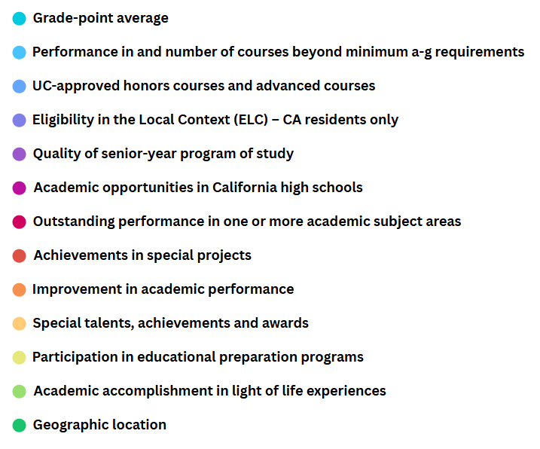

Worksheet: The "Value → Action" Map
Don't pick prompts based on which ones sound "fun." Pick prompts that let you brag about your best stuff.
Step 1: List your top 3 Activities/Accomplishments.
Step 2: Match them to a prompt.
Your Activity | Best PIQ Prompt Match | Key "Action" Verbs to Use
Ex: Robotics Club | Prompt #1 (Leadership) OR Prompt #6 (Academic Subject) | Led, Built, programmed, Organized
Activity 1: ________ | _____________________ | _____________________
Activity 2: ________ | _____________________ | _____________________
Activity 3: ________ | _____________________ | _____________________

Decision Flowchart: "Which Prompt Should I Pick?"
Use this logic to finalize your 4 choices.
Quick Guide to the 8 Prompts:
- Prompt 1 (Leadership): If you led anything (formal or informal), write this.
- Prompt 2 (Creativity): Good for artists, but also problem solvers (e.g., creative coding).
- Prompt 3 (Talent/Skill): The catch-all. Use this for a skill you haven't mentioned yet.
- Prompt 4 (Educational Opportunity/Barrier): Crucial if you took extra community college classes or faced a lack of APs.
- Prompt 5 (Challenge): Only pick this if the challenge impacted your academics/life significantly.
- Prompt 6 (Academic Subject): Mandatory for your intended major. You must show you love what you apply for.
- Prompt 7 (Community Service): If you did volunteer work, put it here.
- Prompt 8 (What sets you apart): The wildcard. Use only if the other 7 don't fit your story.

Ultimate College Essay System: Part 3
Supplemental Essays

Section 10: Supplements Overview
Objective: To understand that while the Personal Statement gets you read, supplements get you admitted.
The "Why" Behind the Extra Work
If the Personal Statement is the first date, the Supplemental Essays are the marriage proposal.
Top 20 universities know you are smart. Supplements exist to answer one specific question: Do you actually belong here, or did you just apply because of our ranking?
- The Personal Statement: Shows your character (Internal).
- The Supplements: Show your fit (External).
Common Categories
Most T20 supplements fall into four buckets. Master these archetypes, and you can recycle (carefully) across schools.
- "Why Us?": Proving you know the school better than the brochure.
- "Why Major?": Proving you have intellectual vitality.
- Community/Diversity: Proving you will be a good roommate and classmate.
- Activity/Leadership: expanding on a resume bullet point.

Section 11: "Why This School" Essay System
Objective: To prove you are a perfect match without quoting the university's mission statement.
The 3-Layer Framework
A generic essay says, "You have a great biology program." A winning essay says, "I need Dr. Smith’s lab to continue my research on enzymes." Use this structure:
- Academic Fit (60%): Specific professors, upper-level courses (not Intro to Psych), research institutes, and unique curriculum methods.
- Social/Personal Fit (30%): Specific clubs, culture, traditions, or values that match yours.
- Campus Contribution (10%): What will you give to the school? (e.g., starting a club, mentoring).
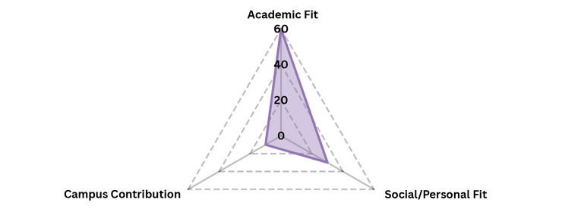

The Research Checklist
Before writing, spend 30 minutes on the college website. Find three "Proper Nouns" (capitalized specific names) that cannot be found at any other school.
Research Area | What to Look For | found It?
Curriculum | Look for "Core Curriculum," "Open Curriculum," or specific concentrations. | ☐
Faculty | Find a professor doing research exactly related to your interests. | ☐
Clubs | Find a club that is weirdly specific (e.g., "The Cheese Society" or "Solar Car Team"). | ☐
Traditions | Look for "Primal Scream," "Dragon Day," or house systems. | ☐

The "Why Us" Template
Use this to build your rough draft. Do not leave the brackets empty.
- "My interest in [Major] is driven by [Specific Intellectual Question]. At [University Name], I am eager to explore this through Professor [Name]'s work on [Topic]. The [Specific Class Name] would allow me to grapple with [Concept], a necessary step for my goal of [Career/Impact]. Beyond the classroom, I plan to join [Club Name] because [Connection to your past hobby]. Finally, I hope to contribute my experience in [Skill] to the [Specific Campus Tradition/Group]."

Section 12: "Why This Major" Essay System
Objective: To demonstrate "Intellectual Vitality"—the ability to love learning for the sake of learning.
The Origin → Exploration → Commitment Arc
Admissions officers hate essays that say, "I have loved engineering since I played with Legos." That is cute, but it is not academic.
Show your journey from "interest" to "obsession."
- Origin (The Spark): A brief moment that sparked curiosity.
- Exploration (The Data): What books did you read? What projects did you build? What internships did you do?
- Future Fit (The School): How does this specific college help you take the next step?
Common Mistakes to Avoid
- The "I want to help people" trap: Too vague. Be specific. Instead of "helping people," say "I want to use biomedical engineering to create affordable prosthetics."
- The "Undecided" wobble: Even if you are undecided, pick a lane for the essay. You can change your major later. Show you have direction, even if the destination changes.
Mini-Example Paragraph
"While I initially loved history for the stories, my internship at the city archives shifted my focus to data. I became obsessed with how census records from 1920 explained current zoning laws. I want to major in Urban Studies to decode how historical policy shapes modern inequality."

Section 13: Diversity / Community / Identity Essays
Objective: To define "diversity" broadly—it is about perspective, not just demographics.
What Colleges Mean by "Community"
When colleges ask about a community you belong to, they aren't just asking about geography or ethnicity.
A community can be:
- Your Dungeons & Dragons group.
- The Saturday morning shift at McDonald's.
- Your multi-generational household.
- Coders who use Python.
The "Shared Value" Formula
To write a great community essay, use this equation:
Shared Value + Your Specific Action = Strong Community.
Reflection Prompts
If you are stuck, answer these:
- The Debate: When did you disagree with someone in your community, and how did you resolve it?
- The Role: What role do you usually play in a group? The leader? The mediator? The skeptic?
- The Background: What is a family tradition that your friends find weird but you love?

Section 14: Leadership, Activity, and Impact Essays
Objective: To turn a resume bullet point into a compelling story of impact.
Micro vs. Macro Impact
Leadership isn't just about holding a gavel or being "President." It is about impact.
- Micro Impact: Helping one person. (Mentoring a freshman who was about to quit band).
- Macro Impact: Changing a system. (Rewriting the band handbook to lower costs for low-income students).
Top 20 schools love it when you show both.
The "Narrative Conversion" Guide
Stop listing duties. Start telling stories.
Resume Language (Boring) | Narrative Language (Compelling)
"Responsible for organizing meetings." | "I noticed meetings were silent, so I introduced 'hot takes' to spark debate."
"Tutored math students." | "I realized John didn't hate math; he hated failing. We switched to visual learning."
"Raised money for charity." | "I managed a team of 10 to turn a $50 budget into a $2,000 donation."
Activity Expansion Template
If a supplement asks you to "elaborate on one activity," use this flow:
- The "Why": Why did you join this in the first place?
- The "Crisis": What was the hardest moment you faced in this role?
- The "Solve": How did you fix it? (Be specific!)
- The "Lesson": What did this teach you about management, empathy, or hard work?
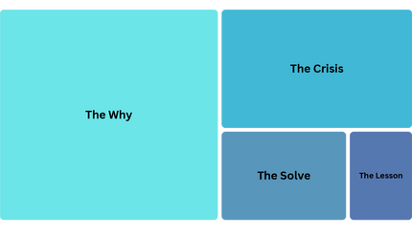

Ultimate College Essay System: Part 4
Revision, Finalization, and Templates

Section 15: Revision Guide
Objective: To turn a messy "Zero Draft" into a polished, word-count-compliant masterpiece.
The "Sculpting" Mindset
Writing is rewriting. Most students think they are bad writers because their first draft is bad.
Reality Check: Everyone’s first draft is bad. Your favorite author’s first draft was bad. The magic happens when you cut the fluff to reveal the statue underneath.
The 200-Word Cutting Guide
You will likely be over the word limit. Use this list to slash word count without losing meaning.
- Delete "Throat Clearing": Phrases like "I believe that," "In my opinion," or "It is important to note that." Just say the thing.
  - Cut: "I believe that leadership is about empathy."
  - Keep: "Leadership is empathy."
- Kill Adverbs: If you use a strong verb, you don't need an adverb.
  - Cut: "I ran quickly to the door."
  - Keep: "I sprinted to the door."
- Remove Redundant Adjectives:
  - Cut: "The massive, huge crowd."
  - Keep: "The massive crowd."
- Check for "To Be" Verbs: Replace "was" and "is" with active verbs.
  - Cut: "There was a loud noise coming from the engine."
  - Keep: "The engine sputtered and cracked."
How to Diagnose a Weak Essay
If your essay feels "off," it usually suffers from one of three diseases.
Symptom | Diagnosis | The Fix
"So What?" | The reader finishes and thinks, "Nice story, but why do I care?" | Add Insight. You have too much plot (80%+) and not enough reflection. Add a paragraph about why this matters to your future.
"The Float" | The essay feels vague, dreamy, or abstract. | Add Data. You need more nouns. Replace "I worked hard" with "I spent 15 hours debugging the code."
"The Robot" | It sounds like a resume or a textbook. | Add Voice. Read it out loud. If it doesn't sound like you talking to a friend, rewrite the intro using casual language.

Section 16: Proofreading Checklist
Objective: To ensure your application is error-free and ready for the "Submit" button.
The "Read Aloud" Rule
Your eyes will trick you. Your ears will not.
Print your essay out. Stand up. Read it out loud to yourself. If you stumble over a sentence, that sentence is awkward. Rewrite it.
A Note for Parents: Boundaries
Parents, your job is to be a mirror, not a painter.
- Do: Tell your student where you are confused. Tell them if it doesn't sound like them. Catch typos.
- Do Not: Rewrite sentences. Add "sophisticated" words they wouldn't use. Change the topic because you think another one is "more impressive."
The Final Submission Checklist
Do not hit submit until you have checked every box.
The "Wrong School" Check: Did you accidentally leave "Columbia" in your "Why Penn" essay? (Cmd+F search for university names).
The Formatting Check: Did pasting it into the text box remove your paragraph breaks? Add them back.
The "Funny Character" Check: Look for weird symbols (â€¢) that happen when you copy/paste quotes or dashes.
The Tone Check: Does the end sound optimistic?
The File Name: If uploading a PDF, is it named "Name_Essay_Final.pdf" or "Draft_v45_messy.pdf"?

Supplemental Templates & Worksheets
Objective: Printable tools to keep you organized throughout the process.
Template 1: Personal Statement Brainstorming Worksheet

Step 1: The Core Values
Circle your Top 3 Values:
Curiosity | Resilience | Community | Efficiency | Creativity | Justice | Family | Humor
Step 2: The Evidence
Match a specific memory to your top values.
Value | The Memory (Be specific!)
1. ________________ | ____________________________________________
2. ________________ | ____________________________________________
3. ________________ | ____________________________________________

Step 3: The Pivot Point
Describe a time you changed your mind or your approach to something.
- Old View: ________________________________________________
- ** The Event:** ________________________________________________
- New View: ________________________________________________

Template 2: Topic Evaluation Scorecard

Proposed Topic: ________________________________________________
Rate on a scale of 1–5 (5 being best):
- Is it unique to me? (Could 100 other students write this?)
[1] [2] [3] [4] [5]
- Does it show growth? (Am I different at the end than the start?)
[1] [2] [3] [4] [5]
- Is it vulnerable? (Do I admit a struggle or flaw?)
[1] [2] [3] [4] [5]
- Is it insight-rich? (Do I explain how I think, not just what I did?)
[1] [2] [3] [4] [5]
Total Score: ______ / 20
(Aim for 15+ to proceed)

Template 3: UC PIQ Outline (The "SAIR" Method)

Chosen Prompt: ________________________________________________
1. Situation (10%):
- What was the problem, opportunity, or baseline?
  - Draft: ________________________________________________
2. Action (60%):
- What specific steps did I take? (Not "we", not the "team").
  - Step 1: ________________________________________________
  - Step 2: ________________________________________________
  - Step 3: ________________________________________________
3. Impact (20%):
- What was the quantifiable result? (Numbers, dollars, retention rates).
  - Draft: ________________________________________________
4. Reflection (10%):
- What does this prove about my leadership or skill?
  - Draft: ________________________________________________

Template 4: "Why Us" Research Checklist

School Name: ________________________________________________
The Academic Connection:
- Specific Class: ________________________________ (Why: ______________)
- Specific Professor: ____________________________ (Why: ______________)
- Specific Institute/Lab: ________________________ (Why: ______________)
The Culture Connection:
- Student Organization: __________________________ (Why: ______________)
- Campus Tradition: ______________________________ (Why: ______________)
The Mission Connection:
- School Motto/Ethos: ____________________________ (How I fit: _________)

Template 5: The 10-Step Revision Checklist

The Big Picture
Does the hook grab attention in the first 2 sentences?
Is the "Insight" clearly stated, not just implied?
Is the tone authentic (not trying too hard to be smart)?
The Paragraphs
Does every paragraph have a clear transition?
Is there a clear beginning, middle, and end?
The Sentences
Did I remove "I think," "I believe," "In conclusion"?
Did I replace weak verbs (was/is/has) with strong action verbs?
Did I cut adverbs (quickly, very, really)?
The Polish
Did I read it out loud to catch awkward rhythms?
Did a parent/teacher check for clarity?

