Design and Implement of College Information System

by

##### **Muhammad Mijanur Rahman**

ID: CSE2001019249

##### **Priva Akther**

ID: CSE2001019112

##### **Minhaj Abdul Miraj**

ID: CSE2001019181

##### **Md Shadiqur Rahman**

ID: CSE2001019227

Supervised by

### Arifur Rahaman

Submitted in partial fulfillment of the requirements for the degree of Bachelor of Science in Computer Science and Engineering

### DEPARTMENT OF COMPUTER SCIENCE AND ENGINEERING SONARGAON UNIVERSITY (SU)

December 2023

# APPROVAL

The project titled **“Design and implement of College Information System”** submitted by Muhammad Mijanur Rahman (CSE2001019249), Priva Akther (CSE2001019112), Minhaj Abdul Miraj (CSE2001019181), Md Shadiqur Rahman (CSE2001019227) to the Department of Computer Science and Engineering, Sonargaon University (SU), has been accepted as satisfactory for the partial fulfillment of the requirements for the degree of Bachelor of Science in Computer Science and Engineering and approved as to its style and contents.

**Board of Examiners**

|  |  |
| --- | --- |
| ----------------------------------------  **Arifur Rahaman**  Assistant Professor and Coordinator  Department of Computer Science and Engineering Sonargaon University (SU) | **Supervisor** |
| ----------------------------------------  (Examiner Name and Signature)  Department of Computer Science and Engineering Sonargaon University (SU) | **Examiner 1** |
| (Examiner Name and Signature)  Department of Computer Science and Engineering Sonargaon University (SU) | **Examiner 2** |
| (Examiner Name and Signature)  Department of Computer Science and Engineering Sonargaon University (SU) | **Examiner 3** |

# DECLARATION

We, here by, declare that the work presented in this report is the outcome of the investigation performed by us under the supervision of **Arifur Rahaman, Assistant Professor &** **Coordinator,** Department of Computer Science and Engineering, Sonargaon University, Dhaka, Bangladesh. We reaffirm that no part of this project has been or is being submitted elsewhere for the award of any degree or diploma.

|  |  |  |  |
| --- | --- | --- | --- |
| Countersigned  **(Arifur Rahaman) Supervisor** | Signature  Muhammad Mijanur Rahman  ID: CSE2001019249  Priva Akther  ID: CSE2001019112  Minhaj Abdul Miraj  ID: CSE2001019181  MD Shadiqur Rahman  ID: CSE2001019227 |  |  |

# ABSTRACT

# In the digital age, a college website serves as the virtual gateway to an educational institution, reflecting its identity, values, and offerings. This abstract introduces the conceptualization and implementation of a dynamic college website, User-Centric Design: Focused on user experience (UX) principles, the website is designed to be intuitive and accessible. The website serves as a centralized repository of information, presenting clear and concise details about academic programs, admission procedures, student exam result, faculty profiles, campus facilities, and extracurricular activities.

# ACKNOWLEDGMENT

At the very beginning, we would like to express my deepest gratitude to the Almighty Allah for giving us the ability and the strength to finish the task successfully within the schedule time.

We are auspicious that we had the kind association as well as supervision of **Arifur Rahaman, Assistant Professor and Coordinator** Department of Computer Science and Engineering, Sonargaon University whose hearted and valuable support with best concern and direction acted as necessary recourse to carry out our project.

We are also thankful to all our teachers during our whole education, for exposing us to the beauty of learning.

Finally, our deepest gratitude and love to my parents for their support, encouragement, and endless love.

# LIST OF ABBREVIATIONS

CSS : Cascading Style Sheets

DBMS : Database Management

DFD : Data Flow Diagram

ERD : Entity Relationship Diagram

ERP : Enterprise Resource Planning

HR : Human Resources

HTML : Hyper Text Markup Language

JS : Java Script

MySQL : My Structured Query Language

OOP : Object-Oriented Programming

PHP : Hypertext Preprocessor

SDM : Systems Development Method

SFD : System Flow Diagram

UML : Unified Modeling Language

**TABLE OF CONTENTS**

|  |  |  |  |
| --- | --- | --- | --- |
| Title |  |  | Page No. |
| **DECLARATION** …………………………………………………………..…… | | | iii |
| **ABSTRACT** ……………………...……………………………………………… | | | iv |
| **ACKNOWLEDGEMENT** ………………………………………….………….. | | | v |
| **LIST OF ABBREVIATION** ………….………………………………………... | | | vi |
| **CHAPTER 1** | | ­­­­­­­­____________________________________________________ | **1 – 3** |
| INTRODUCTION TO COLLEGE MANAGEMENT | | | |
| 1.1 | Introduction ……………………………………..…………………... | | 1-2 |
| 1.2 | The Importance of ERP Software…………………………………… | | 2-3 |
| **CHAPTER 2** | | ____________________________________________________ | **4 – 6** |
| REQUIREMENT ANALYSIS | | | |
| 2.1 | Define Objectives and Scope ……………………………………….. | | 4-6 |
| **CHAPTER 3** | | ____________________________________________________ | **7 – 10** |
| DATABASE MANAGEMENT SYSTEM | | | |
| 3.1 | Database Management System……………………………………... | | 7 |
| 3.2  3.3 | Database table Relationship ………………………………………...  Relationships Between Tables in SQL | | 7-8  9-10 |
| **CHAPTER 4** | | ____________________________________________________ | **11 – 12** |
| SYSTEM REQUIREMENT | | | |
| 4.1 | Software…..………………………………….……………………… | | 11 |
| 4.2 | Hardware Requirement..…………………………………………….. | | 11-12 |
| **CHAPTER 5** | | ____________________________________________________ | **13 – 21** |
| SYSTEM DESIGN | | | |
| 5.1 | Features for College ERP System………………….………….……. | | 13-14 |
| 5.2 | Design Implement………………………………….………….……. | | 15-21 |
|  |  | |  |

**CHAPTER 6** ____________________________________________________ **22-27**

IMPLEMENTATION AND RESULT

6.1 Future Scope ……………………………………………………….. 22-23

6.2 Conclusion……….…………………………………………………. 24-26

6.3 Activity Diagram Of College Management……………………….. 26-27

­­­­**CHAPTER 7 _____________________________________________________ 28-30**

FUTURE ENHANCEMENT

7.1 Future Scope ……………………………………………………… 29-30

7.2 Conclusion……….………………………………………………… 30

**REFERENCES** ……………………………………………………….………….. **31**

**LIST OF FIGURES**

|  |  |  |
| --- | --- | --- |
| **Figure No.** | **Title** | **Page No.** |
| Figure.1.1 | Importance of ERP Software | 3 |
| Figure.2.1 | Requirement analysis | 6 |
| Figure.3.1 | Database management system | 7 |
| Figure.3.2 | Database table Relationship | 8 |
| Figure.3.3 | One-to-many table Relationship | 9 |
| Figure.3.4 | Many-to-one table Relationship | 9 |
| Figure.3.5 | Many-to-many table Relationship | 10 |
| Figure.4.1 | System requirement | 12 |
| Figure.5.1 | Features for College ERP | 14 |
| Figure.5.2 | User-inter page of the application | 15 |
| Figure.5.3 | User-inter page of the application | 15 |
| Figure.5.4 | Admin login form | 16 |
| Figure.5.5 | Admin dashboard | 16 |
| Figure.5.6 | Student admission form | 17 |
| Figure.5.7 | Subject insert section | 17 |
| Figure.5.8 | Student information show | 18 |
| Figure.5.9 | Print Student Basic info | 18 |
| Figure.5.10 | Student filter for insert exam Result | 19 |
| Figure.5.11 | Exam Result student wise insert | 19 |
| Figure.5.12 | Dynamic notice content update | 20 |
| Figure.5.13 | College About content update and insert here | 20 |
| Figure.6.1 | Admin activity Diagram | 23 |
| Figure.6.2 | System Design | 24 |
| Figure.6.3 | Login Activity Diagram | 26 |
| Figure.6.4 | Class Diagram | 27 |

**CHAPTER 1**

**INTRODUCTION TO COLLEGE MANAGEMENT**

### Introduction

An Enterprise Resource Planning (ERP) system for college management is a comprehensive software solution designed to streamline and integrate various academic and administrative processes within an educational institution. This type of system helps colleges and universities manage their resources efficiently, improve decision-making, enhance communication, and provide better services to students, faculty, and staff.

A college management system is a comprehensive software solution designed to automate and manage various administrative and academic functions of a college. It is an advanced version of the Management Information System (MIS) that collects and analyzes college operations data to help management make informed decisions. The software combines the functionalities of a student information system and a management information system, managing the complete student lifecycle, parent, faculty, and other stakeholders in the college. It also handles academic, administrative, and financial activities of the college.

The college management system is designed for large-scale institutions, specialized institutes, college, and other educational organizations. It digitizes and streamlines day-to-day operations, such as student enrollment, admission management, online classes management, finance management, human resource management, student attendance management, student record management, student profile management, student mark management, student fee management, and other small and big operations.

The software offers several benefits, including a unified username and password for all processes, data analysis of various departments, and faster achievement of academic and business goals by reducing expenses..

* **Student Information Management:** Centralized database to store and manage student information, including personal details, academic records, attendance, and extracurricular activities. Facilitates easy access to student profiles and academic histories for administrators, teachers, and students.
* **Course and Curriculum Management:** Manages course offerings, class schedules, and academic calendars. Allows for the creation, modification, and tracking of courses and curricula. Helps in curriculum planning and ensures compliance with academic standards.
* **Attendance Tracking:** Automates the attendance tracking process, making it easier for teachers to record and monitor student attendance. Generates reports on attendance patterns for students and classes.
* **Grading and Assessment:** Streamlines the grading process and provides a platform for teachers to input and manage grades. Supports various grading scales and assessment methods.Enables the generation of transcripts and grade reports.
* **Financial Management:** Manages financial transactions, including tuition fees, scholarships, and other payments. Generates financial reports to help administrators monitor the financial health of the institution.
* **Library Management:** Manages library resources, including book cataloging, circulation, and inventory. Facilitates online access to library resources and supports check-out systems.
* **Exam and Timetable Management:** Manages exam schedules, room assignments, and invigilation details. Facilitates the creation and distribution of timetables.
* **Reporting and Analytics:** Generates various reports and analytics to support data-driven decision-making. Provides insights into student performance, resource utilization, and overall institutional effectiveness.

Implementing an ERP College Management System can lead to increased efficiency, reduced administrative overhead, and improved overall effectiveness in managing educational processes. It helps create a more connected and streamlined environment for students, faculty, and administrators, contributing to the overall success of the educational institution.

### The Importance of ERP Software

Enterprise Resource Planning (ERP) software plays a crucial role in various industries, including the education sector. In the context of colleges and universities, ERP software specifically designed for academic institutions, often referred to as College ERP software, serves as a comprehensive solution to manage and streamline various administrative and academic processes.

College ERP systems provide a centralized platform for managing a wide range of information, including student records, faculty details, course materials, examination schedules, and financial data. This centralized approach enhances data accuracy, reduces redundancy, and facilitates efficient information retrieval.

ERP software automates and streamlines administrative processes such as admissions, registration, attendance tracking, grading, and scheduling. This leads to increased efficiency, reduced paperwork, and minimized errors in routine administrative tasks.

College ERP systems are designed to be adaptable and scalable, allowing institutions to customize the software according to their specific needs and accommodate growth in the future. college ERP software is crucial for modern educational institutions as it enhances operational efficiency, improves communication, ensures data accuracy, and contributes to the overall effectiveness of academic and administrative processes. It serves as a valuable tool for institutions aiming to provide quality education and maintain a competitive edge in the evolving educational landscape.



Figure.1.1 Importance of ERP Software

# CHAPTER 2

## REQUIREMENT ANALYSIS

### Define Objectives and Scope

Requirement analysis for a college ERP (Enterprise Resource Planning) software involves understanding and documenting the specific needs and objectives of the educational institution.

1. **Administrative Requirements**

* **Student Information Management:** Manage student data, including personal details, academic records, attendance, and discipline records. Support for admission processes and enrollment management.
* **Faculty Information Management:** Maintain faculty details, academic qualifications, and teaching schedules. Provide tools for managing faculty performance and workload.
* **Course and Curriculum Management:** Define and manage courses, curriculum structures, and academic programs. Support for course scheduling and allocation of resources.
* **Attendance and Timetable Management:** Track student and faculty attendance. Generate and manage academic timetables efficiently.\
* **Attendance and Timetable Management:** Track student and faculty attendance. Generate and manage academic timetables efficiently.

1. **Learning Management System (LMS)**

* **Online Course Delivery:** Provide tools for uploading course materials, assignments, and quizzes. facilitate online assessments and grading.
* **Collaboration and Communication:** Support communication between students, faculty, and administration. integration with messaging systems, discussion forums, and collaborative tools.

1. **Examination and Grading**

* **Examination Management:** Facilitate exam scheduling, seat allocation, and conduct of exams. Manage the exam result processing and publication.
* **Grading System:** Define and manage grading scales and policies. calculate and store student grades securely.

1. **Library Management**

* **Cataloging and Inventory:** Manage the library catalog, including books, journals, and multimedia resources. track inventory, acquisitions, and circulation.
* **User Management:** Maintain user accounts for students, faculty, and staff. implement check-in and check-out processes for library resources.

1. **Human Resources Management**

* **Employee Information System:** Maintain staff details, including personal information, qualifications, and employment history. handle leave management and attendance tracking for staff.
* **Training and Development:** Support training programs for faculty and staff. track professional development and certifications.

1. **Security and Data Privacy**

* **Access Control:** Implement role-based access controls for different user roles. ensure data security and protection against unauthorized access.
* **Data Privacy Compliance:** Adhere to data privacy regulations and guidelines. implement features to handle sensitive student and staff information securely.

1. **Mobile Accessibility**

* **Mobile App Support:** Develop a mobile app for students, faculty, and staff. enable access to key functionalities on smartphones and tablets.

1. **User Training and Support**

* **Training Programs:** Develop training programs for users to become proficient with the ERP system. provide ongoing support and resources.

1. **Scalability and Future Growth**

* **Scalability:** Ensure that the ERP system can scale to accommodate the growing needs of the college. support additional modules and features in the future.

1. **Feedback and Continuous Improvement**

* **Feedback Mechanism**: Implement mechanisms for collecting feedback from users. use feedback to continuously improve and update the ERP system.

1. **Documentation and Training Materials**

* **User Manuals:** Create comprehensive user manuals and documentation. develop training materials for users.

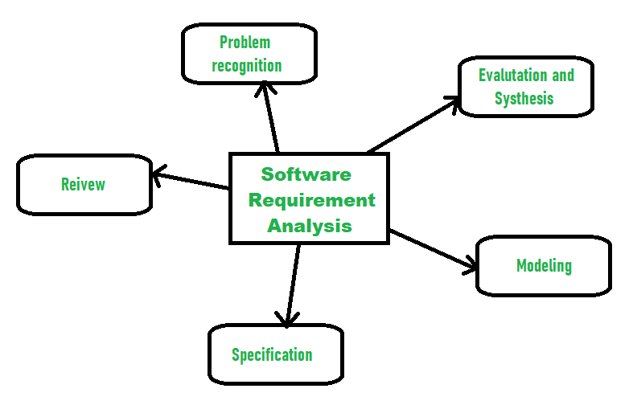

Figure.2.1 Requirement analysis

By thoroughly analyzing and documenting these requirements, I can lay the foundation for a successful ERP implementation in a college setting, promoting efficient operations and enhanced collaboration among stakeholders.

# CHAPTER 3

## DATABASE MANAGEMENT SYSTEM

### Database management system

Implementing a Database Management System (DBMS) for a College Enterprise Resource Planning (ERP) system involves designing a database that efficiently stores and manages information related to various aspects of the college, such as students, courses, faculty, grades, schedules, and more.

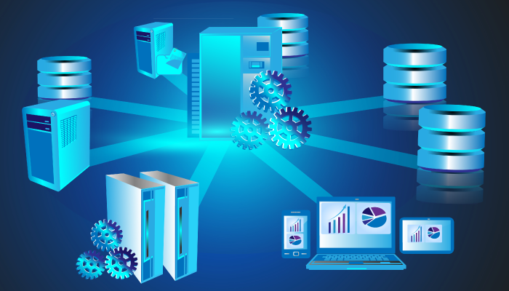

Figure.3.1 Database management system

* 1. **Database Table Relationship**

A relational database collects different types of data sets that use tables, records, and columns. It is used to create a well-defined relationship between database tables so that relational databases can be easily stored. For example of relational databases such as Microsoft SQL Server, Oracle Database, MYSQL, etc.

1. **Entities and Relationships**

* **Students:** StudentID, Name, Date of Birth, Contact Information, Address, Enrolled in Courses, Belongs to Departments.
* **Faculty:** FacultyID, Name, Date of Birth, Contact Information, Address, teaches Courses, Belongs to Departments.
* **Courses:** Course Code, Course Title, Credits, Schedule, enrolled Students, Assigned Faculty, Belongs to Departments.
* **Departments:** Department Code, Department Name, Head of Department, Contains Courses, Enrolled Students, Faculty Members.
* **Enrollment:** EnrollmentID, StudentID, CourseCode, Enrollment Date, Relates Students to Courses.
* **Grades:** StudentID, Grade, relates to Enrollment.
* **Schedule:** ScheduleID, CourseCode, FacultyID, Day, Time, Relates to Courses and Faculty.

1. **Database Table**

* **Student Table:** Student ID, Name, DOB, Contact Info, SSC Pass Information, Address, etc.
* **Faculty Table:** Faculty ID (Primary Key), Name, DOB, Contact Info, Address.
* **Courses Table:** SubjectCode, SubjectName, SubjectType.
* **Departments Table:** DeptCode, DeptName.
* **Enrollment Table:** EnrollmentID, StudentID (Foreign Key), CourseCode (Foreign Key), EnrollmentDate.
* **Grades Table:** EnrollmentID, Grade.
* **Schedule Table:** ScheduleID (Primary Key), CourseCode (Foreign Key), FacultyID (Foreign Key), Day, Time.

1. **Normalization**

* Normalize tables to eliminate data redundancy and improve data integrity, Ensure that each table has a primary key and that foreign keys establish relationships between tables.

1. **Security**

* Implement access controls to ensure that only authorized users can be view and modify sensitive information.

1. **Data Integrity and Constraints**

* Enforce constraints such as primary key constraints, foreign key constraints, and unique constraints to maintain data integrity.

1. **Backup and Recovery**

* Establish regular backup procedures to prevent data loss and ensure quick recovery in case of failures.

1. **User Interfaces**

* Develop user interfaces or applications that interact with the database to provide a seamless experience for end-users, such as students, faculty, and administrators.

SELECT * FROM table1 INNER JOIN table2

ON table1.id = table2.id INNER JOIN table3 ON table2.id = table3.id;

Figure.3.2 Database table Relationship sql

Remember that the specific requirements for a college ERP system may vary based on the institution's size, structure, and the functionalities needed. It's crucial to involve stakeholders, including administrators, faculty, and IT personnel, in the design and implementation process to ensure that the database meets the college's specific needs.

## 3.3 Relationships Between Tables in SQL

When you have tables that are related to each other, their relationships could be one of various types.

### One-to-many

### In a one-to-many kind of relationship, one row of the first table can be related to multiple rows of the second table. In a relational database this can be implemented with the second table having a first_table_id column that says to which row of the first table that row is related.

### 

Figure.3.3 one-to-many table Relationship

### Many-to-one

### In a many-to-one kind of relationship, one row of the first table can be related to one single row of the second table, and one row of the second table can be related to multiple rows of the first table. In a relational database this can be implemented with the first table having a second_table_id column that says to which row of the second table that row is related.

### 

Figure.3.4 many-to-one table Relationship

### Many-to-many

Each row of the table in the middle represents one relationship between the rows of the left table and and the rows of the right table.

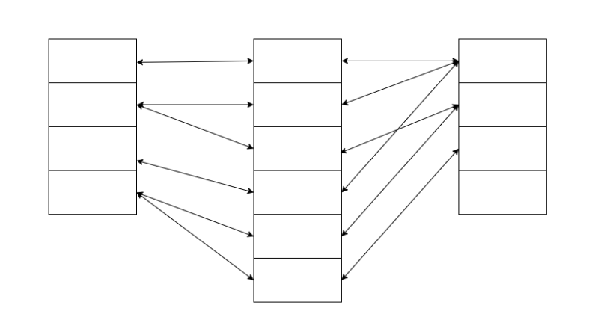

Figure.3.5 many-to-many table Relationship

In practice in MySQL, t

hat middle table will have a column for first_table_id and a column for second_table_id, with each combination being unique.

**CHAPTER 4**

**CHAPTER 5**

## SOFTWARE DESIGN

The College ERP system is a sophisticated software tool that aims to make college administration and academic functions more efficient. It is a central platform connecting various departments, allowing them to communicate and share information seamlessly. With the help of an ERP system, colleges can effortlessly manage and organize activities such as fee collection, student attendance, exam schedules, library management, and more.

* 1. **Features for College ERP System**
* **Fees Management and Accounting:** To streamline the process of managing student fees, payments, and dues, the system should have an integrated fees management module. Additionally, the accounting feature should provide a comprehensive overview of the institution's financial status, encompassing revenue, expenses, budgets, and financial forecasts.
* **Attendance Management:** A feature for managing attendance should make it simple to record and track the attendance of both students and staff. It should offer real-time updates and detailed reports to help identify patterns, irregularities, and trends in attendance.
* **Time Table or Schedule Management:** Having a well-designed timetable or schedule management feature can make scheduling classes easier and prevent any conflicts while ensuring that resources are being used efficiently. This feature should allow for easy adjustments and provide notifications for any changes to the schedule.
* **Library Management:** A useful feature for library management would be automation of tasks like book issuance, tracking, and return. Additionally, it should include a cataloguing system for easy searching and locating of books and resources within the library.
* **Staff Management and Supervision:** It is important for the ERP system to have a powerful staff management function that can manage staff profiles, work schedules, performance evaluations, and payroll management. Additionally, this function should assist in keeping track of staff assignments and progress.
* **Exams Management:** One helpful feature for managing exams is a dedicated exams management tool. This tool can assist with scheduling exams, organizing seating arrangements, grading, and announcing results. Additionally, it should enable teachers to upload and share study materials and resources.
* **Performance Monitoring for Parents**: To improve communication and transparency between parents and the institution, it would be beneficial for the system to include a parent portal. This portal would allow parents to monitor their child's academic performance, attendance, and behavior.
* **Data Import and Export:** To improve the flexibility of data management and enable smooth integration with different systems, the platform should support effortless importing and exporting of data in different file formats. This feature enhances data portability and ease of use.
* **SMS and Email Alerts**: It is important for the ERP system to have the capability to send SMS and email alerts for key updates such as changes in schedules, payment deadlines, and exam reminders. This feature promotes efficient communication and guarantees that all parties are kept up-to-date.
* **Training & Placement**: It is important for the system to have a specific module that is solely dedicated to managing training and placement activities. This module should be able to assist with scheduling training sessions, keeping track of job postings, and monitoring the current status of student placements.
* **Budget/Expenses:** The system should provide a comprehensive overview of the institution's capital expenditures and operational expenditures. This feature aids in financial planning and ensures efficient use of resources.



###### Figure 5.1: Features for College ERP

* 1. **Design Implement**

Designing a College ERP (Enterprise Resource Planning) software involves creating a comprehensive system that integrates various functions within an educational institution. Here's a high-level overview of the system design for a College ERP software.

* **Home Page**

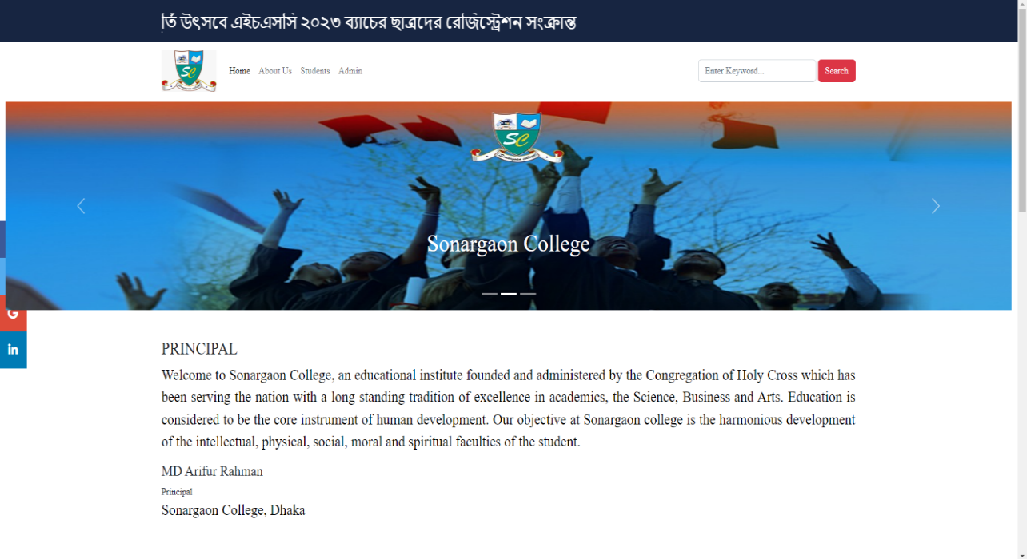

###### Figure 5.2: user-inter page of the application

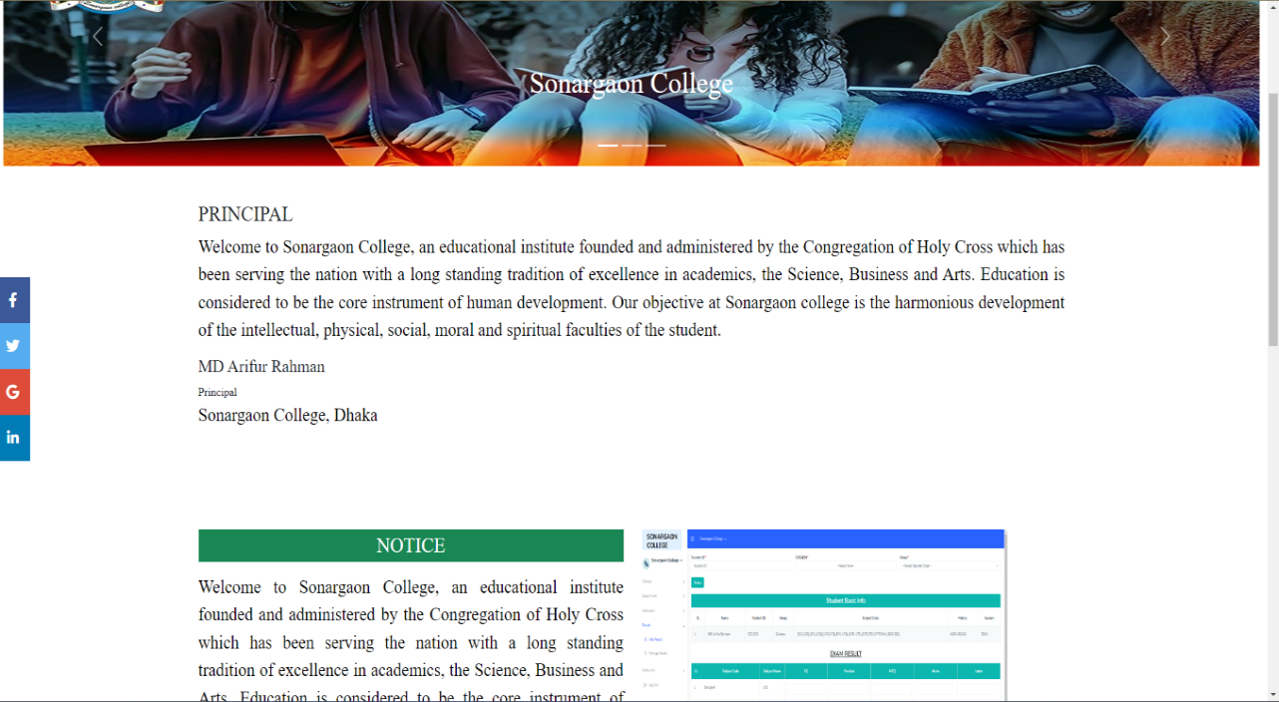

###### Figure 5.3: user-inter page of the application

* **Login Form**

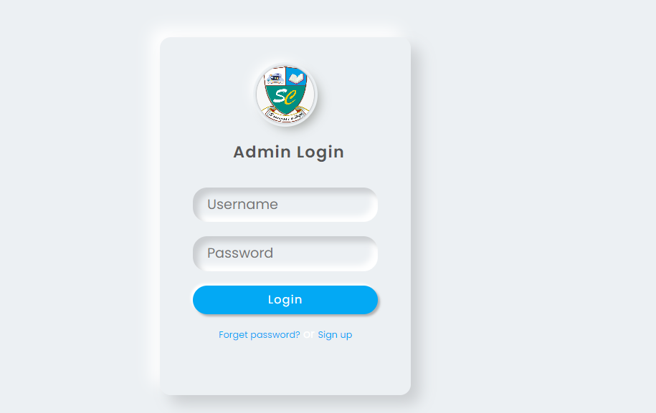

###### Figure 5.4: admin login form

* **Admin Panel**

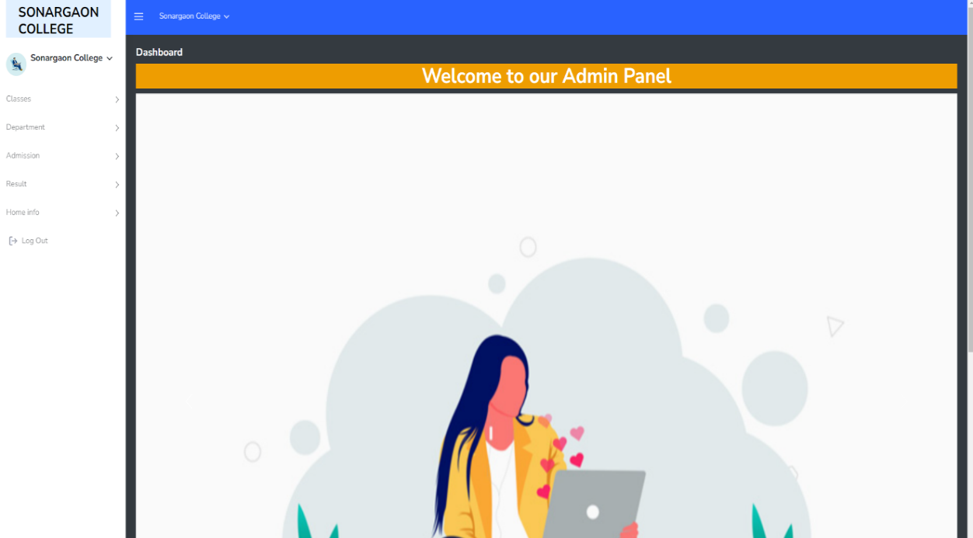

###### Figure 5.5: Admin dashboard

* **Admin Panel**

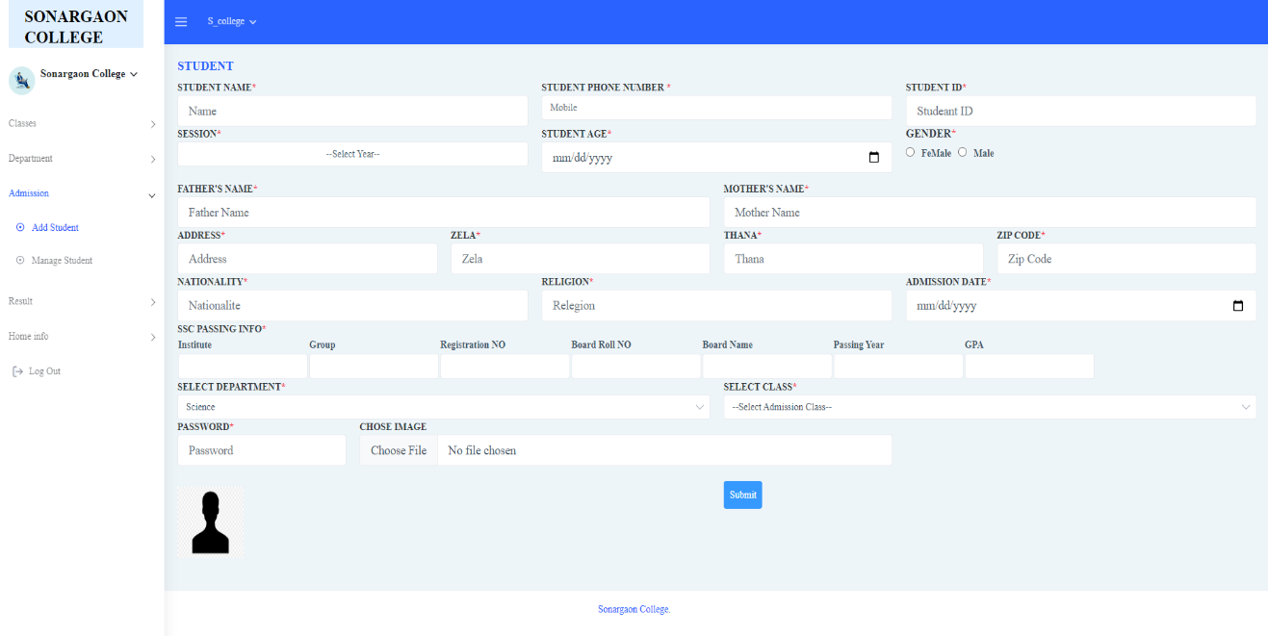

###### Figure 5.6: student admission form

* **Admin panel**

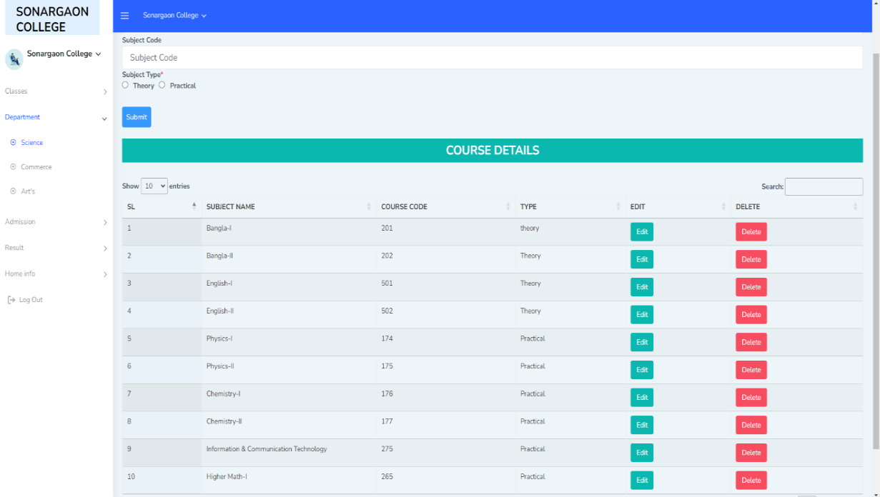

###### Figure 5.7: Subject insert section

* **Admin Panel**

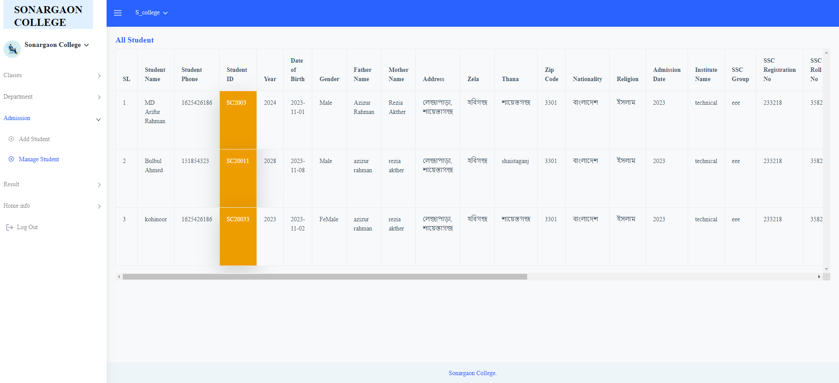

###### Figure 5.8: Student information show

* **Admin Panel**

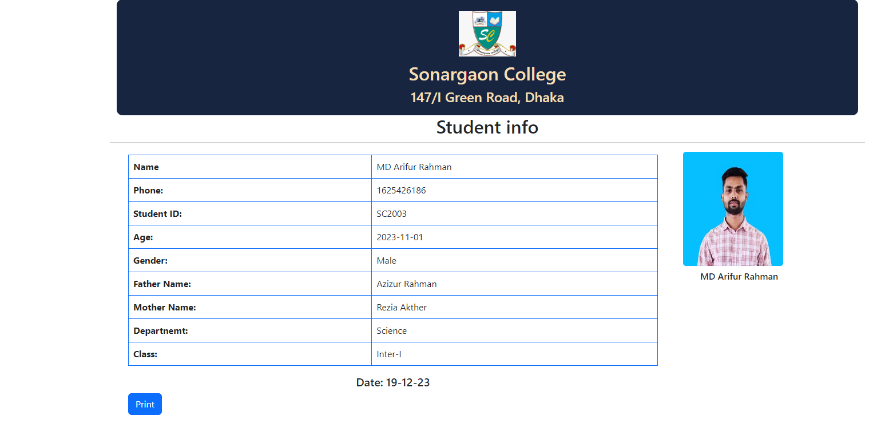

###### Figure 5.9: Print Student Basic info

* **Admin Panel**

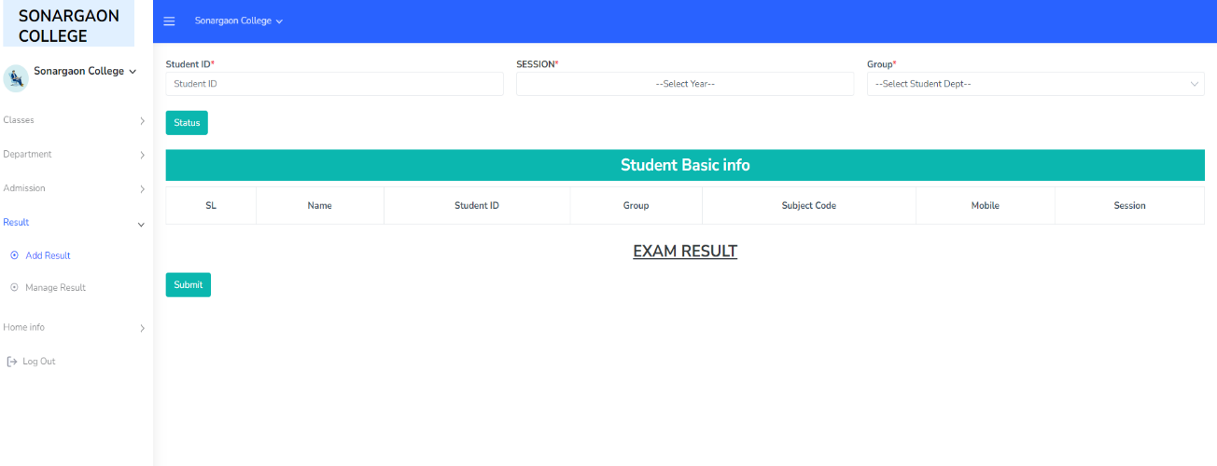

###### Figure 5.10: Student filter for insert exam Result

* **Admin Panel**

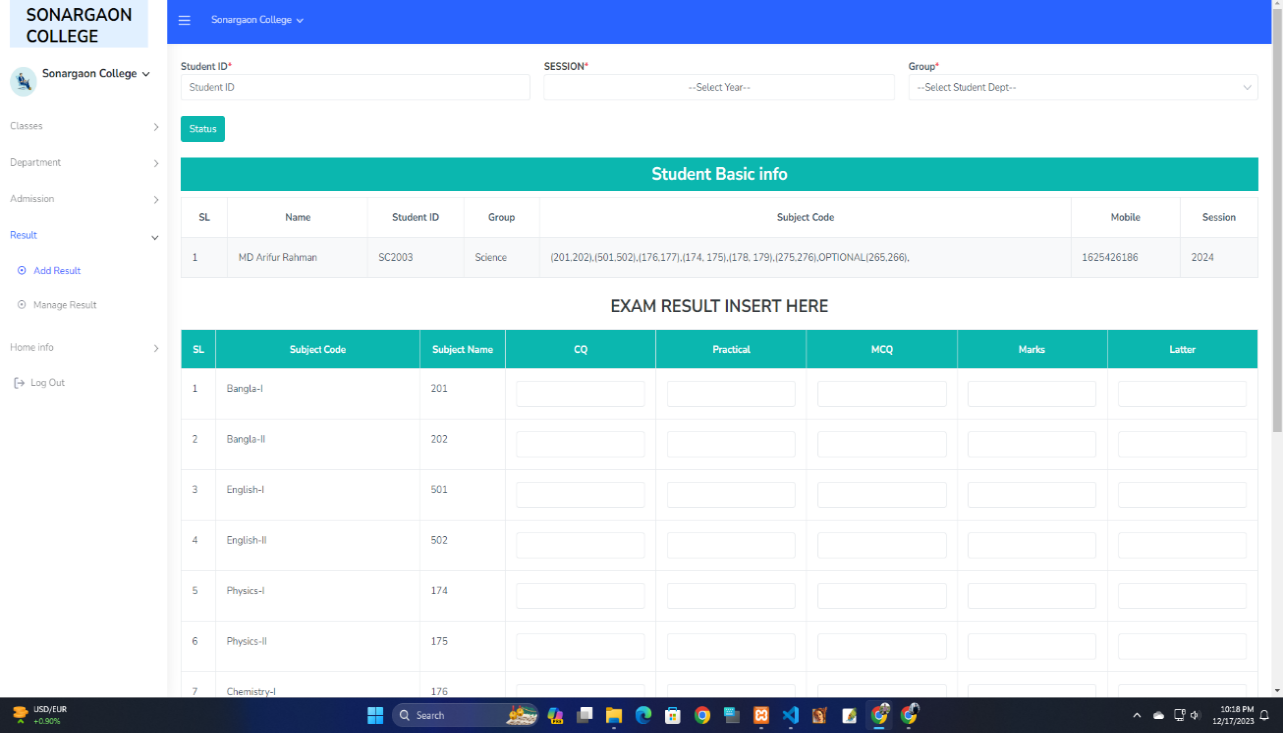

###### Figure 5.11: Exam Result student wise insert

* **Admin Panel**

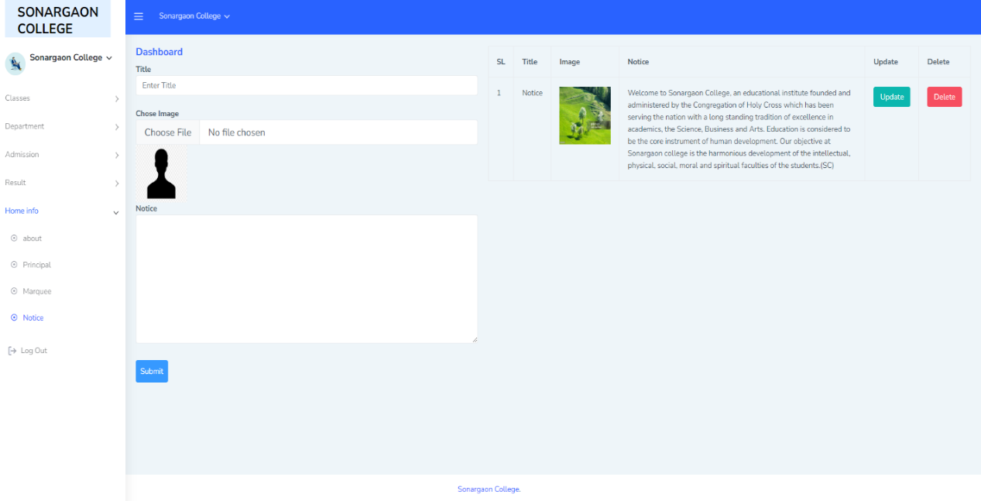

###### Figure 5.12: Dynamic notice content update

* **Admin Panel**

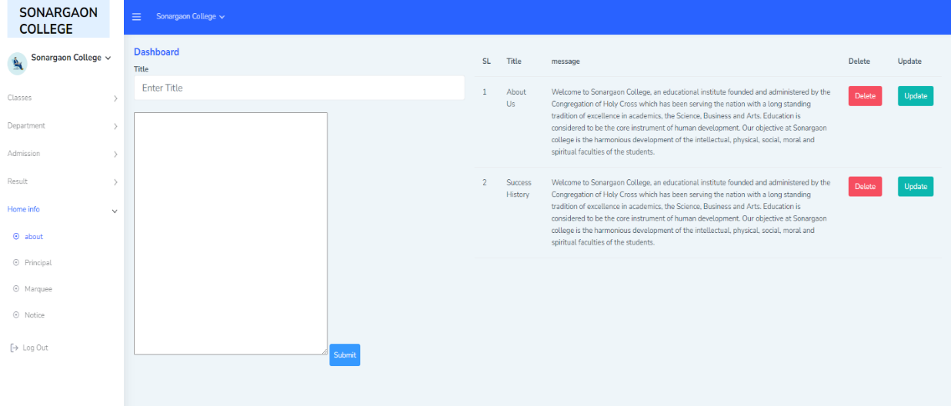

###### Figure 5.13: College About content update and insert here

The central issue for controlling and handling the task by the administrator is therefore solved. before this it was quite hectic for handling the timetable and to keep in touch with day to day agenda. But by creating this software the administrator can now handle the task easily and also save his/her time. The quality time of the administrator is also saved and the manual man power is also saved, the data can be retrieved timely and also whenever it is required by the user. The adequate application of the task by distributing it and by allocating the exact outputs. The storage facility will make the task easy of the handler. Therefore the proposed system will be accessible to the administration by making his/her task easy.

# CHAPTER 6

## IMPLEMENTATION AND RESULT

* 1. **Implementation**

Enterprise Resource Planning system, popularly known as ERP system, the descendant of MRPII offers the answer to the economic and productivity troubles of manufacturing and service enterprises. Thus, the ERP system has become very popular as an enterprise management software tool. It was the larger companies that have opted to use the ERP systems initially. However, the use of ERP has changed and today the term can refer to any type of company, no matter what industry it falls in. In fact, ERP systems are used in almost any type of organization - large or small. The latest ERP tools available in the market today can cover a wide range of functions and integrate them into one unified database. This made ERP to land up into higher educational institutes. In today's competitive business world usage of ERP system is becoming a must for any educational organization to meet the challenges faced in their business process and to have a cutting edge. Studies also reveal that organizations that don't have an ERP implemented are facing numerous problems in their internal processing like attendance management, payroll management, quick decision making, etc. So in order to be different and ready for action the institutes need a central resource planning that can manage the entire information and operations of the institutions.

This paper deals with the implementation of College ERP, the technology used and why every higher educational institute should opt for an ERP. Higher education environments are extremely dynamic, where the education system has been fundamentally changed.

Higher education institutions and the state should leave behind the question of Information support for business processes and should focus on informatics as one of the key factors of quality assurance in higher education. ERP provides a unified enterprise view of the business that encompasses all functions and departments as well as an enterprise database where all business transactions are processed, monitored, and reported. [2] But implementing an ERP system requires careful exercise in strategic thinking, precision planning, and negotiations with all stakeholders.

factors of quality assurance in higher education.

[1]

ERP

provides a unified enterprise view of the business that

encompasses all functions and departments as well as an

enterprise database where all business transactions are

processed, monitored, and reported.

[2]

But implementing an

ERP system requires careful exercise in strategic thinking,

precision planning, and negotiations with all stakeholders.

ERP means the techniques and concepts for integrated management of business or education as a whole, from the viewpoint of effective use of management resources to improve the efficiency of enterprise management. A fully integrated web-based ERP will capture and create accurate, consistent and timely relevant data, and assist in intelligent business decision-making. The primary purpose of E-college is to provide mechanisms for automated processing and management of the entire institution. It reduces data error, ensures that information is managed efficiently and is always up-to-date. Complete student histories for all years, can easily be searched, viewed and reported on press of button.

It is made after extensive study of all the departments like student, faculty, etc of colleges and is provided with the extract of everything a college requires for their database handling, department management and student/staff management. The security issue within ERP has been there for a long time, but most of the solutions are based on the assumption that an ERP system is a closed environment. Higher education institutions are persisting in the IS era by adopting and implementing ERP system. The need to evaluate their benefits and impacts on organizations and individuals are increasingly essential.

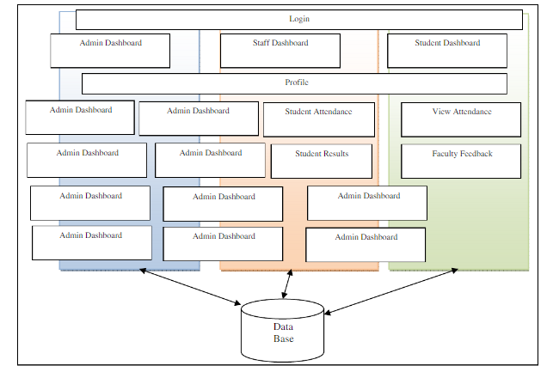

International Journal of Computer Sciences and Engineering Vol.-2(3), pp(134-138) March 2014, E-ISSN: 2347-2693

© 2014, IJCSE All Rights Reserved 135

Fig-I: E-College Architecture

International Journal of Computer Sciences and Engineering Vol.-2(3), pp(134-138) March 2014, E-ISSN: 2347-2693

© 2014, IJCSE All Rights Reserved 135

Fig-I: E-College Architecture

Figure 6.1: Admin activity Diagram

The architecture comprises of various modules as given in the figure. There are 3 major categories in which the whole architecture is divided. These are administrator, staff and student. The architecture is designed such a way that it is self explanatory. The admin roles are user management, staff management, student management, staff attendance. Staff and admin perform some common functions like news management, leave management, time table management, exam management.

* 1. **System design**

The Collage ERP software solution will include the following primary modules/components: student, financial aid, finance, human resources, and advancement, collage data warehouse, reporting and analytics, workflow, document management, and student, faculty, and staff portal. Implementation services will include: technical services, data migration and conversion services, integration services, database management services, and system/end-user training.

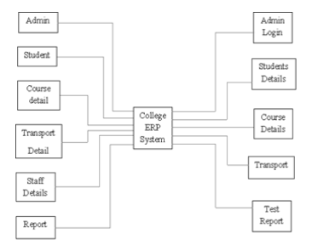

Figure 6.2: System Design

A System Diagram (SD) in software engineering and systems engineering is a diagram that represents the actors outside a system that could interact with that system. This diagram is the high level view of a system. SDs shows a system, often software-based, as a whole and its inputs and outputs from/to external factors. System Diagrams are diagrams used in systems design to represent the more important external factors that interact with the system at hand. This type of diagram according to Kossiakoff (2003) usually "pictures the system at the center, with no details of its internal detail structure, surrounded by all other interacting systems, environment and activities. The objective of a System Diagram is to focus attention on external factors and events that should be considered in developing a complete set of system requirements and constraints".

Students are admitted by admin only to the system. When he got admitted the username and passwords are generated by admin and can be managed by student afterwards. Student has access to personal profile, current attendance record, Class Tests records, Daily Class Routines and all the notifications and upcoming events which are managed by admin. Students also view his respective bus route and bus number through the transportation module. Another important facility provided for students is to view the notification of his/her respective department.

**Workflow:**

1. Start

2. Login

3. View personal information

4. View subjects

5. View teachers

6. View marks

7. View class routines

8. View transport

9. View notice board

10. Logout

Staff members are registered by admin and login details are generated by admin which can be managed by staff afterwards. Staff has access rights to manage all the data of their subjects of respective class. They can manage daily attendance of all students of respective subjects and classes. Staff members are able to give notifications and can upload some documents related to their respective subjects. Staff can generate the daily, monthly or yearly report of individual student as well as class. Mark sheet generation and time table generation facility is also available for staff. Instead of manual work this application gives automatic work.

**Workflow:**

1. Start.

2. Login.

3. View student information.

4. View/Edit student’s marks.

5. Manage daily attendance of students.

6. Add notes.

7. View subjects.

8. View personal class routine.

9. View transport.

Parents are able to track all information and academic records of their respective child. They are not able to view the information relevant to other students. The parents are added by the admin after the admission of their child. Parents can view result sheets, attendance records, notifications etc. This module gives parents to keep track of its respective child’s educational growth. Parents are able to communicate with teachers if they wish. In short this module facilitates to view educational growth of respective child.

**Workflow:**

1. Start

2. View Student Information

3. View student Mark sheet

4. View Transportation

5. Logout

6. Close.

Admin has given the access rights to manage the transport information which is accessible to all the users. Users can view all the routes and respective buses of the routes including their pickup points. Timing of respective bus from pickup point is also shown in this module.

* 1. **Activity Diagram Of College Management**

This is the Login Activity Diagram of College Management System, which shows the flows of Login Activity, where admin will be able to login using their username and password. After login user can manage all the operations on Branches, Courses, College, Login, Faculties. All the pages such as College, Login, Faculties are secure and user can access these page after login. The diagram below helps demonstrate how the login page works in a College Management System. The various objects in the Login, Branches, Courses, College, and Faculties page—interact over the course of the Activity, and user will not be able to access this page without verifying their identity.

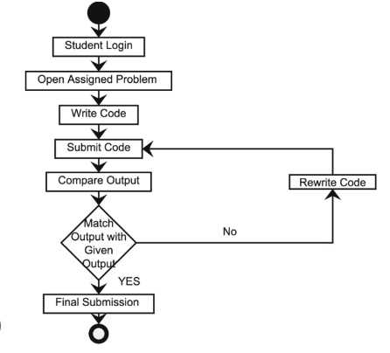

Figure 6.3: Login Activity Diagram

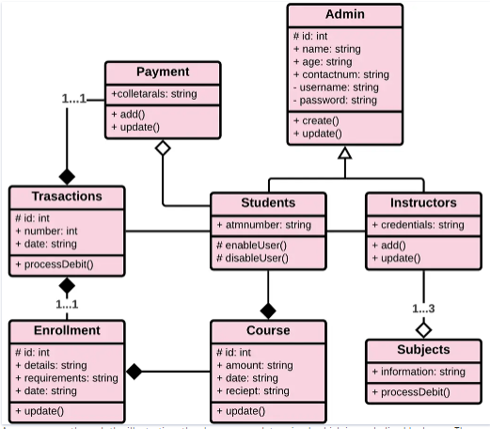

Figure 6.4: Class Diagram

# CHAPTER 7

## FUTURE ENHANCEMENT

To phones, tablets, and laptops, for teaching and learning but there is still a big scope of change that can transform the level of education making all the operations simple, efficient, and relevant. I guess you may have understood what I am talking about? A Higher Education ERP – can transform the complete operations of the institution bringing automation and digital transformation of all the academic and administrative processes of the institution.

The future of education is changing rapidly and will change in the upcoming years, but having an Education ERP Software you can make sure to adopt every change with the same consistency and flow and it will make all the processes easy and smooth providing access to every single thing from just one click.

Enterprise resource planning (ERP) for education is something that is indulged with power BI analytics tools that help in generating important reports for managing all the academic and administrative operations of an institution like admission & enrollment, fees payment & collection, student attendance, academic performance, compliance management and much more. It enables institutions to make data-driven decisions that can lead towards the growth and success of the institution.

An ERP system provides and creates a single version of the truth because everyone uses the same system. Furthermore, College and higher educational institutions include a bulk of data as they collect and process personal and confidential information about their prospective, faculty and enrolled students, alumni, and staff. An ERP system can manage all the data effectively and efficiently.

Institutional development is the most important aspect in an educational institution, having an ERP institution can enhance their workflow along with increasing efficiency, along reducing paperwork. Let’s take an example, like an institution is still following the traditional method using the pen and paper format, and if they require any documents related to one student,

The staff or faculties need to check various documents that will be time-consuming, tedious, and even sometimes it is also possible that some of the documents will get misplaced or missing.

In the second scenario, if an institution will opt for an ERP system, then everything will go in flow providing work efficiency and productivity. The use of an ERP system will reduce the use of paper or faculty keeping the data in a single system that can be accessed from anywhere anytime, and an ERP system can manage multiple branches of an institution keeping data of all the institutions in just a few clicks.

ERP brings automation in education institutions, providing various benefits to the institution, it tightens the complete control providing digital transformation and automation in the institutions.

Just imagine, through automation, institutions can grow and earn a huge success as it becomes so easy for institutions to manage all their academic and administrative tasks easily and efficiently.

* 1. **Future Scope**

The future will most likely see a rush in demand for higher education ERP. Using business intelligence dashboards it will be easy to track key performance indicators, real-time metrics, or any other key student data that could be easily tracked, allowing teachers to make smart decisions with all the information required. So it is most important for higher education institutions to opt for an ERP that can simplify their current as well as future needs. By using an ERP institutions can track attendance and studying reports generated to help faculties and students to have better learning platforms.

I can only state that higher education software for universities and colleges will be truly intelligent and future-ready if it manages to embody the personal touch and the wisdom of conventional learning in its new-age software.

Automation is one of the most important functions that an ERP provides, a higher education ERP automates the complete day-to-day tasks. Students in today’s era demand easier access to everything like marking attendance, fetching timetables and all other tasks, and predicting the future. There are more chances that students will only like institutes that will provide their complete automation and real-time access to things from admission form to result in the announcement.

Opting for cloud-based higher education management software will allow institutions to adopt advances in technology that can help in teaching and learning patterns. It provides easy access to all the academic and administrative tasks through which traditional patterns can be easily erased. With all these, it is also easier to predict that one can anticipate more options and more advanced features using e-learning ERPs in the future.

According to the Education ERP Market Size And Forecast, growing demand for modern learning has improved the level of the education system, improved performance of the academic and administrative department, and enhanced connectivity have made ERP essential for higher education institutions. It is not wrong to estimate that modern trends and technologies are improving the chances of incredible future growth of institutions using ERP. A good and robust ERP provides the personalization and customization of tools and technologies that are needed by the institutions.

Commenting on the personalization of systems using ERP, I can conclude that an ERP will get more powerful having more strong implementation and customization of each institution’s process but for these, institutions must choose a flexible, robust, and well-integrated ERP system.

ERP software can help students and faculty to learn properly bridging the gap between them. It helps institutions with updating all the lessons, assignment details, faculty’s availability and other related information, managing attendance, enrollment tasks, examinations, and all other tasks managing better communication.

* 1. **Conclusion**

The implementation of a College ERP (Enterprise Resource Planning) software is a transformative journey that holds the potential to revolutionize the administrative, academic, and financial landscape of an educational institution. By integrating various modules and automating processes, a well-implemented ERP system brings about numerous benefits.

The centralization of data and automation of routine tasks contribute to streamlined operations, reducing manual efforts and enhancing overall efficiency. Improved data accuracy ensures that stakeholders can rely on up-to-date and precise information for decision-making. The ERP system not only facilitates better communication among staff, faculty, and students but also provides a comprehensive platform for managing diverse aspects of college life.

One of the key advantages of a College ERP software lies in its ability to generate insightful reports and analytics, empowering administrators to make data-driven decisions. This data-driven approach not only enhances the quality of decision-making but also supports the institution in adapting to changing needs and fostering continuous improvement.

Furthermore, the implementation of a College ERP system contributes to cost savings by minimizing manual paperwork, reducing administrative overhead, and optimizing resource allocation. Increased productivity among staff and faculty members is a direct result of automated processes and the elimination of redundant tasks.

From a student perspective, the ERP system enhances the overall experience by providing easy access to crucial information such as schedules, grades, and academic resources. This accessibility fosters a more transparent and collaborative environment between students and the educational institution.

Scalability is a critical factor in the success of a College ERP system. The ability to adapt to future growth, technological advancements, and changing educational requirements ensures that the institution can continue to harness the benefits of the ERP system over the long term.

A well-implemented College ERP software not only modernizes the operational infrastructure of an educational institution but also positions it to thrive in an ever-evolving educational landscape. The successful deployment of such a system requires careful planning, collaboration among stakeholders, and ongoing commitment to refinement and improvement. Ultimately, the College ERP software serves as a catalyst for positive change, fostering efficiency, transparency, and innovation within the academic community.

**REFERENCES**

1. Pranab Garg, Dr.Himanshu Aggarwal “Comparative Analysis Of Erp Institute Vs Non Erp Institute; Teacher Perspective, IJMBS-2011.
2. Xia Hu, Min Zhou,”The Three-dimensional Teaching Mode of ERP

Course in Colleges and Universities”, IEEE-2011.

1. Chongjun Fan, Peng Zhang, Qin Liu, Jianzheng Yang,” Research on ERP Teaching Model Reform for Application-oriented Talents Education” International Education Studies Vol. 4, No. 2; May 2011.
2. Wenjie Yang, Haoxue Liu, Jie Shi,” The Design of Printing Enterprise Resources Planning (ERP) Software” IEEE-2010.
3. W. D. Doyle, “Magnetization reversal in films with biaxial anisotropy,” in 1987 Proc. INTERMAG Conf., pp. 2.2-1–2.2-6.1.