PrivacyMachine - creating random fingerprints to prevent web tracking

Introduction:
Today, web tracking is not only achieved using cookies, but also makes use of far more advanced techniques such as fingerprinting. The open source software PrivacyMachine provides a new concept for counteracting web tracking.

How is a fingerprint generated?
The most important properties of a fingerprint can be read by JavaScript and originally served the purpose of adapting a page to the browser used.
However, the combination of these properties, such as screen resolution or fonts installed in the operating system, is unique and makes it possible to recognise a computer on different pages.

The most elegant solution would be to read as little information as possible via JavaScript and for this to be standardised. But the finances necessary for developing a competitive modern browser mean this is only possible for large companies.

Previous approaches to counteracting web tracking involved attempting to create a large group of users who have the same fingerprint when surfing the web. This means it is no longer possible to identify individual users in the group.
A well-developed example of this approach is the TOR browser.
The following pages calculate how unique a fingerprint is:
https://panopticlick.eff.org
https://amiunique.org

These pages clearly show that it is almost impossible to be in a group of any relevant size without taking drastic measures such as turning off JavaScript.
Most browser setups are unique.

Implementing countermeasures, which are usually achieved by installing several browser plug-ins, have two effects:
- The usability of pages is drastically reduced, because numerous individual options for a page need to be manually unblocked in order for it to work (example: NoScript)
- Each installed plug-in decreases anonymity, because the list of installed plug-ins is also part of the fingerprint.

Why is the PrivacyMachine concept different?
The PrivacyMachine looks like a normal browser; the difference is that a virtual machine is running behind each tab, which shows the content of a standard browser. Every virtual machine is given its own IP address via VPN or TOR.
The advantage is that the machine is reset to a snapshot when the tab is closed → all types of cookies, such as Flash cookies or browser local storage, are deleted.
Furthermore, the fingerprint is changed by altering the properties of the operating system and installed software. These properties make up most of the fingerprint, which is read by the browser using JavaScript and sent to web tracker domains.

Every time a tab is opened, a new unique fingerprint is created.
The user can surf using two different fingerprints in parallel.

Can a user be recognised precisely because their fingerprint is unique?
Yes, if there is only one user. However, it would not make financial sense for a tracking provider to implement the recognition of one individual user.

If a group of, for example, 20 people use the PrivacyMachine, it is not possible to differentiate between individual users. The averaged personal profile either would not make sense – because sex and age change – or the combined profile would be something as general as readers of a print medium → the users are then only shown non-personalised advertisements and the creation of comprehensive personal profiles is prevented.

This screenshot from https://panopticlick.eff.org shows two fingerprints in two VM masks (virtual machines) that are open at the same time.
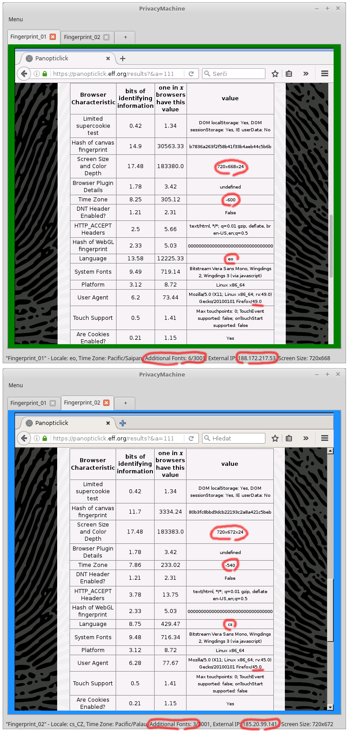
Authors: Bernhard Zach, Olaf Pichler, Alexander Leopold
contact@privacymachine.eu
OpenPGP-Fingerprint: 0C93 F15A 0ECA D404 413B 5B34 C6DE E513 0119 B175

This work is licensed under the „Creative Commons Attribution-ShareAlike 4.0 International License“
http://creativecommons.org/licenses/by-sa/4.0/

„Web tracking“ refers to the recognition of users on different web pages.
A „fingerprint“ consists of all the properties that make a computer unique.

