PrivacyPilot: Static Analysis of Source Code and Privacy Policies for DPDP Act 2023 Compliance

Mridulika Mukerji
Dept. of Computer Science and Engineering (Cybersecurity)
SVKM’s NMIMS Mukesh Patel School of Technology Management & Engineering
Mumbai, India
[e-mail address or ORCID]
Atharva Naik
Dept. of Computer Science and Engineering (Cybersecurity)
SVKM’s NMIMS Mukesh Patel School of Technology Management & Engineering
Mumbai, India
[e-mail address or ORCID]
Nishika Shah
Dept. of Computer Science and Engineering (Cybersecurity)
SVKM’s NMIMS Mukesh Patel School of Technology Management & Engineering
Mumbai, India
[e-mail address or ORCID]

Abstract—India’s Digital Personal Data Protection (DPDP) Act, 2023, and the DPDP Rules, 2025, require a data fiduciary to give notice of the personal data it collects and why, to process that data only for the purposes consented to, and to engage data processors only under a valid contract. Whether a software product meets these obligations depends on two artefacts that are rarely examined together: its source code and its privacy policy. This paper presents PrivacyPilot, a system that statically analyses a GitHub repository together with the product’s privacy policy and reports likely non-compliance against specific provisions of the Act. The code analysis combines identifier-level pattern matching, checksum validation of Aadhaar numbers, named-entity recognition and intra-file taint analysis of Python and JavaScript/TypeScript to locate personal data and the third-party destinations it reaches. The policy analysis extracts the disclosed data categories, the stated purposes, using dependency parsing and sentence embeddings, and the named recipients. A rule engine cross-references the two to detect notice gaps (Sections 5 and 6(1)), undisclosed third-party transmission (Section 8(2)), logging of personal data (Section 8(5)), processing beyond the stated purpose (Section 6(1)) and vague purpose statements (Rule 3 of the DPDP Rules). Repositories of any size are scanned as bounded parallel tasks, and bundled third-party code is analysed and attributed separately. On [N] synthetic repositories with planted violations, PrivacyPilot achieved a recall of [X]% and a precision of [X]%; it was also applied to [N] real-world repositories.
Keywords—DPDP Act 2023, privacy compliance, static analysis, taint analysis, privacy policy analysis, natural language processing

Introduction
The Digital Personal Data Protection (DPDP) Act, 2023 [1] is India’s first comprehensive data protection law, and the DPDP Rules, 2025 [2], notified in November 2025, make most of its obligations operative after an 18-month transition. A data fiduciary must give the data principal a notice of the personal data it will process and the purpose of processing (Section 5); consent must be free, specific, informed and limited to the specified purpose (Section 6(1)); a data processor may be engaged only under a valid contract (Section 8(2)); and reasonable security safeguards must prevent personal data breaches (Section 8(5)). Rule 3 of the DPDP Rules further requires the notice to be clear and plain and to give an itemised description of the personal data and the specified purpose.
Checking these obligations is today largely a manual legal review of the privacy policy. Such a review cannot see what the software actually does: a mobile number sent to an analytics SDK, an Aadhaar number written to a log, or a new data field added in a later release without the policy being updated. Conversely, a code review rarely compares what the code does with what the policy promises. Automated work on this gap exists for other jurisdictions and platforms, mostly Android applications and the General Data Protection Regulation (GDPR) [3], for example [4]–[6], but it does not encode the provisions of the DPDP Act or Indian identifiers such as Aadhaar and PAN.
PrivacyPilot addresses this by analysing a product’s source repository and its privacy policy together and reporting each likely violation with the provision concerned, the evidence (file and line, or the policy clause) and a recommended fix. Its contributions are:
- a rule engine that maps code-level and policy-level evidence to Sections 5, 6(1), 8(2) and 8(5) of the Act and to Rule 3 of the DPDP Rules, with severities and a compliance score;
- a code analysis pipeline for Python and JavaScript/TypeScript that combines identifier patterns, Verhoeff validation of Aadhaar numbers, named-entity recognition and taint analysis to find personal data and the third-party sinks it reaches;
- a policy analysis pipeline that extracts disclosed data categories, stated purposes and named recipients, and flags ambiguous purpose statements, without a large language model in the detection path;
- a scanning architecture with no limit on repository size that also analyses, and separately attributes, bundled third-party code; and
- an evaluation method based on planted violations with strict and lenient matching.
Section II reviews the legal background and related work, Section III describes the design, Section IV the implementation, Section V the evaluation method and Section VI the results. Section VII discusses limitations and Section VIII concludes.

Background and Related Work

The DPDP Act and Rules
The Act applies to digital personal data processed in India and to processing outside India in connection with offering goods or services to data principals in India [1]. Unlike the GDPR, it does not define a class of sensitive personal data. PrivacyPilot therefore uses a project-defined high-risk tier (Aadhaar, PAN, financial, health and biometric data) only to set the severity of a finding; the tier is not a legal category. PrivacyPilot reports likely non-compliance from technical evidence and does not constitute legal advice: obligations such as the existence of a processor contract cannot be verified from code.

Privacy Policy Analysis
The OPP-115 corpus [7] provided annotated website privacy policies that enabled supervised policy classification, and Polisis [8] used it to label policy segments with data practices. PolicyLint [9] detects contradictory statements within a policy. These systems analyse the policy alone and do not check it against the software.

Code and Data-Flow Analysis
TaintDroid [10] tracks personal data dynamically on Android, and FlowDroid [11] performs static taint analysis of Android applications. Zimmeck et al. [4] and MAPS [5] compare an application’s observed practices with its policy at scale, and PoliCheck [6] checks data flows against policy statements, taking the receiving entity into account. These works target compiled mobile applications and GDPR or United States practice. PrivacyPilot instead analyses the source code of web and server applications and maps its findings to DPDP provisions. For personal data detection in text it builds on Microsoft Presidio [12].

System Design
Fig. 1 shows the pipeline. The repository and the privacy policy are analysed independently, and a rule engine combines the results.
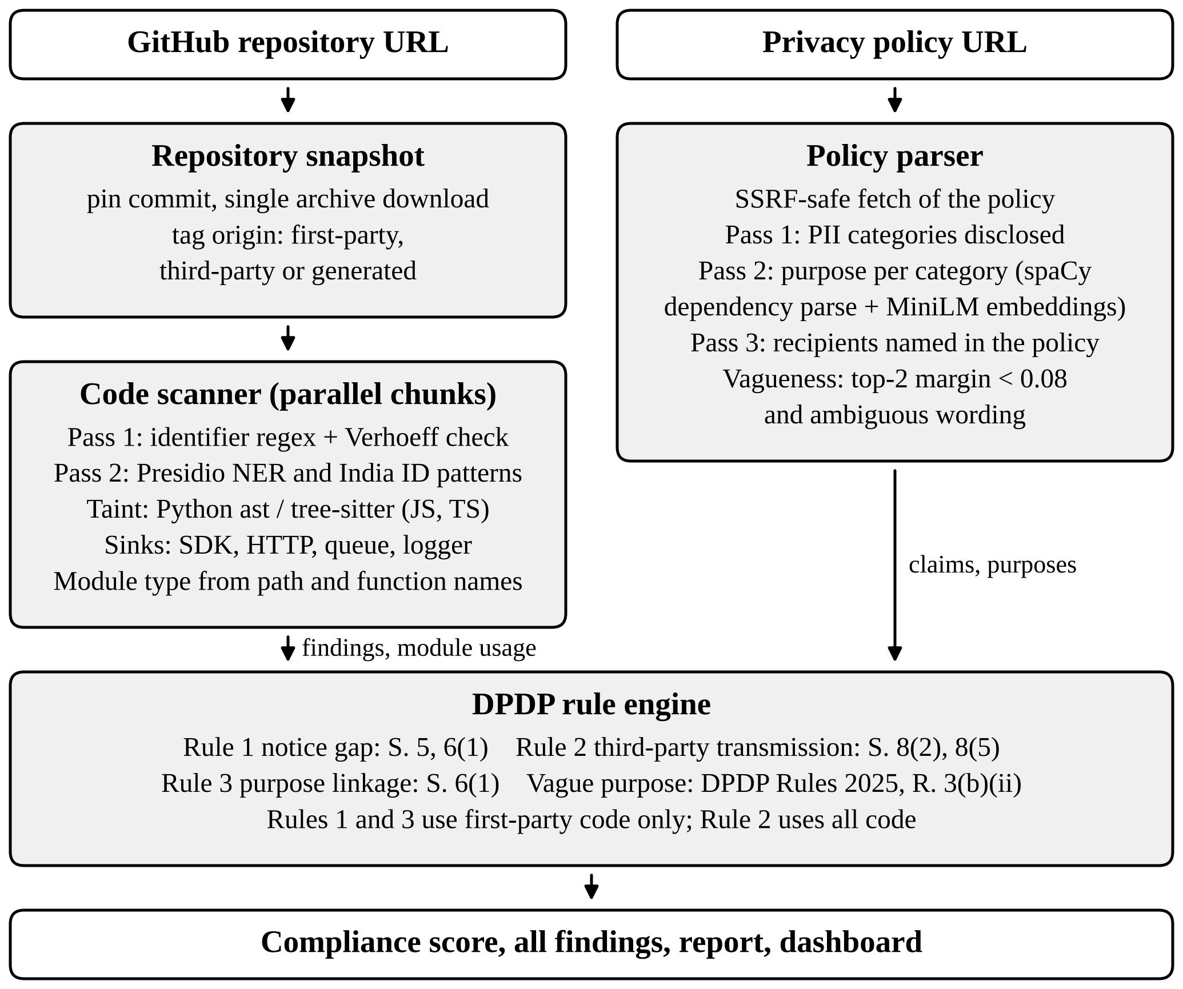
- Architecture of PrivacyPilot.

Repository Acquisition
The default branch is resolved to a commit identifier, and the archive of that commit is downloaded once and streamed to disk, so every part of a scan reads the same snapshot. Only source files the scanner understands (.py, .js, .jsx, .ts, .tsx, .mjs and .cjs) are extracted, and archive paths are checked to prevent directory traversal. Each file is tagged with its origin: first-party (the repository’s own code), third-party (bundled dependencies such as node_modules/ or vendor/) or generated (build output such as dist/ or minified bundles). Third-party code is scanned rather than excluded, because a bundled SDK is precisely where personal data may leave for a third party. If the archive cannot be downloaded, the file list is read from the Git tree and files are fetched individually.

Personal Data Detection in Code
PrivacyPilot recognises ten categories of personal data: Aadhaar, PAN, phone, e-mail, location, health, financial, name, date of birth and biometric. Each line of code is analysed in two passes, followed by a taint analysis of the file.
Pass 1 (identifiers). Identifiers are normalised (phoneNumber becomes phone_number) and matched against a vocabulary for each category; overlapping matches are resolved longest-first, so email_address is e-mail data rather than also location data. Comments and docstrings are skipped. Aadhaar numbers carry a Verhoeff check digit [13]; when a line contains a 12-digit candidate, at least one candidate must pass the Verhoeff check, which rejects timestamps and other digit strings that merely sit next to an Aadhaar identifier.
Pass 2 (named entities). Lines without a Pass 1 match are analysed with Presidio [12] on the spaCy en_core_web_lg pipeline [14], restricted to the entity types that map to the ten categories, together with regular expressions for Indian identifiers. Results below a confidence of 0.7 are discarded, a detected PAN must match the PAN format, a detected Aadhaar number must pass the Verhoeff check, and person and location entities are kept only inside string literals that look like names; together with a list of known SDK names, this removes most library and SDK names mistaken for people or places. A line is sent to the NER pipeline only if an accepted result is possible, and all lines of a file are analysed in one batch. Very long lines, typical of minified code, are analysed in overlapping 2,000-character windows.
Taint analysis and sinks. Python files are parsed with the standard ast module and JavaScript/TypeScript files with tree-sitter [15]. A variable assigned from an expression that carries personal data inherits all of that expression’s categories, iterated to a fixed point. A call is a sink when its callee is a recognised analytics or communication SDK (for example Firebase, Mixpanel, Segment, CleverTap or Twilio), an outbound HTTP client (requests, httpx, axios, fetch), a message queue (for example Kafka or Celery) or a logger, including aliases of an SDK object. The sink of a line is the call that encloses it, so arguments spread over several lines are attributed correctly. One shared vocabulary of sink labels is used by the scanner and the rule engine.
Module type. File paths and function names classify each first-party file into one or more of eight module types: analytics, authentication, payment, notification, database, API, storage and logging. The result is a usage map from each data category to the module types that process it, which Rule 3 compares with the policy’s stated purposes.

Privacy Policy Analysis
The policy is fetched from its URL with safeguards against server-side request forgery: only HTTP(S) is allowed, private and link-local addresses and cloud metadata hosts are rejected, and every redirect is re-validated. The text is split into sentences and list items, and each list item is prefixed with its lead-in sentence so that it keeps its meaning.
Pass 1 finds the data categories the policy discloses using whole-word, longest-phrase matching, and ignores negated statements such as “we do not collect”. Pass 2 finds the purposes stated for each disclosed category. Purpose clauses are extracted with spaCy dependency parsing, and each relevant unit is also classified by cosine similarity between its embedding and six purpose descriptions (service delivery, analytics, marketing, security, communication and research), computed with the all-MiniLM-L6-v2 model [16] through Sentence-BERT [17]; a purpose is accepted at a similarity of at least 0.30. Pass 3 finds third parties that the policy names as recipients of each category.
A purpose statement is flagged as vague when the two highest similarities differ by less than 0.08 and the statement, in its own words, states a purpose and either names two or more purpose categories or uses stock wording such as “improve our services” or “legitimate interests”. The wording condition prevents short, specific list items, which score low against every description, from being flagged.

DPDP Rule Engine
Table I summarises the rules. Let C_{c} be the set of data categories found in first-party code and C_{p} the set disclosed in the policy. The notice gap is
G = C_{c} ∖ C_{p} (1)
and Rule 1 raises one violation per category in G, citing a first-party location. Rule 2 considers every finding whose line reaches a sink. A logger sink is a security safeguard failure under Section 8(5). For an SDK, HTTP or queue sink, if Pass 3 found the SDK named in the policy as a recipient of that category, the remaining gap is that the processor contract required by Section 8(2) cannot be verified, and a medium-severity finding is raised; otherwise the recipient is undisclosed. Rule 2 uses findings from all origins and states in the evidence when the call lies in bundled third-party or generated code, since the data fiduciary is responsible for the software it ships. Rules 1 and 3 concern what the application itself collects and why, so they use first-party code only. Rule 3 maps each module type to the purposes it serves (for example, analytics code to an analytics purpose and authentication code to service delivery or security) and reports a category whose module types serve no purpose stated for it; categories already reported by Rule 1 are skipped to avoid double counting. Every violation carries its evidence and a recommendation.
- Detection Rules and DPDP Provisions
Rule | Condition | Provision | Severity
1. Notice gap | Category in first-party code but not disclosed in the policy | Act S. 5, S. 6(1) | Critical / highª
2a. Undisclosed recipient | Data reaches an SDK, HTTP or queue sink not named for it | Act S. 8(2) | Critical / highª
2b. Contract unverified | Recipient named in the policy for that category | Act S. 8(2) | Medium
2c. Personal data logged | Data reaches a logger | Act S. 8(5) | Critical / highª
3. Purpose linkage | Module type serves no purpose stated for the category | Act S. 6(1) | Critical / highª
Vague purpose | Ambiguous purpose statement | Rules R. 3 | Low
- Critical for the high-risk tier (Aadhaar, PAN, financial, health, biometric), otherwise high.

Compliance Score
With n_{s} violations of severity s and penalty p_{s} (0.20, 0.10, 0.05 and 0.02 for critical, high, medium and low), the score is
S = 100 · ∏_{s ∈ {c, h, m, l} (1 − p_{s})^{n}s (2)
The multiplicative form keeps the score in (0, 100] and strictly decreasing, and, unlike subtracting fixed points, does not saturate at zero, so heavily non-compliant repositories remain distinguishable. Scores of at least 80, 60 and 40 are rated Good, Moderate and Poor, and lower scores Critical; a repository with any critical violation is rated at most Poor.

Implementation
The back end is written in Python with FastAPI, PostgreSQL and a Celery [18] task queue on Redis; the front end uses React. A scan is never one long task. After the snapshot is downloaded, the files are split into chunks of at most 100 files or 1 MB, each scanned by a separate task, so the running time of every task is bounded by its own input rather than by the size of the repository, and the number of worker processes sets the degree of parallelism. The policy is parsed in parallel with the chunks, and a final task merges the chunk results, applies the rules and stores every finding. A chunk that reaches its time limit (240 s by default) returns its unfinished files, which are retried one per task; a file that exceeds the limit twice is reported by name rather than silently dropped. Identical third-party or generated files, common in nested dependency folders, are scanned once and their findings are reused for every copy. The spaCy model is loaded once per worker and shared by its processes.
Progress is reported per file, and a scan is declared stalled only when no scan in the system has progressed for 15 minutes, so a large repository is never failed merely for taking long. The API also verifies that the workers use the same database and the same code version before accepting a scan. The GitHub access token is passed only in the task message and is never stored. An optional large language model writes an executive summary and answers questions about a completed scan; it is not used to detect violations, which are produced only by the deterministic pipeline described above.

Evaluation Methodology

Repositories
The synthetic set consists of [N] repositories modelled on Indian products in the fintech, healthtech, edtech, e-commerce and govtech domains. Each contains Python and/or JavaScript code and a privacy policy into which known violations were deliberately planted; the planted violations, each a pair of a rule and a data category, form the ground truth. The real-world set consists of [N] public repositories with a published privacy policy, selected [selection criteria]. For these, no complete ground truth exists, so the findings were reviewed manually [review procedure].

Matching and Metrics
Detected and planted violations are matched one-to-one within each repository. Under strict matching, a planted violation is a true positive (TP) only if a detection has the same rule and the same data category; under lenient matching, a detection with the same rule but another category also counts. Exact matches are made before lenient ones, so the result does not depend on the order of the ground truth. Planted violations left unmatched are false negatives (FN), and detections left unmatched are false positives (FP). Recall, precision and F1 are reported with Wilson 95% confidence intervals [19], overall, per rule and per category. Scan time and throughput are reported for the real-world set together with the hardware and the number of worker processes used.

Results
Table II gives the overall results on the synthetic set. Under strict matching there were [N] true positives, [N] false negatives and [N] false positives among [N] planted violations. Table III breaks the strict results down by rule. [Summary of the main results, e.g., which rule performs best and the most frequent causes of false positives and false negatives.]
- Results on the Synthetic Repositories
Matching | Recall | Precision | F1 | Recall 95% CI
Strict | [X]% | [X]% | [X]% | [X]–[X]%
Lenient | [X]% | [X]% | [X]% | [X]–[X]%
- Strict Results per Rule (Synthetic Repositories)
Rule | Planted | TP | FN | FP | F1
1. Notice gap | [N] | [N] | [N] | [N] | [X]%
2. Third-party transmission | [N] | [N] | [N] | [N] | [X]%
3. Purpose linkage | [N] | [N] | [N] | [N] | [X]%
Vague purpose | [N] | [N] | [N] | [N] | [X]%
Table IV summarises the real-world scans, measured with [N] worker processes on [hardware]. [Discussion of the real-world findings: the most frequent violation types, the share of findings in third-party code and the effect of the Verhoeff check.]
- Real-World Repositories
Repository | Files (1st / 3rd / gen.) | Findings | Violations | Score | Time (s)
[repo] | [N] / [N] / [N] | [N] | [N] | [X] | [X]
[repo] | [N] / [N] / [N] | [N] | [N] | [X] | [X]
[repo] | [N] / [N] / [N] | [N] | [N] | [X] | [X]

Discussion and Limitations
PrivacyPilot reports likely non-compliance from technical evidence; it cannot verify contracts, consent records or organisational measures, and its output requires legal review. The analysis is static and largely intra-file, so data flows through reflection, dynamic dispatch, configuration or other services are missed, and personal data is recognised from a fixed vocabulary that may miss unconventional field names. Only Python and JavaScript/TypeScript are analysed, and the policy is assumed to be a single English document at one URL. Module types are inferred from file paths and function names, which may not reflect the actual purpose of the code. Sink detection relies on a curated list of SDKs and clients, so less common third parties are recognised only when they are called through a generic HTTP client. Finally, the synthetic repositories were written by the authors, which may favour the patterns the system detects; the real-world scans partly address this.

Conclusion and Future Work
PrivacyPilot cross-references a product’s source code and privacy policy to report likely violations of the DPDP Act, 2023 and the DPDP Rules, 2025, with the provision concerned, the evidence and a recommended fix, and it scales to repositories of any size. Future work includes support for further programming languages, inter-file and inter-service data-flow analysis, policies in Indian languages, consent-flow verification and integration into continuous integration pipelines so that compliance is checked on every change.

Acknowledgment
The authors thank Dr. Rejo Mathew for guidance and feedback throughout this work.

References
- Ministry of Law and Justice, Government of India, “The Digital Personal Data Protection Act, 2023 (No. 22 of 2023),” The Gazette of India, Extraordinary, Aug. 11, 2023.
- Ministry of Electronics and Information Technology, Government of India, “Digital Personal Data Protection Rules, 2025,” The Gazette of India, Extraordinary, Nov. 13, 2025.
- “Regulation (EU) 2016/679 of the European Parliament and of the Council of 27 April 2016 (General Data Protection Regulation),” Official Journal of the European Union, vol. L 119, pp. 1–88, May 2016.
- S. Zimmeck et al., “Automated analysis of privacy requirements for mobile apps,” in Proc. Network and Distributed System Security Symp. (NDSS), San Diego, CA, USA, 2017.
- S. Zimmeck et al., “MAPS: Scaling privacy compliance analysis to a million apps,” Proc. Privacy Enhancing Technologies, vol. 2019, no. 3, pp. 66–86, 2019.
- B. Andow et al., “Actions speak louder than words: Entity-sensitive privacy policy and data flow analysis with PoliCheck,” in Proc. 29th USENIX Security Symp., 2020, pp. 985–1002.
- S. Wilson et al., “The creation and analysis of a website privacy policy corpus,” in Proc. 54th Annu. Meeting of the Association for Computational Linguistics (ACL), Berlin, Germany, 2016, pp. 1330–1340.
- H. Harkous, K. Fawaz, R. Lebret, F. Schaub, K. G. Shin, and K. Aberer, “Polisis: Automated analysis and presentation of privacy policies using deep learning,” in Proc. 27th USENIX Security Symp., Baltimore, MD, USA, 2018, pp. 531–548.
- B. Andow et al., “PolicyLint: Investigating internal privacy policy contradictions on Google Play,” in Proc. 28th USENIX Security Symp., Santa Clara, CA, USA, 2019, pp. 585–602.
- W. Enck et al., “TaintDroid: An information-flow tracking system for realtime privacy monitoring on smartphones,” in Proc. 9th USENIX Symp. Operating Systems Design and Implementation (OSDI), Vancouver, BC, Canada, 2010, pp. 393–407.
- S. Arzt et al., “FlowDroid: Precise context, flow, field, object-sensitive and lifecycle-aware taint analysis for Android apps,” in Proc. 35th ACM SIGPLAN Conf. Programming Language Design and Implementation (PLDI), Edinburgh, U.K., 2014, pp. 259–269.
- Microsoft, “Presidio: Data protection and de-identification SDK,” GitHub repository. [Online]. Available: https://github.com/microsoft/presidio
- J. Verhoeff, Error Detecting Decimal Codes (Mathematical Centre Tracts 29). Amsterdam, The Netherlands: Mathematisch Centrum, 1969.
- M. Honnibal, I. Montani, S. Van Landeghem, and A. Boyd, “spaCy: Industrial-strength natural language processing in Python,” Zenodo, 2020, doi: 10.5281/zenodo.1212303.
- Tree-sitter, “Tree-sitter: An incremental parsing system for programming tools.” [Online]. Available: https://tree-sitter.github.io/tree-sitter/
- W. Wang, F. Wei, L. Dong, H. Bao, N. Yang, and M. Zhou, “MiniLM: Deep self-attention distillation for task-agnostic compression of pre-trained transformers,” in Proc. Advances in Neural Information Processing Systems (NeurIPS), vol. 33, 2020, pp. 5776–5788.
- N. Reimers and I. Gurevych, “Sentence-BERT: Sentence embeddings using Siamese BERT-networks,” in Proc. Conf. Empirical Methods in Natural Language Processing and 9th Int. Joint Conf. Natural Language Processing (EMNLP-IJCNLP), Hong Kong, China, 2019, pp. 3982–3992.
- Celery Project, “Celery: Distributed task queue,” documentation. [Online]. Available: https://docs.celeryq.dev/
- E. B. Wilson, “Probable inference, the law of succession, and statistical inference,” J. American Statistical Association, vol. 22, no. 158, pp. 209–212, 1927.

