

Developing a Digital Platform for Connecting Individuals with Reliable Faith Leaders.

System documentation

Submitted by Emmanuel Limo
DSE-01-8840/2024

A SYSTEM DOCUMENTATION SUBMITTED IN PARTIAL FULFILMENT FOR THE AWARD OF DIPLOMA IN SOFTWARE ENGENEERING BY ZETECH UNIVERSITY.

APRIL 2026

DECLARATION

DEDICATION

ABSTRACT

DEFINATION OF KEY TERMS

ABBREVIATIONS AND ACRONYMS

LIST OF FIGURES

LIST OF TABLES

TABLE OF CONTENTS

CHAPTER ONE: PROJECT PLANNING AND ANALYSIS

Statement of the problem
In This modern era, many individuals seek spiritual guidance and religious consultation through online platform like social media. However, most of the existing platforms do not guarantee credibility, verification or privacy .Users are often exposed to misinformation ,unverified leaders and potential exploitation, which undermines trust in online religious services .there are no structured system that allows individuals to easily identify verified faith leaders, book consultation securely and document the services offered . This lack of a centralized, reliable digital platform creates a gap between individuals seeking genuine spiritual guidance and trustworthy faith leaders. Therefore, there is a need to develop a secure and verified digital system that connects users with reliable faith leaders in an organized and ethical manner.

Study Justification
This study is justified by the growing importance of digital transformation in all sectors, including religion. It will contribute to developing solutions that promote authenticity, accessibility, and accountability in faith-based services. The system will also help faith leaders extend their services beyond physical locations while maintaining ethical boundaries. The project also aims to remove the gap between spiritual care and technology, ensuring trust in digital spaces.

System Objectives

1.3.1 General Objective
To develop a web-based digital platform that connects individuals with verified and reliable faith leaders for secure religious consultation.

1.3.2 Specific Objectives
- To implement user registration and authentication for normal users and faith leaders.
- To implement a faith leader verification and approval mechanism managed by an administrator.
- To develop a secure consultation booking and communication feature between users and faith leaders.
- To implement a documentation and rating system to enhance trust and accountability.
- To package the web-based platform into a mobile application to allow access on smartphones without using a web browser.

Functional Requirements
Participant | User Activities | System features
Normal users | Register and log in | User authentication module
 | Browse verified faith leaders | Faith leader’s database
 | Book consultation | Booking and scheduling system
 | Rate services and experience | Rating and feedback system
Faith leaders | Create profile | Faith leaders profile management
 | Upload credentials | Verification request feature
 | Accept consultations | Consultation dashboard
Administrator | Verify faith leaders | Verification and approval panel
 | Manage users | User management system
 | Monitoring the system | Monitoring dashboard

Breakdown of tools and resources to be used
Software Tools
- Front-End: HTML, CSS, JavaScript – for user interface design and interaction
- Back-End: PHP – for system logic and data processing
- Database: MySQL – for storing user, consultation, and verification data
- Security: Password hashing, HTTPS, role-based access control
Development Environment
- IDE: Visual Studio Code
- Local Server: XAMPP
- Version Control: Git and GitHub
Hardware Resources
- Client Devices: Computers and smartphones
- Server: Localhost and free-tier cloud hosting

Human Resources
- System Developer
- Supervisor
- Test Users

Project Schedule breakdown
PROJECT MILESTONES
Weeks | Project Planning & Analysis  (System Documentation: cover page & Chapter One) | Project Design & Modeling  (System Documentation Chapter Two) | Project Development & Testing  (System Documentation Chapter Three) | Project Deployment  (System Documentation Chapter Three) | Final Touches of System Documentation  (Preliminary Pages, Chapter Four & References) | Project Presentation
7-9 Jan
12-16 Jan
19-23 Jan
26-30 Jan
2-6 Feb
7-13 Feb
16-20 Feb
23-27 Feb
2-6 Mar
9-13 Mar
16-20 Mar
23-27 Mar
3rd Apr

CHAPTER TWO: DESIGN AND MODELING

2.1 Introduction to modeling
This chapter presents the system design and models created to visualize the structure and behavior of the digital platform before actual implementation. Modelling helps in understanding system requirements, user interactions, and data flow, thereby reducing errors during development and ensuring the system meets the intended objectives.

2.2 User Interface models
The system is designed using a hybrid access model, where a general description of the platform is displayed on landing page. This approach is made to increase accessibility, trust, and user onboarding.

2.2.1 Home page design
The public home page is accessible to all visitors without requiring authentication. It provides general information about the platform, its purpose, and highlights the benefits of using verified faith leaders. Visitors can view limited profiles of verified faith leaders, read general guidance articles, and understand how the system works before deciding to register.
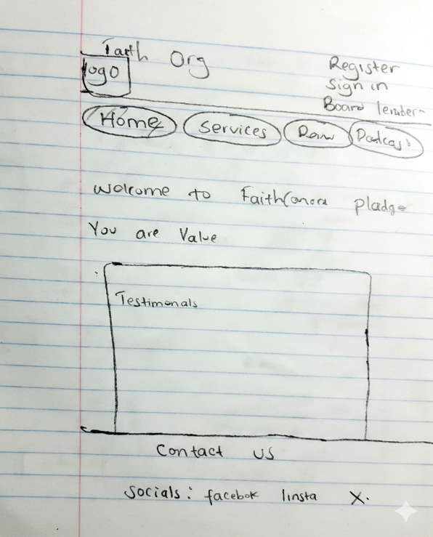

Figure 1.Home page layout

2.2.2 Log in Page design
The login page allows registered users, faith leaders, and administrators to access the system securely using their credentials. It includes input fields for email and password and validates user roles upon successful authentication.

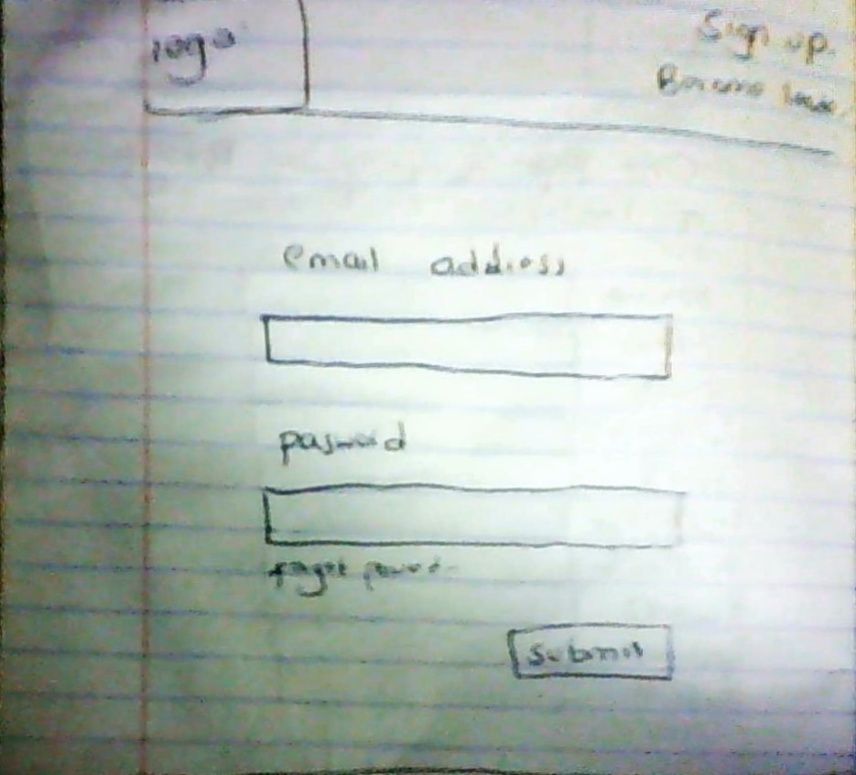

Figure 2.Users log in

2.2.3 Registration form
This form captures inexperienced users into the system so that the system can remember them these users are normal clients and faith leaders the images below show both forms.

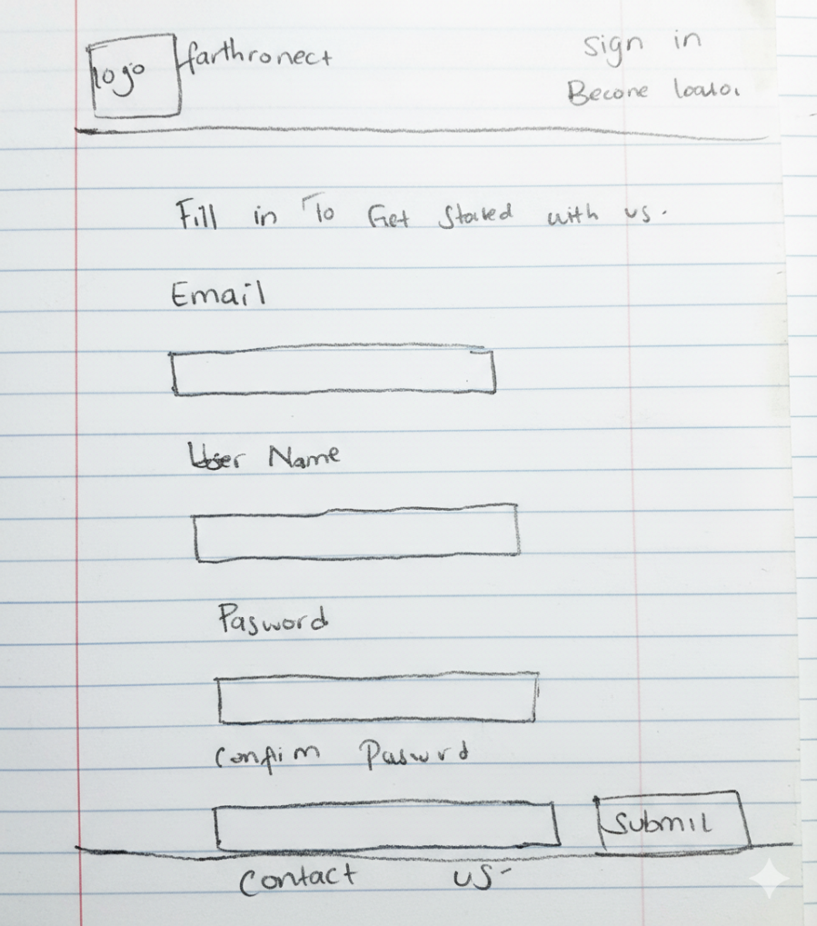
Figure 3.users registration form
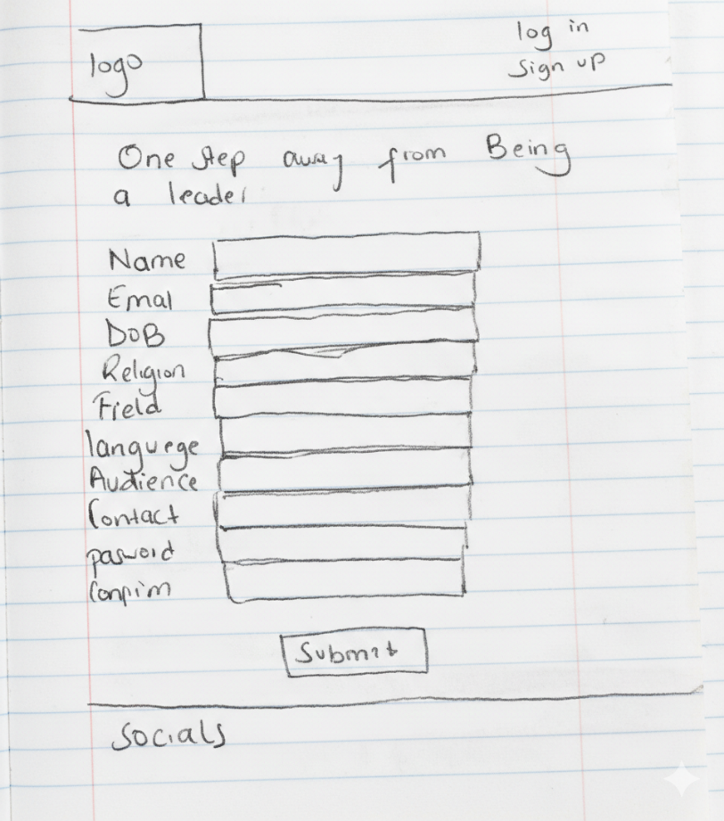
Figure 4.faith leader registration form

2.2.4 faith leader’s dashboard
The profile page displays faith leader details such as name, denomination, verification status, and ratings. Users can view this information before booking consultations.
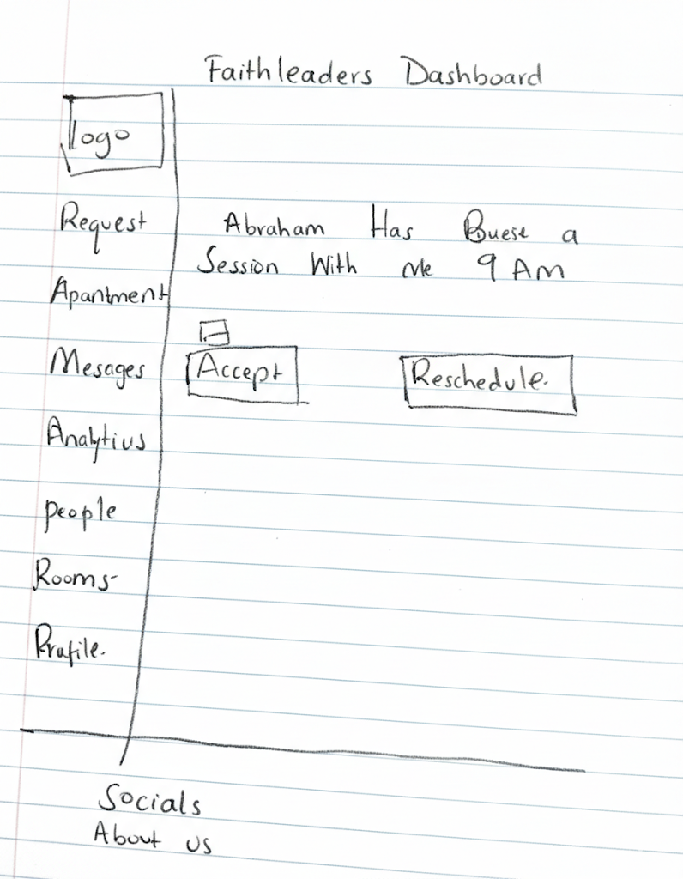
Figure 5.faith leader's dashboard.

2.2.5 Users dashboard
The is the panel presented after a successful login of users. This panel provides them with access to services offered by the platform.

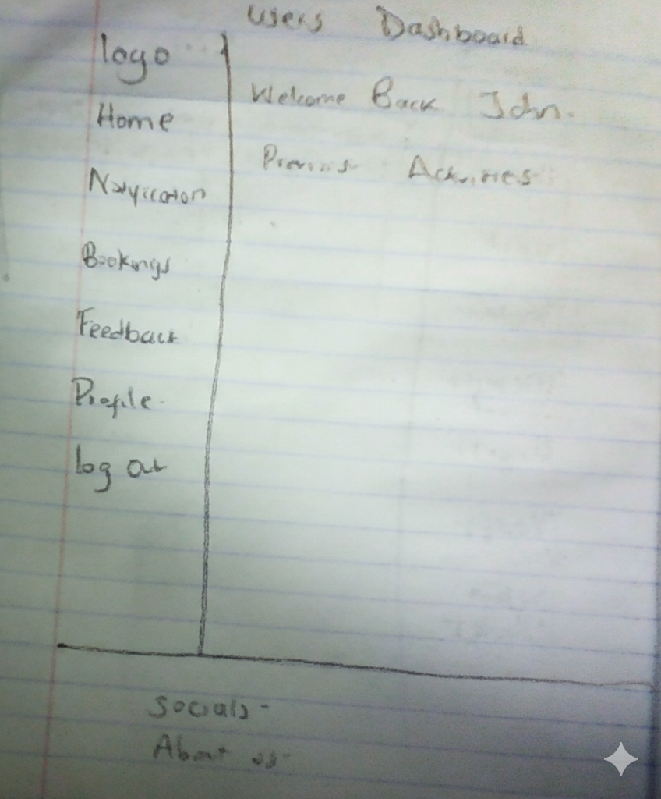
Figure 6.Users dashboard

2.2.6 Administrator dashboard
This dashboard is reserved for system admin to monitor and maintain the platform admin have access to all features to moderate users on platform.
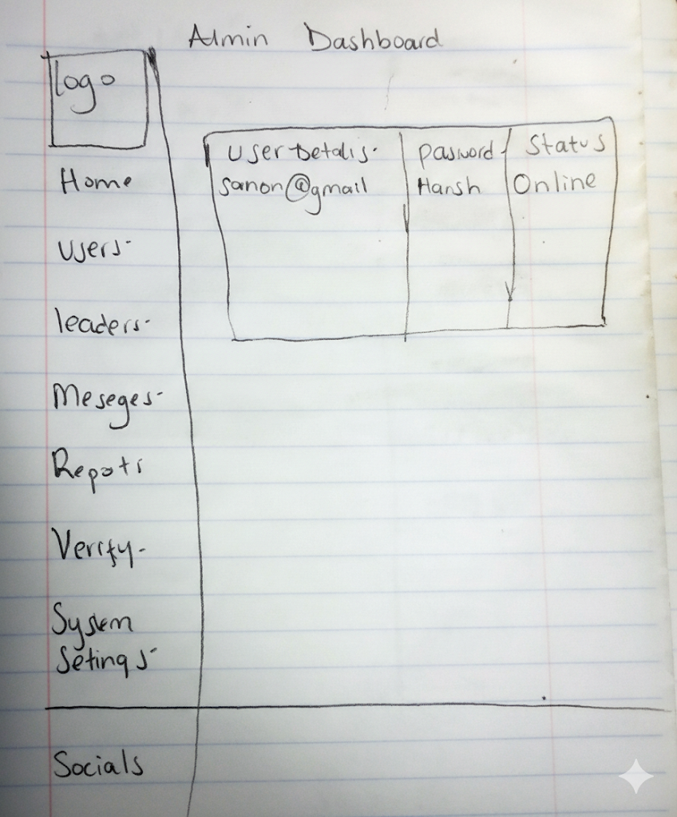
Figure 7.Administrator dashboard.

2.3 Logic Models

2.3.1 User Registration and Login Flowchart
This flowchart illustrates how users register, log in, and are redirected based on their roles within the system.

User inputs details
Start

Details are validated.

Details are sent to the database.

Front end shows approval.

User is logged to the system.

end

Figure 8.Flowchart illustrating log in

2.3.2 Faith Leader Verification Process Flowchart
This diagram shows the process through which a faith leader submits credentials, the administrator reviews them, and approval or rejection is granted.

start
Leader inputs details

Stores the details to the data base.

A verification process is started and is marked as pending.

Leader is logged into the system and verification status updated to verified.
yes
Admin approves.

no
Shows failed.
Show’s success

end

Figure 9.flowchart showing the system verification process.

2.3.3 Consultation Booking Process Flowchart
This flowchart explains the steps involved when a user books a consultation and the faith leader responds.

start
Accepted?
Submits the decision.
The submission is logged into the system and submits to leader.
Selects the leader and submits a request.
retry
Shows failed retry.
Meeting is scheduled.
The leader reviews the request.
The leader is notified of the request.
Users browse the leaders.
fend
Sends details to user.

yes

yes no

No

Figure 10.this flowchart illustrates the booking of sessions

CHAPTER THREE: SYSTEM IMPLEMENTATION
(DEVELOPMENT, TESTING AND DEPLOYMENT)

3.1 Introduction
This chapter documents the development journey of the Faith Connect digital platform, from the initial setup of development tools to the final deployment of the live system. The implementation process followed a structured approach, beginning with environment setup, progressing through user interface development, implementing backend logic, conducting thorough testing, and culminating in system deployment. Each phase was carefully executed to ensure the platform meets its objectives of providing secure, verified, and accountable religious consultation services.

3.2 User Interface Development
The user interface is the frontend component where users interact with the system. All interfaces were developed using HTML for structure, CSS for styling, and JavaScript for interactivity. The development focused on creating intuitive, responsive, and accessible interfaces for three user types: normal users, faith leaders, and administrators.

3.2.1 Login Page Development
The login page serves as the authentication gateway for all registered users. It features a clean, minimalist design with input fields for email and password, a submit button, and links to registration pages for new users. The page implements form validation to ensure all required fields are completed before submission.
[SCREENSHOT PLACEHOLDER: Figure 3.2.1: Login Page Implementation]
Figure 3.2.1: Login Page Implementation
[SCREENSHOT PLACEHOLDER: [Code Screenshot: Login Page HTML/CSS Code]]
[Code Screenshot: Login Page HTML/CSS Code]

3.2.2 Registration Forms Development
Two separate registration forms were developed: one for normal users and another for faith leaders. The normal user registration form captures basic information including full name, email, phone number, and password. The faith leader registration form includes additional fields for denomination, credentials upload, and professional details. Both forms implement client-side validation to ensure data integrity before submission.
[SCREENSHOT PLACEHOLDER: Figure 3.2.2: Registration Forms Implementation]
Figure 3.2.2: Registration Forms Implementation

3.2.3 User Dashboard Development
The user dashboard provides normal users with access to core platform features. The dashboard displays a list of verified faith leaders, allows users to browse leader profiles, book consultations, view consultation history, and submit ratings. The interface uses card-based layouts for faith leader profiles and includes filtering options to help users find appropriate leaders based on denomination and specialization.
[SCREENSHOT PLACEHOLDER: Figure 3.2.3: User Dashboard Implementation]
Figure 3.2.3: User Dashboard Implementation

3.2.4 Faith Leader Dashboard Development
The faith leader dashboard enables leaders to manage their profiles, view consultation requests, respond to bookings, and track their ratings. The dashboard includes sections for pending consultations, completed sessions, and profile management. Leaders can update their availability, manage their schedules, and communicate with users through the platform's messaging feature.
[SCREENSHOT PLACEHOLDER: Figure 3.2.4: Faith Leader Dashboard Implementation]
Figure 3.2.4: Faith Leader Dashboard Implementation

3.2.5 Administrator Dashboard Development
The administrator dashboard provides comprehensive system management capabilities. It displays pending verification requests, allows administrators to review faith leader credentials, manage user accounts, and monitor platform activities. The dashboard includes analytics features showing user statistics, consultation metrics, and system health indicators. Administrators can approve or reject faith leader applications and moderate content to ensure platform integrity.
[SCREENSHOT PLACEHOLDER: Figure 3.2.5: Administrator Dashboard Implementation]
Figure 3.2.5: Administrator Dashboard Implementation

3.2.6 Consultation Booking Interface
The consultation booking interface allows users to schedule sessions with faith leaders. It includes a calendar view showing leader availability, time slot selection, consultation type options (online video, phone call, or in-person), and a message field for users to describe their consultation needs. The interface provides real-time availability updates and confirmation notifications.
[SCREENSHOT PLACEHOLDER: Figure 3.2.6: Consultation Booking Interface]
Figure 3.2.6: Consultation Booking Interface

3.3 Logic Development
The backend logic handles all data processing, business rules, and database operations. Developed using PHP, the backend implements secure authentication, verification workflows, booking management, and data validation. All logic components follow security best practices including input sanitization, SQL injection prevention, and password hashing.

3.3.1 Authentication Logic
The authentication system validates user credentials against the database. When a user submits login information, the system retrieves the stored password hash, verifies it using PHP's password_verify function, and checks the user's role. Upon successful authentication, a session is created with appropriate privileges based on the user type (normal user, faith leader, or administrator). The system implements session timeout and automatic logout after periods of inactivity for security.
[SCREENSHOT PLACEHOLDER: Figure 3.3.1: Authentication Logic Code]
Figure 3.3.1: Authentication Logic Code

3.3.2 Database Connection and Operations
The database connection module establishes secure connections to the MySQL database using PDO (PHP Data Objects) to prevent SQL injection attacks. All database queries use prepared statements with parameter binding. The system implements CRUD (Create, Read, Update, Delete) operations for user management, consultation bookings, ratings, and verification requests. Error handling ensures graceful failure and prevents sensitive information disclosure.
[SCREENSHOT PLACEHOLDER: Figure 3.3.2: Database Connection Code]
Figure 3.3.2: Database Connection Code

3.3.3 Verification System Logic
The verification logic manages the faith leader approval workflow. When faith leaders submit credentials, the system stores the documents securely and flags the account for administrator review. Administrators can view submitted credentials, make approval decisions, and the system automatically updates the faith leader's status. Approved leaders gain access to additional features including consultation management and profile visibility to users. Rejected applications receive notification with feedback for resubmission.
[SCREENSHOT PLACEHOLDER: Figure 3.3.3: Verification Logic Code]
Figure 3.3.3: Verification Logic Code

3.3.4 Booking System Logic
The booking system manages consultation scheduling between users and faith leaders. The logic checks faith leader availability, prevents double-booking, and handles consultation confirmations. When a user requests a consultation, the system creates a booking record, notifies the faith leader, and awaits confirmation. Upon leader acceptance, both parties receive confirmation details. The system tracks consultation status (pending, confirmed, completed, cancelled) and enables rating submission after completion.
[SCREENSHOT PLACEHOLDER: Figure 3.3.4: Booking System Logic]
Figure 3.3.4: Booking System Logic

3.3.5 Rating and Feedback System
The rating system allows users to provide feedback after consultations. Users can rate faith leaders on a 5-star scale and provide written reviews. The system calculates average ratings for each faith leader and displays them prominently on their profiles. This feature enhances transparency and helps users make informed decisions when selecting faith leaders. The logic prevents multiple ratings for the same consultation and validates rating values to ensure data integrity.

3.4 Testing
Comprehensive testing was conducted to ensure the system functions correctly and securely. Testing was performed in multiple phases: unit testing for individual components, integration testing for feature interactions, and user acceptance testing with real users. Each major feature was tested for both success and failure scenarios.

3.4.1 Functional Testing
Functional testing verified that all features work as intended:
User Registration and Authentication: Tested registration forms for both normal users and faith leaders. Verified email validation, password strength requirements, and duplicate account prevention. Confirmed successful login redirects users to appropriate dashboards based on their roles.
Faith Leader Verification: Tested credential upload functionality, administrator review process, and status updates. Verified that only verified leaders appear in user searches and that rejected applications can resubmit.
Consultation Booking: Tested booking creation, availability checking, confirmation workflow, and status updates. Verified double-booking prevention and proper notification delivery to both parties.
Rating System: Tested rating submission, average calculation, and display on faith leader profiles. Verified that users can only rate completed consultations and cannot submit duplicate ratings.

3.4.2 Security Testing
Security testing focused on protecting user data and preventing unauthorized access. Tests included SQL injection attempts on all input fields, cross-site scripting (XSS) tests, session hijacking prevention, and password security. All vulnerabilities discovered during testing were addressed. Password hashing was verified using PHP's password_hash function, and HTTPS encryption was confirmed for all data transmission.

3.4.3 Usability Testing
Usability testing involved classmates and friends who served as test users. Participants performed common tasks such as registration, browsing faith leaders, booking consultations, and submitting ratings. Feedback was collected on interface clarity, navigation ease, and overall user experience. Several improvements were made based on user feedback, including clearer error messages, simplified navigation, and enhanced visual hierarchy.

3.4.4 Testing Results Summary
The following table summarizes the testing results for major system features:
[SCREENSHOT PLACEHOLDER: Table 3.4.1: Testing Results Summary]
Table 3.4.1: Testing Results Summary
All critical issues identified during testing were resolved before deployment. Minor issues were documented for future improvements but did not prevent system launch.

3.5 Deployment
The Faith Connect platform was deployed on InfinityFree, a free web hosting service that provides PHP support and MySQL database capabilities. The deployment process involved several steps to ensure the system operates correctly in the production environment.

3.5.1 Hosting Platform Selection
InfinityFree was selected as the hosting platform due to its free-tier offering that includes unlimited bandwidth, 5GB storage, PHP support, MySQL database, and free SSL certificates through Let's Encrypt. The platform provides adequate resources for the project's requirements while maintaining zero hosting costs. The service also offers cPanel for easy file management and phpMyAdmin for database administration.

3.5.2 Deployment Process
The deployment followed these steps:
1. Account Creation: Created an account on InfinityFree and registered the subdomain faithworldconnect.infinityfreeapp.com.
2. Database Setup: Created a MySQL database through cPanel, imported the database schema, and configured database users with appropriate privileges.
3. File Upload: Uploaded all project files to the htdocs directory using the file manager. Updated configuration files with production database credentials and server paths.
4. SSL Configuration: Enabled free SSL certificate through Let's Encrypt to ensure HTTPS encryption for all data transmission.
5. Testing: Performed comprehensive testing on the live server to verify all features work correctly in the production environment. Created test accounts for each user type and validated the complete user journey.
6. Launch: After successful testing, the platform was made publicly accessible.

3.5.3 Live System Access
The Faith Connect platform is accessible at: https://faithworldconnect.infinityfreeapp.com
The system is fully operational and provides:
• User registration and authentication for normal users and faith leaders
• Faith leader verification system managed by administrators
• Consultation booking and management features
• Rating and feedback system
• Three role-specific dashboards (user, faith leader, administrator)
• Secure data transmission through HTTPS

3.5.4 Post-Deployment Monitoring
After deployment, the system is monitored regularly to ensure optimal performance. InfinityFree provides basic server logs that help track errors and performance issues. Regular backups of the database are performed through phpMyAdmin to prevent data loss. User feedback is collected to identify areas for improvement and bug fixes are deployed as needed.

CHAPTER FOUR: CONCLUSION AND RECOMMENDATION

4.1 Conclusion
The Faith Connect digital platform successfully addresses the identified problem of connecting individuals with verified and reliable faith leaders for secure religious consultation. Through systematic planning, careful design, and thorough implementation, the project achieved all its stated objectives.
Chapter One established the project foundation by identifying the problem statement, justifying the study, and defining clear objectives. The chapter outlined functional requirements for three user types (normal users, faith leaders, and administrators) and detailed the tools and resources used throughout development. The project schedule breakdown provided a structured timeline that guided the implementation process.
Chapter Two presented comprehensive design and modeling work that visualized the system before development began. User interface models showed the planned layouts for the home page, login forms, registration forms, and three distinct dashboards. Logic models, including flowcharts for user registration, faith leader verification, and consultation booking, clarified the system's operational workflows. This modeling phase significantly reduced development errors and ensured the final implementation matched the initial vision.
Chapter Three documented the development journey from environment setup to system deployment. The user interface development section detailed the creation of all frontend components using HTML, CSS, and JavaScript. Logic development explained the PHP backend implementation, including authentication, database operations, verification workflows, and booking management. Comprehensive testing validated system functionality, security, and usability. The deployment process successfully made the platform publicly accessible at faithworldconnect.infinityfreeapp.com.
Throughout this project, several valuable lessons were learned:
Technical Skills: Gained practical experience in full-stack web development, including frontend design with HTML/CSS/JavaScript, backend programming with PHP, and database management with MySQL. Learned to implement secure authentication systems, handle file uploads, and manage complex user workflows.
Security Awareness: Developed understanding of web security vulnerabilities and best practices. Learned the importance of input validation, SQL injection prevention, password hashing, and HTTPS encryption. Recognized that security must be considered at every development stage, not added as an afterthought.
Project Management: Experienced the value of proper planning and scheduling. The project breakdown into milestones helped maintain progress and meet deadlines. Learned to balance multiple aspects of development simultaneously while maintaining focus on core objectives.
User-Centered Design: Understood the importance of considering end-user needs throughout development. Usability testing revealed insights that improved the interface and user experience. Learned that assumptions about user behavior are often incorrect and direct user feedback is invaluable.
Problem-Solving: Encountered and resolved numerous technical challenges, from debugging complex logic errors to optimizing database queries. Developed persistence and systematic troubleshooting approaches that will benefit future projects.
Challenges faced during development included:
• Learning to work with unfamiliar technologies and frameworks
• Debugging complex interactions between frontend and backend components
• Implementing secure file upload and storage mechanisms
• Balancing feature complexity with usability requirements
• Managing time constraints while maintaining code quality
• Adapting to hosting platform limitations on free-tier services
Despite these challenges, the project successfully delivers a functional platform that meets all stated objectives. The system provides a secure, verified, and accountable solution for connecting individuals with faith leaders in the digital age. It demonstrates the practical application of web development skills while addressing a genuine need in society.

4.2 Recommendation
The following recommendations are provided for future developers who may choose to enhance or expand the Faith Connect platform. These suggestions focus on improving existing features, adding new capabilities, and leveraging more advanced technologies to provide better service to users.
1. Video Consultation Integration
Currently, the platform facilitates consultation booking but does not provide integrated video calling capabilities. Future developers should consider integrating WebRTC technology or third-party services like Zoom API, Twilio Video, or Agora.io to enable in-platform video consultations. This would eliminate the need for users and faith leaders to coordinate external communication tools and provide a more seamless experience.
2. Mobile Application Development
While the current web platform is accessible on mobile browsers, a dedicated mobile application would significantly improve user experience. Consider developing native applications for iOS and Android using frameworks like React Native or Flutter. Mobile apps would enable push notifications for consultation reminders, faster load times, and offline capabilities. The fifth specific objective mentioned packaging into a mobile app, which could be pursued using Progressive Web App (PWA) technology or native development.
3. Payment Integration
The platform currently lacks a payment processing system. Future enhancements should integrate payment gateways like M-PESA API for Kenya, PayPal, or Stripe to enable faith leaders to charge for consultations. This would transform the platform into a sustainable business model while maintaining transparency. Consider implementing features like payment holds until consultation completion, automated receipts, and subscription plans for frequent users.
4. Advanced Search and Filtering
Enhance the faith leader search functionality with advanced filters including language spoken, years of experience, specialization areas (marriage counseling, grief counseling, youth guidance), availability times, and price ranges. Implement a recommendation algorithm that suggests faith leaders based on user consultation history and preferences. Consider adding geolocation features to show nearby faith leaders for in-person consultations.
5. AI-Powered Chat Support
Integrate an AI chatbot to provide immediate responses to common questions, guide users through the booking process, and offer general spiritual guidance while users wait for scheduled consultations. Technologies like OpenAI's GPT API or Dialogflow could be used. Ensure the AI system is trained with appropriate religious and ethical guidelines and clearly identifies itself as an AI assistant, not a replacement for human faith leaders.
6. Multi-Language Support
Implement internationalization (i18n) to support multiple languages. Kenya alone has diverse linguistic communities (Swahili, English, local languages), and expanding internationally would require multilingual support. Use frameworks like i18next for JavaScript or gettext for PHP to manage translations. Allow faith leaders to specify languages they offer consultations in.
7. Enhanced Security Features
While the current system implements basic security measures, consider adding two-factor authentication (2FA) using SMS or authenticator apps, end-to-end encryption for consultation messages, and regular security audits. Implement CAPTCHA on registration forms to prevent bot accounts. Consider obtaining security certifications like PCI DSS if payment processing is added.
8. Analytics and Reporting Dashboard
Expand the administrator dashboard with comprehensive analytics including user growth trends, consultation statistics, popular faith leaders, peak usage times, and user satisfaction metrics. Integrate data visualization libraries like Chart.js or D3.js to present information clearly. Provide faith leaders with personal analytics showing their performance metrics, earnings (if payment is implemented), and areas for improvement.
9. Automated Reminder System
Implement automated email and SMS reminders for upcoming consultations. Send reminders 24 hours before, 1 hour before, and 10 minutes before scheduled sessions. Include consultation details, video call links (if video integration is added), and cancellation options. This reduces no-shows and improves user experience.
10. Content Management System
Add a blog or article section where verified faith leaders can publish spiritual guidance articles, devotionals, and educational content. This increases platform value beyond consultation booking and helps with search engine optimization (SEO). Allow users to save favorite articles and subscribe to specific faith leaders' content.
11. Scalability Improvements
As the platform grows, consider migrating from shared hosting to more robust infrastructure. Implement caching mechanisms (Redis, Memcached), use Content Delivery Networks (CDN) for static assets, and optimize database queries with indexing and query optimization. Consider microservices architecture for better scalability and maintainability.
12. Background Verification Enhancement
While the platform currently verifies credentials manually, consider integrating with official religious organization databases or implementing blockchain-based credential verification for improved authenticity. Require periodic credential renewal to ensure faith leaders maintain their certifications.
It is important to emphasize that these recommendations are suggestions for enhancing an already functional system. The current platform successfully meets its core objectives of connecting users with verified faith leaders through secure consultation booking. These recommendations aim to make a good system even better by incorporating advanced technologies and additional features that would benefit users, faith leaders, and platform administrators.
Future developers should prioritize recommendations based on user feedback, resource availability, and strategic goals. Not all enhancements need to be implemented simultaneously; a phased approach focusing on high-impact features first would be most effective.

REFERENCES
Duckett, J. (2014). HTML and CSS: Design and build websites. John Wiley & Sons.
Flanagan, D. (2020). JavaScript: The definitive guide (7th ed.). O'Reilly Media.
InfinityFree. (n.d.). Free web hosting with PHP and MySQL. Retrieved from https://www.infinityfree.net/
MDN Web Docs. (2024). HTTP authentication. Mozilla Developer Network. Retrieved from https://developer.mozilla.org/en-US/docs/Web/HTTP/Authentication
PHP Documentation Group. (2024). PHP manual. Retrieved from https://www.php.net/manual/en/
Robbins, J. N. (2018). Learning web design: A beginner's guide to HTML, CSS, JavaScript, and web graphics (5th ed.). O'Reilly Media.
Tatroe, K., MacIntyre, P., & Lerdorf, R. (2020). Programming PHP: Creating dynamic web pages (4th ed.). O'Reilly Media.
W3Schools. (2024). SQL tutorial. Retrieved from https://www.w3schools.com/sql/
Welling, L., & Thomson, L. (2016). PHP and MySQL web development (5th ed.). Addison-Wesley Professional.
XAMPP. (n.d.). Apache + MariaDB + PHP + Perl. Retrieved from https://www.apachefriends.org/

