Table S1 and table S2 support Item *2.2.2 Sources of ecological parameters of 20 functional groups * in our paper. These data come from the literature summary.

Tab.S1 Sources of input parameters of the Ecopath model of the southwestern Yellow Sea ecosystem

 | Functional Group | Biomass(t/km²) |  | Production/biomass (P/B) |  | Consumption/biomass (Q/B) |  | Diet composition (DC)
 |  | Value | Sources | Value | Sources | Value | Sources | Sources
1 | Charadriiformes | 0.100 | (①, ②, Chen 2005, David et al. 2003, Ge 2007, Ge et al. 2006, Hou et al. 2012, 2013, Hou 2009, Lu et al. 1988, Paul et al 2008, Xu et al. 2010) | 0.10 | (①, ②, Chen 2005, David et al. 2003, Ge 2007, Ge et al. 2006, Hou et al. 2012, 2013, Hou 2009, Lu et al. 1988, Paul et al. 2008, Xu et al. 2010) | 4.33 | (①, ②, Chen 2005, David et al. 2003, Ge 2007, Ge et al. 2006, Hou et al. 2012, 2013, Hou 2009, Lu et al. 1988, Paul et al. 2008, Xu et al. 2010) | (②, Cui et al. 1985, Song et al. 2011)
2 | Anseriformes | 0.156 | (①, ②, Cai et al. 2012, Gao et al. 1992, Wang et al. 2011) | 0.10 | (①, ②, Cai et al. 2012, Gao et al. 1992, Wang et al. 2011) | 9.28 | (①, ②, Cai et al. 2012, Gao et al. 1992, Wang et al. 2011) | (②)
3 | Gruiformes | 0.004 | (①, ②, Li et al. 2000, Ma 1980, Qian 2005, Su et al. 2000, Xu et al. 2010, Zeng et al. 2003) | 0.10 | (①,②, Li et al. 2000, Ma 1980, Qian 2005, Su et al. 2000, Xu et al. 2010, Zeng et al. 2003) | 13.00 | (①,②, Li et al. 2000, Ma 1980, Qian 2005, Su et al. 2000, Xu et al. 2010, Zeng et al. 2003) | (②)
4 | Other Benthic Fish | 0.147 | (YSCS) | 0.85 | (YSCS, ③, ④) | 2.84 | (YSCS, ③, ④, Ouyang et al. 2012) | (③, Yang 2001b, He et al. 2012a, Jin et al. 2012, Zhang et al. 2011)
5 | Other Pelagic Fish | 0.096 | (YSCS) | 0.97 | (YSCS, ③,④) | 5.93 | (YSCS, ③, ④, Ouyang et al. 2012) | (③, Jin et al. 2011)
6 | Dasyatidae | 0.056 | (YSCS) | 1.28 | (YSCS, ③,④) | 4.65 | (YSCS, ③, ④) | (③)
7 | Anguilliformes | 0.072 | (YSCS) | 0.98 | (YSCS, ③,④) | 6.27 | (YSCS, ③, ④) | (③, Zhang et al. 2003, Zhang et al. 2010)
8 | Pleuronectiformes | 0.581 | (YSCS) | 0.97 | (YSCS, ③,④) | 4.22 | (YSCS, ③, ④, Ouyang et al. 2012) | (③, Yang 2001b, He et al. 2012b, Guo et al. 2011, Li et al. 2009, Lin 2007, Xue et al. 2004a, 2004b, 2005)
9 | Sciaenidae | 0.078 | (YSCS) | 0.88 | (YSCS, ③,④) | 4.11 | (YSCS, ①, ②) | (③, Dou et al. 1992a, 1992b)
10 | Engraulidae | 0.183 | (YSCS) | 1.04 | (YSCS, ③,④) | 7.79 | (YSCS, ③, ④, Ouyang et al. 2012) | (③, Yang 2001b, Guo et al. 2007a, 2007b, Guo et al. 2010a, 2011, Guo et al. 2010b)
11 | Stromateidae | 0.229 | (YSCS) | 0.95 | (YSCS, ③,④) | 4.86 | (YSCS, ③, ④, Ouyang et al. 2012) | (③, Yang 2001b)
12 | Decapod | 0.330 | (YSCS) | 7.60 | (Lin et al. 2009b) | 28.90 | (Lin et al. 2009b) | (Yang 2001a, Qian et al.1994)
13 | Brachyura | 1.140 | (YSCS) | 3.50 | (Lin et al. 2009b) | 12.00 | (Lin et al. 2009b) | (Yang 2001a, Jiang et al.1998)
14 | Cephalopoda | 0.136 | (YSCS) | 3.10 | (Lin et al. 2009b) | 9.30 | (Lin et al. 2009b) | (Yang 2001a, Huang 2004)
15 | Benthic Macrobenthos | 9.932 | (YSCS) | 2.00 | (Lin et al. 2009b) | 8.60 | (Lin et al. 2009b) | (Zhang 2012)
16 | Benthic meiobenthos | 4.723 | (Lin et al. 2009b) | 9.00 | (Wu 2011) | 33.00 | (Lin et al. 2009b) | (Zhang 2006)
17 | Jellyfish | 2.400 | (Lin et al. 2009b) | 5.00 | (Lin et al. 2009b) | 20.00 | (Lin et al. 2009b) | (Chen et al. 2003)
18 | Zooplankton | 3.935 | (Lin et al. 2009b) | 25.00 | (Lin et al. 2009b) | 180.00 | (Lin et al. 2009b) | --
19 | Phytoplankton | 8.177 | (YSCS, Zuo et al. 2008a, 2008b) | 200.00 | (Lin et al. 2009b) | 0.00 | -- | --
20 | Detritus | 18.000 | (Lin et al. 2009b) | -- | -- | -- | -- | --
--: not exist. Sources: ①Statistical data from Yancheng Biosphere Reserve; ②http://www.blueanimalbio.com/bird/list.htm/; ③http://www.fishbase.org/; ④http://www.seaaroundus.org/. Diet composition of each functional group was the average weight of DC of all species included in table 1 according to their biomass proportions.

Tab. S2 Diet composition matrix for SYSE Ecopath model

 | 1 | 2 | 3 | 4 | 5 | 6 | 7 | 8 | 9 | 10 | 11 | 12 | 13 | 14 | 15 | 16 | 17 | 18
1 | 0 | 0 | 0 | 0 | 0 | 0 | 0 | 0 | 0 | 0 | 0 | 0 | 0 | 0 | 0 | 0 | 0 | 0
2 | 0 | 0 | 0 | 0 | 0 | 0 | 0 | 0 | 0 | 0 | 0 | 0 | 0 | 0 | 0 | 0 | 0 | 0
3 | 0 | 0 | 0 | 0 | 0 | 0 | 0 | 0 | 0 | 0 | 0 | 0 | 0 | 0 | 0 | 0 | 0 | 0
4 | 0 | 0 | 0 | 0.03 | 0 | 0.1 | 0.1 | 0.01 | 0.05 | 0 | 0 | 0 | 0 | 0 | 0 | 0 | 0 | 0
5 | 0 | 0 | 0 | 0.01 | 0.015 | 0.04 | 0.08 | 0.01 | 0.015 | 0 | 0 | 0 | 0 | 0 | 0 | 0 | 0 | 0
6 | 0 | 0 | 0 | 0 | 0 | 0 | 0 | 0 | 0 | 0 | 0 | 0 | 0 | 0 | 0 | 0 | 0 | 0
7 | 0 | 0 | 0 | 0 | 0 | 0 | 0 | 0 | 0 | 0 | 0 | 0 | 0 | 0 | 0 | 0 | 0 | 0
8 | 0 | 0 | 0 | 0 | 0 | 0.48 | 0.21 | 0.08 | 0 | 0 | 0 | 0 | 0 | 0 | 0 | 0 | 0 | 0
9 | 0 | 0 | 0 | 0 | 0 | 0.12 | 0.06 | 0 | 0.01 | 0 | 0 | 0 | 0 | 0 | 0 | 0 | 0 | 0
10 | 0 | 0 | 0 | 0 | 0.06 | 0.06 | 0.103 | 0.025 | 0.1 | 0 | 0 | 0 | 0 | 0 | 0 | 0 | 0 | 0
11 | 0 | 0 | 0 | 0 | 0.06 | 0 | 0 | 0.06 | 0.08 | 0 | 0 | 0 | 0 | 0 | 0 | 0 | 0 | 0
12 | 0.1 | 0.22 | 0.13 | 0.29 | 0.1 | 0.1 | 0.1 | 0.26 | 0.35 | 0.1 | 0 | 0 | 0.05 | 0.16 | 0 | 0 | 0 | 0
13 | 0.25 | 0.25 | 0.27 | 0.12 | 0 | 0 | 0.247 | 0 | 0.2 | 0.01 | 0 | 0.005 | 0.05 | 0.05 | 0 | 0 | 0 | 0
14 | 0 | 0 | 0 | 0.03 | 0.01 | 0.1 | 0.1 | 0.1 | 0 | 0 | 0 | 0.001 | 0 | 0.03 | 0 | 0 | 0 | 0
15 | 0.65 | 0.53 | 0.6 | 0.13 | 0 | 0 | 0 | 0 | 0 | 0.06 | 0 | 0.4 | 0.4 | 0.28 | 0.05 | 0 | 0 | 0
16 | 0 | 0 | 0 | 0.09 | 0.135 | 0 | 0 | 0.455 | 0.145 | 0.03 | 0 | 0.12 | 0.15 | 0.06 | 0.1 | 0 | 0.04 | 0
17 | 0 | 0 | 0 | 0 | 0 | 0 | 0 | 0 | 0 | 0 | 0.2 | 0 | 0 | 0 | 0.05 | 0 | 0.03 | 0
18 | 0 | 0 | 0 | 0.3 | 0.55 | 0 | 0 | 0 | 0.05 | 0.8 | 0.35 | 0.124 | 0.08 | 0.42 | 0.3 | 0.05 | 0.85 | 0.02
19 | 0 | 0 | 0 | 0 | 0.07 | 0 | 0 | 0 | 0 | 0 | 0.45 | 0.05 | 0.02 | 0 | 0.1 | 0.15 | 0.08 | 0.73
20 | 0 | 0 | 0 | 0 | 0 | 0 | 0 | 0 | 0 | 0 | 0 | 0.3 | 0.25 | 0 | 0.4 | 0.8 | 0 | 0.25

Table S3 and table S4 support Item *2.3.1 Sample sampling and pretreatment * in our paper. These data come from the experiment.

Tab. S3 Biometric Record of SYSE
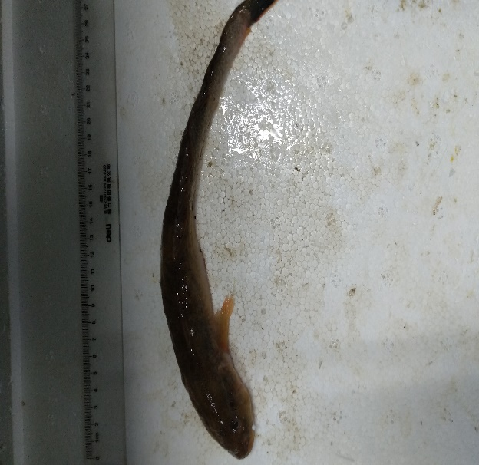 Chaeturichthys stigmatias | 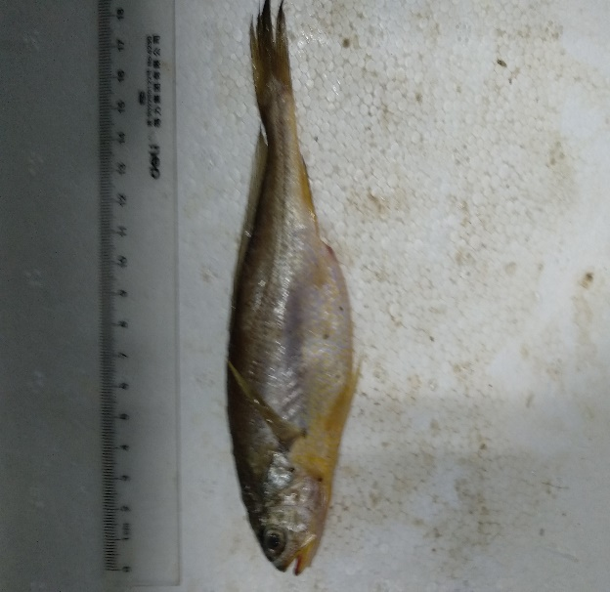 Nibea albiflora
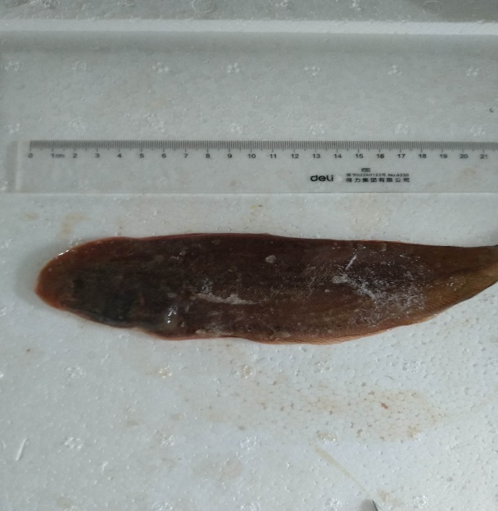 Cynoglossus bilineatus | 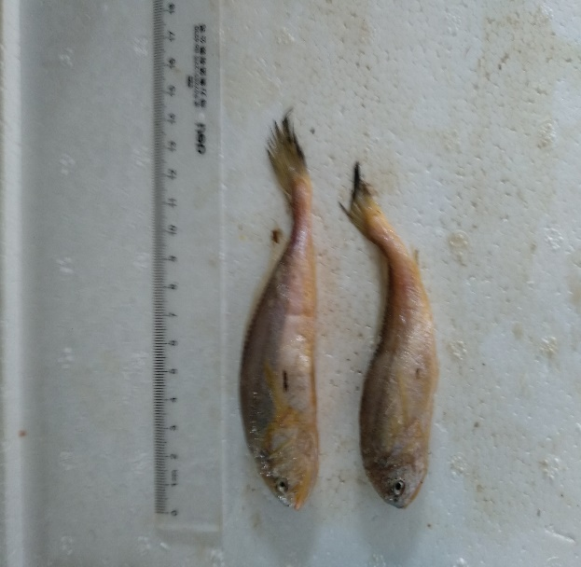 Larimichthys polyactis
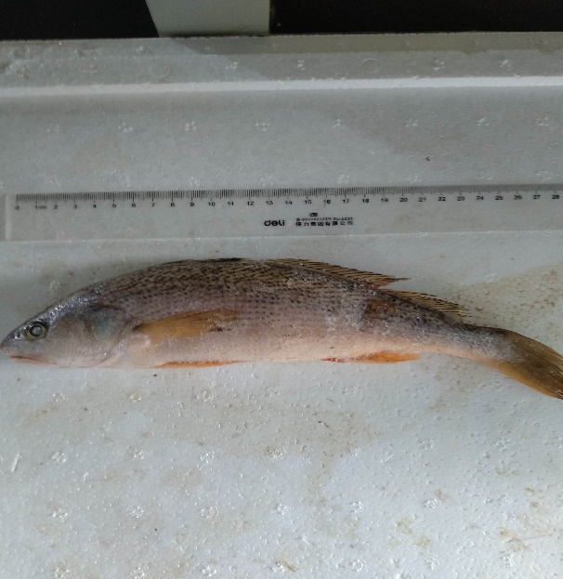 Nibea albiflora | 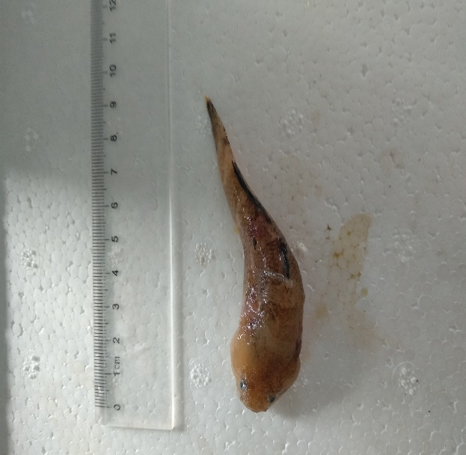Gobiidae
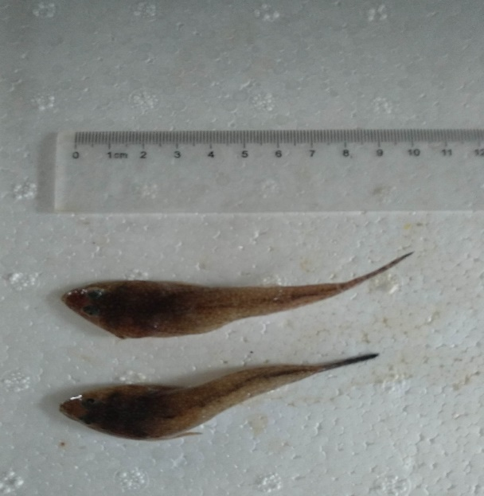Callionymidae | 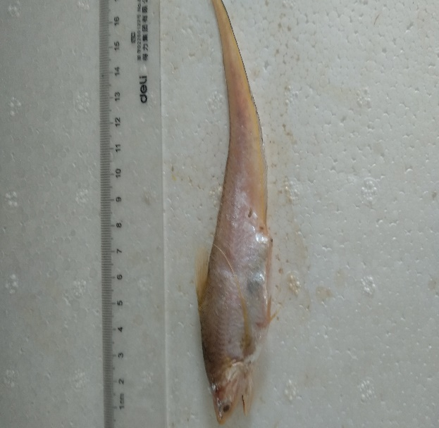Coilia mystus
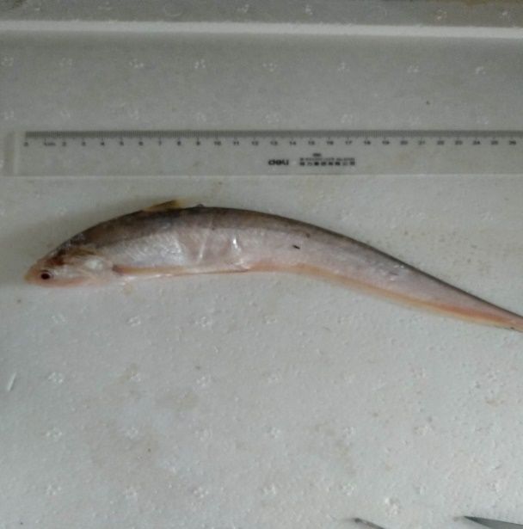Coilia macrognathos Bleeker | 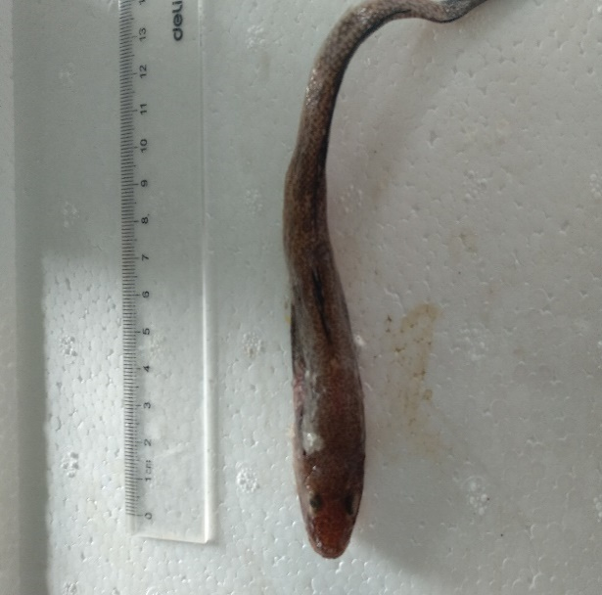Acanthogobius
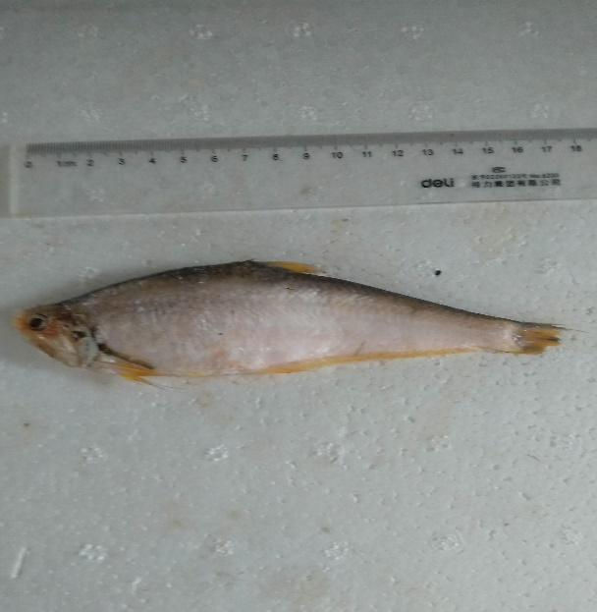Setipinna taty | 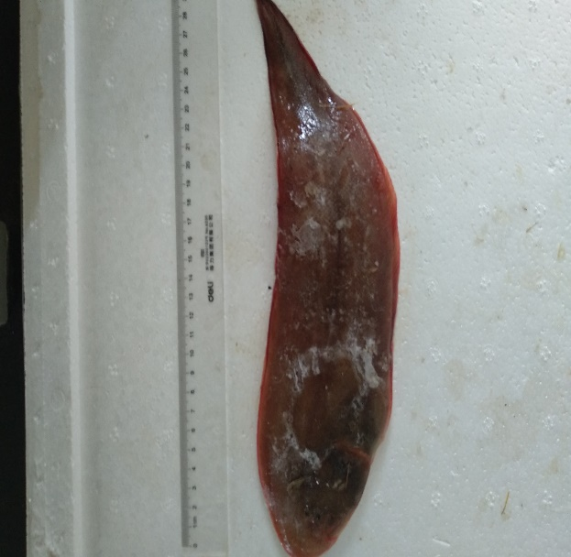Cynoglossus abbreviatus
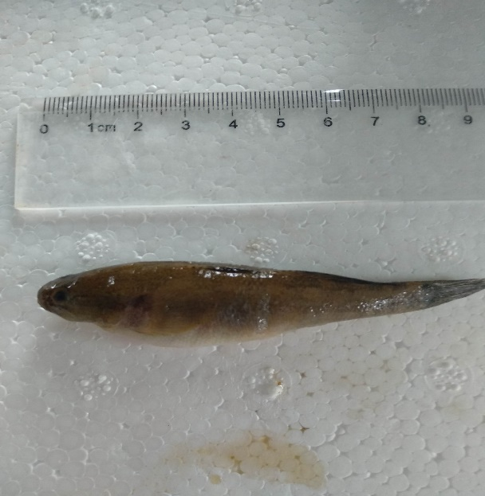Tridentiger trigonocephalus | 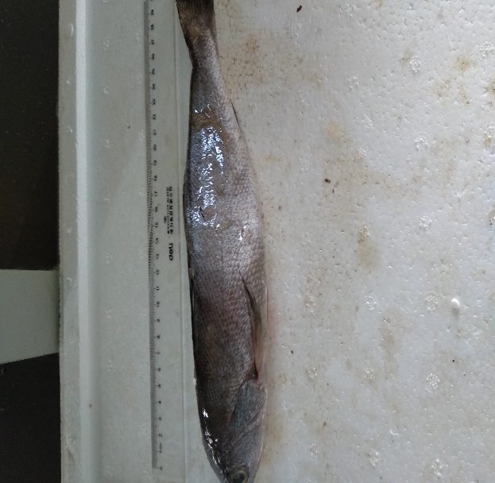Miichthys miiuy
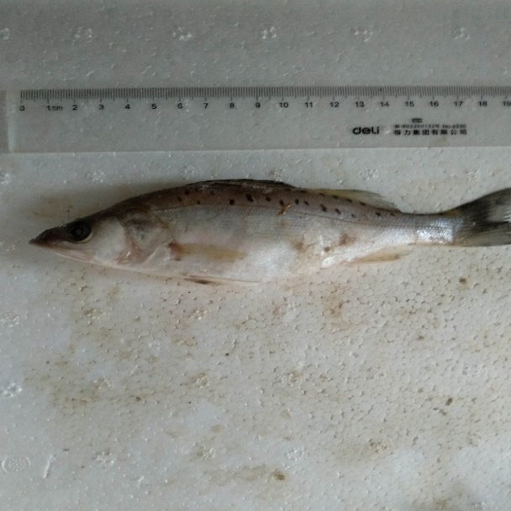Lateolabrax japonocus | 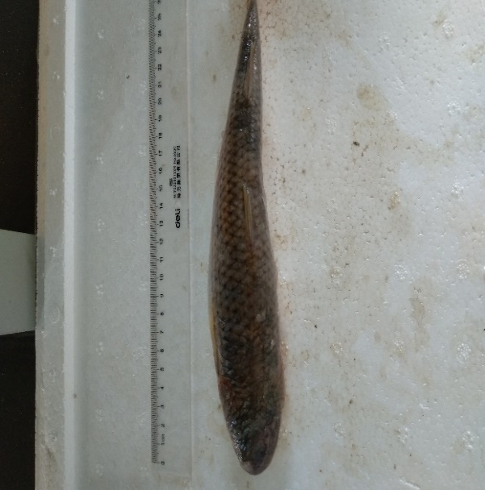Konosirus punctatus
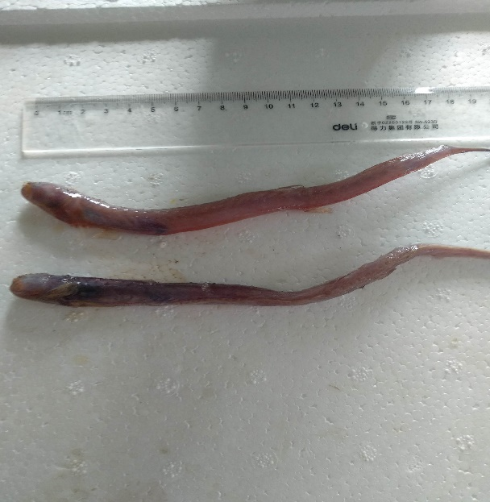Odontamblyopus rubicundus | 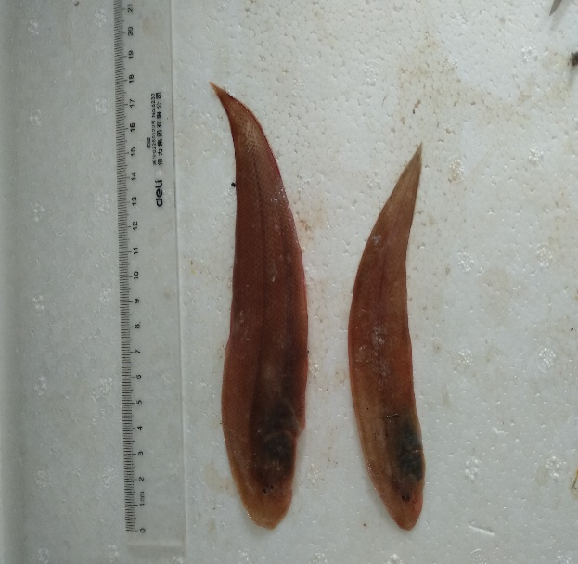Cynoglossus abbreviatus
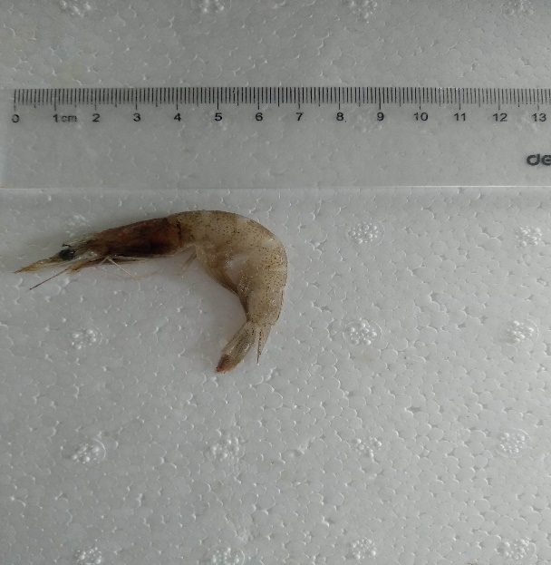Metapenaeus joyneri | 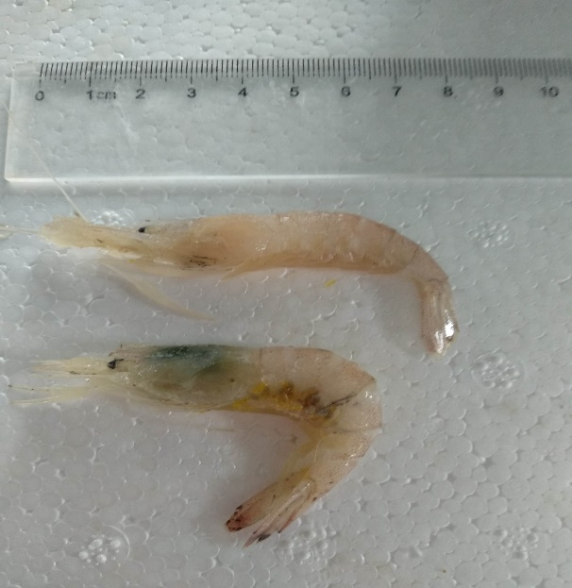Exopalaemon
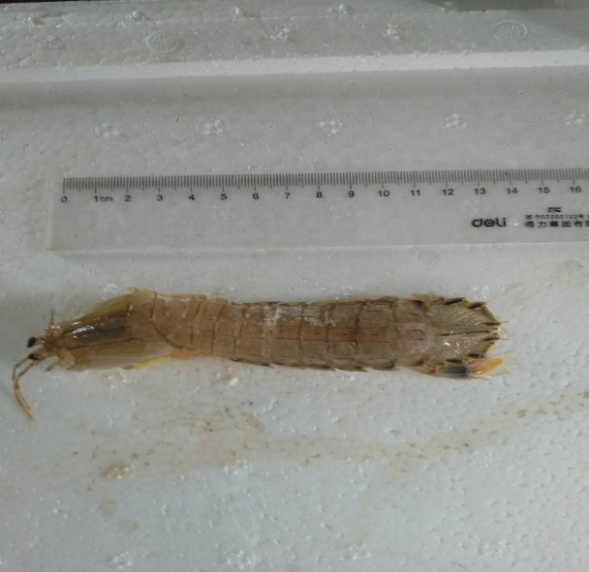Oratosquilla oratoria | 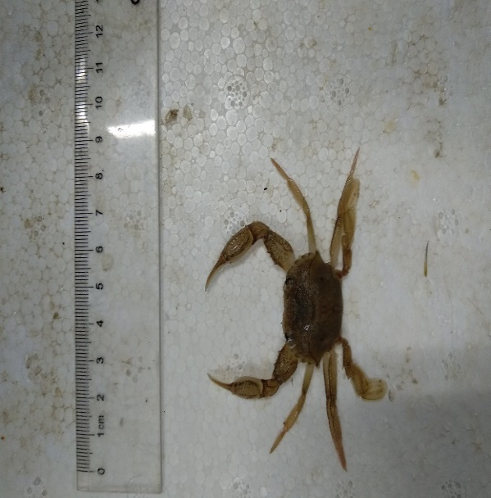Ocypodioae
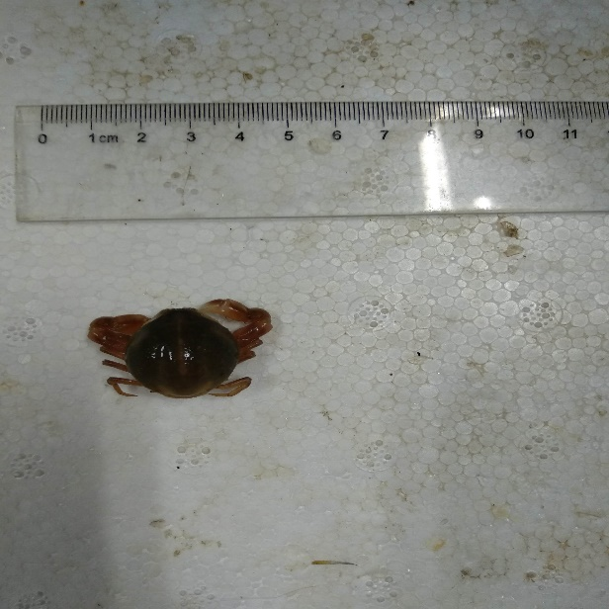Pyrhila pisum | 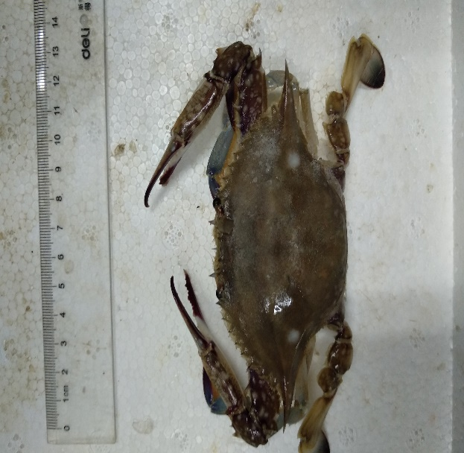Portunus trituberculatus
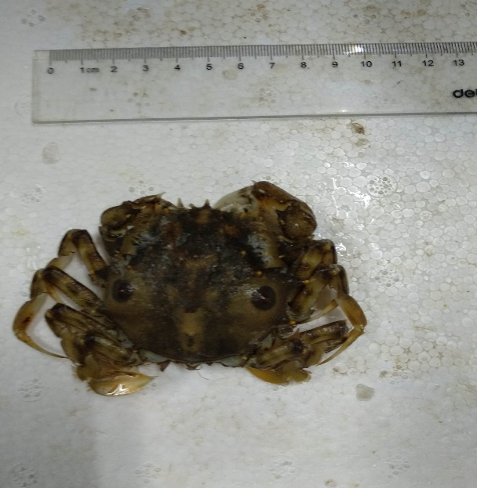Orithyia sinica | 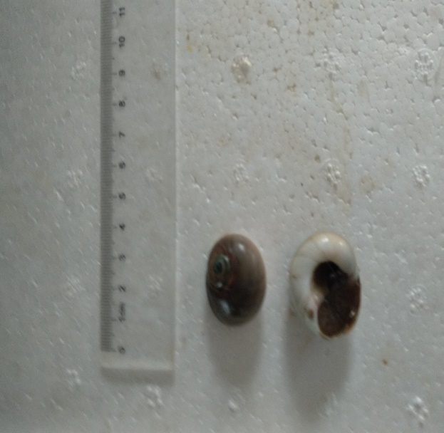Naticidae
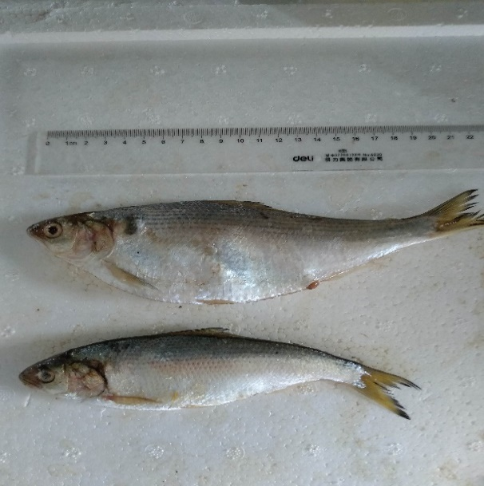Etrumeus teres | 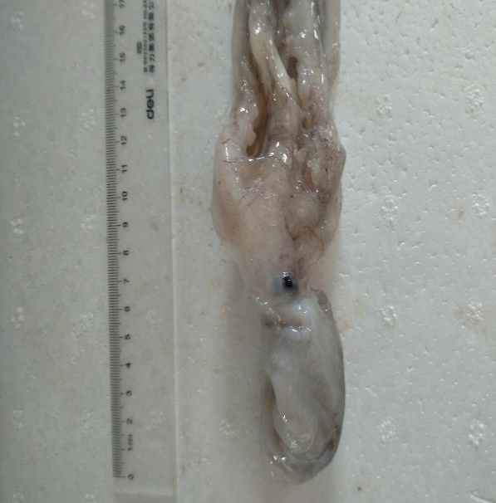Octopus variabilis
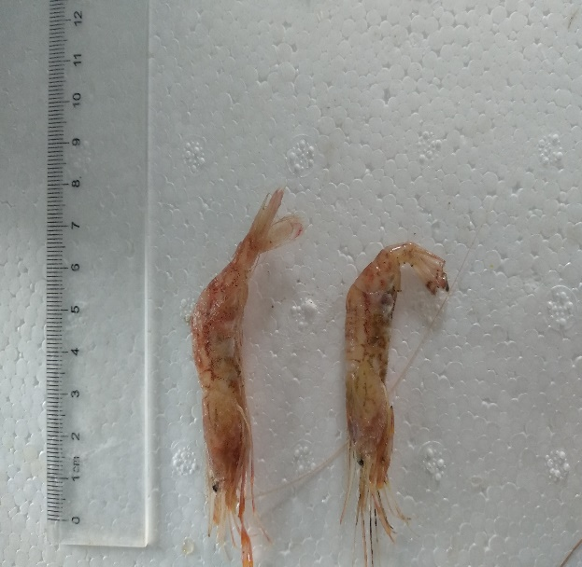Metapenaeus joyneri | 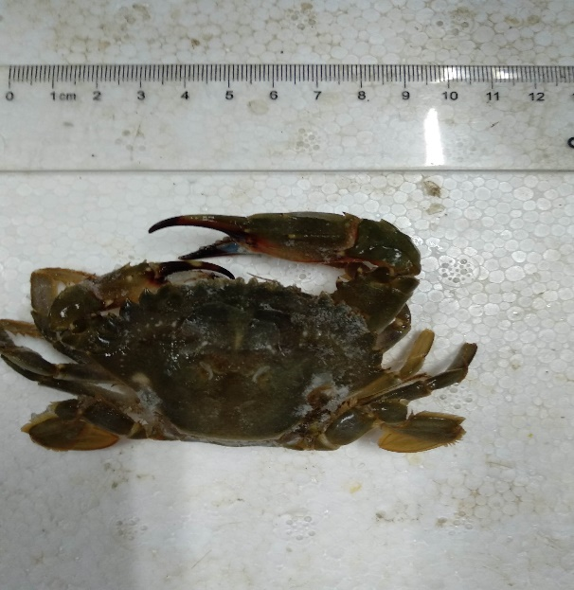Charybdis japonica

Tab.S4 Biometric Record Table of SYSE
Species | Number | Weight (g) | Body length (mm) | Species | Number | Weight (g) | Body length (mm)
Etrumeus teres | 1 | 235 | 242 | Coilia macrognathos Bleeker | 11 | 218 | 41
 |  | 192 | 231 |  |  | 266 | 85
Chaeturichthys stigmatias | 2 | 26 | 152 | Acanthogobius | 12 | 236 | 83
 |  | 27 | 141 |  |  | 286 | 145
Nibea albiflora | 3 | 64 | 152 |  |  | 272 | 104
 |  | 77 | 169 | Cynoglossus abbreviatus | 13 | 59 | 188
 |  | 66 | 160 |  |  | 76 | 218
 |  | 63 | 158 |  |  | 69 | 204
 |  | 43 | 142 | Setipinna taty | 14 | 27 | 138
 |  | 67 | 150 |  |  | 26 | 134
 |  | 36 | 130 |  |  | 23 | 115
Larimichthys polyactis | 4 | 20 | 98 |  |  | 42 | 155
 |  | 17 | 92 |  |  | 35 | 142
 |  | 19 | 97 |  |  | 25 | 126
 |  | 27 | 112 |  |  | 31 | 141
 |  | 11 | 86 | Tridentiger | 15 | 9 | 76
 |  | 11 | 76 | Miichthys miiuy | 16 | 283 | 281
 |  | 21 | 98 | Lateolabrax maculatus | 17 | 80 | 164
 |  | 21 | 100 |  |  | 66 | 148
 |  | 15 | 87 |  |  | 77 | 162
Cynoglossus bilineatus | 5 | 183 | 292 |  |  | 75 | 170
 |  | 142 | 248 | Konosirus punctatus | 18 | 60 | 152
Nibea albiflora（adult） | 6 | 252 | 236 |  |  | 64 | 164
 |  | 180 | 210 |  |  | 66 | 166
Gobiidae | 7 | 14 | 79 |  |  | 57 | 157
Callionymidae | 8 | 6 | 80 |  |  | 138 | 198
 |  | 5 | 74 | Odontamblyopus rubicundus | 19 | 17 | 200
Octopus vulgaris | 9 | 159 | 84 |  |  | 10 | 158
Coilia mystus | 10 | 8 | 110 |  |  | 15 | 145
 |  | 5 | 92 |  |  | 21 | 214
 |  | 23 | 154 |  |  | 17 | 178
 |  | 11 | 128 | Cynoglossus abbreviatus | 20 | 33 | 164
 |  | 13 | 134 |  |  | 13 | 136
 |  | 9 | 110 |  |  | 20 | 138
 |  | 9 | 112 |  |  | 29 | 166
 |  | 6 | 96 |  |  | 17 | 132

Species | Number |  | Weight (g) |  | Carapace Length (mm) |  | Body Length (mm)
Metapenaeus joyneri | 21 |  | 6 |  | 24 |  | 72
 |  |  | 6 |  | 23 |  | 70
 |  |  | 6 |  | 24 |  | 72
Exopalaemon | 22 |  | 4 |  | 18 |  | 56
 |  |  | 5 |  | 20 |  | 58
 |  |  | 2 |  | 14 |  | 38
 |  |  | 4 |  | 21 |  | 52
 |  |  | 5 |  | 18 |  | 54
 |  |  | 4 |  | 19 |  | 50
 |  |  | 5 |  | 20 |  | 51
 |  |  | 1 |  | 15 |  | 40
 |  |  | 2 |  | 18 |  | 47
 |  |  | 1 |  | 15 |  | 40
Palaemon gravieri | 23 |  | 6 |  | 20 |  | 58
 |  |  | 6 |  | 17 |  | 50
 |  |  | 5 |  | 15 |  | 42
 |  |  | 6 |  | 24 |  | 64
 |  |  | 3 |  | 17 |  | 46
 |  |  | 4 |  | 20 |  | 44
Oratosquilla oratoria | 24 |  | 36 |  | 30 |  | 110
 |  |  | 29 |  | 28 |  | 103
 |  |  | 39 |  | 31 |  | 120
 |  |  | 33 |  | 31 |  | 114
 |  |  | 33 |  | 30 |  | 105
 |  |  | 47 |  | 34 |  | 123
Species | Number | Weight (g) |  | Carapace Length (mm) | Carapace Width (mm) | Abdomen Length (mm) |  | Abdomen Width (mm)
Ocypode | 25 | 2 |  | 21 | 30 | 13 |  | 18
Philyra pisum | 26 | 7 |  | 30 | 30 | 20 |  | 14
 |  | 5 |  | 27 | 26 | 18 |  | 13
 |  | 4 |  | 32 | 30 | 19 |  | 14
Charybdis japonica | 27 | 73 |  | 52 | 76 | 41 |  | 32
 |  | 48 |  | 42 | 61 | 39 |  | 24
 |  | 81 |  | 53 | 74 | 40 |  | 28
 |  | 82 |  | 52 | 76 | 42 |  | 32
 |  | 45 |  | 41 | 60 | 38 |  | 25
 |  | 35 |  | 40 | 56 | 28 |  | 19
 |  | 53 |  | 47 | 65 | 39 |  | 24
Portunus trituberculatus | 28 | 88 |  | 58 | 120 | 45 |  | 34
 |  | 54 |  | 53 | 110 | 33 |  | 28
 |  | 72 |  | 60 | 116 | 45 |  | 36
 |  | 88 |  | 64 | 124 | 45 |  | 35
 |  | 75 |  | 56 | 114 | 40 |  | 28
 |  | 90 |  | 58 | 120 | 43 |  | 34
Orithyia sinica | 29 | 62 |  | 64 | 54 | 42 |  | 22
Neverita albumen | 30

Table S5 supports Item *3.3 Stable isotope analysis * in our paper. These data come from the experiment and literature summary.

Tab.S5 $δ^{13}$C and $δ^{15}$N values of major organisms in SYSE
Functional groups | Species | $δ^{13}$C | $δ^{15}$N
Benthic Macrobenthos | Perinereis aibuhitensis | -15.25 | 9.43
 | Mactra veneriformis | -22.75 | 9.36
 | Cyclina sinensis | -19.67 | 9.34
 | Meretrix meretrix | -21.55 | 8.08
 | Moerella iridescens | -14.54 | 8.37
 | Umbonium thomasi | -13.81 | 10.34
 | Bullacta exarata | -11.64 | 8.11
 | Cerithidea largillierli | -16.58 | 9.56
 | Neverita albumen | -17.39 | 11.37
Jelly fish | Rhopilema esculenta Kishinouye | -21.33 | 8.25
 | Rhopilema esculentum Kishinouye | -15.49 | 8.43
Decapod | Metapenaeus joyneri | -17.67 | 9.27
 | Exopalaemon | -17.67 | 11.92
 | Palaemon gravieri | -18.62 | 9.81
 | Oratosquilla oratoria | -16.99 | 9.77
Brachyura | Philyra pisum | -16.00 | 8.44
 | Uca arcuata | -14.27 | 8.36
 | Ocypode＆Orithyia sinica | -18.54 | 12.16
 | Charybdis japonica | -21.83 | 10.51
 | Portunus trituberculatus | -18.64 | 9.83
Cephalopoda | Octopus vulgaris | -17.70 | 11.39
Other benthic fishes | Periophthalmus modestus | -19.57 | 10.11
 | Chaeturichthys stigmatias | -18.78 | 8.84
 | Gobiidae | -25.89 | 10.47
 | Odontamblyopus rubicundus | -21.45 | 10.79
 | Tridentiger | -20.91 | 11.39
 | Acanthogobius | -26.38 | 12.25
 | lateolabrax maculatus | -17.10 | 10.73
 | Callionymidae | -27.29 | 10.87
Other pelagic fishes | Etrumeus teres | -20.64 | 9.78
 | Konosirus punctatus | -16.55 | 10.02
Anchovies | Coilia mystus | -20.01 | 10.49
 | Setipinna taty | -18.66 | 10.11
 | Coilia macrognathos Bleeker | -22.37 | 13.93
Engraulidae | Miichthys miiuy | -16.65 | 7.27
 | Larimichthys polyactis | -18.85 | 11.49
 | Nibea albiflora | -17.97 | 12.60
Pleuronectiformes | Cynoglossus bilineatus | -17.40 | 11.86
 | Cynoglossus abbreviatus | -19.70 | 9.72
 | Cynoglossus robustus | -18.15 | 9.78
Anguilliformes | Conger myriaster | -15.92 | 12.84
 | Muraenesox cinereus | -18.50 | 12.84
Dasyatidae | Raja porosa | -18.93 | 13.73
Anseriformes | Anas platyrhynchos | -19.28 | 8.35
Gruiformes | Grus japonensis | -18.35 | 7.54
 | Grus vipio | -19.25 | 8.31
 | Grus leugeranus | -18.40 | 9.81
Charadriiformes | Calidris alpina | -21.69 | 13.06
 | Larus saundersi | -16.29 | 11.20

Table S6 supports Item *3.3 Stable isotope analysis * in our paper. These data come from the calculations.

Tab.S6 $δ^{13}$C and $δ^{15}$N average of 15 functional groups in SYSE (p=95%)
Functional group | Average
 | $δ^{13}$C | $δ^{15}$N
Charadriiformes | -18.99±2.70 | 12.13±0.93
Anseriformes | -19.28±0.00 | 8.35±0.00
Gruiformes | -18.60±0.29 | 8.87±0.67
Other benthic fishes | -22.17±1.24 | 10.68±0.36
Other pelagic fishes | -18.60±5.37 | 9.90±0.42
Dasyatidae | -18.93±0.00 | 13.73±0.00
Anguilliformes | -18.50±1.29 | 12.84±0.00
Pleuronectiformes | -18.42±0.68 | 10.45±0.70
Sciaenidae | -17.75±0.64 | 10.90±1.62
Engraulidae | -20.35±1.08 | 11.51±1.21
Decapod | -17.74±0.34 | 10.19±0.59
Brachyura | -19.67±1.29 | 10.83±0.71
Cephalopoda | -17.70±0.00 | 11.39±0.00
Benthic Macrobenthos | -17.02±1.23 | 9.33±0.36
Jelly fish | -18.41±2.92 | 8.34±0.09

Table S7, table S8 and table S9 support Item * 3.4 15 major functional groups classification base on SIA * in our paper. These data come from the calculations.

Tab.S7 Cluster analysis link of $δ^{13}$C and $δ^{15}$N values of major group in SYSE
Stage | combination clustering |  | coefficient | the first stage of clustering |  | the next stage
 | cluster 1 | cluster 2 |  | cluster 1 | cluster 2
1 | 9 | 13 | 0.102 | 0 | 0 | 5
2 | 3 | 15 | 0.137 | 0 | 0 | 6
3 | 5 | 8 | 0.145 | 0 | 0 | 8
4 | 1 | 7 | 0.360 | 0 | 0 | 9
5 | 9 | 11 | 0.399 | 1 | 0 | 8
6 | 2 | 3 | 0.445 | 0 | 2 | 11
7 | 10 | 12 | 0.485 | 0 | 0 | 12
8 | 5 | 9 | 0.703 | 3 | 5 | 10
9 | 1 | 6 | 0.746 | 4 | 0 | 12
10 | 5 | 14 | 1.502 | 8 | 0 | 11
11 | 2 | 5 | 2.367 | 6 | 10 | 13
12 | 1 | 10 | 2.476 | 9 | 7 | 13
13 | 1 | 2 | 4.665 | 12 | 11 | 14
14 | 1 | 4 | 9.747 | 13 | 0 | 0

Tab.S8 Member classification of different categories
 | Functional group | Cluster6 | Cluster5 | Cluster3 | Cluster2
1 | Charadriiformes | 2 | 2 | 2 | 2
2 | Anseriformes | 4 | 4 | 3 | 2
3 | Gruiformes | 4 | 4 | 3 | 2
4 | Other benthic fishes | 1 | 1 | 1 | 1
5 | Other pelagic fishes | 6 | 5 | 3 | 2
6 | Dasyatidae | 2 | 2 | 2 | 2
7 | Anguilliformes | 2 | 2 | 2 | 2
8 | Pleuronectiformes | 6 | 5 | 3 | 2
9 | Sciaenidae | 6 | 5 | 3 | 2
10 | Engraulidae | 3 | 3 | 2 | 2
11 | Decapod | 6 | 5 | 3 | 2
12 | Brachyura | 3 | 3 | 2 | 2
13 | Cephalopoda | 6 | 5 | 3 | 2
14 | Benthic Macrobenthos | 5 | 5 | 3 | 2
15 | Jelly fish | 4 | 4 | 3 | 2

Tab.S9 Member classification of Cluster5
category | functional group
1 | Other benthic fishes
2 | Charadriiformes | Dasyatidae | Anguilliformes
3 | Engraulidae | Brachyura
4 | Anseriformes | Gruiformes | Jelly fish
5 | Other pelagic fishes | Pleuronectiformes | Sciaenidae
 | Cephalopoda | Benthic Macrobenthos

