Qt4Android

Hints for Beginners

It is not easy to set up the Qt Environment with Qt 5.x and QtCreator for Android development, therefore I tried to summarize my findings when I set up my environment, explicitly mentioning the errors I saw during building the first demo.

Content

1. Collect the necessary Software 2

2. Setup QtCreator 3

3. Run the first Qt Project for Android 4

4. Second attempt to build the Android project 5

5. Third attempt to build the Android project 6

6. Start now, at least, the built application 8

7. Second attempt to start the Android App on the Emulator 9

8. Run the Android App on a real device 10

9 Ministro 11

10 OpenGL Driver on Windows Desktop 12

11 Effects inside of Windows virtual machines 13

12 Ministro or not Ministro 15

13 Ministro + Qt 5.5 16

Summary 17

# 1. Collect the necessary Software

Start with <http://doc.qt.io/qt-5/android-support.html>

The page describes the first steps:

* 1. Download the Qt Installer, install Qt 5.x. incl. the Android versions
  2. Download QtCreator (version 3.4.2)
  3. Download the JDK (I choose the 32 bit version):   
     jdk-7u79-windows-i586.exe  
     and I unpacked it with 7zip
  4. Download & unpack the Android SDK  
     android-sdk_r24.3.3-windows.zip  
     and unpack
  5. Download the Android NDK  
     android-ndk-r10e-windows-x86.exe  
     and unpack
  6. Download ANT  
     apache-ant-1.9.5-bin.zip  
     and unpack
  7. Download the Google USB Driver  
     usb_driver_windows.zip  
     and unpack

# 2. Setup QtCreator

Start QtCreator and try to set the needed settings… and I encountered the first problem in the Settings dialog:

* 1. No “kits” are recognized
  2. No “Qt Versions” are recognized
  3. No “Compiler” are recognized

I can choose the “Add” button for these, but what to choose in the File-Open dialog?  
There are no hints.

After some recherché on Google I found, that I have to choose the ‘**qmake.exe**’ files in each of the subdirectories of my Qt installation for the “Qt Versions” setting. I had to do that 3 times for the 3 Android subdirectories.  
The next error message, “No compiler found for this version” was unsolvable for several hours, until I **restarted** Qt Creator.

After the restart, the kits and “Qt Versions” and “Compiler” were filled.

# 3. Run the first Qt Project for Android

With the QtCreator Assistant, you can create the first QtQuick Demo App and try to build.

I received the following error:

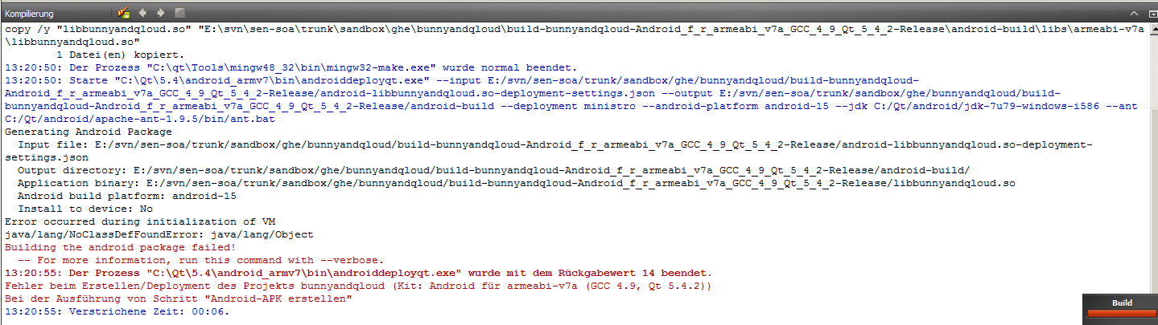

After a new recherché on Google, I found the reason: unpacking “jdk-7u79-windows-i586.exe” with 7zip is not enough: the 7 \jre\jre\lib\*.pack files have to be unpacked with the command:

%javadir%\jdk-7u79-windows-i586\bin\unpack200 charsets.pack charsets.jar

%javadir%\jdk-7u79-windows-i586\bin\unpack200 deploy.pack deploy.jar

%javadir%\jdk-7u79-windows-i586\bin\unpack200 javaws.pack javaws.jar

%javadir%\jdk-7u79-windows-i586\bin\unpack200 jfxrt.pack jfxrt.jar

%javadir%\jdk-7u79-windows-i586\bin\unpack200 jsse.pack jsse.jar

%javadir%\jdk-7u79-windows-i586\bin\unpack200 plugin.pack plugin.jar

%javadir%\jdk-7u79-windows-i586\bin\unpack200 rt.pack rt.jar

# 4. Second attempt to build the Android project

The second build attempt brings the next error message:

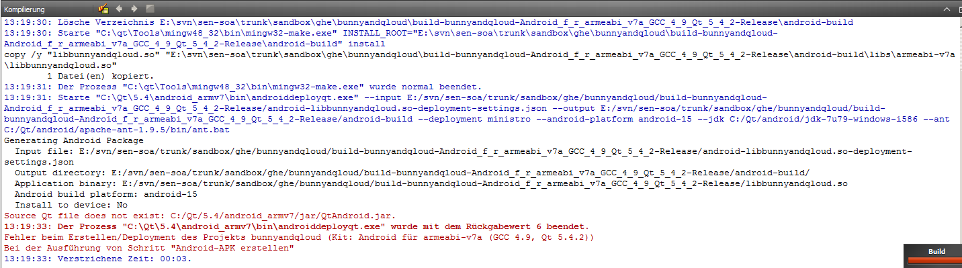

My Solution: **rename manually** all JAR files of the directory %Qt%\5.4\android_armv7\jar\ and remove the ‘-bundled’ part … so, this error is fixed.

**(This problem is fixed with the Qt version 5.5)**

# 5. Third attempt to build the Android project

Now I get several error messages about missing or wrong JDK, depending on the existing Java installation on the development machines:

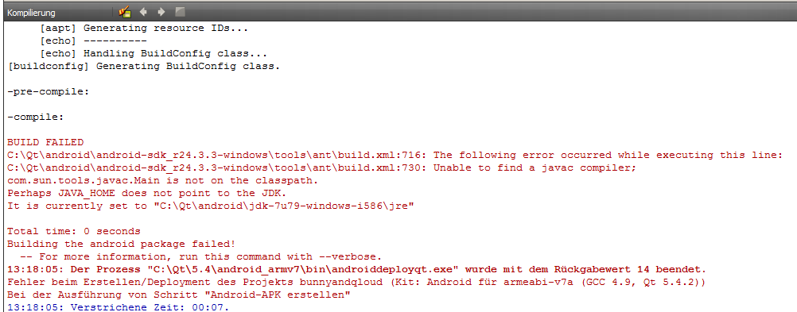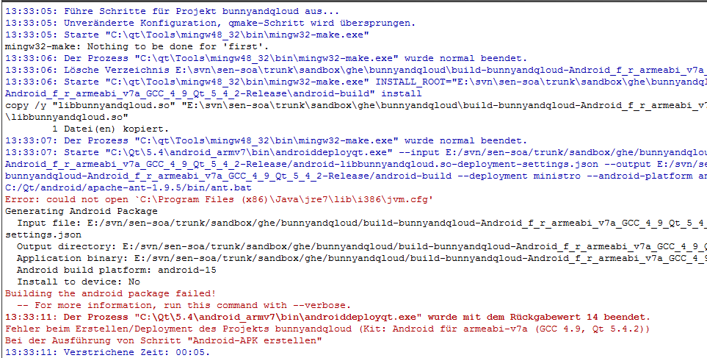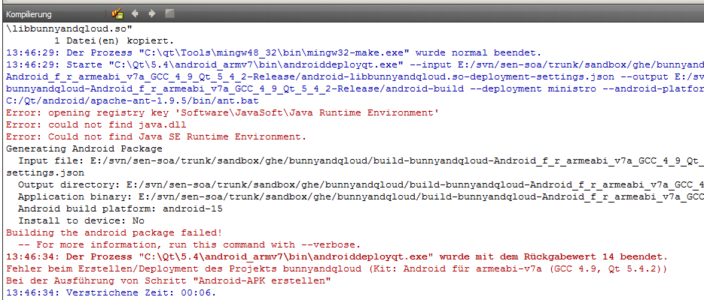

Finding:

The ANT build tool does not respect the setting made in QtCreator (Settings 🡪 Android 🡪 JDK Path).

The only solution: remove all existing Java installations from the development and **install** the JDK version you want to use for the Qt-Android development.

# 6. Start now, at least, the built application

I was now able to build the App, now I started to launch in the Simulator.

Result:

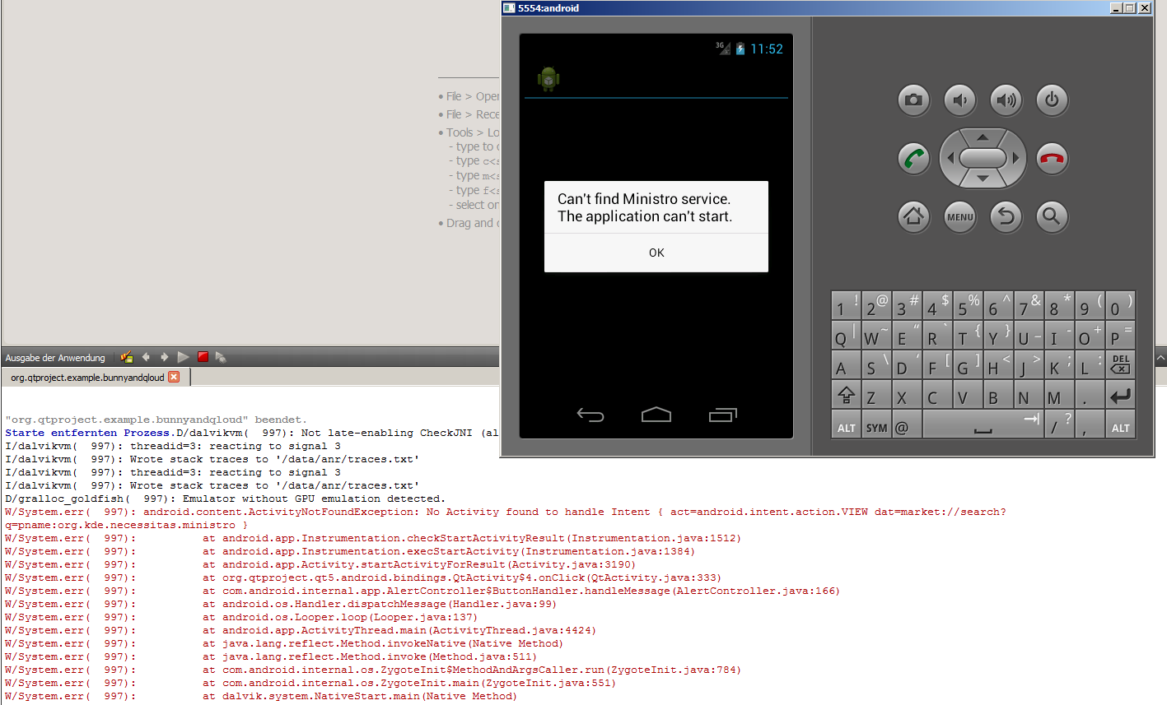

I have no real solution for this error

1. I had to change the build setting and choose “Pack Qt libraries into the APK” instead of “Use Ministro” (☹)  
   or
2. download and install Ministro manually with help of the built-in browser

# 7. Second attempt to start the Android App on the Emulator

I start the first demo again and try to look at the result in the simulator.  
Result:

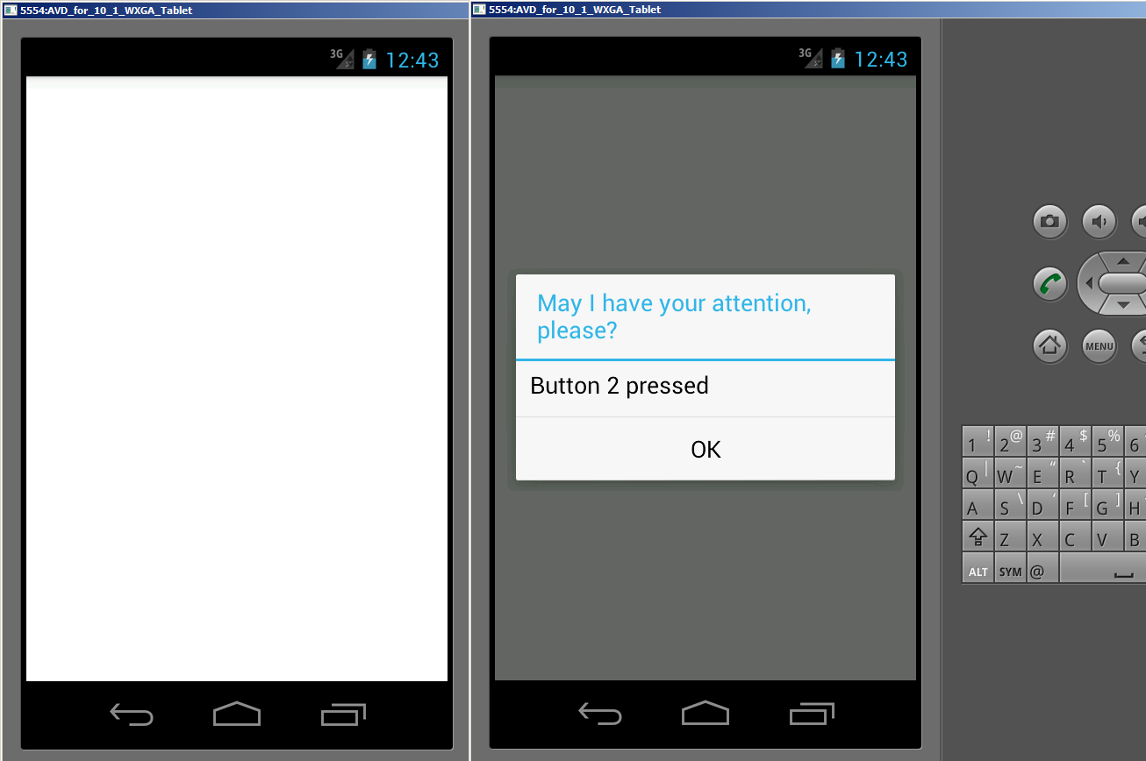

Why is the screen empty white (left on the pic)?

By tapping around blindly I managed to press a button of the demo and see a message box   
(right on the pic).

So, I conclude, the application is somehow running, but I don’t see the UI elements   
(I see a lot of OpenGL-related error messages on the output window of Qt Creator while running the app but these do not help finding the problem).

Solution: the setting “Use Host GPU” checkbox has to be activated on the Emulator settings dialog to make the UI elements visible.

The app is running now on the emulator, but the deployment and the performance of the app is disappointing (possibly “normal” on Java-based systems … ☺, let’s test on a real device!).

# 8. Run the Android App on a real device

I have a Samsung Tablet available, on which I would like to see the performance of the app.

But when trying to install the Google USB Driver, I get an error message: “no device available for the driver” (although the device is plugged in). As a consequence, I don’t see the device in the AVD Manager and cannot choose to install the app there…

Solution:

1. Activate the “Developer Settings” on the device
2. Install the Samsung-specific drivers “SAMSUNG_USB_Driver_for_Mobile_Phones_v1.5.45.0.exe” instead of the Google Drivers

As a result, now I can build and launch the first Qt App on the Android Emulator and on the device.

I still get some error messages (see below picture), but the app is still running … the “real work” can now start!

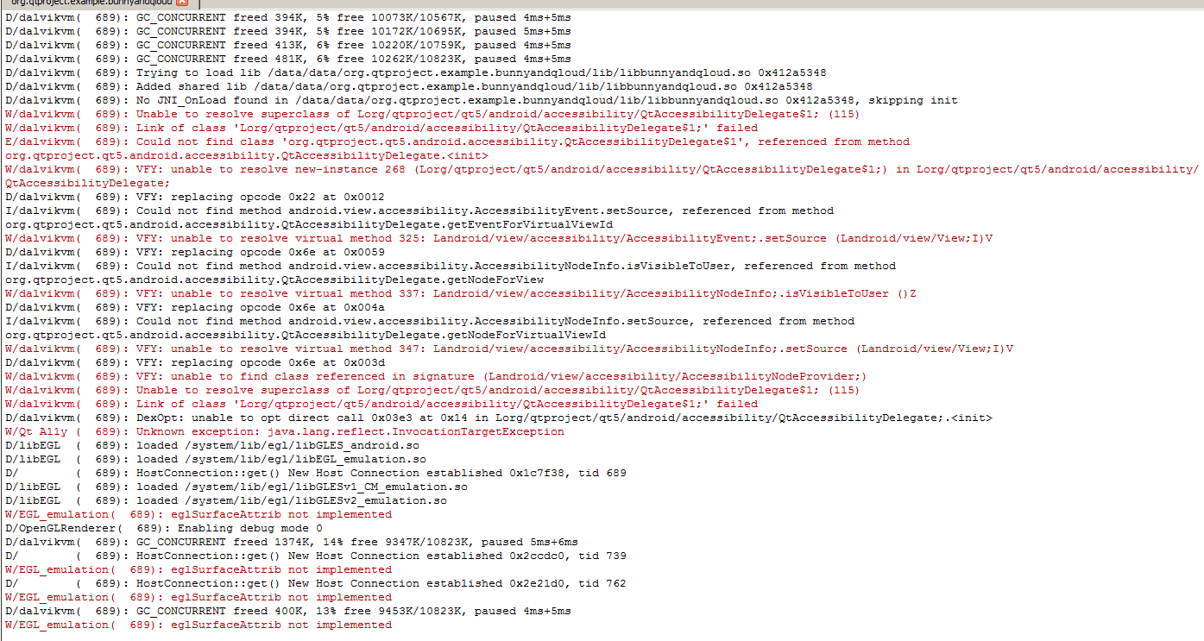

# 9 Ministro

I had great problems with Ministro on the Emulator and on an older Amazon Kindle!

The installation of the Ministro.apk is difficult and I was confused if I should use the downloadable APK version (as on the below picture) or install from the Amazon-Store. I was able to solve the below Error message after several restarts of the emulator.

(to be honest, I think that the root cause of my problems are on the java/Android/Emulator side, not because of a Qt binary).

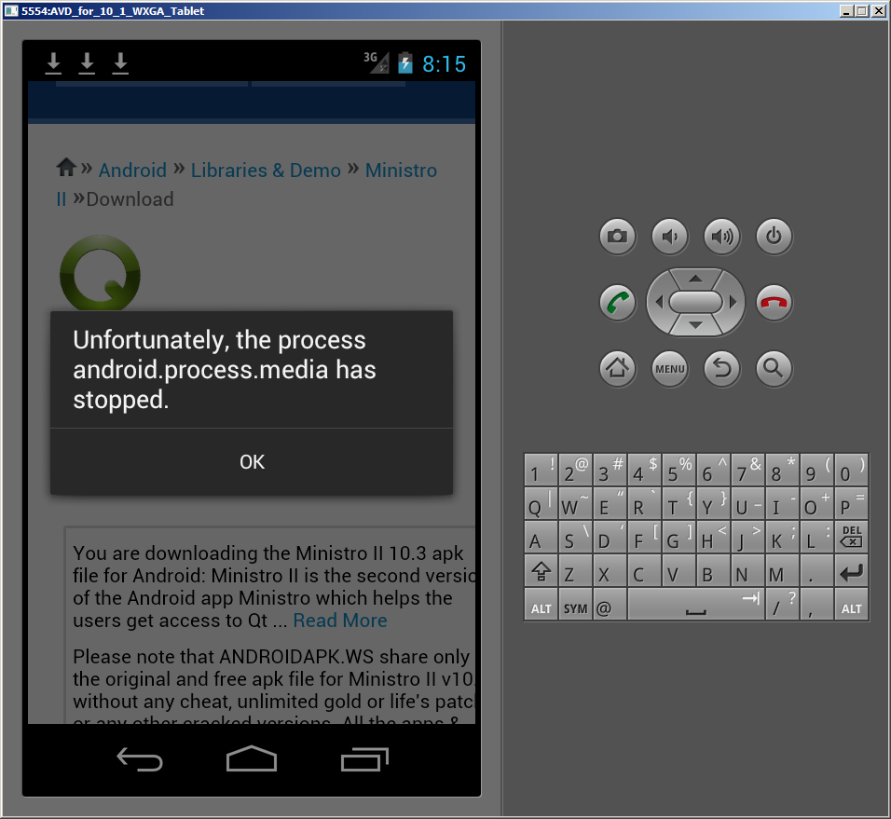

# 10 OpenGL Driver on Windows Desktop

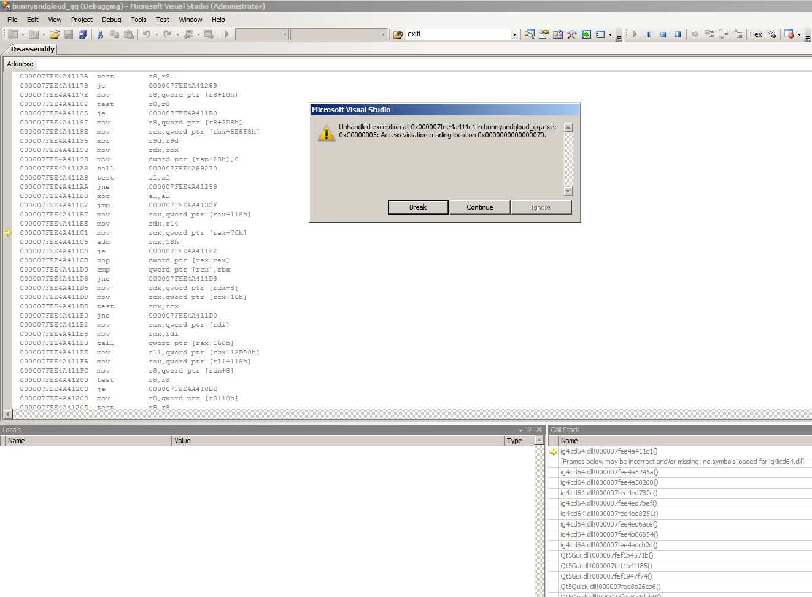

Some INTEL Graphic Card driver cannot handle the load caused by intensive OpenGL effects on Windows Desktop apps, crash in **ig4icd64.dll**.

This is a well-known ‘feature’ (eg. described in <https://developer.blender.org/T31423>) and only solvable by using a software renderer 'opengl32.dll' from http://download.blender.org/ftp/sergey/softwaregl/{win64|win32}/ (much slower)

# 11 Effects inside of Windows virtual machines

Unfortunately, with the Windows Desktop compilation,  
there are weird effects inside of (Windows XP-) virtual machines:

1. An error message will be shown at startup (Windows XP), or
2. The app starts, but shows only a white surface (Windows 7/8)

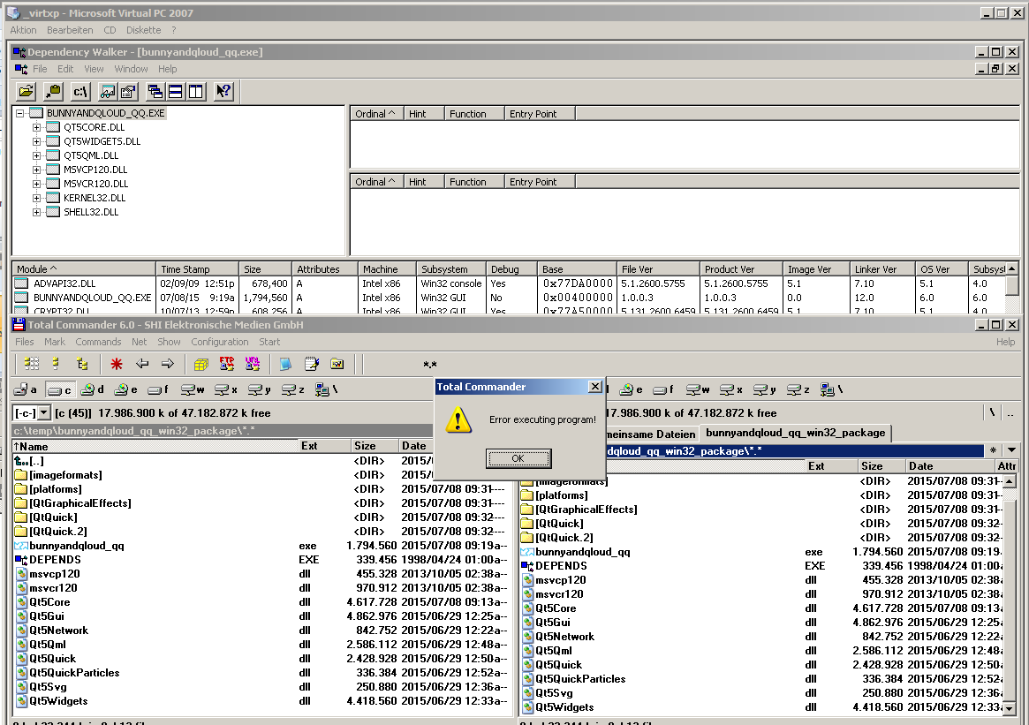

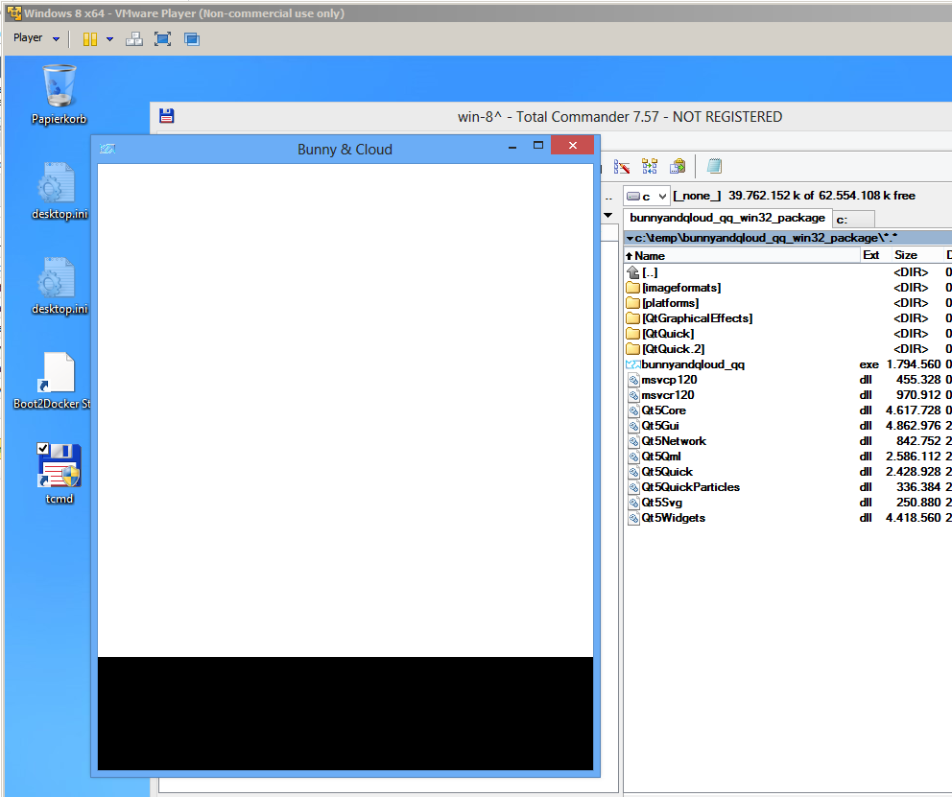

There is a solution for the problem in the VMWare virtual machine with Windows 8: use opengl32.dll from  
<http://download.blender.org/ftp/sergey/softwaregl/win64/> or <http://download.blender.org/ftp/sergey/softwaregl/win32/> .

# 12 Ministro or not Ministro

On the Android Device (but not on the simulator or on the windows Desktop compilation), some OpenGL shader effects do not work, if the Qt libs are “built-in” into the app, but the Ministro-provided libs have to be used. Why?

See below picture: the screenshot on the top is with Ministro libs; in the app below the libs are packed into the APK.

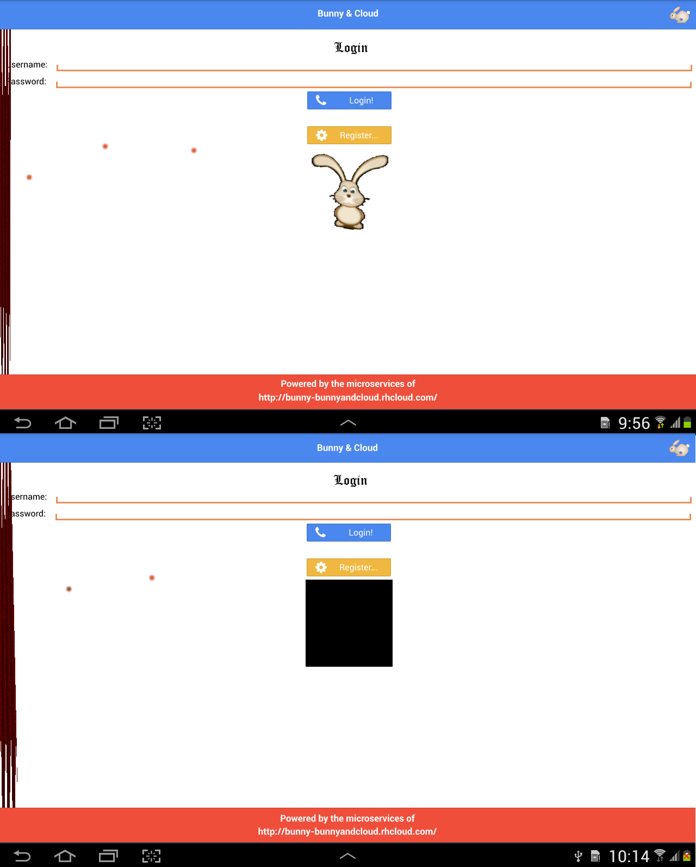

# 13 Ministro + Qt 5.5

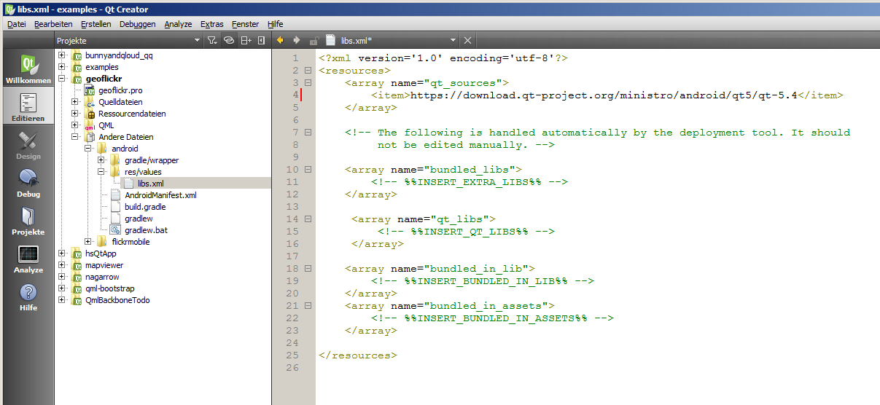

Qt 5.5 + QtCreator 3.4.2 generate an android/res/libs.xml file with the reference to  
<https://download.qt-project.org/ministro/android/qt5/qt-5.4/>  
and there is no  
<https://download.qt-project.org/ministro/android/qt5/qt-5.5>

Consequence: it is impossible to use Ministro with the new features of Qt 5.5  
:-(

# Summary

After a full day I managed to run the first Qt4Android QtQuick Demo app.

I had to implement several workarounds with various reasons:

1. QtCreator does not help much when setting up the “Build-And-Run” and the “Android” settings, although the recognition of the “qmake.exe” files could be easily implemented…
2. JAR-files with the wrong names (without the ‘-bundled’ postfix) are expected by the build.  
   This error will be fixed in the next Qt version (5.5).
3. The necessity of the **Installation** of the Java dependency is not a fault of QtCreator, but the ANT environment. It is unlovely that I have to change the setup of my machine just to support the java-based toolchain.
4. The necessary “Use Host GPU” setting should be checked by QtCreator, as this setting is not activated by default in the Emulator.
5. The complicated setup of the USB Drivers is again not a fault of QtCreator but specific generally to Android development with Samsung devices (☺).
6. The problems inside virtual machines AND the different behavior with and without Ministro are quality problems of the Qt delivery.