# The creation of Mono WAV Files for voice Recognition

1. Use the “Recorder” app to record your voice on Windows 10:

(Workflow see image below)

* 1. Type ‘reko’ in the start menu
  2. Start the “Sprachrekorder” app
  3. Start the Recording
  4. Speak for ca. 20 seconds, e.g. read 3-5 sentences loud
  5. Stop the recording and open the folder with the created .m4a sound file

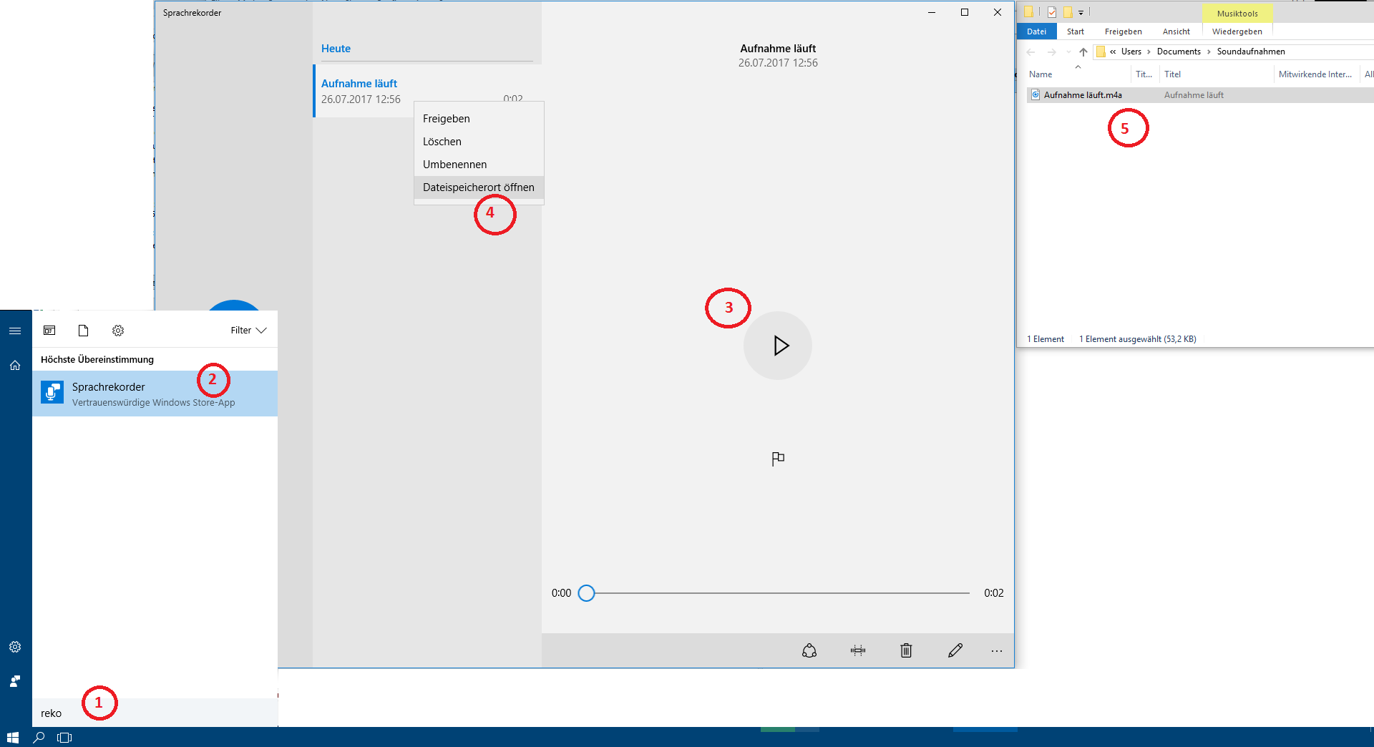

1. Use <http://audio.online-convert.com/convert-to-wav> to convert:  
   (Workflow see image below)
   1. Choose your file
   2. Choose the **mono** audio channel
   3. Click the “Convert file” button
   4. Download the resulted WAV file

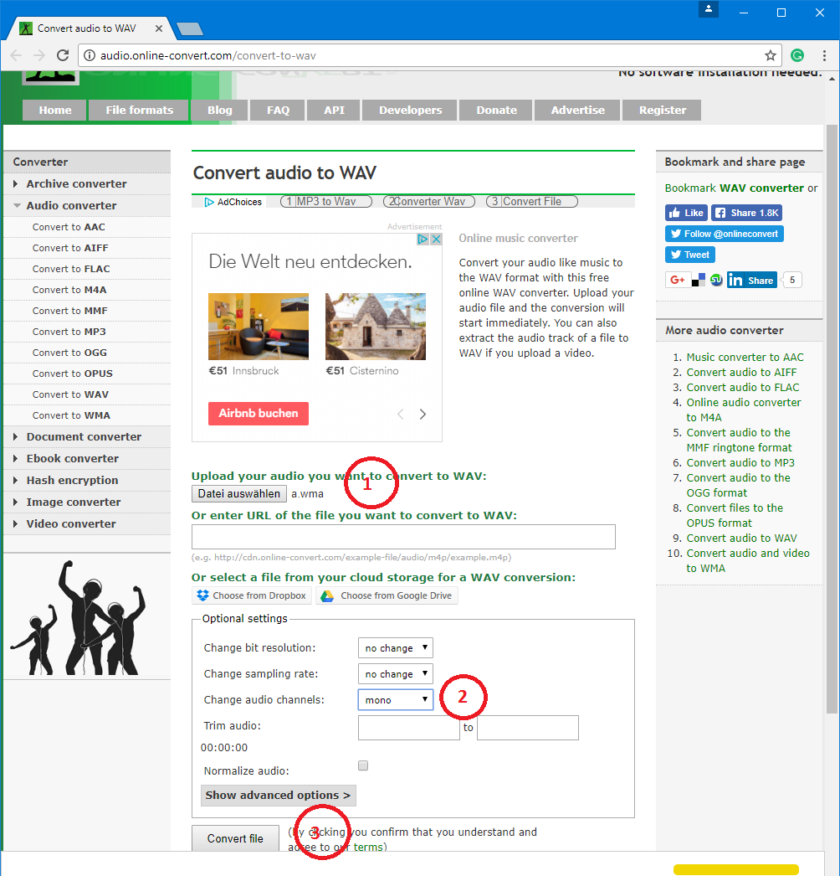

1. Use the above workflow to create at least **4** WAV files