ONLINE MOVIE BOOKING SYSTEM

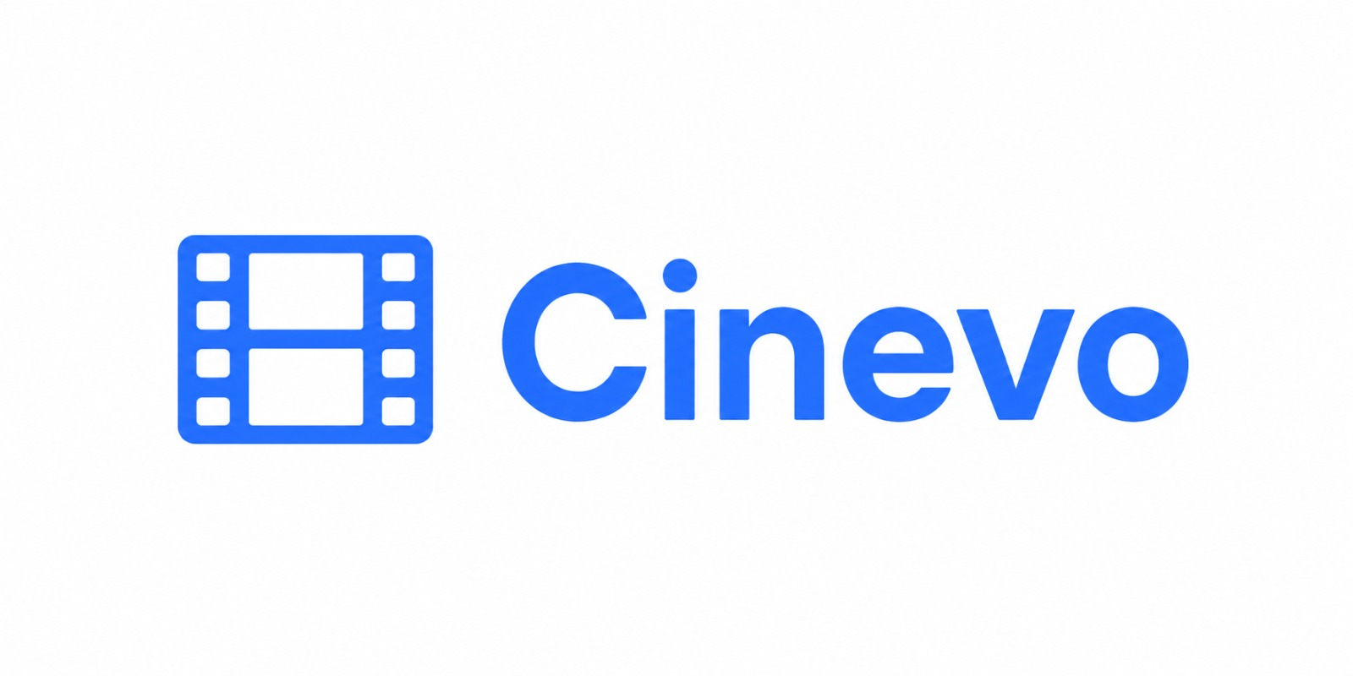

CERTIFICATE
This is to certify that the project entitled “CINEVO” is successfully completed by:

- Muhammad Sadiq (Student 1659539)
- Maria Mustafa (Student 1656416)
- Priya Devi (Student 1659502)
- Dawood Akram (Student 1654148)
- Abdul Kabeer (Student 1659464)

Of batch AI-202506D+05D have successfully completed the given task for the topic.

FACULTY: MISS FASAHAT NAJEEB
SEMESTER: DISM
APTECH LEARNING SHAHRAH-E-FAISAL

Table of Contents
- Introduction
- So What is This E-Project?
- Objectives of The Project
- Problem Statement
- Customer Requirements Specification
- Project Plan
- E-R Diagrams & Algorithms
- GUI Standard Document
- Interface Design Document
- Admin Panel
- Task Sheet
- Project Review and Monitoring Report
- Unit Testing Check List
- Final Check List

Introduction
The thirst for learning, upgrading technical skills and applying the concepts in real life environment at a fast pace is what the industry demands from IT professionals today. However busy work schedules, far-flung locations, unavailability of convenient time-slots pose as major barriers when it comes to applying the concepts into realism. And hence the need to look out for alternative means of implementation in the form of laddered approach.

The above truly pose as constraints especially for our students too! With their busy schedules, it is indeed difficult for our students to keep up with the genuine and constant need for integrated application which can be seen live especially so in the field of IT education where technology can change on the spur of a moment. Well, technology does come to our rescue at such times!!

Keeping the above in mind and in tune with our constant endeavour to use Technology in our training model, we at Aptech have thought of revolutionizing the way our students learn and implement the concepts using tools themselves by providing a live and synchronous E-Project learning environment!

So, what is this E-Project?
E-Project is a step-by-step learning environment that closely simulates the classroom and Lab based learning environment into actual implementation. It is a project implementation at your fingertips!! An electronic, live juncture on the machine that allows you to:
- Practice step by step i.e. laddered approach.
- Build a larger more robust application.
- Usage of certain utilities in applications designed by user.
- Single program to unified code leading to a complete application.
- Learn implementation of concepts in a phased manner.
- Enhance skills and add value.
- Work on real life projects.
- Give a real-life scenario and help to create applications more complicated and useful.
- Mentoring through email support.

The students at the center are expected to complete this E-Project and send the complete project along with the documentation to the E-Projects Team.

Objectives of The Project
The Objective of this program is to give a sample project to work on real life projects. These applications help you build a larger more robust application. The objective is not to teach you concepts but to provide you with a real-life scenario and help you create applications using the tools. You can revise them before you start with the project.

It is very essential that a student has a clear understanding of the subject. Students should go through the project and solve the assignments as per requirements given.

Problem Statement
Watching movies is one of the most popular entertainment mediums these days. People need to surf various websites to watch trailers of movies. They need to browse through different websites to get the movie reviews. Once they find a movie suited to their liking, they need to go to theatres to book a ticket. For this they need to stand in queues to buy tickets.

To ease all these problems we have proposed a solution as Online Movie Ticket Booking System named CINEVO.

Customer Requirements Specification
Online movie booking system is a web portal where you can book tickets in advance, know your movie show timing, watch movie trailer and read reviews for the same. User can know everything about a movie and its show rates and show time just sitting on your couch.

The system is to be created based on the following requirements:
- Just go to the web portal for Online Movie Ticket Booking System and register yourself and gain access to all the movies, theaters and many more features.
- Online Movie Ticketing System in PHP is a very user-friendly project and can be accessed from anywhere.
- There is no need to go to the movie theaters and wait for your turn to book movie tickets.
- User can now just track everything about a movie just by clicking on to it.
- User can buy tickets just by selecting a movie and show timings.
- There are three classes for a movie theatre: Gold, Platinum and Box class. These are different seat categories inside the hall.

Project Plan
- Login and Registration for users.
- View show time just by selecting your preferred date.
- Movie Reviews and ratings.
- Movie trailers.
- Payment Gateway needs to be added to this project. (Optional)
- Admin dashboard.
- Add, delete and edit movie theaters.
- Add, delete and edit movies.
- Add, delete and edit shows and their rates for each class.

E-R-D Diagrams
This ERD (Entity Relationship Diagram) represents the database structure of the CINEVO Movie Ticket Booking System. It illustrates how entities such as users, movies, theaters, shows, bookings, seats, reviews, and pricing are interconnected to manage cinema booking operations efficiently.

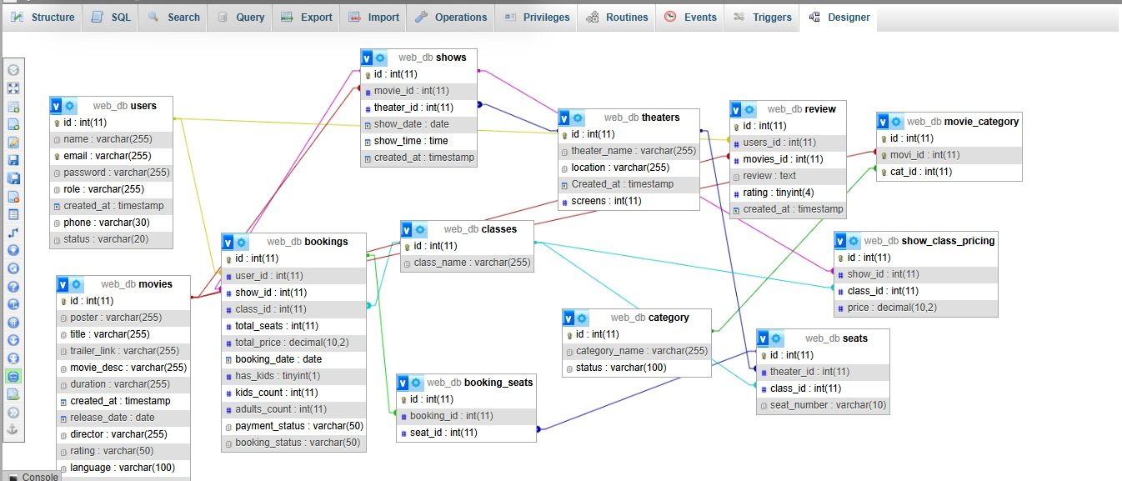

Algorithms
Algorithm | Description
1. Registration | Enter details → Validate → Save data
2. Login | Enter login → Verify user
3. Movie Search | Search movie → Show results
4. Ticket Booking | Select movie → Book ticket
5. Seat Checking | Check seats → Show availability
6. Cancellation | Enter booking ID → Cancel ticket
7. Admin Mgmt. | Login → Manage movies / theaters
8. Payment | Enter payment → Confirm payment

GUI Standard Document
Project Cinevo
- Color Palette: Primary Royal Blue (#2563EB), Deep Navy gradients, Off-White for forms, Vibrant Red for accents.
- Typography: Modern Sans-serif font, Bold headers, gray/white body text.
- Layout & Navigation: Sticky Header (Logo, Menu, Login/Sign Up), Responsive Grid System.
- UI Components: Rounded buttons, standard input forms, status badges.

Interface Design Document

1. Interface Overview
The Cinevo interface is designed to be a high-performance, user-friendly movie booking portal.

2. Screen Hierarchy (Site Map)
- Public Interface: Home Page, About Us, and Contact Us.
- User Interface: Movies Catalog, Show Selection, and Booking History.
- Admin Interface: Movie Management, Theater Controls, and Booking Reports.

3. Key Screen Descriptions
- Home Page & Catalog: Features a filterable grid showing “All Movies”, “Now Showing”, and “Upcoming”.
- About Cinevo Page: Presents the brand mission and key metrics.
- Contact Us Page: A functional form for user inquiries.
- Booking Interface: A streamlined checkout process for seat class selection.

Screenshots

Home Page
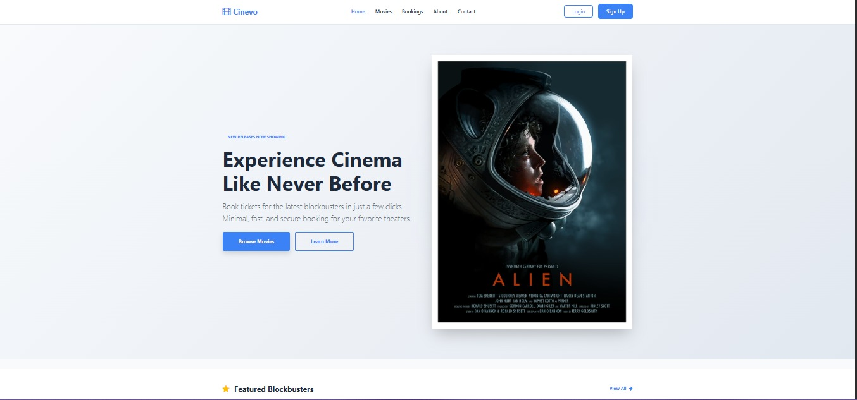

Movie Catalog
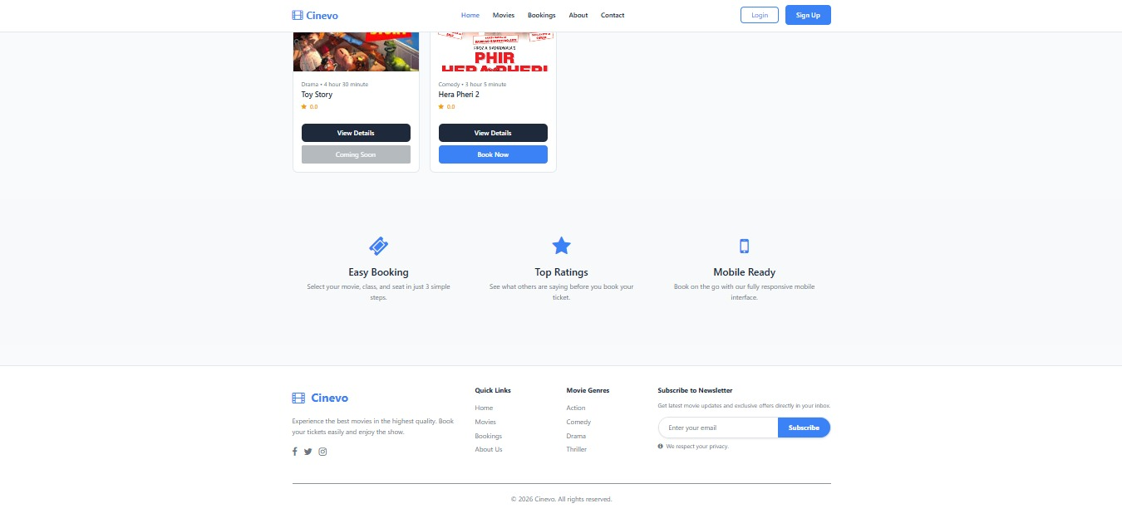

Booking Interface
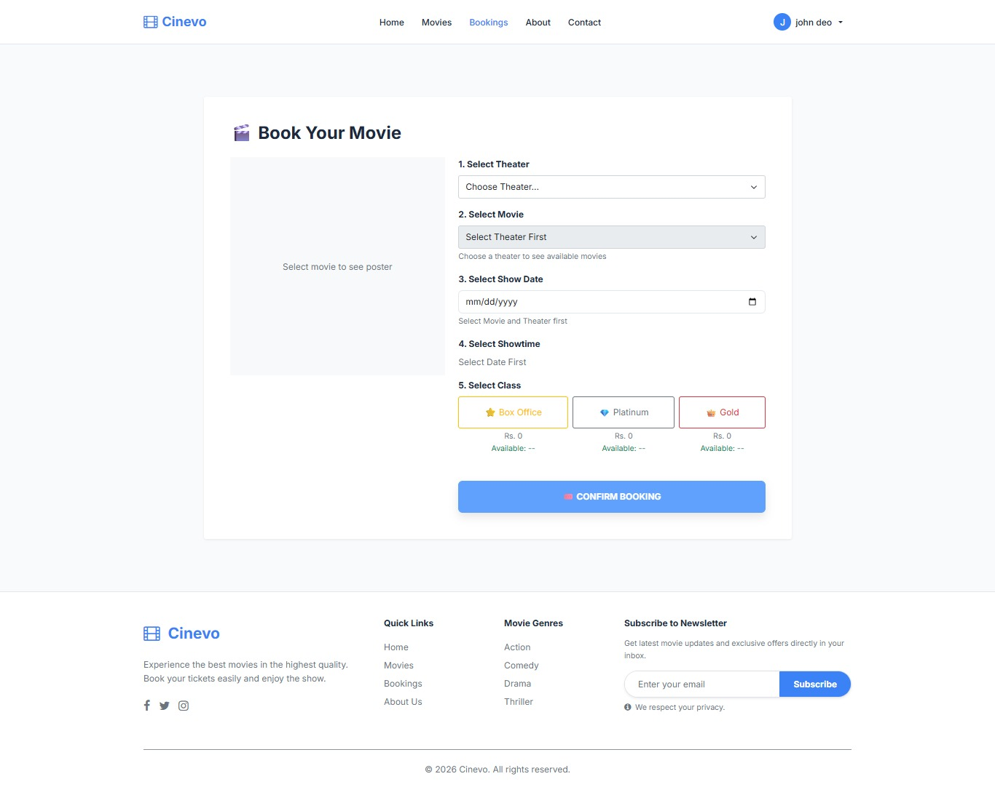

Contact Us
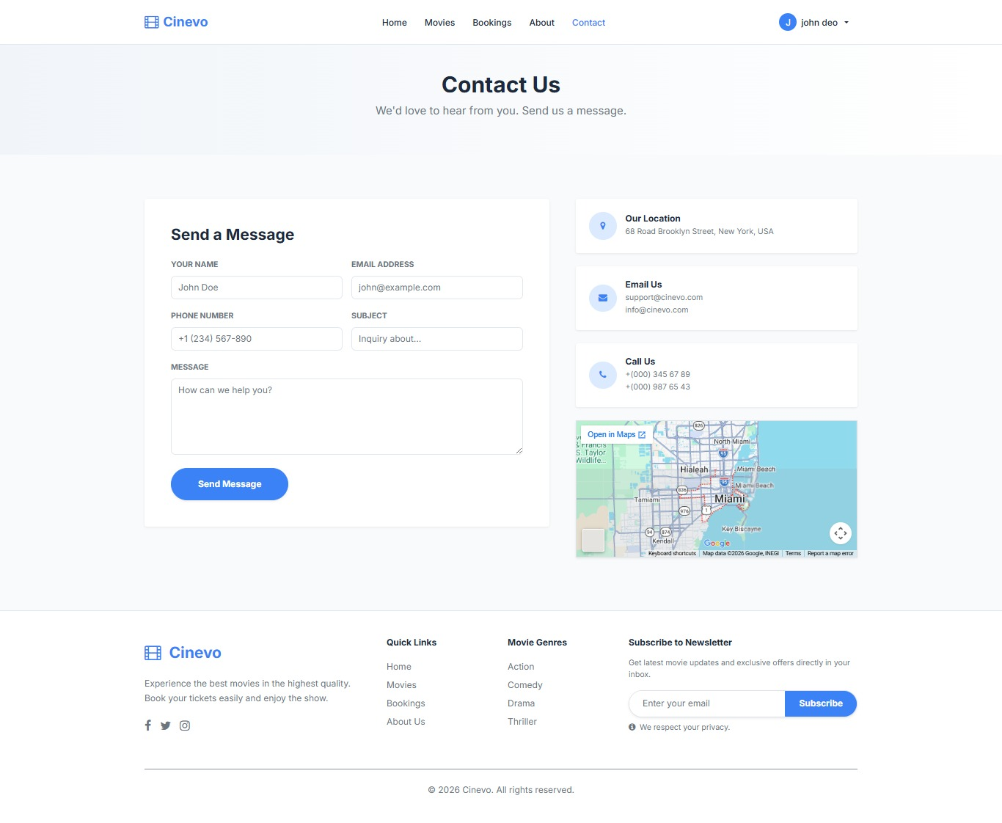

Admin Panel
The central backend hub used by administrators to manage movies, theaters, users, and overall system settings
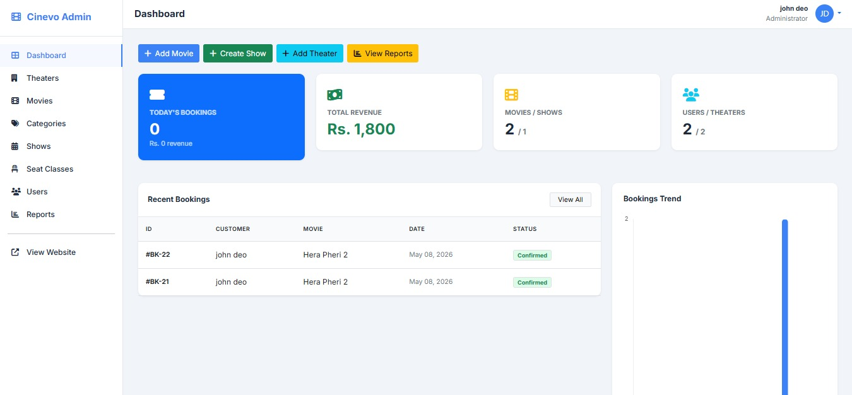

Admin Dashboard
The main screen featuring summary cards and charts that display real-time revenue, daily bookings, and key performance statistics.



Module | Functions
Movie Management | Add / Edit / Delete movies, upload posters, set trailers.
Theater Management | Add / Edit / Delete theater halls and seat categories.
Show Management | Create shows, assign timings, set pricing per class.
User Management | View registered users, manage roles and access.
Booking Reports | View all bookings, filter by date / movie / theater.
Revenue Dashboard | Real-time charts for daily and monthly revenue.

Task Sheet
# | Task Description | Assigned To | Due Date | Status
1 | Database design and ERD creation | Muhammad Sadiq | Week 1 | Completed
2 | Backend: User Registration & Login module | Muhammad Sadiq | Week 2 | Completed
3 | Frontend: Home Page UI design | Maria Mustafa | Week 2 | Completed
4 | Frontend: Movie catalog and detail pages | Priya Devi | Week 3 | Completed
5 | Backend: Admin panel – Movie CRUD | Muhammad Sadiq | Week 3 | Completed
6 | Backend: Theater & Show management | Dawood Akram | Week 3 | Completed
7 | Frontend: Booking and seat selection UI | Maria Mustafa | Week 4 | Completed
8 | Backend: Ticket booking logic | Abdul Kabeer | Week 4 | Completed
9 | YouTube trailer modal integration | Muhammad Sadiq | Week 4 | Completed
10 | Testing and bug fixes | All Members | Week 5 | Completed
11 | Documentation preparation | Priya Devi | Week 5 | Completed
12 | Final review and submission | All Members | Week 6 | Pending

Project Review and Monitoring Report
Project Name | Cinevo – Online Movie Booking System
Batch | AI-202506D+05D
Faculty | Miss Fasahat Najeeb
Semester | DISM
Overall Status | On Track

Milestone Review Summary
Milestone | Planned | Actual | Status | Remarks
DB Design & ERD | Week 1 | Week 1 | Completed | On time
Auth & User Module | Week 2 | Week 2 | Completed | Minor fixes done
Frontend UI | Week 2 | Week 3 | Completed | 1 week delay resolved
Admin Panel CRUD | Week 3 | Week 3 | Completed | All features working
Booking Module | Week 4 | Week 4 | Completed | PRG pattern applied
Trailer Integration | Week 4 | Week 4 | Completed | Autoplay issue fixed
Testing & Bug Fix | Week 5 | Week 5 | Completed | All cases passed
Final Documentation | Week 5 | Week 5 | Completed | Report finalized
Submission | Week 6 | Pending | In Progress | Under final review

Unit Testing Check List

Module 1: User Authentication
- User can register with valid details.
- User can login with correct credentials.
- Password hashing is applied for security.
- Error messages display for invalid login.

Module 2: Movie Catalog
- All movies display in the catalog grid.
- Filters for "Now Showing" and "Upcoming" work.
- Movie detail page displays correct information.
- YouTube trailer opens in a modal.

Module 3: Booking Flow
- User can select movie, date, and show time.
- Seat class selection (Gold / Platinum / Box) works correctly.
- Booking is saved to the database correctly.
- ☑PRG pattern prevents duplicate booking on page refresh
- ☐Booking confirmation page displays booking summary.

Final Check List

Documentation
- Project documentation is complete with all required sections.
- Table of Contents is accurate and all page references are correct.
- Certificate page includes all team member names and IDs.
- Introduction, Objectives, and Problem Statement are clearly written.
- Customer Requirements Specification is complete.
- E-R Diagram is present and accurately represents the database.
- GUI Standard Document and Interface Design Document are included.
- Task Sheet is filled with all assignments and statuses.
- Project Review and Monitoring Report is completed and signed.
- Unit Testing Checklist has all items verified.

Code & Functionality
- Source code is organized in a clean folder structure.
- Database MYSQL script (schema + seed data) is included.
- User registration and login are working correctly.
- Movie catalog displays correctly with trailers and filters.
- Ticket booking flow works end-to-end without errors.
- Admin panel CRUD operations are fully functional.

- No duplicate inserts on page refresh (PRG pattern applied).
- All foreign key constraints are respected in delete operations.
- YouTube trailer autoplay issue is resolved.
- Application is tested on major browsers (Chrome, Edge, Firefox).



