ZQMS-ARC-REC-002



# ASSIGNMENT COVER

REGION: _____________________________________________________________________

PROGRAMME: ___________________________________________________ INTAKE:____

FULL NAME OF STUDENT: ________________________________________ PIN:________

MAILING ADDRESS: __________________________________________________________

CONTACT TELEPHONE/CELL: _________________________ ID. NO.: ________________

COURSE NAME: ______________________________________ COURSE CODE: _________

ASSIGNMENT NO. e.g. 1 or 2: ___________________________ DUE DATE: _____________

ASSIGNMENT TITLE: __________________________________________________________

______________________________________________________________________________

______________________________________________________________________________

MARKER’S COMMENTS: ______________________________________________________

**______________________________________________________________________________**

**______________________________________________________________________________**

**______________________________________________________________________________**

OVERALL MARK: _____________ MARKER’S NAME: ________________________

MARKER’S SIGNATURE:_______________________________ DATE: ___________

**Issue Date**: 3 October 2013 Revision 0

**QUESTION 1**

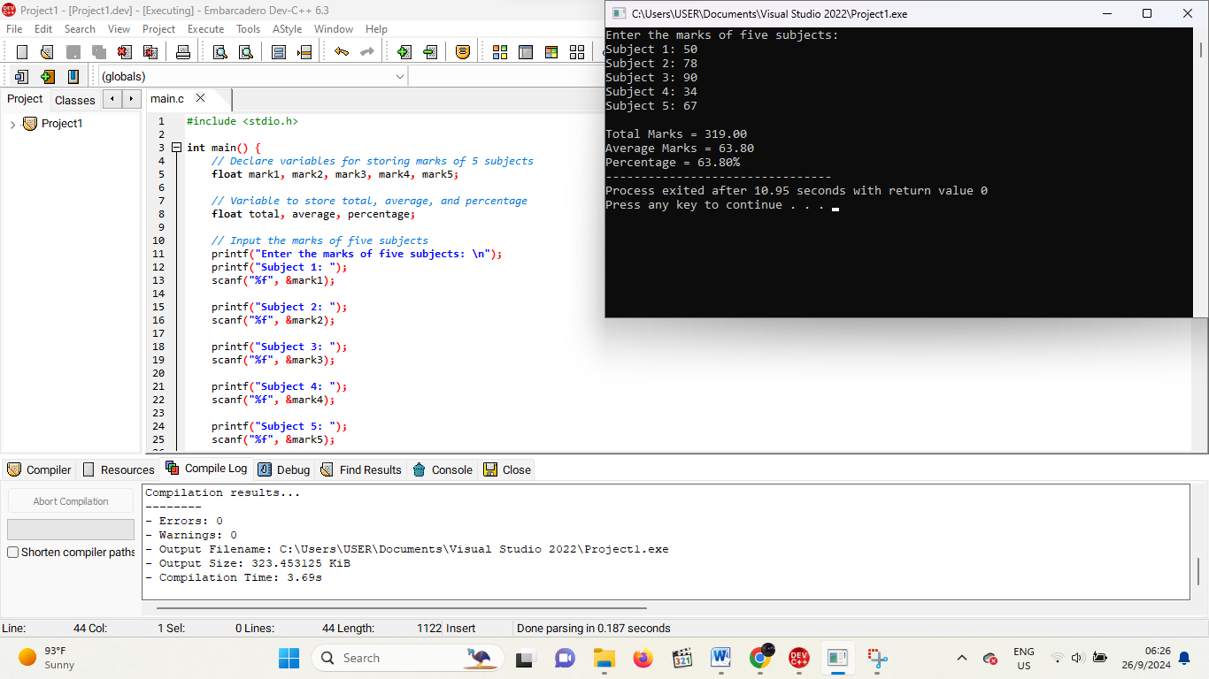

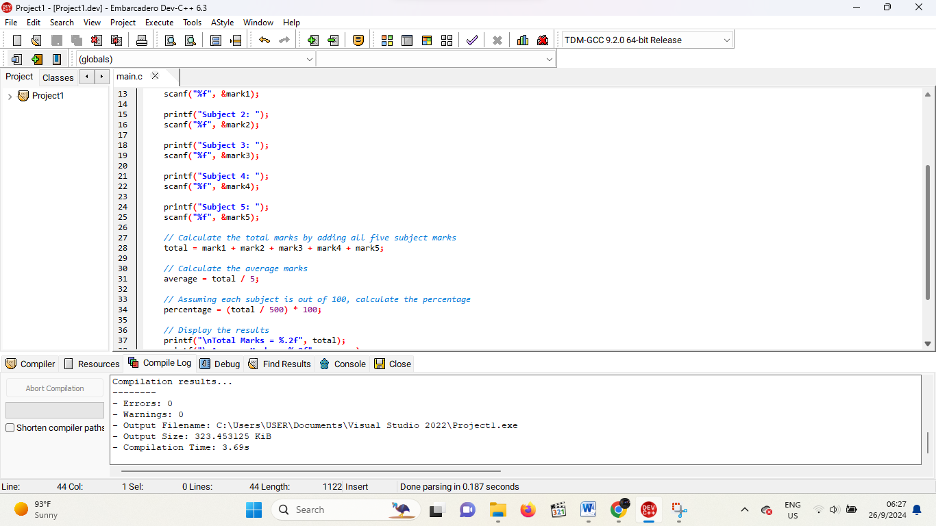

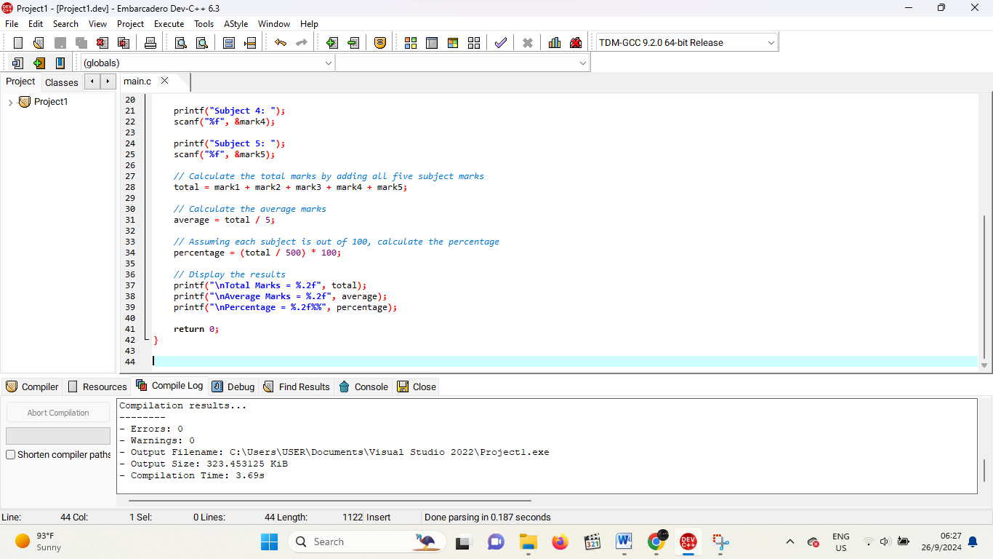

QUESTION 2

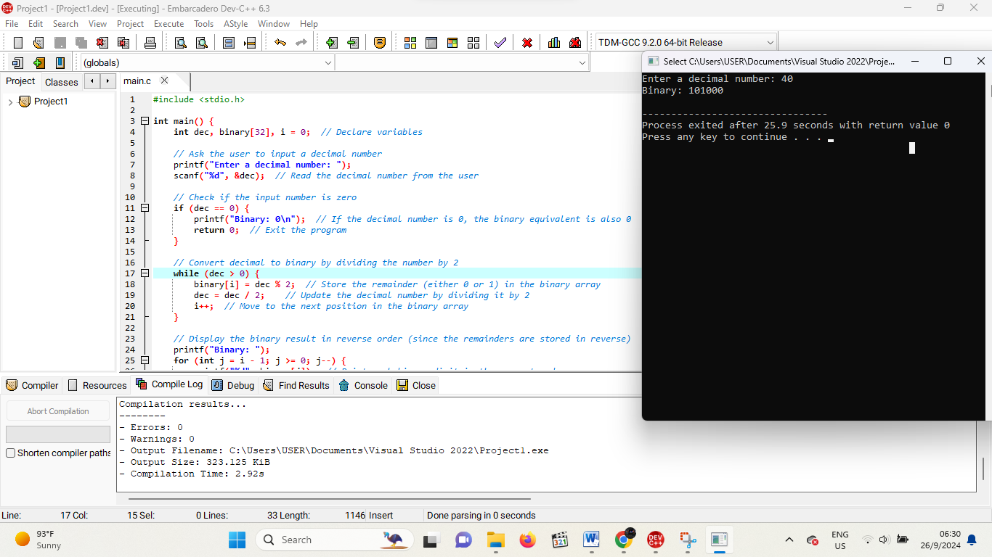

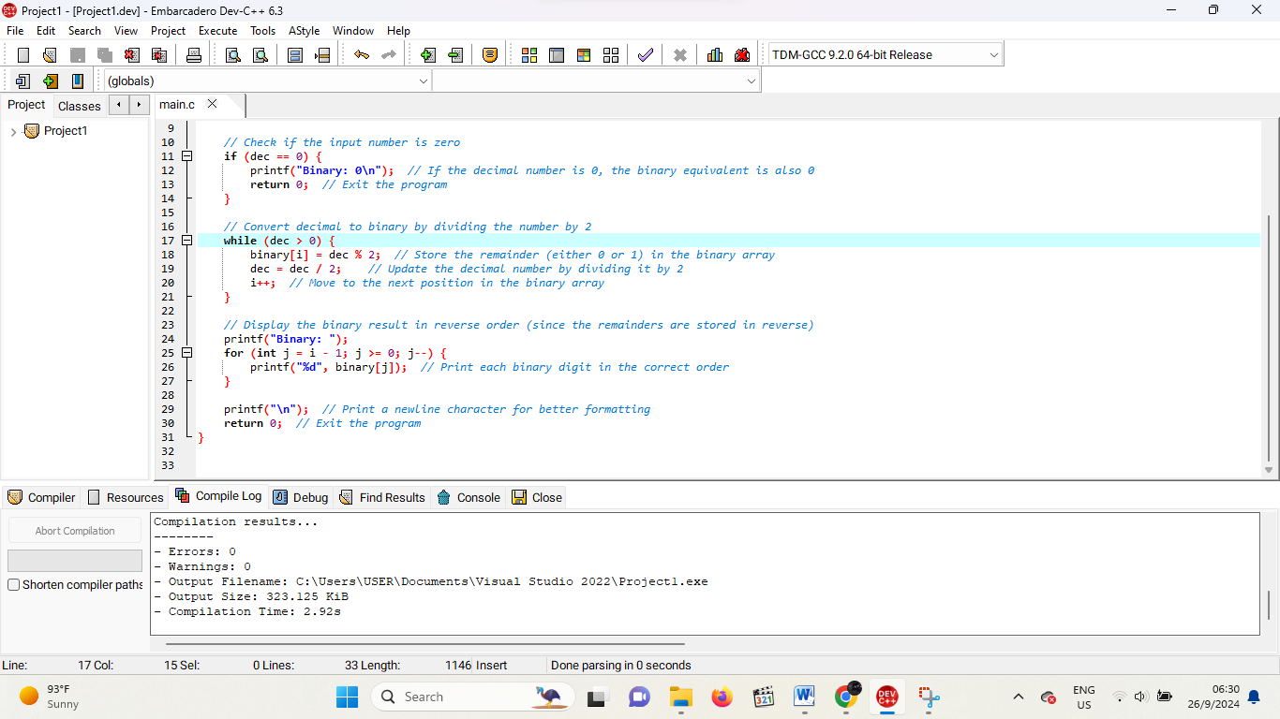

QUESTION 3

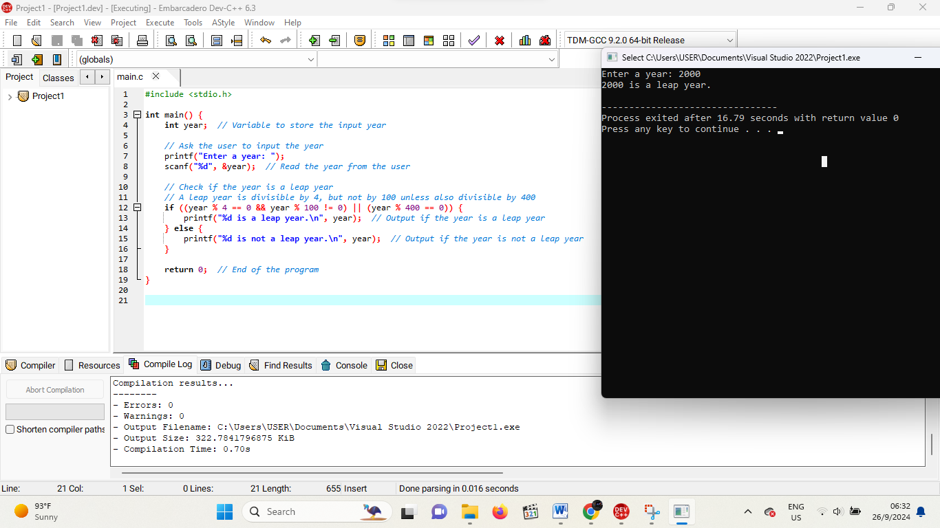

QUESTION 4

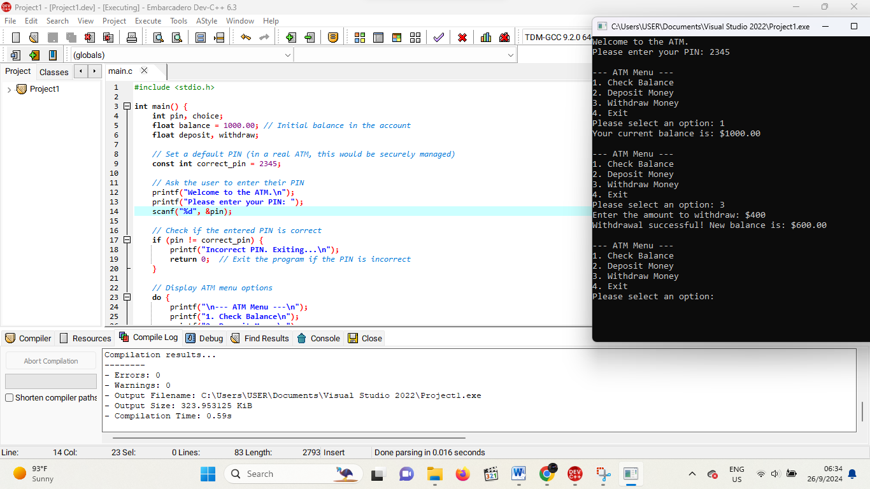

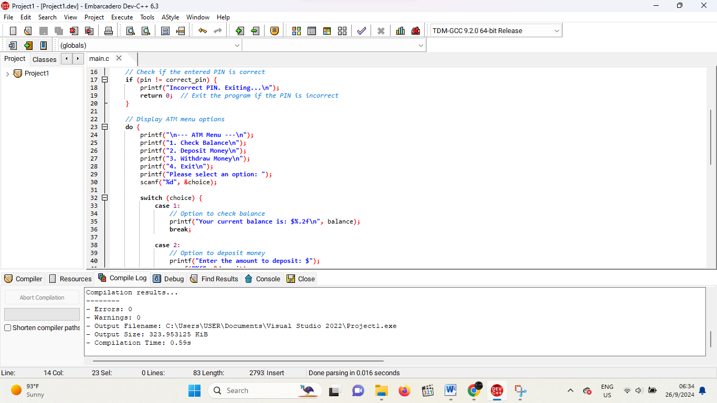

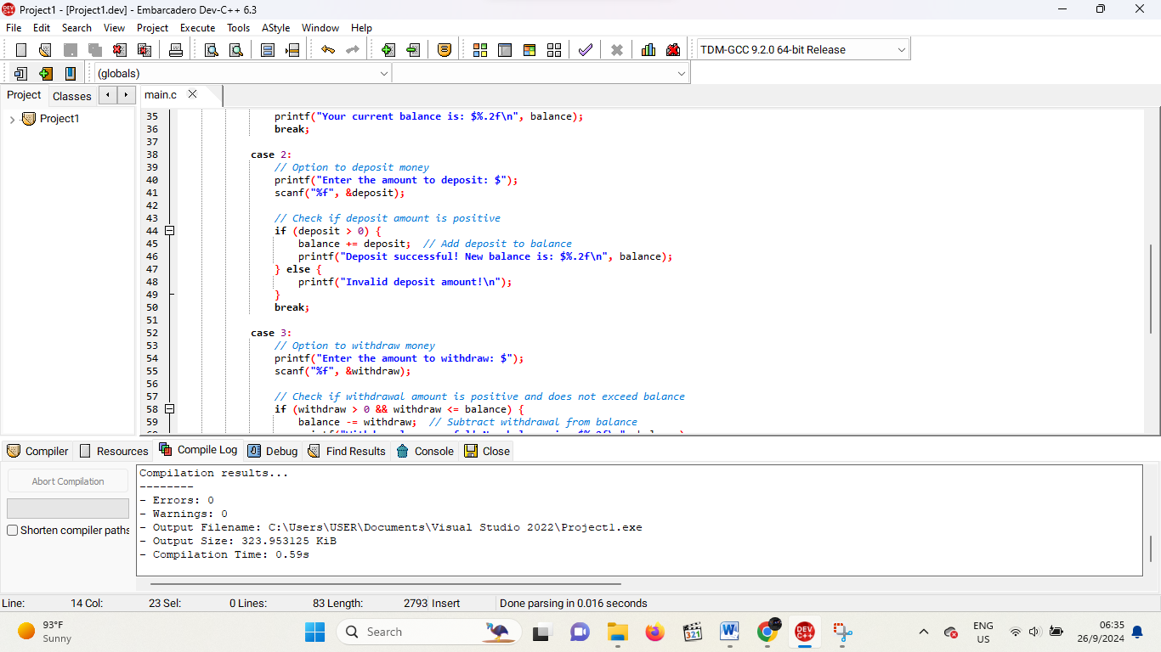

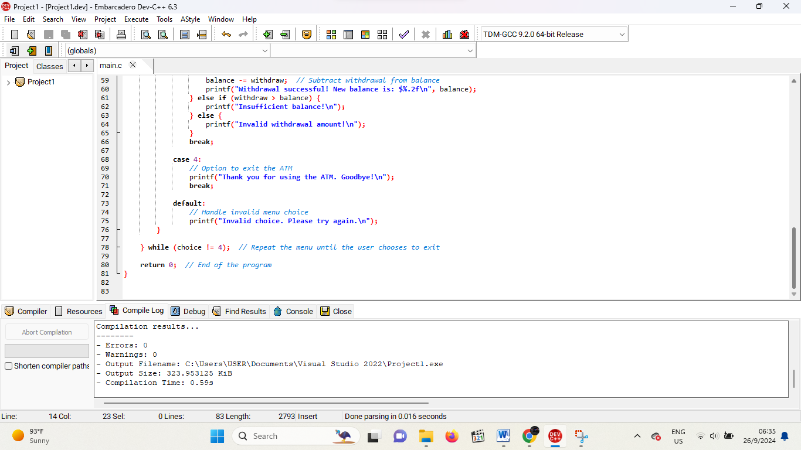

QUESTION 5

