Assignment 1

Course: Web Technology with UI/UX
Course Code: 2010043228
Name: Priya Purohit
Enrollment Number: 2502031030005
Semester: 4th Academic Year: 2025-26
Task-1: Creating Git Repository
Step 1: Open GitHub First, I opened the GitHub website.
Procedure:
- Opened the browser.
- Went to the website https://github.com 3. Logged into my GitHub account.
Screenshot:
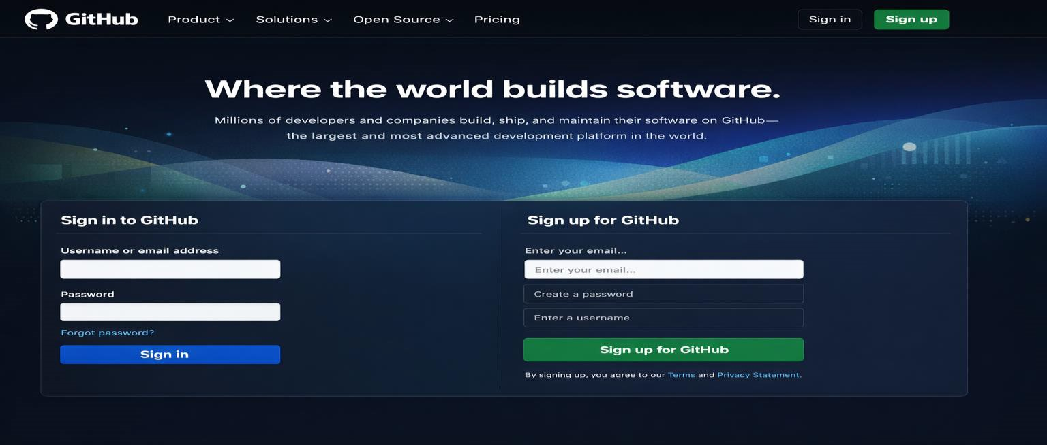

Step 2: Create New Repository
After logging in, I created a new repository.
Procedure:
- Clicked on the "+" icon on the top right corner.
- Selected New Repository.
- Entered my Enrollment Number as Repository Name.
- Selected Public option.
- Clicked on Create Repository.
Screenshot:
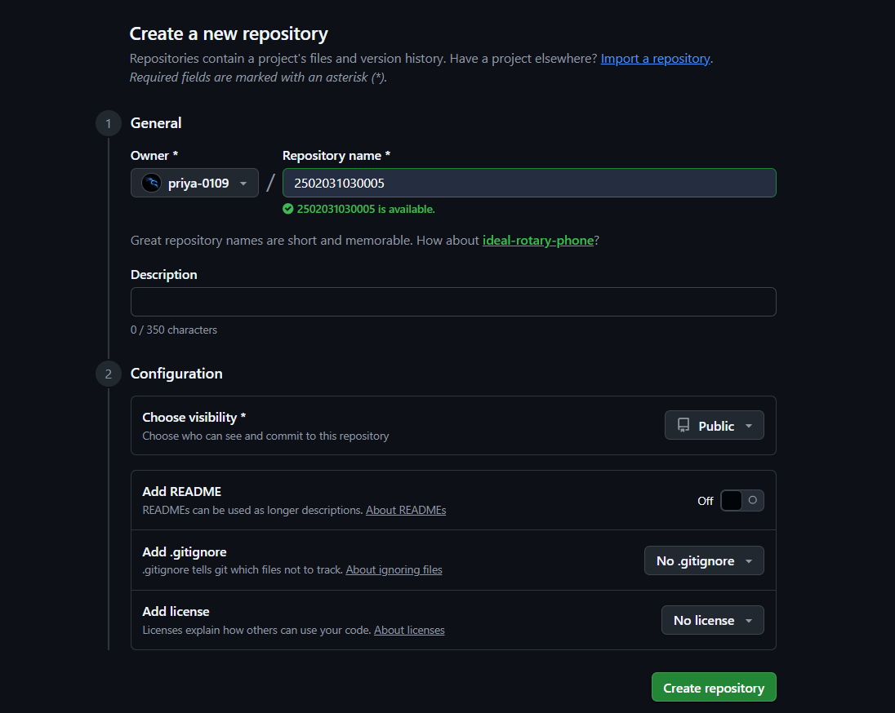

Step 3: Create Assignment_1 Folder Next, I created a folder for Assignment 1.
Procedure:
- Opened the repository.
- Clicked on Add File.
- Selected Create New File.
- Named the folder Assignment_1.
- Added a README file inside it.
- Clicked Commit Changes.
Screenshot:
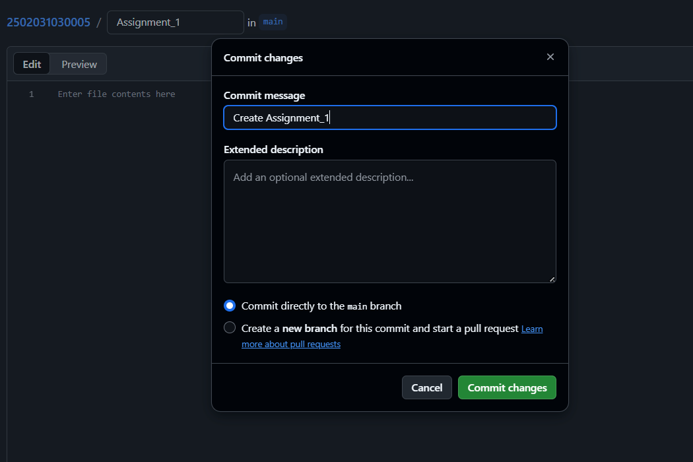

Step 4: Create Assignment_2 Folder After that, I created another folder for Assignment 2.
Procedure:
- Clicked on Add File again.
- Selected Create New File.
- Named the folder Assignment_2.
- Added a README file inside it.
- Clicked Commit Changes.
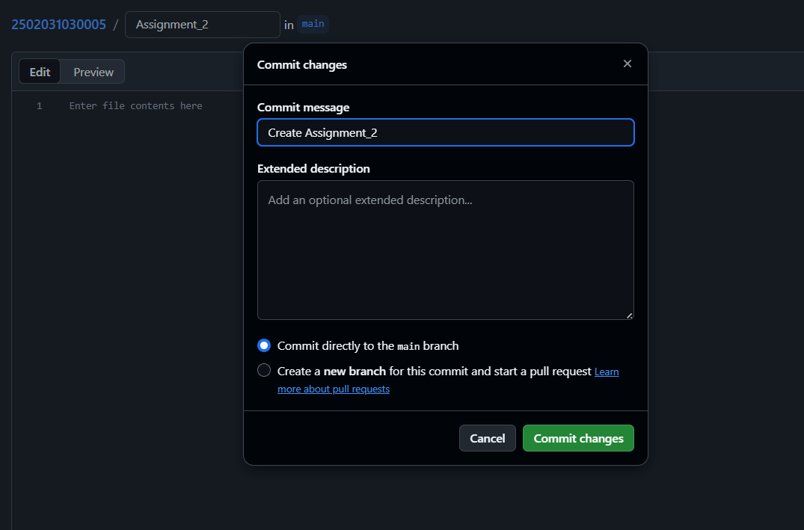

Step 5: Upload Assignment Files
Then I uploaded assignment files into the folders.
Procedure:
- Opened Assignment_1 folder.
- Clicked Add File → Upload Files.
- Uploaded the required assignment iles.
- Clicked Commit Changes.
Screenshot:
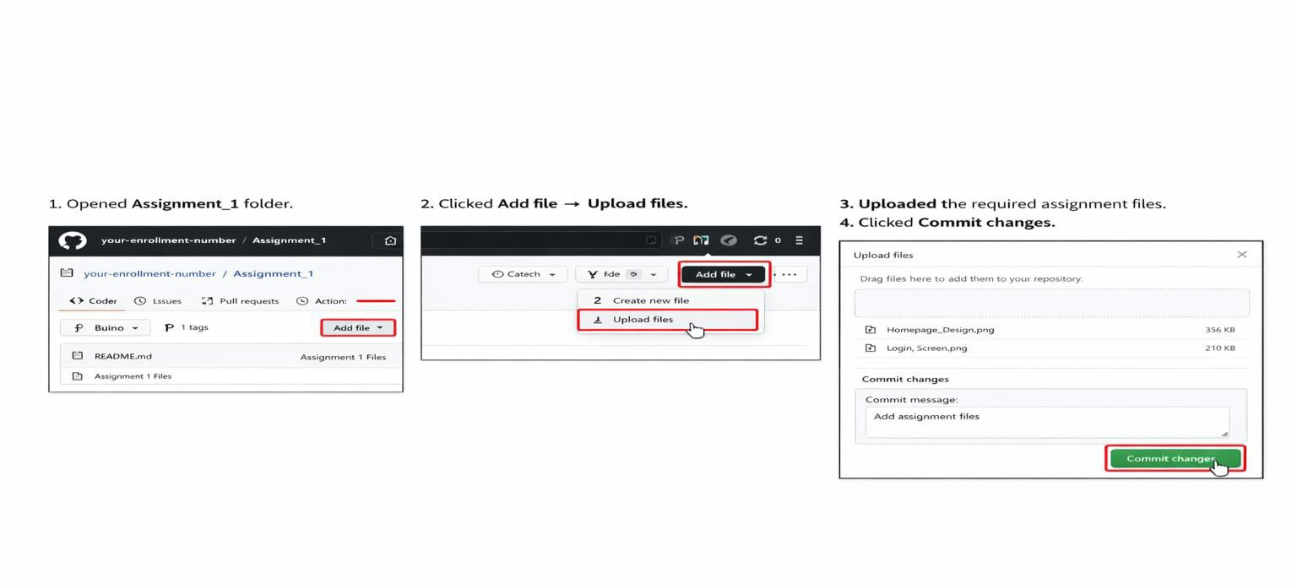

Step 6: Copy Repository Link
Finally, I copied the repository link for submission.
Procedure:
- Opened the main page of the repository.
- Copied the repository URL from the browser.
- Submitted the link in the Google Form.
Screenshot:
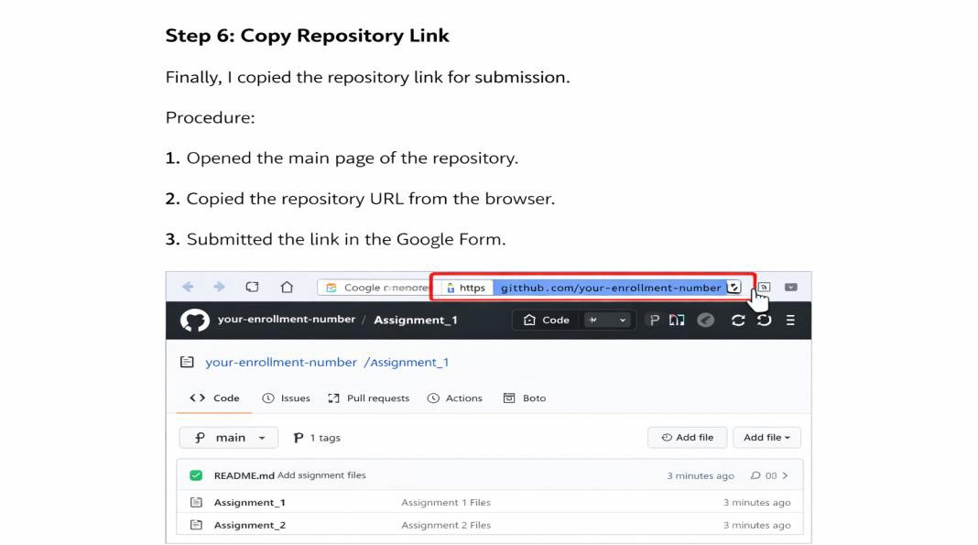

Conclusion:
Thus, the GitHub repository was successfully created using my enrollment number as the repository name. Two folders named Assignment_1 and Assignment_2 were created to organize the assignment files properly. The required files were uploaded to the respective folders and the changes were committed successfully. This task helped me understand how to create a repository, manage folders, upload files, and share the repository link for submission.

