Factors Influencing Student Academic Performance: A Statistical and Predictive Analysis Using Regression Modeling

- Introduction
Academic performance is a multifaceted phenomenon influenced by a wide range of academic, social, economic, and environmental factors. Understanding the determinants of student achievement is of considerable importance to educators, policymakers, and researchers, as it can support the development of effective educational interventions and learning strategies.
Recent advancements in data analytics have enabled researchers to examine educational datasets more comprehensively and identify patterns that may not be evident through traditional methods of analysis. Statistical techniques and predictive modeling approaches provide valuable tools for investigating the relationships between student characteristics and academic outcomes.
The present study aims to analyze a student performance dataset to identify the factors associated with examination scores. Through exploratory data analysis, hypothesis testing, correlation analysis, and regression modeling, this study seeks to evaluate the relative influence of various academic and non-academic factors on student achievement and assess the predictive capability of selected variables.

- Objectives of the study

Primary Objective
To investigate the factors influencing student academic performance and to develop predictive models capable of estimating examination scores based on academic, demographic, and environmental variables.

Specific Objectives
- To examine the structure and characteristics of the student performance dataset.
- To perform exploratory data analysis in order to identify trends, patterns, and distributions within the data.
- To assess the relationships between selected independent variables and examination scores using correlation analysis.
- To evaluate the statistical significance of categorical factors through hypothesis testing techniques.
- To develop and compare simple and multiple linear regression models for predicting examination performance.
- To evaluate model performance using appropriate statistical metrics.
- To derive conclusions and recommendations based on the analytical findings.

- Dataset Description

Dataset Overview
The dataset utilized in this study consists of 6,607 observations and 20 variables representing various aspects of student behavior, educational background, and learning environment.
The dataset includes variables related to:
- Academic engagement (Hours Studied, Attendance, Previous Scores)
- Educational support (Tutoring Sessions, Access to Resources)
- Family and social environment (Parental Involvement, Family Income, Peer Influence)
- Institutional characteristics (Teacher Quality, School Type)
- Personal factors (Physical Activity, Motivation Level)
- Demographic characteristics (Gender, Distance from Home, Internet Access)
The diversity of variables enables a comprehensive examination of both academic and contextual factors that may influence student achievement.

Target Variable
The dependent variable considered in this study is: Exam Score.
Exam Score represents student academic performance and serves as the primary outcome variable throughout the analysis.

Data Characteristics
The dataset contains a combination of:
- Numerical variables
- Ordinal categorical variables
- Nominal categorical variables
This combination necessitated the use of multiple analytical approaches, including descriptive statistics, correlation analysis, analysis of variance (ANOVA), and regression modeling.

Methodology

Research Design
This study adopted a quantitative data analysis approach to investigate the factors influencing student academic performance. Statistical analysis and predictive modeling techniques were employed to identify relationships between explanatory variables and examination scores. The study combined descriptive, inferential, and predictive analytical methods to achieve a comprehensive understanding of the dataset.

Data Collection and Dataset Description
The analysis was conducted using a student performance dataset comprising 6,607 observations and 20 variables. The dataset included information related to academic behavior, educational support, family background, institutional characteristics, and student performance.
The dependent variable selected for the study was Exam Score, while the remaining variables were treated as potential explanatory variables.

Data Preprocessing
Prior to analysis, the dataset was examined for missing values and inconsistencies. Three variables contained missing observations:
- Teacher Quality
- Parental Education Level
- Distance from Home
A total of 229 observations contained missing values. Since each affected row contained only a single missing value and the missing observations represented a relatively small proportion of the dataset, these values were imputed using the mode of their respective variables.

The following mode values were used:
Variable | Imputed variable
Teacher quality | Medium
Parental education level | High School
Distance from home | Near
Following imputation, the dataset contained no missing values and was considered suitable for analysis.

Exploratory Data Analysis (EDA)
Exploratory Data Analysis was conducted to understand the structure and characteristics of the dataset. The following techniques were employed:
- Descriptive statistics
- Frequency distribution analysis
- Histograms
- Box plots
- Scatter plots
- Correlation Heat maps
EDA facilitated the identification of variable distributions, central tendencies, potential outliers, and preliminary relationships between variables and examination scores.

Correlation Analysis
Pearson's correlation coefficient was used to assess the strength and direction of linear relationships between numerical variables and Exam Score. The analysis focused on variables including:
- Hours Studied
- Attendance
- Previous Scores
- Tutoring Sessions
- Physical Activity
Correlation coefficients were interpreted to identify variables exhibiting strong, moderate, or weak associations with academic performance.

Hypothesis Testing
Inferential statistical techniques were employed to evaluate whether selected categorical variables significantly influenced examination performance.
One-way ANOVA tests were performed for:
- Access to Resources
- Parental Involvement
- Motivation Level
The null hypothesis for each test stated that there were no significant differences in mean examination scores among the respective groups.
A significance level of: α=0.05, was adopted throughout the study. Variables with p-values less than 0.05 were considered statistically significant.
The significance of the relationship between Hours Studied and Exam Score was evaluated using Pearson's correlation significance test.

Regression Modeling
To investigate predictive relationships between variables and examination performance, both simple and multiple linear regression models were developed.
Simple linear regression
Separate models were constructed using:
- Hours studied
- Attendence
As individual predictors of exam score.
Multiple linear regression
Two multiple regression models were developed:
Model 1:
- Hours studied
- Attendence
- Previous scores
Model 2:
- Hours studied
- Attendence
- Previous scores
- Tutoring sessions
- Physical activity

4.8 Model Evaluation
Regression models were evaluated using the following metrics:

Coefficient of Determination (R²)
R² was used to quantify the proportion of variance in examination scores explained by the predictors included in the model.

Mean Absolute Error (MAE)
MAE measured the average magnitude of prediction errors.

Root Mean Squared Error (RMSE)
RMSE was used to evaluate prediction accuracy while assigning greater weight to larger prediction errors.

Residual Analysis
Residuals were examined to assess model behavior and identify observations that deviated substantially from model predictions.

- Result and Discussion
  - Descriptive analysis
    - Distribution of examination Scores
Statistic | Value
Count | 6607
Mean | 67.24
Standard deviation | 3.89
Minimum | 55
25th percentile | 65
Median | 67
75th percentile | 69
Maximum | 101

Table 5.1

Discussion
Descriptive statistical analysis was conducted to examine the distribution of examination scores among students included in the dataset. As shown in Table 5.1, the dataset contains 6,607 observations, with a mean examination score of 67.24 marks and a median score of 67 marks.
The close proximity between the mean and median suggests that the distribution of examination scores is approximately centered around 67 marks, indicating the absence of substantial skewness in the central portion of the distribution. The standard deviation of 3.89 marks indicates a moderate level of variability in student performance.
The interquartile range extends from 65 marks (25th percentile) to 69 marks (75th percentile), implying that 50% of students achieved scores within this relatively narrow range. This suggests that the majority of students demonstrated similar levels of academic performance.
However, the maximum score of 101 marks is considerably higher than the upper quartile, indicating the presence of a small number of exceptionally high-performing students. This observation is consistent with the findings from the regression and residual analyses, which identified several students whose performance substantially exceeded model predictions.
Overall, the examination scores appear to be concentrated around the mean, with limited dispersion among most students and a small number of notable high-achieving observations.

    - Distribution of Hours studied
Statistic | Value
Count | 6607
Mean | 19.98
Standard deviation | 5.99
Minimum | 1
25th percentile | 16
Median | 20
75th percentile | 24
Maximum | 44
Table 5.2

Discussion
The variable Hours Studied represents the amount of time students devoted to academic study. As shown in Table 5.2, the average number of study hours was approximately 19.98 hours, with a median value of 20 hours.
The similarity between the mean and median suggests a relatively balanced distribution of study hours among students. The standard deviation of 5.99 hours indicates moderate variability, implying that students differed in their study habits while remaining concentrated around the average.
The interquartile range extends from 16 hours to 24 hours, indicating that 50% of students studied within an 8-hour range. This finding suggests that most students devoted a comparable amount of time to studying.
The minimum and maximum values of 1 hour and 44 hours, respectively, demonstrate the presence of substantial variation at the extremes of the distribution. While some students reported very limited study time, others dedicated considerably more time to academic activities.
Subsequent correlation and regression analyses revealed that hours studied exhibited a moderate positive relationship with examination scores (r = 0.445), indicating that students who spent more time studying generally achieved higher academic performance. However, the strength of this relationship was lower than that observed for attendance, suggesting that study time alone may not fully explain differences in examination outcomes.

Statistic | Value
Count | 6607
Mean | 79.98
Standard deviation | 11.55
Minimum | 60
25th percentile | 70
Median | 80
75th percentile | 90
Maximum | 100
    - Distribution of attendence

Table 5.3

Discussion
Attendance reflects the extent to which students regularly participated in classroom activities and academic instruction. As presented in Table 5.3, the average attendance rate was 79.98%, with a median value of 80%, indicating that students generally maintained a relatively high level of classroom participation.
The attendance distribution exhibited moderate variability, as reflected by a standard deviation of 11.55 percentage points. The interquartile range extended from 70% to 90%, suggesting that half of the students maintained attendance levels within this interval.
The minimum attendance value of 60% and maximum value of 100% indicates substantial differences in student participation patterns. While some students attended only the minimum required proportion of classes represented in the dataset, others maintained perfect attendance records.
Attendance demonstrated the strongest positive association with examination performance among all numerical variables examined in this study (r = 0.581, p < 0.001). Furthermore, simple linear regression analysis using attendance as the sole predictor produced an R² value of 0.338, indicating that attendance alone explained approximately 33.8% of the variation in examination scores.
These findings suggest that regular classroom attendance may be a critical component of academic success. Compared with other academic indicators, attendance appears to capture not only student presence but also broader characteristics such as engagement, consistency, and participation in the learning process.

  - Exploratory Data Analysis
Exploratory Data Analysis (EDA) was performed to visually examine the distributions of key numerical variables and identify patterns, trends, and potential anomalies within the dataset. Histograms were employed to assess the shape, spread, and central tendency of the variables prior to conducting correlation and regression analyses
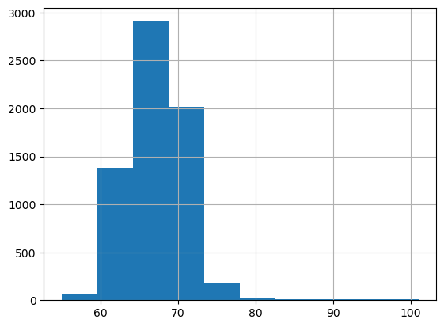
    - Distribution of examination scores
Figure 5.1 Distribution of Examination Scores

Discussion
Figure 5.1 illustrates the distribution of examination scores among the 6,607 students included in the study. The distribution is concentrated around the mean score of 67.24 marks, with the majority of students obtaining scores between 65 and 70 marks. This indicates that academic performance within the dataset is relatively consistent across students.
The histogram does not exhibit substantial skewness, suggesting that examination scores are reasonably balanced around the central tendency. Furthermore, the relatively narrow spread of the distribution indicates limited variability in student performance, although a small number of exceptionally high scores are present, as reflected by the maximum score of 101 marks.
Overall, the distribution suggests that most students achieved moderate examination scores, with only a few observations representing unusually high academic performance.

    - Distribution of Hours Studied
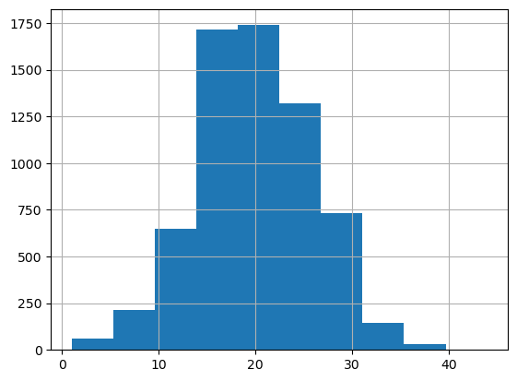
Figure 5.2 distribution of hours studied

Discussion
Figure 5.2 illustrates the distribution of the number of hours studied by students in the dataset. The distribution is approximately symmetric and unimodal, with a clear peak around 20 hours, which is consistent with the mean (19.98 hours) and median (20 hours) obtained from the descriptive statistics.
The majority of students reported studying between 16 and 24 hours, indicating that study habits were fairly consistent across the sample. The frequencies gradually decline on both sides of the peak, suggesting that comparatively few students studied either very few hours or exceptionally long hours.
No evidence of substantial skewness or unusual clustering is observed, implying that the variable is reasonably well distributed. Although a small number of students reported study durations as low as 1 hour and as high as 44 hours, these observations occur infrequently and do not substantially affect the overall distribution.
The approximately symmetric distribution of study hours supports its suitability for subsequent statistical analyses, including correlation and linear regression, where Hours Studied serves as one of the principal predictor variables.

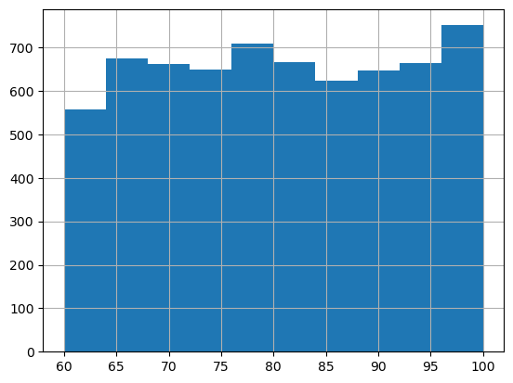
Distribution of Attendance
Figure 5.3 Distribution of Student Attendance

Discussion
Figure 5.3 presents the distribution of student attendance rates within the dataset. Attendance values range from 60% to 100%, with a mean attendance of 79.98% and a median of 80%.
Unlike the distribution of examination scores and hours studied, the attendance variable exhibits a relatively uniform distribution across its range. The frequencies remain fairly consistent between 60% and 100%, indicating that students are well represented across different attendance levels, with no single attendance interval dominating the dataset.
Although there is a slight increase in the frequency of students with attendance rates close to 100%, the overall distribution does not display substantial skewness or pronounced clustering. This balanced distribution provides adequate representation of students with both lower and higher attendance levels, making the variable suitable for comparative and predictive analyses.
The broad spread of attendance values is particularly valuable for subsequent statistical analyses. As demonstrated later through correlation and regression modeling, attendance emerged as one of the strongest predictors of examination performance, suggesting that variation in classroom attendance is closely associated with differences in students' academic achievement.

  - Correlation Analysis
This subsection will examine the relationships between key numerical variables and examination scores. Scatter plots were used to visualize the direction and strength of the relationships, while Pearson's correlation coefficients were calculated to quantify the degree of linear association between variables.
The variables analyzed include:
- Hours Studied
- Attendance
- Previous Scores
- Tutoring Sessions
- Physical Activity
A correlation heat map was also generated to provide a comprehensive overview of the relationships among all numerical variables.
    - Relationship Between Hours Studied and Examination Scores

Figure 5.4 illustrates the relationship between the number of hours studied and students' examination scores. An overall positive trend is evident, indicating that students who devoted more time to studying generally achieved higher examination scores. However, the relationship is not perfectly linear, as considerable variation in examination scores exists among students reporting similar study durations.
Pearson's correlation analysis yielded a correlation coefficient of r = 0.445, indicating a moderate positive linear relationship between hours studied and examination performance. This suggests that increased study time is associated with improved academic outcomes, although additional factors also contribute substantially to student performance.
The scatter plot also reveals the presence of several exceptionally high-scoring students who achieved examination scores above 90 across a range of study hours. These observations suggest that outstanding academic performance may be influenced by factors beyond study duration alone, including attendance, motivation, prior academic achievement, or other unobserved characteristics. Overall, the findings indicate that hours studied is an important predictor of examination performance; however, it does not independently explain the variability observed in student scores.

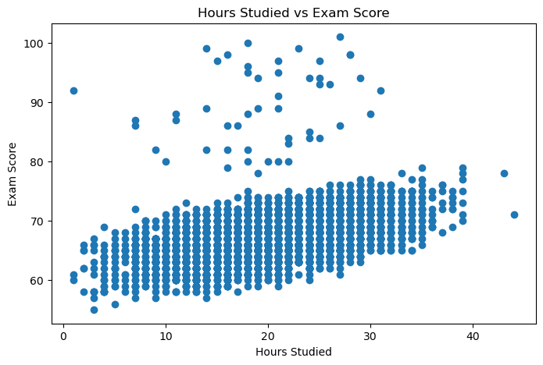
Figure 5.4: Scatter Plot of Hours Studied vs. Examination Score

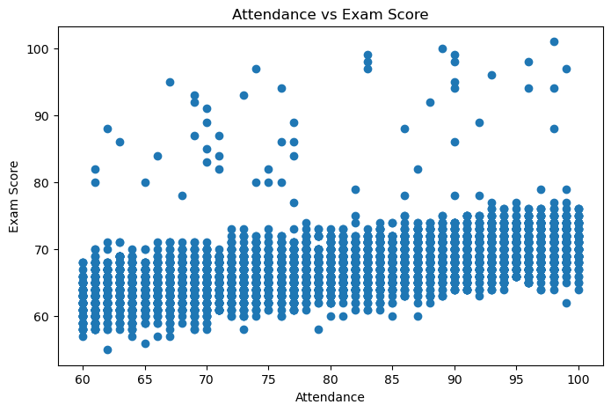
    - Relationship Between Attendance and Examination Scores
Figure 5.5: Scatter Plot of Attendance vs. Examination Scores

Discussion
Figure 5.5 illustrates the relationship between student attendance and examination scores. A clear positive trend is observed, indicating that students with higher attendance generally achieved better examination scores. Although some variability exists within each attendance level, the overall upward pattern suggests a meaningful positive association between regular class attendance and academic performance.
Pearson's correlation analysis produced a correlation coefficient of r = 0.581, indicating a moderately strong positive linear relationship between attendance and examination scores. Among all numerical variables examined in this study, attendance exhibited the strongest correlation with academic performance.
The scatter plot also shows that students with attendance rates above 90% were more likely to achieve higher examination scores, including many of the highest-performing students in the dataset. Nevertheless, some students with excellent attendance attained only average examination scores, while a few students with comparatively lower attendance achieved exceptionally high scores. These observations indicate that attendance, although an important determinant of academic performance, is not the sole factor influencing examination outcomes.
Interestingly, attendance demonstrated a stronger association with examination scores than hours studied. This finding suggests that consistent classroom participation may contribute more substantially to academic success than study duration alone. Regular attendance likely provides students with greater exposure to classroom instruction, teacher guidance, peer interaction, and continuous learning opportunities, all of which may enhance examination performance.
Overall, the findings highlight attendance as one of the most influential predictors of student academic achievement within the dataset.

    - Relationship Between Previous Scores and Examination Scores

Discussion
Figure 5.6 illustrates the relationship between students' previous academic scores and their current examination scores. A positive trend is observable; however, the data points are more widely dispersed than those observed for attendance and hours studied, indicating a weaker linear association.
Pearson's correlation analysis yielded a correlation coefficient of r = 0.181, suggesting a weak positive relationship between previous academic performance and current examination scores. Although students with higher previous scores tended to perform slightly better in the examination, the relationship was relatively modest.
The scatter plot further demonstrates that students with similar previous scores often achieved substantially different examination results. Likewise, several students with average previous scores obtained exceptionally high examination marks, while others with comparatively high previous scores performed only moderately well. These observations suggest that prior academic achievement alone is not a reliable predictor of current examination performance.
Compared with attendance (r = 0.581) and hours studied (r = 0.445), previous scores exhibited a considerably weaker association with examination performance. This finding implies that current academic behaviors and engagement may have a greater influence on examination outcomes than students' historical academic performance. Overall, while previous scores contribute positively to predicting examination performance, their individual explanatory power appears to be limited when considered in isolation.

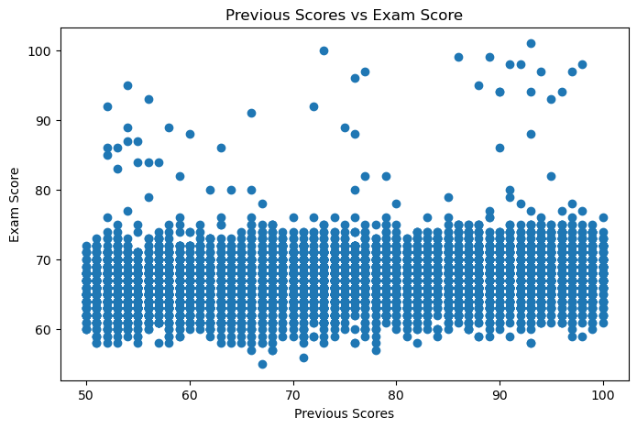
Figure 5.6: Scatter Plot of previous scores vs. Examination Scores

    - Correlation Matrix of Numerical Variables

Discussion
Figure 5.7 presents the Pearson correlation matrix for the numerical variables included in the study. The heat map provides a comprehensive overview of the direction and strength of the linear relationships between the predictor variables and examination scores, as well as the relationships among the predictors themselves.
Among all the variables analyzed, Attendance exhibited the strongest positive correlation with Exam Score (r = 0.581), indicating that students with higher attendance generally achieved better academic performance. Hours Studied demonstrated the second strongest relationship (r = 0.445), suggesting that increased study time was also associated with improved examination outcomes, although its influence was comparatively weaker than attendance.
The remaining variables displayed relatively weak positive correlations with examination scores. Previous Scores (r = 0.181) and Tutoring Sessions (r = 0.157) showed modest associations, implying that while these factors contribute to academic performance, their individual effects are limited. Physical Activity exhibited an almost negligible correlation (r = 0.028), indicating little evidence of a linear relationship with examination scores within the dataset.
An additional observation from the heat map is the absence of strong correlations among the predictor variables themselves. Correlation coefficients between independent variables remain close to zero, suggesting that the predictors measure distinct aspects of student behavior and academic background rather than overlapping information. This indicates a low likelihood of multicollinearity, which is advantageous for multiple linear regression analysis, as highly correlated predictors can lead to unstable coefficient estimates.
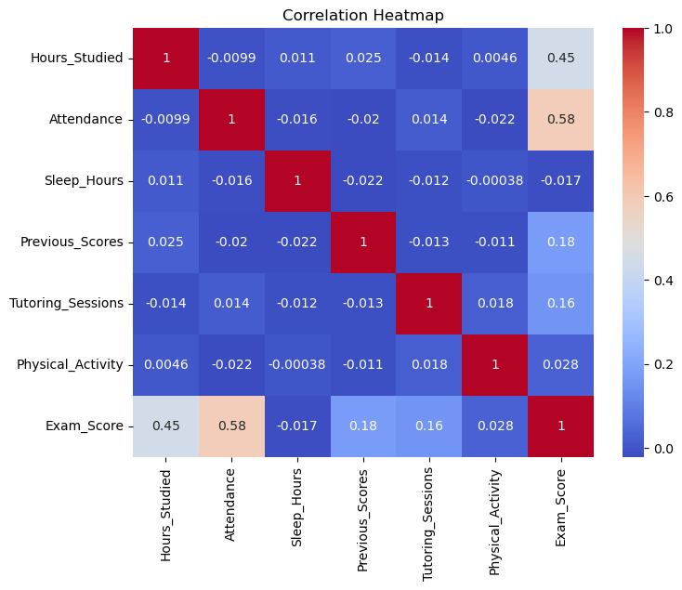
Overall, the correlation analysis suggests that student engagement-related variables, particularly attendance and study hours, exhibit stronger associations with examination performance than historical academic achievement or lifestyle-related variables. These findings provide preliminary evidence supporting the inclusion of multiple academic and behavioral factors in predictive models of student performance.
  - Analysis of Categorical Variables
This section explores the relationship between categorical variables and examination scores through graphical analysis and descriptive comparisons. Boxplots and grouped summary statistics were used to examine variations in student performance across different categories. The objective of this exploratory analysis is to identify observable trends that may indicate potential associations between categorical factors and academic achievement before conducting formal statistical hypothesis testing.
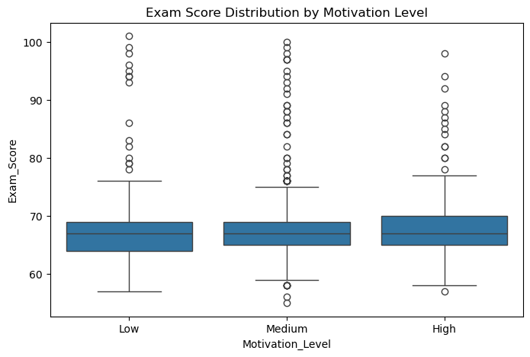
    - Motivation Level

Figure 5.8: Boxplot of Examination Scores by Motivation Level

Discussion
Figure 5.8 illustrates the distribution of examination scores across different levels of student motivation. A gradual increase in examination performance is observed as motivation level increases. Students classified as having high motivation generally achieved higher median examination scores than those with medium or low motivation.
Although some overlap exists among the distributions, the overall upward trend suggests that motivation is positively associated with academic performance. Furthermore, the variability within each category indicates that while motivation contributes to examination outcomes, additional academic and environmental factors also influence student achievement.
The observed pattern suggests that students with greater motivation tend to perform better academically, making motivation a potentially important factor influencing examination performance. This observation is examined further in the inferential analysis using one-way ANOVA.

Parental Involvement

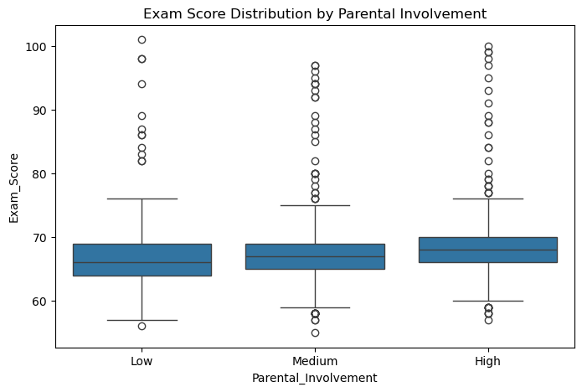
Figure 5.9: Boxplot of Examination Scores by Parental Involvement

Discussion
Figure 5.9 presents the distribution of examination scores across different levels of parental involvement. The boxplot indicates a positive trend in academic performance with increasing parental involvement. Students reporting high parental involvement generally achieved higher median examination scores than those with medium and low parental involvement.
Although the distributions overlap across the three categories, the overall pattern suggests that greater parental involvement is associated with improved academic performance. This may be attributed to factors such as increased academic guidance, encouragement, and monitoring of students' educational progress.
The variability observed within each category indicates that parental involvement alone does not fully determine examination performance. Instead, it likely interacts with other academic and personal factors to influence student achievement.
Overall, the visual analysis suggests a positive association between parental involvement and examination scores. This relationship is examined further through one-way ANOVA in the inferential analysis section.

Access to Resources
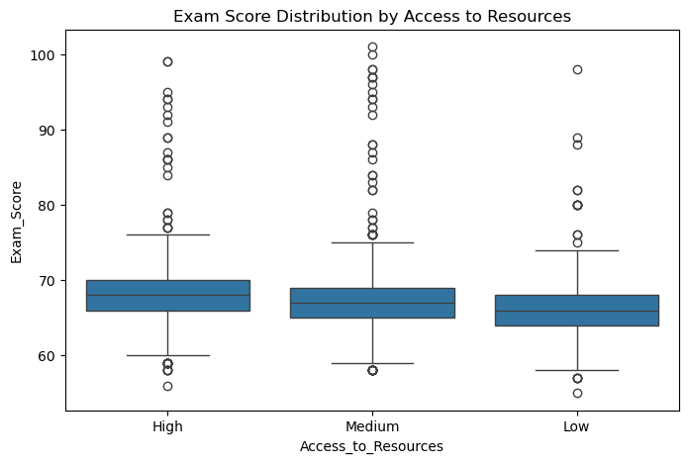
Figure 5.10: Boxplot of Examination Scores by Access to Resources

Discussion
Figure 5.10 illustrates the distribution of examination scores across different levels of access to educational resources. Students with high access to resources generally demonstrated higher examination scores than those with medium or low access, indicating a positive association between resource availability and academic performance.
The boxplot reveals a gradual increase in median examination scores across the three categories. While some overlap exists among the score distributions, the overall trend suggests that access to educational materials and learning resources may contribute positively to student achievement.
The variation in examination scores within each category also indicates that access to resources is not the sole determinant of academic success. Other factors, including study habits, attendance, motivation, and prior academic performance, likely contribute to the observed differences.
The visual findings suggest that improved access to educational resources is associated with better academic outcomes. Statistical confirmation of this relationship is provided later through the ANOVA results presented in the inferential analysis.
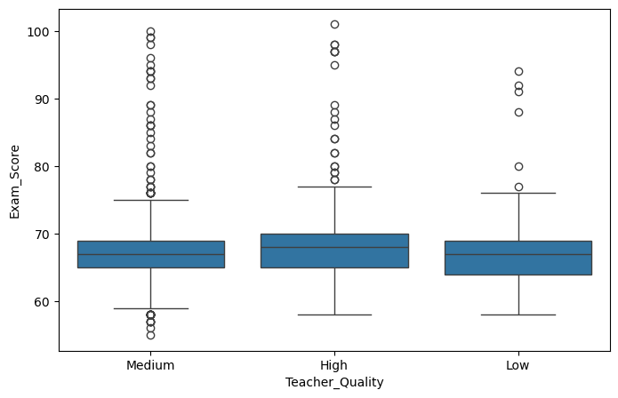
    - Teacher Quality
Figure 5.11: Boxplot of Examination Scores by Teacher Quality

Discussion
Figure 5.11 presents the distribution of examination scores across different levels of perceived teacher quality. Students reporting high teacher quality exhibited the highest median examination scores, while those reporting medium and low teacher quality achieved slightly lower median scores. However, the differences among the three categories are relatively modest, and the distributions overlap considerably.
The interquartile ranges are similar across all categories, indicating comparable variability in examination performance irrespective of teacher quality. Additionally, each category contains several high-scoring outliers, suggesting that exceptional academic performance is observed across all levels of perceived teaching quality.
Overall, the graphical analysis indicates a slight positive association between teacher quality and examination performance. Although students perceiving higher teaching quality tend to perform marginally better, the overlap among the distributions suggests that teacher quality alone is insufficient to explain variations in academic achievement. This relationship is examined further through inferential statistical analysis.
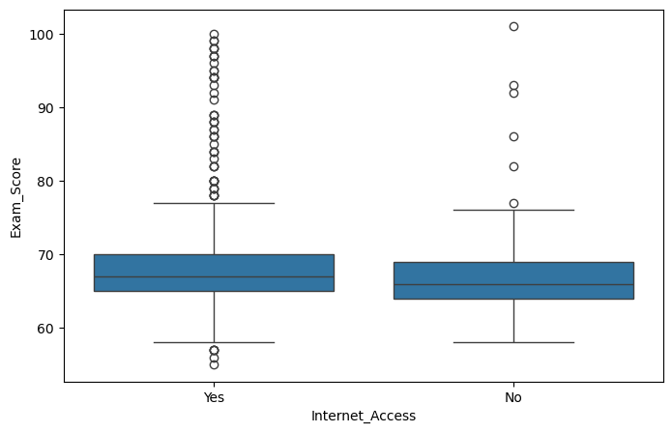
    - Internet Access

Figure 5.12: Boxplot of Examination Scores by Internet Access

Discussion
Figure 5.12 illustrates the distribution of examination scores for students with and without internet access. Students with internet access demonstrate a slightly higher median examination score than those without internet access. Nevertheless, the two distributions overlap substantially, indicating that the difference in academic performance is relatively small.
The variability of examination scores is comparable between the two groups, with both exhibiting similar interquartile ranges. A greater number of high-scoring outliers is observed among students with internet access, although exceptional examination scores are present in both categories.
The graphical findings suggest that internet access may provide students with additional educational opportunities, including access to online learning materials and academic resources. However, the modest difference between the two groups indicates that internet availability alone is unlikely to be a major determinant of examination performance. Statistical testing is presented in the subsequent inferential analysis to evaluate the significance of the observed difference.

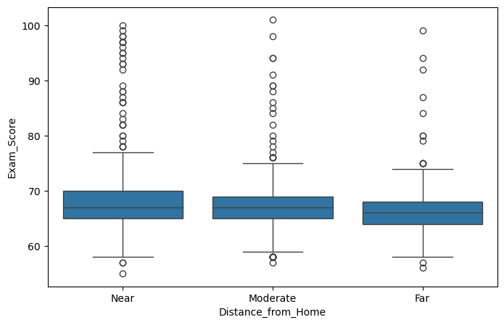
    - Distance from Home
Figure 5.13: Boxplot of Examination Scores by Distance from Home

Discussion
Figure 5.13 presents the distribution of examination scores according to students' distance from home. Students residing near their educational institution achieved the highest median examination scores, followed closely by those living at a moderate distance, while students residing far from the institution exhibited the lowest median scores.
Despite this pattern, the differences among the three categories are relatively small, and considerable overlap exists between the distributions. The interquartile ranges are similar, suggesting that the variability in examination performance remains consistent regardless of residential distance.
The visual analysis indicates a modest decline in examination performance with increasing distance from home. One possible explanation is that longer travel distances may reduce study time or contribute to fatigue; however, such interpretations should be made cautiously, as numerous academic and personal factors may also influence student achievement.
Overall, distance from home appears to have only a limited association with examination performance. The statistical significance of the observed differences is evaluated in the inferential analysis section.
    - Summary of Remaining Categorical Variables
In addition to the categorical variables discussed above, exploratory analysis was also conducted for gender, school type, peer influence, learning disabilities, and parental education level using boxplots and grouped descriptive statistics. Visual examination of these variables revealed only minor differences in examination scores across their respective categories, with substantial overlap in the distributions.
Compared with variables such as motivation level, parental involvement, access to resources, teacher quality, and distance from home, the remaining categorical variables did not exhibit sufficiently distinct patterns to warrant detailed discussion. Consequently, these variables were not explored further through inferential statistical testing and are not emphasized in the subsequent analysis.
Overall, the exploratory analysis indicates that the most pronounced variations in examination performance were associated with academic engagement and learning environment factors, whereas the remaining categorical variables demonstrated comparatively limited variation in student outcomes.

  - Inferential Analysis
Inferential statistical analysis was conducted to determine whether the patterns observed during the exploratory data analysis were statistically significant. One-way Analysis of Variance (ANOVA) was employed to compare the mean examination scores across different categorical groups, while Pearson's correlation analysis was used to evaluate the strength and significance of the linear relationship between selected numerical variables and examination scores. These statistical techniques provide evidence for accepting or rejecting the proposed null hypotheses and support the findings obtained through exploratory analysis.
    - ANOVA (Analysis of Variance)
One-way Analysis of Variance (ANOVA) was performed to determine whether statistically significant differences existed between the mean examination scores of students belonging to different categorical groups. The test compares the variation between group means with the variation within groups. A significance level of α = 0.05 was adopted for all hypothesis tests. If the p-value was less than 0.05, the null hypothesis was rejected, indicating that at least one group mean differed significantly from the others.
      - Motivation Level

- Null Hypothesis (H₀):
There is no significant difference in mean examination scores among students with different levels of motivation.
A
- Alternative Hypothesis (H₁):
At least one motivation level has a significantly different mean examination score.

Results
F-statistic | 25.717
P-value | 7.492 ×10⁻¹²

Discussion
One-way ANOVA demonstrated a statistically significant difference in mean examination scores across the different motivation levels (F = 25.717, p < 0.001). Since the p-value is well below the significance level of 0.05, the null hypothesis is rejected.
The findings indicate that motivation level is significantly associated with examination performance. Although the F-statistic is lower than those obtained for access to educational resources and parental involvement, the results provide strong statistical evidence that students with different levels of motivation exhibit differences in their academic performance.
      - Parental Involvement

- Null Hypothesis (H₀):
There is no significant difference in mean examination scores among different levels of parental involvement.

- Alternative Hypothesis (H₁):
At least one parental involvement category has a different mean examination score.

Results
F-statistic | 84.488
P-value | 5.875 ×10⁻³⁷

Discussion
The one-way ANOVA results indicate a statistically significant difference in mean examination scores across different levels of parental involvement (F = 84.488, p < 0.001). As the p-value is considerably smaller than 0.05, the null hypothesis is rejected.
The probability of observing differences of this magnitude by chance alone is extremely small. Therefore, there is strong statistical evidence that parental involvement is associated with differences in students' examination performance. These findings are consistent with the exploratory analysis, which showed higher examination scores among students reporting greater parental involvement.
      - Access to Resources

- Null Hypothesis (H₀):
There is no significant difference in examination scores among students with different levels of access to educational resources.

- Alternative Hypothesis (H₁):
At least one category differs significantly.

Results
F-statistic | 98.004
P-value | 1.139 × 10⁻⁴²

Discussion
One-way ANOVA revealed a statistically significant difference in mean examination scores among students with different levels of access to educational resources (F = 98.004, p < 0.001). Since the p-value is substantially lower than the significance level of 0.05, the null hypothesis is rejected.
These findings indicate that access to educational resources is significantly associated with examination performance. The results support the pattern observed during the exploratory analysis, where students with greater access to educational resources generally achieved higher examination scores. The large F-statistic further suggests that differences among the group means are considerable relative to the variation within groups.
    - Pearson Correlation Analysis
Pearson's correlation analysis was performed to examine the strength and direction of the linear relationship between hours studied and examination scores. The Pearson correlation coefficient (r) ranges from -1 to +1, where positive values indicate a positive linear relationship, negative values indicate a negative linear relationship, and values close to zero indicate little or no linear association. A significance level of α = 0.05 was used to evaluate the statistical significance of the correlation.
- Null Hypothesis (H₀):
There is no statistically significant linear relationship between hours studied and examination scores.
- Alternative Hypothesis (H₁):
There is a statistically significant linear relationship between hours studied and examination scores.
Results
Correlation coefficient (r) | 0.445
P-value | 1.286 ×10⁻³¹⁹

Discussion
Pearson's correlation analysis revealed a moderate positive correlation between hours studied and examination scores (r = 0.445, p < 0.001). The positive correlation coefficient indicates that students who devoted more time to studying generally achieved higher examination scores.
The p-value is substantially smaller than the predetermined significance level of 0.05, leading to the rejection of the null hypothesis. Therefore, there is sufficient statistical evidence to conclude that a significant positive linear relationship exists between hours studied and examination performance.
Although the relationship is statistically significant, the correlation coefficient indicates a moderate rather than strong association. This suggests that while study duration contributes positively to academic achievement, it does not fully explain variations in examination scores. Other academic, behavioural, and environmental factors are also likely to influence students' performance.
The findings are consistent with the exploratory data analysis, where the scatter plot demonstrated an upward trend between hours studied and examination scores. Furthermore, the results support the subsequent regression analysis, in which hours studied was identified as a significant predictor of examination performance.

Conclusion
Based on the Pearson correlation analysis, the null hypothesis is rejected. The results demonstrate a statistically significant moderate positive relationship between hours studied and examination scores, indicating that increased study time is generally associated with improved academic performance.

  - Regression Analysis
Regression analysis was conducted to examine the predictive relationship between selected independent variables and students' examination scores. Both simple linear regression and multiple linear regression models were developed to evaluate the individual and combined effects of academic and behavioural factors on examination performance. The predictive capability of each model was assessed using the coefficient of determination (R²), regression coefficients, and model evaluation metrics.
    - Simple Linear Regression: Hours Studied
A simple linear regression model was developed to examine the relationship between hours studied (independent variable) and examination score (dependent variable). The model estimates the expected change in examination score for every one-unit increase in study hours.
Intercept | 61.47
Slope | 0.289
R² | 0.198

Exam Score=61.457+0.289(Hours Studied)

The simple linear regression model indicates a positive relationship between hours studied and examination scores. The estimated slope coefficient (β = 0.289) suggests that, on average, each additional hour of study is associated with an increase of approximately 0.289 marks in the predicted examination score.
The intercept (61.457) represents the predicted examination score when the number of study hours is zero. While this value provides the mathematical starting point of the regression equation, it has limited practical interpretation because the observed study hours in the dataset begin above zero.
The model achieved an R² value of 0.198, indicating that approximately 19.8% of the variation in examination scores can be explained by hours studied alone. Although this demonstrates that study time is a significant predictor of academic performance, a substantial proportion of the variation remains unexplained, suggesting that additional factors contribute to examination outcomes.
These findings are consistent with the Pearson correlation analysis, which identified a statistically significant moderate positive relationship between hours studied and examination scores. The relatively modest R² value further supports the conclusion that study duration, while important, is not sufficient on its own to accurately predict students' academic performance.
    - Simple Linear Regression: Attendance
A simple linear regression model was developed to examine the relationship between attendance (independent variable) and examination score (dependent variable). The objective was to evaluate the extent to which students' attendance could predict their academic performance.
Intercept | 51.579
Slope | 0.196
R² | 0.338

Exam Score=51.579+0.196(Attendance)
The simple linear regression model demonstrates a positive relationship between attendance and examination scores. The estimated slope coefficient (β = 0.196) indicates that, on average, a one-unit increase in attendance is associated with an increase of approximately 0.196 marks in the predicted examination score.
The intercept (51.579) represents the predicted examination score when attendance is zero. Similar to the previous model, this value primarily serves as a mathematical component of the regression equation and has limited practical interpretation because the observed attendance values in the dataset do not approach zero.
The model produced an R² value of 0.338, indicating that approximately 33.8% of the variation in examination scores is explained by attendance alone. Compared with the model based solely on hours studied (R² = 0.198), attendance accounts for a substantially larger proportion of the variability in examination performance.
These findings are consistent with the correlation analysis, where attendance exhibited the strongest positive correlation with examination scores among the numerical variables examined. The higher coefficient of determination suggests that attendance is a stronger individual predictor of academic performance than study duration within the present dataset.
    - Multiple Linear Regression (Hours Studied, Attendance and Previous Scores)
A multiple linear regression model was developed using hours studied, attendance, and previous scores as independent variables to predict students' examination scores. Unlike simple linear regression, multiple regression estimates the effect of each predictor while controlling for the influence of the other variables included in the model. This approach provides a more comprehensive understanding of the factors contributing to academic performance.
Predictor | Coefficient
Intercept | 41.999
Hours Studied | 0.290
Attendance | 0.198
Previous Scores | 0.048
R² | 0.572

Exam Score=41.999+0.290(Hours Studied)+0.198(Attendance)+0.048(Previous Scores)

The three-variable multiple regression model explains approximately 57.2% of the variation in examination scores (R² = 0.572), representing a substantial improvement over both simple linear regression models.
Among the predictors, hours studied exhibited the largest regression coefficient (β = 0.290), indicating that, after controlling for attendance and previous scores, each additional hour studied is associated with an increase of approximately 0.290 marks in the predicted examination score. Attendance also demonstrated a positive contribution (β = 0.198), suggesting that students with higher attendance generally achieve better academic performance when other variables remain constant.
The coefficient for previous scores (β = 0.048) was comparatively smaller, indicating a relatively limited contribution to the prediction of current examination scores. Nevertheless, its positive coefficient suggests that previous academic achievement remains a meaningful predictor when considered alongside other academic variables.
Compared with the simple regression models, the considerable increase in the coefficient of determination from 0.198 (Hours Studied) and 0.338 (Attendance) to 0.572 demonstrates that combining multiple predictors substantially improves the model's explanatory power. This finding highlights that academic performance is influenced by multiple interacting factors rather than by any single variable in isolation.
    - Multiple Linear Regression (Five-Variable Model)
A second multiple linear regression model was developed by incorporating two additional predictor variables—tutoring sessions and physical activity—along with hours studied, attendance, and previous scores. The objective was to determine whether the inclusion of these variables improved the model's ability to predict students' examination scores.
Predictor | Coefficient
Intercept | 40.795
Hours Studied | 0.292
Attendance | 0.198
Previous Scores | 0.048
Tutoring Sessions | 0.494
Physical Activity | 0.144
R² | 0.598

Exam Score= 40.795+0.292(Hours Studied)+0.198(Attendance)+0.048(Previous Scores)+0.494(Tutoring Sessions)+0.144(Physical Activity)​

The five-variable multiple regression model explained approximately 59.8% of the variation in examination scores (R² = 0.598), representing the highest predictive performance among all the regression models developed in this study.
All predictor variables exhibited positive regression coefficients, indicating that increases in each variable were associated with higher predicted examination scores when the remaining variables were held constant.
Among the predictors, tutoring sessions had the largest regression coefficient (β = 0.494), suggesting the greatest estimated increase in predicted examination score per unit increase among the variables included in the model. However, it is important to note that regression coefficients should not be compared directly to determine the overall importance of predictors, as each variable is measured on a different numerical scale. Instead, the coefficients should be interpreted as the expected change in examination score associated with a one-unit increase in the respective predictor while holding the other variables constant.
Compared with the previous three-variable model (R² = 0.572), the inclusion of tutoring sessions and physical activity increased the coefficient of determination to 0.598. Although this improvement demonstrates that the additional variables contribute to predicting examination performance, the increase in explanatory power is relatively modest (approximately 2.6 percentage points). This suggests that the majority of the predictive information was already captured by hours studied, attendance, and previous scores.
Overall, the five-variable model provided the best predictive performance among the models evaluated in this study, while illustrating the principle that adding more variables does not necessarily produce substantial improvements in model accuracy.
    - Comparison of Regression Models
Model | R² Score
Simple Linear Regression (Hours Studied) | 0.198
Simple Linear Regression (Attendance) | 0.338
Multiple Linear Regression (3 Variables) | 0.572
Multiple Linear Regression (5 Variables) | 0.598

The above table presents a comparison of the predictive performance of the four regression models developed in this study. Model performance was evaluated using the coefficient of determination (R²), which represents the proportion of variance in examination scores explained by the predictor variables.
The simple linear regression model based on hours studied produced an R² value of 0.198, indicating that study duration alone explained approximately 19.8% of the variation in examination scores. When attendance was used as the sole predictor, the model achieved a higher R² value of 0.338, suggesting that attendance was a stronger individual predictor of academic performance than hours studied.
A substantial improvement in predictive performance was observed when hours studied, attendance, and previous scores were combined in a multiple linear regression model. The R² value increased to 0.572, demonstrating that the combined effect of these variables explained 57.2% of the variation in examination scores. This finding highlights the importance of considering multiple academic factors simultaneously rather than relying on a single predictor.
The addition of tutoring sessions and physical activity further increased the R² value to 0.598, making the five-variable model the best-performing model in the study. However, the improvement over the three-variable model was relatively small, with an increase of only 0.026 in the coefficient of determination. This indicates that while the additional variables contributed positively to prediction, their overall contribution was comparatively limited.
Overall, the comparison demonstrates that incorporating multiple relevant predictors substantially improves the explanatory power of regression models. However, the relatively modest improvement observed after adding the final two variables suggests that increasing model complexity does not always result in proportionally better predictive performance.
  - Model Evaluation
Model evaluation was performed to assess the predictive performance of the final multiple linear regression model. The model's accuracy was evaluated using the Mean Absolute Error (MAE) and Root Mean Squared Error (RMSE). Additionally, residual analysis was conducted to examine the distribution of prediction errors and identify observations for which the model produced relatively large prediction deviations.
    - Prediction Performance
Metric | Value
Mean Absolute Error (MAE) | 1.312
Root Mean Squared Error (RMSE) | 2.466

The predictive performance of the final multiple linear regression model was evaluated using the Mean Absolute Error (MAE) and Root Mean Squared Error (RMSE). The model achieved an MAE of 1.312, indicating that the predicted examination scores differed from the actual scores by an average of approximately 1.3 marks.
The RMSE was 2.466, which is slightly larger than the MAE because RMSE assigns greater weight to larger prediction errors through the squaring of residuals. The difference between the two metrics suggests that while most prediction errors are relatively small, a limited number of observations exhibit comparatively larger deviations.
Overall, the low values of both MAE and RMSE indicate that the regression model provides reasonably accurate predictions of students' examination scores within the context of the available data.
    - Predicted versus Actual Examination Scores
Actual | Predicted
67 | 68.08
61 | 63.41
74 | 73.14
71 | 72.66
70 | 69.73
71 | 69.95
67 | 69.93
66 | 66.71
A comparison of the predicted and actual examination scores demonstrates that the regression model successfully captures the general pattern of student performance. For most observations, the predicted scores closely approximate the corresponding actual examination scores, indicating good predictive accuracy.
Although small differences are evident between observed and predicted values, these deviations are generally limited in magnitude and are consistent with the low MAE and RMSE values obtained during model evaluation. The results therefore suggest that the developed regression model provides reliable estimates of examination scores for the majority of students included in the dataset.
    - Residual Analysis
Residual analysis was conducted to examine the distribution of prediction errors produced by the final regression model. The residuals exhibited a mean value that was effectively zero, indicating that the model does not systematically overestimate or underestimate examination scores.
The standard deviation of the residuals (2.466) corresponds closely with the RMSE value, suggesting that prediction errors are generally small for most observations. The majority of residuals are concentrated near zero, indicating that the model provides accurate predictions for a large proportion of the dataset.
However, a small number of observations exhibited relatively large positive residuals, indicating instances where the actual examination scores were substantially higher than those predicted by the model. These observations represent students whose academic performance exceeded the expectations of the regression model based on the included predictor variables.
Overall, the residual analysis indicates that the regression model performs well for the majority of observations while highlighting a limited number of exceptional cases that may be influenced by factors not included in the analysis.

    - Analysis of Large Residuals
Actual score | Predicted score | Residual
100 | 68.951058 | 31.048942
97 | 66.735325 | 30.264675
98 | 67.889298 | 30.110702
99 | 69.102850 | 29.897150
99 | 69.147732 | 29.852268
97 | 67.550551 | 29.449449
95 | 65.636313 | 29.363687
92 | 63.748872 | 28.251128
95 | 67.390445 | 27.609555
87 | 59.881295 | 27.118705
The observations with the largest positive residuals correspond to students whose actual examination scores were considerably higher than those predicted by the regression model. These cases represent instances in which the included predictor variables were insufficient to fully explain the students' academic performance.
Several factors not incorporated into the regression model may account for these discrepancies, including individual learning ability, examination preparation strategies, psychological factors, classroom engagement, or other personal and environmental influences. Consequently, these observations should not be interpreted as model failures but rather as evidence that academic performance is affected by additional variables beyond those included in the present study.
The identification of such observations also highlights an inherent limitation of predictive modelling. While regression models effectively capture general trends within a population, they cannot account for every source of variation influencing individual outcomes.

- Conclusion

  - Summary of Findings
This project investigated the factors influencing students' examination performance through statistical analysis and predictive modelling using Python. The analytical workflow included descriptive statistics, exploratory data analysis, correlation analysis, inferential statistical testing, and regression modelling to identify significant relationships between academic variables and examination scores.
The exploratory analysis revealed positive associations between examination scores and variables such as hours studied, attendance, access to educational resources, parental involvement, and motivation level. These observations were further supported by inferential statistical tests, where ANOVA confirmed significant differences in examination scores across selected categorical variables, and Pearson's correlation analysis identified a statistically significant moderate positive relationship between hours studied and examination scores.
Multiple regression modelling demonstrated that combining several predictor variables substantially improved predictive performance compared with individual regression models. The final five-variable regression model achieved the highest explanatory power (R² = 0.598), indicating that approximately 59.8% of the variation in examination scores could be explained by the selected predictors. Model evaluation using MAE, RMSE, and residual analysis further indicated satisfactory predictive performance for the majority of observations.
  - Key Takeaways
Several important insights emerged from this analysis. Although hours studied demonstrated a statistically significant positive relationship with examination scores, attendance proved to be a stronger individual predictor within the dataset. This finding illustrates that consistent academic engagement may have a greater influence on performance than study duration alone.
The comparison of regression models highlighted the value of incorporating multiple predictors. While the addition of tutoring sessions and physical activity improved model performance, the increase in explanatory power was relatively modest compared with the improvement achieved by combining hours studied, attendance, and previous scores. This demonstrates that increasing model complexity does not necessarily produce proportionally better predictions.
The project also reinforced the distinction between statistical significance and predictive performance. Some variables exhibited statistically significant differences in examination scores but contributed only modestly to the overall predictive capability of the regression model. This highlights the importance of evaluating both hypothesis-testing results and model performance when interpreting analytical outcomes.

Limitations
Despite achieving satisfactory predictive performance, several limitations should be acknowledged. The analysis was conducted using a single publicly available dataset, which may not fully represent broader student populations or educational environments. Consequently, the findings should be interpreted within the context of the available data.
The regression models were limited to the variables provided in the dataset. Factors such as learning style, socioeconomic status, psychological well-being, classroom participation, teaching methodology, and examination anxiety were not included and may also influence academic performance.
Furthermore, this project focused exclusively on linear regression techniques. Although linear regression provides an interpretable baseline model, it assumes linear relationships between predictors and the target variable. More complex relationships may be better captured by non-linear machine learning algorithms.
  - Future Improvements
Future work could extend this project by comparing the performance of multiple regression with more advanced machine learning algorithms, including Random Forest Regression, Gradient Boosting, Support Vector Regression, and Artificial Neural Networks. Such comparisons would provide insight into whether non-linear models can better capture the complex relationships influencing academic performance.
Additional improvements could include feature engineering, feature selection, cross-validation, hyper parameter optimization, and the application of regularization techniques such as Ridge and Lasso Regression. Incorporating larger and more diverse educational datasets would also improve the robustness and generalizability of the predictive models.
Finally, the developed model could be deployed as an interactive web application using frameworks such as Streamlit, enabling users to estimate examination scores based on selected academic characteristics and providing a practical demonstration of the project's predictive capabilities.

