JAVA ASSIGNMENT

Title:

Develop a student database management in Java.

Problem Explanation:

To develop a student database by implementing three classes such as Student,Details,Cgpa.

Usage of Concepts:

* Interface
* Inheritance
* Packages
* Constructor
* Classes and methods
* Object

Interface used :

Interface is used to implement the abstraction and multiple inheritance .Interface named getable and printable is used in which two methods are declared such as

**void** getinfo();

**void** display();

.Interface getable

Interface printable

class DetailsN

Classes used :

There are three classes in this program such as Student, Details and Cgpa. Three classes are present in the same package called project.

The class Details achieves multiple inheritance by implementing the interface getable and printable.

In the class details ,all the methods that are declared in the interface getable and printable are implemented.

In the class Student the main method is declared in which object is created and the call to the class Cgpa is executed.

In the class Details ,the student details from the user is got using the Scanner class.

Package :

The package is used to group the closely related classes.

Here package called project is created which contains java file Student.java

It is imported in another java file called pack.java.

Constructor :

The constructor for the class Cgpa is created to get the student cgpa from the user.

Inheritance :

Single level inheritance is achieved by class Cgpa which extends the class Details .

Class Details

Class Cgpa

METHODS:

1.getinfo()

This method is used to get the information of the student

from the user.

It is implemented in the class Details and declared in the interface getable.

When a call to the getinfo is invoked by the sub class Cgpa object ,it asks for the student details like name,roll no,dept ,subject marks from the user.

2.display()

This method is used to display the information of the student

from the user.

It is implemented in the class Details and declared in the interface printable.

3.calculate()

This method is used to calculate the Cgpa of the student when the constructor of the class Cgpa is invoked.

To calculate the Cgpa, marks from the getinfo and credits from the

constructor is used.

Output:

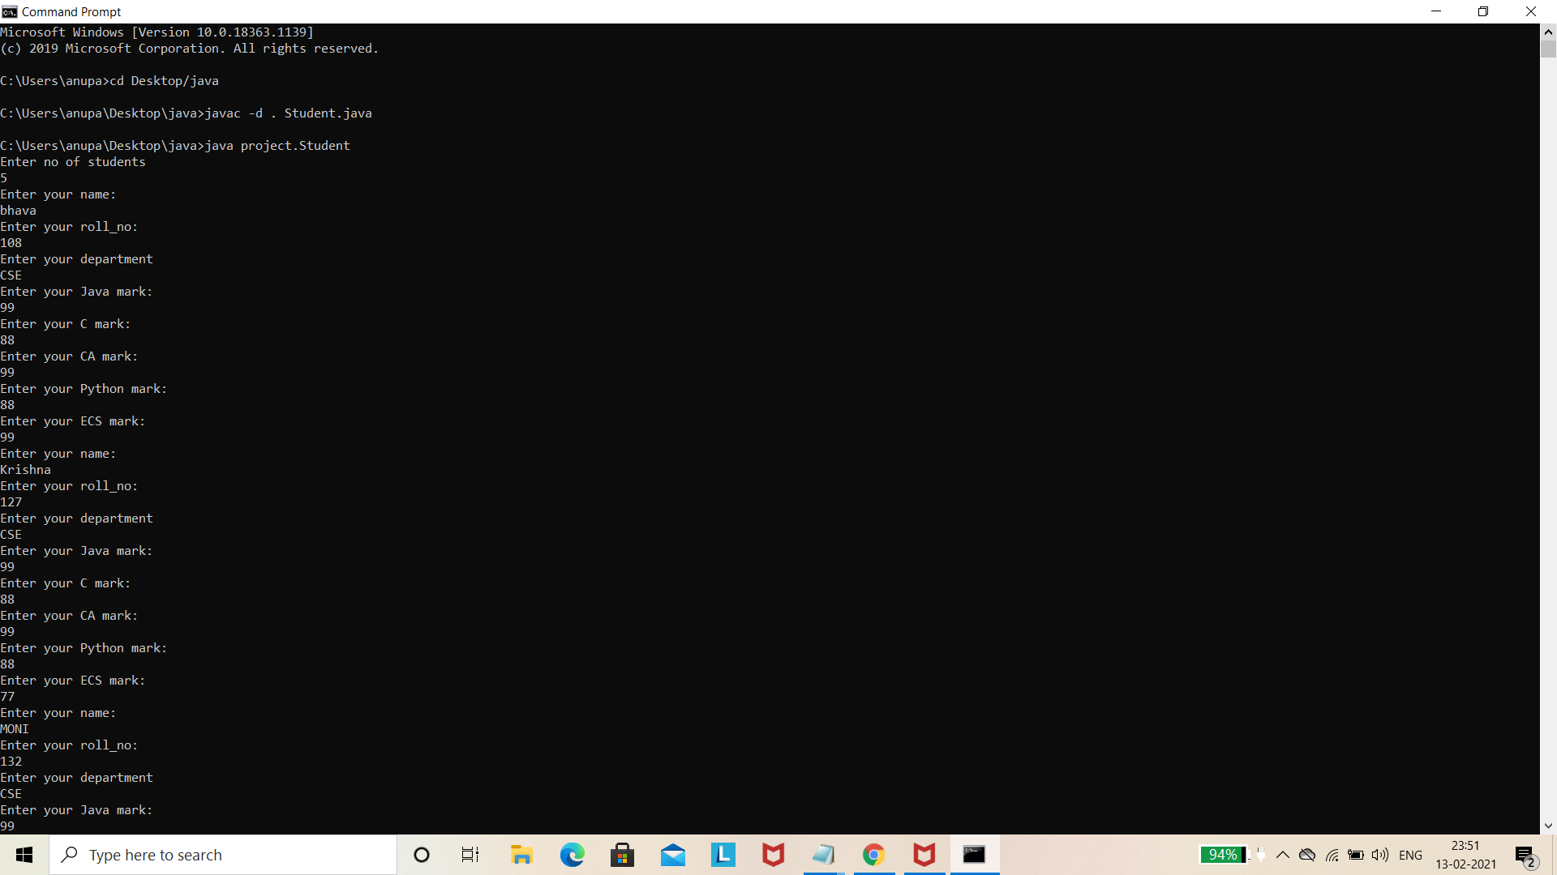

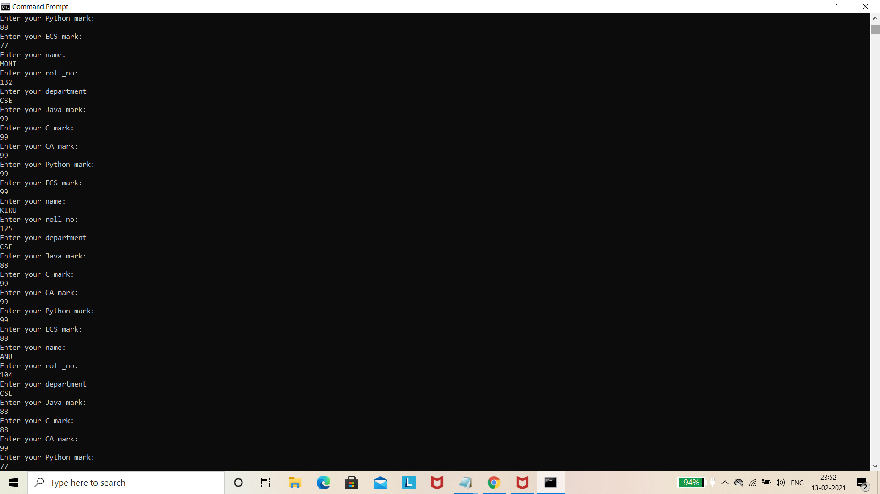

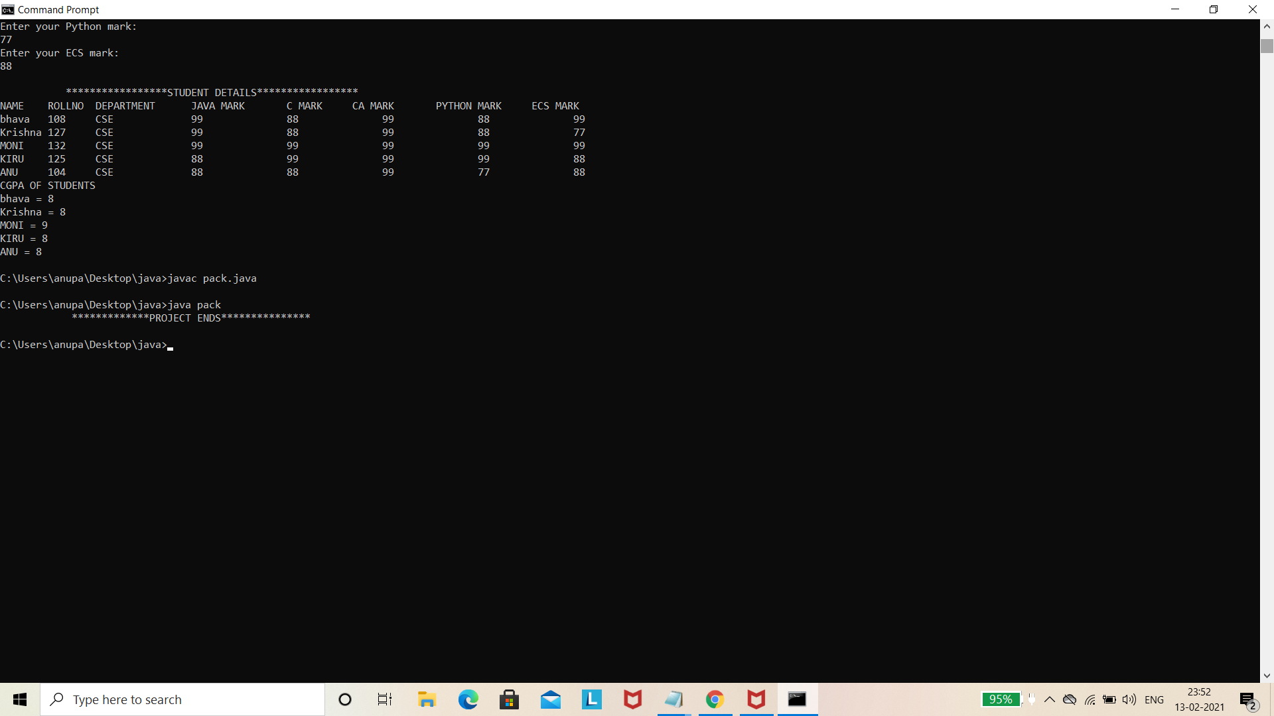

Result :

Thus the student database management in java is developed using the interface ,inheritance ,packages ,constructors etc…