**1. Initialization**: Generate an initial population of binary strings:

$P\left(0\right)=\left\{xi ∣ xi ∈Randomly initialized chromosomes, i=1,2,…,N\right\}$

**2. Evaluation**: Evaluate each string in the population

$f\left(xi \right)=Evaluation function\left(xi \right), ∀xi ∈P\left(t\right)$

**3. Selection of Parents:**

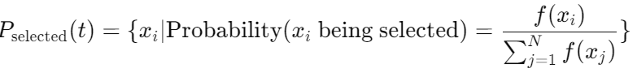

**4. Crossover: $For each pair \left(xi ,xj \right)∈Pselected \left(t\right),$**

$$Generate offspring \left(yk ,yl \right)=Crossover\left(xi ,xj \right)$$

e.g., Single-point crossover: $yk =\left\{xi \left[:c\right]∪xj \left[c:\right]\right\} =Crossover\left(xi ,xj \right)$

where *c is* the crossover point.

**5. Mutation**: For each offspring $yi ∈Offspring population$

$$yi =Mutate \left(yi \right)with probability p$$

$$yi= with probability 1$$

**6. Form New Population: $P\left(t+1\right)=Select next generation from \left(P\left(t\right)∪Offspring population\right)$**

**7**. If **termination** condition met (e.g., maximum generations or satisfactory fitness), stop; else $t=t+1$ and repeat from step 2

Reference:

<https://mealpy.readthedocs.io/en/latest/pages/models/mealpy.evolutionary_based.html> #module-mealpy.evolutionary_based.GA