Task From Rkcreators
Assigned by : Rkcreators IT Team ,
Assigned to : ,
Assigned date :25-06-2026 , Due date :,

- Basic table design
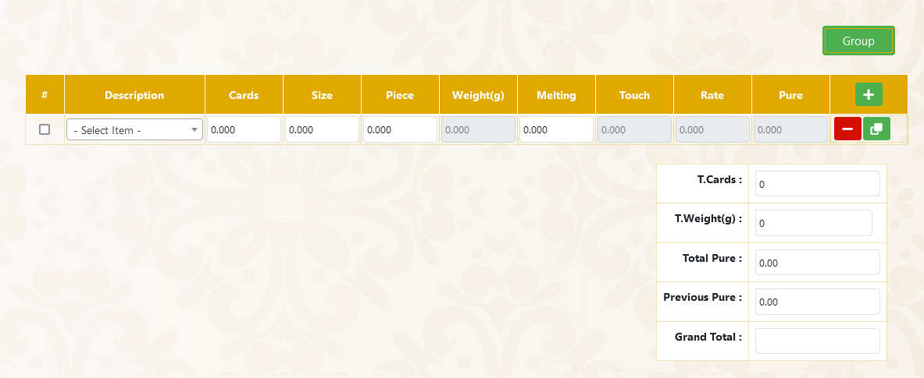

- When the plus(+) button ( Green colour + button ) clicked , the new row should append the table
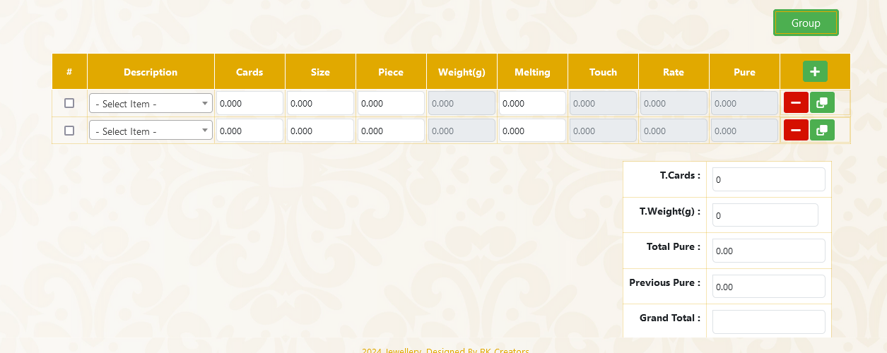

3. Description should be in select option, select drop down with searchable should be like given in the screenshot ,drop down value can given manually by yourself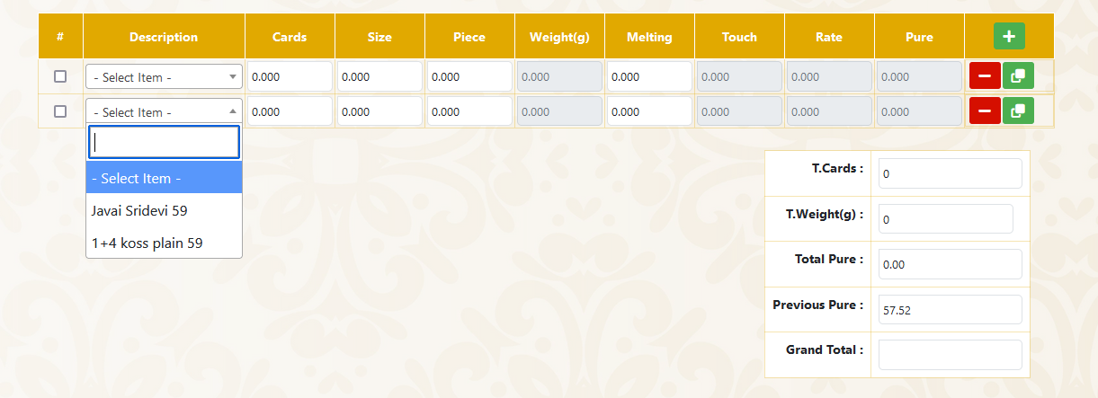
4.While click the clone button ( marked at blue color square) , the row will be clone and append after parent row itself. The values should be same as cloned row .
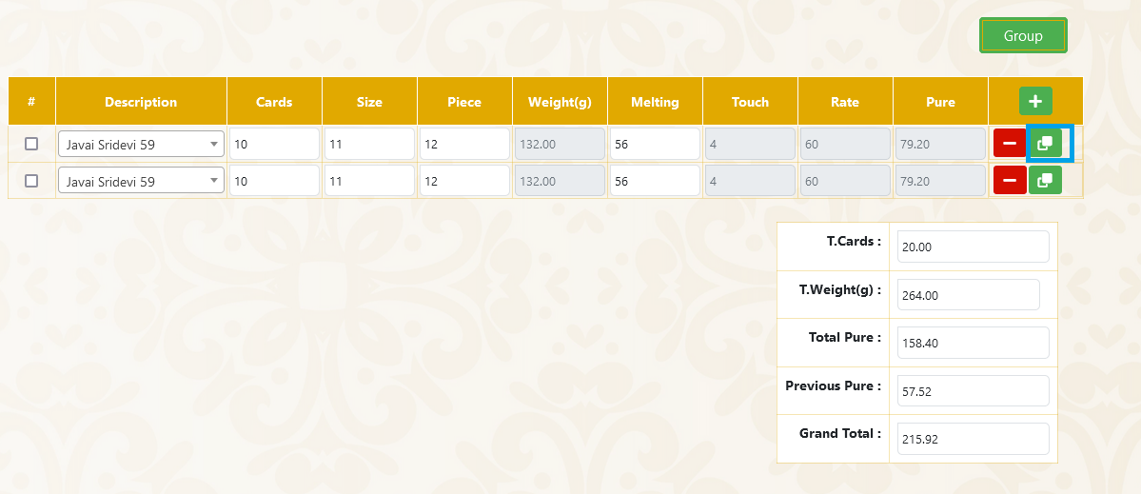

5. Next is group process: first we choose which rows are involving in grouping process using check box. In this state once we click the group button the process should has been given in next example image (like 6th point)
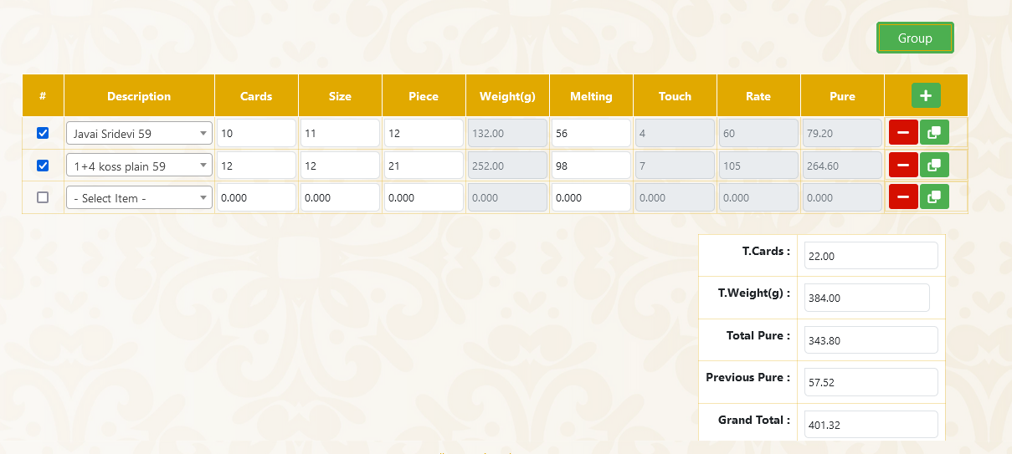

6. after group process the page show like this ,once I group the 1st table the last 2 columns should be hide
a. Example : 1
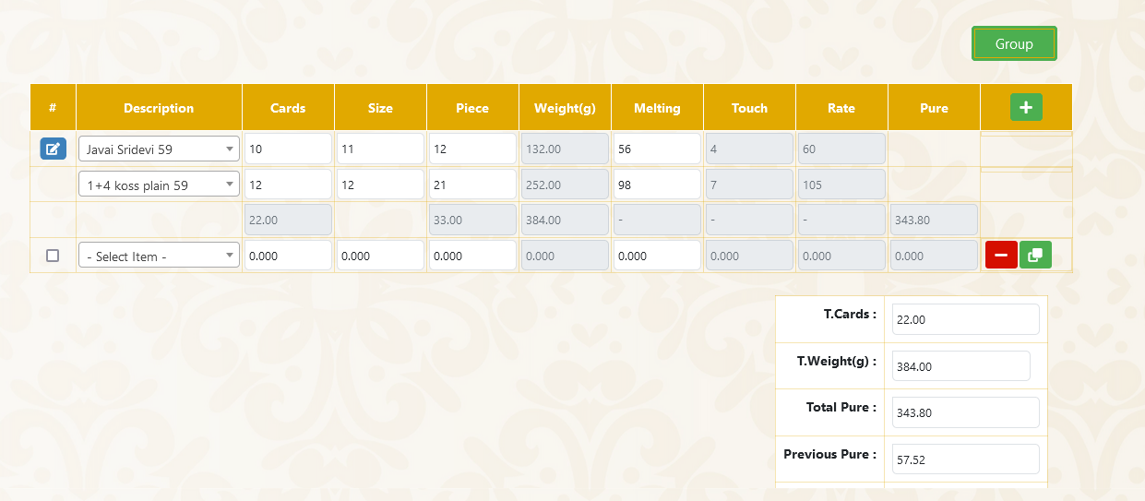

b. Example : 2
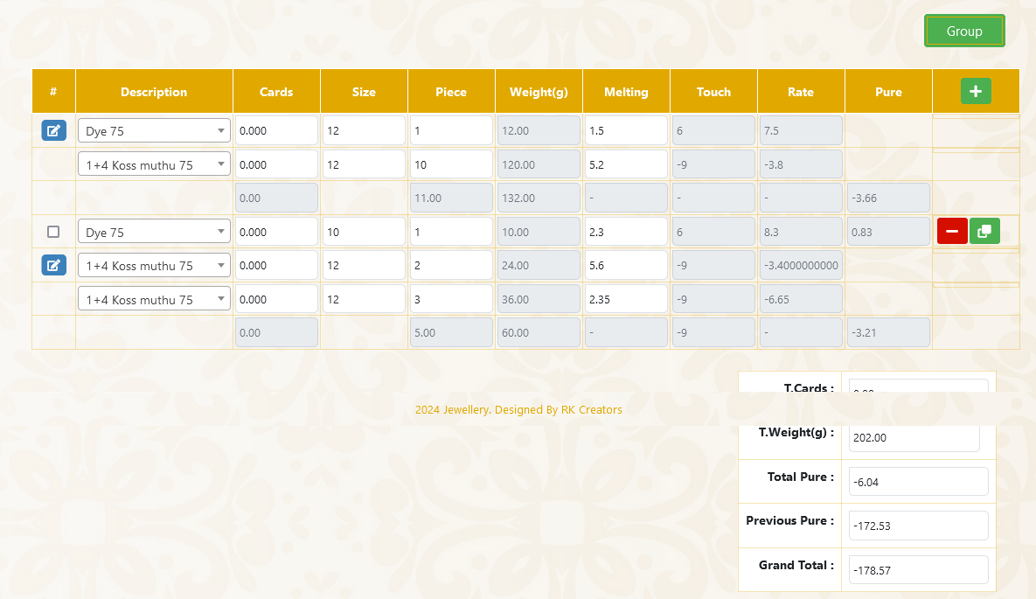
7. Now you can see the edit button (Blue colour edit icon button). Once click the button the edit option shows like given in the below example
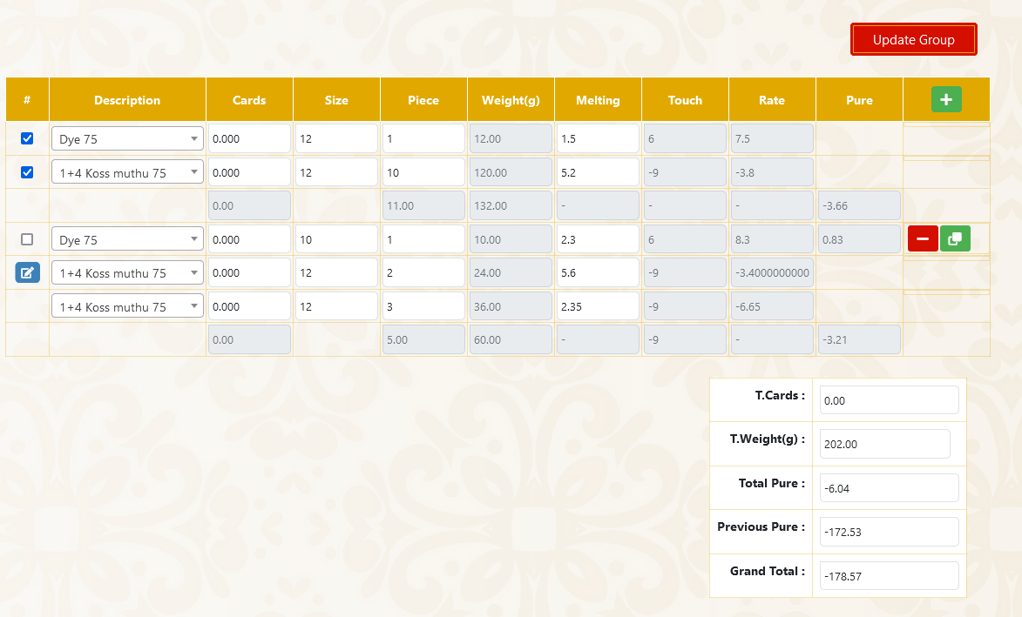

8. Once edit option enabled the check box move to checked state ,now I remove or add any check box and click update group button( like 7 the image ) checked checkbox are also add in the group another are also remove the group ,like given in the image below
Example 1: Add the 3rd row in first group
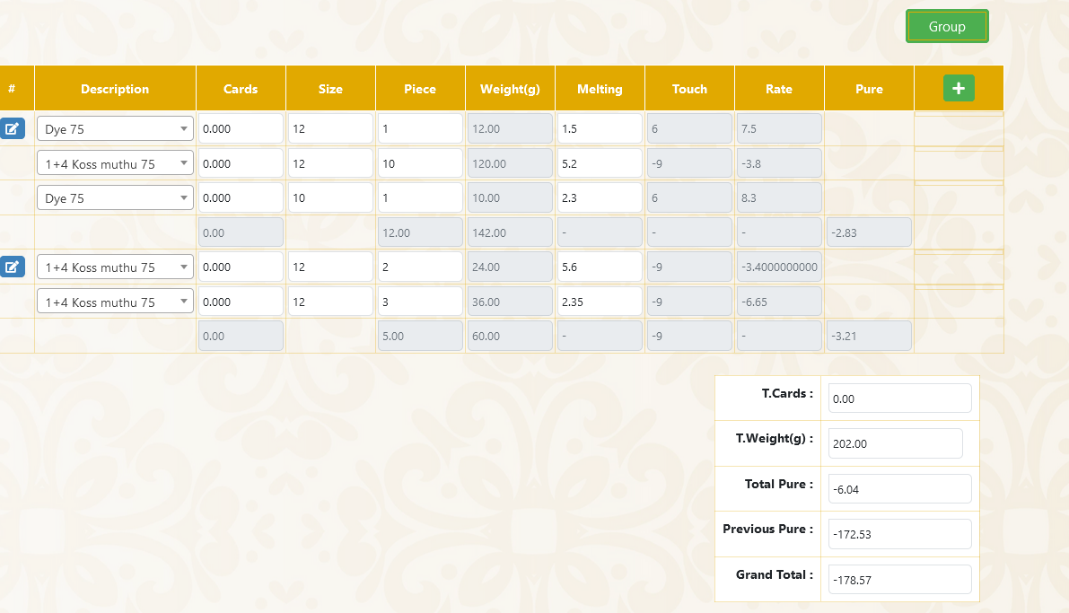

Example 2: remove 2 and 3rd rows in first group
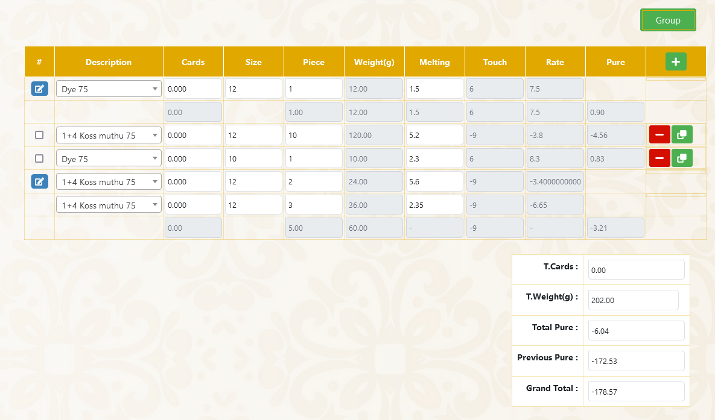

9. Every group have individual total calculation given below here.
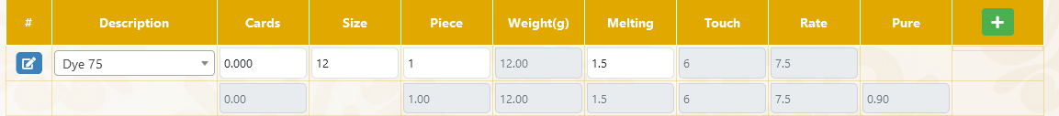

10. Overall total Calculation should be in last row of the table, like 8 example 2 image
11. When I click the remove button (Red colour minus button) the row was should be removed

Calculation:
Weight = Size * Piece;
Pure = Rate = Melting + Touch;

CRUD work should be done using php, Codelgniter 3 or 4

