DOCKER DOCUMENTATION

1. Docker Installation :
For the installation of docker we use the below commands
- Updation
  - sudo apt-get update
- Installation of docker
  - sudo apt install docer.io

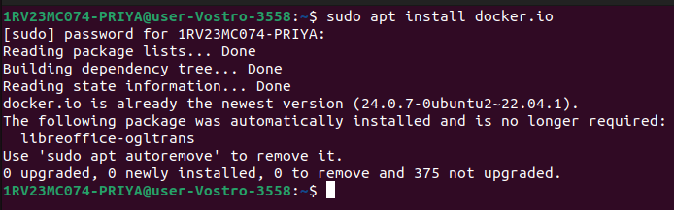

2.Creation of a Docker file:
- create a directory in lower case
mkdir firstfile
- change the directory to the directory which we created
cd firstfile
- create a dockerfile inside the directory which we have created
nano Dockerfile
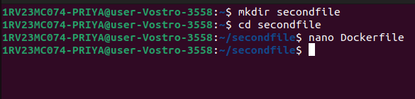

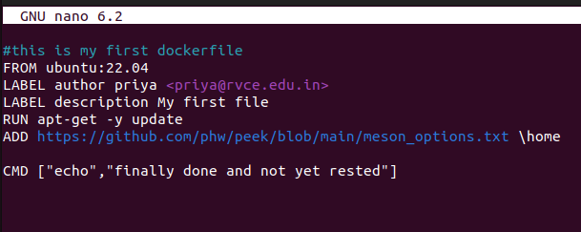

3. Build an image in PWD with no tag.

To build a docker image in the present working directory with no tag use the underlying command:
sudo docker build -t firstfile .
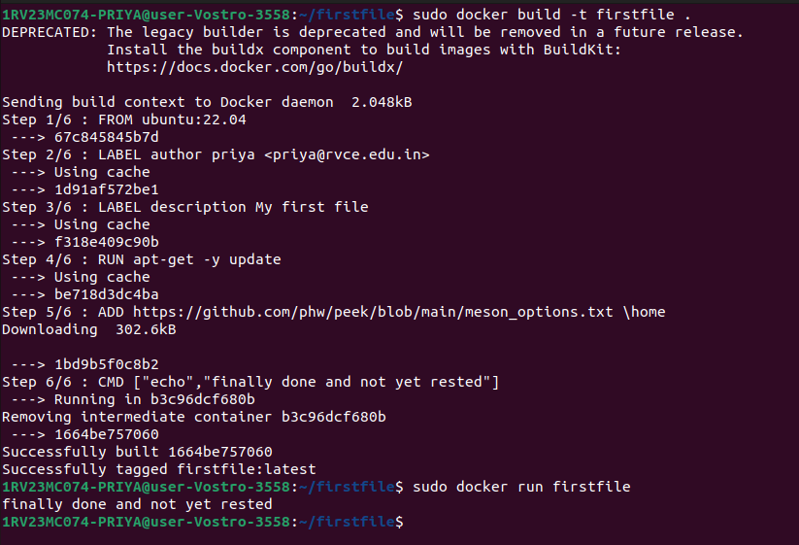

4. Build an image in PWD with tag.

To build an image in pwd with tag-2.4 use the underlying command:
sudo docker build -t firstfile:2.4 .

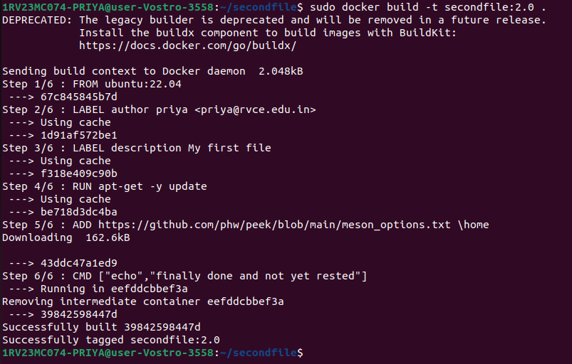
sudo docker images

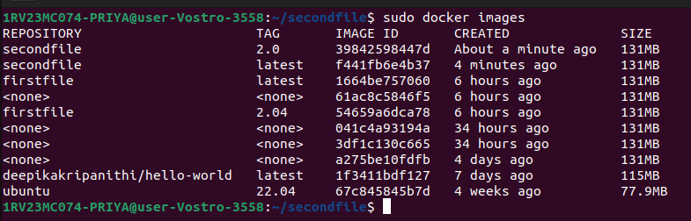

Build an image in PWD- update the file contents with the same tag:
To build an image with updated file contents with the same tag open the Dockerfile and update the contents and save the file and build the images again
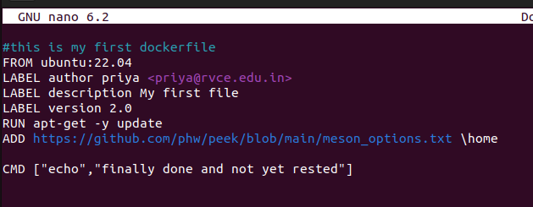

The updated docker image:

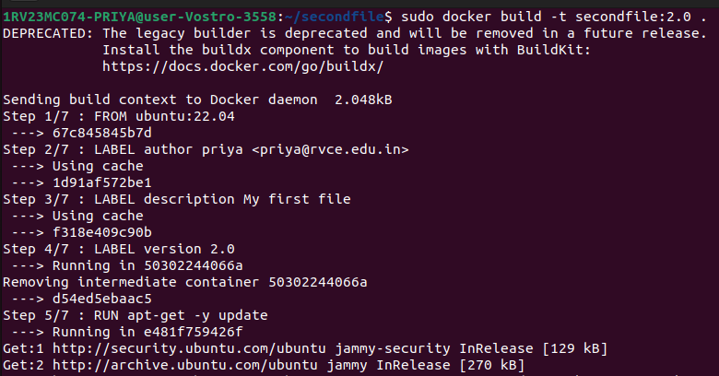

4. Build an image in different location with no tag

To build an image in different location with no tag, move to the directory in which we want to build an image ,
cd Downloads
to build an image,
sudo docker build -t Downloads .
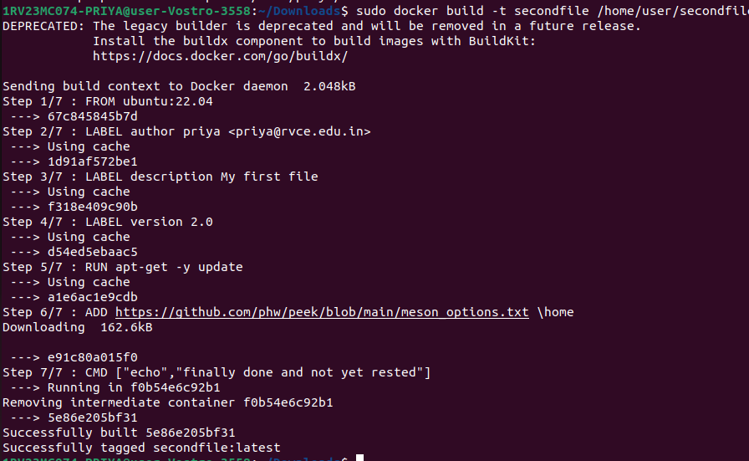

Build an image in different location with tag 3.6
sudo docker build -t secondfile:3.6 .
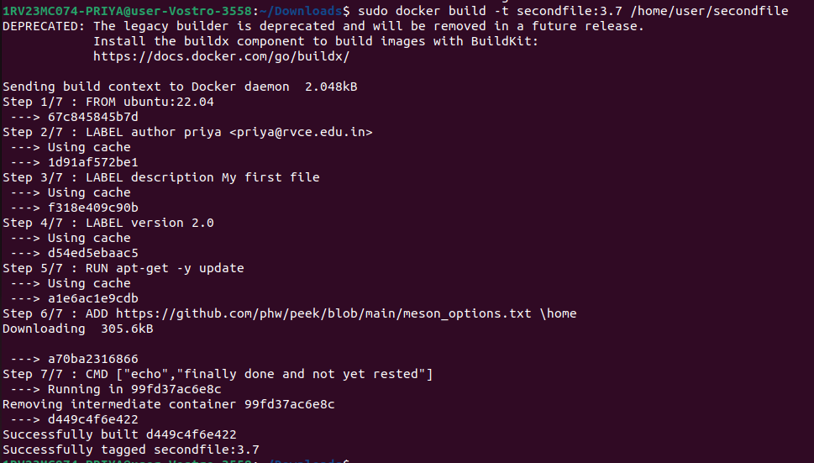
5.Build an Image for Docker Repository with no tag
sudo docker build .
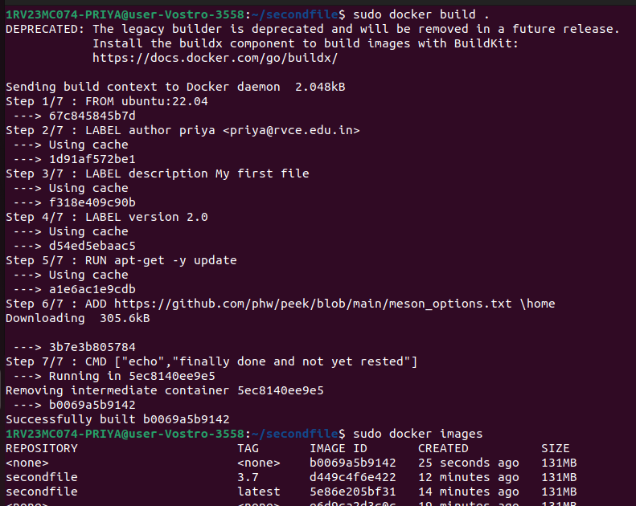

Build an Image for Docker Repository with tag – 4.5
sudo docker build -t firstfile:4.5

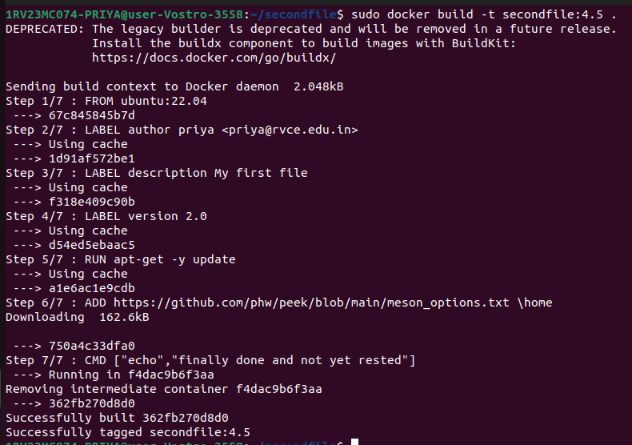

6.Docker Push to docker Repository

To push the docker image into the repository ,first login through the terminal using the following command,

sudo docker login
login using your username and password of Dockerhub

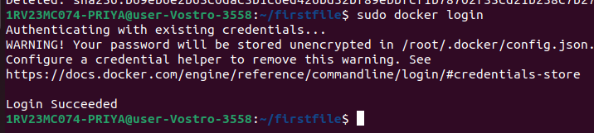

push the docker image to the repository using,
sudo docker push priya4520/firstfile
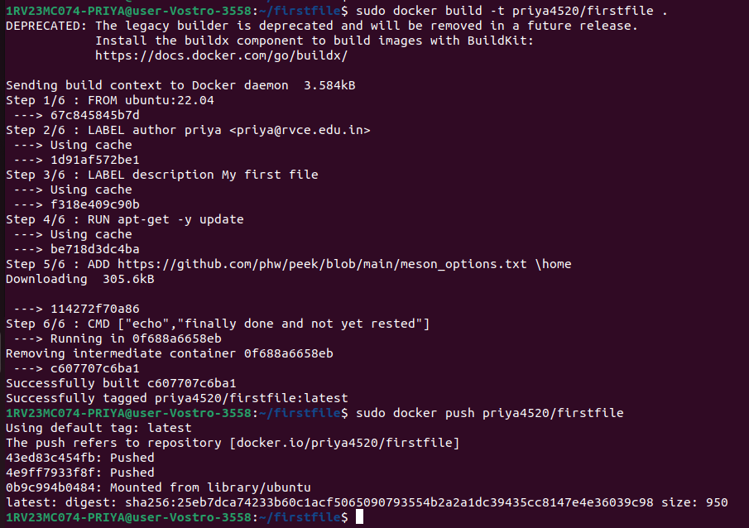
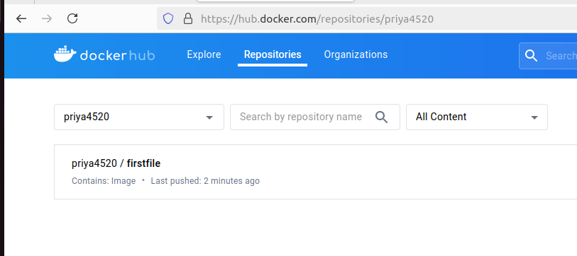

7.Command for removing an Image

sudo docker rmi <IMAGE_ID>
sudo docker rmi a06

