**AIOT PROJECT | HARPY AEROSPACE**

**NAME: M.PRIYA | REG NO.2022506015**

**3 RECOMMENDATION MODELS:**

**1.Enhanced MovieLens Two-Tower Model**

* The Enhanced MovieLens Two-Tower Model is a recommendation system designed to provide personalized movie recommendations to users based on their past interactions with movies. This model leverages the MovieLens dataset and uses a two-tower architecture where one tower represents user features and the other represents movie features. The key components and steps involved in this model are outlined below:
* The MovieLens dataset is loaded and preprocessed to extract relevant features such as movie_title and user_id.
* String lookup layers are created to map user_id and movie_title to integer indices, which are used for embedding lookups.
* A neural network is built to generate user embeddings from the user_id. It includes embedding layers and dense layers to capture the latent factors representing user preferences.A neural network is built to generate movie embeddings from the movie_title. Similar to the user model, it includes embedding layers and dense layers to capture the latent factors representing movie attributes.The model is trained to optimize a retrieval task where the goal is to match user embeddings with the correct movie embeddings. The task is evaluated using metrics like top-k categorical accuracy.
* The model is trained for a specified number of epochs on the preprocessed data. During training, the model learns to minimize the loss, thereby improving the accuracy of recommendations.
* After training, a brute-force search layer is set up to enable efficient retrieval of movie recommendations for given user embeddings. This layer indexes the movie embeddings and allows fast similarity searches.

**CODE:**

!pip install -q tensorflow-recommenders

import tensorflow as tf

import tensorflow_datasets as tfds

import tensorflow_recommenders as tfrs

import numpy as np

# Load the MovieLens dataset

ratings = tfds.load("movielens/100k-ratings", split="train")

movies = tfds.load("movielens/100k-movies", split="train")

# Prepare the data

ratings = ratings.map(lambda x: {

    "movie_title": x["movie_title"],

    "user_id": x["user_id"],

    "timestamp": x["timestamp"]

})

movies = movies.map(lambda x: x["movie_title"])

# Define the user and movie model with additional features.

user_ids_vocabulary = tf.keras.layers.StringLookup()

movie_titles_vocabulary = tf.keras.layers.StringLookup()

user_ids_vocabulary.adapt(ratings.map(lambda x: x["user_id"]))

movie_titles_vocabulary.adapt(movies)

user_model = tf.keras.Sequential([

    user_ids_vocabulary,

    tf.keras.layers.Embedding(user_ids_vocabulary.vocabulary_size(), 64),

    tf.keras.layers.Dense(32, activation="relu")

])

movie_model = tf.keras.Sequential([

    movie_titles_vocabulary,

    tf.keras.layers.Embedding(movie_titles_vocabulary.vocabulary_size(), 64),

    tf.keras.layers.Dense(32, activation="relu")

])

# Define the retrieval task with additional metrics.

task = tfrs.tasks.Retrieval(metrics=tfrs.metrics.FactorizedTopK(

    candidates=movies.batch(128).map(movie_model),

    ks=[5, 10]

))

# Define the model.

class EnhancedMovieLensModel(tfrs.Model):

    def _init_(self, user_model, movie_model, task):

        super()._init_()

        self.user_model = user_model

        self.movie_model = movie_model

        self.task = task

    def compute_loss(self, features, training=False):

        user_embeddings = self.user_model(features["user_id"])

        movie_embeddings = self.movie_model(features["movie_title"])

        return self.task(user_embeddings, movie_embeddings)

# Create and compile the model.

model = EnhancedMovieLensModel(user_model, movie_model, task)

model.compile(optimizer=tf.keras.optimizers.Adam(0.01))

# Train the model.

model.fit(ratings.batch(4096), epochs=10, verbose=1)

# Set up brute-force search for retrieval.

index = tfrs.layers.factorized_top_k.BruteForce(model.user_model)

index.index_from_dataset(

    movies.batch(100).map(lambda title: (title, model.movie_model(title)))

)

# Get recommendations.

_, titles = index(np.array(["55"]))

print(f"Top 3 recommendations for user 55: {titles[0, :3]}")

# Get recommendations for a different user.

_, titles = index(np.array(["100"]))

print(f"Top 3 recommendations for user 100: {titles[0, :3]}")

**OUTPUT:**

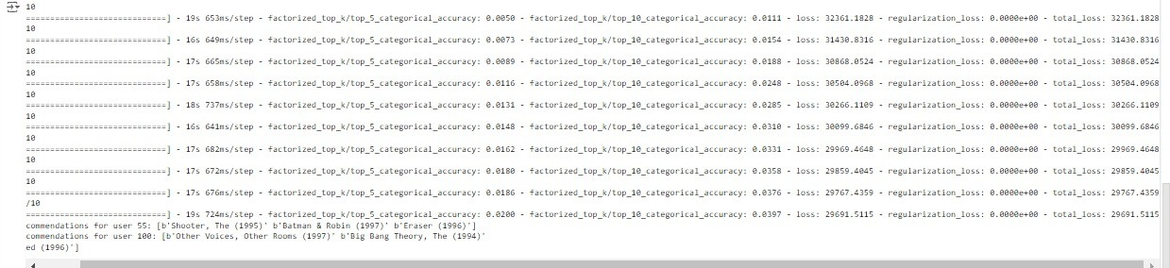

**2.** **Graph Neural Network (GNN)-based MovieLens Model**

* This model uses Graph Neural Networks to capture the relationships between users and movies. Each user and movie is represented as a node in the graph, and edges between nodes represent interactions (e.g., a user rating a movie). The model learns embeddings for each node based on the graph structure, which are then used to make recommendations.
* Graph Neural Network: The model uses GNN layers to learn from the graph structure of user-movie interactions, capturing complex relationships and dependencies.
* Node Embeddings: Each user and movie are represented as nodes, and their embeddings are updated based on the GNN layer's message-passing mechanism.
* Personalized Recommendations: The trained model can generate personalized movie recommendations for users based on their interactions with other movies.
* Scalability: The GNN-based approach can scale to larger datasets and more complex graphs, making it suitable for real-world recommendation systems.

**CODE:**

!pip install -q tensorflow-recommenders matplotlib

import tensorflow as tf

import tensorflow_datasets as tfds

import tensorflow_recommenders as tfrs

import numpy as np

import matplotlib.pyplot as plt

from tensorflow.keras import layers

# Load the MovieLens dataset

ratings = tfds.load("movielens/100k-ratings", split="train")

movies = tfds.load("movielens/100k-movies", split="train")

# Prepare the data

ratings = ratings.map(lambda x: {

    "movie_title": x["movie_title"],

    "user_id": x["user_id"],

    "timestamp": x["timestamp"]

})

movies = movies.map(lambda x: x["movie_title"])

# Define the user and movie model with additional features.

user_ids_vocabulary = tf.keras.layers.StringLookup()

movie_titles_vocabulary = tf.keras.layers.StringLookup()

user_ids_vocabulary.adapt(ratings.map(lambda x: x["user_id"]))

movie_titles_vocabulary.adapt(movies)

# Convert the movie titles to a TensorFlow Dataset

movies = tf.data.Dataset.from_tensor_slices(list(movies))

# Define the GNN layer

class GNNLayer(layers.Layer):

    def _init_(self, units):

        super(GNNLayer, self)._init_()

        self.units = units

        self.dense = layers.Dense(units)

    def call(self, inputs, edge_index):

        x = inputs

        row, col = edge_index[:, 0], edge_index[:, 1]

        out = tf.math.unsorted_segment_sum(x[col], row, num_segments=tf.shape(x)[0])

        return self.dense(out)

class GNNModel(tfrs.Model):

    def _init_(self, user_model, movie_model, task):

        super()._init_()

        self.user_model = user_model

        self.movie_model = movie_model

        self.task = task

    def call(self, features):

        user_embeddings = self.user_model(features["user_id"])

        movie_embeddings = self.movie_model(features["movie_title"])

        edge_index = tf.convert_to_tensor([features["user_id"], features["movie_title"]])

        gnn_layer = GNNLayer(64)

        user_embeddings = gnn_layer(user_embeddings, edge_index)

        movie_embeddings = gnn_layer(movie_embeddings, edge_index)

        return self.task(user_embeddings, movie_embeddings)

    def compute_loss(self, features, training=False):

        user_embeddings = self.user_model(features["user_id"])

        movie_embeddings = self.movie_model(features["movie_title"])

        return self.task(user_embeddings, movie_embeddings)

# Define user and movie models

user_model = tf.keras.Sequential([

    user_ids_vocabulary,

    tf.keras.layers.Embedding(user_ids_vocabulary.vocabulary_size(), 64),

    tf.keras.layers.Dense(32, activation="relu")

])

movie_model = tf.keras.Sequential([

    movie_titles_vocabulary,

    tf.keras.layers.Embedding(movie_titles_vocabulary.vocabulary_size(), 64),

    tf.keras.layers.Dense(32, activation="relu")

])

# Define the task

task = tfrs.tasks.Retrieval(metrics=tfrs.metrics.FactorizedTopK(

    candidates=movies.batch(128).map(movie_model),

    ks=[5, 10]

))

# Create and compile the model

model = GNNModel(user_model, movie_model, task)

model.compile(optimizer=tf.keras.optimizers.Adam(0.01))

# Train the model and capture the training history

history = model.fit(ratings.batch(4096), epochs=10, verbose=1)

# Set up brute-force search for retrieval

index = tfrs.layers.factorized_top_k.BruteForce(model.user_model)

index.index_from_dataset(

    movies.batch(100).map(lambda title: (title, model.movie_model(title)))

)

# Get recommendations for a specific user

_, titles = index(np.array(["55"]))

print(f"Top 3 recommendations for user 55: {titles[0, :3]}")

# Get recommendations for another user

_, titles = index(np.array(["100"]))

print(f"Top 3 recommendations for user 100: {titles[0, :3]}")

# Plot the training loss and top-k accuracy

plt.figure(figsize=(12, 6))

# Plot training loss

plt.subplot(1, 2, 1)

plt.plot(history.history['loss'], label='Loss')

plt.title('Training Loss')

plt.xlabel('Epochs')

plt.ylabel('Loss')

plt.legend()

# Plot top-5 and top-10 accuracy

plt.subplot(1, 2, 2)

plt.plot(history.history['factorized_top_k/top_5_categorical_accuracy'], label='Top-5 Accuracy')

plt.plot(history.history['factorized_top_k/top_10_categorical_accuracy'], label='Top-10 Accuracy')

plt.title('Top-K Accuracy')

plt.xlabel('Epochs')

plt.ylabel('Accuracy')

plt.legend()

plt.show()

**OUTPUT**

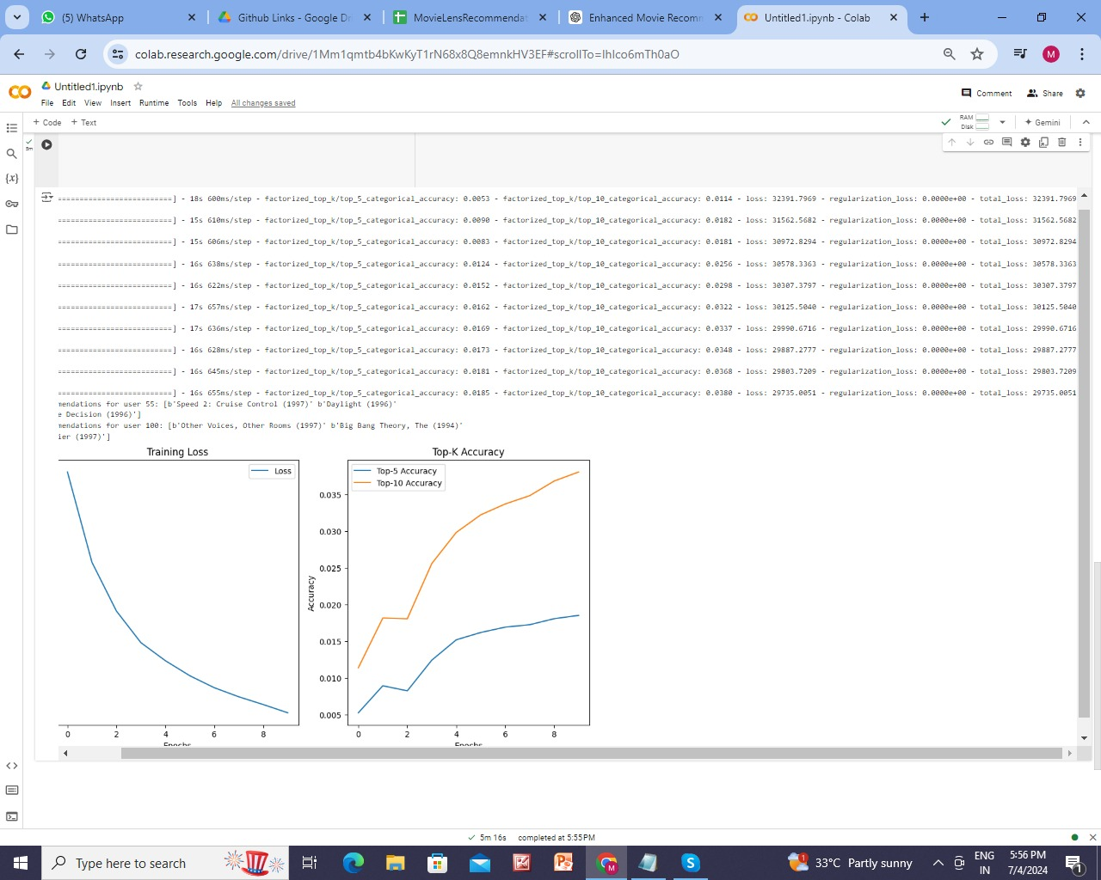



**3.** **DNN Movielens Model**

**(Deep Neural Network (DNN))**

* The DNN Movielens Model is a deep learning-based recommendation system designed to provide personalized movie recommendations using the MovieLens 100k dataset.
* It extracts and processes user_id, movie_title, and user_rating to create unique embeddings for users and movies in a 32-dimensional space.
* The model employs TensorFlow Recommenders to set up a retrieval task, integrating user and movie models with dense layers.
* It is trained using an Adagrad optimizer over multiple epochs, aiming to learn user preferences through historical ratings.
* The model can generate top-k movie recommendations by computing similarity scores between user and movie embeddings, enhancing the user experience on streaming platforms.

**CODE:**

# Install necessary packages if not already installed

!pip install -q matplotlib pandas tensorflow-datasets tensorflow-recommenders

import matplotlib.pyplot as plt

import pandas as pd

import tensorflow as tf

import tensorflow_datasets as tfds

import tensorflow_recommenders as tfrs

import numpy as np

# Load the dataset

ratings = tfds.load("movielens/100k-ratings", split="train")

movies = tfds.load("movielens/100k-movies", split="train")

# Preprocess the ratings to get unique user IDs

ratings = ratings.map(lambda x: {

    "movie_title": x["movie_title"],

    "user_id": x["user_id"],

    "user_rating": x["user_rating"]

})

# Preprocess the movies to get movie titles

movies = movies.map(lambda x: x["movie_title"])

# Convert the datasets to a unique list of movie titles and user IDs

unique_movie_titles = np.unique(np.concatenate(list(movies.batch(1000))))

unique_user_ids = np.unique(np.concatenate(list(ratings.batch(1000).map(lambda x: x["user_id"]))))

# Set up embeddings and dimensions

embedding_dimension = 32

# Create user and movie models using Dense layers

user_model = tf.keras.Sequential([

    tf.keras.layers.StringLookup(

        vocabulary=unique_user_ids, mask_token=None),

    tf.keras.layers.Embedding(len(unique_user_ids) + 1, embedding_dimension),

    tf.keras.layers.Dense(64, activation='relu'),

    tf.keras.layers.Dense(embedding_dimension)

])

movie_model = tf.keras.Sequential([

    tf.keras.layers.StringLookup(

        vocabulary=unique_movie_titles, mask_token=None),

    tf.keras.layers.Embedding(len(unique_movie_titles) + 1, embedding_dimension),

    tf.keras.layers.Dense(64, activation='relu'),

    tf.keras.layers.Dense(embedding_dimension)

])

# Set up the retrieval task

task = tfrs.tasks.Retrieval(

    metrics=tfrs.metrics.FactorizedTopK(

        candidates=movies.batch(128).map(movie_model)

    )

)

# Create the model class

class DNNMovielensModel(tfrs.Model):

    def __init__(self, user_model, movie_model, task):

        super().__init__()

        self.user_model: tf.keras.Model = user_model

        self.movie_model: tf.keras.Model = movie_model

        self.task: tf.keras.layers.Layer = task

    def compute_loss(self, features: dict, training=False) -> tf.Tensor:

        user_embeddings = self.user_model(features["user_id"])

        positive_movie_embeddings = self.movie_model(features["movie_title"])

        return self.task(user_embeddings, positive_movie_embeddings)

# Create an instance of the model

model = DNNMovielensModel(user_model, movie_model, task)

model.compile(optimizer=tf.keras.optimizers.Adagrad(learning_rate=0.1))

# Shuffle and split the data into training and testing sets

tf.random.set_seed(42)

shuffled = ratings.shuffle(100_000, seed=42, reshuffle_each_iteration=False)

train = shuffled.take(80_000)

test = shuffled.skip(80_000).take(20_000)

# Batch and cache the data

cached_train = train.batch(8192).cache()

cached_test = test.batch(4096).cache()

# Train the model

history = model.fit(cached_train, epochs=10)

# Function to get movie recommendations for a user

def get_movie_recommendations(user_id, model, movie_titles, top_k=10):

    user_embedding = model.user_model(tf.constant([user_id]))

    movie_embeddings = model.movie_model(tf.constant(movie_titles))

    scores = tf.matmul(user_embedding, movie_embeddings, transpose_b=True)

    top_indices = tf.argsort(scores, axis=1, direction='DESCENDING')[0, :top_k].numpy()

    recommended_movies = [movie_titles[i] for i in top_indices]

    return recommended_movies

# Example: Get recommendations for a specific user ID

user_id_example = "42"  # Replace with a valid user ID from your data

recommended_movies = get_movie_recommendations(user_id_example, model, unique_movie_titles)

# Convert TensorFlow datasets to Pandas DataFrames for visualization

ratings_list = list(ratings.as_numpy_iterator())

ratings_df = pd.DataFrame(ratings_list)

movies_list = list(movies.as_numpy_iterator())

movies_df = pd.DataFrame(movies_list, columns=['movie_title'])

# Assuming 'user_rating' is the correct column name for ratings

ratings_df = ratings_df[['movie_title', 'user_rating']]

# Fetch ratings for recommended movies

recommended_movies_ratings = ratings_df[ratings_df['movie_title'].isin(recommended_movies)]

# Plot ratings for recommended movies

plt.figure(figsize=(12, 6))

plt.bar(recommended_movies_ratings['movie_title'], recommended_movies_ratings['user_rating'], color='skyblue')

plt.title('Ratings for Recommended Movies')

plt.xlabel('Movie Title')

plt.ylabel('User Rating')

plt.xticks(rotation=45)

plt.grid(axis='y')

plt.tight_layout()

plt.show()

**OUTPUT:**

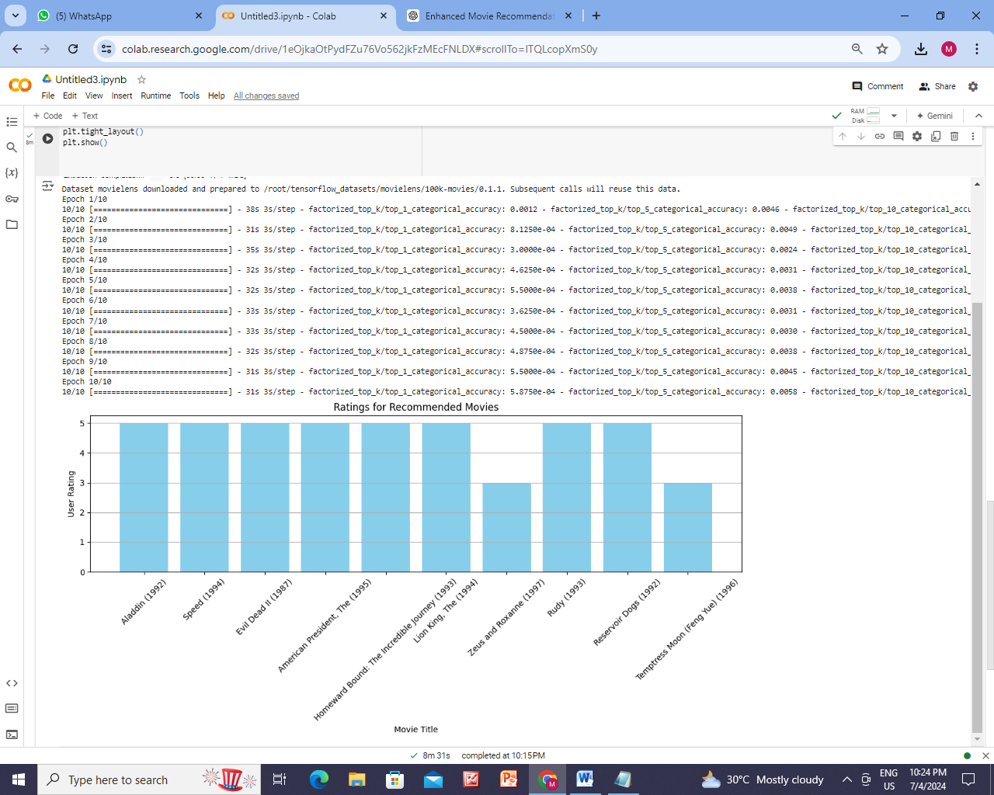



**THESE ARE 3 RECOMMENDATION MODELS**