🚕 NYC Taxi Demand & Weekly Performance Analysis
- Project Overview
This project analyzes four years of NYC taxi trip data . The objective is to identify week-level demand patterns, performance trends, and operational insights using interactive dashboard reporting. The analysis focuses on key performance indicators such as total trips, average fare per trip, average distance per trip, and week-over-week (WoW) changes. By enabling dynamic week selection and multi-year comparison, the dashboard supports short-term demand monitoring and data-driven decision-making.

- Dataset Summary
Data Sources
- 4 CSV files containing trip data (2017–2020)
- 1 Calendar date table
- 1 Location lookup table (pickup/dropoff zones)

- Data Preparation & Transformation (Python – Jupyter Notebook)
Data cleaning and preprocessing were performed using Python (Pandas) to ensure consistency and quality before loading the dataset into MySQL and Power BI.
Data Consolidation
Four yearly CSV files (2017–2020) were imported and combined into a single dataset containing approximately 26 million records. A reusable cleaning function was applied to standardize processing across all files.
Data Cleaning & Validation
- Converted pickup and drop-off columns to datetime format.
- Filtered records between January 2017 and December 2020.
- Removed invalid trips (e.g., pickup after drop-off, trips longer than 24 hours).
- Restricted analysis to standard street-hail trips and valid payment types.
- Corrected passenger counts and converted negative monetary values to absolute values.
- Removed or adjusted records with zero fare or zero distance to maintain logical consistency.
Feature Engineering
- Created derived fields such as trip duration and pickup_date.
- Standardized column names using snake_case for clarity and database compatibility.
Database Integration
The cleaned dataset was uploaded to MySQL in batches using SQLAlchemy. This enabled the creation of optimized SQL views for aggregation and improved performance when connecting to Power BI.

- Database Design & SQL Processing (MySQL)
After data cleaning in Python, the processed dataset was loaded into MySQL for structured storage and optimized reporting.
A dedicated database taxi_trip_db was created to manage all project tables.
Dimension Tables
- Calendar Table: Created to support time-based analysis, including fiscal year, week number, month, and day-level attributes. This enabled week-level aggregation and time intelligence in Power BI.
- Location Table: Stored geographical details such as Borough, Zone, and Service Zone for pickup and drop-off analysis.
SQL Views
To improve performance and simplify Power BI modeling, SQL views were created:
- dim_pickup_location and dim_dropoff_location to standardize location keys and support mapping visuals.
- taxi_trips view to select only required analytical columns and extract pickup_hour for hourly analysis.
This structure ensured clean relationships, reduced data load complexity, and improved dashboard performance.

- Dashboard in Power BI

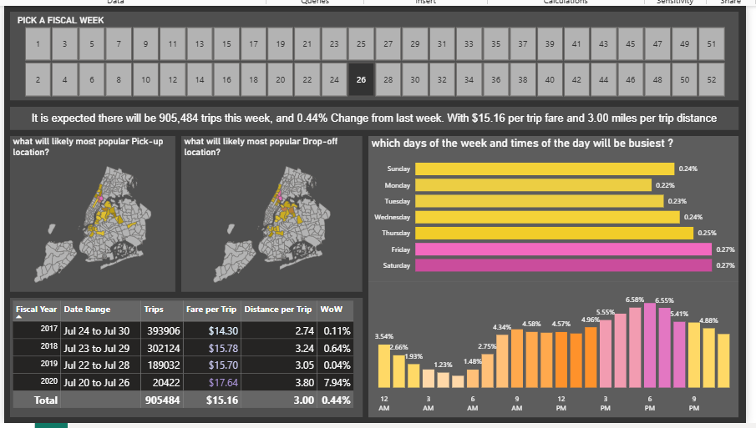

- Business Recommendations
- Trip demand exhibits clear weekly seasonality patterns.
- Evening hours show the highest demand concentration.
- Pickup and drop-off activity is geographically clustered.
- Fare per trip remains relatively stable across years.
- 2020 shows visible performance shifts compared to previous years.
- Week-over-Week tracking reveals short-term volatility in demand.

