**COVID-19 VACCINE ANALYSIS**

**PYTHON FILE**

Libraries:

The Python Standard Library contains the exact syntax, semantics, and tokens of Python.there are more libraries in python.

1. **TensorFlow:**This library was developed by Google in collaboration with the Brain Team. It is an open-source library used for high-level computations. It is also used in machine learning and deep learning algorithms. It contains a large number of tensor operations. Researchers also use this Python library to solve complex computations in Mathematics and Physics.
2. **Matplotlib:**This library is responsible for plotting numerical data. And that’s why it is used in data analysis. It is also an open-source library and plots high-defined figures like pie charts, histograms, scatterplots, graphs, etc.
3. **Pandas:**Pandas are an important library for data scientists. It is an open-source machine learning library that provides flexible high-level data structures and a variety of analysis tools. It eases data analysis, data manipulation, and cleaning of data. Pandas support operations like Sorting, Re-indexing, Iteration, Concatenation, Conversion of data, Visualizations, Aggregations, etc.
4. **Numpy:**The name “Numpy” stands for “Numerical Python”. It is the commonly used library. It is a popular machine learning library that supports large matrices and multi-dimensional data. It consists of in-built mathematical functions for easy computations. Even libraries like TensorFlow use Numpy internally to perform several operations on tensors. Array Interface is one of the key features of this library.
5. **SciPy:**The name “SciPy” stands for “Scientific Python”. It is an open-source library used for high-level scientific computations. This library is built over an extension of Numpy. It works with Numpy to handle complex computations. While Numpy allows sorting and indexing of array data, the numerical data code is stored in SciPy. It is also widely used by application developers and engineers.
6. **Scrapy:**It is an open-source library that is used for extracting data from websites. It provides very fast web crawling and high-level screen scraping. It can also be used for data mining and automated testing of data.
7. **Scikit-learn:**It is a famous Python library to work with complex data. Scikit-learn is an open-source library that supports machine learning. It supports variously supervised and unsupervised algorithms like linear regression, classification, clustering, etc. This library works in association with Numpy and SciPy.
8. **PyGame:**This library provides an easy interface to the Standard Directmedia Library (SDL) platform-independent graphics, audio, and input libraries. It is used for developing video games using computer graphics and audio libraries along with Python programming language.
9. **PyTorch:**PyTorch is the largest machine learning library that optimizes tensor computations. It has rich APIs to perform tensor computations with strong GPU acceleration. It also helps to solve application issues related to neural networks.
10. **PyBrain:**The name “PyBrain” stands for Python Based Reinforcement Learning, Artificial Intelligence, and Neural Networks library. It is an open-source library built for beginners in the field of Machine Learning. It provides fast and easy-to-use algorithms for machine learning tasks. It is so flexible and easily understandable and that’s why is really helpful for developers that are new in research fields.

Data Cleaning

**Data cleaning** is one of the important parts of machine learning. It plays a significant part in building a model. It surely isn’t the fanciest part of machine learning and at the same time, there aren’t any hidden tricks or secrets to uncover. However, the success or failure of a project relies on proper data cleaning. Professional data scientists usually invest a very large portion of their time in this step because of the belief that **“Better data beats fancier algorithms”**.

If we have a well-cleaned dataset, there are chances that we can get achieve good results with simple algorithms also, which can prove very beneficial at times especially in terms of computation when the dataset size is large. Obviously, different types of data will require different types of cleaning. However, this systematic approach can always serve as a good starting point.

**The following are the most common steps involved in data cleaning:**

**Data cleaning** is one of the important parts of machine learning. It plays a significant part in building a model. It surely isn’t the fanciest part of machine learning and at the same time, there aren’t any hidden tricks or secrets to uncover. However, the success or failure of a project relies on proper data cleaning. Professional data scientists usually invest a very large portion of their time in this step because of the belief that **“Better data beats fancier algorithms”**.

import pandas as pd

import numpy as np

# Load the datasetdf = pd.read\_csv('train.csv')df.head()

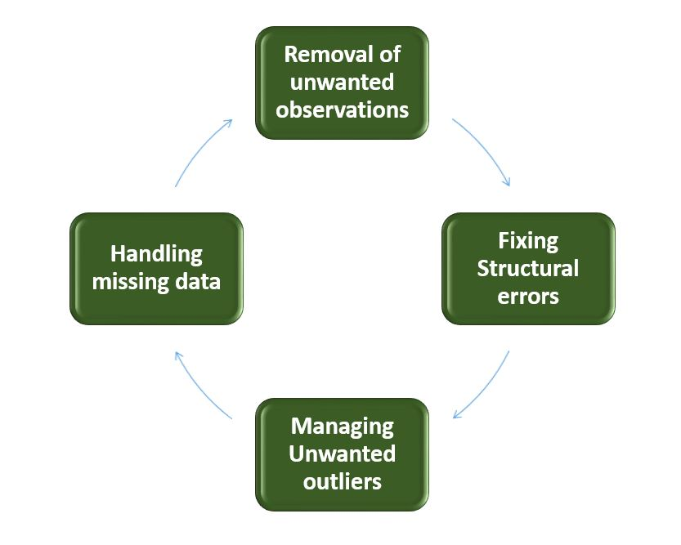

*Data Cleaning*

**Train and test**

Train/Test is a method to measure the accuracy of your model.

It is called Train/Test because you split the data set into two sets: a training set and a testing set.

80% for training, and 20% for testing.

You *train* the model using the training set.You *test* the model using the testing set.

*Train* the model means *create* the model.

*Test* the model means test the accuracy of the model.

import numpy  
import matplotlib.pyplot as plt  
numpy.random.seed(2)  
x = numpy.random.normal(3, 1, 100)  
y = numpy.random.normal(150, 40, 100) / x

plt.scatter(x, y)  
plt.show()

Result:

The x axis represents the number of minutes before making a purchase.

The y axis represents the amount of money spent on the purchase.

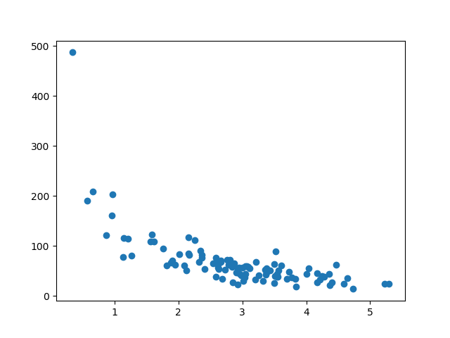

Accuracy and other metrics for prediction evalution

**[Common metrics to evaluate prediction accuracy include](https://www.bing.com/ck/a?!&&p=6738260ed73522d0JmltdHM9MTY5NjgwOTYwMCZpZ3VpZD0wODg5OTg5MS0wMTY3LTY5MDAtMjAxYy04YTIxMDBjYTY4YjkmaW5zaWQ9NTgxMw&ptn=3&hsh=3&fclid=08899891-0167-6900-201c-8a2100ca68b9&psq=accuracy+and+other+metrics+for+prediction+evalution&u=a1aHR0cHM6Ly9pbmRhdGFsYWJzLmNvbS9ibG9nL3ByZWRpY3RpdmUtbW9kZWxzLXBlcmZvcm1hbmNlLWV2YWx1YXRpb24taW1wb3J0YW50&ntb=1" \t "_blank)**:

* Percent correction classification (PCC): measures overall accuracy. Every error has the same weight.
* Confusion matrix: also measures accuracy but distinguished between errors, i.e false positives, false negatives and correct predictions.
* Mean Reciprocal Rank (MRR): average rank for first correct prediction.
* Average precision: concentration of results in highest ranked predictions.
* MAR@K (recall)

Accuracy

Accuracy simply measures how often the classifier correctly predicts. We can define accuracy as the ratio of the number of correct predictions and the total number of predictions.

Accuracy

Accuracy simply measures how often the classifier correctly predicts. We can define accuracy as the ratio of the number of correct predictions and the total number of predictions.

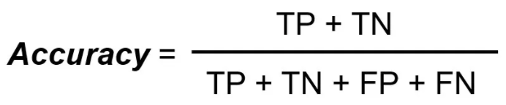

Introduction

Evaluation metrics are tied to machine learning tasks. There are different metrics for the tasks of classification and regression. Some metrics, like precision-recall, are useful for multiple tasks. Classification and regression are examples of supervised learning, which constitutes a majority of machine learning applications. Using different metrics for performance evaluation, we should be able to improve our model’s overall predictive power before we roll it out for production on unseen data. Without doing a proper evaluation of the Machine Learning model by using different evaluation metrics, and only depending on accuracy, can lead to a problem when the respective model is deployed on unseen data and may end in poor predictions.

In the next section, I’ll discuss the Classification evaluation metrics that could help in the generalization of the ML classification model.

Classification Metrics in Machine Learning

Classification is about predicting the class labels given input data. In binary classification, there are only two possible output classes(i.e., Dichotomy). In multiclass classification, more than two possible classes can be present. I’ll focus only on binary classification.

A very common example of binary classification is spam detection, where the input data could include the email text and metadata (sender, sending time), and the output label is either *“spam” or “not spam.”* (*See Figure*) Sometimes, people use some other names also for the two classes: “positive” and “negative,” or “class 1” and “class 0.”

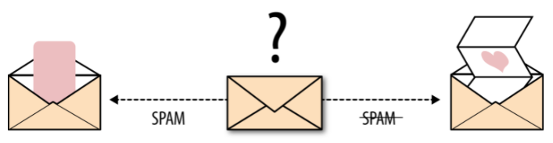 Email spam detection is a binary classification problem (source: From Book — Evaluating Machine Learning Model — O’Reilly)

There are many ways for measuring classification performance. Accuracy, confusion matrix, log-loss, and AUC-ROC are some of the most popular metrics. Precision-recall is a widely used metrics for classification problems.

Accuracy

Accuracy simply measures how often the classifier correctly predicts. We can define accuracy as the ratio of the number of correct predictions and the total number of predictions.



When any model gives an accuracy rate of 99%, you might think that model is performing very good but this is not always true and can be misleading in some situations. I am going to explain this with the help of an example.

*Example*

Consider a binary classification problem, where a model can achieve only two results, either model gives a **correct** or **incorrect**prediction. Now imagine we have a classification task to predict if an image is a dog or cat as shown in the image. In a supervised learning algorithm, we first **fit/train**a model on training data, then **test** the model on **testing data**. Once we have the model’s predictions from the **X\_test** data, we compare them to the**true y\_values** (the correct labels).

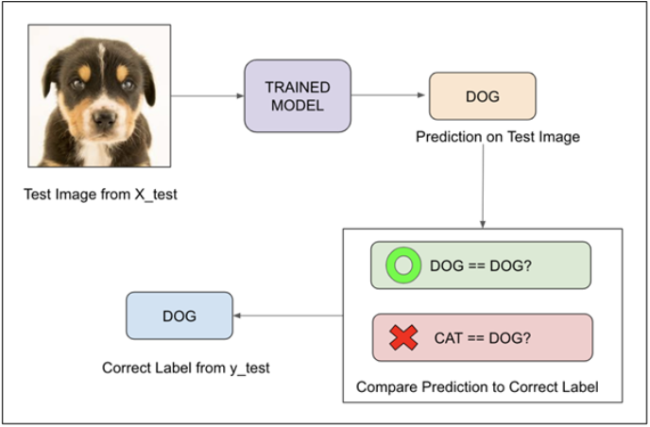

We feed the image of the dog into the training model. Suppose the model predicts that this is a dog, and then we compare the prediction to the correct label. If the model predicts that this image is a cat and then we again compare it to the correct label and it would be incorrect.

We repeat this process for all images in X\_test data. Eventually, we’ll have a count of correct and incorrect matches. But in reality, it is very rare that all incorrect or correct matches hold **equal value**. Therefore one metric won’t tell the entire story.

Accuracy is useful when the target class is ***well balanced*** but is not a good choice for the unbalanced classes. Imagine the scenario where we had 99 images of the dog and only 1 image of a cat present in our training data. Then our model would always predict the dog, and therefore we got 99% accuracy. In reality, Data is always imbalanced for example Spam email, credit card fraud, and medical diagnosis. Hence, if we want to do a better model evaluation and have a full picture of the model evaluation, other metrics such as recall and precision should also be considered.

Visualization

Data visualization provides a good, organized pictorial representation of the

data which makes it easier to understand, observe, analyze. In this tutorial,

we will discuss how to visualize data using Python.



Python provides various libraries that come with different features for

visualizing data. All these libraries come with different features and can

support various types of graphs. In this tutorial, we will be discussing four

such libraries.

**Matplotlib**

Matplotlib is an easy-to-use, low-level data visualization library that is

built on NumPy arrays. It consists of various plots like scatter plot, line plot,

histogram, etc. Matplotlib provides a lot of flexibility.

To install this type the below command in the terminal:

pip install matplotlib

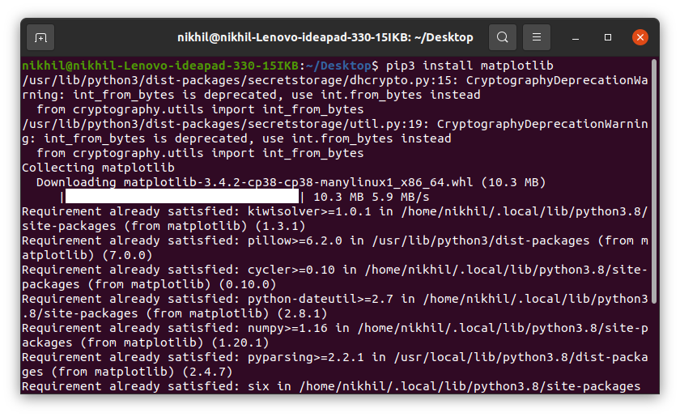

*Refer to the below articles to get more information setting up an environment with Matplotlib.*

* *[Environment Setup for Matplotlib](https://www.geeksforgeeks.org/environment-setup-for-matplotlib/)*
* *[Using Matplotlib with Jupyter Notebook](https://www.geeksforgeeks.org/using-matplotlib-with-jupyter-notebook/)*

After installing Matplotlib, let’s see the most commonly used plots using this library.

* Matplotlib
* Seaborn
* Bokeh
* Plotl

**COVID-19 VACCINE ANALYSIS**

**PHASE 2**

**Explanation:**

COVID-19 vaccine analysis involves rigorous testing in different phases. Initially, researchers conduct lab and animal studies to assess safety and effectiveness. Clinical trials follow, divided into phases to evaluate the vaccine on increasing numbers of volunteers. Regulatory agencies review the data for approval, leading to Emergency Use Authorization or full approval. Continuous monitoring after distribution ensures ongoing safety and efficacy. Global collaboration, publication of results, and transparent communication are integral to the process. The aim is to provide a safe and effective vaccine for public use.

**Detail about Dataset**

**Kaggle** is a [data science competition platform](https://en.wikipedia.org/wiki/Data_science_competition_platform" \o "Data science competition platform) and online

community of [data scientists](https://en.wikipedia.org/wiki/Data_science" \o "Data science) and [machine learning](https://en.wikipedia.org/wiki/Machine_learning" \o "Machine learning) practitioners

under [Google LLC](https://en.wikipedia.org/wiki/Google_LLC" \o "Google LLC).

**DATASET LINK:**

<https://www.kaggle.com/datasets/imdevskp/corona-virus-report/>

The project aims to develop a machine learning-based system that analyzes transaction data in real-time, effectively detecting credit card fraud while minimizing false positives. This solution will help financial institutions protect against fraudulent transactions, reducing financial losses and ensuring customer trust

Consider exploring advanced techniques such as anomaly detection algorithms (e.g., Isolation Forest, One-Class SVM) and ensemble methods for improved fraud detection accuracy

Data sets are also used to store information needed by applications or the operating system itself, such as source programs, macro libraries, or system variables or parameters.

About columns

For analyzing data, we need some libraries. In this section, we are importing all the required libraries like pandas, NumPy, matplotlib, plotly, seaborn, and word cloud that are required for data analysis. Check the below code to import all the required libraries.

import pandas as pd

import numpy as np

import matplotlib.pyplot as plt

import plotly.express as px

import plotly.graph\_objects as go

import matplotlib.patches as mpatches

from plotly.subplots import make\_subplots

from wordcloud import WordCloud

import seaborn as sns

sns.set(color\_codes = True)

sns.set(style="whitegrid")

import plotly.figure\_factory as ff

from plotly.colors import n\_colors

**Numerical Columns**: Numerical columns contain continuous, numeric data. Examples include age, income, temperature, and many other quantitative measurements.

Libraries to be used and way to download

Python is a popular programming language for various tasks such as data analysis, web development, and machine learning. One of the reasons for its popularity is the vast number of libraries available to extend its functionality. These libraries, also known as modules, are pre-written code that can be easily imported and used in your projects. This article will discuss how to download and install Python libraries with examples.

Using pip

The most common way to download and install Python libraries is through pip, the package installer for Python. Pip is a command-line tool that allows you to install, upgrade, and remove Python packages. It is included in the standard library starting from Python version 2.7.9 and above. To use pip, you need to open a command prompt or terminal and type the command

1. "pip install [library name]" (without the brackets).

For example, to download the NumPy library, which is a library for numerical computing, you would type

1. "pip install numpy"

In the command line. After running this command,

pip will download and install the library in your system

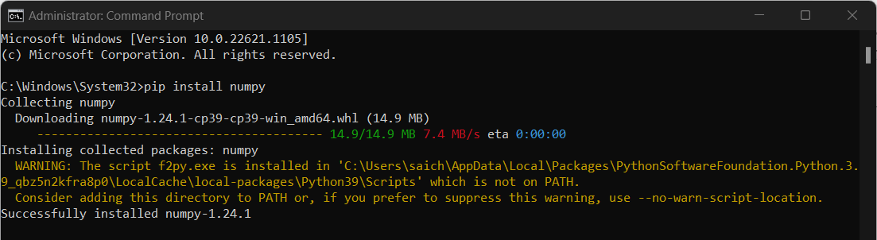

Using conda

Another way to download and install Python libraries is by using Anaconda, a distribution of Python that comes with a package manager called conda. Conda is a cross-platform package manager that can install, update, and remove packages. To install a library using conda, type

1."conda install [library name]"

In the command prompt or terminal. For example, to install the library Matplotlib, which is a library for creating plots and charts, you would type

2."conda install matplotlib"

In the command line. After running this command, conda will download and install the library in your system.

It's worth noting that pip and conda are not mutually exclusive. You can use both together. Conda can install both Python and non-python packages, and pip can only install python packages. Conda is also more powerful when managing dependencies. You can use it to create isolated environments with specific versions of Python and packages, so you don't have conflicts between packages. To create an isolated environment called "myenv" with python 3.8, you can use the command

3."conda create -n myenv python=3.8".

Then activate the environment using

Checking for installed packages

Before installing any library, it's recommended to check if it's already available in your system.

You can use the command:

"pip freeze" **or** "conda list"

Conclusion

There are various ways to download and install Python libraries, including pip, conda, and manual installation. It's important to ensure that the library you're installing is compatible with the version of Python you're using and that all dependencies are satisfied

**How to train and test**

In Python, you can train and test machine learning models using popular libraries like

**1.Data Preparation:**

* + Load and preprocess your dataset.
  + Split your data into a training set and a testing set (or validation set).
  + The training set is used to train the model, and the testing set is used to evaluate its performance.

**2.Choose a Model:**

* + Select an appropriate machine learning or deep learning model for your problem. The choice of the model depends on the nature of your data and the problem you're trying to solve.

**3.Training the Model:**

* + Use the training data to train your chosen model. In Python, this typically involves using libraries like scikit-learn or TensorFlow.
  + For scikit-learn, you can use the **.fit()** method on your model object to train it.
  + For TensorFlow or Keras, you would define a model, compile it, and then use the **fit()** method to train it.

# Example using scikit-learn

from sklearn.model\_selection import train\_test\_split

from sklearn.linear\_model import LinearRegression

# Split data into training and testing sets

X\_train, X\_test, y\_train, y\_test = train\_test\_split(X, y, test\_size=0.2, random\_state=42)

# Create and train a linear regression model

model = LinearRegression()

model.fit(X\_train, y\_train)

**Testing/Evaluating the Model**:

* Once the model is trained, you should test it on the testing dataset to evaluate its performance.
* Use appropriate evaluation metrics for your problem. For classification tasks, you might use metrics like accuracy, precision, recall, F1-score, or ROC AUC. For regression tasks, you might use metrics like mean squared error (MSE) or R-squared.

# Example using scikit-learn

from sklearn.metrics import mean\_squared\_error

# Make predictions on the test set

y\_pred = model.predict(X\_test)

# Calculate the mean squared error

mse = mean\_squared\_error(y\_test, y\_pred)

print("Mean Squared Error:", mse)

**5.Fine-Tuning** (Optional):

* + Depending on the results, you may need to fine-tune your model by adjusting hyperparameters or trying different algorithms.

**6.Deployment** (Optional):

* + If your model performs well and meets your criteria, you can deploy it for use in real-world applications.

Remember that the specific steps and libraries you use may vary depending on the machine learning or deep learning framework you choose and the problem you're trying to solve. The examples provided above are basic and serve as a starting point for the training and testing process in Python.

Rest of explaination:

1. **Python Libraries for Machine Learning:** Python has a rich ecosystem of libraries and frameworks for machine learning, making it a popular choice for data scientists and machine learning practitioners. Some of the most commonly used libraries include:
   * **TensorFlow and Keras:** These libraries are often used for deep learning and neural network-based tasks. TensorFlow is the underlying framework, and Keras is a high-level API for building neural networks.
   * **Pandas:** While not a machine learning library per se, Pandas is used for data manipulation and preparation, which is a crucial step in machine learning.
2. **Training and Testing in Python:** The typical process of training and testing a machine learning model in Python involves the following steps:
   * **Data Preparation:** Load and preprocess the dataset using libraries like Pandas.
   * **Data Splitting:** Split the dataset into training and testing subsets. This is typically done using tools like Scikit-Learn's **train\_test\_split**.
   * **Model Selection:** Choose an appropriate machine learning algorithm or model for your task.
   * **Model Training:** Train the selected model on the training data using methods provided by the chosen library.
   * **Model Testing:** Evaluate the model's performance on the testing dataset to assess its accuracy and other metrics.
3. **Datasets:** Datasets are the foundation of machine learning. They are collections of data used for training and testing machine learning models. Datasets can be diverse and come in various forms, such as tabular data. You can find datasets for various tasks on websites like Kaggle,
4. **Metrics for Accuracy Check:** The choice of metrics depends on the type of machine learning task you're working on. Common metrics include:
   * **Accuracy:** This is the most straightforward metric, especially for classification problems. It measures the ratio of correct predictions to total predictions.

In summary, Python offers a wide range of libraries for machine learning, and the process involves data preparation, model selection, training, testing, and evaluation using appropriate metrics depending on the problem at hand.

Metrices used for the accuracy check

Accuracy check

* Overall Accuracy and Error
* Errors of omission
* Errors of commission
* User’s accuracy
* Producer’s accuracy
* Accuracy statistics
* **Classification Tasks**:
  + **Accuracy**: This is the most common metric for classification tasks. It measures the ratio of correctly predicted instances to the total number of instances.
  + **Precision**: Precision is the number of true positive predictions divided by the sum of true positives and false positives. It is used when you want to minimize false positives.
  + **Recall (Sensitivity)**: Recall is the number of true positive predictions divided by the sum of true positives and false negatives. It is used when you want to minimize false negatives.
  + **Log Loss (Cross-Entropy Loss)**: This metric is often used for probabilistic classifiers. It measures the error between predicted probabilities and actual class labels.
* **Regression Tasks**:
  + **Mean Absolute Error (MAE)**: MAE is the average of the absolute differences between predicted and actual values. It provides a measure of the absolute error.
  + **Mean Squared Error (MSE)**: MSE is the average of the squared differences between predicted and actual values. It amplifies the impact of larger errors.
  + **Root Mean Squared Error (RMSE)**: RMSE is the square root of MSE. It provides a more interpretable measure compared to MSE.
  + **R-squared (R^2)**: R-squared measures the proportion of the variance in the dependent variable that is predictable from the independent variables. It ranges from 0 to 1, where higher values indicate a better fit.
  + **Mean Absolute Percentage Error (MAPE)**: MAPE calculates the percentage difference between predicted and actual values. It is often used in forecasting tasks.
* **Clustering Tasks**:
  + **Silhouette Score**: Silhouette score measures how similar an object is to its own cluster (cohesion) compared to other clusters (separation).
  + **Davies-Bouldin Index**: This index quantifies the average "similarity" between each cluster with the cluster that is most similar to it.
  + **Calinski-Harabasz Index (Variance Ratio Criterion)**: It measures the ratio of between-cluster variance to within-cluster variance. Higher values indicate better cluster separation.
* **Natural Language Processing (NLP)**:
  + **BLEU Score**: Used for machine translation and text generation tasks.
  + **ROUGE Score**: Used for text summarization and document comparison tasks.
  + **Perplexity**: Measures how well a language model predicts a sample. Lower perplexity indicates better performance.
* **Recommendation Systems**:
  + **Mean Average Precision (MAP)**: Measures the quality of a ranked list of recommendations.
  + **Normalized Discounted Cumulative Gain (NDCG)**: Evaluates the quality of a ranking system by taking into account the position of relevant items in the ranked list.

The choice of metric depends on the specific objectives of your project, and sometimes it's useful to consider multiple metrics to get a comprehensive view of model performance. It's essential to select metrics that align with the business or research goals and the nature of the data and task.Top of Form

**COVID-19 VACCINE ANALYSIS**

**DATASET**

The project aims to develop a machine learning-based system that analyzes transaction data in real-time, effectively detecting credit card fraud while minimizing false positives. This solution will help financial institutions protect against fraudulent transactions, reducing financial losses and ensuring customer trust

The Given Dataset is(<https://www.kaggle.com/datasets/imdevskp/corona-virus-report/>)

**DATA PREPROCESSING:**

Data preprocessing is the concept of changing the raw data into a clean data set. The dataset is preprocessed in order to check missing values, noisy data, and other inconsistencies before executing it to the algorithm.

The 5 major steps of data preprocessing:

* Data quality assessment.
* Data cleaning.
* Data transformation.
* Data reduction.

**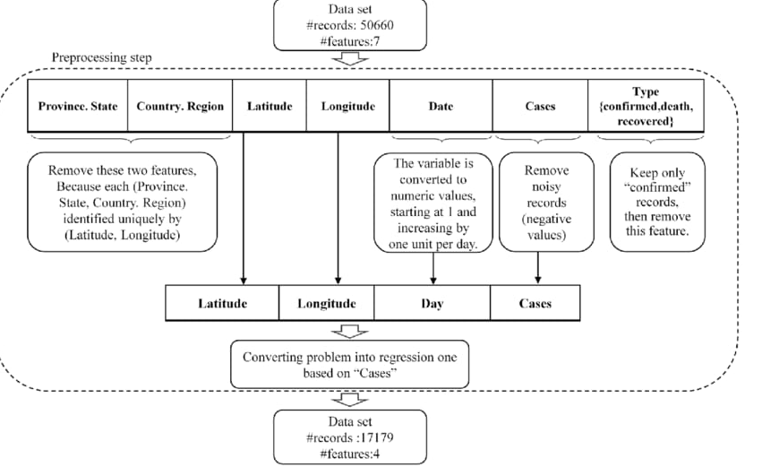**

import pandas as pd *# data manipulation , analysis, cleaning*

import numpy as np *# mathmatical calculations*

*# Plotly - interactive, open-source, and browser-based graphing library for Python*

import plotly.express as px

import plotly.graph\_objects as go

from plotly.subplots import make\_subplots

country\_wise = pd.read\_csv('/kaggle/input/corona-virus-report/country\_wise\_latest.csv')

day\_wise = pd.read\_csv('/kaggle/input/corona-virus-report/day\_wise.csv')

worldometer\_data = pd.read\_csv('/kaggle/input/corona-virus-report/worldometer\_data.csv')

DD\_CW1 = pd.read\_csv('/kaggle/input/corona-virus-report/full\_grouped.csv')

DD\_CW2 = pd.read\_csv('/kaggle/input/corona-virus-report/covid\_19\_clean\_complete.csv')

usa = pd.read\_csv('/kaggle/input/corona-virus-report/usa\_county\_wise.csv')

Country wise Analysis:

1. Total confirmed cases from each country

In [5]:

def plot\_map(df, location\_names,location\_mode,data\_col,scope,hover\_name=None,title=None,palette='Sunset'):

if hover\_name == None:

hover\_name = location\_names

fig = px.choropleth(df,

locations=location\_names,

locationmode =location\_mode,

color = data\_col,

scope = scope,

hover\_name = hover\_name,

hover\_data = data\_col,

title = title,

color\_continuous\_scale = palette)

fig.update\_layout(margin={"r":0,"l":0,"b":0})

fig.show()

plot\_map(country\_wise,location\_names='Country/Region',location\_mode='country names',data\_col='Confirmed',scope='world',palette='Peach',title='Confirmed cases in world')

plot\_map(country\_wise,location\_names='Country/Region',location\_mode='country names',data\_col='Deaths',scope='world',palette='amp', title='Death cases in world')

plot\_map(country\_wise,location\_names='Country/Region',location\_mode='country names',data\_col='Recovered',scope='world',palette='Greens',title='Recovered cases in world')

plot\_map(country\_wise,location\_names='Country/Region',location\_mode='country names',data\_col='Active',scope='world',palette='Oranges',title='Active cases in world')

00.5M1M1.5M2M2.5M3M3.5M4MConfirmedConfirmed cases in world

020k40k60k80k100k120k140kDeathsDeath cases in world

00.2M0.4M0.6M0.8M1M1.2M1.4M1.6M1.8MRecoveredRecovered cases in world

00.5M1M1.5M2M2.5MActiveActive cases in world

**The Vaccination Revelation: Unveiling the Potency of the Covid-19 Cure**



**Introduction**

Welcome to 'The Vaccination Revelation: Unveiling the Potency othe *Covid-19 Cure*'. In this presentation,we will explore the groundbreaking advancements in vaccine research and their impact on combating the pandemic. Join us on this *creative*

journey of discovery!

**Understanding Covid-19**

Before delving into the vaccine,

let's understand the

**Covid-19**

virus.

This highly contagious respiratory illness caused by the novel coronavirus has claimed millions of lives worldwide. We'll explore its transmission, symptoms, and long- term effects.



**The Race for a Vaccine**

Scientists and researchers embarked on an unprecedented race to develop a **safe and effective** vaccine against Covid-19. We'll dive into the different vaccine technologies employed, such as mRNA and viral vector, and the rigorous testing phases they underwent.



**Unveiling the Vaccine Efficacy**

The moment we've been waiting for! We'll discuss the remarkable efﬁcacy rates of authorized vaccines, highlighting their ability to prevent severe illness and reduce transmission. Let's explore the data and understand the real-world impact of these vaccines.



**Addressing Vaccine Misconceptions**

Unfortunately, misinformation and myths surround Covid-19 vaccines. We'll debunk common misconceptions, address safety concerns, and emphasize the extensive testing and regulatory processes that ensure

vaccine reliability.



**Vaccine Distribution and Challenges**

Ensuring equitable distribution of vaccines poses signiﬁcant challenges. We'll explore the global vaccination efforts, supply chain complexities, and strategies to overcome barriers, ensuring that no one is left behind in this ﬁght against the pandemic.



**The Path to Recovery**

As vaccination rates increase, we glimpse a path towards recovery. We'll discuss the potential impact of widespread vaccination on public health, the economy, and the return to a semblance of normalcy. Together, we can overcome this global crisis.

**Conclusion**

In this enlightening journey, we've uncovered the immense power of the *Covid-19 Cure*, the vaccines. From their development to distribution, we've witnessed the triumph of science and human resilience. Let's continue to embrace vaccination as a crucial tool in our ﬁght against the pandemic.

**Thank You!!!**