GATE 0 - PROJECT SYNOPSIS
Themes 1-5 | System / Tool / Engine based Mini Projects

Team No. | 10
Theme No. | 2
Project Title | Large scale Log Processing and Analytics Engine
Guide Name | Ms. Umadevi F M
Team Members | 1. Ananya Bhat  2. Priya Kshirasagar  3. Gurusiddeshwar N  4. Amit K

1. Background & Motivation
Modern systems run on many machines at once, and every application, server and device writes logs in its own format. Different sources use different fields and timestamp styles, the same event is often reported more than once, and some lines are malformed. Because of this, the combined logs cannot be searched or analysed directly. At scale the logs also arrive continuously, so they must be processed as they come in, without loading everything into memory.
This project builds a single-server log processing engine in C++, from scratch and without Kafka or similar tools. Logs from multiple sources arrive in real time over the network. The server cuts them into lines, converts each line into one common fixed schema, removes duplicates and writes the clean records into a single output file, while malformed lines are set aside with a reason.

2. Project Objectives
- Accept log streams from multiple sources at the same time over TCP and split each byte stream into complete log lines (framing).
- Parse lines of different formats (JSON, syslog, CSV, key=value or web-server logs) and normalize them into one fixed schema, sending malformed lines to a rejected file with a reason.
- Remove duplicate records using hash fingerprints held in sharded, bounded time-window sets, so that memory use stays flat and dedup threads do not share locks.
- Connect the stages with bounded queues so that a slow stage automatically slows the stages before it (backpressure), and write all clean records through a single writer thread into one output file.
- Verify correctness and speed with a stress test (many simulated sources with known duplicates), a thread sanitizer, and run counters (received = written + duplicates + rejected) with throughput reporting.

FOUNDATION COURSE INTEGRATION & CONCEPTUAL VIEW
Gate 0 - Themes 1-5
3. Foundation Course Integration
Identify at least three foundational courses that are expected to contribute meaningful technical depth. Mention only broad concepts/areas at this stage.
Sl. No. | Foundation Course | Broad Concepts / Areas Expected to be Applied | Role
1 | Operating Systems | Threads, mutexes and condition variables, file I/O and buffering, memory management | Dominant
2 | Data Structures & Algorithms | Bounded queues, hashing and fingerprints, hash sets, time-window expiry, sharding, complexity analysis | Dominant
3 | Computer Networks | Sockets (TCP), byte streams and message framing, many concurrent connections, flow control | Dominant
4 | Parsing & Text Processing | Tokenizing, format detection, regex or state machines, schema mapping, timestamp normalization | Supporting
4. Conceptual Workflow / System View
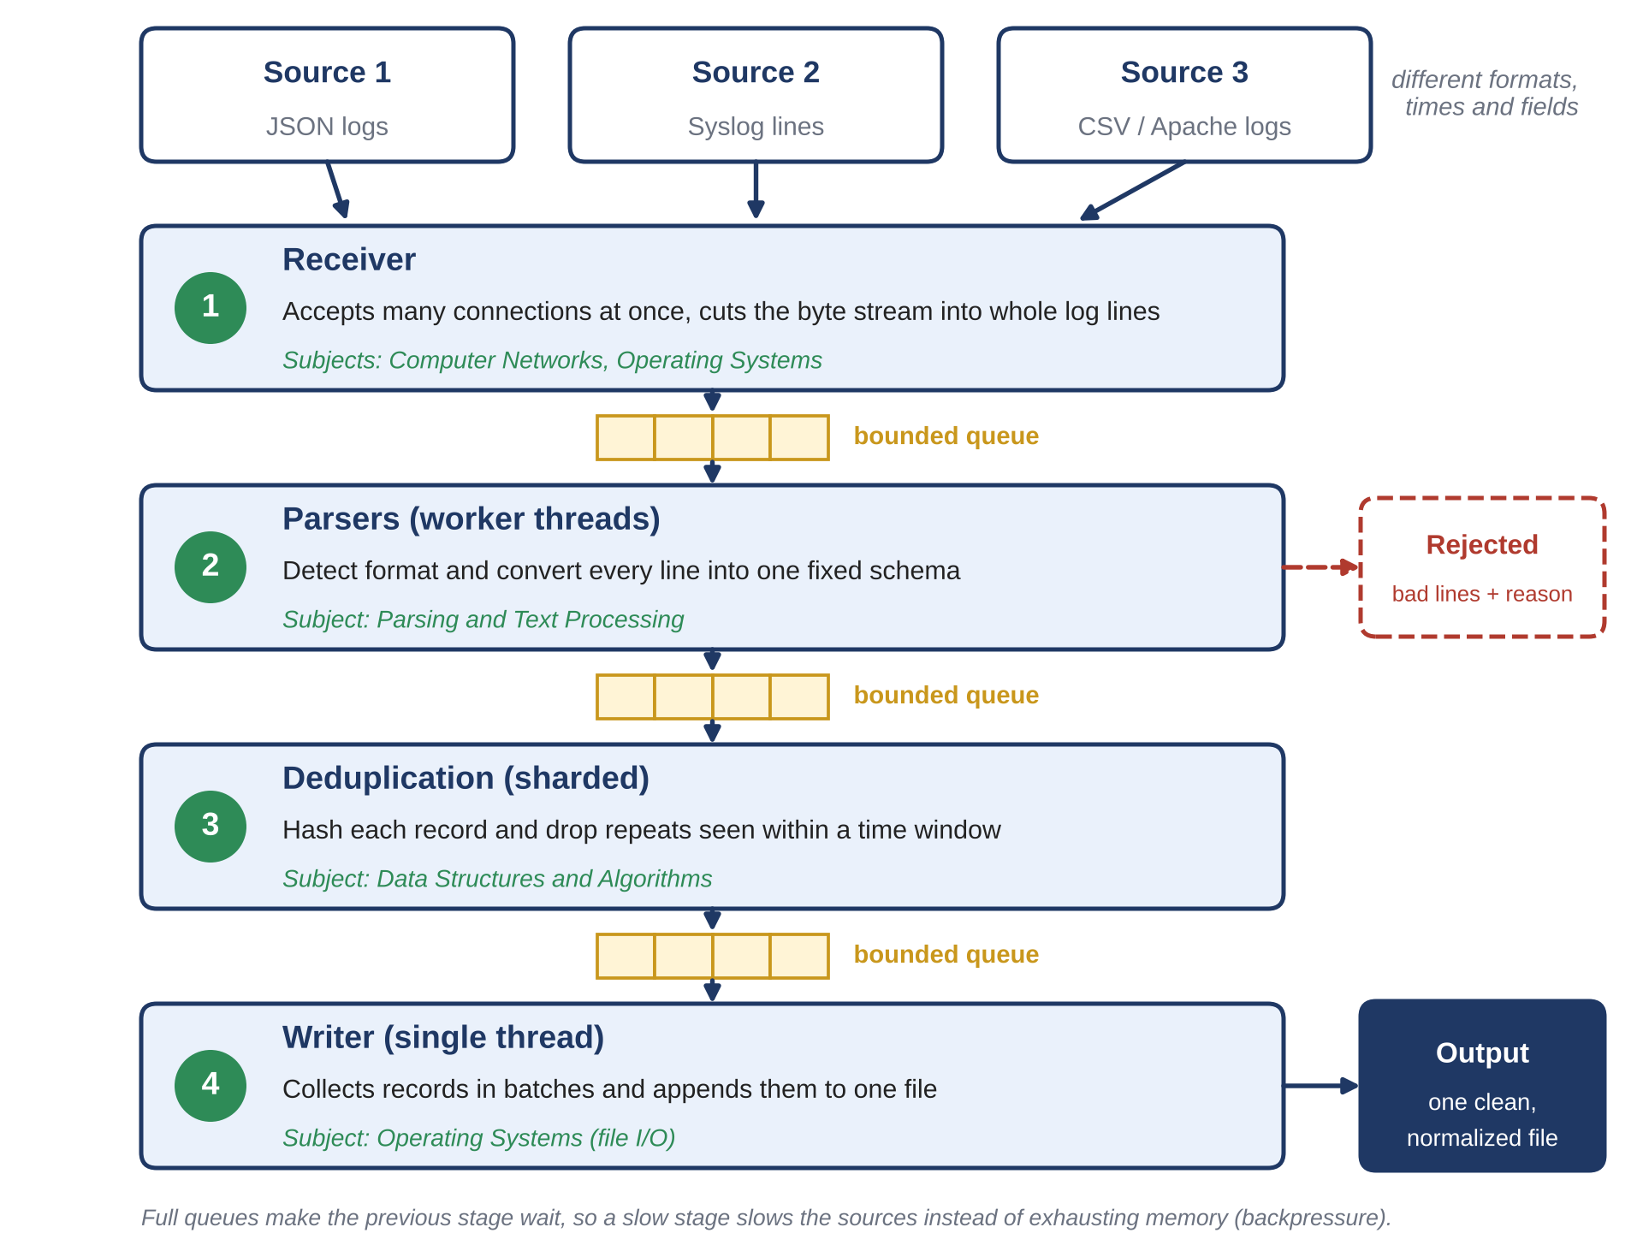

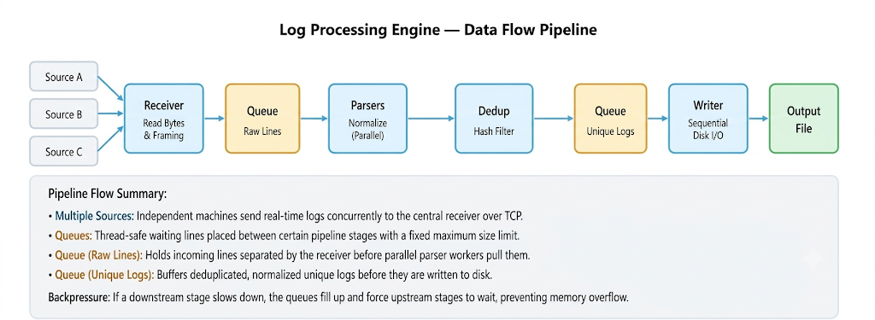

SCOPE & FEASIBILITY
Gate 0 - Themes 1-5
5. Broad Project Scope
Define the tentative technical boundary of the project. Detailed requirements will be derived later in S1.
5.1 Broadly In Scope
# | Broad In-Scope Item
1 | Concurrent ingestion of logs from multiple sources over TCP on one server, with line framing
2 | Parsing of several log formats, normalization to one fixed schema, and quarantine of malformed lines with a reason
3 | Bounded duplicate removal using hash fingerprints within a time window
4 | Bounded queues with backpressure, a single writer producing one normalized output file, graceful shutdown, and run counters with throughput reporting, verified by stress tests
5.2 Out of Scope
# | Out-of-Scope Item | Reason
1 | Multiple servers, distributed processing, and use of Kafka or other external streaming tools | The project is one server built from scratch; external tools would hide the core mechanisms.
2 | Strictly time-sorted output, crash recovery (write-ahead log) | Output follows roughly arrival order; these are advanced topics out of scope
3 | Databases, dashboards, machine-learning anomaly detection, user authentication and production deployment | Not part of the core mechanisms being studied; the output is a single file with run counters for analysis.
6. Feasibility & Constraints
Briefly assess whether the proposed scope is achievable as a 3-credit Mini Project. Identify required resources, prerequisite knowledge and major constraints. Existing libraries/tools may support peripheral functionality but should not completely hide the core mechanisms students are expected to design, implement and study.
Feasibility within 3-credit scope | Achievable as a 3-credit mini project. The pipeline has four small, well-defined engines (ingestion, parsing and normalization, de-duplication, queues and writer) that can be split across four team members and built stage by stage: first single-threaded, then with concurrency added one stage at a time.
Required computing / resources | One laptop (about 8 hardware threads, 16 GB RAM), a C++ compiler with thread and address sanitizers, and a small program to simulate log sources. No special hardware, database or cloud service is needed.
Prerequisite knowledge | Operating systems (threads, mutexes, condition variables, file I/O), data structures (queues, hashing), computer networks (sockets, TCP framing), text parsing basics, and C++.
Major constraints / limitations | Single server and no external streaming tools; limited by laptop cores and 16 GB RAM, so queues and dedup memory must stay bounded; duplicates are detected only within a fixed time window; test senders run on the same laptop, so measured throughput will be below true capacity; throughput is also limited by the single writer and disk speed.
Use of existing libraries / tools | Libraries are used only for peripheral work: the C++ standard library, a JSON parsing library and a test framework. The core mechanisms (bounded queue, framing, format parsers, normalization, sharded de-duplication, single writer and graceful shutdown) are implemented by the team.
Overall feasibility | High. The scope is bounded, the technology is familiar from the foundation courses, and every part can be tested with measurable targets (no lost or doubled records, received = written + duplicates + rejected, logs per second).

