CHAPTER 4 — SPRINT 1 STUDENT HANDBOOK

Complete Solution Design & Selective Partial Implementation
Combined handbook and student-entry templates | Hybrid SDLC: S2–S3 | Weeks 6–9 | Gate 2 / Review 3

4.1 Team and Engine Register
Enter team information only here. In the remaining sections use Engine ID (E1, E2, ...), requirement ID and diagram reference. Do not re-enter names or team details.
Field | Student entry
Team number
Theme
Artefact
Guide name
Department
Repository link
Date

Team members
Student | SRN / USN | Student name | Engine / main responsibility
Student A
Student B
Student C
Student D

Approved engines
Engine ID | Approved engine name | Owner (A–E) | Main function
E1
E2
E3
E4
E5

PART A — UNDERSTANDING AND EXECUTING SPRINT 1

4.2 What is a Sprint?
A sprint is a planned work period in which the team completes agreed technical work and shows evidence. Sprint 1 prepares the complete solution design and may start selected, ready-to-build parts of the software. A sprint is not an SDLC stage.
Term | Meaning for students
Engine | Technical part of the project owned by a student.
Sprint goal | What the team must achieve.
Sprint backlog | Tasks, owners and expected outputs.
Evidence | Diagrams, simple design explanations and any tested early code.
Gate | Faculty review of quality and readiness.

4.3 How Sprint 1 Fits into the Hybrid SDLC
S0 Problem Discovery and S1 Requirements Baseline, including Gates 0 and 1, are completed. Sprint 1 carries forward S2 and S3 activities. Gate 2 is the next formal review. Further implementation, validation, improvement and integration follow in later sprints.
Status | Stage / Review | What it means
Completed | S0–S1 / Gates 0–1 | Use the approved problem, SRS, requirements and engines.
Currently doing | Sprint 1 / S2–S3 | Complete the solution design and begin selected partial implementation if ready.
Next review | Gate 2 / Review 3 | Explain and defend design work and show any early code.
Later | S4–S7 | Broader implementation, testing, corrections, integration and closure.

4.4 Sprint 1 Goal
Convert approved requirements into a complete and consistent solution design for the entire project and every engine. Students may begin selected partial implementation where inputs, outputs and interfaces are clear. A fully working integrated application is not required at Gate 2.

4.5 What Students Should Design
Prepare the overall system architecture first. Then show how engines interact and prepare the internal architecture for each engine. Next, add database, sequence, state, activity, algorithms, interface, security and testing designs only where relevant to the chosen project.
Order | Student output | Expected?
1 | Overall System Architecture Diagram | Every team
2 | Engine Interaction / Dependency Diagram | Every team
3 | Engine-wise Architecture Diagram | Every approved engine
4 | End-to-End Sequence Diagram | At least one
5 | Database ER Diagram and main tables | If persistent data is used
6 | State / Activity Diagram | If meaningful states or workflows exist
7 | Algorithm / Data Structure, interface, security and error decisions | Where applicable
8 | Early working component with a simple check | Optional; if ready

4.6 Which Engine Should Start First?
Begin design for all engines in parallel where possible. Select implementation order based on real dependencies: an engine that produces data or a service needed by another may need to be built first. No student should remain idle while waiting for another engine.

4.7 Week-wise Work and Student Expectations
Use the continuing academic week numbers. Each student should explain the technical work of the assigned engine and maintain dated evidence.
Week | Student work | Expected result
Week 6 | Sprint backlog; overall architecture; engine interaction diagram; identify implementation candidates. | Team can explain the complete system and engine relationships.
Week 7 | Engine-wise diagrams; sequence diagrams; start relevant database/state/workflow design; optionally begin selected code. | Each student can explain engine inputs, outputs and internal operation.
Week 8 | Complete remaining applicable designs; algorithms, APIs, security and tests; continue/check any selected early code. | Complete design for each engine; early code has evidence if undertaken.
Week 9 | Submit diagrams and concise design notes; defend each engine at Gate 2; show code/tests only if available. | Pass / Revise / Resubmit decision.

4.8 Selective Partial Implementation
A student may implement a small, stable part such as an algorithm, database table, API stub or validation rule. Show what works, one simple test, and a Git commit or file reference. Early implementation must follow the design, not replace it.

4.9 Gate 2 Preparation and Assessment
Gate 2 checks whether the proposed solution and every engine are sufficiently designed to continue implementation. Every student must explain the engine independently. The assessment remains 20 raw marks, scaled to 10 ISA marks.
Assessment area | PI | Marks
System Architecture and Engine Decomposition | 12.1.1 | 5
Data/State, Interface and Detailed Design | 3.2.3 | 5
Algorithm, Data Structure and Technical Mechanism Selection | 3.2.2 | 5
Design Modelling, Tool Usage and Traceability | 5.2.1 | 5

Before Gate 2: all required diagrams should be present, any non-applicable design should have a brief reason, and diagrams should not contradict one another.

PART B — SIMPLE STUDENT EVIDENCE TEMPLATES
Fill student/team information only in Section 4.1. Work through these templates in the order shown. For each diagram, paste a readable image in the provided space, or insert a larger image as needed. Add rows only when necessary. Skip items that do not apply and state a short reason.

4.10 Sprint Plan and Backlog
Write only the essential tasks and who will do them.
Task | Engine ID / Owner | Output / Completion check
 |  | ewline-aligned chunks
Parse Log Lines & Drop Duplicates | E2 - DSA | Raw lines parsed into fields via Regex and duplicates filtered via Hash Set.
Configure Schema & Bulk Inserts | E3 - DBMS | Structured log records flushes to columnar database in bulk batches
Build REST API & Interactive UI | E4 - WEb | Dashboard fetches JSON metrics and renders dynamic time-series charts.

Engine ID | Start first / parallel? | Why?
E1 | Start first | Produces the raw log stream that powers all downstream engines.
E2 | Parallel | Can be built using sample chunk inputs while OS reader is finalized.
E3 | Parallel | Table schema can be set up using sample parsed log records.
E4 | Parallel | UI dashboard can be developed using static mock JSON payloads.

Diagram / evidence filename or repository link: ___________________________________

4.11 Overall System Architecture
Show actors, the main parts/engines, data storage and links between them. Do this before describing any engine internally.

Overall System Architecture Diagram
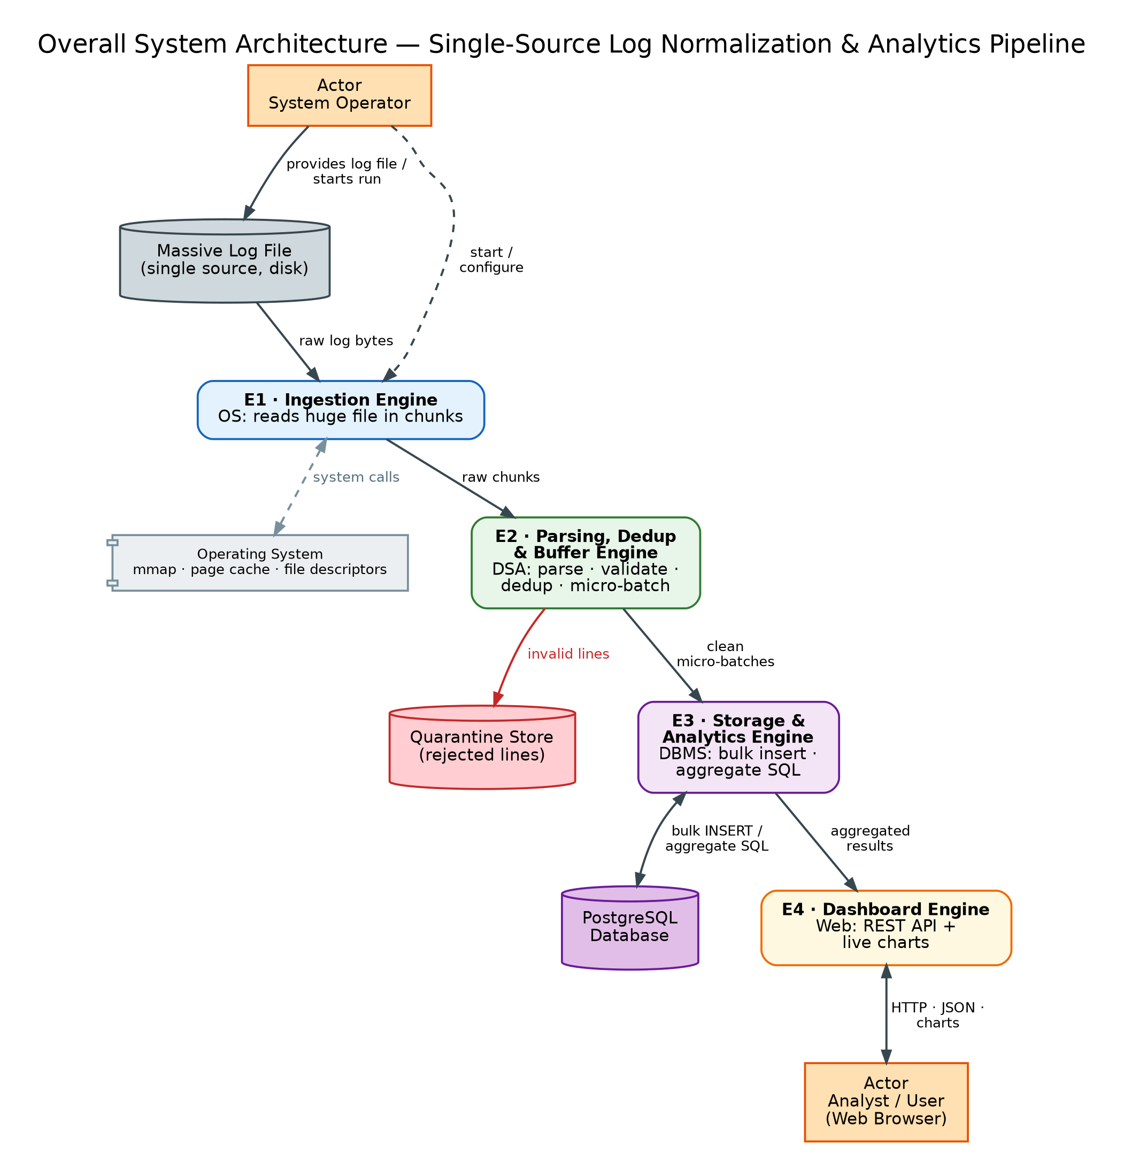

Main part / engine | What it does
Ingestion Engine (OS) | Opens the file and reads it in chunks using (mmap), page cache, file descriptors and system calls; passes raw chunks onto next stage
E2 Parsing, Dedup & Buffer Engine (DSA) | Extracts fields with regex and validates them, drops duplicates using a hash set with a sliding window, and groups records into micro-batches.
E3 Storage & Analytics Engine (DBMS) | Bulk-inserts micro-batches into PostgreSQL and runs aggregate SQL (GROUP BY) for trends
E4 Dashboard Engine (Web) | REST API returns aggregated results as JSON; HTML/CSS/JavaScript dashboard draws live charts.

Diagram / evidence filename or repository link: ___________________________________

4.12 Engine Interaction and Dependencies
Show which engine communicates with which other engine and what information is exchanged.

Engine Interaction Diagram
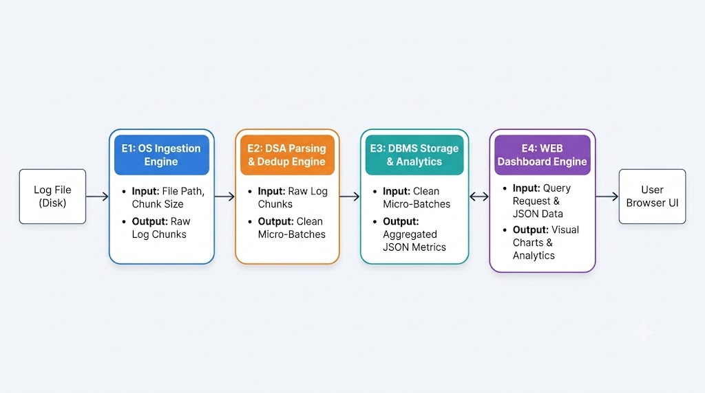

From engine | To engine | Data / message exchanged
Operating System | DSA (Parsing & normalization Engine) | Raw log lines sent in byte chunks
DSA | DBMS (Storage & Analytics Engine) | Clean, deduplicated log records sent in micro-batches
DBMS | WEB (Dashboard Engine) | Summary analytics results (error trends, volume counts) in JSON format
Web |  | Query requests (time range filters, log level selections)

Diagram / evidence filename or repository link: ___________________________________

4.13 Engine-wise Architecture
Prepare this once per approved engine. Show the parts inside the engine, its inputs, outputs and main operations.
Engine ID | Main responsibility | Inputs | Outputs
E1 | Efficiently read the single massive log file using memory mapping, the page cache, and clean file-descriptor handling | Log file path, chunk size, log file on disk | Raw log chunks or lines for E2, plus status, errors and progress offset
E2 | Turns raw log into unique, validated records: regex parsing, validation with quarantine of bad lines, duplicate removal using a bounded hash set with a sliding window, and micro-batch buffering | Raw log chunks from E1 Ingestion Engine. | Clean micro-batches to E3 Storage & Analytics Engine;  rejected lines with the reason to the Quarantine Store;  counts of valid, duplicate and quarantined lines for the run summary.
E3 | Log Data Storage, Bulk Insert Processing, Schema Management, Indexing, Data Consistency, SQL Aggregation, Error Trend Analysis, Event Frequency Analysis, Volume Spike Detection | Normalized Log Records, Deduplicated Log Data, Micro-Batch Records | Stored Log Records, Indexed Database Tables, Aggregated SQL Results, Error Statistics, Event Frequency Reports, Log Volume Trends, Analytical Data for Dashboard

Paste Engine-wise Architecture Diagram(s) — duplicate this space for each engine

Operating System
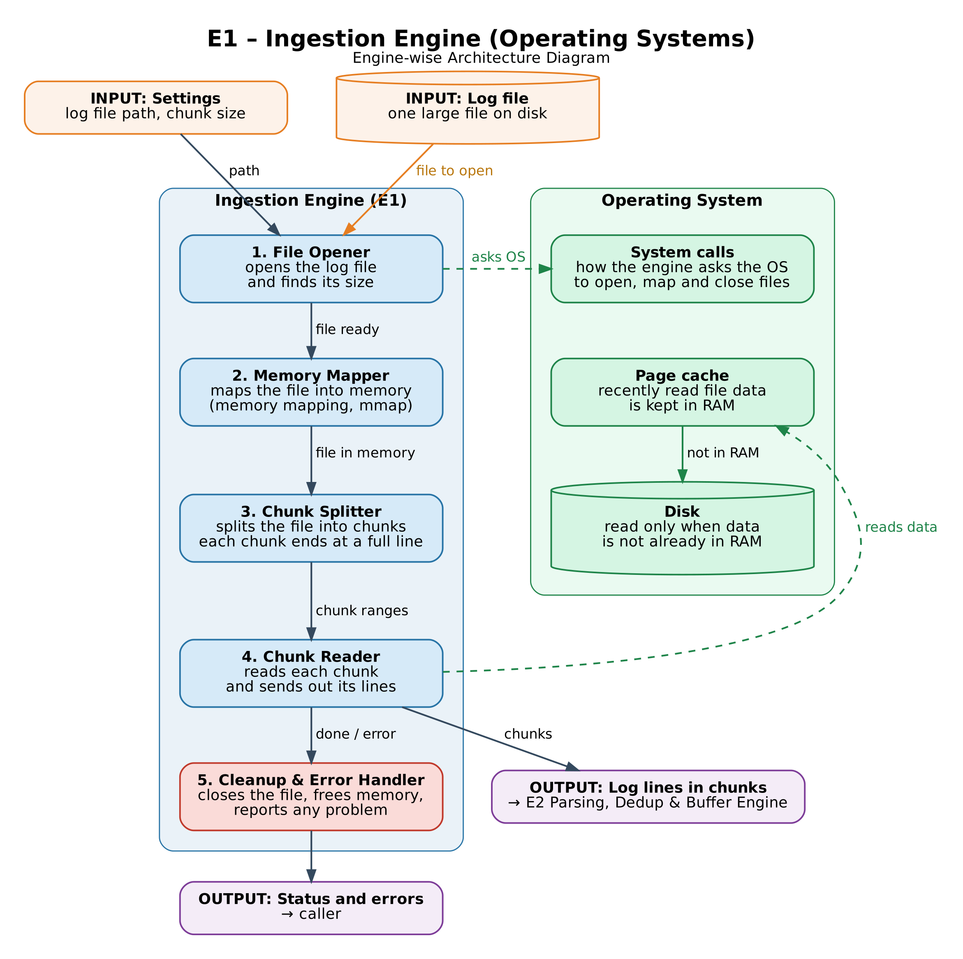

DSA
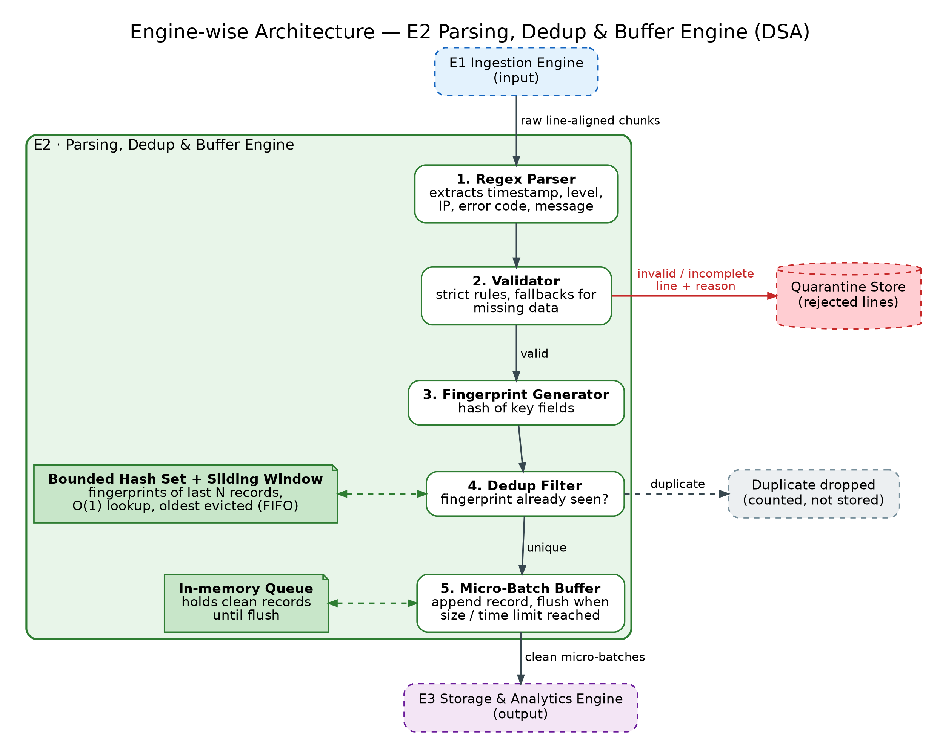

DBMS
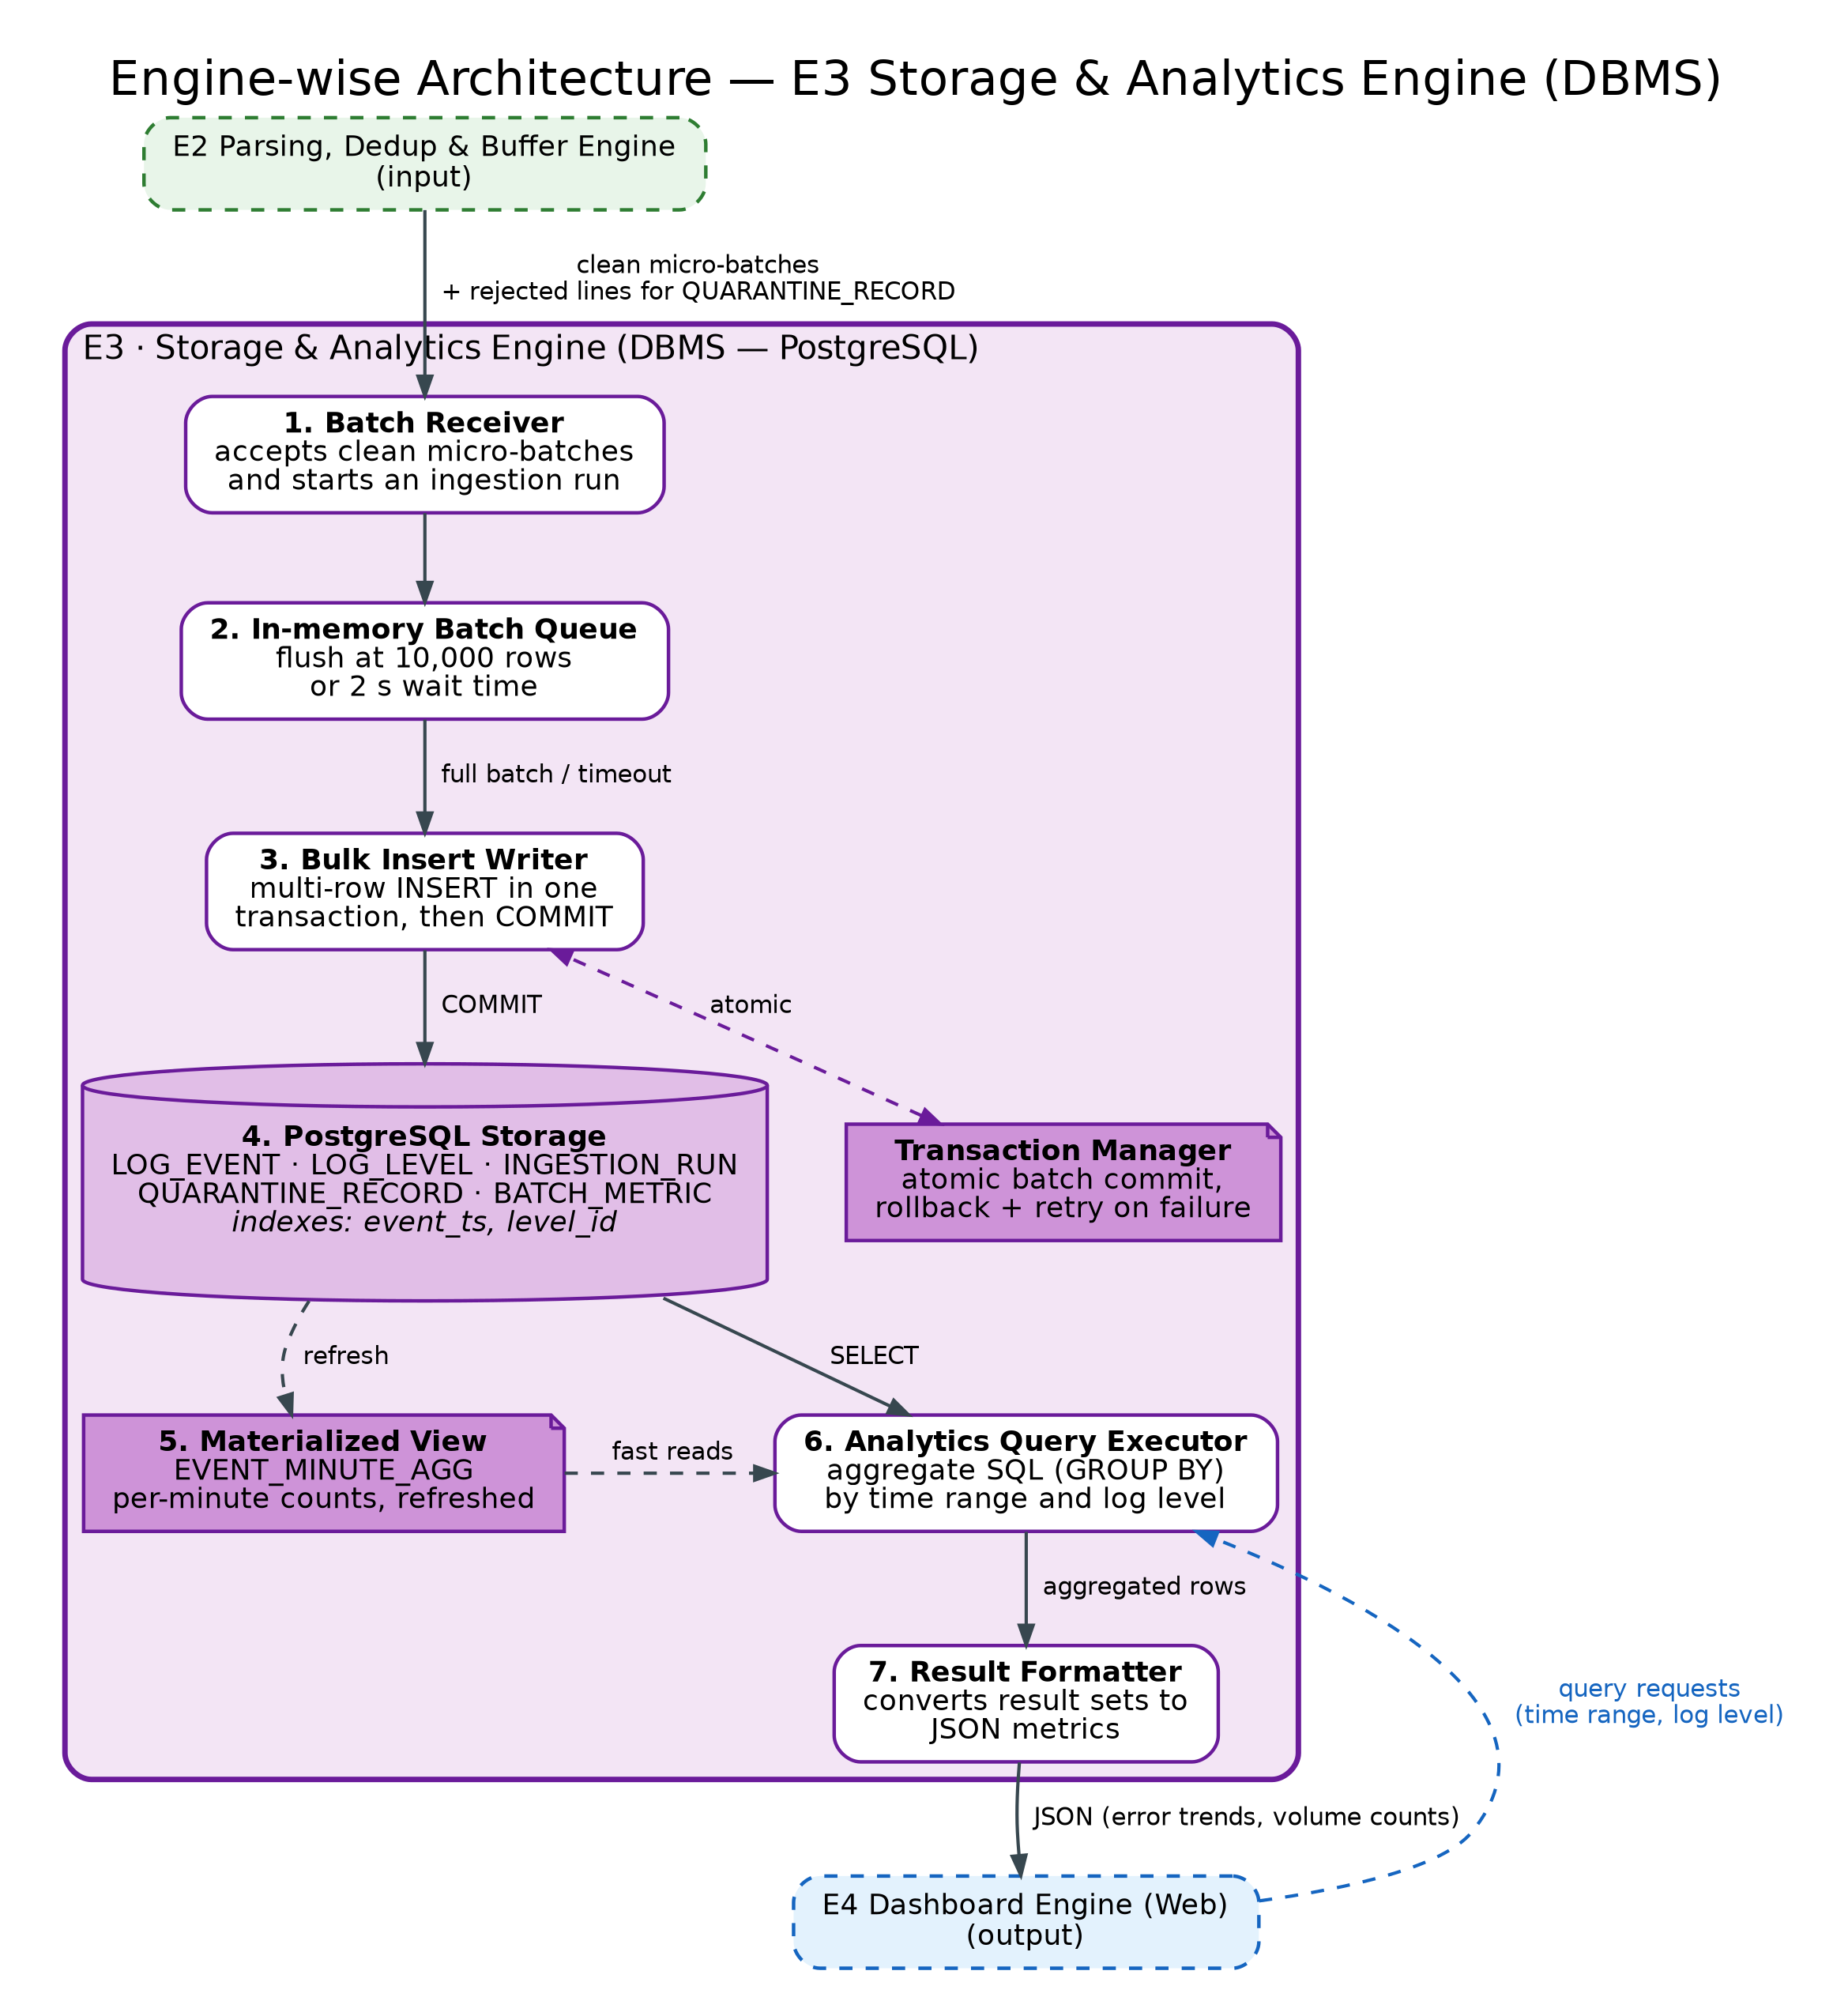

Web Technology

Diagram / evidence filename or repository link: ___________________________________

4.14 Sequence Diagram
Show the order of messages or actions for one main system use case. Include at least one end-to-end sequence.

End-to-End Sequence Diagram
PASTE / DRAW DIAGRAM OR IMAGE HERE

Use case / scenario | Main interaction | If something fails

Diagram / evidence filename or repository link: ___________________________________

4.15 Database Design
Complete only if the project stores structured data. Draw an ER diagram and list the important tables and fields.

Entity Relationship (ER) Diagram
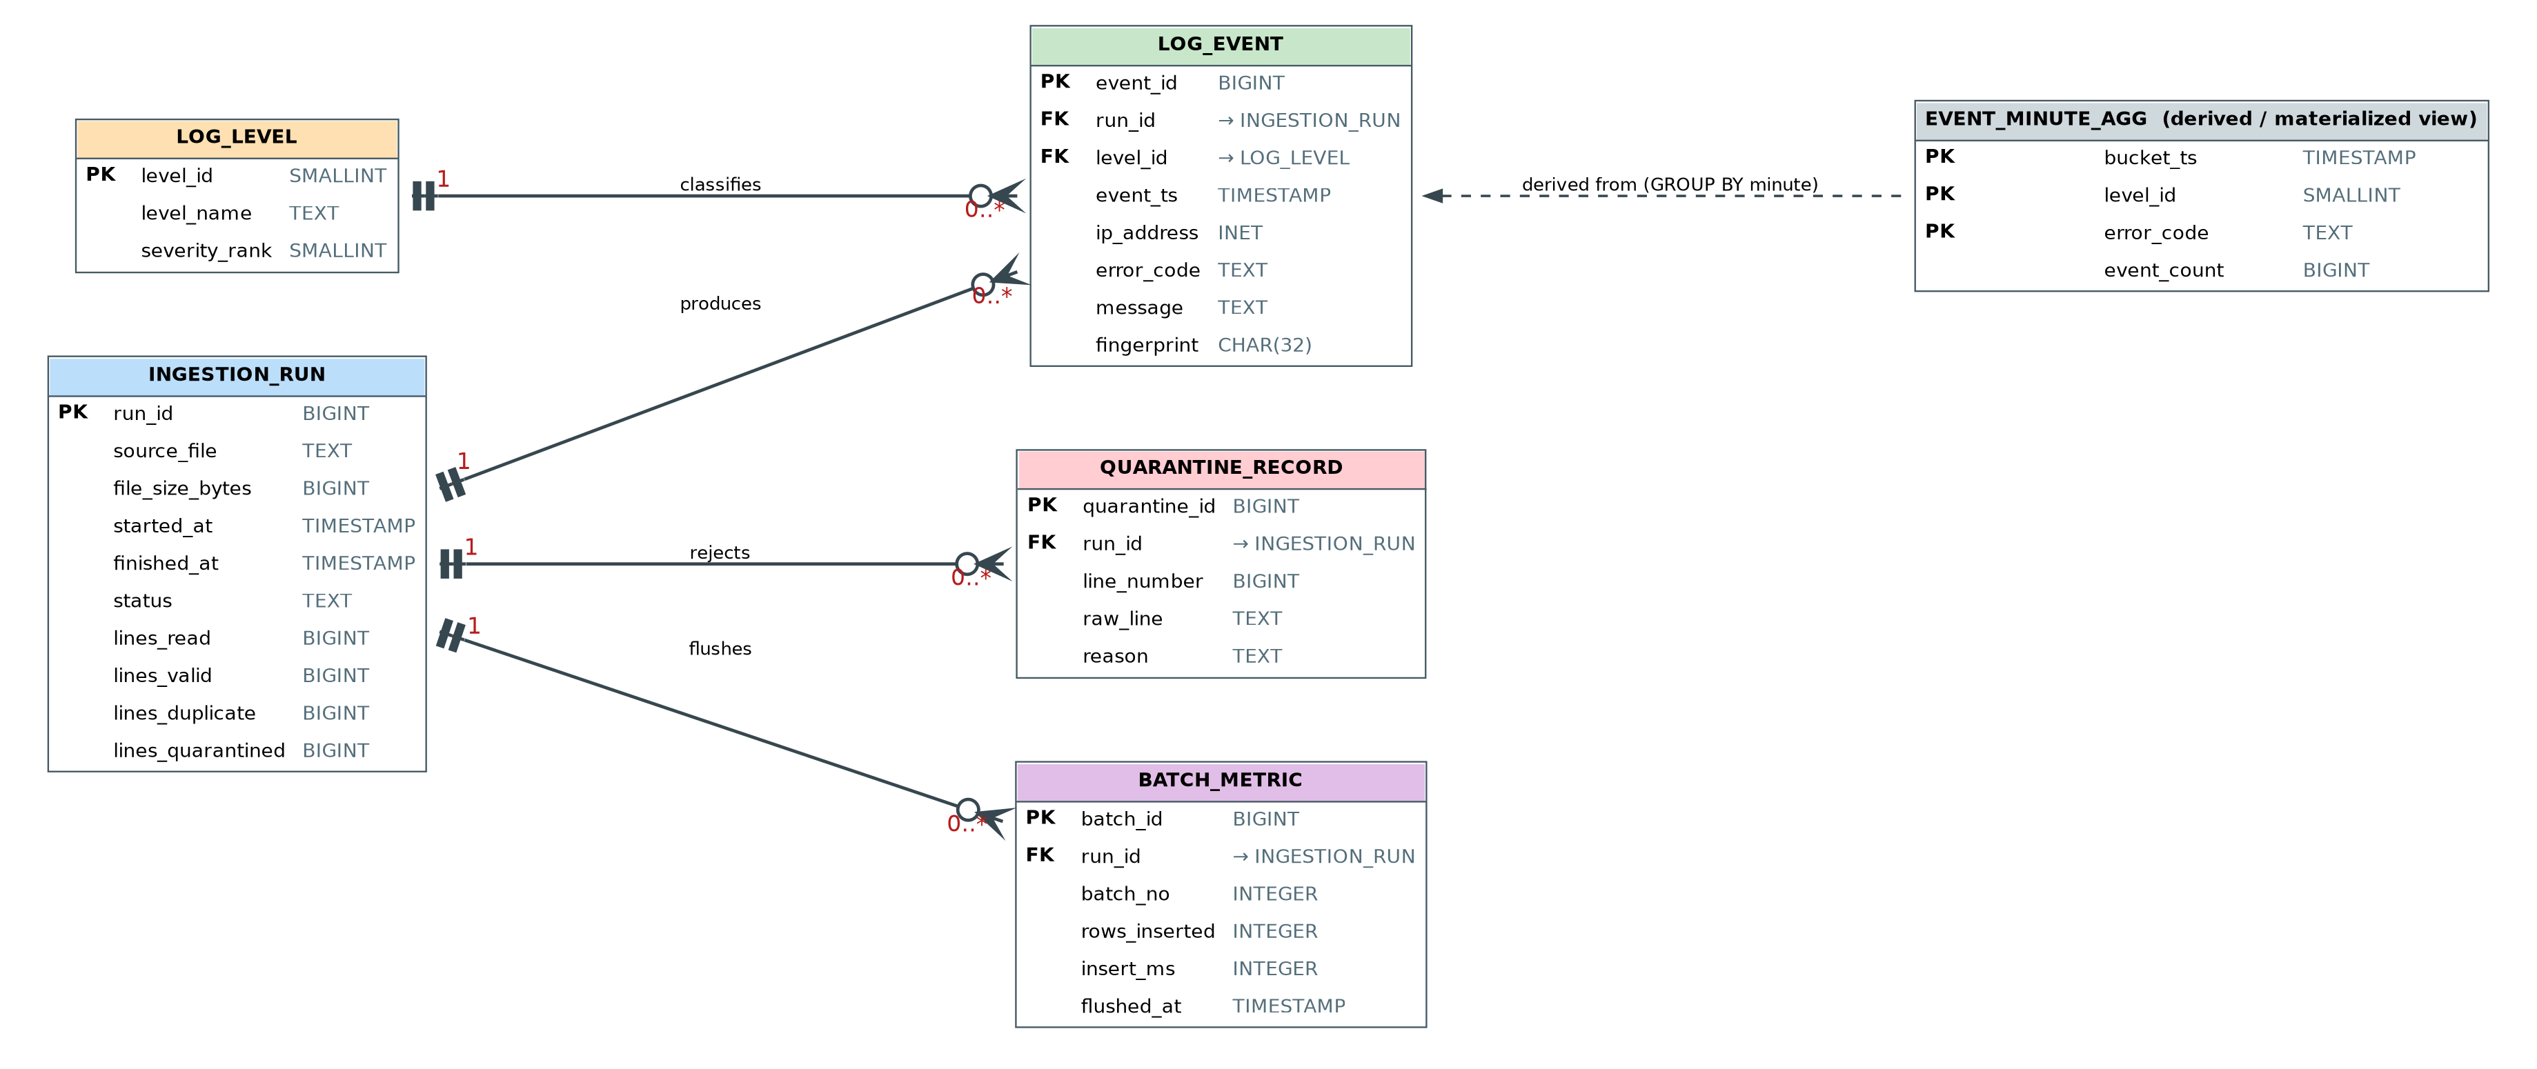

Table / entity | Key fields | Relation / purpose
INGESTION_RUN | run_id (PK), source_file, started_at, finished_at, status, lines_read, lines_valid, lines_duplicate, lines_quarantined | Parent table:  one row per pipeline run with its summary counts.
LOG_EVENT | event_id (PK), run_id (FK), level_id (FK), event_ts, ip_address, error_code, message, fingerprint | Cleaned log records.  Many events belong to one run and one log level.
LOG_LEVEL | level_id (PK), level_name, severity_rank | Lookup table of log levels;  one level classifies many events.
QUARANTINE_RECORD | quarantine_id (PK), run_id (FK), line_number, raw_line, reason | Rejected lines with the reason; many per run.
BATCH_METRIC | batch_id (PK), run_id (FK), batch_no, rows_inserted, insert_ms, flushed_at | Per micro-batch insert statistics; feeds throughput and latency charts.
EVENT_MINUTE_AGG (view) | bucket_ts, level_id, error_code (composite key), event_count | Materialized view derived from LOG_EVENT;  per-minute counts for error-trends

Diagram / evidence filename or repository link: ___________________________________

4.16 State Diagram
Complete if objects or processes have states such as Pending, Approved or Rejected.

State Diagram
PASTE / DRAW DIAGRAM OR IMAGE HERE

State | Event / action | Next state

Diagram / evidence filename or repository link: ___________________________________

4.17 Activity / Workflow Diagram
Complete if important work follows decisions, branches, loops or multiple steps.

Activity / Workflow Diagram
PASTE / DRAW DIAGRAM OR IMAGE HERE

Main step | Decision / alternate path

Diagram / evidence filename or repository link: ___________________________________

4.18 Algorithm and Data Structure
For each engine that uses a significant algorithm, briefly show the steps and why the method is suitable.
Engine ID | Algorithm / data structure | Why selected
Operating System | Data Structure: Virtual Memory Buffer (mmap), File Descriptors (fd)  • Algorithm: Zero-Copy Scanning, Newline-Aligned Chunking (\n) | Reads massive files directly via kernel memory, keeping RAM usage tiny and avoiding slow disk reads.
Data Structure and Algorithm | Data Structure: Bounded Hash Set, Sliding Window Queue, Regex Patterns  • Algorithm: Regex Matching, Fingerprint Hashing | Parses raw log lines quickly and drops duplicate logs instantly with fixed memory.
DBMS | Data Structure: In-Memory Batch Queue, Columnar Storage, Database Indexes  • Algorithm: Bulk Inserting, Aggregate SQL (GROUP BY) | Saves thousands of logs in one write and allows super-fast analytics queries over millions of rows.
Web Technology | Data Structure: JSON Objects, Client-Side Arrays  • Algorithm: REST API Fetching, Chart Canvas Rendering | Sends light JSON data over HTTP to draw live interactive charts in the web browser

Algorithm Flowchart / Pseudocode Image (if useful)
Operating System
ALGORITHM: IngestLogFileWithMmap
INPUT: filePath (string), targetChunkSize (bytes)
OUTPUT: Stream of byte-chunks (aligned to newlines)

1. fd = OS.open(filePath, READ_ONLY)
2. fileSize = OS.fstat(fd).size
3. mmapBuffer = OS.mmap(fd, length=fileSize, access=READ)
4. startOffset = 0

5. WHILE startOffset < fileSize DO
6. endOffset = startOffset + targetChunkSize
7. IF endOffset >= fileSize THEN
8. endOffset = fileSize
9. ELSE
10. // Scan forward to nearest newline to prevent line slicing
11. WHILE endOffset < fileSize AND mmapBuffer[endOffset] != '\n' DO
12. endOffset = endOffset + 1
13. END WHILE
14. IF endOffset < fileSize THEN endOffset = endOffset + 1 // include '\n'
15. END IF
16.
17. chunkData = mmapBuffer[startOffset : endOffset]
18. YIELD chunkData TO ParsingEngine (E2)
19. startOffset = endOffset
20. END WHILE

21. OS.munmap(mmapBuffer)
22. OS.close(fd)

Data Structure and Algorithm
ALGORITHM: ParseAndDeduplicate
INPUT: rawLogChunk (byte-array), slidingWindowSize (integer)
OUTPUT: Clean, unique log records

1. logLines = Split rawLogChunk by newline ('\n')
2. FOR EACH line IN logLines DO
3. // Step 1: Parsing
4. parsedData = RegexMatch(line, LOG_PATTERN)
5. IF parsedData IS NULL THEN
6. SendToQuarantine(line)
7. CONTINUE
8. END IF
9.
10. // Step 2: Deduplication
11. fingerprint = Hash(parsedData.timestamp, parsedData.level, parsedData.message)
12. IF HashSet.contains(fingerprint) THEN
13. CONTINUE // Skip duplicate entry
14. END IF
15.
16. // Maintain Bounded Sliding Window
17. IF Queue.size() >= slidingWindowSize THEN
18. oldFingerprint = Queue.pop()
19. HashSet.remove(oldFingerprint)
20. END IF
21.
22. HashSet.add(fingerprint)
23. Queue.push(fingerprint)
24.
25. SendToDBMSBuffer(parsedData)
26. END FOR

DBMS
ALGORITHM: BatchInsertAndQueryEngine
INPUT: streamOfParsedLogs, maxBatchSize (e.g., 10000), maxWaitTime (e.g., 2 sec)

1. batchBuffer = EMPTY_LIST
2. lastFlushTime = CURRENT_TIME()

3. WHILE pipelineIsRunning DO
4. record = ReceiveFromPipeline()
5. IF record IS NOT NULL THEN
6. batchBuffer.append(record)
7. END IF
8.
9. // Step 1: Micro-Batch Flushing Logic
10. timeElapsed = CURRENT_TIME() - lastFlushTime
11. IF batchBuffer.size >= maxBatchSize OR timeElapsed >= maxWaitTime THEN
12. IF batchBuffer IS NOT EMPTY THEN
13. ExecuteBulkInsert(batchBuffer)
14. batchBuffer.clear()
15. END IF
16. lastFlushTime = CURRENT_TIME()
17. END IF
18. END WHILE

FUNCTION ExecuteBulkInsert(records):
19. SQL = "INSERT INTO log_table (timestamp, level, service, message) VALUES "
20. SQL = SQL + FormatAsBulkValues(records)
21. DatabaseConnection.execute(SQL)
22. COMMIT

FUNCTION FetchErrorAnalytics():
23. query = "SELECT level, COUNT(*) FROM log_table WHERE timestamp >= NOW() - INTERVAL '1 HOUR' GROUP BY level"
24. RETURN DatabaseConnection.query(query)

Web Technology
ALGORITHM: DashboardDataFetchAndRender
INPUT: apiEndpoint (URL), refreshInterval (milliseconds)
OUTPUT: Live visual charts on the browser UI

// Server-Side: API Route Handler
FUNCTION HandleAnalyticsRequest(request, response):
1. analyticsData = DBMS.query("SELECT level, COUNT(*) FROM logs GROUP BY level")
2. jsonPayload = ConvertToJSON(analyticsData)
3. response.setHeader("Content-Type", "application/json")
4. response.send(200, jsonPayload)

// Client-Side: Dashboard Rendering Loop
FUNCTION StartDashboardLoop():
5. WHILE dashboardIsOpen DO
6. rawData = FetchHTTP(apiEndpoint)
7. parsedJSON = ParseJSON(rawData)
8.
9. // Update Time-Series Chart Datasets
10. chartDataset.timestamps.push(parsedJSON.currentTime)
11. chartDataset.errorCounts.push(parsedJSON.errorCount)
12.
13. // Maintain fixed chart window size
14. IF chartDataset.length > MAX_POINTS THEN
15. chartDataset.shift() // Remove oldest data point
16. END IF
17.
18. RenderCanvasChart(chartDataset)
19. Sleep(refreshInterval)
20. END WHILE

Diagram / evidence filename or repository link: ___________________________________

4.19 API / Data Exchange
Complete when engines exchange requests, messages or data. Write the basic input and output format.
From / to engine | Request / data input | Response / result
OS -> DSA | Byte offset ranges and target chunk size (e.g., 64MB) | Raw, newline-aligned byte stream chunk (mmap slice)
DSA -> DBMS | Streamed array of normalized, deduplicated log objects | Execution confirmation (status: "200 OK", inserted record count)
WEB -> DBMS | HTTP GET query parameters (time_range, severity_level) | Aggregated SQL result set (counts grouped by time/severity)
DBMS -> WEB | Aggregated JSON metric payload | Visual dashboard chart update rendered on UI

API Flow / Sample Request–Response (if useful)
PASTE / DRAW DIAGRAM OR IMAGE HERE

Not yet started integration, still working on individual implementation.

Diagram / evidence filename or repository link: ___________________________________

4.20 Security, Errors and Testing
Show important permissions, validation and error responses. Explain how you will check the design.
Area | Simple student explanation
Who can access or change important data? | Read-Only Ingestion & Database Access Constraints:  • The OS Ingestion Engine (E1) opens raw log files in strict read-only mode (O_RDONLY / access=READ) to prevent accidental overwrites.  • Downstream database tables allow write access only to the internal pipeline ingestion engine, while external dashboard API users get read-only SQL access.
What happens for invalid input or a failed request? | Graceful Handling & Error Responses:  • Unparseable or corrupt log lines bypass processing and get logged to a quarantine file (corrupt_logs.log) without crashing the pipeline.  • Database connection failures or micro-batch write errors trigger.  • Invalid WEB API calls return standard HTTP status codes (400 Bad Request or 500 Server Error) with JSON error messages.
Is copying of large data necessary, and who owns it? | Zero-Copy Memory Access & Ownership:  Data copying is avoided by using POSIX mmap, which maps raw files directly from disk into virtual memory address space.  • Memory ownership remains strictly with the host kernel during reading, while clean structured micro-batches are handed over directly to the DBMS engine.
How will you test the main functions? | End-to-End Test Plan:  • OS Engine: Unit test file reading using mock byte offsets and verify chunk alignment on newline (\n) characters.  • DSA Engine: Run unit tests with regex pattern matching against standard log samples and verify duplicate dropping with identical records.  • DBMS Engine: Perform bulk insert throughput tests and verify query execution times under 1 second.  • WEB Engine: Integration test REST endpoints to confirm valid JSON responses are returned for dashboard rendering.

Diagram / evidence filename or repository link: ___________________________________

4.21 Selected Partial Implementation
Optional. Record only the part actually started and tested.
Engine ID | Part started | What works / what is pending | Test / Git reference

Optional Screenshot of Working Component
PASTE / DRAW DIAGRAM OR IMAGE HERE

Diagram / evidence filename or repository link: ___________________________________

4.22 Requirements Mapping and Gate 2 Checklist
Show which design covers each key requirement and confirm the evidence before review.
Requirement ID | Related engine / design diagram

Gate 2 check | Yes / No / N/A
Overall architecture and engine-wise architecture included
End-to-end sequence diagram included
Database / state / activity diagrams added wherever needed
Algorithms, interfaces and security explained where relevant
Any early implementation matches design
Every student can explain assigned engine

Diagram / evidence filename or repository link: ___________________________________

