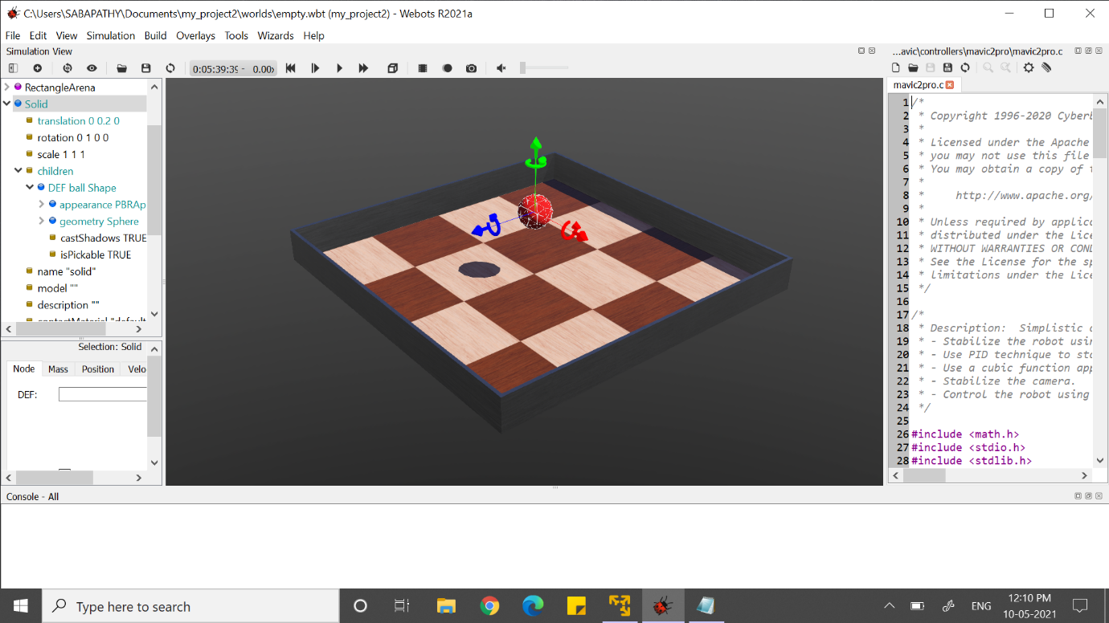

Fig 1.1(creating object in webot)

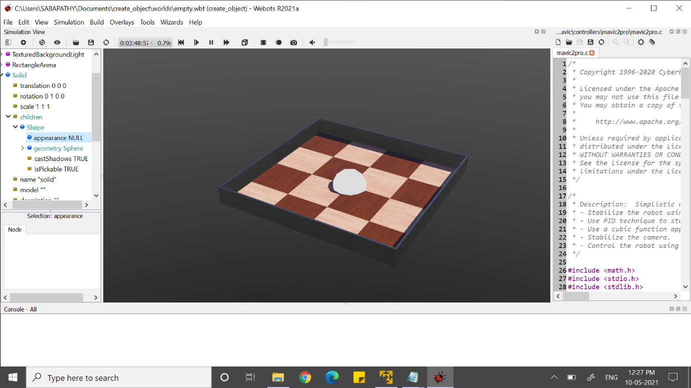

(in solid=> go to children=>create shape=>in that geometry sphere)

Fig 1.2(sphere in rectangle arena)

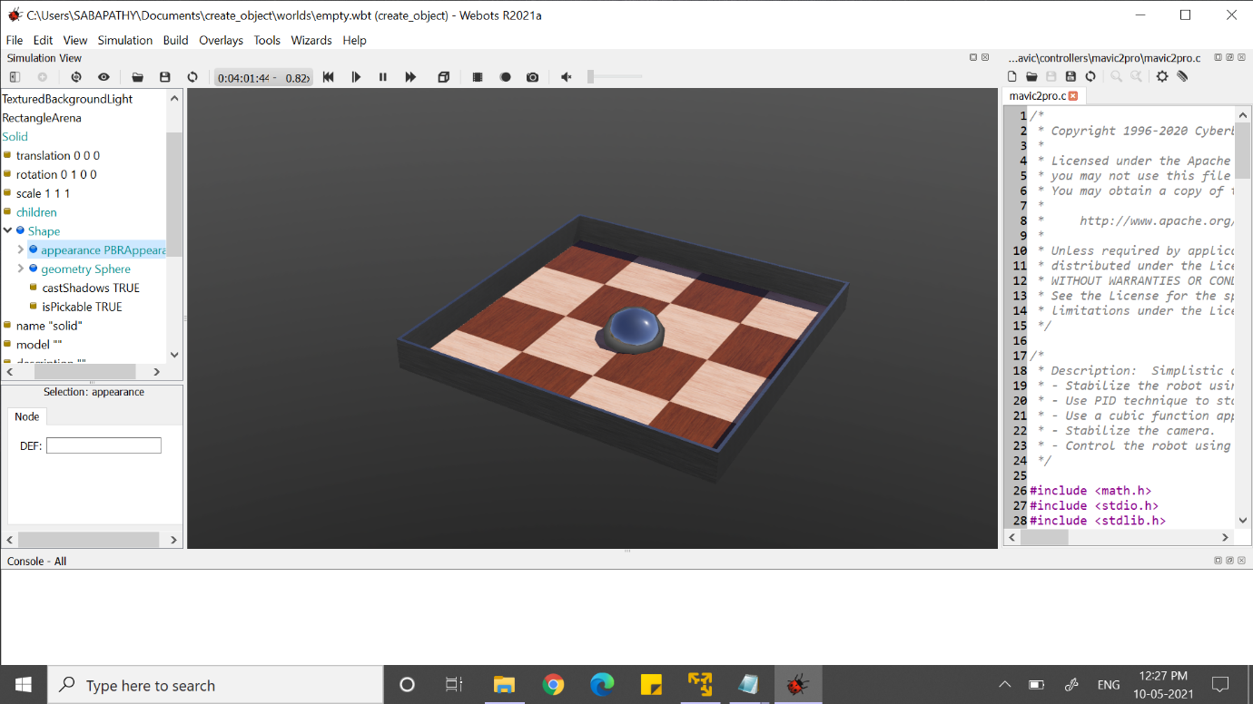

(create the shape under PBRAppearance)

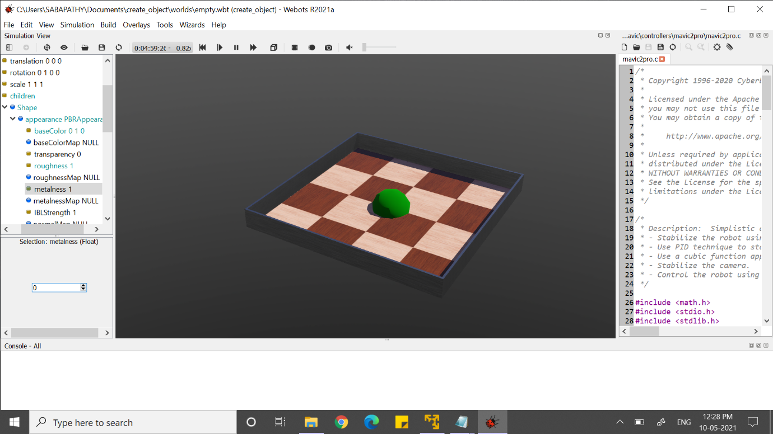

(under appearance PBRAppearance=>we can change colour in base colour)

(change metalness=0 and roughness=1)