TASK – 6 ELEVATE LABS : Create a Strong Password and Evaluate Its Strength. OBJECTIVE : Understand what makes a password strong and test it against password strength tools
NAME : Priya Rose
DATE : 13-08-2025

Password Strength Analysis Report
Objective:
Evaluate multiple passwords of varying complexity using an online password strength checker. Identify best practices for creating secure passwords and understand how complexity improves resistance to common attacks.

Tool Used:
- Website: PasswordMeter.com

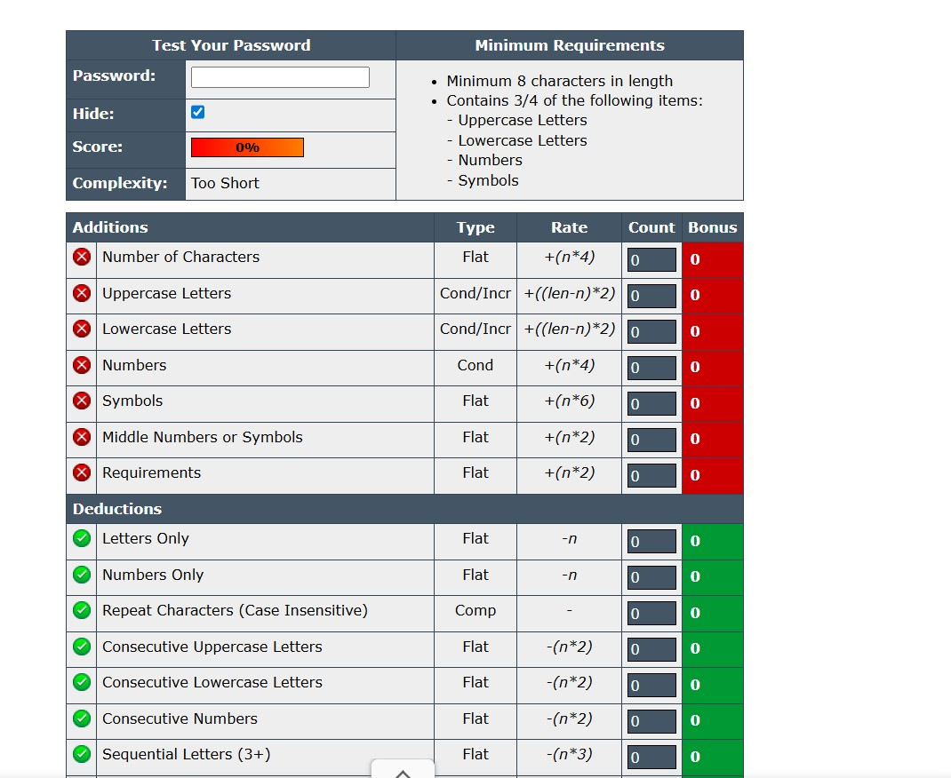

Test Passwords and Results
- Password: password o
- Score: 8% o
- Complexity Level: Very Weak o
- Feedback:
- Too short
- All lowercase letters
- No numbers or special characters
- Very predictable and commonly used
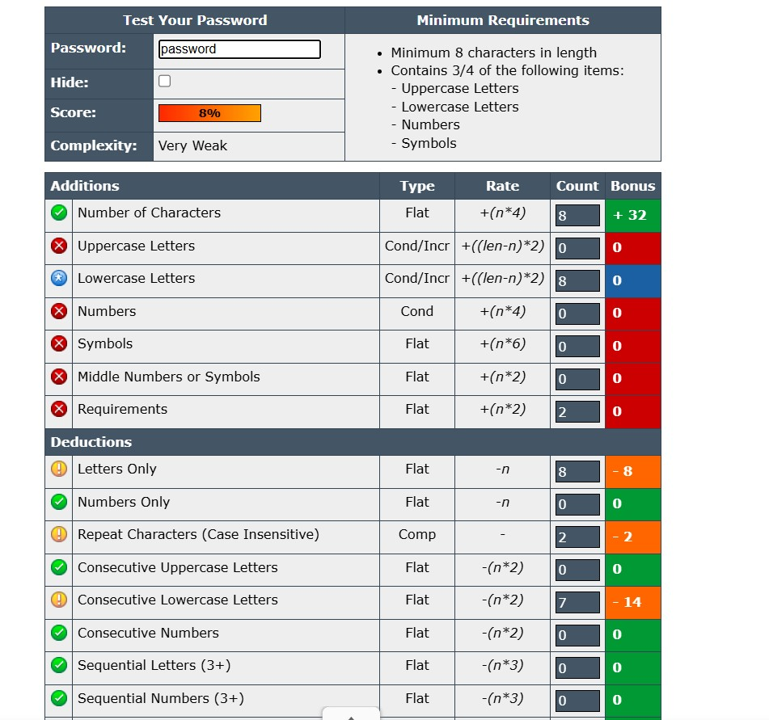

Password : Password1
Score: 54%
Complexity Level: Weak
Feedback:
- Basic structure o
- Includes a capital letter and number o
- No special characters o
- Still predictable
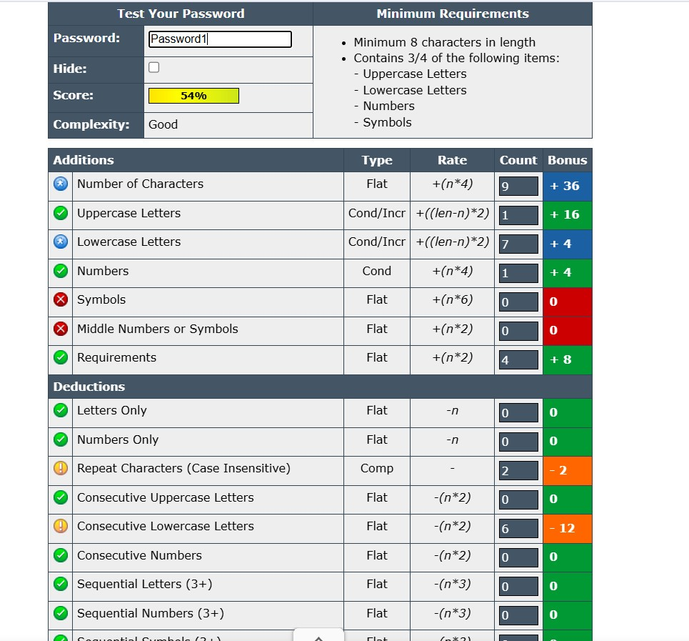

Password : P@ssw0rd123
Score : 100%
Complexity Level: Strong
Feedback:
- Good length o
- Uses a mix of uppercase, lowercase, numbers, and a special character
- Slightly predictable due to use of "password" pattern
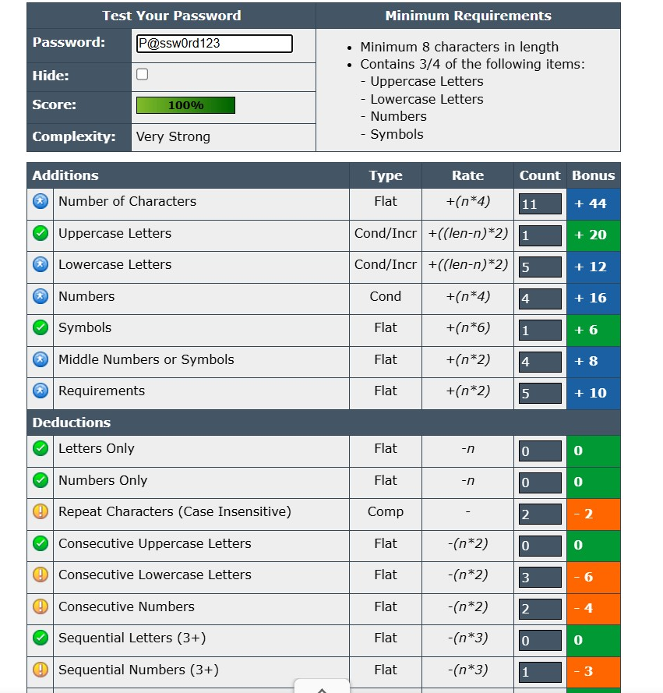

Password : X3$u9!RzQp7@
Score :100%
Complexity Level: Very Strong
Feedback:
- Excellent randomness
- Includes uppercase, lowercase, numbers, and special characters
- High complexity and very secure
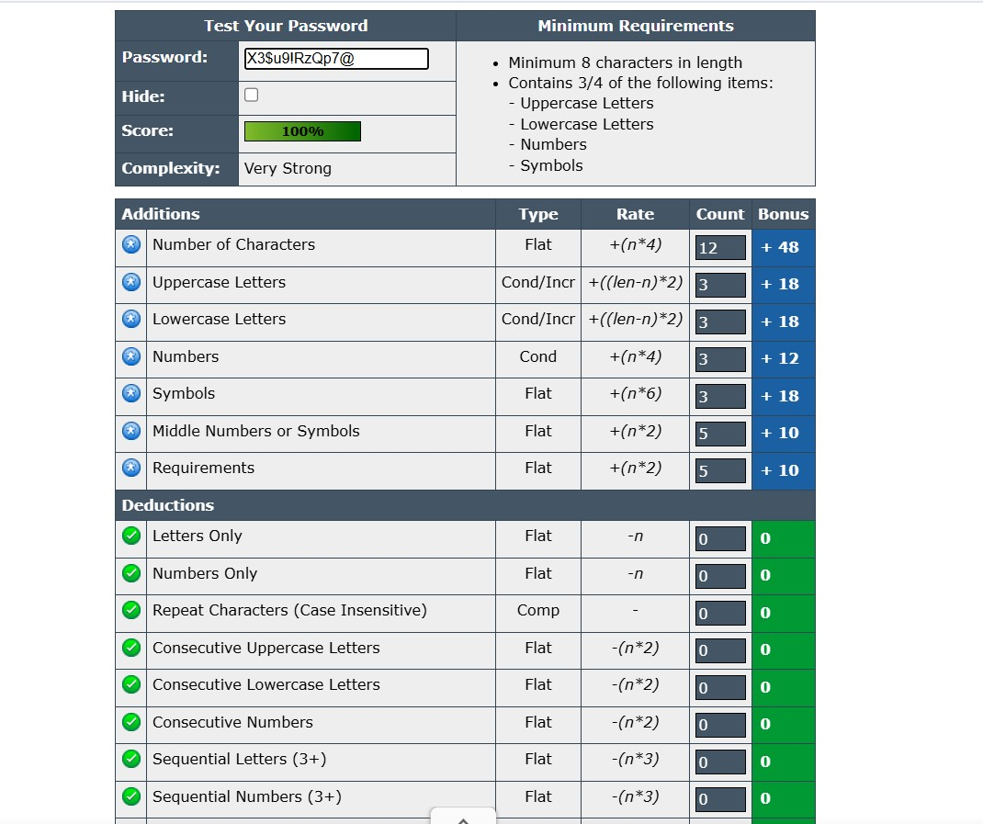

Password : 123456
Score : 4%
Complexity Level: Very Weak
Feedback:
- Too short
- Numeric only
- Extremely common and easy to guess
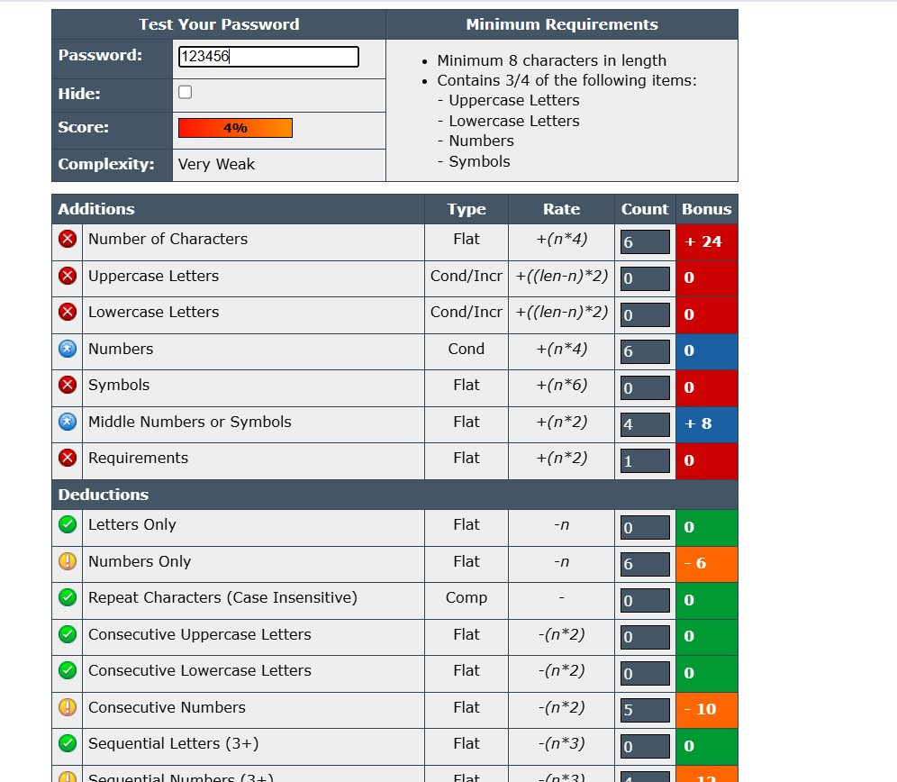

Observations and Feedback Summary What Makes a Password Weak:
- Uses common words (e.g., password, 123456)
- Lacks variety in character types
- Too short (under 8 characters)
- Predictable structure (e.g., capitalized word + number)
What Makes a Password Strong:
- Length of 12 characters or more
- Mix of uppercase, lowercase, numbers, and special characters
- Unpredictable or random character sequences
- Use of passphrases with substitutions (e.g., S0ftw@reEng!n33r)
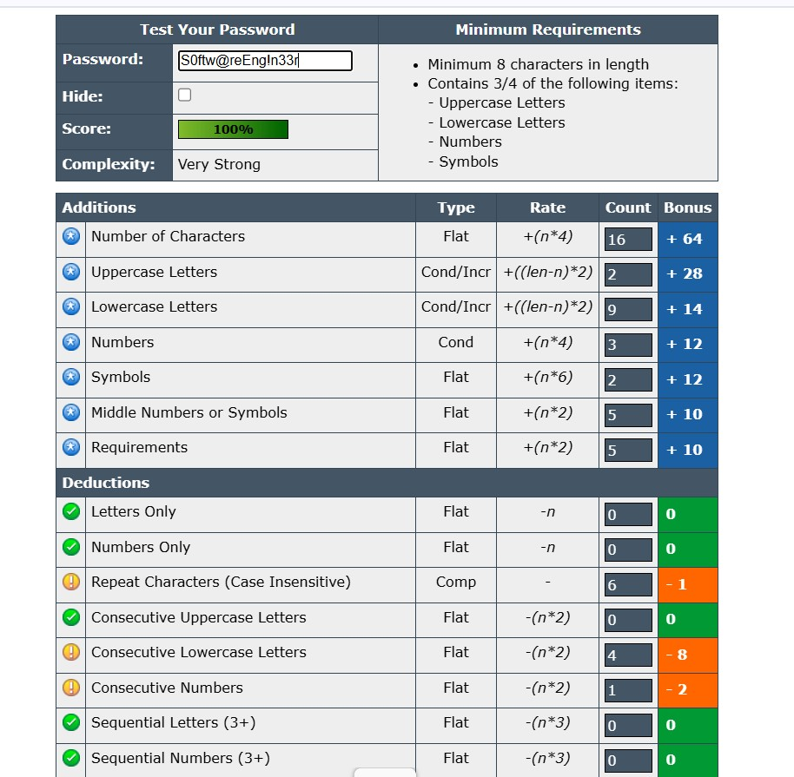
Best Practices for Creating Strong Passwords
- Use at least 12–16 characters.
- Combine uppercase, lowercase, numbers, and symbols.
- Avoid real words or common substitutions (like pa$$word).
- Don’t reuse passwords across multiple accounts.
- Use passphrases made up of unrelated or modified words.
- Consider using a password manager to generate and store complex passwords.

Understanding Password Attacks
• Brute Force Attacks – Try every possible password combination until the correct one is found.
- Long, complex passwords with mixed characters can take years to crack, making brute force attacks ineffective.
• Dictionary Attacks – Use lists of common words, phrases, and predictable patterns.
- Avoid real words and simple substitutions; instead, use unpredictable character combinations.
• Credential Stuffing – Reuse of stolen username-password pairs from one site to log in to others.
- Use unique passwords for each account to limit damage if one password is compromised.
• Phishing Attacks – Trick users into revealing passwords via fake emails, websites, or messages.
- Strong passwords won’t stop phishing, but enabling Multi-Factor Authentication (MFA) adds extra protection.

How Password Complexity Improves Security
- A 6-character simple password can be cracked in seconds.
- A 12-character mixed password can take decades to crack via brute force.
- Every additional character exponentially increases cracking time.

Final Summary
- Use long, unique, and complex passwords for each account.
- Password checkers like PasswordMeter.com offer helpful insights but aren’t foolproof.
- Enable multi-factor authentication (MFA) wherever possible

