**what is frontend/client?**

In telecommunication, the front can be considered a device or service, while the back is the infrastructure that supports provision of service. A rule of thumb is that the client-side (or "front end") is any component manipulated by the user.

**what is backend server?**

A back-end server is a part of the back-end process, which usually consists of three parts: a server, an application and a database. The back end is where the technical processes happen, as opposed to the front end, which is usually where the user's interaction occurs.

**what is framework? and why do we need a framework?**

The purpose of framework is to allow designers and developers to focus on building an unique feature for their web based projects rather than re-inventing by coding. Framework is specially created to help you boost the performance and efficiency of your web app development.

**Explain client server architecture?**

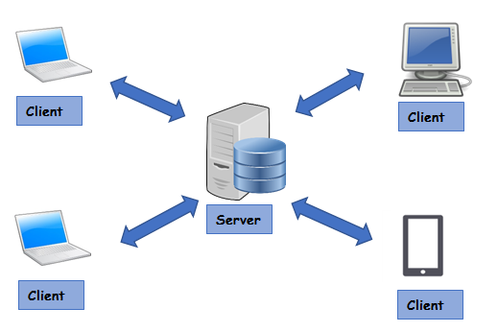

**what is a database and why we need a database? how we can connect to a database?**

A database is a collection of data, usually stored in electronic form. A database is typically designed so that it is easy to store and access information.A good database is crucial to any company or organisation. This is because the database stores all the pertinent details about  the company such as employee records, transactional records, salary details etc.

**Explain how can we develop an application using python? in both frontend and backend?**

Singularly python can’t be used to make both front end and. You need to define an own and unique route for every method.